For this project, we had decided, after much deliberation, to create a “jewellery heist simulator” game. The player would be placed into the position of a thief attempting to break into a jewellery store. They would be able to steal jewellery items from displays and glass cabinets for a larger score (a money counter) displayed on the screen. The player would need to avoid or fight guards in order to find a code and progress further inwards towards the vault, where the highest value items, and therefore highest scoring items, would remain.
Level Design and Development
Written evaluative report
Rebecca Jones (2305750)
2025
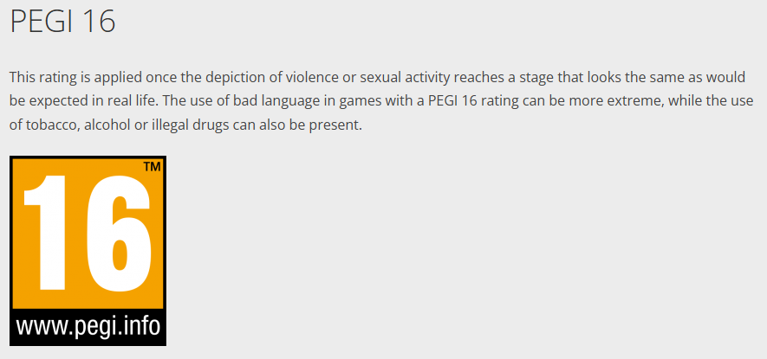
The target age for our game would likely be rated for a Pegi 16 audience, due to the depiction of weapons and violence against security guards in the intended experience as well as being the rating of similar games in the genre [1]. Our game would be aimed at those who enjoy stealth mechanics, beating your own high scores after repeated tries of a level and games with violence.
Screenshot taken from Pegi website [1].
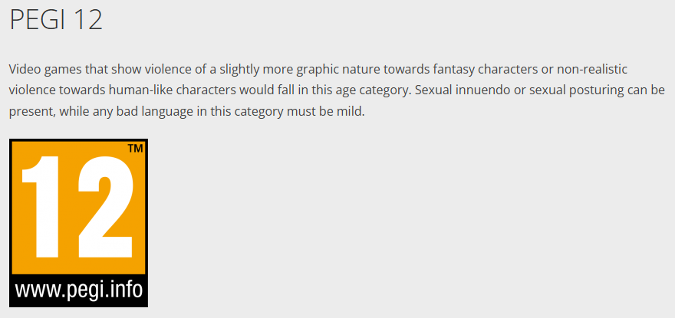
While the intended audience and inspirations for our group’s game were around a Pegi 16 rating, I believe that our project as it currently appears resembles more of a Pegi 12 rating [1], [2]. This is due to the lack of visible blood or injury detail.
Screenshot taken from Pegi website [2].

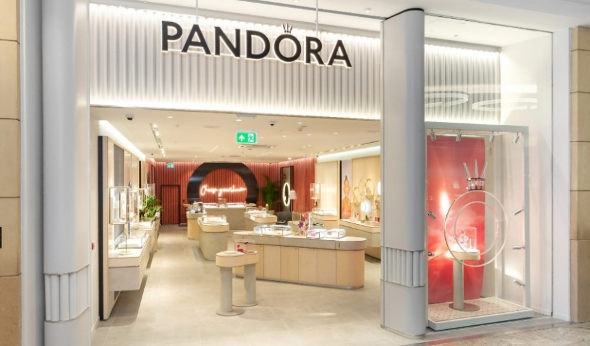
For my own level, I tried to use a primarily monochromatic palette along with marble flooring as I wanted my level to have the look of a high-end jewellery store. I conducted some small visual research into the aesthetics of jewellery shops as I felt it was important for the player to feel a sense of familiarity with the environment they were in even if the premise of the game were not explained to them.
Image of a Pandora jewellery shop [3].
In the above example, you can see that this shop uses a large amount of white in their store, as well as a stone tiled floor. I believe this is because of the colour white’s reputation as a timeless and luxury colour, as seen in something like an expensive wedding dress.
I also believe that stone tiles were used here to further the impression of a high-end and luxury space, as the shop would give a much different impression if something like the patterned tiles of a supermarket were used instead. This could also be as to not distract from the merchandise they are offering. As they also make use of lighting to guide the customer’s eye, in addition to the triangular shaped counter at the front of the store attempting to guide you further in along the left side wall.
In this, shop layout design and game design are not so dissimilar, which is what I had attempted to replicate in my own layout.
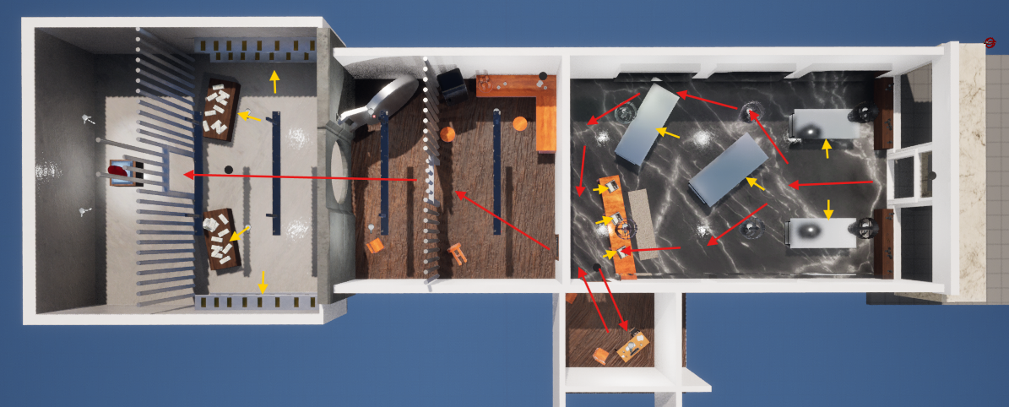
Top-down view of the layout I had made in Unreal Engine, with added arrows.
I have added red arrows to the above screenshot to show the path a player could take as well as yellow arrows to show what the player would interact with (what could add to the money counter).
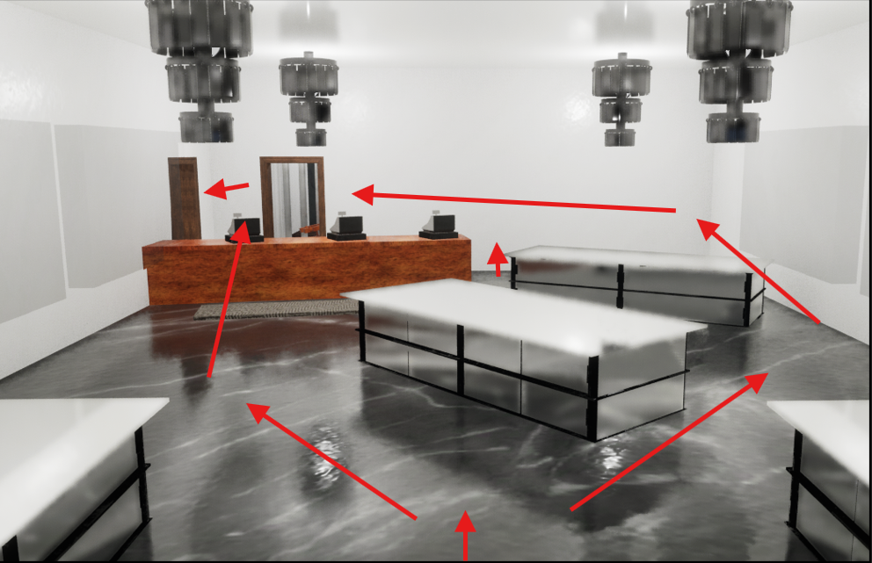
In order to create the walls of the building, I had made a block-out of the level in unreal by scaling cubes for the walls and furniture. Further on, for ease of texturing and to neaten the level, I had re-made the walls and flooring in Maya. This did not take long as the store is made of mostly square shapes. A lot of Unreal Engine’s basic assets were used as placeholders and were eventually replaced by assets created by the design team.
Entrance view of the layout I had made in Unreal Engine, with added arrows.
The counters I have placed drive the player towards the desk, and therefore towards the doors to other rooms. When walking through the block-out myself, I tended to jump the counter as a shortcut and head straight through the door. When creating the level with actual assets I felt it was important to preserve this, not only for myself, but for players who would want to complete levels in a faster time. When arranging the glass cabinets, I felt it was important to place them similar to that of a real jewellery shop, with the intent of making customers look at merchandise. I feel this design method works well with the game's mechanics as we want the player to be able to find these items for a higher score.
As you enter the door, two cabinets are placed on either side. In the middle there is a rotated cabinet, intended to split the customers path either towards the tills or toward more jewellery, still ending at the front desk. I believe this small roundabout section could also be used as a minor stealth section, where the player would crouch behind the counters to avoid a circling guard on a set path. The player could then exit via the back counter and desk, looting cash registers on the way to the security office or the break room/vault area.

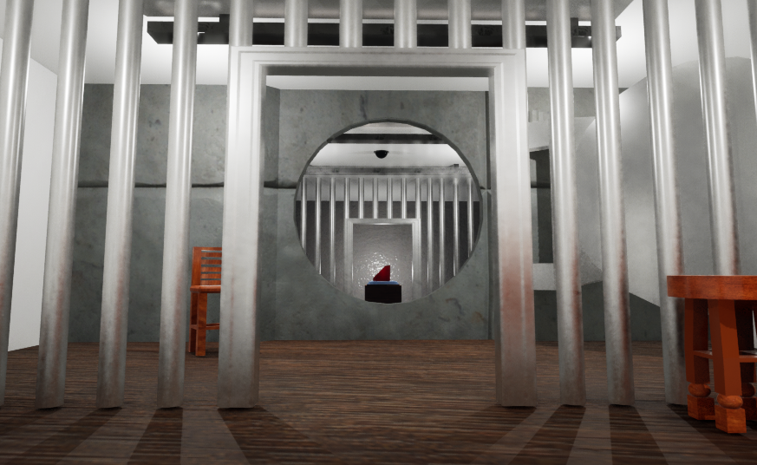
When originally making the vault diamond, I had opted for a more realistic clear colouring but felt this did not stand out enough in both the environment and as an object of high value. In my research I discovered the existence of red diamonds, a rare variety of diamond caused by extreme distortion via heat and pressure once the stone has been formed [4], [5]. This solved the colour contrast issue, as well as placing a large amount of researched additional value in being the rarest type of an already expensive gemstone [5].
Red diamond inside of the vault in Unreal Engine.
I have used multiple methods in order to increase the diamond's visual importance, such as; using composition by placing the diamond in a central position and framing it using the vault wall (as seen in the above example), placing spotlights above the diamond, similar to real jewellery shops, putting the diamond in a separate area with its own pedestal, and finally by exaggerating the size. As red diamonds have never been found in particularly large sizes, this too could be an exaggeration to emphasize the value of the in-game diamond [5]. This asset was created with reference images of a stereotypical diamond shape followed by alterations after feedback by a member of the group and is intended as a major reward for the player after getting to the vault.

I also conducted some small research into different safes for valuables. When originally looking for safe designs, I had looked to traditional, smaller safes, at most being the size of a fridge. After some discussion, the idea of a walk-in vault was brought up, which led to me looking at larger bank-style vault doors, as well as the addition of a dedicated vault room at the back of the level.
In my opinion this change was greatly beneficial as it gives the player a solid end goal in the level and grants the items inside a higher level of importance, highlighting their value. This asset was created using my visual research into bank-style vault doors and their mechanics and is intended as the primary obstacle for the player as far as the level itself is concerned. The player will need to take extra steps in order to find the key code located in the office, get around the guards and opening the vault door, playing its animation. Higher risk and higher reward.
Other assets made by myself; smaller jewellery pieces which could be found by the player for additional points, a computer security desk with associated clutter, a cash register which could be interacted with for additional points with animation and finally an unused baton weapon.
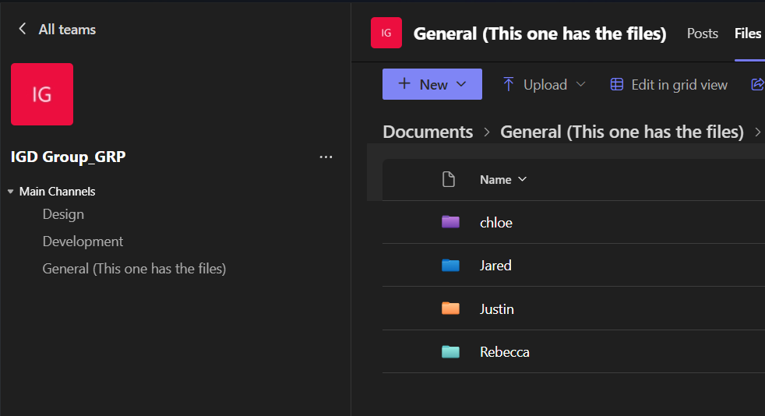
When trying to organise in the beginning, I had made a Microsoft Teams chat for the purpose of trading ideas and files. Another team member also created a separate Discord group chat; however, I feel that this was primarily used for non-work communications, in addition to a team member not being included due to not having the application nor wanting to join.
Screenshot of our Teams group as an example of file organisation.
While the Teams chat had worked for a while, many files would be buried under discussions, and I began to get messages similar to “Where is this file?”, “Could you send that to me again?” and “I don’t think she sent that file”. To solve this, I discovered that students have the ability to make their own Teams groups, similar to class groups. This made organising files much easier as there was now a file system we were all able to see.
I also added to both the Teams group and chat an app called ‘Polly’ which allows users to send polls to each other, I believed this would be useful as an easier way to ask for group opinions since it was something with which we were struggling. Before this, I had also tried to create a shared OneDrive file for assets, though this was unsuccessful as no one used it and the link itself got buried under messages.
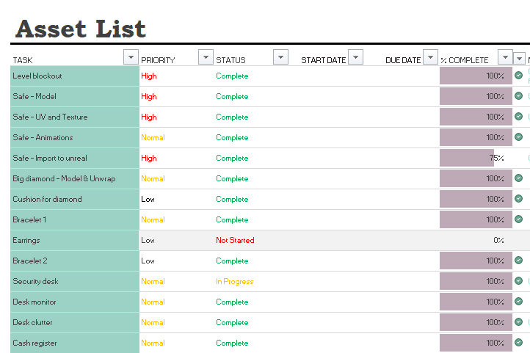
Screenshot of the asset list using my own section as an example.
Using the template on the Moodle page, I had shared an asset list excel sheet with the design team. I had also suggested assigning colour-codes to members so we would be able to claim tasks, this is because I was afraid that due to a lack of communication that multiple team members would work on the same asset. On this sheet, we were able to see what assets were being created as well as their progress. Small notes could also be added, so team members could communicate what was currently happening with each asset. I believe that this was the most successful tool that our group used as it made seeing what other designers were doing extremely easy and also provided a means of communication that likely would not have happened otherwise.
In organising my own files for this project, I had adopted the use of naming conventions. For example, if I were to name a file it would look something like “IGD_Diamond_02”. Meaning the module title, asset name and also what version of the asset this is. This is so related project files could easily be found if lost, to identify which asset it is and to have multiple iterations of the file saved in the case of accidental destruction of work. On reflection, I wish that I had suggested that all team members keep to similar naming conventions, perhaps adding initials onto the file names to avoid confusion, as I feel like we had quite a few files named things like “Most recent version” and “This is the version with XYZ”, which I personally found created some confusion.
If I were to start another project like this, I would try to be more vocal in the matter of team organisation and check in more often with fellow team members. Helpfully, I feel that this assignment has led me to discover multiple different organisational resources that could easily be carried over to future projects.

In my opinion, I feel the research I did was helpful to my existing contributions though I do feel more could have been done to inform my work rather than creating what I think things should look like. In future, I shall endeavour to be more thorough and take more notes in order to apply my findings in my practical work. Reflecting on my methods in this report, I feel I have been limited in my sources, mostly keeping to online searched articles and image boards. To improve this, I could look for new sources of information such as visiting real-life locations, acquiring books on the desired subject, and playing similar games.
As far as sharing research among the group went, to my knowledge this was an incredibly small amount. If I recall correctly there was an early attempt to make a shared mood board, but this predates the heist game idea. Aside from some sharing of images for what asset appearances could look like, I am of the belief that group pooling of information was low.
Overall, I believe that our group’s final project suffered immensely from a breakdown of communication between team members, and while I am not innocent of this either at times, I believe more could have been done to form a more cohesive final product.

Bibliography

- “PEGI 16,” Pegi Public Site, pegi.info. https://pegi.info/pegi-16 (accessed May 09, 2025).
- “PEGI 12,” Pegi Public Site, https://pegi.info/pegi-12 (accessed May 09, 2025).
- “FIRST LOOK: Pandora unveils new store concept,” Professional Jeweller, Sep. 20, 2019. https://www.professionaljeweller.com/first-look-pandora-unveils-new-store-concept/
- T. Nace, “12 Most Expensive Gemstones In The World,” Forbes, Nov. 02, 2015. https://www.forbes.com/sites/trevornace/2015/11/02/12-most-expensive-gemstones-world/#76cd0f981538 (accessed May 09, 2025).
- G. Mobley, “The Red Diamond Is the Rarest of All,” Natural Diamonds, Apr. 14, 2025. https://www.naturaldiamonds.com/science-of-diamonds/rare-natural-red-diamond/

