Globally responsible business
BMSP6001
Alexandra Olivia Safadi
Due: 29th November 2019
Word count: 2,673

This essay will outline key aspects of corporate social responsibility (CSR) through investigating ethics that contribute to the subject. This essay aims to explore the theories behind being a responsible business, positive and negative factors of sustainability reporting and lastly aiming to form a view on whether CSR should be voluntary or enforced.
Organisations goals depend on factors such as a company’s motive, whether the company operates to provide social impacts, if the company is profit driven, follows a philanthropist view, corporate citizenship view or follows corporate social responsibility ethics. Professor Muhammad Yunus is passionate in social responsibly within organisations, he expresses, ‘ Engaging in social business is beneficial to a company because it focusses on business’s ability to address social issues, involves one-time investment with sustainable results, and produces other positive effects such as employee motivation and improved organizational culture’ (Yunus, n.d.). Alternatively, professionals within private sector organisations suggest that business profit should be a company’s first priority. Having previously investigated key aspects within private and social businesses, both arguments consist of fair points. However, I do not believe that profitability should become powering as customers may begin to question ethical reasoning within the company. Instead, the question regarding ‘how’ increased profits are achieved is vital and this illustrates sectors of responsibility that should be considered. Individuals that are philanthropists invest their wealth to bring good to society. Andrew Carnegie is a well-known philanthropist that states, ‘No man can become rich without himself enriching others’ he also states, ‘The man who dies rich dies disgraced’ (Emmie Martin, 2015). Whereas, corporate citizenship involves how conscious corporations are for society. Corporate citizens aim to provide adequate level of lifestyle and standards of living for those around them whilst continuing to create profit and gain stakeholders. I think that there is a need for businesses who are socially responsible like Muhammad Yunus’ who established the Grameen Bank to positively impact society and gain an insight into community needs rather than profit driven organisations that often disregard these factors.
Having outlined the differences regarding what businesses view as ‘being responsible’ is, it is apparent that there are different motives behind each type of organisation. This is often due to the company’s ethics. Ethics are often defined as values or moral principles that affect a person’s decision making. Ethics determine what an individuals or corporation believe will positively impact themselves and society (All About Philosophy, 2019). However, ethical differences are often divided due to aspects such as religion, culture and the motives of a business (BBC, 2019). Ethics have been divided into categories such as Metaethics, Applied and Normative. The Normative ethics strategy relates to business, this strategy questions moral judgement such as what is wrong or right. The answers to moral judgement according to the normative strategy fall into two categories- Teleological and Deontological (Norman, 2010).
Teleological and deontological ethics are two opposite theories. Teleological ethics introduced by Jeremy Bentham, evaluate the positive and negative aspects of the consequences of an action. Alternatively, Deontological ethics introduced by Immanuel Kant, evaluate the positives and negatives of the action through looking at the action alone and is focussed on set rules (Hasa, 2019). I am favourable of the Teleological approach as it evaluates true outcomes of a business strategy to improve them which is ultimately what sustainability reporting (SR) aims to achieve.
Sustainability is the main focus of SR and can be defined as an approach to management that companies utilise to create social and environmental value along with economic growth. Theorist Drucker outlines the need to stay frequent with the quick pace-of-change and the importance of staying current with modernisation in society (Drucker, 1995). Sustainability could possibly be a solution supporting Drucker’s theory as it provides answers to challenges that organisations face within the modern world (Deloitte, 2019). The concept of SR involves pursuing social, environmental values and economic growth which provides a summary of the company’s values and priorities. SR involves a summary prepared by corporations regarding their effort to operate in an environmentally friendly fashion. SR can aid in creating corporate social responsibility (CSR).
Business responsibility is also known as CSR and can be defined differently depending on the business’s values, ethics and beliefs. According to Carol Sanford, ‘A Responsible Business sees stakeholders as full partners and meaningful instruments for the evolution of healthier communities and more successful businesses’ (Sanford, 2011). However, Howard R. Bowen (1953) is one of the main theorists that questioned what power to society businesses should be required to accept. According to ‘Social responsibility of the businessman’ published in 1953, CSR involves, ‘the obligation of businessmen to pursue those policies, to make those decisions, or to follow those lines of action which are desirable in terms of objectives and values of our society’ (Bowen, 1953). I personally agree with Bowen’s definition of CSR as he considers the value of our society. Findings suggest that CSR is relatively broad and the concept can be interpreted differently between businesses, government, academics and political parties. The common consensus amongst the different definitions regarding CSR suggest that for a business to become socially responsible they must carefully manage shareholders. Businesses that incorporate CSR are often larger businesses as they are able to give back to society. Larger organisations have competitive advantage as they can influence high standards with regards to being sustainably responsible. However, many larger businesses incorporate sustainability to benefit their brand image rather than to positively affect the environment. Regardless of the motive within the company, this effort raises awareness and creates an impressive brand image.
When companies considered CSR, voluntary and philanthropist views they can positively impact both business and society as CSR attributions can aid in strengthening relations amongst employees and the company through boosting morale and educating staff, encouraging positive changes within employees personal and business behaviour whilst obtaining profits and maximizing shareholder value. However, this idea has been criticized by economist Milton Friedman (1970) as he expressed that the only social responsibility of organisations is to maximise their financial gain (Ian Watson, 2009). Despite differences between organisations, businesses are obliged to take responsibility of certain fundamental legalities and ethics within their company. Aspects of CSR have been outlined below.
Aspects that create CSR (ranked in importance, 1 being most important) | Business responsibility
1 Workplace  4 Beliefs and Values | Companies consist of staff; businesses often argue how responsible they should be over their employees. However, the well-being report (2018) suggests that if a company motivates, engages, trained, and manage their staff correctly this will result in a successful working environment as employees will be happy within their position (Reba, 2018). Maslow’s hierarchy of needs supports the idea that when an individual is happy, feeling valued and appreciated they will perform better within all aspects in their life including work. Until they become fully accomplished beings resulting in being self-actualised (McLeod, 2018).  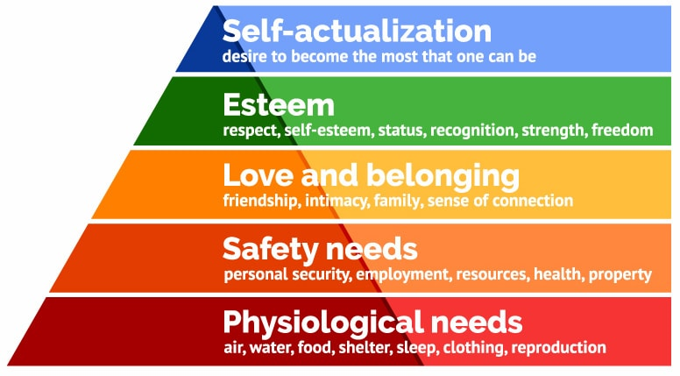  (McLeod, 2018)  2 Environment  3 Community  Businesses must follow Laws and legislation that relate to their specific sector. However, it is estimated that companies could save ‘£6.4bn per year on costs that involve waste disposal, heating, water, paper, transport and others. When these statistics are illustrated it becomes clear why some companies cut costs through simply disregarding enforced rules (organisation for responsible businesses , 2019).  Involving the area where the company is situated can create multiple benefits such as creating a good reputation. Incorporating local produce also supports the local economy and allows a company to learn about their clients’ needs and wants.  Companies are often extremely misleading in marketing products, treatment of staff, customers, suppliers and other stakeholders. Greed in terms of profit have caused huge issues within responsibility of businesses and it would be interesting to discover if this issue would still exist if business owners implemented their personal ethical values to their company.  5 manufacturing  Businesses must be aware of their product materials, the manufacturing of their products and the affects their service has on stakeholders. It is questionable whether businesses today are aware of unethical issues within their company or whether they are simply ignoring issues such as child labour or toxic emissions from manufacturing as their main focus is driven on creating low prices for buyers in order to have competitive advantage within their industry.

SR and CSR are currently voluntary, professionals’ continuously debate whether CSR and SR should be voluntary or mandatory. European commission’s (EC) (2001) defined CSR as ‘a concept whereby companies integrate social and environmental concerns in their business operations and their interaction with their stakeholders on a voluntary basis’. However, the renewed EU strategy defines CSR as ‘the responsibility of enterprises for their impacts on society’, removing the ‘voluntariness’ of the practise (Justo, 2019). This statement could be outlining a possible movement within CSR being voluntary, addressing importance of businesses adopting sustainability motives such as completing SR. Professional Jacob Anderson states that sustainability is an aim that will determine business models in future development and that businesses are beginning to realise that sustainability is brining positive impacts to businesses today (view benefits of sustainability reporting table) (Anderson, 2015).

Benefits of sustainability reporting and Corporate social responsibility | Negative aspects pf sustainability reporting and CSR
Creates openness between stakeholders/ customers’ needs which also reduces the risk of bad reputation.  Creates a positive brand image.  Through considering waste, materials, manufacturing, energy consumption, internal management and decision-making processes the company may save money.  keeping companies current and aware of newly developed changes that contribute to being sustainable.  Introducing the sustainability act creates innovation inside businesses and creates a competitive advantage- ‘80% of the C-level executives interviewed believe sustainability is a way to gain competitive advantage in today’s global market’ (Anderson, 2015)  Businesses can evaluate potential risks and illustrate how to overcome them which allows companies to identify a new approach of initiating modern ideas, products and activity that attracts investments – transferring knowledge regarding sustainability within organisations.  Identifies strengths, weaknesses, opportunities and threats as it creates a broad vision and encourages regular strategies for company development.  Customers/ stakeholders will understand the intrinsic values within a company regarding shat is intangible/ tangible.  Sustainability reports gather important data which is cost effective.  Regulates business requirements whilst creating a positive change.  Once other companies witness large organisations creating a sustainable change, they are likely to joining rather than risking being perceived badly by stakeholders and customers.  Improves a company’s green initiative  Ernst & Young suggest that SR is the ‘best practice employed by companies worldwide’ as it can better performances already in place (Anderson, 2015).  Benefits organisations internally.  There are multiple stakeholders within an organisation that rely on a company’s choice and decisions and government. reporting provides opportunity for government and businesses to build a relationship as its vital to continue establishing trust of stakeholders without affecting the businesses growth (Anderson, 2015).  SR are currently voluntary, however, companies that complete these reports benefit as they show corporation’s dedication to social, economic, governance model and environmental values and responsibilities.  SR allows organisations to develop a deeper understanding into potential threats and opportunities that they may face in future which can aid with their business tools such as when completing a SWOT (Wise Geek, 2019). | Sustainability reporting is voluntary meaning that there are no consequences if a company chose not to operate.  A company is able to create their own frame-work for the sustainability reporting which makes it easy for companies to mislead stakeholders/ customers.  If a company mislead stakeholders with incorrect or false information there are no consequences or punishment for the misstatement.  It is difficult to measure social responsibilities related with sustainability and it is challenging to motivate and change a company’s ethical stance and values.  Changing to be a CSR could go against the company’s objectives.  CSR can cost money – for example, allowing staff to volunteer during working hours for campaigns.

Having outlined the advantages of SR and the responsibilities and outcomes of a Corporation that is Sustainably Responsible, it is clear that CSR creates positive impacts for businesses as well as the environment. CSR has developed popularity due to stakeholders becoming aware of the importance of sustainability. I agree with Drucker’s theory that the environment is constantly altering within businesses and externally. Burke-Litwin’s theory supports this theory, his model identifies that external factors such as market, competition, economy and legislation are drivers of change. This model identifies the multiple external factors which drive change and that once customers and other stakeholders are prioritising sustainability organisations are forced to implement the change (Litwin, 1992).

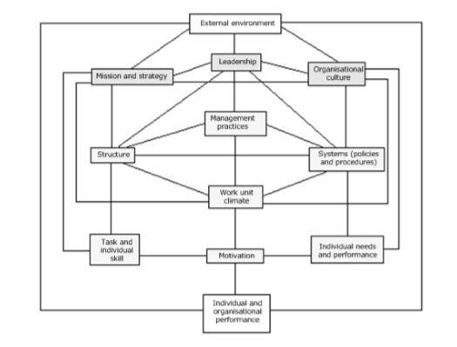 (Litwin, A Causal Model of Organisation Performance and Change, 1992)
The theory above outlines the need of considering micro and macro environments. I agree with this theory as I believe due to the modern environment and Drucker’s statement organisations must practice genuine CSR to be successful in the modern marketplace. However, due to corporations becoming aware of the need to be responsible, greenwashing has developed. Greenwashing is when a company is claiming to be environmentally friendly and responsible whilst they are misleading stakeholders and customers (Juneja, 2019).
Burke-Litwin’s theory is similar to the triple bottom line theory (TBL) as TBL places people and the planet equally with profit in the mission of an organization. I am favourable of theories that consider both internal and external environments as both of these environments are continuously altering therefore it is vital to constantly asses and modernise them. The responsible business map below also consists of similar principles to these theories.
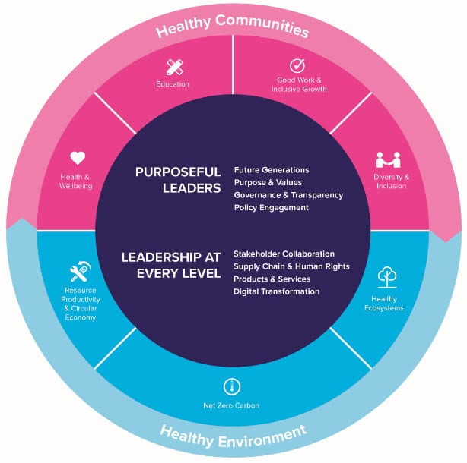 (The Prince's Responsible Business Network, 2019)
The prince’s responsible business network has created the responsible business map above. I am favourable of this illustration as I personally believe that business and society interlinked creates further benefits. I believe that if all companies try to achieve all of the aspects within the map, they will be positively affected and in turn become close to being a responsible business which will positively effect aspects such as economy, society and the environment whilst complying with ethics.
TBL involves the genuine practice of CSR, unlike greenwashing, CSR provides a commitment to stakeholders and the planet to motivate a healthy existence for organization to abide by (BC Campus, 2019). The bottom line (1994) described by John Elkington, refers to the financial situation of a company. He questions whether the company is creating profit, consistent financially, or occurring debt. I personally do not consider this theory as the ‘bottom line’ of business. Alternatively, I am favourable of Elkington suggestion regarding the TBL as Elkington suggests that a company must consider three measures rather than one. He suggests that the bottom line consists of economic, environmental and social results. I believe it is important for companies to progress beyond the initiative to create profit as I believe that if creating larger profits maximises damage to the environment or effects individuals negatively the company should reassess their business strategy. TBL outlines that all aspects within businesses, society and governments should work in partnership with each other to create a positive outcome. This theory links with Mattie Stepanek’s quote, ‘Unity is strength… when there is teamwork and collaboration, wonderful things can be achieved’ (Stepanek, n.d.).
I have come to the determination that CSR should be mandatory especially for larger organisations. However, with already existing pressures from the macro and micro environment I am aware that small companies may begin to feel pressured if this became mandatory. However, I am aware that if this was made mandatory for large organisations and not smaller companies this could cause conflict as well as a difficulty to place regulations. For example, companies consist of different ethics and motives which could lead to further greenwashing and companies may question at which point it would become mandatory for small organisations to have to become responsible which could later encourage companies to mislead stakeholders to avoid the mandatory implementation that large companies have. Therefore, I have formed the opinion that CSR should be mandatory for all companies, large or small. In order for this to become mandatory, correct global frame work must be made and agreed so that the system becomes regulated.

References

All About Philosophy. (2019). What are Ethics. Retrieved from All About Philosophy : https://www.allaboutphilosophy.org/what-are-ethics-faq.htm
Anderson, J. (2015, May 21). The Importance of Sustainability Reporting. Retrieved from ADEC Innovations: https://info.esg.adec-innovations.com/blog/bid/363174/the-importance-of-sustainability-reporting
BBC. (2019). Ethics: a general introduction . Retrieved from BBC: http://www.bbc.co.uk/ethics/introduction/intro_1.shtml
BC Campus. (2019). Corporate Social Responsibility (CSR) . Retrieved from BC Campus: https://opentextbc.ca/businessethicsopenstax/chapter/corporate-social-responsibility-csr/
Bowen, H. R. (1953). Social responsibilities of the businessman. In H. R. Bowen. New York, Harper . Retrieved from Social-responsibility.at.
Caulkins, D. (2013, December 20). President Howard Bowen & Corporate Social Responsibility. Retrieved from Grinnell College: https://www.grinnell.edu/news/president-howard-bowen-corporate-social-responsibility
Deloitte. (2019). Sustainability and Corporate Social Responsibility (CSR). Retrieved from Deloitte: https://www2.deloitte.com/ru/en/pages/risk/solutions/sustainability-and-csr.html
Drucker, P. F. (1995). Managing in a Time of Great Change" by Peter F. Drucker. Truman Talley Books. Retrieved from Strategy- business .
Emmie Martin. (2015, December 2). The top philanthropists in the world. Retrieved from Independent: https://www.independent.co.uk/news/people/the-20-most-generous-people-in-the-world-a6757046.html
Hasa. (2019, February 7). Difference Between Teleological and Deontological. Retrieved from Difference Between: https://www.differencebetween.com/difference-between-teleological-and-deontological/
Hayes, A. (2019, June 12). Corporate Citizenship. Retrieved from Investopedia: https://www.investopedia.com/terms/c/corporatecitizenship.asp
Ian Watson, P. P. (2009, July 14). Milton Friedman on Corporate Social Responsibility. Retrieved from The Lucid Manager: https://lucidmanager.org/milton-friedman-corporate-social-responsibility/
Juneja, P. (2019). Green Washing, Corporate Spin and CSR. Retrieved from MSG: https://www.managementstudyguide.com/role-of-media-and-corporate-social-responsibility.htm
Justo, A. A. (2019). Should CSR be mandatory, voluntary or both? Corporate Social Responsibility. Retrieved from file:///C:/Users/Windows/AppData/Local/Packages/Microsoft.MicrosoftEdge_8wekyb3d8bbwe/TempState/Downloads/ShouldCSRbemandatoryvoluntaryorboth%20(1).pdf
Litwin, B. &. (1992). A Causal Model of Organisation Performance and Change. Journal of Management, 523-545.
Litwin, B. &. (1992). A Causal Model of Organisation Performance and Change. Retrieved from https://www.exeter.ac.uk/media/universityofexeter/humanresources/documents/learningdevelopment/understanding_drivers_for_change.pdf
McLeod, S. (2018). Maslow's Hierarchy of Needs. Retrieved from Simply Psychology: https://www.simplypsychology.org/maslow.html
Medium. (2019, March 5). Advantages and disadvantages of sustainability reporting. Retrieved from Medium: https://medium.com/@makemyassignments/advantages-and-disadvantages-of-sustainability-reporting-57d03437496b
Norman, W. (2010, July 20). Business Ethics. Retrieved from HBS: https://www.hbs.edu/faculty/conferences/2016-newe/Documents/Norman,%20Business%20Ethics,%20IntEncycEthics.pdf
organisation for responsible businesses . (2019). What is Responsible Business. Retrieved from organisation for responsible businesses : http://www.orbuk.org.uk/responsible_business.php
Reba. (2018). How benefits can help improve employees’ happiness. Retrieved from Reba : https://reba.global/content/how-benefits-can-help-improve-employees-happiness
Sanford, C. (2011). The Responsible Business. In The Responsible Business.
Stepanek, M. (n.d.). Mattie Stepanek quotes. Retrieved from Brainy Quote: https://www.brainyquote.com/quotes/mattie_stepanek_319300
The Prince's Responsible Business Network. (2019). The Responsible Business Map. Retrieved from BITC: https://www.bitc.org.uk/the-responsible-business-map/
Wise Geek. (2019). What is corporate sustaibility report? Retrieved from Wise Geek: https://www.wisegeek.com/what-is-corporate-sustainability-reporting.htm
Yunus, M. (n.d.). Muhammad Yunus Quotes. Retrieved from Brainy Quotes: https://www.brainyquote.com/authors/muhammad-yunus-quotes

