Leading and implementing workplace change

Module Code: BMSW6103

Student Name: Nadeem Arif

Student ID: 1711109

Lecturer Name: Syed Jaffery
Contents
Introduction 3
Analysis of Organisational History and Change in External Environment 3
History of the Organisation 3
Structure of Retail Industry 4
Macro Environmental Analysis of Sainsbury’s 4
Micro Environmental Analysis of Sainsbury’s 7
SWOT Analysis of the Company 7
Barriers to Enter a New Market 8
Impact of External Environmental Change on the Organisation 8
Model for Change 9
Lewin’s 3 Stage Change Model 9
Step 1: Unfreeze 9
Step 2: Change 10
Step 3: Refreeze 10
Kotter’s 8 Steps Change Model 11
Critical Analysis of the organisational culture of Sainsbury’s and the ways in which change affects the organisation 16
Conclusion 17
References 19

Introduction
The changes in the economic aspect of each and every country is very much evident from the past few decades. The fast rate at which there has been a huge shift in the economic changes from the Western countries to the Asian countries like China and India is impacting the already established countries in the Western part. In order to measure the changes and to assess the probable causes of change, this report will focus on various aspects of the organisation of Sainsbury’s and related to the UK market. The report will focus on the retail industry of the UK and how it has changed from the previous times in order to keep pace with the change. A detailed macro and micro environmental analysis will be conducted to understand the scenarios better. Along with detailed market analysis, few models of change will also be discussed in the report which will effectively highlight the issues related to strategic organisational change. Lastly, the effectiveness and impact of organisational culture will also be analysed in order to understand its influence on the change management programme.

Analysis of Organisational History and Change in External Environment

History of the Organisation
Sainsbury’s, when the company was first opened in 1869 it was just a dairy shop. The company was founded by John James Sainsbury and his wife named Mary Ann Sainsbury. That store was located in the Drury Lane of London, which was considered to be the poorest locality in London. The store became popular within a span of time after their opening because it offered high quality products at minimal prices. Within 1882 stores were located in other shopping streets of the capital such as in Islington, Stepney and Kentish Town. In the same year, Sainsbury's first branded product was launched which was Bacon (Aluko and Knight, 2017). During the largest stock market floatation in 1973, Sainsbury's went public. Sainsbury's has been the UK's largest and most revenue generating supermarket group for decades. However, management of the company became inefficient with time and Tesco which is another UK based company, caught up with them in 1995. The company since then has been lacking in their innovative business strategies which has been implemented well by its competitors in the local market. The suppliers of many raw materials used to be delivered by many countries from Asia. Because of increase in globalisation, the number of various companies in every sector kept on growing with time in the Asian countries because of which the prices of importing raw materials in the UK became more costlier (Aluko and Knight, 2017). This has affected the company’s growth to a great extent in the last few decades.
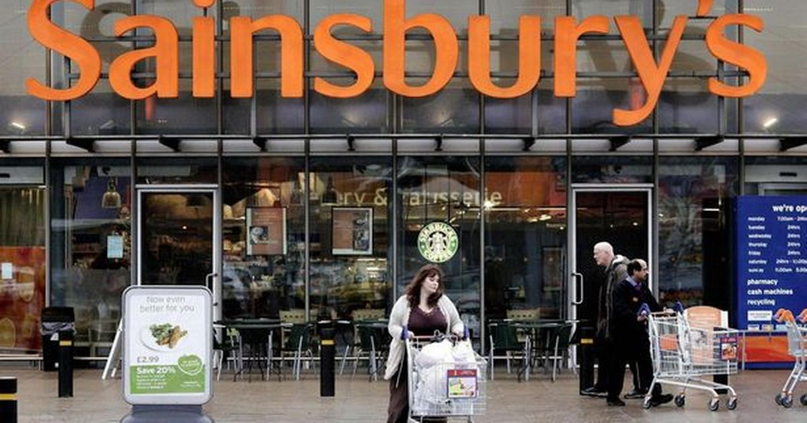
Figure 1. J Sainsbury plc (Source: Forbes)

Structure of Retail Industry
The size of the retail industry in the United Kingdom has always been huge in terms of economic benefit and also in terms of the variety of products in the industry. The output of the retail sector itself was more than ninety billion pounds in 2017. The retail sector of the UK helps the local people to a huge extent. There are nearly three million people working directly or indirectly associated with the retail industry in the UK (Khan et al., 2019). The retail sector contributes five percent of the Gross Value Added to the economy of the United Kingdom. Among all the businesses in the UK there were nearly three hundred twenty thousand retail businesses in 2018 which was about 5.6 percent of the total retail business in the UK. Because of the impact of Covid-19, many small and medium businesses have been affected immensely which resulted in a major decline in the number of business operations all across the UK (Dolega et al., 2019). The contribution of the retail industry to the UK’s economy in that period has also not been great because of lockdown.

Macro Environmental Analysis of Sainsbury’s
The macro environmental analysis of the company will help to create a better understanding of the external environmental factors which impact the industry and the businesses that are involved with it. The analysis will be done with the help of PESTLE analysis which involves six major factors including environmental, political, social, technological, economical and legal aspects of the retail industry (Paul and Yeates, 2014).
Political Aspects
The UK voted to move out from the European Union in 2016. This move by the UK was termed as Brexit, which can have irreversible impact on the organisation of Sainsbury’s and in the whole retail industry. The implementation of Brexit in the UK will ensure that all the products and raw materials which used to be imported from other European countries will now have to be imported with a higher price tag (Paul and Yeates, 2014). This will make the final products more costly for the consumers and will also make the business of the large organisations like Sainsbury’s more competitive. This political move will not only cost the companies their profit but will also hamper the economic contribution of the companies to the country’s economy (Bentham, 2018).
Economic Aspects
With the rising price of the fuel in the last few years because of heavy import duty and low supply of fossil fuel it has impacted the industry from various sides. Hugh fuel price will add up to the high transportation cost of goods and services which will finally add up to the end user products of the consumers. Along with that, the companies also need to make sure about the product pricing in order to sell them to the consumers at the lowest possible price which will fetch them with more loss than profit (Bentham, 2018).
Another economic factor which comes in play for Sainsbury’s is that the increasing demand of their employees for the rise in their wages. If the company plans to deliver the needs of their employee’s demands then it will hugely increase the expenses of the company which will affect the company’s growth and will make it much slower. With increase in the expenses the company will lose more of their profit to the wages of their employees (Paul and Yeates, 2014). If the company tries to maintain their profit margin along with increasing the employee wage then they have to increase product prices which will again hamper the sales of their company.
Sociocultural Aspects
The sociocultural aspect that can be considered as one of the most important at recent times is the trend of fair-trade movement across every sector in the market. Similarly, the concept of fair-trade in the retail industry also helps in gaining more consumer base which will give benefit to the company for a much longer term (Bentham, 2018). The consumers focus more on the company policies or their CSRs which will benefit the society and the environment and based on that consumers prefer to buy products. Therefore, the sociocultural aspects also play an essential role in the change management.
Technological Aspect
The technologies have moved way too far where they used to be a few decades back. With huge technological advancements the retail companies can now effectively analyse the consumer behaviour with much cost effective and efficient way. With BigData analysis and artificial intelligence Sainsbury’s can access various data and information about the market and about their consumers (Bentham, 2018). It will help them to strategically formulate their marketing plans which can gain them more consumers and profit. The online platforms are also very effective in delivering various items to the consumers which is another factor that involves advancement in technology (Paul and Yeates, 2014).
Legal Aspect
With the inception of 'sugar tax' in the UK, companies will have to switch products to avoid these taxes and save money for their profit. Rules were introduced to ban Sainsbury's from serving fatty, salty and sweet foods which contain high amounts of sugar to the children under 16 years. This provides very limited opportunity for Sainsbury's advertisements. It is also essential to get government approval. Only if the inspector has approved the product; it can be distributed in the market (Paul and Yeates, 2014).
Environmental Factors
The government and the consumers of the UK expect the institution to respect the environment. Sainsbury's genuinely supports and strives to achieve the United Nations Sustainable Development Goals. They started cutting their own waste from the supply chain of cattle and lamb. In addition, Sainsbury's strives to lower its carbon footprint. They also say they appreciate the customers for reducing food waste. Either way, Sainsbury's appears to be eco-friendly. However, if there are no numbers or data on Sainsbury's website, reliability will be questioned (Bentham, 2018).

Micro Environmental Analysis of Sainsbury’s

SWOT Analysis of the Company
Strengths
From small stores of groceries offering a limited selection of products, the expansion of brand to smaller stores which then evolved into supermarkets and served different categories of products to meet the daily demands of customers. The chain of supermarkets is now one of the top four UK supermarkets that are present in the country. Sainsbury's business philosophy is to support customers to live healthy which will cost less. By pursuing and maintaining a profitable strategy across all categories of the products, Sainsbury’s has been successful to gain and retain customers from every area of sales, many of whom are loyal to the brand and depend on the company for their daily needs (FATRICIA, 2016).
Weaknesses
Like most brands of the industry, Sainsbury's faces multiple risk factors with brand switching. Despite the network's loyalty plans and promotions Sainsbury’s continues to view customer retention as a challenge. Due to increased competition in the retail sector and increased risk because of online stores, most of the retailers lost sales. In order to encourage customers to buy, Sainsbury's has sought to reduce costs and keep prices competitive, which is no longer acceptable (FATRICIA, 2016).
Opportunities
In most of the rural areas or in the remote places all across the United Kingdom, people do not use branded products. Sainsbury’s can effectively open new brands of stores which will meet the demands of people in such areas (FATRICIA, 2016). As there are very few such supermarkets, therefore, it is a great opportunity for the company to increase their presence in such places which will provide them with huge benefits from volume selling.
Threats
The main threat of the company is their ever rising competitors like Tesco and Asda. There are also other threats such as their lack of improvised inventory in their range of products. With fewer options for various products, people choose to buy from competitors rather than Sainsbury’s (FATRICIA, 2016).

Barriers to Enter a New Market
There are various barriers which can be observed from the above analysis that the company can have if they plan to enter a new market. Sainsbury’s is a very old and heritage company in the retail sector which does not have the long list of products that their competitors are providing. This along with many other issues with the company has led them to attract more loss over the period of the last few decades. The company therefore, if plans to enter a new market, initially they will be facing a lot of short supply from their suppliers as the demands will increase. And upon falling to meet the demand the company will attract a negative image in the new market which will give a more loss for a longer period of time (Chang and Wu, 2014). The management of such huge issues in the international market would have an adverse effect on the company.

Impact of External Environmental Change on the Organisation
The changes that occurred in the external environment of Sainsbury’s with the span of time has immensely impacted the growth of the company. Even the impact of covid-19 have shattered their many business goals for the year 2020. The macro environmental changes have also provided the company with many challenges that they need to acknowledge and improve. With such impact the company failed to implement their strategic plans in order to grow their business. Sainsbury’s organisation also have had a very poor experience with their management which led to many failed organisational objectives and thus, increasing the deficiency in the organisational performance.

Model for Change

Lewin’s 3 Stage Change Model
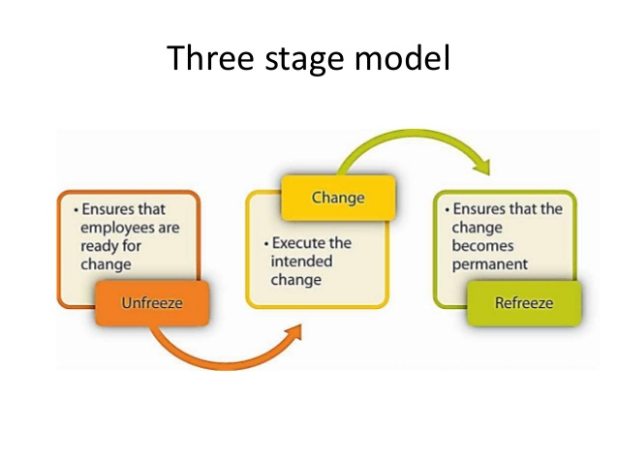
Figure 2. Lewin’s 3 Stage Change Model (Source: Forbes)
Kurt Lewin suggested that the person's behaviour in response to the suggested change was a function of the behaviour of the group. Any force or interaction that influences the structure of the group also influences a person's behaviour and ability to change. Therefore, during the change process, it is essential to keep the field or group environment in mind (Burnes and Bargal, 2017). The three stages that are present in this model are unfreezing, change process and refreezing.

Step 1: Unfreeze
This stage of the model focuses on first determining what are the changes that needed to be done in order to gain effectiveness. The company must perform surveys within its organisation to assess the need of change. It will allow the company to understand the necessity of change for the organisation. After doing the needful to conduct an internal survey, the management of the company must hold talks with all the stakeholders which will be essential to apply further changes. The stakeholders will allow the management to form a proper structure to support change. The management along with the stakeholders will frame the issues that the organisation is facing. With proper analysis of these aspects, a proper marketing is needed to why the change is needed for the company and how it may help them (Burnes and Bargal, 2017). The long-term plans will be discussed which will mention the whole concept of change and its importance.

Step 2: Change
To effectively implement the change within the organisation of Sainsbury’s it is essential to share all the information about the change with each and everyone involved from the lowest level of the company to the highest level of the company. Especially, all the leaders of the company must have a clear idea about the change that must be implemented well. The leaders will then help the employees to work on certain objectives in order to successfully implement the change in the organisation (Burnes and Bargal, 2017). The communication must be clear between every section of the business which will help the process of change to be properly in flow with ultimate effectiveness. The promotion and empowerment of the employees is very much needed in this stage as it will ensure proper change in the change management process of the organisation. Along with these it must be ensured that everyone is being involved in the change process, only then the change will be effective in the organisation for long run.

Step 3: Refreeze
This is the last stage which must be inculcated with the organisational culture. With its inculcation in the organisational culture the change will be everlasting in the organisation and will develop the company to a greater level in the market. It is also very essential to allow the change in the organisation to sustain in the organisation which will only be successful upon a few things. Such as maintaining a regular feedback session from the employees, creating a reward system and many more (Burnes and Bargal, 2017). Lastly, but most importantly it is very much recommended that the training and support within the organisation is must to develop the skills and knowledge of the employees who will develop the growth of the organisation of Sainsbury’s.

Kotter’s 8 Steps Change Model
Implementing change within an organisation has never been easy. There are various forms of barriers that disrupt the teamwork or the leadership, the culture and so on of the organisations. This model helps in addressing those challenges and helps in increasing the effectiveness of the company and efficiency of the employees so that they can contribute to the success and growth of the organisation of Sainsbury’s (Galli, 2018). Following these steps will ensure that the organisation is not only prepared to embrace the changes within the organisation but will also be prepared for any type of potential threats that the company can encounter.
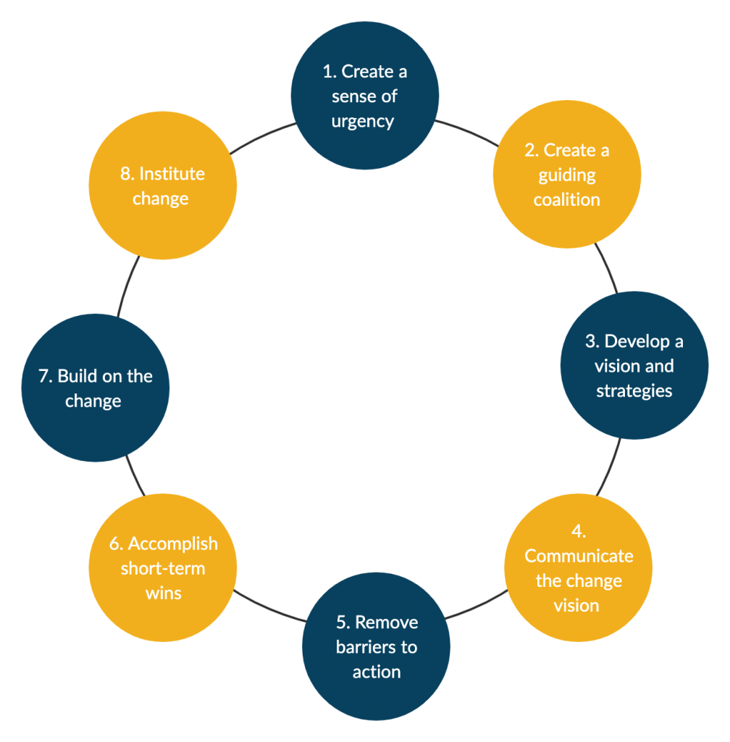
Figure 3. Kotter’s 8 Steps Change Model (Source: Forbes)
Creating a sense of urgency
The initial step of the model is to establish a sense of urgency among the employees and the managers of the company. There should be a mutual feeling involved and change should be a perspective that everyone within the organisation is willing to make. Change within the organisation will foster innovation and facilitate growth within Sainsbury’s. Therefore, it is essential for the company to focus on the initiates of change taking place. The primary objective of the model is to prepare the employees for the change that is about to take place and further motivate themselves so that they can contribute to the development and improvement of the organisation (Castner, 2021). To attain the changes within the organisation, the employees and the managers along with 75% of the organisation’s management should support the change. In order to establish an environment where the individuals are aware of the problem that exists, it is essential for them to identify the various threats and opportunities that are affecting the activities of the workplace along with analysing the internal factors of the company with the help of SWOT analysis. There should be an open discussion amongst the employees as to why the change is necessary and necessary support should be provided by the stakeholders (Calegari et al., 2015).
Putting together a guiding coalition
This step brings forward an efficient team who has the right skill set, qualification, connection and sufficient power to be able to provide proper guidance and influence the stakeholders to help in the change taking place within Sainsbury’s. The nature of the change is one of the determinants of the size of the team (Weiss and Li, 2020).
- The sponsor: Sainsbury’s appoints a senior executive who will be responsible for initiating a change in the company. His/her responsibility is to provide support at an executive level and allocate the resources that are necessary for the facilitation of the change within the company (Calegari et al., 2015).
- The senior guiding team: Members at this stage are selected by the sponsor. The team that will be appointed will be solely responsible for the development and formulation of the different visions and strategies, proving and collecting of the resources, removing the various obstacles, and providing a guidance to the organisation during the process of change by helping in resolving the conflicts and facilitating communication with the stakeholders (Wais, 2021).
- Filed guiding team: This group of people consists of credible and respected individuals who represent the organisation of Sainsbury and are solely responsible to carry out the role of communicating the vision of the company and guiding the individuals of the organisation.
- Change teams: This group consists of the members of the managers and the supervisors who are responsible for monitoring the activities and ensuring that the tasks are being completed in a timely manner.
After the formation of the team members, their duty is to focus on the goals and objectives of the company and establish an environment which fosters trust and commitment towards the workplace (Weiss and Li, 2020).
Developing vision and strategies
This step is the stage where formulation of strategies and creation of objectives are ensured in order to help the team in achieving these goals and objectives. It helps create a picture of the organisation in the mere future after the change in the company has been implemented. This helps the individuals and the employees get motivated and obtain the objectives of the company ensuring maximum effectiveness within Sainsbury’s. In order to create a sustainable vision for the company, it must follow the given steps.
- Aligning the activities with the values of the organisation and the changes that have been initiated (Wais, 2021).
- Taking ideas and accepting those from the employees who actively took part in the decision making and development of the vision of the company
- Incorporation of the data such as the market research data, business trends.
Communication of the change vision
This step primarily focuses on communicating the vision and strategies of the company in an effective manner that helps the employees and the staff of the organisation to accept the change that has taken place within the organisation of Sainsbury’s (Wais, 2021). The objective of this step is to make sure that the employees support the process of change along with sacrificing to enhance the activities within the organisation so that the best results can be achieved within the organisation. In order to get this done in an effective manner the necessary steps should be ensured
- Communicating the strategies and the vision of the company and by incorporating them in the process of decision making, problem solving and many other stages so that there can be a facilitation of practice within the workplace (Calegari et al., 2015).
- Feedback method from the employees should be enabled to understand whether the change within the workplace has been beneficial or not
- Usage of simple words while communicating the changes and the vision of the company
- Making optimum usage of the resources and the channels of the company that are available b(Weiss and Li, 2020).
Removing the barriers to action
In the process of implementing the change in the organisational context of Sainsbury’s, there are many obstacles and barriers that are being encountered by the company. Barriers within the company may appear in various forms. These might include the insufficient processes, the resistance to the changes, the policies of the organisation, the structure of the organisation and so on. It is the responsibility of the managers and the guiding team to ensure and facilitate activities that helps in removal of these barriers within Sainsbury’s. These barriers should be removed as they form an obstacle towards attaining the objectives and the achieving the change process within Sainsbury’s. In order to remove the barrier within the organisation, it is important to (Wais, 2021)
- Understand the various forms of barriers and obstacles within Sainsbury’s that are blocking the path of achieving the various operational aspects of the company along with its objectives and goals
- Ensure that the processes, policies, structure, reward system of Sainsbury’s are in alignment with the change that have been encountered and implemented within the company.
- Recognise and reward the employees and the staff who actively participate in the process of implementing change within the organisation (Chen, 2021).
Accomplishing the short term wins
The achievement of complete transformation within Sainsbury’s may take a huge amount of time. A short-term win is defined as the improvement process that takes place within the organisation which can be implemented within the structure of Sainsbury’s at a short span of time. This quick win is visible by the organisation. This short term win within Sainsbury’s can be achieved by the following process (Weiss and Li, 2020)
- It is important to identify the short term wins within the organisation which could include the small efforts, the process improvement, the reduction in the costs, the increase in the profit margin of the company
- It is essential to break down the project of change into subparts so that achieving the subparts are easily obtainable
- It is important to acknowledge and reward the ones that have actively participated within the development and implementation of change within the organisation of Sainsbury’s (Chen, 2021)
Building on the Change
This step focuses on sustaining the implementation of the change that has taken place within the company by ensuring that all the members of the company are working together in collaboration towards attaining and achieving the vision of change (Calegari et al., 2015). In order to achieve so in the organisation, it is necessary to do the following :
- Identifying what went right and what went wrong so that deciding on what to improve can be evaluated after the win takes place
- Consolidating the several gains that have taken place within the organisation with the help of the short term quick wins of the company. Understanding this will help the company implement further and larger changes within the structure of the organisation.
- Identification and removal of the processes within Sainsbury’s that are unnecessary in nature and are interdependent (Chen, 2021)
- It is important to continue with the delivery of the vision and communicating the vision within Sainsbury’s
Make Change Stick
In this step, the change leaders work rigorously to nurture and refine a culture that is suitable for the organisation of Sainsbury’s. These also include the various norms and values of the organisation along with the different processes and reward systems of the company. In order to successfully implement the change within Sainsbury’s, it is important to ensure the following:
- Discussing the various importance with the various changes that has taken place within the organisation and results in making the organisation better
- Identifying and incorporation of the various norms and values that helps in reinforcing the changes within the organisation (Weiss and Li, 2020).
- Incorporating the new norms in order to hire new talents and employee promotions
- Helping to improve the skills of the employees of the organisation with the help of training and development programs to increase the competencies of the company within the market (Calegari et al., 2015).
Two of the major string factors that have contributed to the success and growth of Sainsbury’s in the competitive market are its leadership and communication within the company. The management of Sainsbury’s believes that with leadership comes the delegation of work and job among the other members of the team which helps them to achieve the objectives of the business successfully. Effective leadership within the organisation has enabled the company to achieve its goals, mission and vision. Sainsbury’s utilises the transformational leadership style which helps the leaders of the company motivate the other employees towards guiding them in attaining the goals of the company (Chen, 2021). They also believe in the participative leadership style where all the employees will come forward to collaborate and actively participate to achieve their goals both personal and professional. The changes that have been facilitated within the structure of Sainsbury’s have been effectively managed by the employees and the managers of the company. They have hugely contributed in participating and sacrificing to support the various changes that have been implemented by the company. These aspects have improved the functional areas of the company along with providing the company with a competitive edge over the others in the market (Phuchanajita, 2021).

Critical Analysis of the organisational culture of Sainsbury’s and the ways in which change affects the organisation
The culture within Sainsbury’s is typical in nature. The activities that are carried within the organisation is dependent on the universal beliefs, policies and the procedures of the organisation of Sainsbury’s. The organisational culture within Sainsbury’s helps in fostering innovation and creativity within the organisation thus providing a competitive edge to the company in the market. The culture of Sainsbury’s helps keep the employees motivated so that they can strive to attain the objectives and goals of the company. This gives the company better outcome and generates more revenue thus eventually increasing the effectiveness and revenue generation of the company (Douglas, 2018). It also gives the company stability in the competitive marketplace. The management of Sainsbury’s believes that with leadership comes the delegation of work and job among the other members of the team which helps them to achieve the objectives of the business successfully. Effective leadership within the organisation has enabled the company to achieve its goals, mission and vision. The changes that have been facilitated within the structure of Sainsbury’s have been effectively managed by the employees and the managers of the company. They have hugely contributed in participating and sacrificing to support the various changes that have been implemented by the company. These aspects have improved the functional areas of the company along with providing the company with a competitive edge over the others in the market (Phuchanajita, 2021).
With the advancement in the technological aspect, there has been a huge increase in the productivity and profitability of the company. Technology has ensured that there is a better facilitation of work within the organisation of Sainsbury’s and that these deadlines and jobs can be achieved much faster. Having a proper understanding of the external and internal factors along with the macro and the micro factors have enabled the employees to perform better (Tamzid and Parves, 2017). The organisation have also introduced training and development programs within the organisation to facilitate proper training of the personnel and staff members so that they could enhance their skills and contribute to the achievability of the organisation's objectives. Post the pandemic hit, there has been a major shift in the organisational culture of Sainsbury’s. As most of the people are working from home, the company is required to redefine its cultural aspects. This should be considered in order to take preventive measures to maintain a supportive community for the employees. The changes taking place as a part of the decision making policies and structure of the organisation have impacted the activities of organisation in many ways (Aluko and Knight, 2017). Strategies should be formulated so that an establishment of better outcome and effectiveness can be created.
Both the micro and the macro environmental changes have resulted in posing major challenges for the company that they need to acknowledge and improve. With such impact the company failed to implement their strategic plans in order to grow their business. Sainsbury’s organisation also have had a very poor experience with their management which led to many failed organisational objectives and thus, increasing the deficiency in the organisational performance (Aluko and Knight, 2017).
Conclusion
With the help of the above report, it can be noticed that Sainsbury’s and its business activities have evolved and developed after the pandemic struck the globe. The impact on the organisation and the various changes could be identified with the help of the SWOT and PESTLE analysis along with the analysis of the external factors. The theories and models of change enabled the company to formulate strategies that could enhance the effectiveness of the company along with improving the efficiency of the employees. It facilitated an understanding of the organisational culture of the organisation of Sainsbury’s along with how the management monitored and handled these changes within the company.

References
al Habibi, B., (2019). HR practices of Marks & Spencer, Selfridges, Primark, and Sainsbury’s (Doctoral dissertation, University of Science & Technology).
Alexander, A., (2015). Decision-making authority in British supermarket chains. Business History, 57(4), pp.614-637.
Aluko, O. and Knight, H., (2017). From corner store to superstore: a historical analysis of Sainsbury’s co-evolution. Journal of Management History.
Aluko, O. and Knight, H., (2017). From corner store to superstore: a historical analysis of Sainsbury’s co-evolution. Journal of Management History.
Audzeyeva, A. and Hudson, R., (2016). How to get the most from a business intelligence application during the post implementation phase? Deep structure transformation at a UK retail bank. European Journal of Information Systems, 25(1), pp.29-46.
Badu, D., Hou, B., Karimi, I., Fiorini, M.M. and Patel, R., Sustainability Report.
Bentham, J., (2018). Business and Economics in the News–Sainsbury's and Asda-the decade's mega-merger. Teaching Business & Economics, 22(3), pp.11-12.
Burnes, B. and Bargal, D., (2017). Kurt Lewin: 70 years on. Journal of Change Management, 17(2), pp.91-100.
Calegari, M.F., Sibley, R.E. and Turner, M.E., (2015). A roadmap for using Kotter's organizational change model to build faculty engagement in accreditation. Academy of Educational Leadership Journal, 19(3), p.31.
Castner, J., (2021). Leading and Accelerating Change. Journal of Emergency Nursing, 47(2), p.218.
Chang, S.J. and Wu, B., (2014). Institutional barriers and industry dynamics. Strategic Management Journal, 35(8), pp.1103-1123.
Chen, C.J., (2021). SoTL enculturation guided by Kotter’s model of change. International Journal for Academic Development, pp.1-5.
Dolega, L., Reynolds, J., Singleton, A. and Pavlis, M., (2019). Beyond retail: New ways of classifying UK shopping and consumption spaces. Environment and Planning B: Urban Analytics and City Science, p.2399808319840666.
Douglas, C., (2018). Adapting to organisational culture: A staged adaptation model.
FATRICIA, R.S., (2016). SWOT ANALYSIS OF SAINSBURY’S SUPERMARKET. Jurnal Manajemen Terapan dan Keuangan, 5(1), pp.19-35.
Galli, B.J., (2018). Change management models: A comparative analysis and concerns. IEEE Engineering Management Review, 46(3), pp.124-132.
Gilani, H. and Cunningham, L., (2017). Employer branding and its influence on employee retention: A literature review. The Marketing Review, 17(2), pp.239-256.
Grassi, A. and Vallati, M., (2019), May. AI to Facilitate Legal Analysis in the PESTLE Context. In Proceedings of the 2019 Emerging Technology Conference. University of Huddersfield.
Hansmann, S., (2021). 4 In Practice I: Working-With. In Monospace and Multiverse (pp. 103-138). transcript-Verlag.
Hearn, J., (2017). Culture: Nations, banks and the organisation of power and social life. In Salvage ethnography in the financial sector. Manchester University Press.
Helmold, M., (2019). Tools in PM. In Progress in Performance Management (pp. 111-122). Springer, Cham.
Jones, P. and Comfort, D., (2019). Stories and Retailer Brands: A Study of the UK’s Leading Retailers. Indonesian Journal of Contemporary Management Research, 1(2), pp.65-77.
Kang, S.P., Chen, Y., Svihla, V., Gallup, A., Ferris, K. and Datye, A.K., (2020). Guiding change in higher education: an emergent, iterative application of Kotter’s change model. Studies in Higher Education, pp.1-20.
Khan, Z., Shahbaz, M., Ahmad, M., Rabbi, F. and Siqun, Y., (2019). Total retail goods consumption, industry structure, urban population growth and pollution intensity: an application of panel data analysis for China. Environmental Science and Pollution Research, 26(31), pp.32224-32242.
Kim, Y., (2016). Leadership in change.
Nakamura, M. and Suzuki, K., (2015). A Study on the Changing Structure of Retail Logistics. In Toward Sustainable Operations of Supply Chain and Logistics Systems (pp. 67-79). Springer, Cham.
Ortega-Altamirano, D.V., Rodríguez-Oliveros, G., González-Unzaga, M.A. and Reyes-Morales, H., (2018). Perceptions of childcare staff for preventing overweight in Mexican preschool children: A SWOT analysis. salud pública de méxico, 60, pp.166-174.
Paul, D. and Yeates, D. eds., (2014). Business analysis. BCS, The Chartered Institute for IT.
Perera, R., (2017). The PESTLE analysis. Nerdynaut.
Phuchanajita, B., (2021). Leadership of Organization Administrators under the Era of Technological Change. Psychology and Education Journal, 58(1), pp.1336-1339.
Rahman, M., Uddin, M. and Lodorfos, G., (2017). Barriers to enter in foreign markets: evidence from SMEs in emerging market. International Marketing Review.
RASHID, C.A., (2020). Balanced Score Card and Benchmarking as an Accounting Tool to Evaluate Morrison’s Performance. Journal of Global Economics and Business, 1(3), pp.59-72.
Rhodes, C. and Brien, P., (2014). The retail industry: statistics and policy. House of Commons Library Briefing Paper, available at http://researchbriefings. files. parliament. uk/documents/SN06186/SN06186. pdf (accessed 13th August, 2018).
Rohwer, L. and Topić, M., (2019). The communication of Corporate–NGO Partnerships: analysis of Sainsbury’s collaboration with Comic Relief. Journal of Brand Management, 26(1), pp.35-48.
Sainsbury, D., (2020). Toward a dynamic capability theory of economic growth. Industrial and Corporate Change, 29(4), pp.1047-1065.
Sarayreh, B.H., Khudair, H. and Barakat, E.A., (2013). Comparative study: The Kurt Lewin of change management. International Journal of Computer and Information Technology, 2(4), pp.626-629.
Sargeant, A., (2014). Fundraising management: Analysis, planning and practice. Routledge.
Schleimer, S., (2018). Accounting and Financial Analysis of UK Supermarkets. GRIN Verlag.
Shirey, M.R., (2013). Lewin’s theory of planned change as a strategic resource. JONA: The Journal of Nursing Administration, 43(2), pp.69-72.
Sivalingam, R., (2018). Strategic Management. Industry Analysis, Strategic Drift and Re-Strategizing. GRIN Verlag.
Small, A., Gist, D., Souza, D., Dalton, J., Magny-Normilus, C. and David, D., (2016). Using Kotter's change model for implementing bedside handoff: a quality improvement project. Journal of nursing care quality, 31(4), pp.304-309.
Tamzid, M. and Parves, M.T., (2017). Human Resource Management Policies and Diversity Management (A Case Study on Sainsbury’s). Human Resource Management, 8(4).
Upadhyay, A., Kumar, A. and Akter, S., (2021). An analysis of UK retailers’ initiatives towards circular economy transition and policy-driven directions. Clean Technologies and Environmental Policy, pp.1-9.
Wais, M., (2021). ORGANIZATIONAL CHANGE: ORGANIZATIONAL CHANGE PERSPECTIVE IN AGE OF AI. Mohammed Wais.
Weiss, P.G. and Li, S.T.T., (2020). Leading change to address the needs and well-being of trainees during the COVID-19 pandemic. Academic pediatrics, 20(6), pp.735-741.

