DATA ANALYSIS AND VISUALISATION
Name of the Student: MIHAIL DIMITROV MILCHOV

Name of the University: University of Wales Trinity Saint David

Author notes

Introduction and Background
According to Lucas, digital advancement has increased the opportunity to upgrade educational platforms through online learning applications and tools that can also enhance the student interest in learning and academic performance. The pre-test post-test method is a commonly utilised experimental method that is used to examine the effectiveness of an implemented tool or policy in the education system. This study is aimed to examine the impact of an online learning application on the academic performance of primary school children. Student performance can be measured through objective understanding while using numerical analysis of interpretation for the evaluation. For numerical evaluation of the major variable of this study positivism philosophy based statistical analysis has been used in this study. The deductive approach has been used for this study to test the hypothesis, where the hypothesis has been developed based on the aim of this research.

Data Source and Method
The data was collected by involving 40 children, who are 5 years old and are learning mathematical concepts of local primary school. The purpose of this study is to examine the effectiveness of utilizing an online learning application for teaching students. In order to examine the effectiveness of the online learning application, the examination scores have been taken and compared. The examination scores of the chosen group of children, before implementing the learning application and after implementing the learning application have been collected. The scores are stored in two different attributes or columns. Firstly, the data has been stored in Ms-Excel. After that, it is imported to SPSS data analysis software for descriptive and inferential analysis. SPSS data analysis tool is a highly reliable tool for examining quantitative data using a wide range of statistical analysis, modelling and visualization. After conducting the analysis both tabular data and graphical data are considered for numerical interpretation and visualisation-based interpretation.

Descriptive Findings
Descriptive statistics have been conducted in order to understand the overall scores for both pre-application test scores and post-application test scores. Both central tendency and deviation related statistical values have been analysed. For central tendency mean and median have been considered and to examine the deviance maximum, minimum, range, variance and standard deviation have been considered.
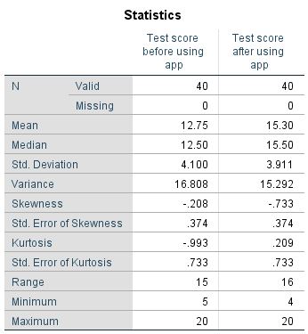
Table 1: Descriptive Statistics
From the above statistical report, it can be found that the average test score before implementing the application is 12.75 and after implementing the application is 15.30. As per the average, it can be interpreted that the average test score of school students have been increased after implementing the online learning application. The standard deviation for pre-test and post-test is 4.1 and 3.9 indicates a moderate level deviation. The pre-implementation scores are ranged from 5 to 20 and post-implementation scores are ranged from 4 to 20. Therefore, the lower limit of test scores has been reduced after implementing the online learning application.

Testable Hypothesis
According to the research purpose, it can be found that the study has been conducted to find the effectiveness of online application by comparing the examination scores of the students that are collected before implementation of the online application and after the implementation of the online application. Based on this aim and underlying variables the following hypothesis has been selected for this research.
Null Hypothesis (H0): There is no significant difference between the mean of test scores before the application use and mean test scores after the application usage. (µ1 - µ2 = 0)
Alternate Hypothesis (H0): The mean of scores after application use is significantly higher than the mean of scores before the application usage. (µ1 - µ2 ≠ 0)

Selection of Hypothesis test
As per the purpose of this study and the hypothesis of this study, it can be found that the pre-test scores and post-test scores should be compared to each other to find whether the difference is significant. In order to compare the two datasets, the mean value comparison statistics have been used.
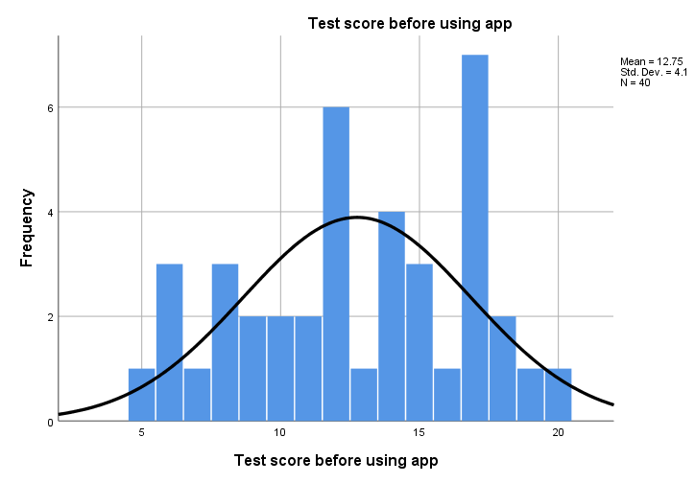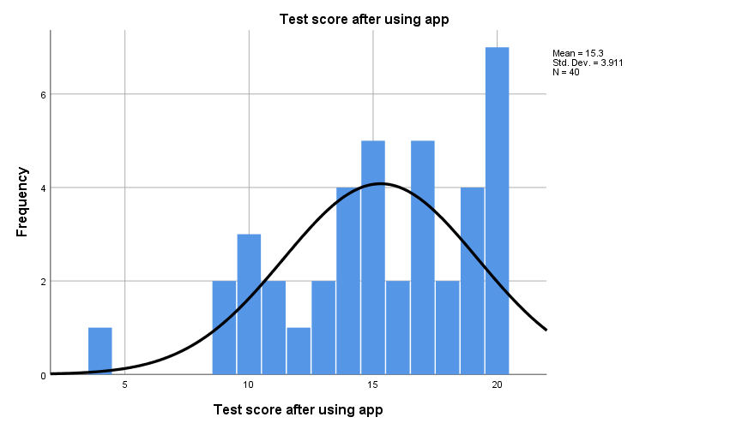
Figure 1: Histogram for data distribution
The lower level of skewness and kurtosis value indicates the dataset is more likely to have a normal distribution. As per table 1, it can be found that the skewness value of both pre-test score and post-test scores are within -1 to +1. Similarly, the kurtosis values for both pre-test score and post-test are also within the range of -3 to +3. It indicates that the data distribution of each dataset is normal. In order to analyse the mean difference for a dataset with normal distribution, the T-test analysis is used. For comparing these two normal datasets of test scores, T-test statistical analysis has been used for this study. Here, the dataset is not independent. The two datasets have been collected from a particular group of children and therefore an equal variance is expected within the two datasets.

Hypothesis Testing

Hypothesis test for 0.10 significance level
The following hypothesis testing has been done using the significant level 0.10. In order to conduct the t-test for this significance level the CI or Confidence interval value has been selected as CI = 90%.
Table 2: Paired Sample T-test for significance level 0.10
According to table 2, it can be seen that the 2-tail significance value or p-value is 0.000, which is less than 0.10. It can be also seen that both lower CI 90% (1.52) and upper CI 90% (3.59) indicate two positive and fairly large values. It has been found that for 90% of the children, the minimum level of increased test scores after implementing the online application is 1.52 and the maximum level of increased score is 3.58. Therefore, the difference between mean scores are statistically significant and therefore the null hypothesis H0 is rejected and alternative hypothesis H1 is accepted. Hence, the mean of scores after application usage is significantly higher than the mean of scores before the application usage considering the 0.10 significance level.
Hypothesis | Description | Significance level 0.10
Null Hypothesis (H0): | There is no significant difference between the mean of test scores before the application use and mean test scores after the application usage | Rejected
Alternate Hypothesis (H0): | The mean of scores after application use is significantly higher than the mean of scores before the application usage | Accepted

Hypothesis test for 0.05 significance level
In order to conduct the hypothesis testing using the significant level 0.05 for the t-test for this significance level the CI or Confidence interval value has been selected as CI = 95%. The results are presented below.
Table 3: Paired Sample T-test for significance level 0.05
As per the findings of Table 3, it can be found that the 2-tail significance value or p-value is 0.000, which is less than 0.05. It can be also seen that both lower CI 95% (1.3) and upper CI 95% (3.79) indicate two positive and fairly large values. It implies that for 95% of the children, the minimum level of increased test scores after implementing the online application is 0.614 and the maximum is 1.308. Therefore, the difference between mean scores are statistically significant and therefore the null hypothesis H0 is rejected and alternative hypothesis H1 is accepted for significance level 0.05. Hence, the mean of scores after application usage is significantly higher than the mean of scores before the application usage considering the 0.05 as the significance level.
Hypothesis | Description | Significance level 0.05
Null Hypothesis (H0): | There is no significant difference between the mean of test scores before the application use and mean test scores after the application usage | Rejected
Alternate Hypothesis (H0): | The mean of scores after application use is significantly higher than the mean of scores before the application usage | Accepted

Hypothesis test for 0.01 significance level
The following hypothesis testing has been done using the significance level of 0.00. In order to conduct the t-test for this significance level, the CI or Confidence interval value has been selected as CI = 99%.
Table 4: Paired Sample T-test for significance level 0.01
According to table 4, it can be seen that the 2-tail significance value or p-value is 0.000, which is less than 0.01. It can be also found that both lower CI 99% (0.88) and upper CI 99% (4.21) are two positive and fairly large values. It has been found that for 99% of the children, the minimum level of increased test scores after implementing the online application is 0.88 and the maximum level of increased score is 4.212. Therefore, the difference between mean scores are statistically significant and therefore the null hypothesis H0 is rejected and alternative hypothesis H1 is accepted. Hence, the mean of scores after application usage is significantly higher than the mean of scores before the application usage considering the 0.01 significance level.
Hypothesis | Description | Significance level 0.01
Null Hypothesis (H0): | There is no significant difference between the mean of test scores before the application use and mean test scores after the application usage | Rejected
Alternate Hypothesis (H0): | The mean of scores after application use is significantly higher than the mean of scores before the application usage | Accepted

Investigation of Outliers
The outliers are the observation of data that lies at the abnormal distance for the original set of values within the dataset. It is often caused due to inaccurate observation and instrumental error. In the following section, the outliers for pre-test scores and post-test scores are examined by the quartile methods.
Table 4: The Quartiles and Percentiles analysis
As per the above findings regarding quartiles, it can be found that the first quartile of Q1 of pre-test score is 9.25 and second quartile or Q2 of the post-test score is 17.00.
Interquartile range or IQR of Pre-test score = 17.00 – 9.25 = 7.75
1.5 IQR = 7.75 x 1.5 = 11.63
Minor outliers’ lower range for pre-test dataset: 12.50 – 11.63 = 0.87
Minor outliers’ upper range for pre-test dataset 12.50 +11.63 = 24.13
As per the above descriptive statistics it has been found that the minimum and maximum pre-test scores are 5 and 20. Hence, the max and minimum values are within the outliers’ range. There is no outlier in the exam scores of the student at are taken before implementing the online application.
Q1 of pre-test score is 13 and second quartile or Q2 of post-test score is 19.
Interquartile range or IQR of Post-test score = 19 – 13 = 6
1.5 IQR = 6 x 1.5 = 9
Minor outliers’ lower range is: 15.50 – 9 =6.50
Minor outliers’ upper range is: 15.50 +9 = 24.50
The minimum and maximum of post-test scores are 4 and 20. Hence, the max and minimum values of scores that are taken after the implementation of the online application are within the outliers’ range. There is no outlier in post-test scores.
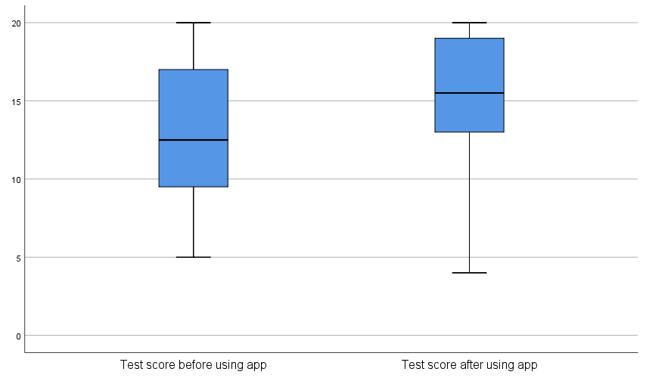
Figure 2: Box Plot for Pre-Test and Post-Test Scores
As per the above visual presentation, it can be found that in both pre-test and post-test datasets there are no outliers. Therefore, no outlier adjustment is required for both pre-test scores and a post-test score of the student.

Unconsidered factors and controlling
The formation of assessment toll as well as design and execution of the tools have a significant impact on the academic performance of the students. In this case, the formation of assessment tools has not been modulated to measure the effectiveness of online learning. The post-implementation assessment tool may be much easier to achieve a high score than the previous tool. Therefore, to mitigate the confounding effect assessment method and tool should be constant for both the pre-implementation test and post-implementation test.
The duration of engagement and quality of engagement of the student with the learning activities can influence the academic performance of the student. In this study, the students may be getting more scores because they are engaging with the learning activities more than the earlier condition. In order to mitigate the confounding effect of the engagement time, it should be ensured that the students are engaged in the learning activities after the online application.

Conclusion
As per the study, it can be found that for all significance levels the hypothesis is accepted. It implies that the mean of scores after application use is significantly higher than the mean of scores before application usage. It indicates that the online application that is implemented has increased the academic performance of the student. The absence of outliers indicates that the observations are accurate. Some factors should be considered to reduce confounding effects that are the utilized assessment tool, duration of engagement and quality of engagement of the students.

References

Lucas AM. What Works & For Who? An Analysis of the Impact of an Online Application to Increase Parent Involvement at the High School Level (Doctoral dissertation, Northeastern University).
Marsonet M. Philosophy and logical positivism. Academicus International Scientific Journal. 2019;10(19):32-6.
Denis DJ. SPSS data analysis for univariate, bivariate, and multivariate statistics. John Wiley & Sons; 2018 Sep 25.
Kim TK, Park JH. More about the basic assumptions of t-test: normality and sample size. Korean journal of anesthesiology. 2019 Aug;72(4):331.
Jones PR. A note on detecting statistical outliers in psychophysical data. Attention, Perception, & Psychophysics. 2019 Jul;81(5):1189-96.
Tawafak RM, Romli AB, bin Abdullah Arshah R, Almaroof RA. Assessing the impact of technology learning and assessment method on academic performance. EURASIA Journal of Mathematics, Science and Technology Education. 2018 Mar 21;14(6):2241-54.
Staneva M. Empirical Analysis II: The Effects of Student Work on Academic Performance and Study Duration. InEmployment alongside Bachelor’s Studies in Germany 2020 (pp. 131-158). Springer VS, Wiesbaden.

