Introduction:
The companies are trying to reach more customers by making their brand International and their ultimate target is to reach more customers in a highly competitive business environment. There are some specific tools that can analyze the Global business environment to achieve some results.
This report mainly focuses on applying various tools, and models to the Luxury fashion company Burberry, and providing overviews of the cultural forces that impact the company, environmental issues, economic issues, and comparing the Similarities and differences between a company in the two countries (UK, China). The considerations involved in the planning of market entry international level. And the tools like PESTLE porter’s five force analysis, and discussion on Macro-environment factors that impacts a company’s decisions. The SWOT analysis is used to understand the potential of the company at the international level.
This report compares the Segmentation, Targeting, and Positioning of the brand. Which helps to enhance the company’s performance, and how they are effectively delivering its service to its Niche consumers, and recommends the future growth possibilities for the brand international level, by using the TOWS matrix.

COMPANY BACKGROUND
In the segmentation of Luxury and fashion Brands, the British fashion Icon, Burberry creates its strong brand identity in the United Kingdom, Founded by Thomas Burberry 160 years ago in Basingstoke London (Peter Bug, 2016), it all started in the year 1856, and from then to now, this brand gets a Global recognition all over in-terms of Fashion and luxury good industry. (Peter Bug, 2016). Thomas Burberry started his journey at the age of 21, making a Trench coat creates a mark in the United Kingdom fashion market.
They currently provide designer wear and ready-to-wear clothes for all types of generations with premium pricing in Leather Goods, perfumes, Trench coats footwear, etc (Burberryplc, 2022)
The legacy of Burberry was started during World war 1, the iconic Burberry provides apparel and equipment for Military forces In Britain, and the craftsmanship and detailing of those products gain huge attention from both civilians and normal citizens in Great Britain. (Tynan, 2022)
Burberry Holds Fashion shows in London Germany Paris and some other eastern continental countries in 1960 (Burberryplc, 2022). In the year 1964 Burberry become the outwear sponsor for the women’s Olympics held in Tokyo, by the year 2000 the first store In London was opened on Bond Street, this store is the major plan for improving their store networks all over the world (Burberryplc, 2022)
By the Year 2022 April 2, there are 418 stores with 11000 employees running successfully and delivering customer satisfaction, gaining a global revenue of 2.89bn GBP (Tugba, S 2022)
As a strategical foresight to capture the eastern continent, they opened a luxury store in Shenzhen China, named a store called, “A store of tomorrow for today” to inspire Luxury customers by using social media as a medium to attract them. (Burberryplc, 2022). There all are good at following the trends by showing environmental care and focusing on sustainability and doing donations for the young generations to achieve their goals and dreams (Burberryplc, 2022)

Macro Environment Analysis
Political Forces: (UK and China)
Political forces mean the interaction or interference of politics and government with a foreign business or company doing business in a particular country, China and the UK’s political relations are long-remembered histories, in recent years UK-China relations have been disturbed due to China increasing direct Interventions, in the region of Hong-Kong, in the year 2021. Due to the recent detentions of Uyghurs in Xinjiang, the countries like the UK, EU, US, and Canada made imposed on China (House of Lords, 2021), the political factors in the UK also affecting the business, and some of the factors are tax, laws, and political instability. (BBC, 2022) Recent issues in the country have taxation issues and raising or lowering taxes leads to profit changes.
Studies claim that UK politics are clean and Transparent when compared to other countries, but the UK facing strong political instability with a recent political emergency. while coming to taxation UK has a VAT of 20% on Luxury goods and China is a 13% VAT on luxury or imported goods. Based on these conditions’ investors are thinking to invest, in the China region to turn that into a strong favorable region.

Economic Forces:
The economic factors directly impact the company having long-term relationships with customers, some of the factors, Inflation, recession, and the GDP of the countries. For example, if the ratio of inflation is increased, the companies tend to increase the price of products or services (Rastogi, 2016) Burberry focuses on the country’s economic factors like Inflation, industry economic growth rate, Interest rates, etc. At present UK facing a severe economic downturn, UK is entering into a severe Recession and it last until 2023, some of the key numbers are In the UK economy the GDP has fallen from 4.3 to negative 1.3 with an inflation rate of 7.0% (KPMG, 2022) On the other hand, China is the world’s second-largest economy with an inflation rate of 1.7% (IMF, 2022) and a GDP of 3.0%,(KPMG, 2022) so while comparing the UK economy and the Chinese economy the chance of investment is more for Burberry. So the China economy is bigger than the UK so Burberry focuses more on China to make that a favorable condition to tackle the market share and attract new investors.
Socio-cultural:
The sociological factor is important for companies doing business in one or more countries, it’s mostly related to understanding the culture, traditions, and demographics of countries (Rastogi, 2016) after the pandemic the cultural changes are observed, a drop in importance of social life in luxury product consumption, especially for Burberry after a pandemic they shut down the flagship store in Hong-Kong due to lack of tourism, but now the situations are changing, the sales are return and back in track as Younger shoppers are attracted by new campaigns and collections, after the pandemic most of the customers are preferred online and digital platform for shopping this change happens after the pandemic, in China Burberry commissioned a new campaign 2021 for Chinese Lunar new year in WeChat app which gains more response than 2020.
Hofstede Cultural Dimension:
The cultural dimensions framework is related to a Dutch Scholar and researcher Geert Hofstede, it consists of Six Dimensions, the content in dimensions opposing the culture in High or Low scores. (Hofstede, 2011). The scores are statistical not every line is equally strong to any country. Those dimensions are Power Distance, Individuality, Masculinity, uncertain avoidance, Long term orientation, and Indulgence. Culture is defined as the shared personality of a person or group from an organization or Society (Zhang, 2022) this Cultural Dimension tells about how cultural and psychological differences affect consumer purchase of Luxury Goods, Hofstede’s cultural Model gives you a clear understanding of Cultural differences Between China and Britain, it brings the challenges in Marketing activities.
While Comparing the results of Hofstede, shows that Britain has low Power Distance, high Individualism level, medium to High Masculinity, Low uncertainty, medium level of long-term Orientation, and High Indulgence nature (Zhang, 2022) all across the country while comparing it with, china has High power Distance, low Individualism, low Uncertainty avoidance, medium Long term orientation and, medium Masculinity and High Indulgence. These differences will create an influence on customer buying psychology, by understanding the scores of 2 Countries (China, UK) with a cross-cultural Framework.
The United Kingdom mostly tends to be more Individualistic and has less power distance and high Indulgence. On the Other Hand, China tends to be more collectivist with more Indulgence and more power Distance. These two countries are different from each other in terms of culture, but they have some shared values that can be useful for the company. The exclusivity of products, conformity, and hedonism affect the customers buying interest in luxury brands, so it is very important to reposition the brand function to change the consumer perception.
Hofstede Insights analysis:
The UK is one of the countries which have a diverse cultural superpower, where most of the cities have different cultural groups, and London is compared as the cultural capital (Zhang, 2022). According to the below Hofstede Insights its shows, the power distance score Uk is low because they believe in equality and didn’t accept any unfair distribution of power, British people give priority to social relationship, and has a score of 89 at the individual level. This shows a huge difference in china with a score of 51 in long-term orientation. And the indulgence score is low (24) for China and high for the British (69) the comparison with China indicates, High power Distance and low Individual level, China mostly accepts superior- Subordinate leadership because of their historical Influence. And coming to the Individualism level in china has low (20) that indicate that people mostly put group and family interests ahead of their individual interests, and Long term orientation China scores 87 which tells about the Chinese have the most pragmatic approach towards society. (Zhang, 2022), and the Indulgence level between UK and China is between 24, and 69. China scores Low indulgence level which country has a low interest in leisure time, but anyway there is some similarity in Masculinity in both Countries, this defines both countries are success-oriented in nature.
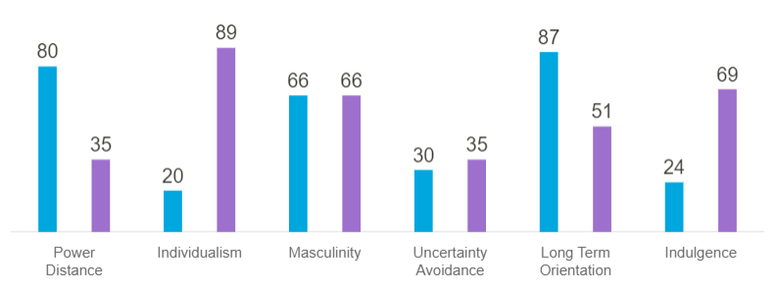
Source: (Hofstede, 2022)
Technological:
Nowadays technology become a vital part of every business, and most companies use technology as their competitive advantage, the interlinking of technology and the internet is getting more, and there are some factors to be noticed, the technical infrastructure of a company like types of equipment, company websites, databases, social media, shopping website (Perera, 2017), recently Burberry uses gaming technology to streamline their fashion designs, a recent partnership with ‘Koffecup’ a digital product company based in London In China, they partnered with ‘Minecraft’ gaming company. The Digital channels like Websites and social media platforms Facebook, Twitter, and Instagram are widely used for customer service and feedback. They invest more in software tools and technologies to provide effective service to their customers, tools like CRM, Chatbots with AI, E-commerce, and marketing analytics. (Burberry plc, 2022) these investments in technology create more favorable conditions for Burberry.
Environmental:
Now, most businesses follow clean and sustainability and give attention to the environment, due to increasing global warming companies facing severe pressure to control environmental pollution. Ecological considerations are very important to manufacturing companies, Burberry launched a new campaign to reduce its CO2 emission overall supply chain activities by the year 2040, (Emily, 2021), but Burberry faces severe criticism on environmental issues in the year 2021 they burned all unsold items to reduce the overstock faces severe criticism,(The Guardian, 2017) and Chinese Xinjiang cotton issues, made severe impacts on their sustainable activities, these can create a slightly unfavorable condition for Burberry

Similarities and Differences: (UK, China)
There are several differences to be noticed in the macro environment analysis of China and the UK, in the political environment two countries are different from each other, In UK the country faces severe political instability, and in China, the political reasons in China also effecting due to severe Outbreak of corona from China, and the international relations are not showing much concern, in the UK the tax and other utility bills like energy, water bills are High, and the UK current GDP also in negative condition taxation and inflation rates are very low in China when compared to UK economy so this might be a favorable condition to invest in world’s second-largest economic China, by analysing the Hofstede cultural model, the regional differences can be known there are some differences in cultural activities between China and UK no two countries are similar except In Masculinity dimension of Hofstede, in environmental issues the company faces severe criticism in UK and China the issues are mentioned above.
PORTER’S FIVE FORCES:
Porter’s five forces is a model to analyze the external competitive forces, developed by Michael E porter, it has five major competitive strategy techniques to analyze the industry and its competitors. (Bruij, 2018). Michael E Porter claims that the main aim of this model is, to understand the competition and rivalry for the organization from the external environment (Porter, 1979) this force contains five main Variables, Threat of new entrants, Rivalry among competitors, Bargain power of suppliers, Bargaining power of buyers, Threat of substitutes. This tool helps to understand the existing threats to organizations from existing competitors. According to Michael E Porter, this model is a Structured-Conduct Performance paradigm. (Porter, 2008)
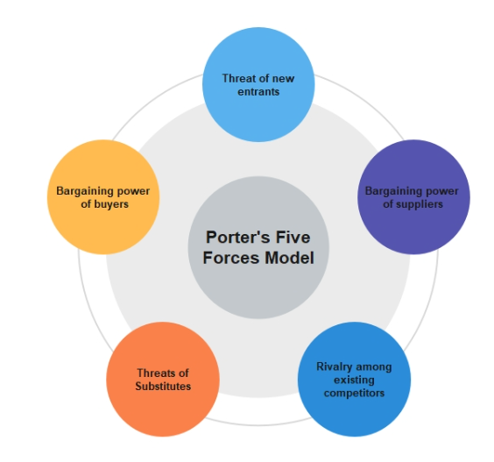
Source: edrawmind.com
Porter’s five force tool is helpful for Organizations to understand more about the structure of Organisations, performances in the selected Marketing sectors, and Profitability. However, this Model also faces some challenges and limitations in Modern Business, but most industries follow this competitive strategy to achieve a competitive advantage,
RIVALRY (UK and CHINA)
Considering Rivalry is the Major issue that any luxury brand faces, in terms of the international market, most of Luxury brands face severe competition. The Higher rivalry leads to less profit for the industry (Porter, 2008). As an international brand, the competition is more because the brand has to face existing Local and international competitors.
Burberry has some of the major competitors at the international level majorly in UK and China, are LVMH, Armani, Prada, Coach, Gucci, Versace, and Dior, these are, major competitors in luxury brand segmentation in the United Kingdom, (Bhasin, 2018) along with this Domestic and Local brands in china dominate the International brands, at respective segments, Chinese brands like Moutai, Shanghai Tang, Huawei, Peak sports products Co, ANTA sports products. These are the specific brands in china that are Rivals of Burberry (Achim, 2021) by Looking at the major competitors in China and the UK the rivalry for Burberry is High, and the impact of rivals on Burberry is high.
SIMILARITIES AND DIFFERENCES:
Burberry Provides the same range of products in UK and China, as a home-manufacturing luxury brand from the UK, the market share and competition is moderate (similarweb.com, 2022) but the majority of the rivals are the same in, local and international markets. In China, the competition Is high because the difference is Local competitors have already gained some market share, from a recent study of data insights in china markets says, the local competition heated up, along with high operation costs, and different service expectations, (langer, 2022) challenges facing towards celebrity endorsement leads to loss of market share for Burberry.
THREAT OF NEW ENTRANTS: UK AND CHINA
Burberry recently collaborated with Minecraft, an International Leading video game company (Burberry, plc 2022) this initiative of the company is to create the brand story of Burberry is visible more to their customers in a new way, the company follows new trends and able to adapt them in new geolocations, new cultural trends in different parts of the world. The brand gets recognition all over the world and stands in the Top 100 Luxury brands for six consecutive years, Burberry is mostly active in all channels of distribution, (Khanah, 2016) Burberry evokes the heritage of Royal Britain, elegance, their products stand out based on their comfort durability and long-lasting. The barriers for new entrants are Low – medium influence on Burberry.
Similarities and Differences:
For Luxury Brands the Stakes are high in china, and the company faces similar threats in the UK and China in terms of new entrants, According to porter’s list of conditions that influence the threats (Porter's, 2008), government policy is a major difference in both countries, cultural Difference is more in UK and China, Economical difference to be considered. (Froese, 2019)
BARGAINING POWER OF BUYERS: (UK AND CHINA)
The Power of buyers for Burberry is low- medium, and the competition is high in the luxury segment, the price of the products in luxury fashion is almost the same when compared to other brands, and companies tend to reduce the buyer’s power by implementing the Loyalty programs. (Porter, 2008) In China, luxury brands face low bargaining power toward customers because of the large population in china and the attractiveness of fashion, as the same, the bargaining power of buyers is low in the UK, the products are referred to the Niche market and discounts are not applicable. Burberry mostly focuses on marketing segmentation to provide various ranges of prices and products to satisfy the needs of larger customers.
Similarities and Differences: UK and CHINA
The bargaining power of customers stands the same in China and UK, the recent studies show that (Pamela, 2022) people in UK and china tend that the high price is not a cost, it is a source of pride and satisfaction.
BARGAINING POWER OF SUPPLIERS: (UK and CHINA)
Suppliers are vital value adders to the company, based on their geolocations and the goods they are providing. Burberry depends mostly on raw materials from suppliers to support production and their daily business operations, they maintain strong relations with suppliers Burberry made agreements before onboarding, to maintain a healthy relationship. In 2020 the UK’s modern slavery Act was legalized, by neglecting all types of slavery and forced labor within the group and all over their supply chain. The bargaining power of suppliers is low for Burberry.
Similarities and Differences: UK and CHINA
In terms of the supply chain, both countries are facing the same similarities, while coming to the UK modern slavery act the supplier’s power agreements are low, while in china backlashes are facing Burberry due to their poor performance in human rights and forced labor issues in Xinjiang areas in china (Isabel, 2021) this shows there are differences in terms of bargaining power of suppliers.
THREAT OF SUBSTITUTES: (UK and CHINA)
Burberry products are high-involvement luxury products in China and UK, although the competition is high in this segment, Burberry tried to reduce the risk of replacement is low for their products, Recently Burberry made a partnership with Minecraft video gaming company to carry out their strategic campaign into more advanced stage, most of the consumers recognize the value and cultural heritage of Burberry so the reason for switching is Hard and low.
Similarities and differences: (UK and CHINA)
The switching costs for Burberry in the UK are low when compared to China, the brand faces gained huge recognition in terms of loyalty and heritage quality while coming to china there is some criticism towards the brand based upon social issues, and Burberry lost a brand ambassador and its collaboration with popular video game creator “Honor of kings” during the cotton crisis in Xinjiang, (Law, 2022)
SWOT ANALYSIS:
SWOT analysis is a strategic planning tool to identify the strengths weaknesses opportunities and Threats of an existing organization (kotler, 2009). Every organization has two environments one is internal by itself and the other is outside, to understand better insights into internal and external environmental conditions SWOT analysis is mostly preferred. The variables of strengths and opportunities are considered favorable conditions and weaknesses and threats are considered as most Unfavourable conditions (Gurel, 2017)
STRENGTHS: (UK CHINA)  BRAND RECOGNITION:  Starting in 1860, Burberry gets huge recognition in terms of carrying heritage in the British fashion industry, according to the (Syncforce, 2022) the brand secures a rank of 96 in China’s Luxury market and followed with the brand secures a rank of 2 (Tugba, 2021)in Britain market. The brand is well known for providing Luxury Garments with long durability for their customers.  UNIQUE DESIGNS AND DIVERSE IN PRODUCTS:  The iconic brand has different segments in terms of generating revenue, men women, children, and other luxury accessories. Their unique design checked pattern is one of the major styles that have a trademark created in the fashion industry all over the world, | WEAKNESS (UK, CHINA)  Premium Price Range:  Although the product quality demands a high price, that is only available for high social class people, (Bhasin, 2019) in China and UK the scenarios are the same, the economic conditions in UK and China are struggling to beat the Covid crisis, and at this time people tend to spend on health segments rather than beauty products.  Limited global Presence:  The band has created a strong base on its own, but according to global presence, the brand is a little behind other brands (Bhasin, 2018) For example Burberry ranks 359 on the list of top 1000 brands in the world, where their major competitor Gucci is ranked 52,(Comparably, 2021) this shows Burberry has some gaps while giving competition in Luxury Brand

Global availability:  As of 2022, the brand got huge recognition globally, with almost 218 stores worldwide (Statista, 2022) doing business within the direct store, the franchise stores are 57, (Statista, 2022), and 147 concession stores total.  Royal Warrant Award:  Burberry has received the Royal Warrant award twice in its fashion journey (Bhasin, 2019) this means the company has a strong relationship with supplying their goods and products to the royal family.  Huge Financial Resources:  Burberry has a brand value of 3.9bn Euro and generates a global revenue of 2.83bn GBP, these statistics show Burberry has a strong financial position in the global market which creates a barrier to sustainability in fashion. | Low Product Lines:  Most of the other Luxury brands have diversified their products in the Home, decor, and other utility products, (Bhasin, 2018) but Burberry doesn’t have this segment this become a weakness, according to recent statistics the global fashion industry generates revenue from 97.3bn USD in 2021-22 and it has expected rise of 5% CAGR 2022-2027 (Statista, 2022)  Uneven Product development:  The products of Burberry are limited, they have limited designs offered to customers, not many varieties of cloth in all categories of fashion, and limited clothing styles increase the rate of switching to other brands. Mostly the product availability is the same in UK and China.

Opportunities UK and CHINA:  Expanding Products and Markets:  Extending the products will increase their market share and gives a new set of opportunities to differentiate themselves from other competitors.  New Emergent Market:  Burberry has a great heritage in Britain, the company has the potential to enter new markets like Thailand, Turkey, India, and some of the Gulf countries, along with existing countries like China and UK. because of their growing economy after the covid introduced Luxury products into Emerging economies increases the brand revenue (Aditya, 2021)  Introduce Into Luxury Furniture:  The Luxury furniture market also Increasing year by year, in the year 2022 furniture market has a global revenue of 30bn USD (Statista, 2022) the normal furniture market in China and the UK has a revenue of 82 bn USD and 22.13bn, this shows the furniture market can create an opportunity new marketplace.  Using Technology to solve Counterfeit:  Most fashion brands face a common and crucial problem of Counterfeit and fake copies of their products mostly, in eastern markets like China, Vietnam, and Thailand. As a luxury brand having good financial resources usage of Artificial intelligence leads to tackling counterfeiting. And using environmental marketing to tackle the other criticism. | Threats (UK and CHINA):  High-Level Competition:  There are many rivals like Gucci, Louis Vuitton, Armani, Chanel, Dior, etc. it creating a strong threat to the survival of Burberry. (Bhasin, 2022) But bringing new and fresh variants in fashion reduces the threat of Burberry.  Facing Severe Criticism:  The recent issue in the Xinjiang Cotton region disturbs the company’s societal marketing issue, and Chinese people are starting to boycott the products, this issue leads to many several factors Burberry affecting the cultural differences in UK and China.  The decline of demand for Luxury brands:  We all know that the world is facing a covid crisis, which makes a strong decline in the economy In UK and China, recent statistics say that the fashion industry has improved slowly to gain economic independence.  Counterfeit And Fake:  There are a lot of fake products that are circulating in the market, this is a major issue that most fashion brands are facing (Bhasin, 2021). So this need to be tackle by the organization

SEGMENTATION TARGETING POSITIONING:
SEGMENTATION:
The process of identifying the segment of the market by dividing the large customer base into smaller sub-groups of customers. Mostly market segmentation is an activity based on customer Orientation used by many companies. (Camilleri, 2018) there are three categories in the segmentation, Geographical (it considers, country, region, and area) Demographic (age, type, culture family, gender) psychographic (values, attitudes, lifestyle, living status), and the overall aim of segmentation is to identify the high returns and adds more profit to the company.
Geographical
After the Pandemic ends, most companies are focusing on expansion and have been investing in various geographical areas, in recent times Burberry’s geographic strategy has been investing in Asia Pacific (Burberry plc, 2022) Another well-established market area is EMEIA, this region has a grew of 45% in the financial year 2022, in American countries the performance also declined about 4% (Burberry plc, 2022) claimed by Burberry in their annual report, in the other hand Mainland China, Japan, Asia-pacific region facing a slight increase.
Demographic:
Burberry Focus on all groups of Ages, the brand has different segments in groups which as Child wear, the younger generation, In China sales have been boosted by the mid-teens age group of 20, and some of the clothes are available for men and women at age of 40-45 (Burberry, 2022) As a premium brand the pricing was affordable high-Income people with exclusivity design they are carrying their heritage giving different product lines according to customers behavior.
Geo-Demographic:
We all know that the United Kingdom is a geo-demographic area, which means different communities and people with different backgrounds, for example, Burberry is intrigued with Japanese culture and made a blueberry Blue label, Burberry black label specifically for the region people, (Gerhard, 2015) Burberry offers its goods to all people without any cultural racism (Arsalan, 2022)

TARGETING:
After the Market segmentation is completed, the company be aware of the needs and wants of selected segments, it is important to identify the most profitable segments and to decide which segments to be improved, (Camilleri, 2018) there are three segments in Targeting Un-differentiate, differentiate, and Niche or concentrated. Burberry uses concentrated Targeting. As a luxury brand segmentation Marketing (Kotler, et al., 2009) is an expensive technique the company categorized its products to customers based on their desired quality and set a price mark that is only available to higher-class people. Burberry has targeted High-income groups and wealthy women in the United Kingdom, while in China they have a separate target base, Chinese culture has importance to families, which resembles Chinese longing for unity (Jia, 2022)
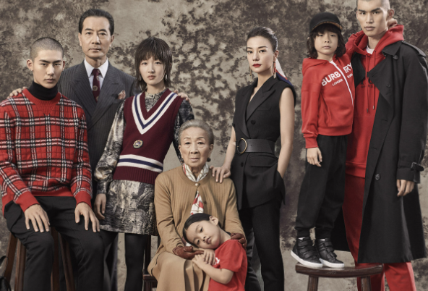
(Financial Times, 2022) (Jia, 2022)
POSITIONING:
The final stage after successful targeting of the Market next step is Positioning, this stage consists of how the customers perceived the products, and firms finalize the position to target their customer’s minds effectively rather than competitors. (Camilleri, 2018) customers continuously compare their products, so companies need to position their products according to customer perceptions, this leads to creating an image of the brand’s products and taking control of the market. (Kotler, 2022). There are some positioning strategies most companies follow, including those Benefit positioning, User positioning, and Competitive positioning, Burberry products are premium range and excellent in quality, fine raw materials, and detailed craftmanship add more value to their products, they use Benefit positioning also uses celebrity endorsement and strategical partnership. For example, in China Burberry partnered with Minecraft and celebrities to represent the brand in China and UK.

Similarities and Differences: (UK and China)
There are key points to be considered in the STP of Burberry, as observed in the above context the company uses some similar strategies to segment its broad customer base into similar Groups based on their Income, age, and in terms of geographical segmentation company focusing more on Asian-Pacific region like China when compared to their Home. In targeting the company slightly changes its strategy they focus on the younger generation and wealthy women having high social status, on the other hand, they are targeting high-income families in China, creating a Niche market with family groups based on cultural importance in different countries. In terms of Targeting, they are following two different strategies to conquer the market. While coming to the Positioning strategy, the concept of positioning has even similarities In UK and China. They use benefit positioning in Both countries but the brand ambassadors are different to represent the brand to gain more market awareness.
Perceptual Map of Burberry:
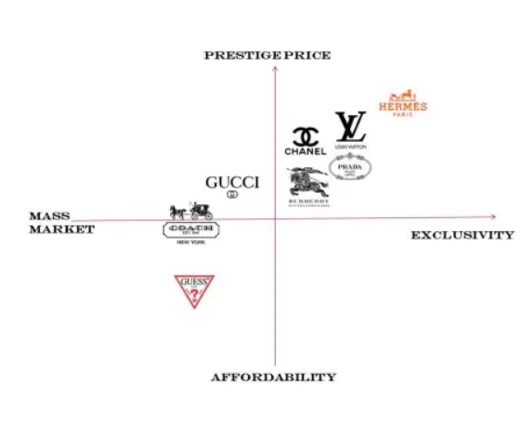
Source: (Wadavi, 2016)

Marketing Mix Elements: (UK and CHINA)
In marketing theory, the 7p’s of marketing is a core concept, in recent years this concept is much more evolved by McCarthy’s 4p’s model, and several modifications are proposed by Kotler, this marketing mix is a framework most companies use to satisfy the customer needs and meet the market objectives, (Rafiq, 2022) in the early age there are 4p’s of include (price, place promotion, product ) but the markets are dynamic environments later Bitner and Booms, proposed other 3p that includes (people process and physical evidence) this tool is useful to tailor the market and influence the customers.
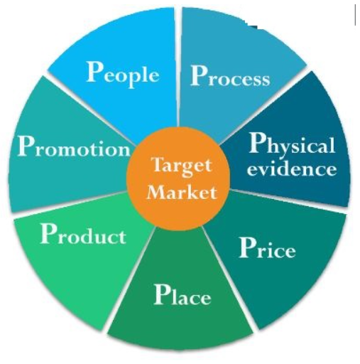
Source: Business Research Methodology
The 7p’s in the marketing mix is :
- Product
- Price
- Place
- Promotion
- People
- Process
- Physical evidence
Product:
Burberry specializes in fashion clothes and satisfies various target consumers by providing quality Luxury goods, the company offers a wide variety of products, from their Iconic trench coat to Jackets and shits, bags, and other fashion accessories, all the products Burberry has unique craftsmanship and details elegance that describes the brand. The company started to make trench coats for the British military and slowly find the company’s internal potential and started Line filling, adding more products to the existing product to reduce the gap. While maintaining the same quality, and comfort for its customers. (Bhasin, 2018)
Burberry has 3 sub-brands include Burberry London, Burberry Prorsum, and Burberry Brit. And they have an iconic fragrance collection named Burberry touch, Burberry Weekend, the majority of the sales are from menswear, but their major focus is highly societal women. Comparing UK and China there are 10266 products present in the United Kingdom offering the best deals while China got only 66 best deals, (Zhang, 2022).
Price:
Burberry Follows a Premium Pricing strategy because of the high craftsmanship involved in the production of goods, this is regular in luxury brands, and the high price keeps the goods exclusive and available only for a Niche market. The pricing factor depends on many factors, Burberry is a luxury fashion brand the price mark is almost the same in all countries, lowering of price dilutes the brand image (Bhasin, 2018) there are some key actions taken by the marketing committee to increase the price of simple polo T-shirt of 125 GBP to 275 GBP in 2015 to give tough competition to Gucci, (Zhang, 2022), now we compare the price in both the UK and China, in UK the price of Mid-length Camden Heritage Car coat is around 1490 GBP (Burberry, 2022) in 2022 when comparing the same price in China which is 16900 Yuan, which is almost equal to 2028 GBP.
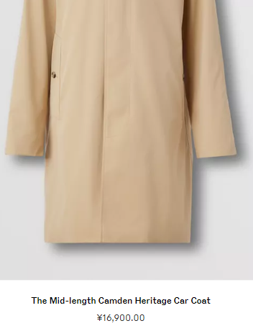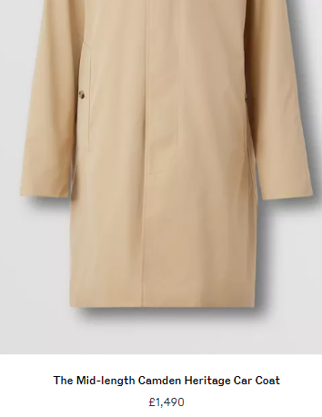
(Burberry plc, China 2022) (Burberry plc UK, 2022)
Place:
Burberry has around 400 store networks all over the world, managing effectively in 34 countries in China there are 65 stores running successfully and in USA there are 62 stores. The products are sold through direct channels of distribution and limited franchising their motto is one brand one company (Bhasin, 2022) and they are successfully doing business by using their brand assets and most of their areas are in influential and potential regions where premium customers frequently spot them.
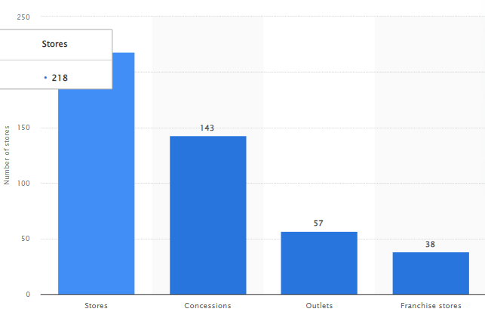
(Statista, 2022)
Promotion:
Brand promotion is one of the core activities for Burberry, Burberry uses IMC-integrated Marketing Communication for promoting its brands, IMC consists of Advertising, public relations, Sponsoring, Direct and digital marketing, in China the promotion of Burberry uses Digital channels as its main medium of Promotions, in China WeChat is the most used social media platform by Chinese people, they launched a WeChat mini-program (Luxury China, 2022) where customers can unlock the most exclusive content and personalized experiences through the WeChat Mini-program the usage of social media is improved a lot and plays a major role in Customer Journey. And recently Burberry partnered with Minecraft to go deeper into the metaverse and gaming world this adds more benefit to the company and bridges the gap between digital and Physical, (Vouge, 2022) in the other hand Burberry started a new campaign Voice of Tomorrow in the United Kingdom inspired by youth brings the talent together as One, united by passion and commitment (Burberry, 2022) in this campaign they use celebrity endorsement and most popular fashion influencers in the United Kingdom and company stick hands together support charities sponsorships for young generations (Burberry, 2022)
People:
The products of Burberry are well-crafted and Luxury segmented products, so the company requires excellent workmanship and talented persons for their growth, so the Organization believes in the power of creativity, creating an environment where everyone is equally supported, and finding creative talent in each individual carrying out the Burberry heritage and innovation to shaping the future of Luxury (Burberry,2022) according to recent statistics there are 9234 employees serving their duties in Burberry, around 4000 employees in EMIEA region (Statista, 2022)
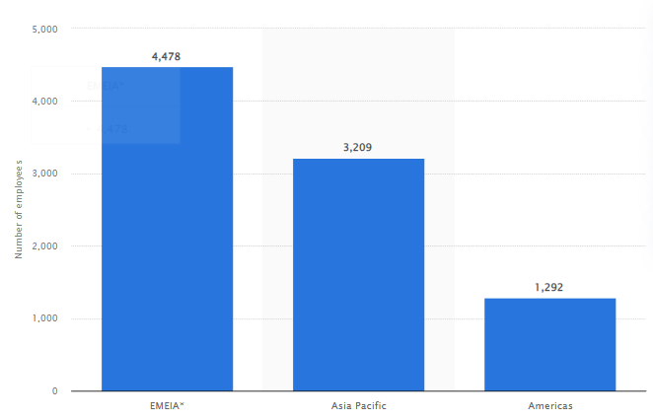
includes Europe Middle East, India, and Africa. In China, there are 1000+ employees working in 65 stores and in the UK there are almost 2905 employees working. (Statista, 2022)
Process:
The process of availability of products in-store inventory Burberry, to tackle this situation Burberry develop its strong IT and supply chain this team performs key issues of managing stock and services to other Global locations, The company uses Artificial intelligence in a unique way to deliver their services, For example, their products are spread across 50 countries and stores are fitted with RFID tags which can communicate the shopper’s mobiles, giving information about items were produced and recommendations are made (Forbes, 2017) they have a strong communication dialog box in the website which helps customers to raise any queries and complaints (Burberry, 2022) their website mentioned clear restrictions on shipping and service deliveries, some of the countries like South Korea, Taiwan, Japan regions are may not possible to deliver fragrances. ( Burberry, 2022)
Physical Evidence:
Burberry manages its Physical and offline stores very effectively, a new Iconic pop-up store on Jeju Island shows its outwear collection, this store is in the South Korean province, In China, there are 65 physical stores, (Statista, 2022) in the United Kingdom the biggest store with 44000 Square feet is one of the major fashion attraction in London. Burberry promotes good technology inside the store, and the staff is also well-trained to handle the customers, with good attire appearance with good standards, the staff and sales associates use tablets and electronic devices in hand whenever the identified customers came into the store, and the sales assistant use this device to offer better purchase suggestions based on previous activity. (Forbes, 2022) and the online website are having the same user interface in UK and China but the language importance is different.
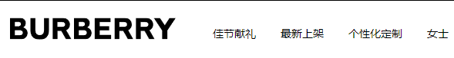
(Burberry China website, 2022) (Burberry UK website, 2022)

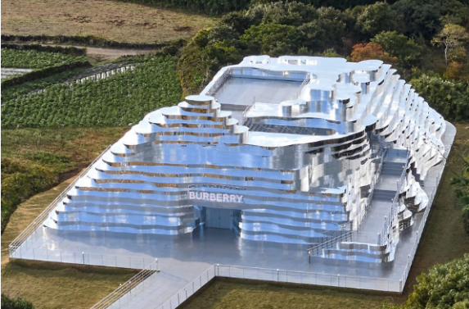
(Finney, 2022)
Similarities and Differences:
Although the company uses a similar Marketing Mix In the UK and China there are some noticeable changes in the marketing Mix, while coming to the product there are 10266 products available with the best deals, when compare to China there are only 66 best deals. There are much more differences in the Price, the iconic trench coat is 1490 GBP, and the same product costs 16900 Yuan, which is equal to 2028 GBP, this huge difference in price comparison between China and UK. (Zhang, 2022) and direct channel distribution is similar in both countries. When comes to promotion In China Burberry mostly focuses on Digital promotions and uses a specific social media App named WeChat In China, in the UK there is no Specific social media collaboration mostly using celebrity endorsement. These are the major similarities and differences to be noticed.
Market entry methods:
The mode of entry is defined as an institutional arrangement that makes the possible entry of the Company’s product, services, technology, or other resources into foreign countries. (Christopher et.al, 2008) there are three entry-ways mostly that any company follows while making available to the global market or foreign market, those are Licensing, Franchising, joint venture, and own subsidiary, based on the resources of the company the decision is chosen, and each method of entry has a different level of control i.e the authority over operational activities, decision making, strategy makings, and resources or assets of the company having.

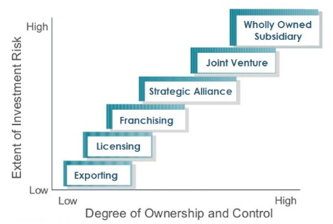
Source: (McGraw-Hill publications, 2010)

While coming to Burberry the company mostly does, financing and directly operated stores along with that a strong online shopping channel (Burberry plc, 2022) although they give licenses for a particular category of products like eye-wear and beauty.
Franchising:
This franchising is defined as the process of doing business with owners who license their products and operations, branding, this all will be done in exchange for a franchising fee (Adam,2022). Burberry uses franchising to enter China or any other new market with different geographical background from its home country of manufacturing. The franchising worked very well for Burberry to introduce them into China in 2010.(Daxue, 2022)
Currently, Burberry wants to increase the store count by giving franchising to interested investors and business persons, their goal is to go deep into underpenetrated areas, to capture the global market by the year 2025(Burberry, 2021)

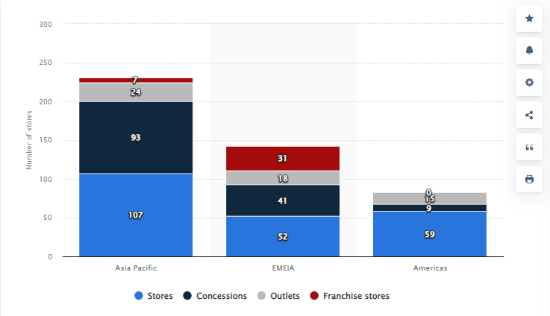

Source: (Statista, 2022)

Flagship stores:
When compared to other entry methods opening a flagship store is more advantageous, the flagship store has more control and involvement, and Burberry opened a flagship store in China which adds more control in the market. In the span of 2 years, Burberry opened almost 7 flagship stores by the year 2012, the British fashion house opened its first Flagship store in Shanghai China, (Moore, 2020) with high-tech involvement and catch commercials all over the malls. This flagship store is inspired by their Iconic store in Regent Street London this place is well enriched with British craftsmanship and in the same way, the flagship in China also resembles the Heritage of the brand helping Chinese customers feel and relates to the brand to Chinese culture. (Moore, 2022) At the early stage of expansion Burberry has less market knowledge and shows low involvement to know and test the market reactions, after gaining pure knowledge of the market they want to introduce big house operations by using franchises. 
Source: (Luxuo, 2021) China Flagship Store
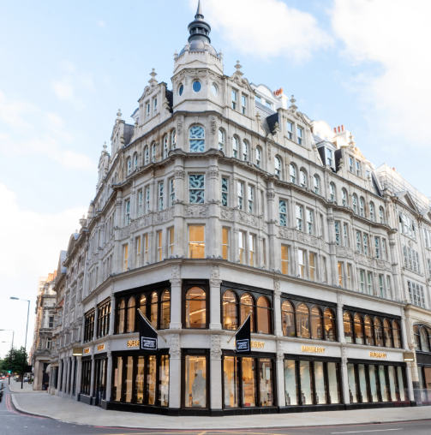
Source: (Vouge, 2021) London flagship store
Advantages and Disadvantages of Franchising:
In recent years Franchising became a famous mode of entry in business, most organizations choose to franchise to enter new international markets because franchising has eased circumstances. (Salar, 2013) There are some lists of advantages to be noticed in franchising, firstly Brand recognition, branding is the core con[ponent of business, mostly lot of customer base can be created through branding so franchises have a strong advantage of Brand recognition, and Low risk, (Salar, 2013) while entering into the new markets the risk of failure is more, by taking the franchise the risk of failure might be decreased when compared to the new business. And the next advantage is an easy setup, the new entrepreneurs or other newly established businesses are challenged and facing struggles to build themselves in the market, franchising eliminates this problem. (Salar, 2013) There are some disadvantages to be mentioned High cost is a major concern, it demands high initial deposits, maintenance rents, taxes, security deposits, employment, taxes, and dependency is the next factor, franchisors need to follow the franchise, and franchise wants to invest and make a profit and finally, franchisor became a part in profit and finally (Salar, 2013) Strict rules, the franchisor provides a set of rules and regulations, terms and conditions need to be followed by the franchiser, the hierarchy might be high, but without rules, the companies didn’t grow better.

Directional Development strategy:
Igor Ansoff is one of the strategic management planning tools, in the year 1957, he developed a matrix for growth, the Ansoff matrix also known as the product-market matrix. This tool is used by most organizations to develop their business effectively and penetrate the market field, many studies prove that by applying the Ansoff matrix to business development entrepreneurs successfully apply it (Loredana, 2017). The Ansoff matrix is a framework taught in many business schools, it is a simple tool to visualize and find out where the growth opportunities for business, (Peterdy, 2022) there are four quadrants in the matrix each quadrant has a specific growth strategy, and Market Penetration: it describes the existing products in existing markets, Market Development: selling of existing products into new markets. Product Development: Introducing new products into existing markets. Diversification: New products and altogether in new markets
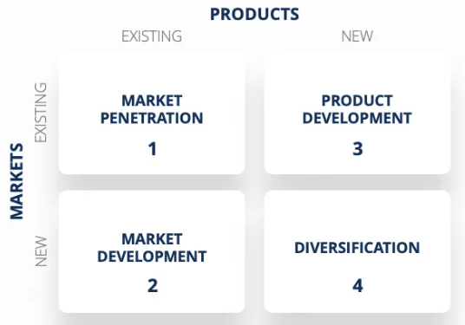
Ansoff matrix (Source: Corporate finance.com)
Burberry has been successful in delivering global operations and finding strategic growth decisions in different regions, Burberry always extends its products to find and attract new customers from various regions all over the world, so here in the matrix the quadrants are Market Development and Product development to increase sales in China and UK, Burberry trying to increase its production capacity to attract new customers at different regions the market Development involves entering new international markets, and Domestic markets, Burberry ready for new markets.

Recommendations: TOWS Matrix:
SO  - Burberry has a strong brand name, and strong brand recognition all over the world while coming to rankings Burberry performs well, so by using the brand name, the company can focus on emergent markets to gain more market share.  - As a company having diversified products, they have an opportunity to launch or to enter into future segments that can increase the profits for the Company.  - the company has abundant financial resources and revenue was also generated. after the pandemic, so having good financial resources and the chance to evolve in technology and invest more in technology.  ST  - To eliminate the criticism faced at the global level, the company needs to start effective campaigns by using its financial resources to tackle and remove the impact of Xinjiang cotton issues, and green environment effects, by doing environmental societal marketing, and counterfeiting is the major threat that can be controlled by introducing AI to control the fake circulation of items in online. | WO  - Burberry facing Uneven Product development, Burberry has recent partnerships with technology and gaming platforms, like Minecraft, Burberry has a chance to produce a new variant in outfits by using VFX and creating gaming character outfits to attract the younger target audience.  - Even though the brand has brand recognition, the presence of the brand is limited worldwide, so to counter this company has to expand into new markets like India, and Turkey, which are growing economies after the pandemic.  WT  - Low product lines and uneven product development can cause severe drawbacks in high-competition businesses, so this can be tackled by investing more in R&D, to bring new products and variants, new cultural campaigns in China and UK, and making a trail on developing countries, first launch a low involvement products like beauty products, glasses, after getting the expected response try to invest more on those countries.

REFERENCES:
Aditya, S. (2021) comprehensive swot analysis of Burberry. Available at: https://iide.co/case-studies/swot-analysis-of-burberry/ (Accessed: 10 Sep 2021).
Adina-Laura, A. (2021) These western brands are winning China’s local market . Available at: https://jingdaily.com/western-brands-winning-china-localization-gucci-burberry/ URL (Accessed: 17-3-2021).
Adam, H. (2021) What is franchise and how is it works. Available at: https://www.investopedia.com/terms/f/franchise.asp#:~:text=A%20franchise%20is%20a%20business,that%20grants%20licenses%20to%20franchisees. (Accessed: 04 Sep 2021).
Arsanal. (Macro environment of Burberry) Business and Finance. Available at: https://academic-master.com/macro-environment-of-burberry/ (Accessed: 7 Oct 2022).
Apps run the world (2017) Burberry Group plc software and digital transformation initiatives. Available at: https://www.appsruntheworld.com/customers-database/customers/view/burberry-group-plc-united-kingdom (Accessed: No date)
Burberry (2020) Burberry launches a new campaign as part of its initiative to support the voice of tomorrow. Available at: https://www.burberryplc.com/en/news/corporate/2020/burberry-launches-new-campaign-as-part-of-its-initiative-to-supp.html (Accessed: 10 Nov 2020).
Bernard, M. (2017) The amazing way Burberry uses AI and Big data. Available at: https://www.forbes.com/sites/bernardmarr/2017/09/25/the-amazing-ways-burberry-is-using-artificial-intelligence-and-big-data-to-drive-success/?sh=1ea8f60c4f63 (Accessed: 25 Sep 2015).
Bhasin, H. (2018) Top 10 competitors for Burberry. Available at: https://www.marketing91.com/top-10-burberry-competitors/ URL (Accessed: 3-11-2018).
Bhasin, H. (2019) Swot analysis of Burberry. Available at: https://www.marketing91.com/swot-analysis-of-burberry/ (Accessed: 28 Jan 2019).
Burberry (2022) First quarter trading Update. Available at: https://www.burberryplc.com/en/news/financial/2022/first-quarter-trading-update.html#:~:text=Overall%2C%20comparable%20store%20sales%20advanced,China%2C%20including%20our%20digital%20hub. (Accessed: 15 July 2022).
Camilleri, M.A. (2018) 'Market Segmentation Targeting and positioning', In travel marketing tourism economics and airline products, Chapter 4, pp. 69-83 Available at: https://www.researchgate.net/publication/319085560_Market_Segmentation_Targeting_and_Positioning (Accessed: Dec 2017).
Daxue consulting (2020) Burberry in china sales increasing faster than any region. Available at: https://daxueconsulting.com/china-market-research-on-burberry/ (Accessed: 04 July 2020).
Emily, C. (2021) Burberry plans to be climate positive by 2040. Available at: https://www.vogue.co.uk/fashion/article/burberry-climate-positive-2040 (Accessed: 10 June 2021).
Froese, F.J., Sutherland, D., Lee, J.Y. et al. (2019) 'Challenges for foreign companies in China: implications for research and practice', asian business and management, 18, 249-262 . Available at: https://link.springer.com/article/10.1057/s41291-019-00084-0#Sec2 (Accessed: 22 August 2019).
Fasol, G. (2015) Burberry solves Japan’s problem at least now. Available at: https://www.japanstrategy.com/2015/08/18/burberry-mackintosh-sanyo-shokai/#:~:text=Burberry%20Blue%20Label%20was%20a,without%20the%20%E2%80%9CBurberry%E2%80%9D%20brand. (Accessed: 18 Aug 2015).
Froese, F. (2019) 'challenges for foreign companies in China, Asian business and management, 18, 249-262. Available at: https://doi.org/10.1057/s41291-019-00084-0
Gerand, H. et al. (2018) 'The Relevance of Porter's Five force analysis in today's Innovative and changing business environment', SSRN Electronic Journal, Page reference. 24 Available at: DOI 0.2139/ssrn.3192207
GMA (2020) Burberry uses Virtual reality in china. Available at: https://marketingtochina.com/burberry-uses-virtual-reality-in-china/ (Accessed: 18 Aug 2020).
Hitesh, B. (2018) Marketing mix of Burberry. Available at: https://www.marketing91.com/marketing-mix-of-burberry-burberry-marketing-mix/ (Accessed: 02 Dec 2018).
Jia, HE. (2019) Do you know how to target the Chinese market? Available at: https://www.linkedin.com/pulse/do-you-know-how-target-chinese-market-burberry-has-failed-jia-he (Accessed: 19 Feb 2019).
Kotler, P. and Keller, K. (2009) Marketing Management. upper Saddle River NJ: Prentice Hall
KPMG (2022) China economic Monitor. Available at: https://assets.kpmg/content/dam/kpmg/cn/pdf/en/2022/11/china-economic-monitor-q4-2022.pdf (Accessed: 30 Nov 2022).
KPMG (2022) UK economic Outlook. Available at: https://assets.kpmg/content/dam/kpmg/uk/pdf/2022/12/uk-eo-december-2022.pdf (Accessed: Dec 2022).

Moore, C.M., Doherty A.M., (2010) 'Flagship store as a market entry method the prescriptive of luxury fashion retailing', European journal of marketing, Vol 44 1/2, pp. 139-161 Available at: https://doi.org/10.1108/03090561011008646 (Accessed: 16 Feb 2020).
Porter, Michael E. (2008) 'The five competitive forces that shape Strategy', Harvard business Review, Special issue on HBS Centennial, Page reference. 78-93
Pamela, N. (2022) Forget quality and sustainability. Available at: https://www.forbes.com/sites/pamdanziger/2022/03/12/forget-quality-and-sustainability-high-price-drives-consumer-demand-for-luxury-brands/?sh=23aa99c23da5 (Accessed: March 2022)
RAFIQ, M. and AHMED, P.K., 1995. Using the 7Ps as a generic marketing mix: An exploratory survey of UK and European marketing academics. Marketing Intelligence & Planning, 13(9), pp. 4.
Rastogi, N. (2016) 'PESTLE Technique', International research journal of engineering and technology, 3(1), pp 2-3. Available at: https://www.irjet.net/archives/V3/i1/IRJET-V3I165.pdf (Accessed: Jan 2016).
Salar, M. and Salar, O., 2014. Determining pros and cons of franchising by using swot analysis. Procedia-Social and Behavioral Sciences, 122, pp.515-519. Available at: https://www.sciencedirect.com/science/article/pii/S1877042814014025
Statista (2022) Luxury Fashion worldwide. Available at: https://www.statista.com/outlook/cmo/luxury-goods/luxury-fashion/worldwide (Accessed: Jun 2022).

Statista research department (2022) Global Luxury furniture market size. Available at: https://www.statista.com/statistics/977810/luxury-furniture-market-value-worldwide/ (Accessed: 27 July 2022).

Tugba, S. (2022) Number of Burberry stores worldwide outlet type and region. Available at: https://www.statista.com/statistics/439354/burberry-s-number-of-stores-worldwide-by-outlet-type-and-region/ (Accessed: 12 July 2022).
Tugba, S. (2022) Number of Burberry employees worldwide 2022. Available at: https://www.statista.com/statistics/870031/burberry-s-number-of-employees-worldwide-by-region/ (Accessed: 12 July 2022).
Tynan, J. (2022) 'military dress and Men's outdoor Leisurewear ', Journal of design history, Vol 24(2), pp 6. Available at: https://academic.oup.com/jdh/article/24/2/139/507127
Zhang, Y. (2022) 'Burberry's marketing activities in the UK and China', An analysis based on cultural and psychological differences, ICEMBE, pp. 1-10 Available at: https://www.clausiuspress.com/conferences/LNEMSS/ICEMBE%202022/EE023.pdf (Accessed: 2022).

