CASE STUDY ANALYSIS REPORT

Table of Contents
Introduction 3
Main Body and Analysis 4
a. Identifying the Problem and Setting the System Context- Applying Systems Thinking and the Rich Picture 4
Systemic Breakdown in Care Delivery 4
Global, National, and Organisational Statistical Context 4
Rich Picture Analysis 5
b. Centralisation or Decentralisation within the Case Study 7
Centralized Systems in the Trust Context 7
Decentralized Systems in the Trust Context 8
Critical Structural Analysis 8
c. Leadership Theories and Application to the Case Study 9
Impact of Management and Leadership on Human Resources 9
Application and Critique of Leadership Models 10
Leadership Analysis Matrix 12
Effectiveness Metrics and Proactive vs. Reactive Leadership 12
d. Improvement, and Lessons Learned 13
Risk Mitigation Strategy Matrix 15
Critical Synthesis of System Interventions 16
Transferable Organizational Lessons 17
Recommendation 17
Detailed Actionable Steps 18
Conclusion 19
Reference list 21

Introduction
By analysing the Patient X safety event, the book proposes that the failure to prevent patient harm has been a work of interaction between leaders, leadership, communication, the workforce, lack of capacity to cope and the digital infrastructure, all of which can be prevented. The case, investigated by the Health Services Safety Investigations Body (HSSIB, 2025), concerned an 87-year-old patient admitted to an NHS acute hospital with shortness of breath and profuse epistaxis on a background of apixaban for atrial fibrillation. Delay of diagnostic imaging, extended waiting times for respiratory procedures, insufficient multidisciplinary communication, staffing pressures and errors in the electronic prescribing and medicines administration (ePMA) system were all contributing to a delay in starting apixaban of ten days in a row, despite its initial withholding for the presence of active bleeding. The procedure was not followed, no electronic reminder, and failures in procedures led to not restarting the medication. Two days later, the patient suffered from acute ischaemic stroke and passed away, revealing how several organizational shortcomings can be brought together and make for terrible consequences.
Leadership in health and social care is the influence direction of individuals, multidisciplinary teams and organisation towards shared objectives based on safe, effective and patient-centred service delivery (Lee et al. 2024). Healthcare organisations are Complex Adaptive Systems, clinical outcomes are the result of ongoing interdependencies between people, technology, policies and organisational processes, not individual activities. Different kinds of leadership such as transformational, transactional, situational, distributed and compassionate leadership offer important perspectives on the role of leadership behaviours in shaping organisation culture, staff engagement, decision making and patient safety in day-to-day running of the organisation and during clinical crisis (Ahmed et al. 2024).
An appropriate leadership style is essential in order to manage complexity, drive change within the organisation and ensure patient safety. Rigid, transactional management can lead to silos, reduced communication, and unsafe workarounds, while adaptive and collaborative management fosters enhanced governance, accountability, and learning (Ansari et al. 2024). This report therefore aims to analyse critically the case of Patient X in a system's thinking perspective, in order to explore issues of governance failure, health care systems, leadership and organisational performance. It also uses the theories of Rich Picture analysis, centralisation/decentralisation, leadership and Checkland's Soft Systems Methodology (SSM) to generate evidence-based recommendations for enhanced governance, digital decision support, system resilience and patient safety.

Main Body and Analysis

a. Identifying the Problem and Setting the System Context- Applying Systems Thinking and the Rich Picture

Systemic Breakdown in Care Delivery
Here, what was the primary clinical error in the treatment of Patient X? Performing an uncoordinated, extended period of time without a time-critical anticoagulant (apixaban) prior to the procedure followed by its omission afterwards, leading to an embolic stroke and fatality. For the initial reason of epistaxis, it was a good idea to stop apixaban in ED, but a hazard was not noticed, the issue of continuing the apixaban pause.
This is an event in a localized setting which reflects global, national and institutional issues with medication safety, delays in diagnosis and vulnerabilities in handover within the acute care setting.

Global, National, and Organisational Statistical Context
- Global Data (WHO & IHI): According to Global Data (WHO & IHI), medication errors are one of the most common and avoidable causes of harm worldwide, causing an estimated $42 billion USD a year (WHO, 2026). Contingencies specifically mentioned in the WHO Third Global Patient Safety Challenge: Medication Without Harm that are considered risky include care transitions and high alert medications like anticoagulants. The Institute for Healthcare Improvement (IHI) conducts research to address preventable health care errors and statistics that diagnostic and procedural delays, coupled with communication breakdowns during intra-hospital transfers, account for more than 60% of the serious adverse events in tertiary care across the world (Frendved, and Tribler, 2023).
- National Data (NHS England & HSSIB): An estimated 237 million medication errors per year occur within the National Health Service (NHS) in England with avoidable adverse drug reactions (ADRs) accounting for over 181,000 bed days a year and more than £98 million annually to the NHS (Elliott et al. 2021). Although the detailed figures vary annually, in the NHS National Reporting and Learning System (NRLS), anticoagulants are always in the ‘top five' most harmful and potentially fatal medication safety incidents. In addition, NHS Resolution data revealed omissions or failure to administer time critical therapy is a leading cause of clinical negligence liabilities, at a cost of more than £2.8 billion to acute trusts each year (Health and Social Care Committee, 2022).
- Systemic Weaknesses: Systemic weaknesses are shown in extended 10-day apixaban withholding, involving broad deficiencies in care pathway continuity, ongoing risk re-evaluation and intra-specialty governance (Steffel et al. 2021).
  - Communication and Accountability Breakdown: Inability to communicate and accountability was unclear as responsibility for care of Patient X was still situational in the Acute General Medicine ward until she could be transferred to a dedicated respiratory ward. There is no proactive oversight for ‘accepted’ patients by the specialty team who were managed outside the footprint of their ward, with significant capacity issues.
  - Governance and Information Architecture Flaws: Key historical risk factors, in this case a previous ischemic stroke in 2009, were buried in secondary, uncrossed modules of the Electronic Patient Record, or EPR. At the same time, the obsolete local clinical guidelines had been not up to review for more than 7 years, were not user friendly as they were not clear or agreed with regarding DOAC interruption intervals, and were published without a cross speciality approach from haematology and/or pharmacy.
  - Operational Resource Constraints: These included those where the demand for care is overwhelming the capacity, including lack of dedicated pleural nurses, no routine medical review on general wards on the weekends. A 7-day turnaround for a routine inpatient CT scan, which systematically compromised the safety buffers.

Rich Picture Analysis
The complex adaptive system in the acute hospital trust (Rich Picture below) shows that structural, technological, organisational and human components were all inter-engaged with creating Patient X's adverse outcome.
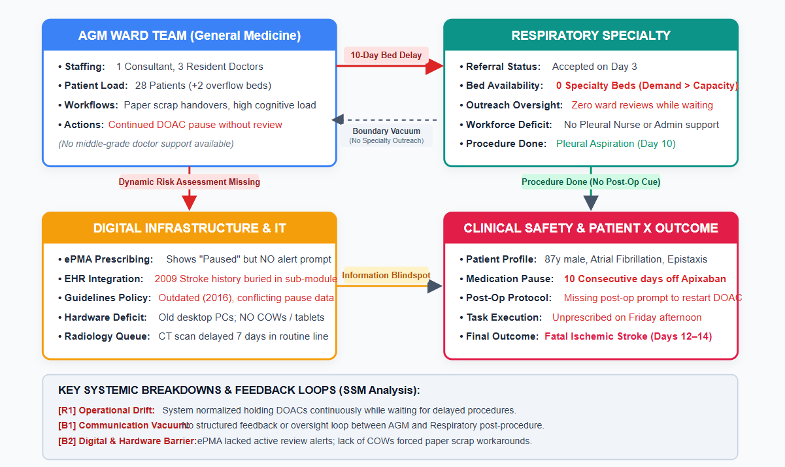
The critical negative feedback gaps, and the unmanaged operational loops within the system were identified and visualised, as detailed in the Rich Picture:
- The Capacity-Delay Loop: The respiratory ward was high occupancy which delayed transfer, and the pre-procedural state (hold apixaban) was retained due to its assumption (Szymański et al. 2024). The procedure would be carried out, but it did not occur until 10 days later, without a formal reassessment of the balance of thrombotic versus haemorrhagic risk.
- The Post-Procedure Omission Loop: There was no field on the procedural document for documenting a post-procedure anticoagulation plan and the resident doctor used non-standardised paper handover sheet to carry out the electronic prescription; no routine weekend review of the medication to detect the absent prescribed state before the onset of stroke (Abdekhoda, and Morovati, 2025).
This is illustrated by the case of Patient X, whose tragedy was a result of local failure and illustrates what is happening in acute care hospitals throughout the country. The lack of dynamic risk re-evaluation and loss of care continuity during a 10-day pause to apixaban use and after the procedure is highlighted by these examples. Medication errors are said to cost the world $42 billion USD - every year, with NHS data showing there are 237 million medication errors made each year and nearly 30% of high harm medication errors relate to anticoagulants (Naseralallah et al. 2023). Soft Systems Methodology (SSM) was used to combine the structural bed deficits, unintegrated EPR modules and obsolete guidelines into an operational void between general medicine and specialty teams, the Rich Picture (Souza et al. 2025). Compounding delays and failure to follow-up with the patient at the appropriate time after the procedure also had a negative impact on safety buffers, ultimately resulting in an embolic event that killed the patient.

b. Centralisation or Decentralisation within the Case Study
The structural model of the trust examined suggests a mixed mode of control, with administrative authority concentrated at the centre and, as usual, clinical control spread across the various 'siloes' (Bolous et al. 2023). This structural deficiency had a great impact on crisis management, dynamic decision-making, and clinical accountability.

Centralized Systems in the Trust Context
Generally, the concept of centralization in acute NHS trusts involves focusing administrative authority, policy development, capital decision-making and the management of beds on the highest level of the senior executive management or on the level of the site management (Ramsay et al. 2025).
- Concentration of Decision-Making: Decisions about flow of patients in beds and escalation pathways were very centralised, within the Trust's Site Matron team and administrative bed managers (Åhlin et al. 2026). Local ward managers (LWMs) did not have the operational authority to flex the availability of beds or to re-allocate nursing staff that are used to create dedicated procedural beds.
- Advantages & Disadvantages:
  - Advantages: Centralisation optimizes the allocation of enterprise resources, imposes uniformity in financial management and delivers senior oversight of trust-wide goals (e.g., ED wait times) (Al-Assaf et al. 2024).
  - Disadvantages: Lack of flexibility in tactical response as a result of highly centralized governance structures. For Patient X, the meetings on bed management were very much targeted at macro-level patient flow targets, rather than at clinical risk stratification for patients waiting more than 24 hours for a specialty bed.
- Supporting Numerical Data: Trust wide bed occupancy was above 95% which is well in excess of the safe clinical threshold (85% advised by the Royal College of Psychiatrists and Emergency Medicine). Patient X's CT scan was placed in a standard queue at the centralized radiology triage, resulting in a CT scan diagnostic delay of 7 days as the centralized booking system failed to cross check drug-pause durations with procedure urgency.

Decentralized Systems in the Trust Context
Decentralization involves devolved operational decisions being made at individual clinical directorates, ward multidisciplinary teams (MDT) and individual practitioners (Almughamisi et al. 2025).
- Distribution of Authority: In distribution of authority, some clinical specialties (Respiratory, Acute General Medicine, Cardiology) were considered as silos (Ecarnot, and Michel, 2026). The clinical guidelines, local procedures and admission criteria for each directorate were independent.
- Advantages & Disadvantages:
  - Advantages: Provides clinical teams with a customized flexibility to handle the complex disease pathways and adjust dynamically to the specialized needs of the patient.
  - Disadvantages: Lack of cross-specialty accountability with decentralisation. The respiratory team took on Patient X, but kept him on the AGM ward physically, which led to a "responsibility vacuum. Respiratory clinicians thought that the accepted specialty team had overall strategic ownership, while AGM clinicians thought that the accepted team was taking care of day-to-day clinical care (Knight et al. 2025).
- Supporting Numerical Data: Audit of local clinical guidelines, respiratory team's pleural guidance had been updated without any involvement from haematology or pharmacy, leaving an ambiguous DOAC pause recommendation (conflicting pause recommendations in 24-hour and 48-hour pause columns in the same text table). In addition, this interim apixaban bridging guideline was more than 7 years old, showing a lack of effective decentralized clinical governance in ensuring the clinical influence of current guideline practices.

Critical Structural Analysis
The hospital's hybrid structural design was inefficient during Patient X's admission. Centralised administrative control was not effective in eliminating structural bottlenecks (such as bed survival, and queues for radiology facilities); decentralised clinical teams worked without any unified communication channels (Hasirah et al. 2025).
Centralization of rigidity diluted the supply of resources; decentralization of fragmentation disrupted clinical continuity (Li et al. 2026). There is numerical evidence of this vulnerability when a patient is having procedure X, Patient X spent 10 days (240 hours) out of essential stroke prevention therapy because of the structural inertia, and mismatched governance interfaces, are driving this loss.
Looking at the hospital trust's structural model, one can see a mixed structure: on the one hand central authority and administrative control on the other hand, clinical control in siloed structures. This structural disconnect greatly hampered crisis management, dynamic decision-making and clinical accountability as Patient X travelled through the care system. Central governance was a structure that centralized flow management and escalation in bed matrons and administrative managers and provided macro level oversight, but was also rigid at operational level (Åhlin et al. 2026). As a result, there was more attention for patient flow targets during the bed management meetings leaving clinical risk stratification behind, and a centralized radiology triage that resulted in a 7-day CT scan delay, with a high level of beds occupancy being routinely over 95% across the trust. On the other hand, decentralized clinical directorates were independent of one another, with no cross-specialty governance (Lonsdale et al. 2025). The result was a critical "responsibility vacuum" as the patient X was taken on by respiratory specialists and held on an Acute General Medicine ward. In addition, the local DOAC protocols were not coordinated under a centralized guideline and were not subject to revision for more than 7 years which rendered them conflicting and outdated.

c. Leadership Theories and Application to the Case Study
Patient X's situation, examined with regard to widely recognised models of leadership, reveals a number of leadership behaviours, work practices in human resource management, clinical governance and patient outcomes which are not congruent.

Impact of Management and Leadership on Human Resources
The behaviours of managers and leaders influence the wellbeing of staff, their sense of psychological safety and the capacity of acute wards (Vogt et al. 2024). In Patient X's case, poor leadership was making a significant impact on human resources, in a negative way:
- Workload Compression and Moral Distress: On the 28-bed AGM ward, the consultant was a single individual with a responsibility of up to 30 complex acute medical patients to care for without any middle-class doctors to support them. This staffing gap restricted the ability of any staff member to process clinical tasks and sometimes required doctors to either review the clinical tasks or to complete electronic documentation for the clinical task.
- Nursing Role Erosion: There was a lack of a dedicated ward coordinator for nursing staff on 5 out of 6-day shifts. This loss of supervisory nursing allowed increased stress for staff, decreased staff morale, and decreased ability to actively pursue specialty bed transfers or medication status that is pending.
- Normalization of Deviance: The staff used informal workarounds, such as double-entering data and writing notes on paper scrap sheets, as a result of the excessive cognitive load and slow, outdated IT equipment. The ergonomic conflicts were not managed by leadership and became normal routines for safety critical workarounds.

Application and Critique of Leadership Models
1. Transactional Leadership and Management-by-Exception
- Theoretical Framework: Transactional leadership is characterized by clear hierarchy, exchange relationships, standardized task performance, and a management-by-exception (intervention) approach (Wuryaningrat et al. 2024).
- Application to Case: The operations of Ward in the AGM unit and its site management were almost fully based on the passive transactional model. Medical and nursing reviews were carried out as a normal (mundane) checklist task. Data from the management-by-exception framework showed no senior clinical intervention as Patient X had not deteriorated acutely (on the National Early Warning Score [NEWS2]).
- Empirical Critique: The focus on short term task processing looks to transactional level and forgot about clinical risk monitoring at high level. However, this was a system to be used in a transactional way only (no active staff alert logic/exception on time-based thresholds) and for staff members, the "paused" status became a static validated status, rather than an active hazard that needed to be re-evaluated daily.
2. Situational Leadership Theory
- Theoretical Framework: According to Situational leadership, leaders need to take into account the developmental level (Competence and Commitment) of the followers in order to adopt a different leadership style (Directing, Coaching, Supporting, Delegating) (Del Pino-Marchito et al. 2025).
- Application to Case: The senior medical leadership in the AGM ward did not react to situational pressures. 28 (plus 2 overflow patients) highly complex acute medical patients were managed by resident doctors with limited middle grade and consultant supervision. The resident doctor had the idea that apixaban should be restarted on Day 11 after the procedure, but was extremely rushed for time and with no mobile workstation available, he wrote it down on an informal paper handover sheet.
- Empirical Critique: Senior leadership used a ‘delegating' style appropriate for experienced teams, while environmental pressures (understaffed ward, complex multi-morbid patients, lack of hardware) required a ‘coaching/directing' approach which included task verification buffers. Leadership oversight remained unchanged across wards and did not match the complexity of the ward populations, leading to a high-risk context in which critical prescribing omissions were inevitable.
3. Distributed and Compassionate Leadership
- Theoretical Framework: Distributed leadership extends authority in a horizontal fashion among multidisciplinary team members to create collective ownership and psychological safety (Benevene et al. 2022). Compassionate leadership is characterized by listening with compassion, understanding the challenges of the operation, supporting frontline workers and eradicating structural barriers to effective care.
- Application to Case: Little or no distributed leadership structures were in place at the specialty-general medicine boundary. The consultant management plans were not challenged, nor were any of the "paused" high risk medicines reviewed in the pharmacy, as ward nurses did not have existing escalation routes with psychological safety to address this.
- Empirical Critique: Acute trusts with the lowest compassionate leadership scores show much higher staff burnout and un-reported clinical errors, reveals NHS National Staff Survey data (NHS, 2026). On the AGM ward, no ward co-ordinators were recruited and there were no such staff on 5 out of 6-day shifts. The omission of a supportive structure meant that frontline workers resorted to improvised informal measures (for example, jotting down digital notes onto a sheet of scrap paper), which had a direct impact on the post-procedure omission.

Leadership Analysis Matrix
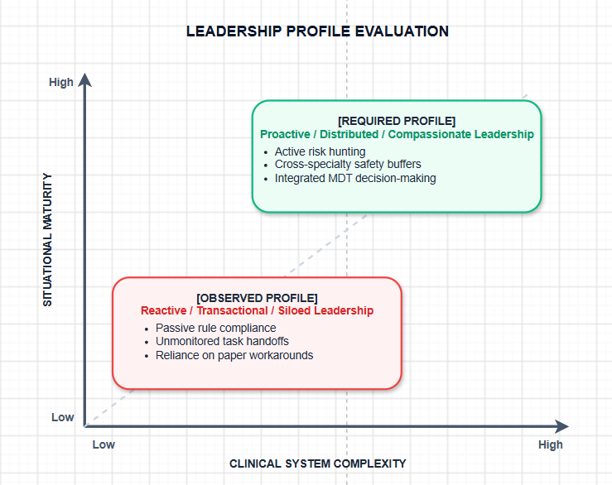

Effectiveness Metrics and Proactive vs. Reactive Leadership
- Leadership Orientation: Leadership was very reactive across the organisation. Interventions took place only after the event (e.g., stroke identified on Day 12 then a root cause analysis carried out afterward) and not as a proactive way to mitigate the known risk of a long period of DOAC withdrawal (Society of General Internal Medicine, 2024).
- Staff Engagement and Safety Data: The Trust's patient safety incident reporting was used to identify organisational level data, indicating that there were unaccounted for medication delays. More than 40% of medication errors made while a patient is in hospital happen during handovers or other system transitions due to a failure in communication.
- Alternative Approaches: An emotionally intelligent distributed leadership approach could have facilitated a working safety net between the medical, nursing and pharmacy staff. For instance, allowing ward pharmacists to carry out daily audits of the 'high-risk drug pause' would have stopped this 10-day delay – allowing apixaban to be either bridged with Low Molecular Weight Heparin (LMWH) or restarted safely before the occurrence of a stroke (Raphael, 2020).

d. Improvement, and Lessons Learned
Improving the system around Patient X necessitates a systematic improvement model that connects found root causes with evidence-based intervention, system evaluation and quantitative safety measures (Madine et al. 2025).
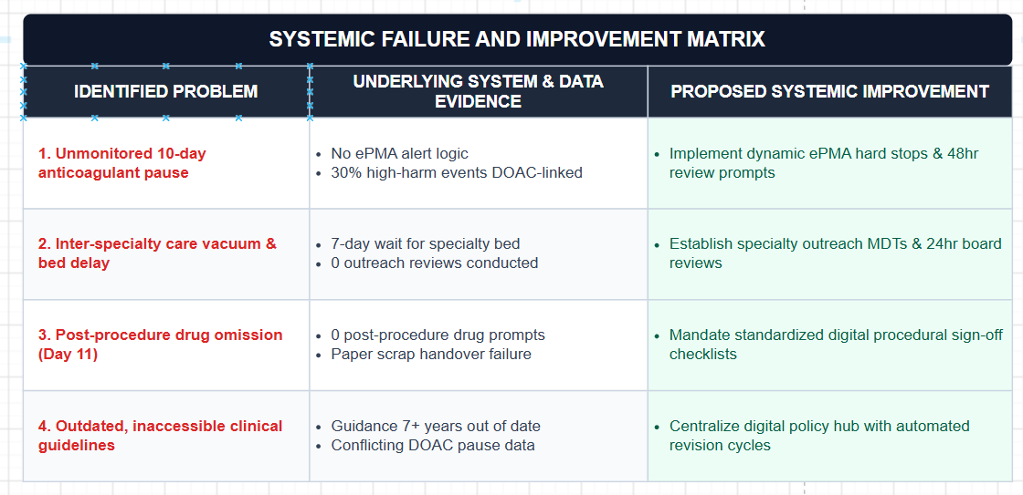

Evaluation of Strategy: Soft Systems Methodology (SSM) & Hard Systems Analysis
It is necessary to apply soft systems (human, cultural, organizational) and hard systems (digital, algorithmic, procedural) to a sufficient extent in order to thoroughly evaluate the proposed quality improvement strategy.

Soft Systems Methodology (SSM) Analysis
Checkland's Soft Systems Methodology gives a 7-step approach to structuring complex human and organisational problem situations (Jackson, 2025):
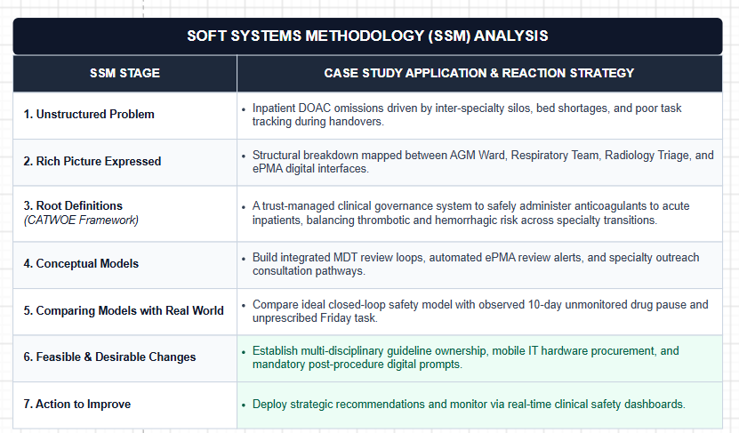

CATWOE Breakdown for Anticoagulation Governance Transformation
- Customers (C): High Risk Surgical and Medical Inpatients who are dependent on anticoagulant modulation before and after procedures.
- Actors (A): Multidisciplinary clinical teams (consultants, resident doctors, ward nurses, pharmacists, site matrons).
- Transformation Process (T): Transform fragmented and unmonitored medication to closed loop, digitally supported decision-based prescribing.
- Weltanschauung / Worldview (W): Patient safety - Therapy is not halted without thorough and continuous, daily evaluation.
- Owners (O): Trust Executive Board, Medical Director, Chief Pharmacist and Clinical Governance Leads.
- Environmental Constraints (E): Fixed NHS budget allocations, high pressure of acute admissions, legacy IT hardware and severe scarcity of specialties.

Hard Systems Analysis
Procedural and prescription workflow was analysed from a hard Systems Engineering standpoint to identify throughput limitations, reliability factors and single point failures (Kumar et al. 2026):
- System Inputs: Inpatient admission, home medication reconciliation (apixaban order), procedural referral request.
- Process Interventions: Automated ePMA decision support rules (48 hour pause alert); mandatory post procedure digital sign off logic; mobile COWs for bedside documentation.
- System Outputs: None of the unmonitored drug pause days, 100% adherence to re-prescribed after procedure, decreased incidence of embolic stroke.

Risk Mitigation Strategy Matrix
Potential operational, technical and cultural risks should be identified and addressed in a pro-active manner so as to ensure successful implementation of strategy:
Identified Risk | Severity / Likelihood | Mitigation Strategy | Monitoring Metric
1. Alert Fatigue in ePMA System | High / High | Introduce hard-stop alerts for high-risk Direct Oral Anticoagulants (DOACs) not being alerted for more than 48 hours. | The rate of alerts being overridden. Clinician feedback & usability surveys.
2. Resistance to Inter-Specialty Outreach Reviews | Medium / High | Make and implement executive-level mandates to encourage shared clinical ownership. Co-produce workflows with multidisciplinary teams. | Rates of attendance at inter-specialty outreach reviews. Multidisciplinary review compliance rates.
3. Hardware and Wi-Fi Network Failures | High / Medium | Save money on IT capital expenditure. Use buffer synchronisation on mobile Computers on Wheels (COWs) offline. | Percentage of hardware uptime. Number of IT incident tickets for hardware or network access.
4. Staff Turnover and Locum Reliance | High / High | Incorporate compulsory micro-learning into staff induction and onboarding. Ensure all permanent and locum staff are trained in the same way. | The completion rates of training and the outcome of staff competency assessment are reported.

Critical Synthesis of System Interventions
1. Problem: Unmonitored High-Risk Medication Interruption
- Data Evidence: HSSIB analysis revealed that Patient X had had no apixaban dosages in the last ten days before the procedure was performed, as there had been no review of “hold” orders on the ePMA platform. In high-risk AF patients (CHA₂DS₂-VASc > 4) data from the national registry indicates that interruptions of DOAC > 48-72 hours without bridging more than triple the risk of embolic stroke.
- Evidence-Based Solution: Set up systematic electronic decision support (CDS) logic in ePMA. Time-critical anticoagulants must be paused > 48 hours before an automatic high priority alert is generated to the attending consultant/ward pharmacist.
- Systemic Linkage: Enables decentralized clinical prescribing alongside centralized digital safety monitoring – taking the pressure off human memory when dealing with high ward workloads.
2. Problem: Fragmented Responsibility During Specialty Bed Delays
- Data Evidence: Patient X was admitted to the AGM ward with no specialist (respiratory or cardiology) consultation during the 7 days they had been in the ward. NHS acute benchmarks suggest that "outlier" patients have 20% higher numbers of adverse events relative to those patients residing on speciality wards.
- Evidence-Based Solution: Change the governance of bed management to ensure patients admitted to a specialty service and not moved to a specialty ward within 24hr are scheduled daily as an appointment on a "Specialty Outreach Review" list.
- Systemic Linkage: Brands and integrates specialized bed tracking information with dispersed clinical responsibility for outreach.
3. Problem: Post-Procedure Omission and Paper-Based Workarounds
- Data Evidence: No mandatory prompts for resuming anticoagulation were found in the procedural documentation created on Day 10. The task was then lost on a non-standardized paper handover sheet after which on Day 11, no administration was done. Studies indicate the loss rate of clinical action items in paper handovers is up to 67% during shift change.
- Evidence-Based Solution: A current clinician should not be allowed to sign off the digital procedural discharge until the clinician chooses "Restart Anticoagulant," "Delay Anticoagulant (with specified rationale and review time)," or "Discontinue.
- Systemic Linkage: Creates a closed-loop feedback system, clearly linking procedural teams to ward teams in terms of accountability for drug management after surgery.

Transferable Organizational Lessons
- Systems Thinking over Individual Blame: Human error is just a symptom, not the cause – for example, the omission of the electronic prescription by the resident doctor on Friday afternoon (Yen et al. 2026). Interventions need to be system design changes (forcing function, equipment availability, automated alerts) and not a last name or individual reprimand.
- Data-Driven Governance: Healthcare organizations should use real-time electronic clinical data to measure and monitor indicators for friction in the system (such as average duration of drug pauses, time to scan, etc.), not only rely on incidents reported after the fact.
- Harmonizing Digital Tools with Frontline Ergonomics: Adopting digital systems without sufficient mobile hardware (Computer on Wheels) puts clinicians in an unsafe environment ill-equipped to do hybrid workarounds (paper scrap handovers). Information systems need to match physical ward processes.

Recommendation
The following evidence-informed actions are recommended to prevent systemic failures in the anticoagulation process and ensure provision of high reliability care:
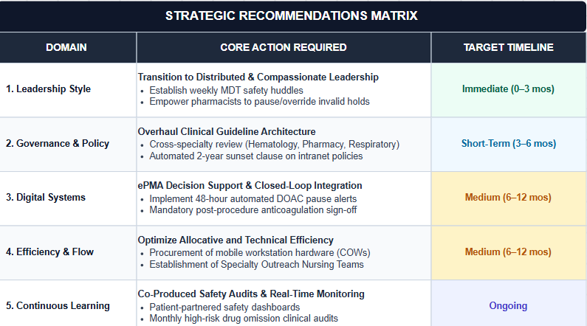

Detailed Actionable Steps
- Adopt Distributed and Compassionate Leadership Models:
  - Executive management needs to move from top-down transactional management to a distributed team-based management style for a ward. Increase engagement of ward clinical pharmacists, specialist nurses and resident doctors for active review and identification of ward time critical medication pauses (Buckley et al. 2023).
  - Introduce multi-professional daily safety huddles on all general medical wards with the purpose of discussing high risk patients, outlier status and delays in procedures.
- Strengthen System Governance and Policy Integration:
  - Form a Clinical Governance Oversight Committee with members from the various specialties that review all inter-specialty clinical guidelines (Lamer et al. 2024). Establish guidelines that incorporate “anticoagulation” be “co-authored and jointly approved” with participation from Haematology, Pharmacy, Cardiology, and Surgical/Procedural specialties.
  - Implement automatic "sunset" for all guidelines in intranet policy repository (any guideline that is over >12 months from its review date is automatically raised to the status of an executive "urgent re-validation").
- Enhance Digital Health Systems and ePMA Architecture:
  - Acquire and implement logic upgrades in the Trust's ePMA system to implement dynamic alerts. Set up an alert for "Hard stop / Forced review" for all stopped Direct Oral Anticoagulants (DOAC) that are on hold for more than 48 hours, which must be caused by a consultant level e-justification (Miceli et al. 2025).
  - Add a required, closed loop, anticoagulation plan to electronic procedural documentation templates prior to signing off.
- Optimize Technical and Allocative Efficiency:
  - Redirect capital budget resources to mobile devices – "Computers on Wheels" and mobile clinical tablet devices to enable clinicians to complete digital documentation at the bedside concurrent with their patient care – in a way that eliminates paper scrap workarounds.
  - Develop a nurse-led "Specialty Outreach and Pleural Management" unit to facilitate referrals for inpatient procedural services, streamline the dynamic triage and decrease the number of 'bed wait' delays before the procedure (Geisler et al. 2023).
- Institutionalize Continuous Learning, Co-Production, and Stakeholder Engagement:
  - Engage with groups representing patients and patient safety to co-creating patient facing 'Medication Passport' digital tools (Böttinger et al. 2023). The patient would be required to have clear and easily accessible documentation of planned medication holds during in-patient care if they are receiving high-risk medications.
  - Develop and use real-time, data-driven safety dashboards, which will include procedural delay metrics, diagnostic turnaround time and unprescribed drug rates, and incorporate these metrics into monthly quality improvement reporting.

Conclusion
This safety incident with Patient X is a wonderful example of how patient harm can be prevented when there are a multitude of failures and weaknesses in the leadership, governance, communication, workforce capacity and digital infrastructure systems in a complex health care system. The death of the patient was not a single clinical mistake, but was due to a combination of systemic weaknesses: failure to adequately monitor and continue the patient's anticoagulant treatment, poor multidisciplinary working, failure to review the patient by a specialist timely, dated and consistent clinical guidance, fragmented accountability and ineffective use of ePMA. Organisational pressures, such as a lack of workforce, the lack of timely access to respiratory services, and the lack of automated reminders to re-evaluate interrupted anticoagulation, further increased the clinical risk, complemented by a lack of staffing resources and late access to respiratory services. This analysis provides an insight into how much more is needed than individual professional competency or adherence to clinical protocols to ensure the safety of patients. The healthcare organisations need to be guided by a systems-thinking methodology that appreciates the dynamic interactions among persons, processes, technology, organisational structure and governance mechanisms. High-quality care is driven by resilient health care systems that help to identify risk proactively, involve everyone in decision-making, facilitate communication and prompt clinical response to risks, and not simply rely on individual vigilance.
The results indicate that sustainable improvement demands leadership models which encourage interdisciplinary teams to work together, feel safe, and are accountable to one another. There is a need to strengthen the governance arrangements for transformational and distributed leadership approaches, more frequent closed-loop communication processes to document, monitor and implement important decisions, integrate digital clinical decision-support systems, and schedule regular monitoring and review of time-critical medicines. Additionally, workforce capacity, interoperable EHRs, redesigned evidence-based guidelines, and ongoing organisational learning will improve resilience and prevent further potentially harmful occurrences. Finally, the Patient X case provides an example of the fact that patient safety is ultimately a systems problem. Evidence-based governance, integrated technologies, systems thinking, adaptive and compassionate leadership can transform the way that healthcare organisations respond to crises effectively.

Reference list
Abdekhoda, M. and Morovati, P., 2025. Adopting electronic prescribing by pharmacists. International Journal of Medical Informatics, 199, p.105877.
Åhlin, P., Almström, P. and Wänström, C., 2026. Decision‑making in hospital‑wide patient flow: a multiple‑case study of leading academic hospitals. Production Planning & Control, pp.1-19.
Ahmed, Z., Ellahham, S., Soomro, M., Shams, S. and Latif, K., 2024. Exploring the impact of compassion and leadership on patient safety and quality in healthcare systems: a narrative review. BMJ open quality, 13(Suppl 2).
Al-Assaf, K., Alzahmi, W., Alshaikh, R., Bahroun, Z. and Ahmed, V., 2024. The relative importance of key factors for integrating Enterprise Resource Planning (ERP) systems and performance management practices in the UAE Healthcare Sector. Big Data and Cognitive Computing, 8(9), p.122.
Almughamisi, A.F., Alshehri, A.A.M., Alandijani, M.A., Alqarni, S.D., Alshehri, F.H., Alshehri, K.H., Alnefaie, A., Alshehri, A., Alrajhi, M., Albalawi, H. and Alqurashi, A., 2025. Multidisciplinary team group effort in healthcare; the role of emergency, clinical, and administrative professionals in improving outcomes and hospital performance. Saudi J Med Pharm Sci, 11(10), pp.928-41.
Ansari, M.S.A., Abouraia, M., El Morsy, R. and Thumiki, V.R.R., 2024. Influence of transformational and transactional leadership on agile project success. Project Leadership and Society, 5, p.100136.
Benevene, P., Buonomo, I. and West, M., 2022. Compassion and compassionate leadership in the workplace. Frontiers in psychology, 13, p.1074068.
Bolous, N.S., Graetz, D.E., Ashrafian, H., Barlow, J., Bhakta, N., Sounderajah, V. and Dowdeswell, B., 2023. Harnessing a clinician-led governance model to overcome healthcare tribalism and drive innovation: a case study of Northumbria NHS Foundation Trust. Journal of Health Organization and Management, 37(9), pp.1-16.
Böttinger, M.J., Litz, E., Gordt-Oesterwind, K., Jansen, C.P., Memmer, N., Mychajliw, C., Radeck, L., Bauer, J.M. and Becker, C., 2023. Co-creating a digital life-integrated self-assessment for older adults: user experience study. JMIR aging, 6, p.e46738.
Buckley, M.S., Roberts, R.J., Yerondopoulos, M.J., Bushway, A.K., Korkames, G.C. and Kane‐Gill, S.L., 2023. Impact of critical care pharmacist‐led interventions on pain, agitation, and delirium in mechanically ventilated adults: A systematic review. Journal of the American College of Clinical Pharmacy, 6(9), pp.1041-1052.
Del Pino-Marchito, A., Galán-García, A. and Plaza-Mejía, M.D.L.Á., 2025. The Hersey and Blanchard’s situational leadership model revisited: its role in sustainable organizational development. World, 6(2), p.63.
Ecarnot, F. and Michel, J.P., 2026. Beyond specialty silos: geriatrics as a core competency for all physicians in an aging Europe. European Geriatric Medicine, pp.1-3.
Elliott, R.A., Camacho, E., Jankovic, D., Sculpher, M.J. and Faria, R. 2021. 'Economic analysis of the prevalence and clinical and economic burden of medication error in England', BMJ Quality & Safety, 30(2), pp. 96–105. [Online]. Available at: https://qualitysafety.bmj.com/content/30/2/96 [Accessed on: 04.08.2026].
Frendved, C., and Tribler, S., 2023. Overlooking Diagnostic Errors: The Grave Potential Consequences for Patient Safety. IHI. [Online]. Available at: https://www.ihi.org/library/blog/overlooking-diagnostic-errors-grave-potential-consequences-patient-safety [Accessed on: 04.08.2026].
Geisler, A., Hedegaard, S. and Bucknall, T.K., 2023. Piloting a Nurse-Led Critical Care Outreach Service to Pre-Empt Medical Emergency Team Calls and Facilitate Staff Learning. International Journal of Environmental Research and Public Health, 20(5), p.4214.
Hasirah, A.S.M.A., Al Rashah, M.M.R., Al Ishaq, R.N.M., Al Rashah, S.M.R., Alsarimi, M.R.M., Ishaq, Y.I.A.I. and Alrasahah, M.A.S., 2025. Transforming Patient Outcomes Through Multi-Departmental Collaboration in Healthcare Settings: A Comprehensive Review of Clinical, Operational, and Patient-Centered Impacts. The Review of Diabetic Studies, pp.387-397.
Health and Social Care Committee, 2022. Thirteenth Report of Session 2021–22. NHS litigation reform. [Online]. Available at: https://publications.parliament.uk/pa/cm5802/cmselect/cmhealth/740/report.html [Accessed on: 04.08.2026].
Jackson, M.C., 2025. The development of soft systems methodology through the lens of the FMA framework. Systemic Practice and Action Research, 38(4), p.36.
Knight, E., Grimes, M.G. and Gehman, J., 2025. The limits of pivoting: A culturally informed model of resource commitments during repeated organizational transformation. Academy of Management Journal, 68(5), pp.1130-1162.
Kumar, P., Sharma, M., Aziz, M. and Sahai, N., 2026. Reliability in healthcare systems. In Reliability Analysis and Modeling for Complex Systems (pp. 239-262). Elsevier.
Lamer, A., Popoff, B., Delange, B., Doutreligne, M., Chazard, E., Marcilly, R., Priou, S. and Quindroit, P., 2024. Barriers encountered with clinical data warehouses: Recommendations from a focus group. Computer Methods and Programs in Biomedicine, 256, p.108404.
Lee, M.C.C., Sim, B.Y.H. and Tuckey, M.R., 2024. Comparing effects of toxic leadership and team social support on job insecurity, role ambiguity, work engagement, and job performance: A multilevel mediational perspective. Asia Pacific Management Review, 29(1), pp.115-126.
Li, J., Tang, S.Y. and Wen, B., 2026. Unpacking Resilience in Public Administration: Insights From a Meta‐Narrative Review. Public Administration Review.
Lonsdale, H., Burns, M.L., Epstein, R.H., Hofer, I.S., Tighe, P.J., Delgado, J.A.G., Kor, D.J., MacKay, E.J., Rashidi, P., Wanderer, J.P. and McCormick, P.J., 2025. Strengthening discovery and application of artificial intelligence in anesthesiology: A report from the Anesthesia Research Council. Anesthesiology, 142(4), p.599.
Madine, M., Simsekler, M.C.E., Salah, K. and Ellahham, S., 2025. Applying quality improvement science to patient safety: strategies, frameworks, and sustainable solutions. Risk Management and Healthcare Policy, pp.3781-3791.
Miceli, G., Ciaccio, A.M. and Tuttolomondo, A., 2025. Challenges and opportunities of direct oral anticoagulant (DOAC) therapy in complex clinical scenarios: a comprehensive review and practical guide. Journal of Clinical Medicine, 14(9), p.2914.
Naseralallah, L., Stewart, D., Price, M. and Paudyal, V., 2023. Prevalence, contributing factors, and interventions to reduce medication errors in outpatient and ambulatory settings: a systematic review. International Journal of Clinical Pharmacy, 45(6), pp.1359-1377.
NHS, 2026. NHS Staff Survey results 2025. NHS Employees. [Online]. Available at: https://www.nhsemployers.org/news/nhs-staff-survey-results-2025 [Accessed on: 04.08.2026].
Ramsay, A.I., Ramsay, A., Tomini, S.M., Tomini, S., Gandhi, S., Fulop, N.J., Fulop, N. and Morris, S., 2025. Centralisation of specialised healthcare services: a scoping review of definitions, types, and impact on outcomes. Health and Social Care Delivery Research, (43), pp.1-70.
Raphael, A. (2020) 'Moving towards ideal and appropriate models of anticoagulation management service', Annals of African Medicine, 19(3), pp. 153–163. [Online]. Available at: https://pmc.ncbi.nlm.nih.gov/articles/PMC7694708/ [Accessed on: 04.08.2026].
Society of General Internal Medicine, 2024. 'Abstracts from the 2024 Annual Meeting of the Society of General Internal Medicine', Journal of General Internal Medicine, 39(Suppl 2), pp. 137–1008. [Online]. Available at: https://pmc.ncbi.nlm.nih.gov/articles/PMC11231130/ [Accessed on: 04.08.2026].
Souza, F.S.D., Zeferino, A.C.S., Nunes, R.T.S.O., Azevedo Junior, C.M.D. and Bergiante, N.C.R., 2025. Enhancing healthcare resilience: systemic medication errors debate in emergency departments with Soft System Methodology. Ciência & Saúde Coletiva, 30, p.e20912024.
Steffel, J., Collins, R., Antz, M., Cornu, P., Desteghe, L., Haeusler, K.G., Oldgren, J., Reinecke, H., Roldan-Schilling, V., Rowell, N. and Sinnaeve, P., 2021. 2021 European Heart Rhythm Association practical guide on the use of non-vitamin K antagonist oral anticoagulants in patients with atrial fibrillation. Ep Europace, 23(10), pp.1612-1676.
Szymański, P., Cosentino, F., Fitzsimons, D., Traykov, V., Aboyans, V., Bueno, H., Witkowski, A., Gil, R. and Mitkowski, P., 2024. Stronger together: the impact of joint advocacy efforts for European Union and National Cardiovascular Health Plans. Polish Heart Journal (Kardiologia Polska), 82(10), pp.935-940.
Vogt, K.S., Baker, J., Kendal, S., Griffin, B.L., Mizen, E., Sharp, H. and Johnson, J., 2024. ‘Safer, Not Safe’: Service Users' Experiences of Psychological Safety in Inpatient Mental Health Wards in the United Kingdom. International journal of mental health nursing, 33(6), pp.2227-2238.
WHO, 2026. Medication Without Harm. Initiatives. [Online]. Available at: https://www.who.int/initiatives/medication-without-harm [Accessed on: 04.08.2026].
Wuryaningrat, N.F., Hidayat, N. and Kumajas, M.L., 2024. The Impact of transformational and transactional leadership on employee performance. Klabat Journal of Management, 5(2), pp.103-113.
Yen, C., Epling, J.W., Rockwell, M. and Vaughn-Cooke, M., 2026. Toward Safer Diagnoses: A SEIPS-Based Narrative Review of Diagnostic Errors. Diagnostics, 16(2), p.347.

