M6X02113
Consultancy Report
For Urban Foundry

Company contact details:
ben@urbanfoundry.co.uk
01792 655264
2 Princess Way,
Swansea,
SA1 3LW
Siobhan Thomas
P146060
Acknowledgements

The consultant would like to give thanks to Dr Benjamin Reynolds for allowing the Consultancy Project to be carried out on Urban Foundry and for giving assistance as it was needed throughout the project and also to the stallholders for participating in the research by filling out questionnaire. Finally, the consultant would like to thank Michael Davies for giving feedback throughout the module and giving assistance where needed.

Executive Summary

This report has analysed the data collected from 32 stallholders at Uplands Market regarding their use of non-biodegradable products. The data has been analysed and has found that 20 of the 32 stallholders already use biodegradable products and of the 11 that stated they did not use biodegradable products, 8 of those would consider changing their materials providing the cost of the new materials would be similar to what they are already paying. Recommendations of further research has been given following this data analysis and alternative materials have been suggested.

Contents Page

Acknowledgements …………………………………………... Page 1
Executive Summary ………………………………………….. Page 2
Introduction ……………………………………………………. Page 4
Research Methods …………………………………………… Page 5
Findings ……………………………………………………..… Pages 6-8
Discussion and analysis …………………………………….. Pages 9-10
Conclusions …………………………………….…………….. Pages 11-13
Recommendations …………………………………………… Pages 14-15
Appendices ……………………………………………………. Pages 16-18
Bibliography ……………………………………………………. Page 19

Introduction

This report has been created to carry out primary research regarding the use of biodegradable products by traders at Uplands and Marina Market. The research has been carried out and analysed on behalf of Urban Foundry which has resulted in recommendations being given on this topic. The primary information was collected through questionnaires which were handed out to the market traders and then used to gather relevant further secondary research.
The rationale behind this project is the increasing awareness of single use plastics and how it is impacting on the environment. According to Surfers Against Sewage (2018), 8 million pieces of plastic pollution find their way into the world’s oceans every day, which means that plastics consistently make up 60-90% of all marine debris. Not only can cutting down use of non-biodegradable plastic help there be less litter, but Livestrong (2018) also state that producing biodegradable plastic products produce 68% less greenhouse gases than is used to make non-biodegradable plastic products.
Although biodegradable plastic products are argued to be more environmentally friendly, they can also cause issues if not recycled properly which poses another set of environmental problems. It could be argued that wooden based products are the best for the environment as they are made of all-natural resources, but this can also contribute to deforestation which needs to be considered. Further discussion on these issues will be given during the report but it is important to bear in mind the potential issues with all single-use products.

Research Methods

To gather information surrounding this issue, it was agreed upon that questionnaires would be given out at both Uplands and Marina Markets which are organised and delivered by Urban Foundry. By doing this, it enables the researcher to find out information on what single-use products are being used by the market stall holders who attend these events. This is beneficial to Urban Foundry as it enables the organisation to see if the stall holders that attend their events are being environmentally conscious when purchasing their products and allows them to identify problem areas surrounding the single-use plastic issue.
A questionnaire (see Appendix 1) was initially due to be given out to stallholders at both Uplands and Marina markets but the researcher incurred an issue which meant that the questionnaire was only able to be given out to stallholders at Uplands Market. Most traders which attend both markets tend to be the same, so this still enabled vital information to be gathered as Uplands Market has the most stallholders out of the two markets. Although the questionnaire is basic, it gathers the information needed by Urban Foundry to see the problem areas. By asking the questions such as “Are all of the products that you provide to customers biodegradable”, it allows Urban Foundry to see which companies are already using the most environmentally friendly products and which companies may need help with finding alternative products. It was also important for the questionnaire to be relatively short in length as stallholders would be working whilst given the questionnaire and may not have a lot of time to complete a lengthy questionnaire filled with open questions.

Findings

The information that has been collected has been gathered into charts by the researcher to have a clear picture of the outcomes. The charts shown here include all the responses from stallholders at Uplands Market which allows the researcher to analyse the findings and give appropriate recommendations. When referring to the questionnaire that was given to stallholders, question two enquires about what goods are being sold at the stalls. After deliberation, the researcher felt that the data collected from this answer was not as relevant to the research as the other answers so has decided to omit these results from the report.
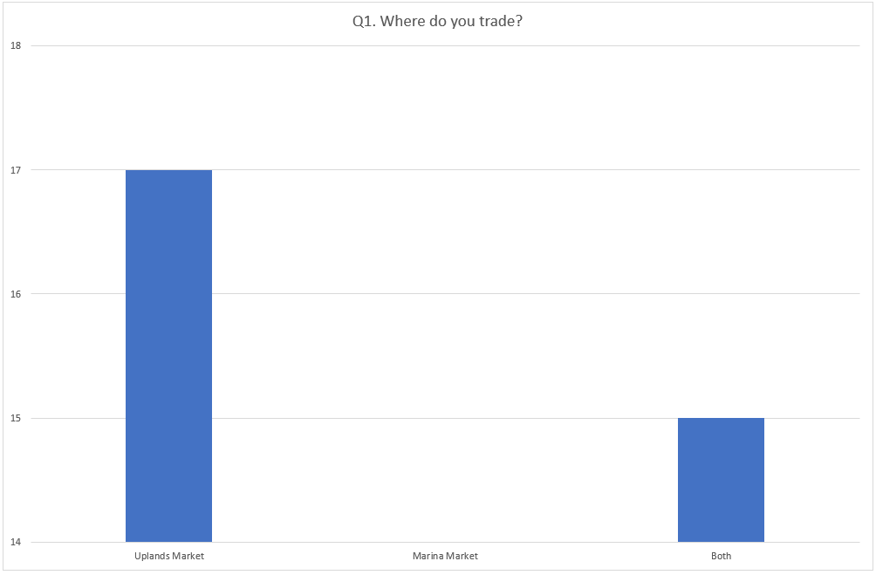
The data from question one allows the researcher to see whether the stallholder trades at one market or both. This is key information to collect as it shows whether the stallholders at both markets are as environmentally sustainable as each other or if one market uses more environmentally friendly material overall. As stated previously, no data was collected at Marina Market but it can be seen that at least 15 stallholders of the 32 questioned at Uplands Market also sell to Marina Market.
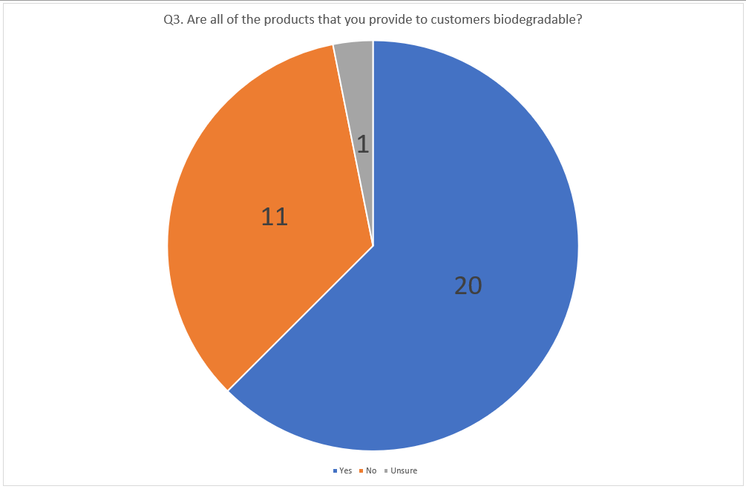
Question three is one of the most important questions which has been asked to stallholders as it shows which traders are more environmentally aware than others. It also allows further questions to be asked on the topic if the answer to question three is no. These questionnaires did not ask the name of the stalls as some stallholders may not want their names to be associated with some of answers. The potential issue for stallholders could have been if they did not use environmentally friendly products and did not want to start using them, this could make some customers not want to do trade with them if they believe in shopping more consciously.
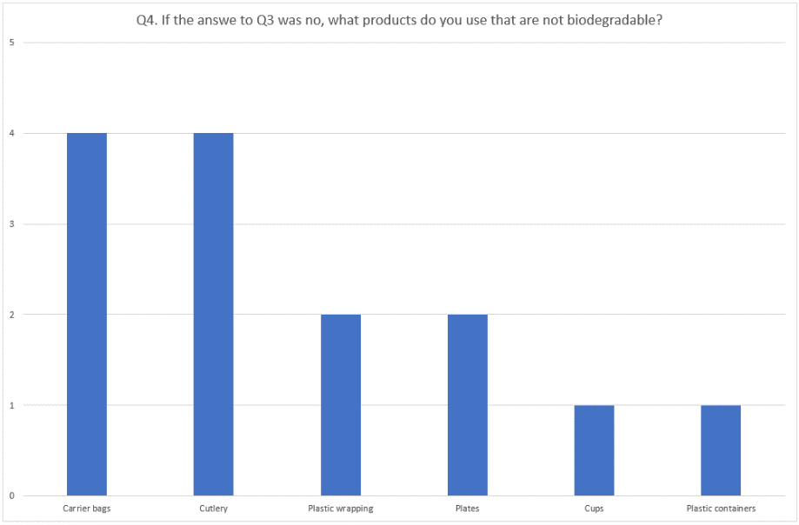

Question four allows the researcher to find out exactly which products need to be addressed within the research and is also a crucial question to ask when carrying out the data collection.

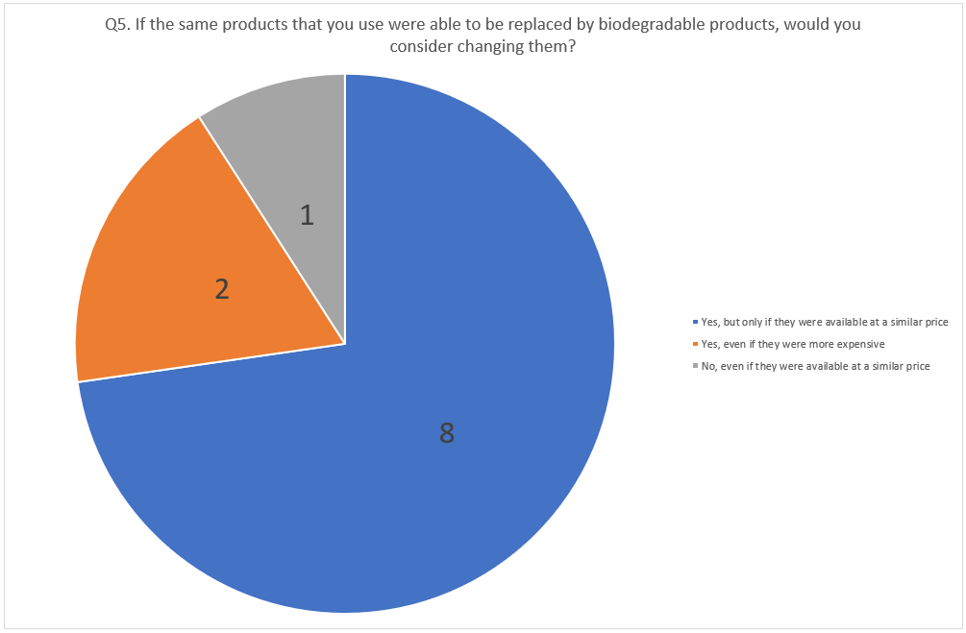
Question five enables the researcher to see whether the stallholders would be willing to change their products for ones that are more environmentally friendly and also whether the cost of doing that would be a factor in their decision.

Finally, question six gives an insight into how the stallholders think their customers perceive the importance of using environmentally friendly products.
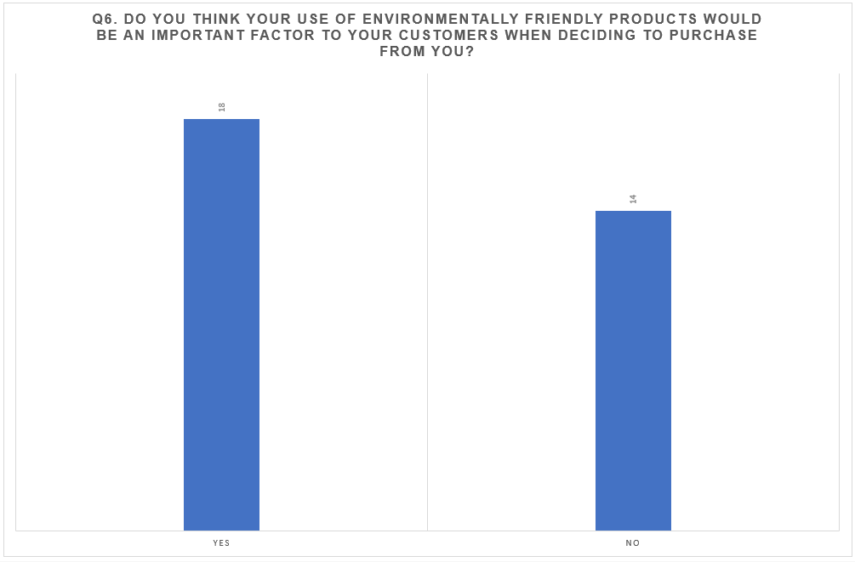

Discussion and analysis

By looking at the findings displayed, it enabled the consultant to find trends and patterns within the data that will help with the recommendations. The first discussion is regarding the results from question three which is displayed on page 7. Out of the 32 stallholders that completed the questionnaire, 20 participants stated that they already use biodegradable products within their stall. This could be due to the rising awareness surrounding the topic of plastic pollution and the environment. It could also be due to stallholders realising that their customer base is always looking for a more environmentally friendly way of shopping. With this assumption in mind, question six could be showing an opposing argument. Even though 18 stallholders believed that biodegradable products were important to their customers, 14 participants believed that it was not. That is a large number that don’t think their customers would particularly feel that they would benefit from a change in products, although that is only the belief of the actual stallholders and not the market attendees. As discussed in the recommendations, further surveys or questionnaires could be given to attendees at the market to see whether this information if accurate or to see if customers that attend the markets feel strongly about how environmentally friendly the products are that they are buying.
Question four allows the researcher to get more insight into the people who answered no to question four. It can be seen on page 7 that carrier bags and disposable cutlery are the non-biodegradable products which are used most by stallholders. This answer also shows that aside from carrier bags and cutlery, plastic wrapping, plates, cups and plastic containers have also been selected by the participants as items that they use which are not biodegradable. This information allows the researcher to find these products in alternative materials and give them as an option to the stallholders. In addition to these findings, question five allows further detail to be found regarding the non-biodegradable products. From the eleven people that answered no to question three, eight stated that they would be happy to use biodegradable products on the basis that the environmentally friendly products were available at a similar price to what they were currently paying, and two people would be happy to use the products even if they were more expensive. When compared to the results from question six, this shows a total of ten people that would be willing to change their products meaning they could either believe that the customers would benefit from the change, or that they think a change is important for their own personal views on plastic.

Conclusions

After analysing the gathered data, there are many different outcomes that could be taken from the results. One way to give conclusions to the data is by comparing them to the project’s objectives which was agreed prior to the research being carried out. This allows a focal point for the consultation and for the correct outcomes to be gathered.

- Evaluate the current use of biodegradable and non-biodegradable products by traders at Uplands and Marina Markets.

This has been carried out by asking the traders what products they use at their stalls which are biodegradable and finding out which materials were being used that are non-biodegradable. Although the questionnaire was not given out at Marina Market, the information gathered was still able to be used to see what products, if any, were being used that were non-biodegradable. The main conclusion regarding this objective is that plastic bags and cutlery are the biggest area of non-biodegradable products that are being used by the stallholders within the market. The most environmentally friendly products which the stallholders could use would be paper as it easily breaks down and biodegrades. On the other hand, it can be argued that paper products are still not completely sustainable as they contribute to deforestation. For the purpose of finding biodegradable products, paper is the best option that the stallholders could purchase as these are often the cheapest option too.

- Identify which materials could feasibly be changed for more environmentally friendly options

Again, by looking at the research, the products that were listed by traders would all be feasible to change to paper-based products. For example, plastic carrier bags could be changed to paper carrier bags, cups could be changed to paper cups and plates could also be changed to paper plates. The only product that could be more difficult to substitute would be the cutlery as there is no paper alternative. The closest thing available could be wooden cutlery which is more environmentally friendly that plastic as it is biodegradable, but it may work out slightly more expensive than some of the paper-based product changes.

- Recommend new biodegradable or recyclable options to traders

Research shows that one of the best options for biodegradable materials is bamboo as the bamboo tree grows four times quicker than any other tree and the products that are created are fully biodegradable and compostable. There are also alternative products which could be provided to customers at a cost such as reusable cutlery which would stop the amount of waste that was being generated, but for some of the customers, what they purchase at the markets will be consumer there so a more long term solution may not be suitable. The consultant has given some alternative products which the stallholders can use based on the information collected from the questionnaires.
The first product is the change from plastic to paper carrier bags which have been found and shown in appendix 2. These bags are 100% biodegradable and work out at 27p per bag which is a low cost to pay if it is for a stallholder who believed that providing biodegradable products is important to their customers. As of 2015, there has been a government charge of 5p per carrier bag given to customers purchasing goods. This means that stallholders could charge the customers who purchase from them 5p for a paper bag which could then go towards purchasing more bags if the cost between plastic and paper bags is higher. They could also provide tote bags of hessian or other recycled material which would allow customers to purchase a bag from the stallholder which would have their brand on them and would again stop the contribution of single-use products from the markets.
The second product which has been recommended is bamboo cutlery which has been shown in appendix 3. Again, these are biodegradable and compostable and work out at 13p per item. This item would potentially be the hardest to give a long-term solution to as once they have been used, they would need to be washed which is not viable for pop-up events. Although by using bamboo instead of plastic, it allows them to become environmentally friendly.
Biodegradable cups have also been sourced in appendix 4 which are available at 19p per cup and can be found, along with the other products on Amazon. Again, stallholders could potentially offer reusable cups or offer a discount if customers bring their own cups which would take away the need for disposable items.
Lastly, disposable plates have been sourced which are 20p each and are again made from bamboo which is arguably the most sustainable material for disposable products. These can be found in appendix 5. Alike the cutlery, it would be more difficult to offer a reusable option for plates and bowls as they would need to be washed once used which is not viable for the open markets.

Recommendations

By analysing the data collected, it enables the consultant to give recommendations based on the findings. One recommendation would be for the stallholders who do not already use biodegradable products to start using more environmentally friendly materials. This allows the markets to become more environmentally sustainable and allows the traders to be more aware of their customer’s growing need to shop more consciously. As previously mentioned, it could also be viable for stallholders to sell reusable items such as bags and cups which customers could purchase and be offered a discount when they reuse them at the stalls.
Another recommendation is for more research to be carried out regarding environmentally sustainable materials. This could include looking at what materials stallholders use to make their goods and not just the materials that are given to the customers. This would allow the local businesses that hold a stall at the markets to be more environmentally friendly which would mean they would be adding less non-biodegradable materials to landfill when they attend other events or when they are making their products. By gathering this information, it would also allow the organisation to see which stallholders are the most sustainable for future events.
More research could also be carried out by asking attendees of the market whether they think it is important for businesses to use more environmentally friendly products and packaging. This would allow the stallholders to see whether there is a need to change their packaging or not and whether that change would affect the amount of custom they receive. This could potentially be the best step for the organisation to take because by asking attendees of the markets how they perceive the importance of stallholders providing biodegradable products, it could allow stallholders to see if they would benefit from making changes to what the provide. It would also help to identify any changing patterns in consumerism amongst local events which could be compared to patterns nationwide to see if customers attending the markets are conscious.
Another recommendation could be for more research to be carried out with specific stallholders. If there are certain companies which produce more waste than other, then it may be in the benefit of Urban Foundry for them to investigate whether that waste they are producing is environmentally damaging or not. For some stallholders, they may have a minimum carbon footprint, especially if they are making recycled goods such as natural jewellery, but for stallholders who are producing items such as food, they would more than likely be using the most waste as customers will dispose of the cutlery and plates as soon as they have eaten the items which have been bought.

Appendices

Appendix 1
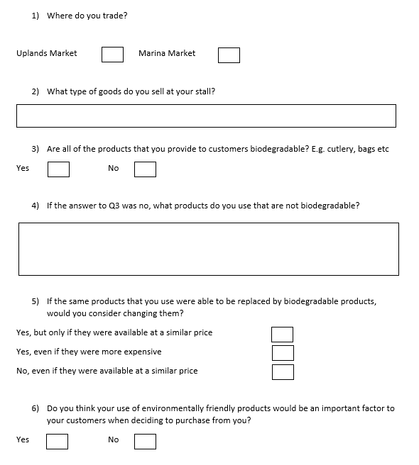

Appendix 2

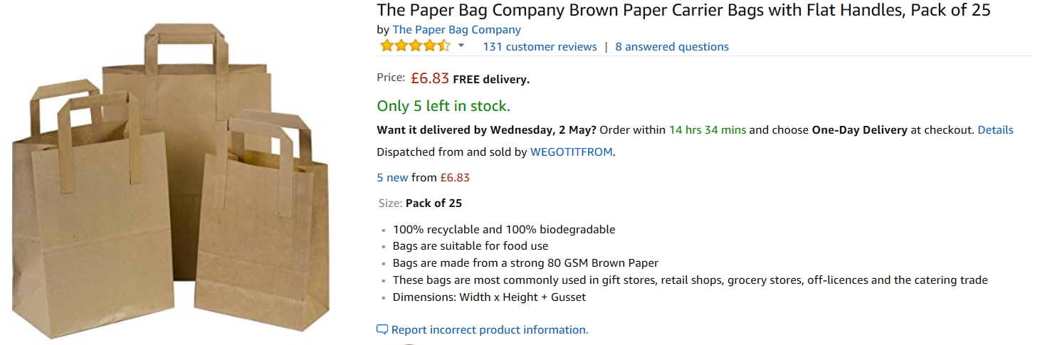
- Amazon (2018)(a) The Paper Bag Company. [Online} Available at: https://www.amazon.co.uk/Paper-Bag-Company-Carrier-Handles/dp/B06XDGDD9J [ Accessed on 29th April 2018]

Appendix 3

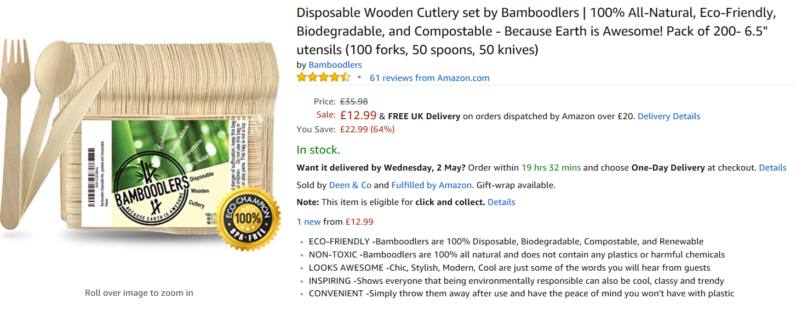
- Amazon (2018)(b) Bamboodlers. [Online] Available at: https://www.amazon.co.uk/Bamboodlers-All-Natural-Eco-Friendly-Biodegradable-Compostable/dp/B06XDY3RXL/ref=sr_1_9?s=kitchen&ie=UTF8&qid=1525127186&sr=1-9&keywords=wooden+cutlery [Accessed on 29th April 2018]

Appendix 4

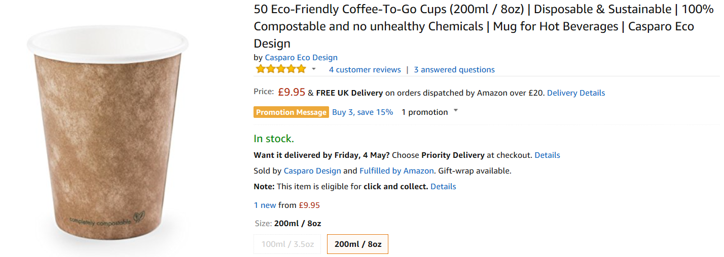

- Amazon (2018)(c) Casparo Eco Design. [Online] Available at: https://www.amazon.co.uk/Eco-Friendly-Sustainable-Casparo-Eco-Design/dp/B01M6Y7J0O/ref=sr_1_1?s=kitchen&ie=UTF8&qid=1525127420&sr=1-1&keywords=biodegradable+single+use+cups [Accessed on 29th April 2018]

Appendix 5

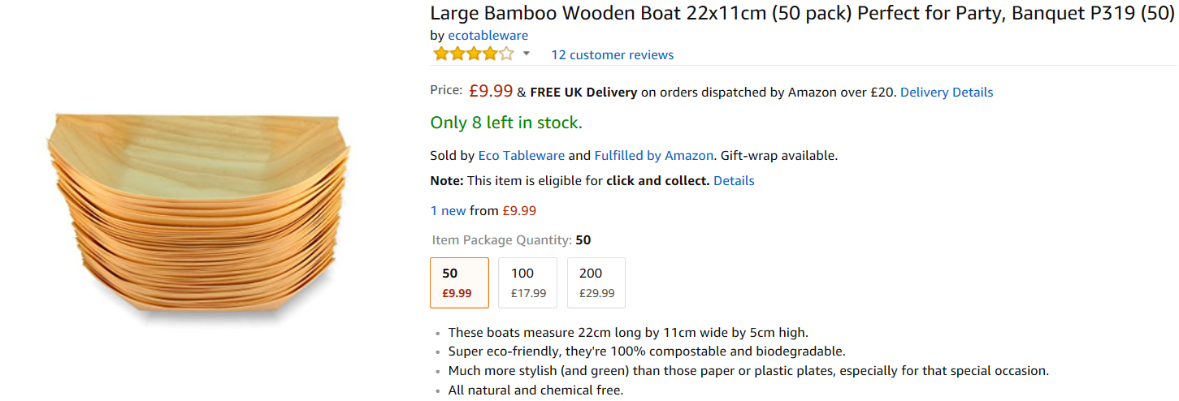

- Amazon (2018)(d) Eco Tableware. [Online] Available at: https://www.amazon.co.uk/Bamboo-Wooden-22x11cm-Perfect-Banquet/dp/B01MS5EDF2/ref=sr_1_2?s=kitchen&ie=UTF8&qid=1525127324&sr=1-2&keywords=biodegradable+paper+plates [ Accessed on 29th April 2018]

Bibliography

- Amazon (2018)(a) The Paper Bag Company. [Online} Available at: https://www.amazon.co.uk/Paper-Bag-Company-Carrier-Handles/dp/B06XDGDD9J [ Accessed on 29th April 2018]
- Amazon (2018)(b) Bamboodlers. [Online] Available at: https://www.amazon.co.uk/Bamboodlers-All-Natural-Eco-Friendly-Biodegradable-Compostable/dp/B06XDY3RXL/ref=sr_1_9?s=kitchen&ie=UTF8&qid=1525127186&sr=1-9&keywords=wooden+cutlery [Accessed on 29th April 2018]
- Amazon (2018)(c) Casparo Eco Design. [Online] Available at: https://www.amazon.co.uk/Eco-Friendly-Sustainable-Casparo-Eco-Design/dp/B01M6Y7J0O/ref=sr_1_1?s=kitchen&ie=UTF8&qid=1525127420&sr=1-1&keywords=biodegradable+single+use+cups [Accessed on 29th April 2018]
- Amazon (2018)(d) Eco Tableware. [Online] Available at: https://www.amazon.co.uk/Bamboo-Wooden-22x11cm-Perfect-Banquet/dp/B01MS5EDF2/ref=sr_1_2?s=kitchen&ie=UTF8&qid=1525127324&sr=1-2&keywords=biodegradable+paper+plates [ Accessed on 29th April 2018]
- Livestrong (2018) The Advantages of Biodegradable Products. [Online] Available at: https://www.livestrong.com/article/158244-types-of-biodegradable-products/ [Accessed on 12th March 2018]
- Surfers Against Sewage (2018) Plastic Pollution Figures and Stats. [Online] Available at: https://www.sas.org.uk/our-work/plastic-pollution/plastic-pollution-facts-figures/ [Accessed on 12th March 2018]

