Male victims of Domestic Abuse: Has society’s perceptions had an impact on the reporting of domestic abuse

Nick MILLER
1910667

BSc (Hons) Professional Policing Practice
Word Count: 8,800

Acknowledgements

First and foremost, I'd want to thank my dissertation tutor, Dr Rhiannon Sandy, for all her help and support throughout this process.
In addition, I would like to thank all of the university staff and police staff from my time at training who have helped me throughout this process. I would also like to thank my colleagues who have been very supportive and a great sounding board when I have needed them.
Finally, I would like to give my sincere thanks to my wife Sarah, for all her love, support and patience, and for looking after our beautiful girls and taking care of everything whilst I have been busy studying and finishing all of my academic work. You and the girls have been my motivation and I hope all this hard work will eventually pay off for us.

Declaration

This work has not previously been accepted in substance for any degree and is not being concurrently submitted in candidature for any degree.
Signed: 1910667. Date: 23/06/2022

STATEMENT 1
This dissertation is being submitted in partial fulfilment of the requirements for the degree of BA.
Signed: 1910667. Date: 23/06/2022

STATEMENT 2
This dissertation is the result of my own independent work/investigation, except where otherwise stated.
Other sources are acknowledged by footnotes giving explicit references. A bibliography is appended.
Signed: 1910667. Date: 23/06/2022

STATEMENT 3
I hereby give consent for my dissertation, if accepted, to be available for photocopying and for interlibrary loan, and for the title and summary to be made available to outside organisations.
Signed: 1910667. Date: 23/06/2022

STATEMENT 4
I hereby give consent for my dissertation, if accepted, to be available on the university’s IT system to those who have consent to use the system.
Signed: 1910667. Date: 23/06/2022

Abstract

Despite a great deal of academic literature surrounding domestic abuse in general, it is fair to suggest that the majority of research focuses mainly on male perpetrated domestic abuse and ‘the female victim’. There is little research or academic literature on male victims of domestic abuse.
The aim of this dissertation was to explore society’s perceptions on male victims of domestic abuse, as well as the potential barriers which prevent male victims of domestic abuse from reporting or speaking out. The researcher also investigated how male victims are treated by police officers and what support services are available to them.
The researcher carried out an in-depth critical analysis of relevant and existing academic literature surrounding the topic of male victims of domestic abuse. The researcher then conducted their own primary research in the form of questionnaires to gather quantitative data, which was then compared to the secondary data to see if any themes emerged.
The finding from this project were then documented, and as a result, recommendations were made to assist in raising awareness and to improve support services for male victims of domestic abuse. It is hoped that these recommendations may help to destigmatise society’s perceptions and improve reporting.

Contents Table
Acknowledgements 2
Declaration 3
Abstract 4
1. Chapter One: Introduction 7
1.2 Background / Literature Review 7
2. Chapter Two: Literature Review 9
2.1 Background 9
2.1.2 History 9
2.2 Aims of Research 9
2.3 How the research findings can lead to the actual dissertation question 10
2.4 Discussion 10
2.4.1 Are society’s perceptions and stigmas having an impact on males reporting domestic abuse? 10
2.4.2 Is there a lack of empathy and awareness from Police in relation to male victims of Domestic Abuse? 12
2.4.3 Are there enough support services available for Male victims of Domestic Abuse? 13
2.4 Conclusion 14
3. Chapter Three: Methodology 16
3.1 Introduction 16
3.2 Research Onion 16
3.3 Research Philosophy 17
3.4 Research Approach 18
3.5 Ethical Considerations 19
3.6 Research Strategy and Choice 19
3.7 Time Horizon 20
3.8 Techniques: Data Collection and Analysis 20
3.9 Sample 20
3.9.1 Reliability and Validity 21
3.9.2 Limitations 21
3.9.3 Conclusion 21
4. Chapter Four: Analysis of Results 22
4.1 Introduction 22
4.2 Data Analysis 22
4.3 Advantages of Using Microsoft Forms 22
4.4 Disadvantages of Using Microsoft Forms 22
4.5 Questionnaire Findings 23
4.5.1 Are Society’s perceptions and stigmas having an impact on males reporting Domestic Abuse? 23
4.5.2 Is there a lack of empathy and awareness from Police in relation to male victims of Domestic Abuse? 24
4.5.3 Is there enough support services available to male victims of Domestic Abuse? 24
4.6 Conclusion 25
5. Findings and Conclusion 26
5.1 Introduction 26
5.2 The achievement of objectives 26
5.3 Main Findings 27
5.4 Recommendations / Further Research 27
5.4.1 Recommendation One: Having more awareness campaigns. 28
5.4.2 Recommendation Two: Education programmes for young children. 28
5.4.3 Recommendation Three: Implement regular Domestic Abuse training programmes for Police Officers. 28
5.4.4 Recommendation Four: Greater funding from Government for support services exclusively for male victims of Domestic Abuse. 28
5.5 Limitations 29
5.6 Conclusion 29
5.7 Self-Reflection 30
6. Bibliography 31
7. Appendices 38
7.1 Appendix One: Questionnaire 38
7.2 Appendix Two: Questionnaire Results 44
7.3 Appendix Three: Dissertation Proposal 51
7.4 Appendix Four: Ethics Form 56
Outline any anticipated risks that may adversely affect any of the participants, the researchers and/or the University, and the steps that will be taken to address them. 65
Full risk assessment completed and appended? 65
Yes 65
☐ 65
No 65
☒ 65

Chapter One: Introduction

This dissertation will look at the difficulties that affect male victims of domestic abuse. It will discuss the potential reasons for the lack of reporting by male victims and explore whether society has created a social injustice through the stigmas attached to male victims of domestic abuse.
Research suggests that services available to victims of domestic abuse are lop-sided towards female victims. The purpose of this research is to determine whether male victims feel that they are being treated fairly by police and third-party organisations, and whether there is enough publicity and support around the issue.
This subject was chosen by the researcher as it is something that they have had first-hand experience of. It is an important subject and one in which they believe more awareness is needed in identifying and supporting male victims. Domestic abuse is not gender specific and does not discriminate, it affects all persons, regardless of age or gender.
Furthermore, domestic abuse is a significant component of everyday policing. It would be extremely beneficial for serving police officers to be able to recognise victims of domestic abuse and guide them in the correct path for after-care support. It is intended that by doing so, early intervention would be implemented, providing greater protection for male victims whilst encouraging them and others to seek help.

1.2 Background / Literature Review
Unfortunately, Domestic violence is not a new phenomenon. Domestic violence refers to a wide range of acts of violence and abuse which is committed by one family member against another (Shipway, 2004). In the early 1900’s, domestic violence was considered a private matter, and discussing it in public was not deemed acceptable or a social concern (Kronenberg, 2013).
Back then, patriarchal societies existed, and it was considered normal and reasonable for women to be subordinate family members while males were dominant and in control. As a result, males often used violent acts and behaviours as a means to keep the family in line (Kennedy, 2011). Even more distressing is the fact that laws up until the 1970’s frequently disregarded, or even condoned, this type of violence.
Domestic violence established a categorisation and societal construction that victims of domestic abuse are exclusively female (Tsui, 2014) and therefore an ideal victim. Ideal crime victims are considered to be weak, innocent, and faultless personalities who are empowered by someone physically stronger than them (Strobl, 2010; Tsui, 2014). As a result, whereas female victims of domestic violence already struggle to acquire victim status, the stigma surrounding domestic abuse makes male victims suffer much more (Tsui, 2014).
During the 1970’s, feminist movements such as the Woman’s Liberation Movement (WLM) achieved substantial accomplishments and helped change the social landscape, including the equality and the personal dynamics between men and women. The movement was one of the first to address previously unseen crimes such as ‘battered wives’ as a serious issue. It saw the arrival of safe houses and refuges, opened by women-centred charities such as Rape Crisis and Woman’s Aid. These charities helped women who were suffering from abuse and violence in an intimate relationship as they had no help or protection (Harne and Radford, 2008).
Since the feminism movements in the 1970’s, domestic abuse has been increasingly recognised as a serious social problem. The Police and local authorities across the world made it a priority in an attempt to eradicate it. (Mooney, 2000). Domestic violence does not discriminate, it happens across all cultures and age groups (Flink et al, 2008), it is a problem that spans borders and countries; it is a global concern.
The public pressure generated by these women’s rights protests prompted the UK to pass its very first piece of domestic violence legislation, the Domestic Violence and Matrimonial Proceedings Act 1976, which established civil protection orders for victims (Bradley, 1978).
The pressure has grown and grown over the years which has prompted the UK government to pass laws which offer better protection for victims of domestic violence. The Home Office definition of domestic violence changed in 2012 to include 16 and 17 year-olds and the phrasing altered to comprise coercive control (Home office, 2013). The Government definition of domestic violence and abuse is:
‘Any incident or pattern of incidents of controlling, coercive or threatening behaviour, violence or abuse between those aged 16 or over who are or have been intimate partners or family members regardless of gender or sexuality. This can encompass, but is not limited to, the following types of abuse: psychological, physical, sexual, financial, and emotional’ (Home Office, 2013).
Despite new laws being introduced and domestic violence now being viewed as unacceptable it is still a common occurrence in practically every society. Today, it is estimated by the Crime Survey for England and Wales that in the year ending March 2020, approximately 5.5 percent of adults aged 16 to 74 years (2.3 million) experienced domestic abuse in the previous year (ONS, 2020). On average police receive an emergency call in relation to domestic abuse every 30 seconds (HMIC, 2014).
However, in South Wales it is even more prevalent. According to Alun Michael, South Wales Police Crime Commissioner, South Wales Police receive a call relating to Domestic Violence every 15 minutes. This figure equates to 93 calls every day and accounts for a third of all crime recorded (Lewis, 2019).
In reality, these statistics show that a police officer is likely to respond to a domestic call numerous times throughout their shift. As a result, it is critical that police recognise DV victims so that they may intervene and provide them assistance and support, as well as referring them to the appropriate support agencies.

2. Chapter Two: Literature Review

2.1 Background

2.1.2 History
As previously mentioned, domestic violence is not a new phenomenon. It has deep historical origins which was born from societal inequity between men and women (Hague and Malos 1998). Historically, violence within a relationship was seen as a natural aspect of a marriage, something that women should anticipate and suffer while married (Erez, 2002). Until the 1900’s, there were no laws against domestic violence and most legal systems viewed wife beating as a permissible use of a husband's authority over his wife (Kennedy, 2011). Domestic abuse was only recognised as a crime during the 1970s, justifying intervention by the criminal justice system (Erez, 2002).
Since the 1970’s, domestic abuse has been increasingly recognised as a serious social problem. As a result, Police and local authorities have made more of a conscious effort in trying to eradicate domestic abuse from our society. (Mooney 2000). Domestic abuse reporting has improved over-time, but the phenomenon is still commonly understood from the perspective of male to female violence. This is supported by a large body of research and policy focusing on female victims of domestic violence (Josolyn, 2011). However, evidence suggests that a sizeable number of men are victims of female-inflicted violence but do not report it due to a number reasons (Machado et al, 2017). This dissertation will explore some of the theories suggested that contribute to the lack of reporting.

2.2 Aims of Research
In today’s society, domestic violence against men is frequently overlooked (Moss, 2014). Issues such as service provisions, attitudes and treatment by the police, third parties, and the general public all have the potential to create barriers for male victims to come forward and receive the assistance they require. The aim of this literature review is to look at the different themes which were discovered within the existing literature already published. The first of which is; has society’s perceptions had an impact on males reporting domestic violence? The following section will discuss whether there is a lack of empathy and awareness from police surrounding male victims of domestic abuse. The third section will focus on the number of support services available to male victims of domestic abuse.

2.3 How the research findings can lead to the actual dissertation question
This study is being carried out to investigate the possible reasons why male victims of domestic violence do not disclose domestic incidents to the police. Domestic violence is significantly underreported by both genders, however for male victims it is more so (Walby & Allen, 2004). It is a tough crime to identify since it frequently occurs behind closed doors, and no one knows what is going on until the victim speaks up. Domestic violence is not gender specific or discriminatory; it affects all people, regardless of age or gender (Buttell & Carney, 2014). It is intended that through investigating this topic, recommendations may be made to not only protect male victims of domestic abuse, but also to encourage male victims of domestic abuse to speak out. With better awareness and support from police and third-party agencies it is hoped that more male victims will have the confidence to report abuse to police.

2.4 Discussion

2.4.1 Are society’s perceptions and stigmas having an impact on males reporting domestic abuse?
Historically, within a relationship, men were expected to dominate women. Males would often use violent acts and behaviours as a means of keeping their families and wives in line (Dobash and Dobash, 1979). For this reason, it is argued that society has mocked and humiliated males thought to have been ‘battered’ and/or dominated by their wives (Steinmetz, 1977). It is these types of stigmas which can hinder male victims of domestic abuse from reporting the abuse since they are viewed as the ‘stronger sex’ and, as such should be able to fight back against their abuser (Domesticshelters.org, 2015).
According to numerous studies, another reason for the lack of reporting by male victims of domestic abuse is that males are concerned that they will not be believed and will instead be treated as the perpetrator themselves (Barkhuizen, 2015; Douglas et al, 2012; Hines & Douglas, 2009, Shuler, 2010; Tsui 2014, Tsui, Chung & Leung, 2010). Swan and Snow (2006), highlight the concern that many females accused of perpetrating domestic abuse frequently utilise the idea of self-defence as an explanation or to provide legitimacy for their actions.
Grady (2002) also contends that when it is agreed that the female perpetrator has been violent, justifications such as self-defence are frequently utilised as a falsehood and an excuse to claim that the female perpetrator is truly the victim. This can have serious consequences for the male victim because the female offenders' violent outbursts are simply excused and characterised as victim behaviours of attempting to defend themselves, which means they are allowed off the hook. This reinforces the present cultural stereotype that domestic abuse is solely committed by men.
Tsui (2010) states that men who have been assaulted by their partners do not wish to disclose the violence to police as they wish to avoid other practical implications, such as losing contact with their children, losing their job or not having an alternative place to stay. As a consequence, male victims tend to ‘suffer in silence’ and put up with the abuse to maintain their lifestyle. Victims want the abuse to stop but not the relationship. A prime example of this is Alex SKEEL, who was abused by his partner Jordan Worth. Worth was the first female in Briton to be arrested for coercive and controlling behaviour (Hicks, 2019).
According to Dempsey (2013), the lack of reporting by male victims of domestic abuse is attributed to males not being as good as females in recognising domestic abuse. He states that women are more likely to report domestic abuse, whilst males tend to trivialise the abuse experienced, with a greater reluctance to inform others.
Domestic abuse is not just physical, it can come in many forms (Victim Support, 2021). Domestic abuse also includes, controlling or coercive behaviour (which can include, psychological and/or emotional abuse), sexual abuse, financial or economic abuse, harassment and stalking. The stereotypes and stigmas surrounding the idea that only men can be perpetrators are absurd. Domestic abuse isn’t just about being the ‘stronger sex’. Domestic abuse is wide-ranging and females are just as likely as males to be perpetrators (Buttell and Carney, 2014). It is not a gender issue, nor is it a matter of physical strength; rather, it is a matter of power (Elliot, 1996). Despite the fact that females in most cases may not be as physically powerful as men, they are capable of becoming perpetrators and quite capable of controlling and harming their victims (George & Yarwood, 2004).
According to research conducted by Migliaccio (2001), male victims of domestic abuse do not disclose the abuse to others because it makes them feel humiliated and makes them feel less of a man. Being a male victim of domestic abuse carries with it the stigmas of weakness, shame, and embarrassment (Tsui, 2014). A survey conducted by Mankind.org (2020), found that 49 percent of male victims did not tell anyone that they are a victim of domestic abuse. Compared to female victims, males are two and a half times less likely to tell anyone.

McCarrick (2016), states that because of the ingrained societal sense of shame and emasculation, men find it increasingly difficult to talk about their personal experiences of domestic abuse. She came to the conclusion that society needs to do more to understand the emotional experiences of male victims in order to create a gender balanced view of domestic abuse.

2.4.2 Is there a lack of empathy and awareness from Police in relation to male victims of Domestic Abuse?
This part of the literature review will explore how police officers have been perceived when responding to domestic incidences. Davies (1998) states that the conventional policing response to a domestic abuse incident was to avoid intervening and not arresting the perpetrator, based on the premise that even if the perpetrator is apprehended, the chances of them being punished are slim.
According to Channel 4’s Dispatches (1998) programme, a poll conducted called ‘Battered men’ found that 49 percent of men never contacted police for help because they believed the police would be unsympathetic and would not believe them, simply because they are men. Other findings from the same study included the fact that 25 percent of males who contacted police for assistance were in fact arrested themselves. Another conclusion was that when no arrests were made but positive action was implemented, it was mostly males who were removed from the address, even if they were clear victims. This study was conducted 24 years ago, at that time it highlighted some of the issues that male victims of domestic abuse faced but there has not been a more recent study to further explore what issues male victims of domestic abuse face today. This highlights the gap in the current literature review.
A study by Stets and Straus (1992) states that women are 10 times more likely to call the police in relation to a Domestic incident. Whether females are victims or not, it is more likely to be the males who are arrested first, in line with police procedures such as ‘taking positive actions’ (College of Policing, 2018). According to Stitt & Macklin (1995), it is these arrest methods that contribute to the stigmas associated with male victims, who are often not believed.
McCarrick (2016) discovered that male victims of Domestic abuse are routinely detained on false claims, and their admissions of victimisation are ignored by the police and criminal justice system. McCarrick observed, through interviews with male victims of Domestic abuse, that males are frequently removed or arrested despite being the one who made the initial contact to the police.

The inferences made by society organisations such as the police contribute to the stigmatisation of male victims, which ultimately impacts on trust and legitimacy. (Bell, 2015). Failure to challenge inequality in policy and practice may have the unintended consequence of preventing the issue of relationship violence from being addressed adequately.

Is unconscious bias having an impact on how Domestic abuse is investigated? Unconscious bias has been characterised as the process by which a person makes sense of their surroundings by creating assumptions and connections about people's traits without being consciously aware of this process (Jones and Cornish, 2013). Such 'mental shortcuts' may be a role in the persistence of prejudice in organisations.
According to Jones and Cornish’s research, approximately 40 percent of people demonstrate unconscious bias against certain genders or ethnicities. This demonstrates that, in order to ensure equal opportunity in our organisations and society, we must make conscious efforts to eliminate unconscious bias.
According to an article by the Mail Online, campaigners say that police are more likely to believe female victims of psychological abuse because of their unconscious bias against men. It was documented that between December 2015 and March 2017, there were 4,246 allegations made of coercive control. Out of those 4,246 cases, a total of 272 individuals were charged for this offence, with only four individuals being female (Mail Online, 2018).
The overall police response to domestic abuse victims is not good enough. This is despite considerable improvements made over recent years. Despite new legislation in 2015 which made coercive and controlling behaviour an offence (Home Office, 2015), many officers are still not dealing with domestic incidences appropriately. There are too many discrepancies, and this has been highlighted in the HMIC 2014 report, Everyone’s business; improving the police response to domestic abuse (HMIC, 2014).
This report highlighted those improvements were drastically needed from police forces and officers when responding to domestic incidences. As a result of this report, the College of Policing and domestic abuse charity, SafeLives collaborated to develop a training package called ‘Domestic Abuse Matters’. This package was created with the intention of having a long-term impact by challenging police attitudes, cultures, and behaviour while responding to domestic abuse calls. It was thought that by gaining a better knowledge of coercive and controlling behaviour, improvements would be more consistent and long-lasting (SafeLives, 2015).
This report found that only 21 percent of officers were confident in dealing with domestic incidences before having the training compared to 95 percent of officers who felt extremely confident after having had the training. The training programme had a positive impact on better empathy and understanding, leading to a 41 percent increase in arrests (SafeLives, 2015).

2.4.3 Are there enough support services available for Male victims of Domestic Abuse?
From research conducted for this study, it has been found that there is very little help for male victims of domestic abuse compared to females. This was evident in the lack of studies and websites dedicated to male victims of domestic abuse. The majority of websites and studies conducted depicted males as being the perpetrators.

In addition to the stigmas and barriers faced by male victims of domestic abuse, there is a widespread issue of little or no service provisions in many locations (Huntley et al, 2019) with a disproportionate amount of refuge beds available mostly for women throughout England and Wales.
Fogg (2008) noted that there was a complete lack of support services available for male victims. He stated that, despite the absence of support and shelter places for male victims, he recognised that there was an abundance of support programmes available for men seeking to address their aggressive behaviour. Fogg also discovered that there was no service comparable to this for female abusers. This research indicates that stigmas still exist to this day and that males are being let down by support services and as a consequence they feel that they have to ‘suffer in silence’ and have felt abandoned, let down and alone after reporting domestic violence.
According to Mankind.org (2020), there are 39 domestic abuse organisations with a total of 238 spaces or safe houses. Out of those 238 spaces, only 58 are dedicated to men. That equates to just 25 percent of the overall spaces available. These findings lend support to the theory that male victims of domestic abuse are underserved because support is biased in favour of female victims. There needs to be more support services dedicated to male victims of domestic abuse if confidence, awareness, and reporting are to improve.

As stated, support services for domestic abuse victims are predominantly geared towards females. A very small portion of these services do offer support to male victims, however this is not widely known or advertised. Even the introduction of Clare’s Law in 2014 has caused confusion amongst victims of domestic abuse. The name itself automatically suggests that the disclosure scheme can only be used by females, which is not the case.

A report by Strickland (2013) even highlighted that legal paperwork which was put forward to the government, to help pass the law was heavily biased towards female victims of domestic abuse. The language used only referred to female victims, with no mention or consideration that males could be victims of domestic abuse. This would strengthen the view that there is a clear bias towards females.
Josolyn (2011), states that the service requirements of female victims and male victims are vastly different. As a result, it is believed that therapy programmes for male victims should be designed so that they are tailored to fit their individual needs. Bates (2017) argues that current domestic abuse services are not working inclusively and that this is stopping male victims from seeking help. Furthermore, it is clear that the majority of domestic violence victims would feel more comfortable approaching services if they were gender specific (Hester et al., 2012).

2.4 Conclusion
Due to decades of stereotyping, domestic violence has generally been perceived through a biased perspective, implying that only males perpetrate violence against women. However, evidence indicates that males can also be subjected to detrimental mistreatment by their female partners. The present collection of research data on male victims of domestic abuse demonstrates how male victimisation is generally underestimated and ignored.

Because of the gendered character of violence in society, it is difficult for males to recognise their violent relationships, but it is also difficult for society to perceive male survivors of domestic abuse. Ideas about Masculinity and conventional gender roles frequently cause men to feel guilty and scared of being judged by others for the violence they see, and many men are re-victimized when they share their stories with formal sources of support.

Male survivors also encounter several challenges to seeking help and disclosing their experiences with formal agencies due to stereotypes that men cannot be victims of domestic abuse, which often leads to dismissive or re-victimisation behaviours. This makes males more hesitant to seek help in the future, and it gives female perpetrators more opportunities to further isolate men through administrative abuse.

Overall, the research reviewed suggests that men feel their options of help and support are limited. This is due to the lack of services specifically for them, with the perception that support services are solely for female victims of domestic abuse. The ramifications of not seeking help means that male victims are silent about their partner’s violence and chose not to seek help, putting them at risk of harm and long-term mental health effects.

3. Chapter Three: Methodology

3.1 Introduction
The previous chapter of this dissertation looked at the existing literature surrounding male victims of domestic violence. This chapter will explain to the reader how the study will be carried out. This is referred to as the Methodology. A methodology is a collection of systems, techniques, processes, or principles that are used to carry out a systematic research process for a dissertation. The goal is to provide a unique and important result that will add to the field of study. Research is essential for learning and comprehension. It is the process of increasing awareness and knowledge surrounding a particular subject (Saunders et al., 2016). It helps in identifying areas of strength as well as areas of weakness.
There are two types of research: primary and secondary. Primary research is data which has been directly collected by the researcher from individuals, rather than relying on pre-existing data which has been collected from previous studies. This is otherwise known as secondary research (Bryman, 2016).
According to the literature review, there is a noticeable lack of contemporary academic research and studies on the reasons why male victims of domestic abuse under-report the issue. As a result, this study will opt to undertake primary research in order to answer the questions. Conducting this type of research will help to bridge the gap in the existing literature, whilst facilitating a better understanding of society’s perceptions today. It is intended that by gaining a greater understanding from those who participate in this research, improvements may be identified and implemented to increase awareness, confidence, and support services for male victims of domestic violence.

3.2 Research Onion
The research onion was developed by Saunders et al. (2016) to describe the different stages through which a researcher must pass when developing an effective methodology. It will serve as a guide throughout the process as each layer, when viewed from the outside, describes a more thorough level of the research process.
It provides the researcher with an effective process for developing a research approach, ensuring its reliability and validity. This method of research is widely used as it is flexible and can be applied to a wide range of circumstances (Bryman 2012). This dissertation will investigate and describe the many stages of the research onion, as well as clarify the principles at each level.

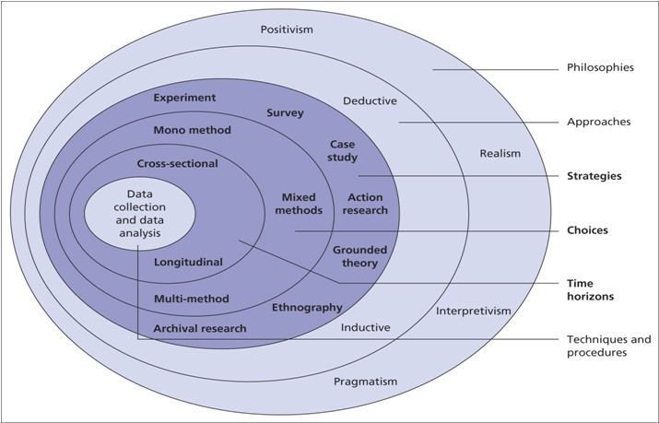
Fig 3. Diagram of Research Onion (Saunders et al, 2009)

3.3 Research Philosophy
There are three different Philosophies that hold significance when planning and carrying out research. These are Ontology, Epistemology and Axiology. For this study, the researcher will use the epistemology philosophy. Epistemology is the theory of knowledge. It is concerned with the minds relation to reality.
Each philosophy is made up of philosophical instances. It is these philosophies that provide structure and guidance while carrying out research. The philosophical approach for this study will be ‘Interpretivism’. However, ‘Interpretivism’ is closely linked to ‘Realism’ and ‘Positivism’ as they can all fall under the Epistemology philosophy. ‘Interpretivism’ allows individuals to understand how they and others think and behave. According to Bryman (2016), using the interpretive approach can help in gaining a better understanding of a culture and provide explanations as to why things happen.

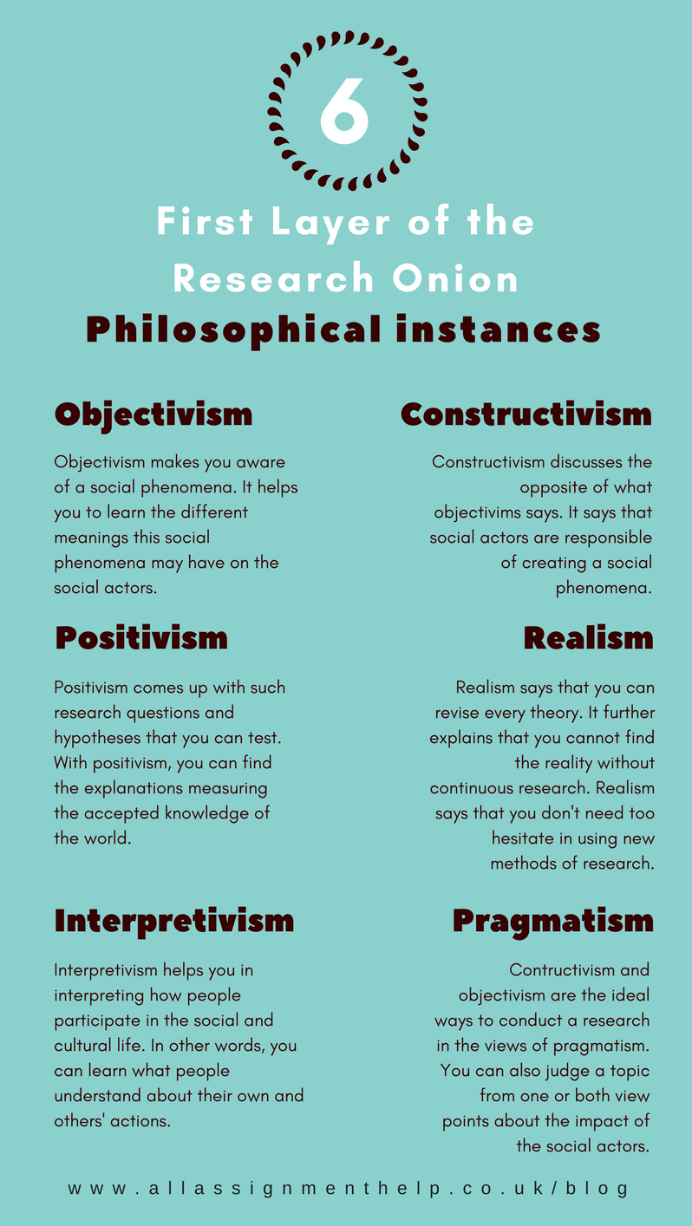
Fig 4. First layer of the Research Onion (Saunders et al, 2009)

3.4 Research Approach
According to Saunders et al. (2016), two types of research approaches are commonly used in academic writing: the Deductive method and Inductive method. A deductive method goes from theories to data, whereas an inductive method goes from data to theory. To put it simply, a deductive process begins with a theory and proceeds to acquire data or evidence that may prove or disprove that theory. An inductive approach is one in which a researcher examines the outcome or action and sets out to collect data to account for the potential reasons as to why a phenomenon exists.
This research uses the ‘Deductive’ approach with the aim of collecting data to help prove or disprove the many theories that have already been identified in earlier chapters of this dissertation (surrounding the issues male victims face when attempting to report abuse).
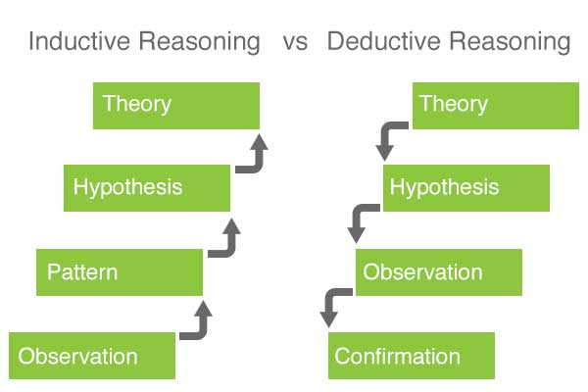
Fig 5. Inductive and Deductive Approaches (Elmansy, 2016)

3.5 Ethical Considerations
This study will not include any victims of domestic violence due to the delicate nature of this subject matter. Participation is entirely voluntary, and all participants will be fully informed of the nature of the study and will have the right to withdraw at any time. All information submitted will be anonymised, with all personal data eliminated, ensuring that no personal information will be collected or retained, guaranteeing that no persons or places will be recognised.

3.6 Research Strategy and Choice
The researchers chosen strategy is to create a questionnaire using Outlook Microsoft Forms which will then be available online via hyperlinks and social media websites. This approach acknowledges that this is a sensitive subject and participants may be put off if it was conducted face to face (Lelkes et al., 2011). By doing it this way, total anonymity will hopefully encourage individuals to participate who may normally be put off.
Furthermore, this method is the most straightforward and efficient way to conduct a survey. It is cost effective and due to the volume of quantitative data required; this method is the easiest way to ensure that there are enough participants. By achieving high participant numbers, enough quantitative data will be gathered to determine the outcome, and the reliability and validity of this research will be strengthened.
The only disadvantage envisaged will be that the results from the questionnaire will take a lot of time and energy to gather and analyse the quantitative data found.

3.7 Time Horizon
Two different types of time horizons: Longitudinal and Cross sectional. A Longitude study is a method that allows you to analyse and compare behaviours and events over a longer period. A Cross-sectional study design is a type of observational study which allows the researcher to analyse data from participants from a specific point in time, such as surveys/questionnaires (Setia, 2016).
For this research project, the cross-sectional method will be used as this method is the most efficient model when conducting population-based surveys (Mann, 2003). This method is also the most appropriate as the research is over a short period of time.

3.8 Techniques: Data Collection and Analysis
Due to several factors, such as, the nature of the subject, COVID restrictions, and sheer volume of anticipated participants, the survey will be conducted online by utilising Google forms. This will be disseminated to willing participants who can complete in their own time and return.
In order to collate enough data, the researcher will complete between 50 and 100 surveys. The quantitative data will then be analysed and displayed into various graphs and charts show the findings and to see if any patterns or recommendations can be identified.

3.9 Sample
A sample is a small section of a larger population (Bryman, 2016). When carrying out research, it is necessary to sample a small section of the population, as the general population would be too large to allow for comparison (Ghauri et al, 2020).
However, sample sizes of less than 25 tend to produce results that are distorted by individual respondents. In such cases, the larger the sample size, the more reliable the findings will be (Flick, 2011). This is especially true for quantitative research.
Quantitative research requires a higher volume of participants to determine the reliability of the study’s findings. The sample characteristics are also important in qualitative research, but much smaller samples are typically used, as it is more personal and less reliant on volume data from many sources.
The researcher aims to target between 50-100 respondents consisting of police officers and members of the general public. This will provide the researcher with the opportunity to observe individual’s perceptions of the issues that male victim’s face when reporting domestic abuse. This sample size is ideal as the research will use the primary data from the results of the questionnaire to undertake quantitative research.

3.9.1 Reliability and Validity
When evaluating any measuring approach for data collection in a successful study, reliability and validity are two of the most important and fundamental variables to consider.
Although the terms validity and reliability are frequently used interchangeably, they have significant differences. Reliability demonstrates consistency, while validity demonstrates whether the tests effectively measure what they are intended to measure (Drost, 2011).
Questionnaires are regarded as a valid and dependable method of data collection because they provide a large amount of information outlining the participants’ point of view (Akinci and Saunders, 2015).
When conducting this study, the reliability and validity of the results will be strengthened by adhering to a predetermined structure contained within the research onion.

3.9.2 Limitations
As with every study, there are always constraints or possible problems that are outside the control of the researcher. When it comes to research methodology and data analysis, there is no “gold standard”. Most approaches cannot be properly duplicated and, as a result, cannot be confirmed. Due to the imposed constraint of 10,000 words, it is anticipated that the scope of this study would be constrained. Time constraints/deadlines may also have an influence on participation rates and study outcomes. Furthermore, there are simply not enough studies/papers pertaining to male victims of domestic abuse, making spotting patterns problematic. Furthermore, because male victims of domestic violence cannot be included in the study, ethical considerations will have an influence on the genuine reasons why they do not disclose domestic violence. However, because males will be included in the study, but not as victims, the explanations will not be a real portrayal, but rather an indicator of why male victims of domestic abuse do not speak out. All of the aforementioned factors may have an influence on results, and it is critical to recognise them.

3.9.3 Conclusion
This chapter has identified and described all the various aspects of this research methodology. The goal of the following chapter will be to compile, analyse, and present the findings from the data collection methods identified in this chapter.

4. Chapter Four: Analysis of Results

4.1 Introduction
The previous chapter described the research's methods and methodology. This chapter seeks to examine the various causes or hurdles that prevent male victims of domestic abuse from speaking out or seeking help. The literature review within this study highlighted that there is a noticeable lack of contemporary academic research and studies on the reasons why male victims of domestic abuse under-report the issue. As a result, primary research has been undertaken, in the form of a survey, to address the research questions. By conducting this type of research, it will assist in filling the gap in the current literature while also allowing for a better grasp of society's attitudes today. It is hoped that by acquiring a better understanding from people who engage in this research, measures to boost awareness, confidence, and support services for male victims of domestic abuse may be discovered and implemented.
The purpose of this chapter will be to assemble, analyse, and present the findings from the study’s primary research. An online survey was constructed, giving the public an insight into the reasons as to why male victims fail to report domestic violence. This generated 84 responses. All questions findings from the primary survey can be found in the Appendix.

4.2 Data Analysis
Data analysis put simply is the process of going through, organising and pulling information from a large quantity of data that has been gathered to allow any patterns or themes to become clearer, with consistent or similar answers potentially pointing towards an answer for a question research question (Bryman and Hardy, 2009). The data analysis throughout this chapter will continually seek to address the research question that has been consistently mentioned throughout the research project. The data was collected and analysed through using Microsoft Office Forms survey tool.

4.3 Advantages of Using Microsoft Forms
Using the Microsoft Office forms survey tool to collect data was advantageous for data analysis. For example, it facilitated a quick and swift response from participants. It allowed for greater numbers to participate which was essential for the quantitative data needed for this research. It also allowed participants to remain anonymous, encouraging participation. The format was very simplistic and easy to follow and the data collected was easy to understand and disseminate.

4.4 Disadvantages of Using Microsoft Forms
Some of the disadvantages of using a survey is that respondents may not feel compelled to submit accurate or truthful responses. Respondents may not feel comfortable offering responses that portray themselves negatively. The number of respondents who reply to a survey question may differ from those who do not respond, resulting in bias. Participants who do not follow the instructions given may have an adverse effect on the data collected. For example, one person has answered questions which were specifically for police officers.
Data errors due to question non-responses may exist. For example, on four of the questions, not every respondent answered them. For question 19 there were only 83 responses. Question 20 only had 66 responses. Question 21 had 81 responses and question 22 had 83 responses. Although these errors did not have a significant impact on the overall findings, it is something that needs to be taken into account when conducting surveys for primary research

4.5 Questionnaire Findings

4.5.1 Are Society’s perceptions and stigmas having an impact on males reporting Domestic Abuse?
When the 84 replies were analysed, it became evidently clear that cultural beliefs and stigmas still continue to have a significant impact on male victims reporting domestic abuse. According to the survey statistics, 100% of respondents believed that there are still stigmas in today's society that impede male victims of domestic abuse from speaking out and seeking help. This supports the findings of studies previously undertaken by, Hague & Malos (1998), Dobash & Dobash (1979), Migliaccio (2001), Tsui (2014), Steinmetz (1977) McCarrick (2016) Mankind.org (2020).
In addition, respondents were also asked if there was enough awareness surrounding male victims of domestic abuse. Only 2% of those surveyed said ‘yes’, while 98% of the respondents said ‘no’. These findings are consistent with those of Moss (2014). Likewise, 98% of respondents thought that overall there needed to be more awareness for all victims of domestic abuse, while only 2% of respondents thought there was already enough awareness.
When the respondents were asked if domestic abuse was under-reported, 94% of respondents answered ‘yes’, 2% of respondents answered ‘no’ and 4% of respondents answered ‘maybe’. This clearly shows that the public perceive that domestic abuse is massively under-reported, especially for male victims. This echoes Walby and Allens (2004) findings, as noted in the literature review.
When analysing the data further, 87% of respondents thought females were more likely to be victims of domestic abuse, while only 13% of respondents thought males were more likely to be victims. These findings are similar to what Police officers answered when asked ‘in your experience who is often the perpetrator’. The findings from this questions found that in the police officers experience, 95% of perpetrators were males, while only 5% of perpetrators were female. Police officers were also asked ‘if you attend at a domestic incident and there are no disclosures, or obvious signs of any assaults, who would you remove from the address to prevent any future incidents’. This question found that 85% of police officers answered ‘males’, with nobody answering ‘female’. 15% of officers stated that ‘they prefer not to say’. This is backed up by College of Policing (2018); Akbar (2015) & Jones and Cornish (2013).
Having analysed the findings, it is evident that there is a very clear pattern which would indicate that stigmas still exist in modern society. This is highlighted by the fact that 99% of respondent thought that females are capable of domestic abuse, while only 1% of respondents said that females are not capable of being perpetrators. Buttell & Carney (2014), Elliot (1996) and George & Yarwood (2004) all state that females are just as likely to be perpetrators as domestic violence is not gender specific. This begs the questions, that if females are capable of being domestic abuse perpetrators then why are male victims not reporting this more.

4.5.2 Is there a lack of empathy and awareness from Police in relation to male victims of Domestic Abuse?
When analysing the data, 73% of the respondents believed that there was indeed a ‘lack of empathy and awareness from police officers’ when dealing with male victims of domestic abuse. Only 27% of the respondents felt that there was enough empathy and awareness from police when dealing with male victims of domestic abuse. However, it should be noted that out of the 84 respondents, 23% of the respondents were police officers. The figure of 73% for this question may well have been higher if police officers were not included in this question. This question clearly demonstrates the disparity between ‘what the general public think and what police officers think’. The majority of the public believe that police officers are less sympathetic than what police officers perceive themselves to be. This is supported by Davies (1998); Bell (2015); McCarrick (2016); Dispatches (1998) & Mail Online (2018).
Police officers were also asked if they believed that they were good at recognising ‘other forms of domestic abuse’. 85% answering ‘yes’, 10% answered ‘no’, and 5% answered ‘prefer not to say’. In the literature review, the HMIC (2014) report highlighted that there were far too many discrepancies in with the way officer’s dealt with domestic abuse incidences. However, this report is 8 years old. As a consequence of that report, the College of Policing and domestic charity, Safelives (2015) collaborated and to develop a training package called ‘Domestic Abuse Matters’. This package was intended to have a positive impact on officers by challenging their attitudes, cultures and behaviour when attending domestic abuse incidents. This package contributed to domestic incidents being dealt with more consistently. Since the introduction of ‘Domestic Abuse Matters’, there has been a significant increase in confidence from officers in recognising and dealing with domestic abuse incidences. The evaluation findings from the ‘Domestic Abuse Matters’ report found that only 21% of officers were confident in dealing with domestic calls compared to 95% after having had the training (Safelives, 2015). This corroborates the findings of this study, as 79% of officers that took part have 5 years or less service. With such low service, they would have had the ‘Domestic Abuse Matters’ input, therefore showing an improvement in confidence since 2014. This is reflected in the high percentage score for ‘recognising other forms of domestic abuse’.

4.5.3 Is there enough support services available to male victims of Domestic Abuse?
When analysing the 84 responses, 80% of respondents said that there was not enough support services available for victims of domestic abuse. Huntley et al (2019) reached similar conclusions in their research. The findings were even more damning when asked ‘Do you believe there is enough support services for male victims of Domestic Abuse?’ The study found that a staggering 98% of respondents who took part did not believe that there were enough support services available for male victims of domestic abuse. Furthermore, when asked if ‘support services were specifically targeted towards female victims’, 98% said that they believed they were.’ Fogg (2008) & Mankind (2020) endorse this, as documented in the Literature review.
Respondents were asked, ‘what support services they were aware of’. 29% wasn’t aware of any services at all, with only 17% mentioning Live Fear Free and 15% mentioning Woman’s Aid. Other responses included, Police, Solicitors, MARAC, Council, Housing, Women’s Shelter and Women’s refuge. Although some services were mentioned, these were predominately geared towards female victims. Male victims of domestic abuse are continually being overlooked as the current service provisions are not working inclusively for them (Dr Liz Bates, 2017). This is further supported by Josolyn (2011) & Hestler et al (2012). According to the research, male victims have little assistance and support. This is putting them at harm and reinforces society's belief that males cannot be victims of domestic abuse.

4.6 Conclusion
In conclusion, the present study identified that the general public overwhelmingly believes that there are still stigmas around in today’s society, which prevent male victims of domestic abuse from reporting. The public also believe that male victims are let down by support services which limit them from speaking out and getting help. This study has supported the secondary research conducted in the literature review. This chapter effectively analysed the data obtained on the public’s perceptions of the hurdles that impede male victims of domestic abuse from reporting. The following chapter will examine the data in greater depth to discover distinct trends, allowing for recommendations to be made for raising awareness, confidence in reporting and for enhancing aftercare services which are specific for male victims.

5. Findings and Conclusion

5.1 Introduction
The previous chapters of this dissertation have guided the research project through the introduction, research, planning and analysis phases of the research process, with the most recent chapter analysing the results from the primary data collected through the quantitative research. As a result of the quantitative data analysis, prominent themes emerged that closely correspond to comparable findings reported in this project's literature investigation. This chapter will specifically detail these tendencies and, based on the findings, will provide recommendations to help eradicate stigmas, raise awareness, and improve support systems for male victims of domestic abuse. This chapter will also present a conclusion in respect to the problems that male victims of domestic violence have when reporting abuse?, as well as highlight both the limits of this specific study as well as future academic research prospects in this subject.

5.2 The achievement of objectives
The primary aims of this research project was to look at the difficulties that male victims of domestic abuse faced when reporting abuse. This study has completed the set objectives.
- Review the literature surrounding domestic violence and male victimisation

- To identify and evaluate secondary data and services for males who are victims of domestic violence
Objectives one and two was achieved by performing an exhaustive literature review focusing on locating existing research and statistics addressing the challenges male victims of domestic abuse encountered when reporting domestic abuse. With previous studies illustrating the existence of stigmas within society, the current study attempted to analyse what today's society attitudes are in respect to male victims of domestic violence.

- To conduct primary surveys with friends, family, Police officers, third party charities/organisations to ascertain their thoughts, ideas and recommendations on where help and support can be improved.
Objective three was achieved by using the research onion (Saunders et al, 2016). This study utilized an interpretivism method, followed by a deductive strategy, with the goal of gathering evidence to help confirm or reject the several ideas discovered in the literature review chapter. To investigate public attitudes, a questionnaire was created and given to a representative sample of the general community.

- To collate, analyse and display both primary and secondary data to establish trends and identify areas for improvement.
The fourth objective was met by producing a survey utilising outlook forms. This enabled the collection of quantifiable data for analysis. The quantitative data was then compared to the secondary research data to see if any patterns formed and if there was any link with what had previously been investigated.

5.3 Main Findings
Based on the findings from the primary research, it is clear that male victims are still treated differently than their female counterparts. The primary data supports the secondary data in the literature review. When the two sets of data were compared, it was evident that there are still stigmas in society that make it difficult for male victims of domestic violence to speak out and seek treatment.
Furthermore, the primary study indicated that the general public still believe that police officers lack empathy while responding to domestic abuse incidents. From the 84 individuals who participated in the survey, 73% of them, (which equates to 61 individuals) believed that police were not empathetic towards domestic abuse victims. This was not the case among the serving police officers who participated in the survey. From the 84 individuals who did participate in this survey, 19 of those participants are police officers. They accounted for a large proportion of the 27% (23 individuals) who believed that police officers do show empathy towards domestic abuse victims. When the 27% is broken down further, it is worth noting that 22% of that result came from police officers.
There appears to be a schism between what the public and police believe about how domestic incidents are handled. The study found that greater domestic abuse training for police would be advantageous in ensuring that domestic incidents are handled more successfully and that the public believes they are receiving the best service available. This will go a long way to improving public legitimacy and confidence within the police, hopefully resulting in more reporting and positive interactions with the public.
Lastly, the survey found that the general public thought that they was not enough support services available for victims of domestic abuse, particularly male victims. When victims believe that there is no support available to them, then they are less likely to report domestic abuse for fear of being ridiculed or by not getting the help and support they need (Migliaccio 2001). It is imperative that there is more awareness and support services available to victims of domestic abuse, especially male victims if social stigmas are going to be eradicated from today’s society.

5.4 Recommendations / Further Research
The following recommendations are based on the perspectives drawn from the various discoveries and findings made whilst conducting the research project. The overwhelming opinion among participants in this survey was that societal stigmas still persist in today's culture, preventing male victims of domestic violence from reaching out and seeking help. It is clear that the only way to break down these obstacles and encourage male victims of domestic abuse to come forward and report abuse is to debunk the myth that domestic abuse solely affects women. This can be accomplished through:

5.4.1 Recommendation One: Having more awareness campaigns.
There are currently awareness campaigns for domestic abuse victims but these are geared towards female victims. This just reinforces the notion that only females are capable of being victims of domestic abuse. There needs to be more awareness campaigns to raise awareness for male victims of domestic abuse. Awareness campaigns are found to be effective in communicating and raising awareness of certain issues by ensuring individuals can relate to the message (Hester & Westmarland, 2005), by clearly communicating what the problem is and what it wants victims to do. It can also help to address any barriers or stigmas that exist and can signpost individuals to services and resources for additional support.

5.4.2 Recommendation Two: Education programmes for young children.
A more long-time goal to help change societies stigmas in the future, is to generate awareness amongst young people, as the youth are the future. Young children in schools, colleges and universities should be educated on healthy relationships and what is acceptable behaviour from a partner, and to communicate effectively without becoming aggressive or submissive. They also need to be aware that domestic violence is not gender specific and anyone can be a victim.

5.4.3 Recommendation Three: Implement regular Domestic Abuse training programmes for Police Officers.
To implement more regular domestic abuse training programs for police officers. In 2014, a report by HMIC highlighted that the overall police response to domestic abuse incidents was not good enough and as a consequence, victims of domestic abuse were feeling let down, resulting in a lack of trust, confidence and reporting. By implementing regular domestic abuse training to police officers, it can only help in increasing public confidence, reporting and legitimacy. The study has highlighted the impact that programmes, such as the ‘Domestic Abuse Matters’ programme has had on police officers (Safelives, 2018). Forces have recognised that regular training has benefitted officers by making them more confident and knowledgeable when dealing with domestic abuse incidences. Forces are now introducing a yearly 1 day domestic abuse training course for officers, to raise awareness and standards. Programmes such as this have contributed to domestic incidences being dealt with more consistently, but more needs to be done.

5.4.4 Recommendation Four: Greater funding from Government for support services exclusively for male victims of Domestic Abuse.
More funding from Government to increase and improve support services that are exclusively available to male victims of domestic abuse, including hostels, safe houses and drop in centres. It has been highlighted that the majority of support services are lob-sided towards female victims of domestic abuse, and of the limited services that are available are not working exclusively for them, putting them at risk of harm and reinforces society that males cannot be victims of domestic abuse.

5.5 Limitations
As with any study, there are always limitations or potential weaknesses which are outside of the researcher’s control. There is no ‘gold model’ when conducting research methods and analysing data. Most methodologies cannot be truly replicated and therefore are unable to be verified per se (Theofanidis & Fountouki, 2018). The study itself is limited in scope due to the set limit of 10,000 words. Also, time restraints/deadlines could have an impact on participation numbers and research findings. Furthermore, it is apparent that there is clearly not enough studies/papers in relation to male victims of domestic abuse, so identifying trends could prove difficult. Furthermore, due to ethical considerations, male victims have not been included in the study, thus the true reasons why male victims do not report domestic violence may not be identified. All of the above may have an impact on results and it is important to acknowledge them. The quantitative data collected has been very beneficial in terms of numbers and statistics, however qualitative data could provide a better insight in terms of interviews with organisations and possibly victims dependent on who is conducting the research and that there are no ethical issues.

5.6 Conclusion
In conclusion, it is obvious from reviewing the academic literature and primary research, it reveals that male victims of domestic abuse do not receive the same recognition and care as their female counterparts. This proves that the study hypothesis is correct. As observed in the first section of the analysis of findings chapter, male victims continue to face bias and discrimination as a result of society's ingrained ideology and attitudes around domestic abuse. Male victims of domestic abuse often have difficulty attaining victim status, causing them to believe they are not victims of domestic abuse.
Similarly, as discussed in the second section of the analysis of results chapter, the ideology of feminism, which portrays women as immune to criticism in domestic abuse situations, has had an impact on how male victims are treated in society (Strobl 2010 , Tsui, 2014), not only by the general public but also by institutions such as the government and police. It is apparent that male domestic violence victims do not feel supported. Not only do victims feel isolated by their offenders, they also feel isolated by society, the police, and other organisations, as noted in the third section of the findings analysis. This is a major issue in society.

Today's society has never been more inclusive; over recent years there has been a small shift in acceptance for same sex couples, transgender individuals, equal rights for females and diverse communities. So, why is it that this is not reflected in the reporting of domestic abuse from male victims? So, why is there still this stigma in society which prevents male victims from speaking out? This just confirms that more needs to be done to remove the stigmas which are still evident today within society. It seems that males are still getting a rough deal and are not treated the same as their female counterparts. It’s no surprise to learn that suicide is the biggest cause of death in males under the age of 50 (McGregor, 2017). More needs to be done to ensure that males are afforded the same treatment as females.
The dissertation has addressed and focused on the challenges that male victims of domestic abuse experience. The researcher has adopted an unbiased stance and has highlighted the benefits of the existing level of assistance. Gaps in the current literature have been discovered and highlighted throughout this study. These gaps might be researched further in the near future in order to enhance existing knowledge and increase support and awareness. The dissertation has raised awareness to the existing issues, with the hope that further resources would be introduced to address the issues that male victims of domestic abuse face.

5.7 Self-Reflection
Throughout the study, the researchers gained a deep understanding of the difficulties male victims of domestic abuse face when trying to report domestic abuse.
This study has at times, presented difficulties to the researcher in terms of time management and self-study. The dissertation has taught the researcher the independent process of self-learning and the importance of time management and engagement with my dissertation tutor, which has proved invaluable throughout this study. The researcher has established new skills through using a variety of programs such as word excel and outlook forms to complete the dissertation questionnaire.
It was the researchers desire to identify the various issues that male victims faced when trying to report domestic abuse. The researcher feels hopeful that, with the increased knowledge gained as a result of this study, recommendations can be put forward to improve the current situations for male victims of domestic abuse.

Bibliography

Akinci, C. and Saunders, M. (2015) ‘Using questionnaire surveys for within-organisation HRD research’: In handbook of research methods on human resource development. London: Edward Elgar Publishing.

Barkhuizen, M. (2015). ‘Police reaction to male victims of domestic violence in South Africa’: Case study analysis. Police practice and research, 16 (4), pp. 291-302.

Bates, E., (2017). ‘Hidden victims’: men and their experience of domestic violence.

Bell, D. (2015).
Available at: http://www.telegraph.co.uk/men/thinking-man/We-must-stop-indoctrinating-boys-in-feminist-ideology.html (Accessed 17th January 2022)

Bradley, D., 1978. Domestic Violence and Matrimonial Proceedings Act 1976. The Modern Law Review, 41(5), pp.592-598.

Bryman, A and Hardy, M. (2009) Handbook of Data Analysis. London: Sage Publications

Bryman, A. (2016). Social Research Methods. 5th ed. Oxford: Oxford University Press.

Buttell, F. and Carney, M.M., (2014). Women who perpetrate relationship violence: Moving beyond political correctness. Routledge.

College of Policing, (2018)
Available at: https://www.app.college.police.uk/app-content/major-investigation-and-public-protection/domestic-abuse/arrest-and-other-positive-approaches (Accessed 17th January 2022)
Cornish, T. and Jones, P., (2016).
Available at: http://www.ecu.ac.uk/publications/unconscious-bias-in-higher-education (Accessed 17th January 2022).

Davis, R. L., (1998). Domestic violence: Facts and fallacies. Greenwood Publishing Group.

Dempsey, B., (2013). ‘Men’s experiences of domestic abuse in Scotland’. What we know and how we can know more. Abused Men In Scotland (AMIS).

Dispatches (1998). ‘Battered men’ survey: Detailed Survey Results, [online} Available at: https://www.parity.charity/index.php/2021/06/11/dispatches-battered-men-survey-results Accessed on 23rd January 2022

Dobash, R.E. and Dobash, R., (1979). Violence against wives: A case against the patriarchy (pp. 179-206). New York: Free Press.

DomesticShelter.org, (2015)
Available at: https://www.domesticshelters.org/articles/men-as-survivors/male-victims-of-abuse-face-stigmas (Accessed 10th January 2022)

Douglas, E, Hines, D. and McCarthy, S., (2012). Men who sustain Female-to-Male Partner Violence Associated With Where They Seek Help and How They Rate Those Resources. Violence and Victims, 27(6), pp.871-894.

Drost, E. A., (2011). ‘Validity and reliability in social science research’. Education Research and perspectives, 38(1), pp. 105-123.

Elliott, P. (1996) Shattering Illusions: Same-Sex Domestic Violence in Renzetti, C. M. and Miley, C. H. (eds.) (1996) Violence in Gay and Lesbian Domestic Partnerships. Abingdon: Routledge.

Elmansy, R (2016)
Available at: http://www.designorate.com/inductive-reasoning-in-user-experience-research/ (Accessed 25th February 2022).

Erez,E., (2002). Domestic violence and the criminal justice system: An overview. Online Journal of issues in Nursing, 7(1), p.4.

Flick, U., (2011). ‘A beginner’s guide to doing a research project’. Introducing Research.

Fogg, A. (2008). A scourge that touches everyone. [Online] Available at: https://www.theguardian.com/commentisfree/2008/aug/01/ukcrime.gender Accessed 19th January 2022).

George, M.J. and Yarwood, D.J., (2004). Male domestic violence victims survey 2001: Main findings. Dewar Research.

Ghauri, P., Gronhaug, K. and Strange, R. (2020) Research Methods in Business Studies. Cambridge University Press.

Grady, A., 2002. ‘Female-on-male domestic abuse’: uncommon or ignored. New visions of crime victims.

Harne, L., and Radford, J. (2008). ‘Tackling Domestic Violence’: Theories, Policies And Practice: Theories, Policies and Practice. Berkshire: McGraw- Hill Education.

Hague, G.M. and Malos, E.M., (1998). ‘Domestic violence’: Action for change. New Clarion Press.

Hester, M. and Westmarland, N., (2005). ‘Tackling domestic violence’: effective interventions and approaches. Home Office Research, Development and Statistics Directorate.

Hester, M., Williamson, E., Regan, L., Coulter, M., Chantler, K., Gangoli, G., Davenport, R. and Green, L., (2012). Exploring the service and support needs of male, lesbian, gay, bi-sexual and transgendered and black and other minority ethnic victims of domestic and sexual violence. Bristol University of Bristol.

Hines, D.A. and Douglas, E.M., (2009). Women’s use of intimate partner violence against men: Prevalence, implications, and consequences. Journal of aggression, maltreatment & trauma, 18(6), pp.572-586.

HMIC, (2014)
Available at: http://www.justiceinspectorates.gov.uk/hmicfrs/wp-content/uploads/2014/improving-the-police-response-to-domestic-abuse.pdf (Accessed 18th January 2022.

Home Office, (2013).
Available at: https://service.gov.uk/government/uploads/system/uploads/attachment_data/file/142701/guide-on-definition-of-dv.pdf (Accessed on 3rd November, 2021).

Home Office, (2015)Available at: http://www.gov.uk/government/news/coercive-or-controlling-behaviour-now-a-crime (Accessed 18th January 2022)

Huntley, A.L., Potter, L., Williamson, E., Malpass, A., Szilassy, E. and Feder, G., (2019). Help-seeking by male victims of domestic violence and abuse (DVA): a systematic review and qualitative evidence synthesis. BMJ open, 9(6), p.e021960.

Josolyn, S., (2011). Men’s experience of violence and abuse from a female intimate partner: power masculinity and institutional systems (Doctoral dissertation, University of East London).

Kenney, K. (2011). ‘Domestic Violence’: Essential Issues. Minneapolis: ABDO Publications.

Kronenberg, (2013). Kronenberg, J., 2013. A brief early history of women's shelters and the movement against domestic violence
Lelkes, Y, et al. (2011)
Available at: http://pprg.stanford.edu/wp-content/uploads/Anonymity-JESP-FINAL-June-2012.pdf (Accessed 25th February 2022).

Lewis, A, (2019)
Available at: http://www.walesonline.co.uk/news/local-news/south-wales-police-recieves-call (Accessed on 29th October, 2021)

Machado, A, Santos, A., Graham-Kevan, N. and Matos, M., 2017. ‘Expoloring help seeking experiences of male victims of female perpetrators of IPV’. Journal of Family Violence, 32(5), pp. 513-523.

Mail Online, (2018)
Available at: http://www.dailymail.co.uk/news/article/police-ignore-psychologicalabuse-males-unconcious-bias-say-Campaigners.html (Accessed 17th January 2022).

Mann, C.J., 2003. ‘Observational research methods’. Research design II: cohort, cross sectional, and case-control studies. Emergency medicine journal, 20(1), pp.54-60.

Mankind.org, (2020)
Available at: http://www.mankind.org.uk/statistics/statistics-on-male-victims-of-domestic-abuse (Accessed 15th January 2022).

McCarrick, J. (2016). ‘Male victims of domestic violence are reluctant to report the abuse they suffer for fear of being accused of violence themselves, according to new research by Teeside University academic.

McGregor, (2017)
Available at: https://www.huffingtonpost.co.uk/paul-mcgregor/suicide-is-the-biggest-killer-of-men-under-50 (Accessed 4th May 2022)

Mooney, J., and Cavanagh, K. 2002. ‘Gender Violence and the Social Order’. Contemporary Sociology, 31(2), p.216.

Moss, R. (2014). Domestic Violence Against Men: Why We Need To Pay More Attention to Vulnerable Males. [Online] Available at: http://huffingtonpost.co.uk/2014/11/06/domestic-violence-against-men (Accessed 17th January 2022).

ONS, (2020)
Available at: https://www.ons.gov.uk/peoplepopulationandcommunity/crimeandjustice/articles/domesticabuseprevalenceandtrendsenglandandwales/yearendingmarch2020 (Accessed 29th October, 2021)

SafeLives, (2015)
Available at: http://safelives.org.uk/training/police (Accessed 18th January 2022)

Saunders, M. (2009) Research methods for business students. England: Pearson Education Limited.

Saunders, M., Lewis, P. & Thornhill, A. (2016). Research Methods for business students. 7th ed. Essex: Pearson Education Limited.

Setia, M. (2016) ‘Methodology Series Module 3: Cross Sectional Studies’, Indian Journal of Dermatology, 61(3), pp. 261-264.

Shipway, L. (2004) ‘Domestic Violence’: A Handbook for health Professionals. London: Routledge.

Shuler, C.A., (2010). ‘Male victims of intimate partner violence in the United States;: An examination of the review of literature through the critical theoretical perspective. International Journal of Criminal Justice Sciences, 5(1), pp.163-173.

Steinmetz, S.K., (1977). ‘The Battered Husband Syndrome’. Victimology, 2 (3-4), pp.499-509.

Stets, J., and Staus, M. (1992). ‘Gender differences in reporting marital violence’. New Brunswick: Transaction Publishers.

Stitt, S. and Macklin, A., (1995). ‘Battered men’: The hidden victims of domestic violence. John Moores University Consumer Research.

Strickland, P. (2013). “Clare’s law”: the domestic Violence Disclosure Scheme. Available at: https://researchbriefings.files.parliament.uk/documents/SN06250/SN06250.pdf (Accessed 23rd January 2022).

Strobl, R. (2010). Becoming the Victim. In Shoham, S., Knepper, P., and Kett, M. (eds.).(2010). International Handbook of Victimology. Florida: CRC Press, Chapter 1.

Swan, S.C. and Snow, D.L., (2006). The development of a theory of women’s use of violence in intimate relationships. Violence against women, 12(11), pp.1026-1045.

Theofanidis, D. and Fountouki, A., (2018). Limitations and delimitations in the research process. Perioperative Nursing-Quarterly scientific, online official journal of GORNA, 7(3 September-December 2018), pp.155-163.

Tsui, V. (2014). ‘Male Victims of Intimate Partner Abuse’: Use and Helpfulness of Services. Social Work. 59, (2) 121-130.

Tsui, V., Cheung, M. and Leung, P., (2010). ‘Help-seeking among victims of partner abuse’: Men’s hard times. Journal of community psychology, 38(6), pp. 769-780.

Walby, S and Allen, J., (2004). ‘Domestic violence, sexual Assault & stalking’: Findings from the British crime survey. London: Home Office Research Study.

7. Appendices

7.1 Appendix One: Questionnaire

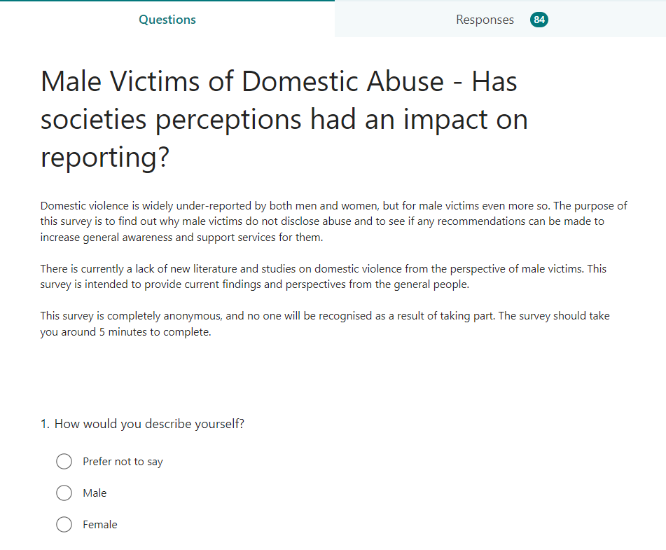
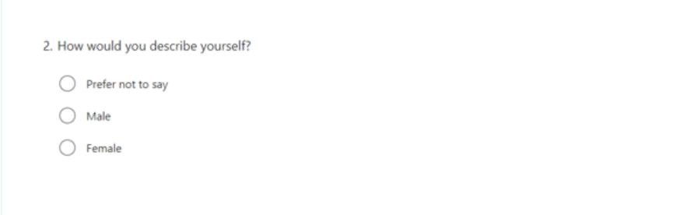
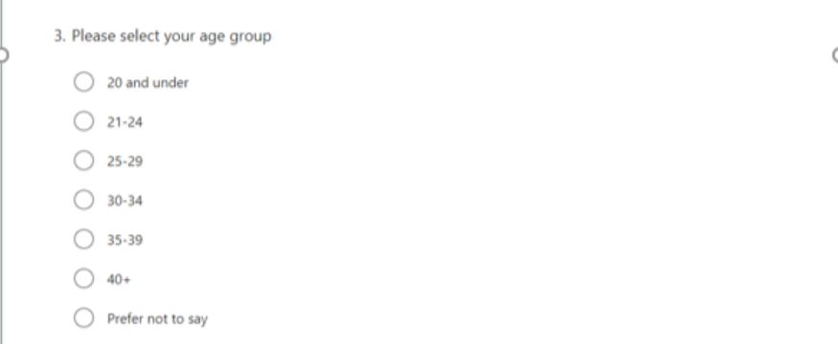
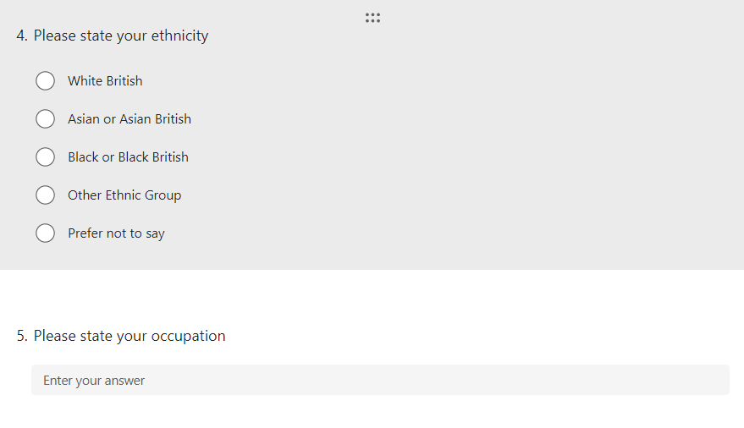


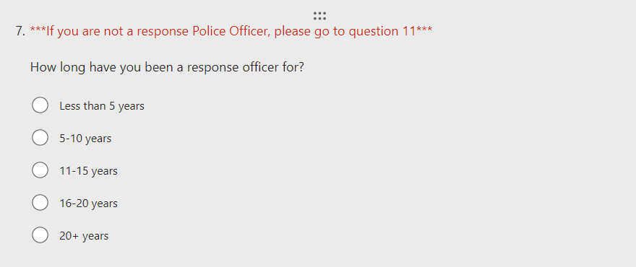
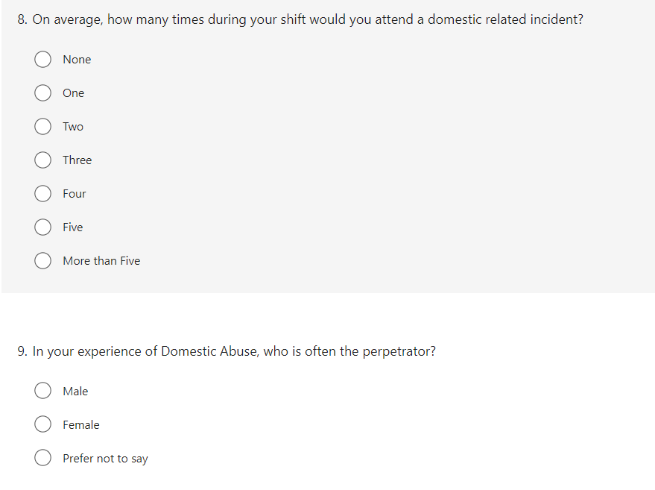
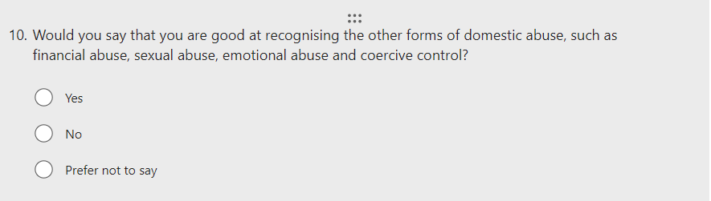
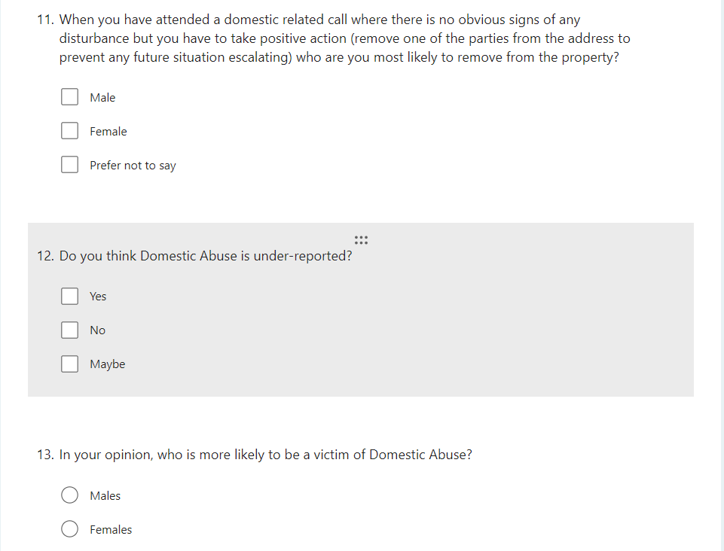
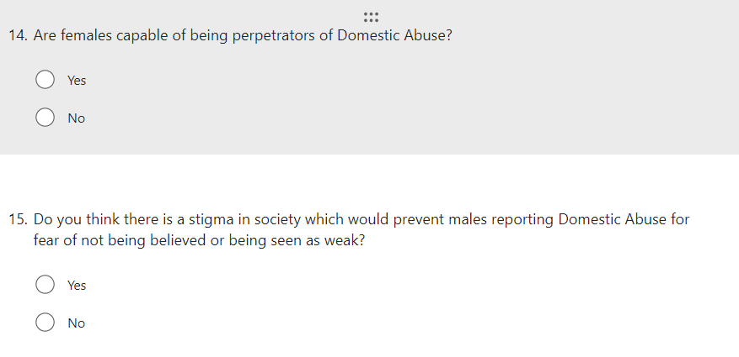
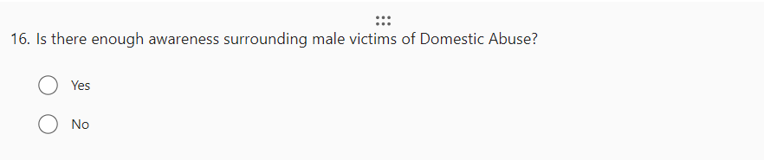
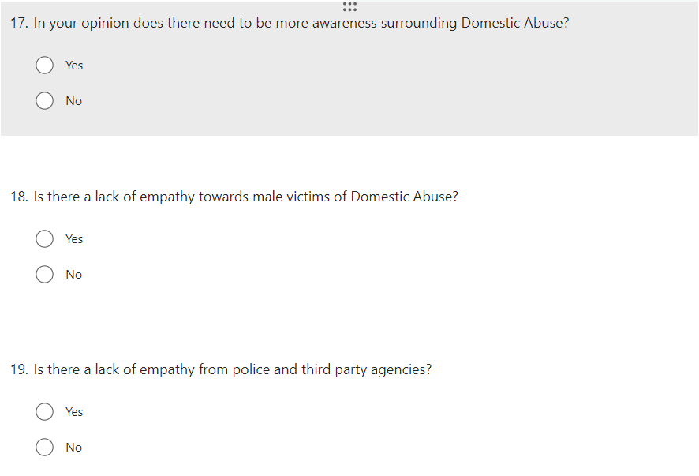
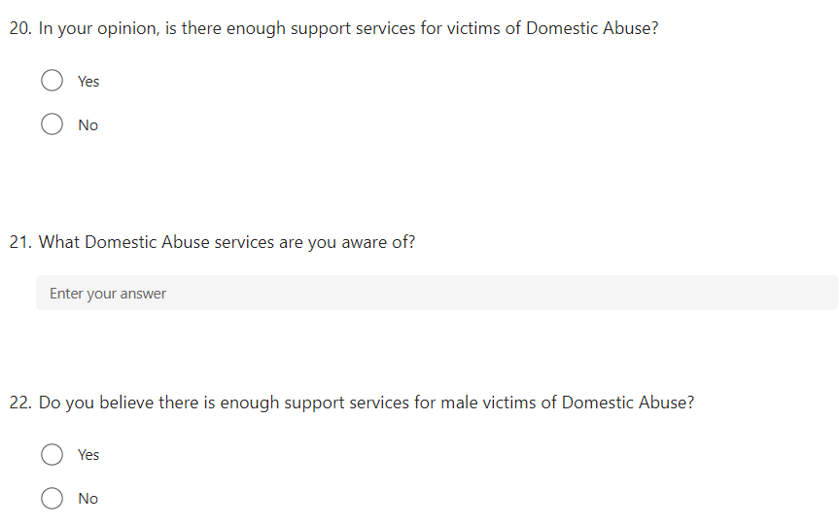

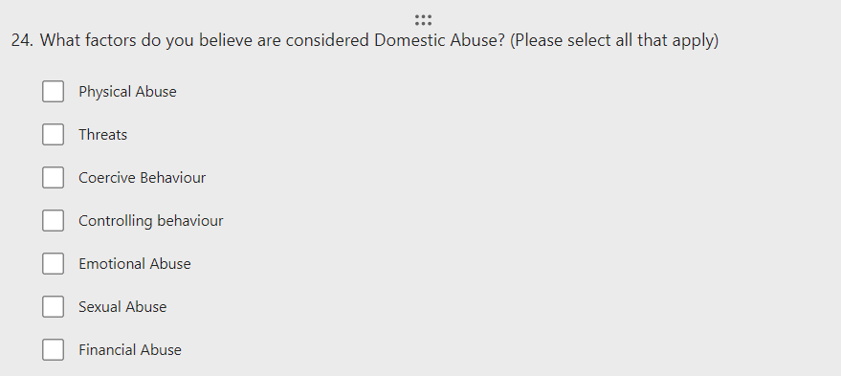

7.2 Appendix Two: Questionnaire Results

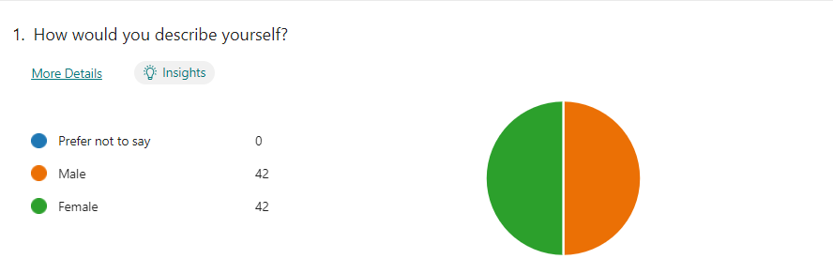

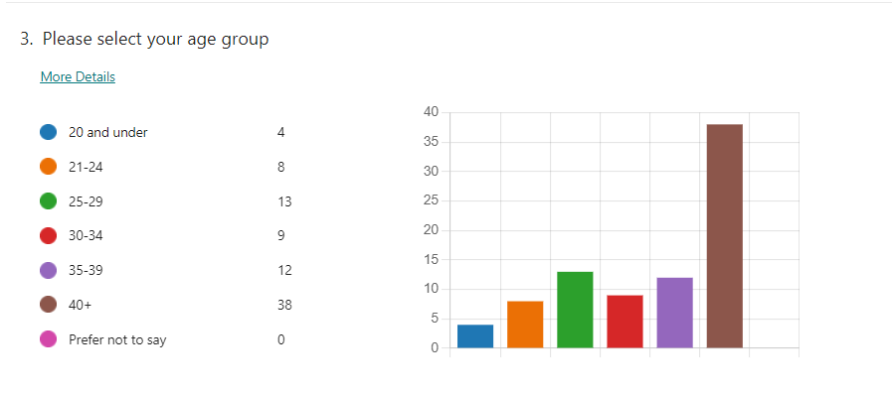
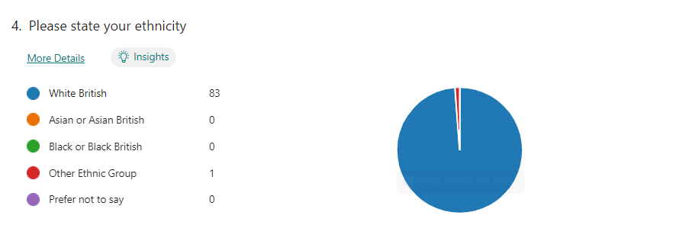
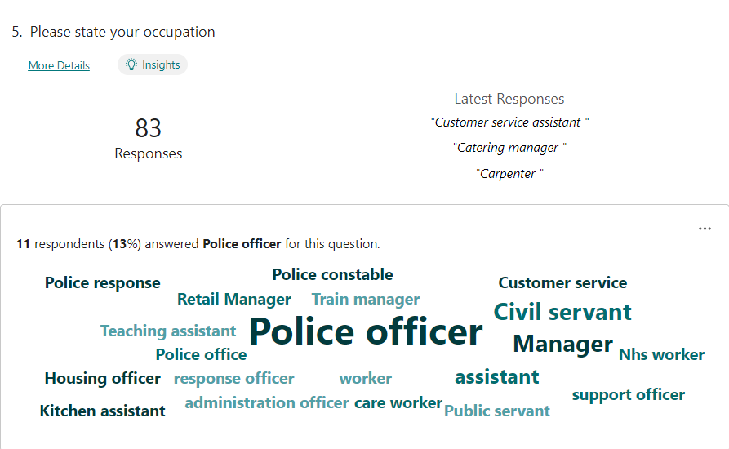

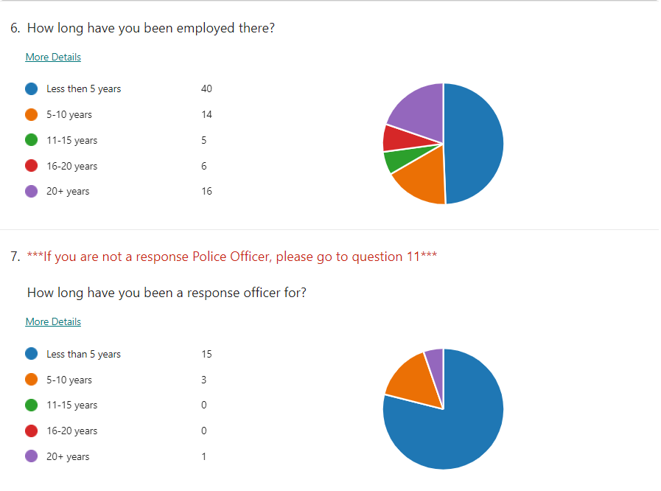
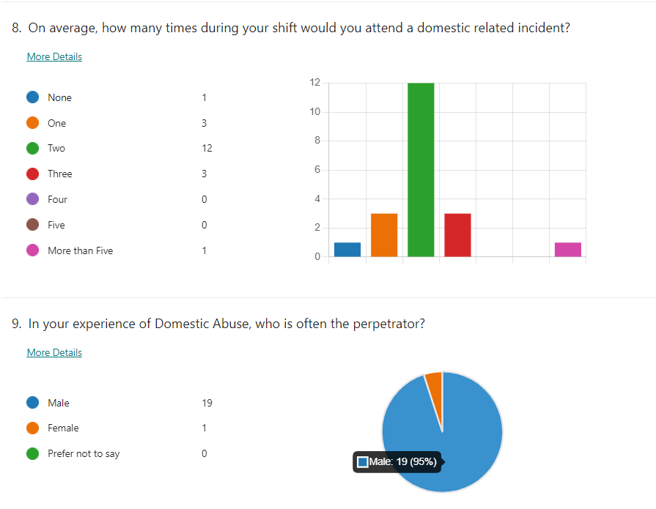
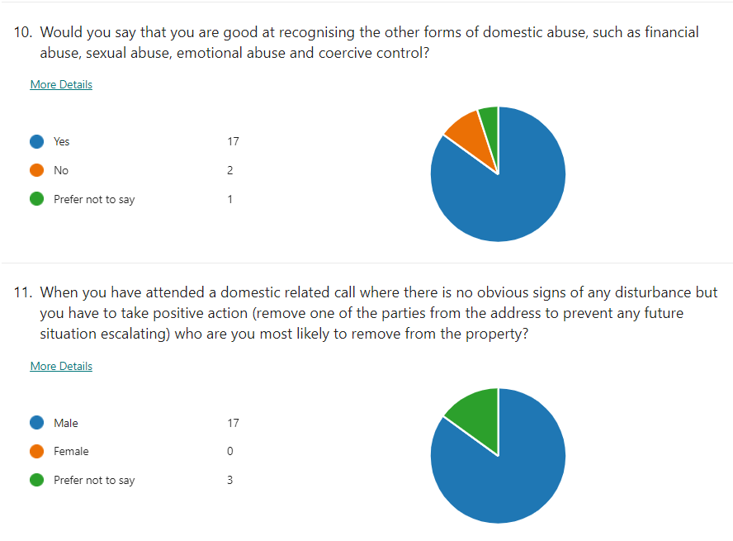
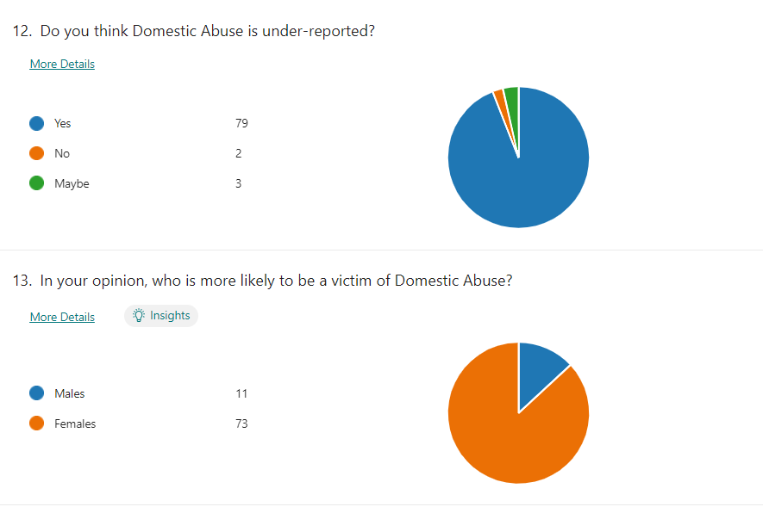
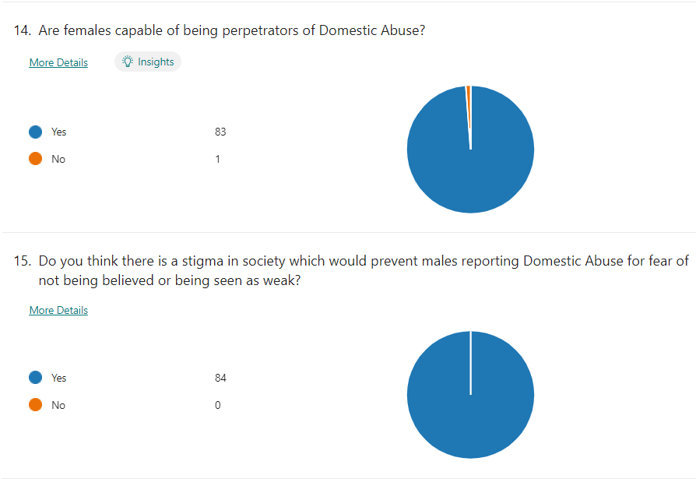
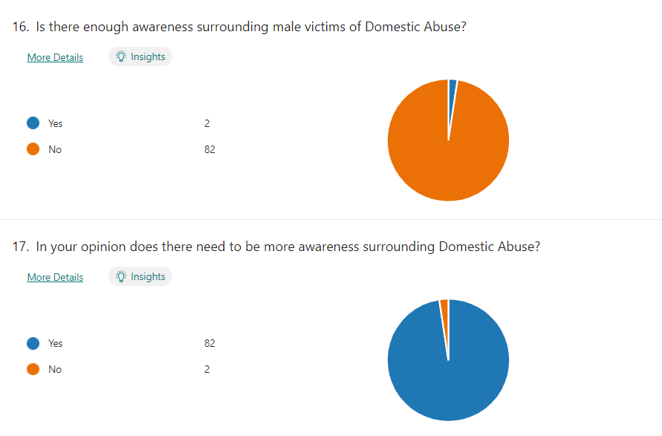
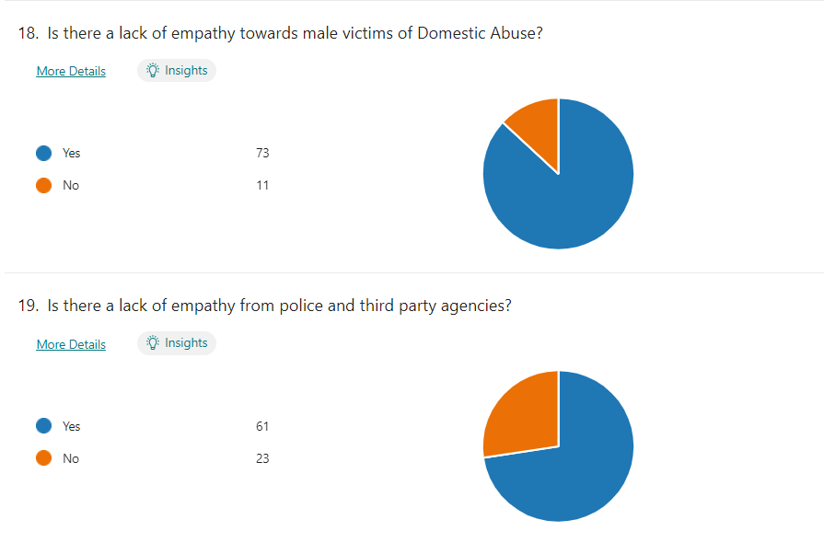
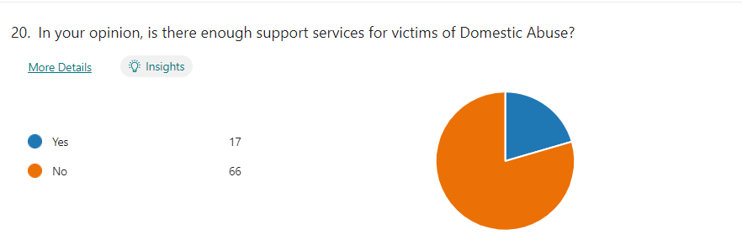
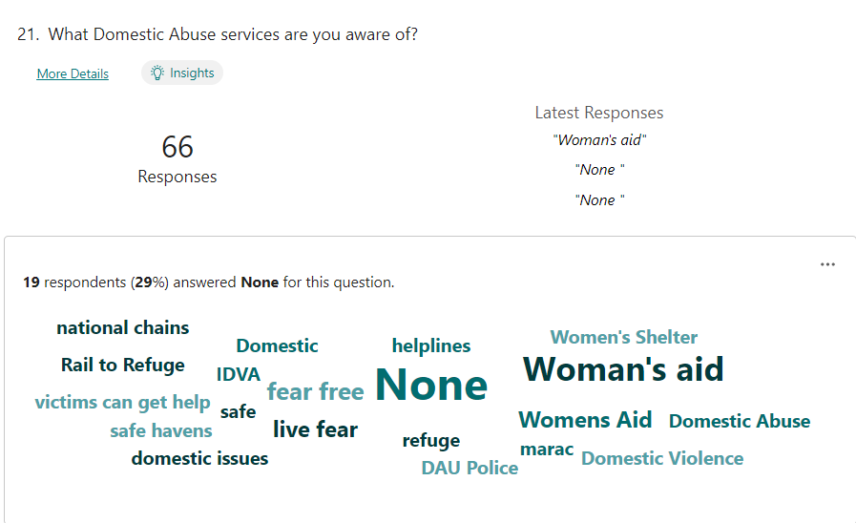
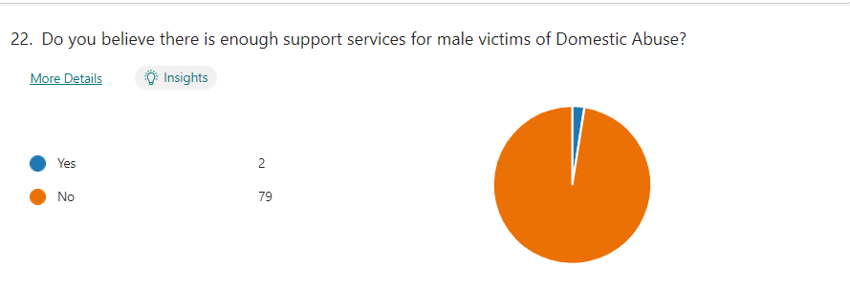
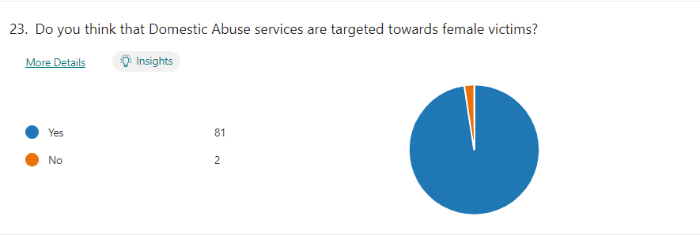
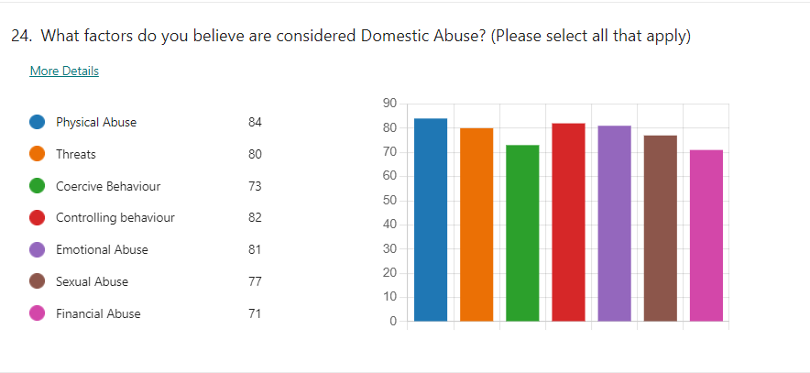

7.3 Appendix Three: Dissertation Proposal

Male victims of Domestic Abuse: Has society perceptions had an impact on the reporting of domestic abuse.

Introduction
This dissertation will look at the difficulties that affect male victims of domestic abuse. It will discuss the potential reasons for the lack of reporting by male victims and explore whether society has created a social injustice through the stigmas attached to male victims of domestic abuse.
Research suggests that services available to victims of domestic abuse are lop-sided towards female victims. The purpose of this research is to determine whether male victims feel that they are being treated fairly by police and third-party organisations, and whether there is enough publicity and support around the issue.
This subject was chosen by the researcher as it is something that they have had first-hand experience of. It is an important subject and one in which they believe more awareness is needed in identifying and supporting male victims. Domestic abuse is not gender specific and does not discriminate, it affects all persons, regardless of age or gender.
Furthermore, domestic abuse is a significant component of everyday policing. It would be extremely beneficial for serving police officers to be able to recognise victims of domestic abuse and guide them in the correct path for after-care support. It is intended that by doing so, early intervention would be implemented, providing greater protection for male victims whilst encouraging them and others to seek help.

Background/Literature review
Unfortunately, Domestic violence is not a new phenomenon. Domestic violence refers to a wide range of acts of violence and abuse which is committed by one family member against another (Shipway, 2004). In the early 1900’s, domestic violence was considered a private matter, and discussing it in public was not deemed acceptable or a social concern (Kronenberg, 2013).
Back then, patriarchal societies existed and it was considered normal and reasonable for women to be subordinate family members while males were dominant and in control. As a result, males often used violent acts and behaviours as a means to keep the family in line (Kennedy, 2011). Even more distressing is the fact that laws up until the 1970’s frequently disregarded, or even condoned, this type of violence.
Domestic violence established a categorisation and societal construction that victims of domestic abuse are exclusively female (Tsui, 2014) and therefore an ideal victim. Ideal crime victims are considered to be weak, innocent, and faultless personalities who are empowered by someone physically stronger than them (Strobl,2010; Tsui, 2014). As a result, whereas female victims of domestic violence already struggle to acquire victim status, the stigma surrounding domestic abuse makes male victims suffer much more (Tsui, 2014).
During the 1970’s, feminist movements such as the Woman’s Liberation Movement (WLM) achieved substantial accomplishments and helped change the social landscape, including the equality and the personal dynamics between men and women. The movement was one of the first to address previously unseen crimes such as ‘battered wives’ as a serious issue. It saw the arrival of safe houses and refuges, opened by women-centred charities such as Rape Crisis and Woman’s Aid. These charities helped women who were suffering from abuse and violence in an intimate relationship as they had no help or protection (Harne and Radford, 2008).
Since the feminism movements in the 1970’s, domestic abuse has been increasingly recognised as a serious social problem. The Police and local authorities across the world made it a priority in an attempt to eradicate it. (Mooney, 2000). Domestic violence does not discriminate, it happens across all cultures and age groups (Flink et al, 2008), it is a problem that spans borders and countries; it is a global concern.
The public pressure generated by these women’s rights protests prompted the UK to pass its very first piece of domestic violence legislation, the Domestic Violence and Matrimonial Proceedings Act 1976, which established civil protection orders for victims (Bradley, 1978).
The pressure has grown and grown over the years which has prompted the UK government to pass laws which offer better protection for victims of domestic violence. The Home Office definition of domestic violence changed in 2012 to include 16 and 17 year-olds and the phrasing altered to comprise coercive control (Home office, 2013). The Government definition of domestic violence and abuse is:
‘Any incident or pattern of incidents of controlling, coercive or threatening behaviour, violence or abuse between those aged 16 or over who are or have been intimate partners or family members regardless of gender or sexuality. This can encompass, but is not limited to, the following types of abuse: psychological, physical, sexual, financial, and emotional’ (Home Office, 2013).
Despite new laws being introduced and domestic violence now being viewed as unacceptable it is still a common occurrence in practically every society. Today, it is estimated by the Crime Survey for England and Wales that in the year ending March 2020, approximately 5.5 percent of adults aged 16 to 74 years (2.3 million) experienced domestic abuse in the previous year (ONS, 2020). On average police receive an emergency call in relation to domestic abuse every 30 seconds (HMIC, 2014).
However, in South Wales it is even more prevalent. According to Alun Michael, South Wales Police Crime Commissioner, South Wales Police receive a call relating to Domestic Violence every 15 minutes. This figure equates to 93 calls every day and accounts for a third of all crime recorded (Lewis, 2019).
In reality, these statistics show that a police officer is likely to respond to a domestic call numerous times throughout their shift. As a result, it is critical that police recognise DV victims so that they may intervene and provide them assistance and support, as well as referring them to the appropriate support agencies.

Methodology
The term ‘Methodology’ refers to the specific procedures or techniques used to find, select, process and analyse information about a topic (Creswell, 2017).The methodology portion of a research article helps the reader to objectively examine the overall validity and reliability of the study.
The primary research for this study will comprise of surveys to Police officers, third party agencies/charities and adult males. The data from the survey will then depend on qualitative and quantitative research to critically examine this topic matter in depth. This type of research is known as triangulation. Triangulation refers to the various ways to collect and evaluate data on the same issue. By combining different types or sources of data, the validity of your findings can be strengthened (Bekhet & Zauszniewski, 2012).

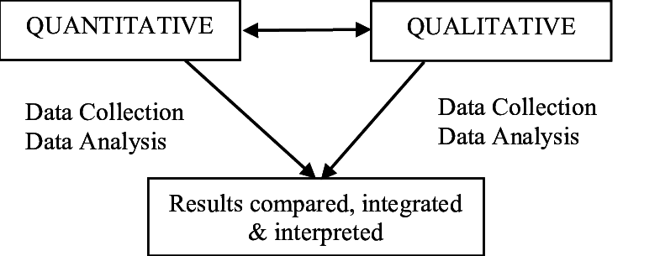
Fig 1. Triangulation Methodology (Bramble et al, 2008).

The primary findings will then be displayed in various graphs and charts and compared to existing secondary findings to identify any patterns or gaps where recommendations can be made. It is critical that the survey be completed to a standard in which the questions are neither leading or subject to interpretation and are geared to produce an accurate response to the issue being questioned.

Aims and Objectives
The aims of the study are;
- To identify if male victims of domestic abuse are under-reporting and the potential reasons for not reporting.
- To establish if social stigmas still exist around domestic abuse.
- Is there a lack of empathy from Police and other third party services?
- Are there enough support services out there for male victims of domestic abuse?
- Is there enough awareness surrounding male victims of domestic abuse.
The aims of the research will be met by the following objectives
- Review the literature surrounding domestic violence and male victimisation
- To identify and evaluate secondary data and services for males who are victims of domestic violence
- To conduct primary surveys with friends, family, Police officers, third party charities/organisations to ascertain their thoughts, ideas and recommendations on where help and support can be improved.
- To collate, analyse and display both primary and secondary data to establish trends and identify areas for improvement.

Limitations
As with any study, there are always limitations or potential weaknesses which are outside of the researcher’s control. There is no ‘gold model’ when conducting research methods and analysing data. Most methodologies cannot be truly replicated and therefore are unable to be verified per se.
For this study, it is envisaged that it will be limited in scope due to the set limit of 10,000 words. Also, time restraints/deadlines could have an impact on participation numbers and research findings. Furthermore, it is apparent that there is clearly not enough studies/papers in relation to male victims of domestic abuse, so identifying trends could prove difficult. Furthermore, ethical issues will have an impact on the true reasons why male victims of domestic abuse do not report domestic violence, as they cannot be included in the study. However, males will be included in the study albeit not victims so the reasons will not be a true reflection but an indication as to the reason why. All of the above may have an impact on results and it is important to acknowledge them.

Ethical issues
They will be no significant ethical restraints as victims will not be included in this study. Permission will be requested from participants to utilise anonymised information, the questions themselves will be ethical, and, as previously stated, all personal details will be excluded, guaranteeing no individuals or locations can be identified.
Time frame/Gantt Chart
The current timeframes are set out by the submission deadlines determined by the university. These are as follows:

Fig 2. Time frame for submissions.

I aim to complete all work far ahead of the submission dates, allowing me adequate opportunity to communicate with my designated supervisor and make recommended changes to my academic work as the project advances. I aim to keep in frequent communication with him to ensure that my project stays on schedule.

Word Count 1537

7.4 Appendix Four: Ethics Form

APPLICATION FOR ETHICAL APPROVAL

In order for research to result in benefit and minimise risk of harm, it must be conducted ethically. A researcher may not be covered by the University’s insurance if ethical approval has not been obtained prior to commencement.

The University follows the OECD Frascati manual definition of research activity: “creative work undertaken on a systematic basis in order to increase the stock of knowledge, including knowledge of man, culture and society, and the use of this stock of knowledge to devise new applications”. As such this covers activities undertaken by members of staff, postgraduate research students, and both taught postgraduate and undergraduate students working on dissertations/projects.

The individual undertaking the research activity is known as the “principal researcher”.

Ethical approval is not required for routine audits, performance reviews, quality assurance studies, testing within normal educational requirements, and literary or artistic criticism.

Please read the notes for guidance before completing ALL sections of the form.

This form must be completed and approved prior to undertaking any research activity. Please see Checklist for details of process for different categories of application.

Delete the Guidance Notes at the end of the form BEFORE submitting your application

SECTION A: About You (Principal Researcher)
Full Name: |  | NICK MILLER
Tick all boxes which apply: |  | Member of staff: | ☐ | Honorary research fellow: | ☐
Undergraduate Student | ☒ | Taught Postgraduate Student | ☐ | Postgraduate Research Student | ☐

Institute/Academic Discipline/Centre: | UWTSD
Campus: | SWANSEA
E-mail address: | 1910667@STUDENT.UWTSD.AC.UK
Contact Telephone Number: | 07817964584
For students:
Student Number: | 1910667
Programme of Study: | PROFESSIONAL POLICE PRACTICE
Director of Studies/Supervisor: | CHRISTOPHER RICHARDS

SECTION B: Approval for Research Activity
Has the research activity received approval in principle?  (please check the Guidance Notes as to the appropriate approval process for different levels of research by different categories of individual) |  | YES | ☒ | NO | ☐
 |  |  |  | Date
If Yes, please indicate source of approval (and date where known): Approval in principle must be obtained from the relevant source prior to seeking ethical approval | Research Degrees Committee |  | ☒
 | Institute Research Committee |  | ☐
 | Other (write in) |  | ☐

SECTION C: Internal and External Ethical Guidance Materials
Please list the core ethical guidance documents that have been referred to during the completion of this form (including any discipline-specific codes of research ethics, and also any specific ethical guidance relating to the proposed methodology). Please tick to confirm that your research proposal adheres to these codes and guidelines.
UWTSD Research Ethics & Integrity Code of Practice | ☒
UWTSD Research Data Management Policy | ☒
 | ☐

SECTION D: External Collaborative Research Activity
Does the research activity involve collaborators outside of the University? |  | YES | ☐ | NO | ☒
If Yes, please provide the name of the external organisation and name and contact details for the main contact person and confirmation this person has consented to their personal data being shared.as part of this collaboration.
Institution
Contact person name
Contact person e-mail address

Has this individual consented to sharing their details on this form? |  | YES | ☐ | NO |  |  | ☐
Are you in receipt of a KESS scholarship? |  | YES | ☐ | NO |  |  | ☐
Is your research externally funded |  | YES | ☐ | NO |  |  | ☐
Are you specifically employed to undertake this research in either a paid or voluntary capacity? | Voluntary | YES | ☐ | NO |  | ☐
 | Employed | YES | ☐ | NO |  | ☐
Is the research being undertaken within an existing UWTSD Athrofa Professional Learning Partnership (APLP) | If YES then the permission question below does not need to be answered. | YES | ☐ | NO |  |  | ☐
Permission to undertake the research has been provided by the partner organisation | (If YES attach copy)  If NO the application cannot continue | YES | ☐ | NO |  |  | ☐

Where research activity is carried out in collaboration with an external organisation
Does this organisation have its own ethics approval system? | YES | ☐ | NO | ☐
If Yes, please attach a copy of any final approval (or interim approval) from the organisation

SECTION E: Details of Research Activity
Indicative title: | The study of Domestic Abuse to see if there is any coloration between the lack of reporting by male victims and societal stigmas.
Proposed start date: | 23/09/2021 | Proposed end date: | 27/06/2021
Introduction to the Research (maximum 300 words)
Ensure that you write for a Non-Specialist Audience when outlining your response to the three points below:
- Purpose of Research Activity
- Proposed Research Question
- Aims of Research Activity
- Objectives of Research Activity
Demonstrate, briefly, how Existing Research has informed the proposed activity and explain
- What the research activity will add to the body of knowledge
- How it addresses an area of importance.
Purpose of Research Activity

The purpose of this study is to investigate the reasons why there are disproportionate levels of reporting of Domestic Abuse by Male victims compared to that of females.

Domestic abuse is not gender specific and is for all persons, regardless of age, gender or sex.

This study will look at the societal stigmas of the past to establish if it is still having an impact on men today when reporting domestic abuse.

Furthermore, it will look at what services are available for males, as research suggest services are lob-sided towards females.

Are these factors having an impact on the reporting of domestic abuse and their welfare.

(this box should expand as you type)
Research Question

Male victims of Domestic Abuse: Has society perceptions had an impact on the reporting of domestic abuse.

(this box should expand as you type)
Aims of Research Activity

- To identify if male victims of domestic abuse are under-reporting and the potential reasons for not reporting.
- To establish if social stigmas still exist around domestic abuse.
- Is there a lack of empathy from Police and other third party services.
- Are there enough support services out there for male victims of domestic abuse.
- Is there enough awareness surrounding male victims of domestic abuse.

(this box should expand as you type)
Objectives of Research Activity

- Review the literature surrounding domestic violence and male victimisation
- To identify and evaluate secondary data and services for males who are victims of domestic violence
- To conduct primary surveys with friends, family, Police officers, third party charities/organisations to ascertain their thoughts, ideas and recommendations on where help and support can be improved.
- To collate, analyse and display both primary and secondary data to establish trends and identify areas for improvement.

(this box should expand as you type)
Proposed methods (maximum 600 words)
Provide a brief summary of all the methods that may be used in the research activity, making it clear what specific techniques may be used. If methods other than those listed in this section are deemed appropriate later, additional ethical approval for those methods will be needed.
I will consider using a survey to ask individuals, police and any third party agencies a series of questions to enable me to gather data to analyses for potential tends or gaps compared to secondary data.

(this box should expand as you type)

Location of research activity
Identify all locations where research activity will take place.
Swansea
(this box should expand as you type)
Research activity outside of the UK
If research activity will take place overseas, you are responsible for ensuring that local ethical considerations are complied with and that the relevant permissions are sought. Specify any local guidelines (e.g. from local professional associations/learned societies/universities) that exist and whether these involve any ethical stipulations beyond those usual in the UK (provide details of any licenses or permissions required). Also specify whether there are any specific ethical issues raised by the local context in which the research activity is taking place, for example, particular cultural and/or legal sensitivities or vulnerabilities of participants.
N/A

(this box should expand as you type)
Use of documentation not in the public domain: Are any documents NOT publicly available? | NO | ☒
 | YES | ☐
If Yes, please provide details here of how you will gain access to specific documentation that is not in the public domain and that this is in accordance with prevailing data protection law of the country in question and England and Wales.

(this box should expand as you type)

SECTION F: Scope of Research Activity
Will the research activity include: | YES | NO
Use of a questionnaire or similar research instrument? | ☒ | ☐
Use of interviews? | ☐ | ☒
Use of diaries? | ☐ | ☒
Participant observation with their knowledge? | ☐ | ☒
Participant observation without their knowledge? | ☐ | ☒
Use of video or audio recording? | ☐ | ☒
Access to personal or confidential information without the participants’ specific consent? | ☐ | ☒
Administration of any questions, test stimuli, presentation that may be experienced as physically, mentally or emotionally harmful / offensive? | ☐ | ☒
Performance of any acts which may cause embarrassment or affect self-esteem? | ☐ | ☒
Investigation of participants involved in illegal activities? | ☐ | ☒
Use of procedures that involve deception? | ☐ | ☒
Administration of any substance, agent or placebo? | ☐ | ☒
Working with live vertebrate animals? | ☐ | ☒
Other primary data collection methods, please explain in this box  For example, ‘focus groups’. Please indicate the type of data collection method(s) in this box and tick the accompany box. | ☐ | ☒
Details of any other primary data collection method:  (this box should expand as you type) | ☐ | ☒
If NO to every question, then the research activity is (ethically) low risk and may be exempt from some of the following sections (please refer to Guidance Notes).

If YES to any question, then no research activity should be undertaken until full ethical approval has been obtained.

SECTION G: Intended Participants
Who are the intended participants: | YES | NO
Students or staff at the University? | ☐ | ☒
Adults (over the age of 18 and competent to give consent)? | ☒ | ☐
Vulnerable adults? | ☐ | ☒
Children and Young People under the age of 18? (Consent from Parent, Carer or Guardian will be required) | ☐ | ☒
Prisoners? | ☐ | ☒
Young offenders? | ☐ | ☒
Those who could be considered to have a particularly dependent relationship with the investigator or a gatekeeper? | ☐ | ☒
People engaged in illegal activities? | ☐ | ☒
Others (please identify specifically any group who may be unable to give consent) please indicate here and tick the appropriate box. | ☐ | ☒
Other – please indicate here:  (this box should expand as you type) | ☐ | ☒

Participant numbers and source
Provide an estimate of the expected number of participants. How will you identify participants and how will they be recruited?
How many participants are expected? | I ANTICIPATE THAT THERE WILL BE APPROXIMATELY 15 – 30 PARTICIPANTS  (this box should expand as you type)
Who will the participants be? | POLICE OFFICERS, THIRD PARTY ORGANISATIONS ,ADULTS (PERSONS OVER THE AGE OF 18)  (this box should expand as you type)
How will you identify the participants? | I WILL ALLOCATE EACH PERSON A NUMBER SO THAT WILL BE THE METHOD FOR IDENTIFYING THEM. NO NAMES OR ADDRESSES WILL BE TAKEN OR DISCLOSED.  (this box should expand as you type)

Information for participants: | YES | NO | N/A
Will you describe the main research procedures to participants in advance, so that they are informed about what to expect? | ☒ | ☐ | ☐
Will you tell participants that their participation is voluntary? | ☒ | ☐ | ☐
Will you obtain written consent for participation? | ☒ | ☐ | ☐
Will you explain to participants that refusal to participate in the research will not affect their treatment or education (if relevant)? | ☐ | ☐ | ☒
If the research is observational, will you ask participants for their consent to being observed? | ☐ | ☐ | ☒
Will you tell participants that they may withdraw from the research at any time and for any reason? | ☒ | ☐ | ☐
With questionnaires, will you give participants the option of omitting questions they do not want to answer? | ☒ | ☐ | ☐
Will you tell participants that their data will be treated with full confidentiality and that, if published, it will not be identifiable as theirs? | ☒ | ☐ | ☐
Will you debrief participants at the end of their participation, in a way appropriate to the type of research undertaken? | ☒ | ☐ | ☐
If NO to any of above questions, please give an explanation
(this box should expand as you type)

Information for participants: | YES | NO | N/A
Will participants be paid? | ☐ | ☒ | ☐
Is specialist electrical or other equipment to be used with participants? | ☐ | ☒ | ☐
Are there any financial or other interests to the investigator or University arising from this study? | ☐ | ☒ | ☐
Will the research activity involve deliberately misleading participants in any way, or the partial or full concealment of the specific study aims? | ☐ | ☒ | ☐
If YES to any question, please provide full details
(this box should expand as you type)

SECTION H: Anticipated Risks

Outline any anticipated risks that may adversely affect any of the participants, the researchers and/or the University, and the steps that will be taken to address them.

If you have completed a full risk assessment (for example as required by a laboratory, or external research collaborator) you may append that to this form.
Full risk assessment completed and appended? |  | Yes | ☐
 |  | No | ☒
Risks to participants
For example: emotional distress, financial disclosure, physical harm, transfer of personal data, sensitive organisational information
Risk to Participant:  POSSIBLE EMOTIONAL DISTRESS  (this box should expand as you type) | How will you mitigate the Risk to Participant  FIRSTLY, I WILL EXPLAIN CLEARLY TO ALL POTENTIAL PARTICIPANTS WHAT MY SURVEY SUBJECT IS BEFORE ASKING THEM TO TAKE PART.  I WILL STATE THAT THIS SURVEY IS NOT SUITABLE FOR DV VICTMS AS STATED ON THE ETHICAL FORM.  I DO NOT WANT TO CAUSE ANY PERSON ANY ALARM OR DISTRESS  (this box should expand as you type)
If research activity may include sensitive, embarrassing or upsetting topics (e.g. sexual activity, drug use) or issues likely to disclose information requiring further action (e.g. criminal activity), give details of the procedures to deal with these issues, including any support/advice (e.g. helpline numbers) to be offered to participants. Note that where applicable, consent procedures should make it clear that if something potentially or actually illegal is discovered in the course of a project, it may need to be disclosed to the proper authorities
N/A

(this box should expand as you type)
Risks to investigator
For example: personal safety, physical harm, emotional distress, risk of accusation of harm/impropriety, conflict of interest
Risk to Investigator:  POSSIBLE COVID WHEN SPEAKING WITH PARTICIPANTS FACE TO FACE.  (this box should expand as you type) | How will you mitigate the Risk to Investigator:  TO WEAR A FACE MASK AND MAINTAIN PROPER PPE AND SAFE DISTANCE.  (this box should expand as you type)
University/institutional risks
For example: adverse publicity, financial loss, data protection
Risk to University:  N/A  (this box should expand as you type) | How will you mitigate the Risk to University:  N/A  (this box should expand as you type)

Disclosure and Barring Service
If the research activity involves children or vulnerable adults, a Disclosure and Barring Service (DBS) certificate must be obtained before any contact with such participants. | YES | NO | N/A
Does your research require you to hold a current DBS Certificate? | ☐ | ☐ | ☒

SECTION I: Feedback, Consent and Confidentiality
Feedback
What de-briefing and feedback will be provided to participants, how will this be done and when?
AFTER THE FINDINGS HAVE BEEN COLLATED AND ANALYSED I WILL KEEP THE RESULTS FOR MY OWN PURPOSE. PARTICIPANTS WILL NOT BE CONTACTED BUT SHOULD WISH TO FIND OUT THE RESUILTS, MY CONTACT NUMBER WILL BE PROVIDED AND RESULTS WILL BE DISCUSSED.

(this box should expand as you type)
Informed consent
Describe the arrangements to inform potential participants, before providing consent, of what is involved in participating. Describe the arrangements for participants to provide full consent before data collection begins. If gaining consent in this way is inappropriate, explain how consent will be obtained and recorded in accordance with prevailing data protection legislation.
BEFORE PARTICIPANTS TAKE PART IN ANY STUDY SURVEY, THE TERMS AND CONDITIONS IN RELATION TO INFORMATION GATHERING AND CONSENT WILL BE FULLY EXPLAINED .

(this box should expand as you type)
Confidentiality / Anonymity
Set out how anonymity of participants and confidentiality will be ensured in any outputs. If anonymity is not being offered, explain why this is the case.
CONFIDENTIALITY AND ANONYMITY WILL BE OFFERED FROM THE OUTSET. NO PERSONAL DATA, SUCH AS NAMES, ADDRESS WILL BE DOCUMENTED ON THE SURVEYS. PARTICIOANTS WILL BE ALLOCATED A NUMBER AND THAT WILL BE THE METHOD TO IDENTIFY THEM.

(this box should expand as you type)

SECTION J: Data Protection and Storage
In completing this section refer to the University’s Research Data Management Policy and the extensive resources on the University’s Research Data Management web pages (http://uwtsd.ac.uk/library/research-data-management/).
Does the research activity involve personal data (as defined by the General Data Protection Regulation 2016 “GDPR” and the Data Protection Act 2018 “DPA”)? | YES | NO
“Personal data” means any information relating to an identified or identifiable natural person (‘data subject’). An identifiable natural person is one who can be identified, directly or indirectly, in particular by reference to an identifier such as a name, an identification number, location data, an online identifier or to one or more factors specific to the physical, physiological, genetic, mental, economic, cultural or social identity of that natural person. | ☐ | X
If YES, provide a description of the data and explain why this data needs to be collected:
(this box should expand as you type)
Does it involve special category data (as defined by the GDPR)? | YES | NO
“Special category data” means sensitive personal data consisting of information as to the data subjects’ –  (a) racial or ethnic origin,  (b) political opinions,  (c ) religious beliefs or other beliefs of a similar nature,  (d) membership of a trade union (within the meaning of the Trade Union and Labour Relations (Consolidation) Act 1992),  (e) physical or mental health or condition,  (f) sexual life,  (g) genetics,  (h) biometric data (as used for ID purposes), | ☐ | X
If YES, provide a description of the special category data and explain why this data needs to be collected:
(this box should expand as you type)
Will the research activity involve storing personal data and/or special category data on one of the following: | YES | NO
Manual files (i.e. in paper form)? | ☐ | ☒
University computers? | ☐ | ☒
Private company computers? | ☐ | ☒
Home or other personal computers? | ☐ | ☒
Laptop computers/ CDs/ Portable disk-drives/ memory sticks? | ☒ | ☐
“Cloud” storage or websites? | ☐ | ☒
Other – specify: | ☐ | ☒
For all stored data, explain the measures in place to ensure the security of the data collected, data confidentiality, including details of password protection, encryption, anonymisation and pseudonymisation:
LAPTOP IS PASSWORD PROTECTED AND ONLY I HAVE ACCESS TO IT

(this box should expand as you type)
All Data Storage
Will the research activity involve any of the following activities: | YES | NO
Electronic transfer of data in any form? | ☐ | ☒
Sharing of data with others at the University? | ☐ | ☒
Sharing of data with other organisations? | ☐ | ☒
Export of data outside the European Union or importing of data from outside the UK? | ☐ | ☒
Use of personal addresses, postcodes, faxes, emails or telephone numbers? | ☐ | ☒
Publication of data that might allow identification of individuals? | ☐ | ☒
Use of data management system? | ☐ | ☒
Data archiving? | ☐ | ☒
If YES to any question, please provide full details, explaining how this will be conducted in accordance with the GDPR and DPA (and/or any international equivalent):
N/A
(this box should expand as you type)
List all who will have access to the data generated by the research activity:
THE RESEARCHER (MYSELF)

(this box should expand as you type)
List who will have control of, and act as custodian(s) for, data generated by the research activity:
THE RESEARCHER (MYSELF)

(this box should expand as you type)
Give details of data storage arrangements, including security measures in place to protect the data, where data will be stored, how long for, and in what form. Will data be archived – if so how and if not why not.
(this box should expand as you type)
Please indicate if your data will be stored in the UWTSD Research Data Repository (see https://researchdata.uwtsd.ac.uk/ ). If so please explain. (Most relevant to academic staff)
N/A

(this box should expand as you type)
Confirm that you have read the UWTSD guidance on data management (see https://www.uwtsd.ac.uk/library/research-data-management/) | YES | ☒
 | NO | ☐
Confirm that you are aware that you need to keep all data until after your research has completed or the end of your funding | YES | ☒
 | NO | ☐

SECTION K: Declaration
The information which I have provided is correct and complete to the best of my knowledge. I have attempted to identify any risks and issues related to the research activity and acknowledge my obligations and the rights of the participants.

In submitting this application I hereby confirm that I undertake to ensure that the above named research activity will meet the University’s Research Ethics and Integrity Code of Practice which is published on the website: https://www.uwtsd.ac.uk/research/research-ethics/
Signature of applicant: | NICK MILLER | Date:14/11/2021

For STUDENT Submissions:
Director of Studies/Supervisor: |  | Date:
Signature: |  | Date:

For STAFF Submissions:
Academic Director/ Assistant Dean: |  | Date:
Signature: |  | Date:

Checklist: Please complete the checklist below to ensure that you have completed the form according to the guidelines and attached any required documentation:
☒ | I have read the guidance notes supplied before completing the form.
☒ | I have completed ALL RELEVANT sections of the form in full.
☒ | I confirm that the research activity has received approval in principle
☐ | I have attached a copy of final/interim approval from external organisation (where appropriate)
☐ | I have attached a full risk assessment (and have NOT completed Section H of this form) (where appropriate) ONLY TICK IF YOU HAVE ATTACHED A FULL RISK ASSESSMENT
☒ | I understand that it is my responsibility to ensure that the above named research activity will meet the University’s Research Ethics and Integrity Code of Practice.
☒ | I understand that before commencing data collection all documents aimed at respondents (including information sheets, consent forms, questionnaires, interview schedules etc.) must be confirmed by the DoS/Supervisor, module tutor or Academic Director.
☒ | I have deleted the guidance notes before submitting the PG2 for consideration

RESEARCH STUDENTS AND STAFF ONLY
All communications relating to this application during its processing must be in writing and emailed to pgresearch@uwtsd.ac.uk , with the title ‘Ethical Approval’ followed by your name.
You will be informed of the outcome of your claim by email; therefore it is important that you check your University and personal email accounts regularly.

STUDENTS ON UNDERGRADUATE OR TAUGHT MASTERS PROGRAMMES should submit this form (and receive the outcome) via systems explained to you by the supervisor/module leader.

This form is available electronically from the Academic Office web pages: https://www.uwtsd.ac.uk/academic-office/appendices-and-forms/

Application Process

All staff research projects and all research students must submit the Ethical Approval Form to the University Research Ethics Committee via the Academic Office (pgresearch@uwtsd.ac.uk). Staff research directly in relation to personal study for taught undergraduate or Masters programmes should be submitted via the Institute procedures explained below.

Taught masters and taught undergraduate research Ethical Approval Forms are considered within Institutes. Institutes will provide details of the specific processes for this. Where the Ethical issues within any single ethical application are of particular concern the Institute will refer these to the University Research Ethics Committee. Any student activity that involves the collection of primary data needs to undergo Ethical approval, this includes assignment work as well as dissertations.

