

Student name: Warda Ibrahim
Student ID: 2235246

Module name: Independent Project Methodology Poster

Module code: BMHP6020

Supervisor’s name: Bianca Sanfilippo

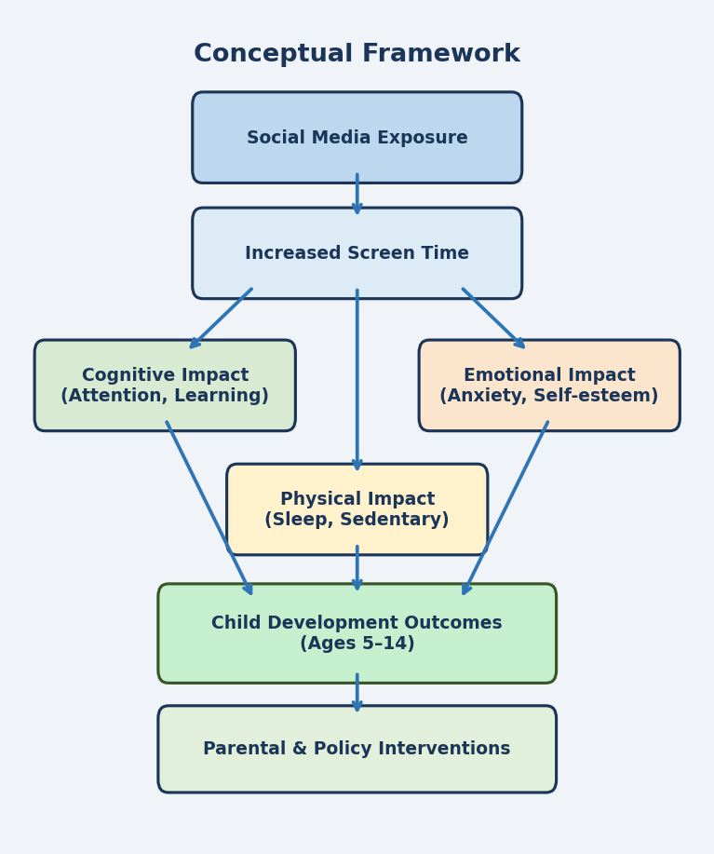 |  | The Impact of Social Media on Children’s Screen Time  Purpose: To investigate the significance of social media on the screen time of children aged 5-14, the cognitive, emotional, and physical developmental effects of augmented screen time as a result of exposure to social media.  Procedure: Literature search on peer-reviewed articles. Search databases: UWTSD Library, PubMed, Google Scholar and ProQuest. The papers that were published since 2015 and targeted children between the ages of 5 and 14 were used.   |  | 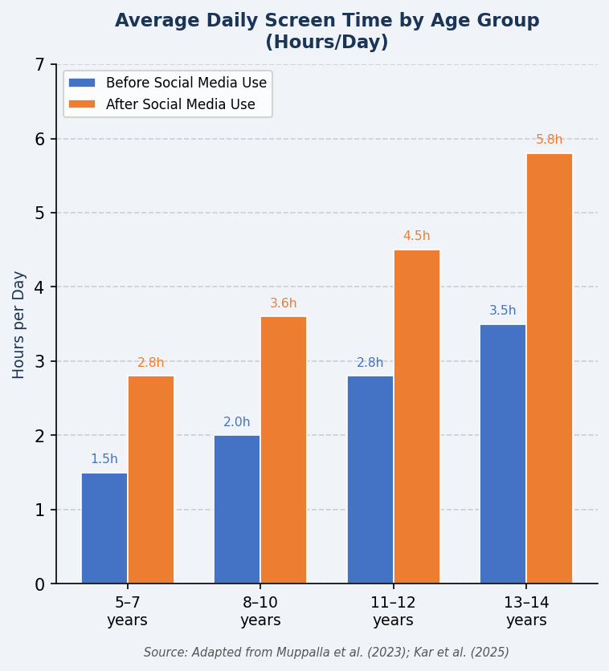
Methodology  The proposed study will follow an approach of a systematic review to examine the available peer-reviewed literature on the effects of social media on the screen time of children. A systematic review is suitable because it enables a rigorous, transparent and reproducible synthesis of existing evidence (Muppalla et al., 2023). The authors of the review consider the peer-reviewed articles, government reports, and other reliable academic sources that were published after 2015, which warrant currency and relevance to the current trends regarding social media usage among children. |  |  |  | Data Analysis  Thematic analysis will be used to analyse data. Thematic analysis is the process of identifying, analysing, and reporting common patterns (themes) in the selected literature (George et al., 2023). Inductively, common themes will be identified based on the data, which will revolve around the following themes: (1) level of social media use among children aged 514 years; (2) correlation between social media and screen time; (3) cognitive, emotional, and physical developmental effects; and (4) recommendations to parents, educators, and policymakers.  Ethical Considerations  The research employs a secondary/systematic review approach and no direct interaction with a participant. No personal information will be taken. References of all sources will be done using Harvard referencing. This study is in compliance with the code of practice of the UWTSD Research Ethics and Integrity Code and the UWTSD Research Data Management Policy. Ethical approval has been sought through the PG 2/E1 form. The data in the form of research will be stored safely using cloud (UWTSD systems), and it will be accessible to the supervisor and the researcher only.

Data Collection
Secondary data will be obtained. UWTSD Library, PubMed, Google Scholar, and ProQuest databases will be systematically searched. Inclusion criteria: peer-reviewed articles on screen time and social media use among children aged 5-14, published in English since 2015. Exclusion criteria: non-peer reviewed articles, studies published before 2015, and those outside the specified age range. The dissertation will reference 50-100 sources (Kar et al., 2025; Joseph et al., 2022).

References
George, A.S., Hovan George, A., Baskar, T. and Shahul, A., 2023. Screens Steal Time: How Excessive Screen Use Impacts the Lives of Young People. Partners Universal Innovative Research Publication (PUIRP), 1(2). https://doi.org/10.5281/zenodo.10250536
Joseph, G.V., M., A.T., Elizabeth, S., Vargheese, S. and Thomas, J., 2022. The Impact of Screen Time and Mobile Dependency on Cognition, Socialization and Behaviour among Early Childhood Students during the COVID Pandemic. Digital Education Review. Available at: https://eric.ed.gov/?id=EJ1363209
Kar, S.S., Dube, R., Goud, B.K.M., Gibrata, Q.S., El-Balbissi, A.A., Al Salim, T.A. and Fatayerji, R.N.M.A.K., 2025. Impact of Screen Time on Development of Children. Children, 12(10), p.1297. https://doi.org/10.3390/children12101297
Muppalla, S.K., Vuppalapati, S., Pulliahgaru, A.R. and Sreenivasulu, H., 2023. Effects of Excessive Screen Time on Child Development: an Updated Review and Strategies for Management. Cureus, 15(6), pp.1–5. https://doi.org/10.7759/cureus.40608

