Student name: Mariana Lavinia Neda
Student id: 2312753
Module title &code:Developing a Research Proposal BMSW5014
Assessment type : Research Proposal

BA(Hons) Developing Leadership and Management

Developing a Research Proposal - LEVEL 5

Topic: “A Critical Evaluation of how Managers Motivate Employees to Increase Productivity at Work in an Organisation”

Table of Content
Task 1: Research Proposal 3
Introduction and Background Context 3
Aims, Objectives and Research Questions 4
Aim of the Study 4
Research Questions 4
Initial Literature Review 4
Roles and Responsibilities of Managers to Motivate Employees for Enhancing Organisational Productivity 4
Relevant Motivational Theories and Their Applications in Organisational Contexts for Enhancing Employee Productivity 5
Potential Challenges and Probable Mitigation Strategies in Employee Motivational Approaches 7
Conceptual Framework 8
Description, Evaluation and Justification of Proposed Methodology and Sampling 8
Research Method 8
Data Collection Method 9
Ethical Considerations, Reliability and Validity 10
Conclusion 11
Reference List 12
Research Instrument 14
Task 2: Recorded Presentation 15
Slide 1: Title Slide 15
Slide 2: Introduction 15
Slide 3: Methodology 16
Slide 4: Methodology 16
Slide 5: Ethical Considerations 17
Slide 6: Ethical Considerations 18
Slide 7: Limitations and Recommendations 19
Slide 8: Conclusion 20
Slide 9: Reference List 20

Task 1: Research Proposal

Introduction and Background Context
Motivating employees is crucial in this contemporary era, rather than forcing them to increase their productivity levels. To achieve overall success and competitive advantages in business contexts, motivating employees is important. Based on the research work of Kalogiannidis (2021), it can be said that motivation is not only providing financial treats or performance appraisal, but also promoting employees’ performance and organisational performance to achieve success in the marketplace. Different motivational theories, including Maslow’s theory, McGregor’s theory, Herzberg’s theory and others, are followed by managers in organisational contexts to motivate employees for better performance and high productivity. This study aims to explore real-world motivation factors that are directly involved with advanced management practices, develop a proper structure for conducting an in-depth analysis and identify potential ethical considerations that can make a study relevant and accepted.
Rationale of the Study
In dynamic work environments, performance, employee motivation, workplace culture, innovation, and employee well-being have become vital for organisations to maintain proper employee productivity. Based on the research work of Theng (2023), it has been observed that to motivate employees to enhance productivity, managers need to consider ethical practices along with different employee engagement strategies and innovation factors to achieve success in a competitive environment. After having a handful of motivation strategies in workplaces, not all approaches are ideal for every business. For a better understanding, it can be said that considering employees’ financial and social needs is vital for multinational public companies (Engidaw, 2021), whereas considering the need to protect intellectual properties is important for cooperative society-based firms. So, to identify the fittest motivational strategies for individualised business dynamics, it becomes important to evaluate different contemporary managerial strategies by which organisations can motivate employees properly. Thus, selecting this topic, based on the real-world context, is relevant and justified. Moreover, it can be deduced that this topic is aligned with real-world scenarios because many international firms consider ethical management practices to promote performance enhancement. It has been observed that most academic papers discuss that considering employee motivation helps managers to enhance employee performance in a universal oversight. However, sometimes generic motivational approaches are not applicable to all organisational settings. This study aims to overcome this literature gap by focusing on individualised insights on the right motivational approaches for the right places.

Aims, Objectives and Research Questions

Aim of the Study
The aim of this study is to critically identify and analyse how managers motivate employees in different organisational settings to enhance their productivity levels by considering real-world scenarios and academic viewpoints.
Objectives
- To evaluate managers’ responsibilities in motivating employees to enhance their productivity levels.
- To identify relevant key motivational theories for organisational managers to enhance employee productivity.
- To evaluate and analyse intrinsic and extrinsic motivational approaches for managers to enhance employee productivity.
- To identify potential challenges and their probable mitigation strategies in employee motivation approaches.

Research Questions
How do managers motivate employees in workplace settings to increase their productivity levels?
- What specific motivational strategies are considered by managers to enhance employee performance?
- How do different motivational approaches foster employee performance rates in organisational settings?

Initial Literature Review

Roles and Responsibilities of Managers to Motivate Employees for Enhancing Organisational Productivity
In organisational settings, to motivate employees for enhancing overall productivity rates, managers play pivotal roles. As per the findings of Kumari et al. (2021), it has been observed that managers motivate employees by creating a positive workplace environment, especially where employees feel engaged, valued and supported. Additionally, by developing specific objectives, managers’ role in the process of motivating employees is crucial to meet organisational needs. On the other hand, based on the perspective of Susanto et al. (2023), it can be argued that instead of establishing an engaging work environment and formulating objectives, managers inside the workplace create constructive workplace competition, providing performance-based appraisal and maintaining transparent communication chains for fostering employee motivation levels. As opined by Setyawati et al. (2022), apart from work appraisal and incentives, managers offer carrer development opportunities to employees and motivate them to achieve high-end productivity in the workplace. From the same study, it has also been identified that it is important for managers to identify employees’ requirements and provide proper support within the workplace settings, and motivate them to achieve corporate goals. From the study of Karsim et al. (2023), it has been identified that to maintain proper internal connections between employees, managers try to make effective communication channels and an environment of collaboration to enhance overall productivity rates. Thus, it can be said that to enhance employees’ productivity rates inside the workplace, managers play an important role in the workplace.
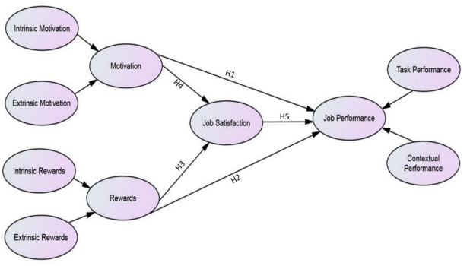
Inter-Connection Between Different Motivational Factors to Enhance Performance
(Source: Kumari et al. 2021)

Relevant Motivational Theories and Their Applications in Organisational Contexts for Enhancing Employee Productivity
Different researchers proposed different relevant motivational theories, which can be implemented in the context of employee motivation for enhanced productivity. According to the research work of Ghaleb and Dahiam (2024), it has been found that as per the theory of Maslow's Hierarchy of Needs, motivation practices of employees depend upon some specific fundamental security provision of employers, including job security, fair pay policies, career opportunities, performance recognition and self-actualisation. Employers need to consider these basic needs and provide an engaging workplace environment where employees feel free to participate and enhance their productivity levels. For both small and large organisational contexts, employers can easily implement this theory to enhance employees’ performance.
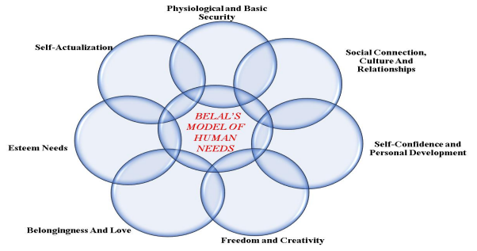
Theories of Maslow's Hierarchy of Needs
(Source: Ghaleb, B.D.S. and Dahiam, 2024)
As per the perspective of Mitsakis and Galanakis (2022), it can be said that Herzberg's Two-Factor Theory is still relevant in the 21st century, which portrays two basic factors, including Hygiene Factors (wages, working environments and employment benefits) and Motivators (incentives, recognition and workplace achievements). This theory identifies that hygiene factors have the ability to meet employees’ requirements and reduce motivational obstacles, whereas motivators increase workplace involvement. In workplace settings, managers consider both factors and try to maintain fair wage policies with supporting engagement factors, such as incentives, recognition and supportive workplace environment policies to motivate employees for enhanced productivity. McGregor’s Theory refers to the aspects of employee motivation from the perspective of a manager by considering Theory X and Theory Y. According to the perspective of Galani and Galanakis (2022), it can be said that in workplace settings, managers identify employees’ needs and specific motivator factors and meet them to develop an engaging workplace setting for enhanced productivity.

Potential Challenges and Probable Mitigation Strategies in Employee Motivational Approaches
While implementing effective employee motivation strategies in the workplace, managers generally face multiple problems. According to the perspective of Ghani et al. (2022), it has been identified that the findings of employees’ needs from a diversified range are difficult. Employees from different backgrounds and different workplace settings have different requirements. Based on the research work of Azmy (2021), it has been observed that limited budget resources and effective resource utilisation methods might create challenges for managers in conducting employee motivation-based practices, including reward policies. Additionally, excessive external pressure for enhanced productivity or a limited employee base might also create challenges for managers to implement worthy motivation strategies. However, based on the opinion of Ghani et al. (2022), it has been observed that developing proper resource utilisation models, creating proper budget frameworks and controlling external pressure tactfully can offer potential mitigation strategies for managers to enhance opportunities for implementing motivation strategies for enhanced employee productivity.
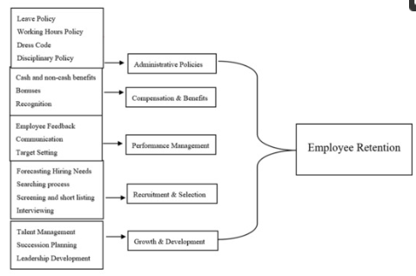
Factors Affecting Employee Retention
(Source: Ghani et al. 2022)

Conceptual Framework
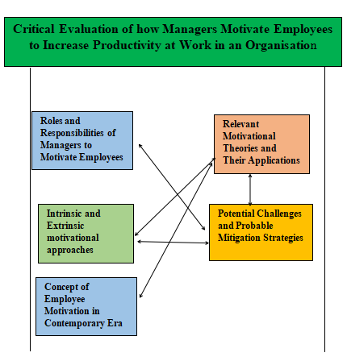
Conceptual Framework
(Source: Developed as per Study)

Description, Evaluation and Justification of Proposed Methodology and Sampling

Research Method
According to the perspective of Saunders et al. (2019), it has been identified that the concept of Research Method refers to the process of conducting a study to meet its objectives. The research method is a scientific process that helps researchers determine the most effective ways to conduct a study to achieve results. Within research work, three types of research strategies are widely popular, including Qualitative, Quantitative and Mixed Strategy. Based on the research work of Creswell and Creswell (2018), it has been found that the qualitative research strategy refers to the process of collecting subjective data that cannot be measured by numeric values. On the other hand, to conduct studies, when researchers use statistical data, which can be calculated by numeric values, it is known as a quantitative research strategy. Additionally, when researchers use both qualitative and quantitative research strategies to identify a specific research problem, it is known as the mixed method. To identify and evaluate managers’ rules in organisational settings to motivate employees for enhanced productivity, the study will use the mixed method, because of its opportunities to introduce both countable and non-countable data and conduct critical analysis accordingly.
Justification of Selecting the Research Method: The main objective of the study is to identify managers’ roles and responsibilities to enhance employees’ productivity by fostering effective motivational practices. The utilisation of scholarly articles is important to understand theoretical aspects (Tracy, 2021). On the other hand, considering statistical data by involving participants directly from the industrial sector will be beneficial for the study to get the actual insights into the specific study. It has been observed that utilisation of a mixed method (where both countable and non-countable data are present) helps researchers to make critical analysis by comparing and contrasting different approaches. Thus, ther utilisation of mixed methodological strategy is appropriate and justified.

Data Collection Method
Three Types of data collection methods are identified for conducting a dissertation, including the primary method, the secondary method and the mixed method. As per the viewpoint of Coolican (2018), it has been identified that the primary method is identified as the actions of collecting data directly from fieldwork, whereas the secondary method refers to the actions of collecting data from different existing resources, like journals, articles, publications, authorised websites and others. To identify data from different journals like ‘Future Business Journal’ and conference papers like ‘Proceeding Medan International Conference on Economic and Business’, this study will develop a comparative analysis, based on the selected problem. Moreover, by conducting interviews and surveys, this study will also collect primary data from industrial areas to get actual insights on real-time incidents in the market through the random sampling strategy. Based on the perspective of Plano and Ivankova (2015), it is found that the mixed method is the process of collecting important research data from different scholarly resources along with participants’ opinions. This study will consider the mixed method, which combines both primary and secondary research strategies.
Justification of Selecting the Method: As opined by Plano and Ivankova (2015), it can be said that the mixed data collection method helps researchers to get both theoretical perspectives and real-time knowledge, and the probability of biased identification becomes low. To get a proper insight into the selected problem, considering the mixed data collection method with random sampling is justified.
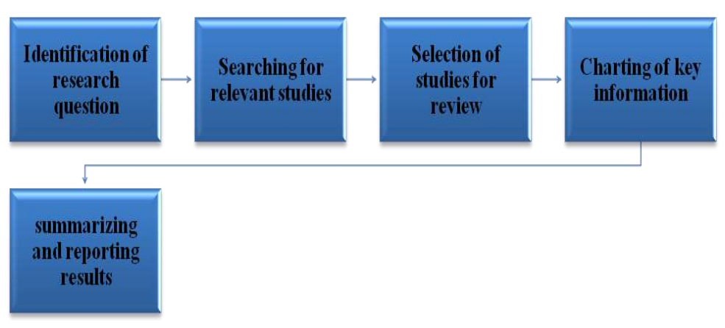
Process of Secondary Qualitative Research
(Source: Kalogiannidis, 2021)

Ethical Considerations, Reliability and Validity
Ethical Considerations: This study will consider ethical norms while conducting the data collection and analysis. The researcher will protect the confidentiality of individual respondents’ responses, based on the Data Protection Act (2018) and maintain academic dignity by recognising former researchers’ studies through a thorough bibliography (Hasan et al., 2021). This research will use informed consent before collecting responses from participants and acknowledge voluntary participation properly.
Reliability and Validity: To ensure reliability and validity of the study and avoid all types of information-related bias, this study will utilise the mixed method, where the researcher will involve both scholarly perspectives and real-time datasets, derived from the interview and survey. This mixed method will show the accuracy of the actual scenario and enhance credibility in front of tutors.
Academic Integrity: This study will avoid all types of academic misconduct, such as utilising plagiarised content and the use of generative AI, to maintain academic integrity throughout the study. Moreover, this study will acknowledge former researchers by creating a detailed reference list and in-text citations throughout the project.

Conclusion
After completing the entire study on the research proposal, it can be concluded that to identify managers’ roles and responsibilities in organisational contexts to enhance employee motivation, it is important to conduct both primary and secondary studies to identify the actual industrial contexts accordingly. For further development, the study might involve more participants in the interview and survey to get wider responses from different genres.

Reference List
Kalogiannidis, S., 2021. Impact of employee motivation on organizational performance. A scoping review paper for public sector. The Strategic Journal of Business & Change Management, 8 (3), 984, 996(3).
Theng, B.P., 2023. The Impact of Employee Motivation on Productivity. International Journal of Health, Economics, and Social Sciences (IJHESS), 5(1), pp.209-221.
Engidaw, A.E., 2021. The effect of motivation on employee engagement in public sectors: in the case of North Wollo zone. Journal of Innovation and Entrepreneurship, 10(1), p.43.
Kumari, K., Barkat Ali, S., Un Nisa Khan, N. and Abbas, J., 2021. Examining the role of motivation and reward in employees’ job performance through mediating effect of job satisfaction: An empirical evidence. International Journal of Organizational Leadership, 10(4), pp.401-420.
Susanto, P.C., Syailendra, S. and Suryawan, R.F., 2023. Determination of motivation and performance: Analysis of job satisfaction, employee engagement and leadership. International Journal of Business and Applied Economics, 2(2), pp.59-68.
Setyawati, N.W., PG, D.S.W. and Rianto, M.R., 2022. Career development, motivation and promotion on employee performance. East Asian Journal of Multidisciplinary Research, 1(9), pp.1957-1970.
Karsim, K., Susilowati, E., Setiawan, W.B., Syafii, M. and Rijal, S., 2023. Nurturing Job Satisfaction: Social Interactions and Work Environment via Empowering Motivation. Jurnal Informatika Ekonomi Bisnis, pp.772-778.
Ghaleb, B.D.S. and Dahiam, B., 2024. Towards A Dynamic Model of Human Needs: A Critical Analysis of Maslow’s Hierarchy. International Journal of Multidisciplinary Approach Research and Science, 2(03), pp.1028-1046.
Mitsakis, M. and Galanakis, M., 2022. An empirical examination of Herzberg’s theory in the 21st century workplace. Organizational psychology re-examined. Psychology, 13(2), pp.264-272.
Ghani, B., Zada, M., Memon, K.R., Ullah, R., Khattak, A., Han, H., Ariza-Montes, A. and Araya-Castillo, L., 2022. Challenges and strategies for employee retention in the hospitality industry: A review. Sustainability, 14(5), p.2885.
Azmy, A., 2021. The effect of employee engagement and job satisfaction on workforce agility through talent management in public transportation companies. Media Ekonomi Dan Manajemen, 36(2), pp.212-229.
Galani, A. and Galanakis, M., 2022. Organizational Psychology on the Rise—McGregor’s X and Y Theory: A Systematic Literature Review. Psychology, 13(5), pp.782-789.
Creswell, J.W. and Creswell, J.D., 2018. Research design: Qualitative, quantitative, and mixed methods approach. 5th ed. Thousand Oaks, CA: SAGE Publications.
Saunders, M.N.K., Lewis, P. and Thornhill, A., 2019. Research methods for business students. 8th ed. Harlow: Pearson Education.
Tracy, S. J. (2020) – Qualitative Research Methods: Collecting Evidence, Crafting Analysis, Communicating Impact (2nd ed.)
Coolican, H. (2018) – Research Methods and Statistics in Psychology (7th ed.)
Plano Clark, V. L., and Ivankova, N. V. (2015) – Mixed Methods Research: A Guide to the Field
Hasan, N., Rana, R.U., Chowdhury, S., Dola, A.J. and Rony, M.K.K., 2021. Ethical considerations in research. Journal of Nursing Research, Patient Safety and Practise (JNRPSP) 2799-1210, 1(01), pp.1-4.

Research Instrument
Appendix 1: Interview Questions
- Which employee motivation strategies do you prefer to enhance employee productivity in your organisation?
- What is your opinion on making balanced infrastructure in organisational contexts by involving both extrinsic and intrinsic motivators?
- What specific challenges do you face while conducting employee motivation for increasing workplace productivity?
- How do you measure the effectiveness of the motivational approach to achieve extended productivity?
Appendix 2: Survey Questions
- Please mention your work experience as a manager.
- 0-05 years
- 05-10 years
- 10-25 years
- More than 25 years
- Do you feel engaged with your current organisational roles?
- Highly Disagree
- Disagree
- Neutral
- Agree
- Highly Agree
- Which type of motivation do you think is perfect for your organisation?
- Extrinsic
- Intrinsic
- Both
- None of all
- Do you think giving carrer opportunities can motivate employees?
- Yes
- No
- Sometimes
- Not sure
- Are performance-based reward strategies beneficial for employee motivation?
- Yes
- No
- Sometimes
- Not sure
- Do you think managers are responsible for motivating employees for better performance?
- Yes
- No
- Sometimes
- Not sure
- Which type of motivation strategies are essential for employees to enhance their productivity?
Monetary support
Acknowledgement
Carrer opportunities
All of the above
- Do you think transparent communication is important for managers to enhance employee motivation levels for higher organisational productivity?
- Yes
- No
- Sometimes
- Not sure
- The identification of employees’ needs is essential for developing workplace motivation.
- Highly Disagree
- Disagree
- Neutral
- Agree
- Highly Agree
- Do you think that feedback-based performance analysis can support managers in motivating employees for higher employee productivity?
- Yes
- No
- Sometimes
- Not sure

Task 2: Recorded Presentation

Slide 1: Title Slide
- Student Name: Lavinia Neda
- Module Name: Developing a Research Proposal
- Research Title: Developing a Research Proposal
- Student ID:
- Research Topic: A Critical Evaluation of how Managers Motivate Employees to Increase Productivity at Work in an Organisation

Slide 2: Introduction
Employee motivation becomes important for managers in this contemporary context to increase the overall productivity of a firm.
Identification of high-end employee notification factors becomes vital to maintain the competitiveness of Companies because, with proper motivation approaches, organisations can enhance their productivity levels.
Different academic theories and perspectives, along with real-time data, will utilise this project to identify employee motivation strategies in different organisational settings.
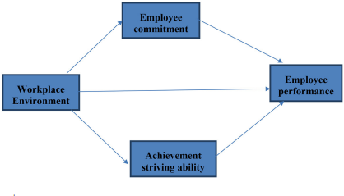
Employee Motivation Contexts
(Source: Zhenjing et al. 2022)
Note: In dynamic work environments, employee motivation becomes important for organisations to maintain high productivity rates. To motivate employees for increasing productivity, managers consider different strategic practices to achieve success in a competitive environment.

Slide 3: Methodology
- This study will employ the Mixed Research Method.
- The mixed research method is a combination of both qualitative as well as quantitative data identification strategies (Flick, 2023).
- The study will use both statistical and theoretical data to conduct a critical analysis, based on the research topic.
- Academic information and real-time market data will be utilised for the study.
- This research style will help to avoid any type of bias within the project.
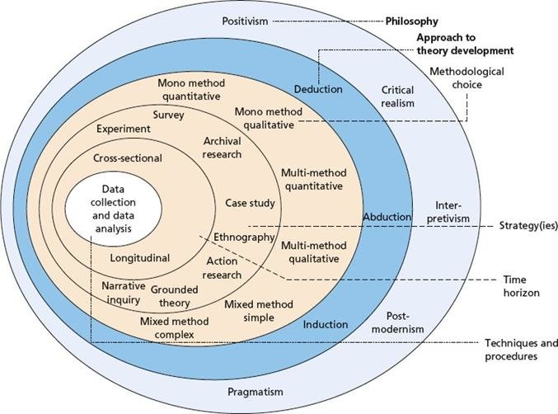
Layers of Research Methods
(Source: Melnikovas et al., 2018)
Note: The study will intend to identify the roles of managers to increase the employee motivation level for enhanced productivity. So, the researcher will use the mixed method, where theoretical aspects and real-time data sets will be present. This mixed research method is justified for the study because it will help the researcher to make a critical analysis by comparing theoretical aspects with real-time responses.

Slide 4: Methodology
- Mixed Data Collection Method will be followed in this study.
- Both primary as wel as secondary resources will use in this data collection method (Tashakkori and Teddlie, 2020).
- The researcher will utilise a survey and an interview to collect primary data.
- Different scholarly articles, journals, books and authentic websites will be used as secondary data resources.
- By involving 30 participants, this study will use random sampling for the survey.
- By maintaining data consistency and authenticity, the researcher will maintain research reliability.
- For validity, the study will provide ethical consent forms from responses for the primary research
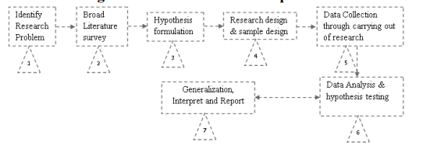
Flow Chart of Research Methods
(Source: Mishra and Alok, 2022)
Notes: The study will use a mixed method, where the involvement of both primary and secondary data ensures reliability and advancement of the study. For primary research, the study will involve different participants, and for the secondary research, the study will use scholarly articles, journals, books and authentic websites. Here, the researcher will utilise a random sampling method involving 30 participants for the primary study. The study will also involve 05 managers to collect their perspectives, based on the research topic, through the interview process. It is anticipated that this combination will help the researcher to conduct a critical analysis and reach research findings efficiently.

Slide 5: Ethical Considerations
- The study will collect informed consent from participants to ensure their prior permission.
- The study will protect the confidentiality of responses by considering the Data Protection Act (2018) (Legislation, 2024).
- The study will take prior permission from participants before utilising their responses.

Data Protection Act
(Source: Legislation, 2024)
Note: In this research, the researcher will develop a clear constant form for participants by explaining, purpose, objectives and processes of this study to make the research more ethical. Addtionally, the researcher will protect participants’ responses confidentially and take their prior permission before utilising these responses. The main reason behind using these practices is securing the standard and making the study exclusive in front of others.

Slide 6: Ethical Considerations
- The researcher will utilise effective measurements to protect participants from unwanted harms, including data leakage and the misuse of their responses.
- The study will maintain academic integrity by acknowledging previous researchers through a detailed bibliography.
- This study will be concerned with academic integrity and will refrain from any kind of academic misconduct.
- The study will not use plagiarised content or use generative AI throughout the study.
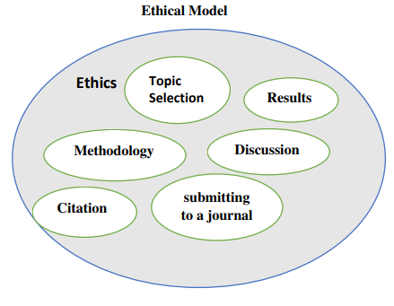
Ethical Model for Study
(Source: Hasan et al., 2021)
Note: To maintain the standard of the study, the researcher will protect participants' interests and academic integrity as per the university guidelines. Additionally, the study will maintain its standards by avoiding any kind of academic misconduct and falsification of data. Based on the university guidelines about research, the study will develop its methods and outline its research processes to make the study worthy.

Slide 7: Limitations and Recommendations
Potential Limitations
- Generalised data finding patterns and utilisation of responses from limited candidates might create challenges for systematic explanation.
- The allocated time is short for this study, which might not be sufficient for conducting and analysing large datasets.
- Strict industrial protocols to reach managers and employees might create challenges for proper data collection techniques.
Recommendations
- The Study may involve more participants to get wider responses.
- The researcher can visit managers with proper formalities to avail of easy access.
Note: During the time of analysis, the researcher might face multiple difficulties, including the presence of limited participants in the survey program, shortage of time and strict protocols to reach industrial people. To overcome such situations, the researcher might consider proper formalities to reach more industrial personnel and introduce more participants to get wider response ranges and conduct an in-depth analysis.

Slide 8: Conclusion
- This initial study showed further development stages of the research.
- This study will utilise a mixed data collection method in this study.
- To maintain academic standards, the research will thoroughly employ ethical considerations.
Note: From the initial analysis, it can be concluded that to make the study more efficient and what the researcher will employ both quantitative and qualitative strategies along with a mixed Data Collection method, where both primary and secondary data will be used. It is anticipated that the study will complete its overall findings within the deadline and maintain ethical standards.

Slide 9: Reference List
Flick, U. (2023) – An Introduction to Qualitative and Quantitative Research (7th ed.)
Tashakkori, A., and Teddlie, C. (2010) – Mixed Methodology: Combining Qualitative and Quantitative Approaches
Legislation, 2024, ‘Data Protection Act (2018)’, available at: https://www.legislation.gov.uk/ukpga/2018/12/contents accessed on: 31-05-2025
Zhenjing, G., Chupradit, S., Ku, K.Y., Nassani, A.A. and Haffar, M., 2022. Impact of employees' workplace environment on employees' performance: a multi-mediation model. Frontiers in public health, 10, p.890400.
Melnikovas, A., 2018. Towards an Explicit Research Methodology: Adapting Research Onion Model for Futures Studies. Journal of futures Studies, 23(2)
Mishra, S.B. and Alok, S., 2022. Handbook of research methodology. Educreation publishing.
Hasan, N., Rana, R.U., Chowdhury, S., Dola, A.J. and Rony, M.K.K., 2021. Ethical considerations in research. Journal of Nursing Research, Patient Safety and Practise (JNRPSP) 2799-1210, 1(01), pp.1-4.

