Name: Jay Streader
Student Number: 2501188
Course title: BA Design Craft: Glass, Ceramics and Jewellery
Module: ADDA4023
Tutor: Menna Buss

Word count: 1,557

Curating a Show

Introduction:
I want to bring a show to the public which brings to light the beauty of tattoos and their historical importance. I feel as though this is a significant topic that needs to be investigated as we just don’t talk about this artform’s cultural importance and generational magnitude. I would like to present this show at the Last Rites Gallery in New York City as this location is one of the only places that is both a tattoo studio and an art gallery. I think displaying this message in a place like this is going to make the meaning of this curation a lot easier to understand. “I cannot remember a time that I have not been fascinated by the art of tattooing. Tattoos are a symbol of freedom and self-expression, as well as on of the few things in life that we can truly own without the risk of having it taken away” ( Aitken-Smith, 2016, p.1).

Context:
The intention is to showcase the 2,500 year old Siberian ice mummy who has some of the world’s oldest and most intricate tattoos that have been preserved through mummification. The tattoos themselves seems to be a combination of real and mythical creatures which may shed some light on this woman’s ancient Pazyryk culture, which isn’t a culture many people know much about. Having this artifact displayed in this show would not only bring people that are interested in tattoos but also intrigue those who are fascinated by history. While not much is known about the person that was found, It is known she was buried with silk clothing and jewellery and had these incredibly intricate tattoos which has shown that the Pazyryk people where not just barbarians as originally thought, but a highly artistic and sophisticated group. There has been much debate about her origin and heritage, this has led to conflicts about who should keep her remains. Russian researchers have claimed that the mummy was not genetically related to modern Altaians (claiming her DNA is more European) which has been used to justify keeping her body in Russia. This was seen by locals as a move to undermine their cultural sovereignty. This display of her with a full description about where she was from and the cultural importance of her people would not only affect audiences with an exciting exhibit but also shed important light on the history of the Altaians.
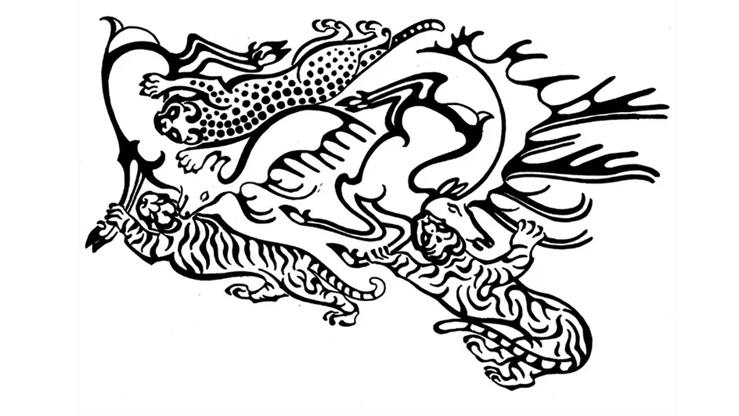
Fig. 1. Tattoo design located on the Siberian ice mummy’s right arm.
Also having a space for current and contemporary artists to display their works is vital for this exhibition as not only is this a conversation about historical significates but how that translates now and how has it evolved. Also on display will be the work of Olivier Maximilian, a Swedish artist who has had a long career in tattooing and now dedicates his time to creating 3D pieces inspired by tattoo styles, folklore and witchcraft combining functional as well as decorative ware. Maximilian has a BA in Fine Art from Duncan of Jordanstone College of Art and Design, Dundee. In 2021 he displayed his work in his first group exhibition at the Galleri Granen, Sundsvall.
The pieces of Maximilian’s work selected are his Thorn Vase and his Skull Bowl. His Thorn Vase is thrown in stoneware with hand sculpted thorns. He used a white red speckled glaze and a metallic glaze combined with hand painted cobalt oxide to create the look and finish he was going for. It is 14.5cm wide and 17.5cm tall and works as a fully functional vase.
The Skull Bowl is made using an off white red speckled glaze and hand painted with cobalt oxide. It is 14.5cm wide and 4cm tall and is completely dishwasher safe meaning it can be used just like any other household bowl.
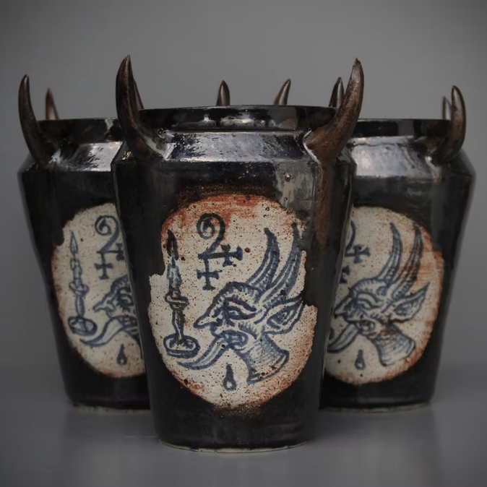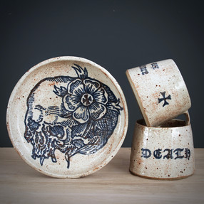
Fig. 2. The work of Maximilian I would like to show

“Historically, tattooing was limited to specific groups: members of tribes, criminals, and/or slaves forcibly tattooed; early Christians voluntarily tattooed themselves to honour Christ. Tattoos in these cases signified membership of specific groups enabling their identification. The premodern use of tattooing bore little resemblance to todays practice particularly the tattooing process and the diversity of contemporary consumers. Their use and purpose has expanded dramatically in the 21st Century. While tattoos may hold no inherent meaning, many are currently used as records of important life events providing reminders of loved ones.” (Rees, 2021, Chapter 1).
This quote from Dr Michael Rees’ book ‘Tattooing in contemporary: Identity and Authenticity’ perfectly explains why I feel that the art of tattooing is so important and needs to be displayed. Tattoos have always carried such significance, whether it’s, historical tribal tattoos, nonconsensual tattoos given to slaves, or even that tattoo your friend has to remember their dog who is no longer with them. They all tell a story and you can use these stories to track the change in society and this will likely continue until the end of time.

Analysis:
This exhibitions main artefact is the 2,500 year old Siberian Ice Mummy who was found with some of the oldest and most intricate tattoos in human history, as a rare show of such a significant artefact, large audience numbers may be expected. The tattoos found on the mummy depict various animals and mythical creatures which have led researchers to believe she was of Scythian heritage due to similar style paintings found in this area. This discovery immensely important to the modern Altaians as it gives insight on the life style and behaviours of their ancestors. She was also found buried with silk clothing and gold jewellery. It was often believed that people from the Pazyryk culture ( which it is believed the mummy is from) were nothing more than “savages” but these findings have shown that they were highly sophisticated and artistic.
As well as this, my exhibit will heavily focus on her origins and culture. This is important because the Russian scientists who found her have claimed that the mummy was not genetically related to modern Altaians and have claimed her DNA is more European which has been used to justify keeping her body in Russia. This was seen by locals as a move to undermine their cultural sovereignty. For these reasons I feel as though this would be the ideal artifact for my show as it not only highlights the history of tattooing and how far back it dates, but also has a massive cultural importance and could shine light on a culture that many of us are not aware of, hopefully leading to more research and more knowledge about these people.
Further research on curation concludes that the most important aspect was a cohesive theme. This is why I decided to use the Last Rites Gallery in New York as I thought there was no better place to hold my exhibit on tattoos and their historical importance than an art gallery that is also a working tattoo studio. I knew that the people who would be most likely to know about the venue and attend would be people who are also passionate about tattooing and find my show insightful. I also thought that if my show was to bring new eyes to the gallery it would also bring new potential customers to the tattoo artists who work there, supporting the industry further.
When considering the logistics, such as shipping and insurance and after a brief panic about how difficult it would be to insure a 2,500 year old mummy I remembered it was not a real show and moved on with my ideas.
The map created of the proposed layout for show making the most of the open plan layout at the gallery which can be seen below.
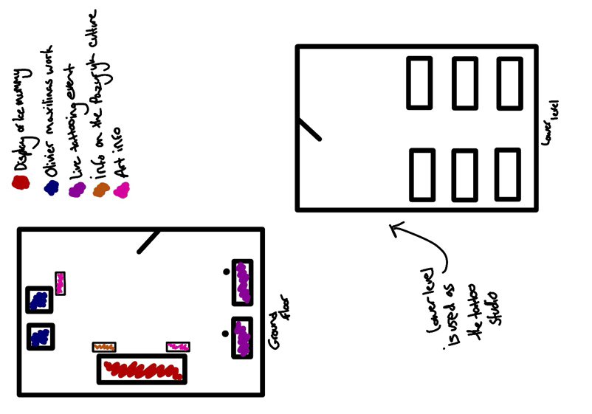
Fig. 3. Floor plan

Having a few public engagement events would be vital to give further vale to the show. Hosting a private view of my exhibit before it opens to the public including a Live Q&A from Olivier Maximilian to talk about his work. This private view would help raise money for the venue and provide the exhibition with valuable feedback and an idea of the public reception to the event. The Q&A would also help get more eyes on Oliver and his work.
Another event that could be hosted is a Live tattooing event to showcase tattooing as an art form. People could have the chance to explore the art form and see the process from start to finish.
To conclude, there is a strong emphasis on exposure as the show highlights tattooing is getting more and more common every day yet people appreciate or are even aware of its history and how far back it dates. It would also be important to teach people the meaning of historical tattoos and how they can be used to identify culture and deep history of the people who have them. Not every tattoo is made to have a deep meaning, but every single tattoo is a continuation of this ever changing and evolving artform therefore has roots far deeper than most will ever even realise. The tattoos found on this 2,500 year old mummy have changed our modern perception of a group of people we once believed to be savages and has shown us that they were in fact a deeply artistic and sophisticated group of people. The hope would be that people leave my show with an understanding of how significant tattoos can be and how much they can show us about people.

Reference list:
Aitken-Smith, T. (2016) The tattoo Dictionary: an A-Z to the secret language of tattoos. London: Mitchell Beazley.
Rees, M. (2021) tattooing in contemporary society: identity and authenticity. Abingdon: Routledge.

Bibliography:
Bayley, L. (2019) Curating and collecting. In: reshaping the collectible: When Artworks Live in the Museum. London: Tate. Available at: https://www.tate.org.uk/research/reshaping-the-collectible/research-approach-curating-collecting-museolgy (Accessed 12 April 2026)
Booth, P. (2025) Paul Booth Art. Available at: https//www.paulboothart.com/ (Accessed: 12 April 2026)
Aitken-Smith, T. (2016) The tattoo Dictionary: an A-Z to the secret language of tattoos. London: Mitchell Beazley.
Rannard, G. (2025) 2,500-year-old Siberian ‘ice mummy’ had intricate tattoos. BBC News. Available at: https://www.bbc.co.uk/news/articles/c4gzx0zm68vo (Accessed 13 April 2026)
Dasgupta, p. (2021) The story behind the Siberian Ice Maiden and her tattoos. Medium. Available at: https://medium.com/teatime-history/the-story-behind-the-siberian-ice-maiden-and-her-tattoos-acfcacf70dc4 (Accessed 14 April 2026)
Maximilan, O. (2025) About. Available at: https:www.oliviermaximilian.com/about (Accessed: 14 April 2026)
Rees, M. (2021) tattooing in contemporary society: identity and authenticity. Abingdon: Routledge.

