Dissertation Proposal

Are police inconsistencies jeopardising the trust and support provided to victims of domestic violence
Introduction
Over recent years, domestic abuse through various media channels has become a more commonly discussed topic, which in turn has created an upward trend of domestic abuse cases being reported.
Whilst research will primarily focus on UK-based domestic violence, it is evident that on a global scale domestic abuse is a common problem for many countries with a report by the World Health Organisation reporting that 37% of women in less developed countries between the ages of 15-49 years old will have experienced some sort of intimate partner-related violence in their lifetime. Of these countries less than 10% of victims seek support from the police; the majority turn to family and friends instead for support.
Research will be based and conducted within the England and Wales police force to ensure accuracy of statistics and data compiled, along with qualitative research conducted within these forces to attempt to answer the research question.
Within England and Wales there is a visible trend whereby the reported number of domestic related crimes have almost doubled within a four-year period. Between 2015 – 2019, the below table shows that the reported crimes have risen from 421,185 to 746,219.
Table 9: Number of domestic abuse-related crimes recorded by the police and percentage of offences that were domestic abuse-related, by police force area, English regions and Wales, year ending March 2016 to year ending March 2019^{1,2}
England and Wales |  |  |  |  |  |  |  |  |  | Police recorded crime
Area code | Police force area | Total number of domestic abuse-related crimes | Percentage of all crimes that were domestic abuse-related |  | Total number of domestic abuse-related crimes | Percentage of all crimes that were domestic abuse-related | Total number of domestic abuse-related crimes | Percentage of all crimes that were domestic abuse-related | Total number of domestic abuse-related crimes | Percentage of all crimes that were domestic abuse-related
Area code | Police force area | Apr '15 to Mar '16 |  |  | Apr '16 to Mar '17 |  | Apr '17 to Mar '18 |  | Apr '18 to Mar '19
K04000001 | ENGLAND AND WALES | 421,185 | 11 |  | 488,049 | 11 | 599,549 | 12 | 746,219 | 14
(Figure 1)

In the year ending March 2021, the trend has continued to rise whereby the number of incidents reported sat at 1,459,663. However only 58% of these were recorded as crimes.
Whilst the numbers recorded by police can be recognised as a positive and used as an evidential measure that victims are beginning to trust the police processes. However, the statistic that whether the crime prosecution service (CPS) charging rate has decreased for the third successive year of domestic-abuse related crimes to 70% from 76% for the year ending March 2021 can be an argument for police inconsistencies or police officer incompetence remains to be seen.
From experiencing first-hand in a role as a police officer the difference in decision making of identical crimes, research will be conducted as to whether their recommendations should be made on a base point to ensure there is a more accurate or reliable threshold across the board.
Research Methodology
Quantative method is defined as ‘a systematic investigation of phenomena by gathering quantifiable data and performing statistical, mathematical, or computational techniques.’
Qualitative method is defined as ‘a method of research that produces descriptive (non-numerical) data, such as observations of behaviour or personal accounts of experiences.’
Research in the dissertation will be conducted through two both methods.
Qualitative research will be the primary used source of information gathering throughout the dissertation, through various different methods. This will be current and published news articles, honest and trustworthy websites or domains and published books. Th online library at UWTSD will also be a method of choice should the needs arise.
There are many articles and documents that are available to access especially on recent events that have unfolded that question the trust in police behaviours and actions.
Quantative research will be conducted to prove or disprove the research question proposed. This will be conducted through surveys distributed to both serving officers for completion and members of the public. This will be conducted on an anonymous basis for completion through survey monkey. Due to different data requirements, the surveys distributed to both will contain different content.
Questionnaires will be conducted with willing participants from both the workplace and members of the public. These will be identified through social media and other social settings. The need for two separate surveys will be to gather different types of data from an internal and external basis.
By completing both research method’s it will enable to analyses a greater depth from various sources which at its conclusion will be to attempt to answer the proposal question and to make any necessary recommendations that are identified throughout the method.
Research Rationale
With the UK Government adapting laws and creating further laws to assist with the support and protection of domestic violence victims, it is concerning that there remains a differentiation between incidents reported to the police and incidents disclosed through third party research studies, such as questionnaires or polls. The table below shows a survey conducted whereby the pattern of domestic abuse has remained consistent over a ten-year period, whilst official figures how a trend in the number of domestic related crimes reported.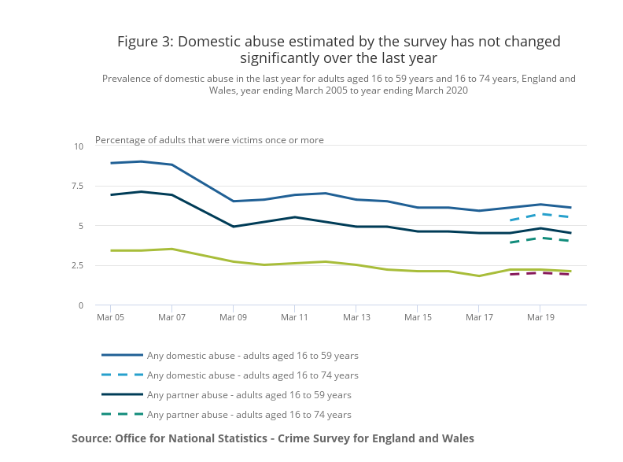
(Figure 2)
The objective of the research is to identify if recent negativity surrounding police officers in various fields has damaged police reputations as a whole or whether inconsistencies between policing processes of neighbouring forces is a reason for the trend gaps.
Through identifying research topics to be answered throughout the research study, such as:
- What differences if/any are taken by neighbouring police forces when responding to DV incidents.
- What is positive action – Are the police victim led?
- What support looks like after police involvement?
Within the research gathered from both Quantitative and Qualitive channels and the analysis of the information gathered, the proposal will be answered.
How police inconsistencies are jeopardising the trust and support provided to victims of domestic violence
Analysis will be completed following research to attempt to make recommendations for improvements to be made to ensure that the victims are able to feel supported throughout their journey with police involvement and post-police involvement. At present there is evidence to support suggestions trust has been lost in police actions. It is the aim of the research to identify the truth and accuracy of this and to establish the reasons behind this from relevant sources.
With domestic abuse becoming more widely recognised within both males and females, it is imperative that victims have the knowledge and belief that when they reach out for support that prosecution of offenders follows and in return will help to ensure protection of their vulnerabilities. With that being said, it is also vital to conclude that thorough investigations take place to identify a correct offender and the true nature of the incidents reported.

Reliability
Throughout the research, both qualitative methods and quantitative methods will be used. This will be used to ensure that biased personal opinions are kept to a minimum.
Through either channel of both quantitative and qualitative research there may be opinions that lead towards one side of the argument. Therefore, it is with a great aim to gather research from both methods to help to provide a reliability to the gathered data. By achieving this it is maximising the results that will be gained and give a better understanding of the recommendations made at the conclusion of the research.
Through Quantitative research the ability is there to gather information that can help to prove or disprove the proposal question. This will be the aim whilst gathering information and research will be completed through many platforms to ensure accuracy and reliability.
Through the completion of qualitative research, questionnaires will be distributed through the ‘survey monkey’ website anonymously to police officers and member of the public. This will be to gather evidence to identify if the general census is similar from both and to consider any additional factors provided by either.
Resource and Time Management
Due to full-time work commitments, time management has been considered in the approach to meet an achievable timeframe for research and completion. Due to the employment within the police force, some research can be achieved on-the-job through evaluation of knowledge on processes. Other positives can be utilising officers’ thoughts through anonymous research data.
The university has constant availability to use the online learning to assist with writing materials and functions. Using an online calculator of everyday time restraints, the below highlights the disposable time available each week to complete research.
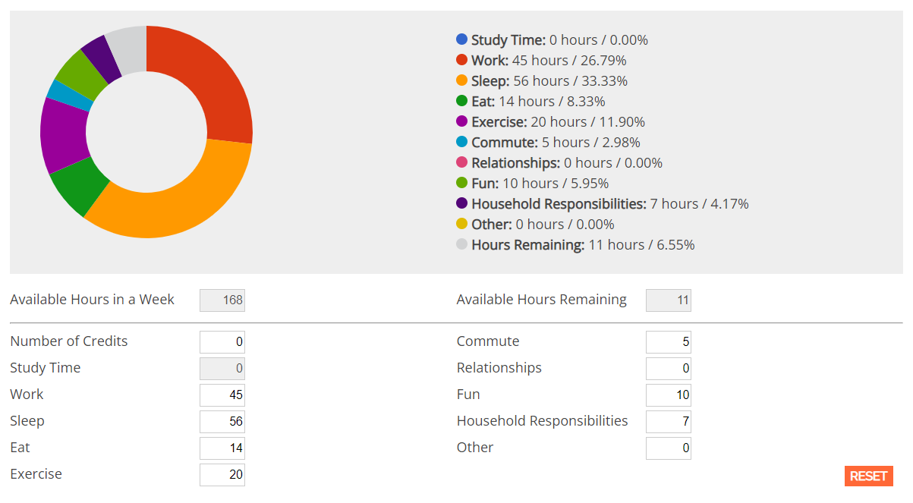
(Figure 3)
With support from employers, dedicated days have been built into my work rota to allow for comprehensive research and study time. This will allow for adequate analysis of any research completed in relevance to the study.

