Qualification: CIPD Diploma in Applied Human Resources

Module: Understanding Coaching and Mentoring within the Organisation

On the Job Training Record

Word Count: 1153 words

Student Name: Melanie Gough
Student Number: 1910141
CIPD Membership Number: 54660544

By signing below, I confirm that the work/evidence presented is my own, unaided work. I understand the regulations pertaining to candidate malpractice and the action that may be taken as a result.

Signed: M. R. Gough

Date: 25/07/2021

Contents
Meeting to understand Valero’s approach to coaching and mentoring 3
Valero’s learning and development policy relating to coaching and mentoring 5
Meeting to discuss my development needs regarding coaching and mentoring 6
References 7
Appendix 1 - Coaching and Mentoring Training 8
Appendix 2 – Coaching Guide 10
Appendix 3 - Coaching Questions Guide 13

Meeting to understand Valero’s approach to coaching and mentoring

Present: Joanne James, HR Manager; Tracey Bryant, Manager Learning and Development, Melanie Gough, HR Business Partner

Valero Pembroke Refinery is committed to the concept of coaching and mentoring to improve employee performance and encourages coaching and mentoring through several initiatives.

Coaching and Mentoring Learning and Development (Appendix 1)
Valero offer coaching and mentoring related training sessions via the Valero Training and Development portal.

Driving Performance Excellence: Coaching
This training session is available for Supervisors to learn the qualities of an effective coach and help them coach employees. Supervisors will also explore formal and informal coaching, coaching strategies to help improve their coaching skills, and recognise how employees want to be coached.

Emerging Leaders – Series 3: The Art and Science of Coaching
This training session is available for those employees identified as ‘high potential’ and ‘emerging leaders’. The training is designed to for individuals to practise their coaching skills and be shown different ways that a leader can effectively coach their employees.

Responding to Coaching (Virtual)
This course is designed to teach individuals how to respond to and ask for informal and formal coaching.

Frontline Experience
This course is designed to help recently promoted professionals successfully make the transition from the individual contributor role to the supervisor.

Frontline Experience: Coaching
This course is designed to help supervisors to get the most from their direct reports by learning a step-by-step approach to basic coaching.

Special Ops Training – Mentor Version
This course is designed to help selected mentors facilitate learning with new operators upon completion of the Basic Operator Training (BOT) programme. Mentors will learn basic skills to enhance on the job training, such as giving and receiving feedback and asking effective questions.

Individual Development Plan Training
This course is designed to help individuals create an individual development training plan that will help them set immediate, short-term and long-term goals in preparation for structured discussions with a mentor or supervisor.

Coaching Guide
The Coaching Guide is a tool that can be used by supervisors and managers to prepare for a coaching conversation or an employee check-in meeting. The guide includes questions and tips to consider during each step of the coaching model, and reminds supervisors that “the most important part of a formal coaching conversation is preparation” (Valero, n.d.)

Supervisors can use the Coaching Guide to:
- Prepare for a coaching conversation
- Understand the employees perspective
- Ensure the employee understands your perspective
- Create an action plan
- Facilitate an employee check-in conversation
- Effectively document coaching and check-in sessions

Coaching Questions Guide
The Coaching Questions Guide is a tool that can be used by supervisors and managers to help build the Valero culture, drive for results, and create success within their team, and stresses that “supervisors don't need to have all the answers: they just need to ask the right questions” (Valero, n.d.)

Supervisors can use the Coaching Questions Guide to understand:
- What's going on in your employees role
- What inspires your employee
- What your employee would like to focus on in their development

Valero Apprenticeship Programme
The Valero apprenticeship programme uses a ‘peer mentoring’ approach. New apprentices are assigned a peer mentor – an ex-apprentice who has been through the apprenticeship programme a few years earlier. A peer mentoring programme is often considered “the best approach for a new employee, this is someone to introduce a mentee to organizational culture and show them the ropes”. (Behesti, (2019))

Parental / Family Leave and Career Break
Employees who take advantage of the Parental / Family Leave or Career Break leave of absence policy will be assigned a mentor from within their department, who will be responsible for informing them of the work being done in the department and any new developments within the Company and ensuring that they receive relevant Company literature or relevant press releases during their leave of absence.

Valero’s learning and development policy relating to coaching and mentoring

Valero is committed to coaching and mentoring, although a written down policy is not yet currently in existence. In 2020, Valero appointed a new Learning and Development (L&D) Manager, who is a qualified Coach-Mentor, a European Mentoring Coaching Council (EMCC) member and an EMCC European Quality Award (EQA) practitioner with over 20 years’ experience in coaching and mentoring. As an ambassador for coaching and mentoring, the L&D Manager is keen to introduce a learning and development policy relating to coaching and mentoring at Valero. The benefit of having a policy is that it can “provide consistency and transparency for employees and managers, helping to enhance the psychological contract and create a positive organisational culture” (George, (2021))

The policy would potentially include the following:
The scope of the coaching and mentoring programme
The role of the coach and mentor
The benefits of coaching and mentoring
Formal mentoring
Informal coaching and mentoring
The responsibilities of the coach and mentor
The responsibilities of the line manager
Coaching and mentoring training
Other training, learning and development initiatives

Valero offer several coaching and mentoring related training courses for supervisors and employees that could be incorporated

- Driving Performance Excellence: Coaching
- Emerging Leaders Series 3: The Art and Science of Coaching
- Responding to Coaching (Virtual)
- Frontline Experience
- Frontline Experience: Coaching
- Special Ops Training – Mentor Version
- Individual Development Plan Training

Meeting to discuss my development needs regarding coaching and mentoring

Present: Joanne James, HR Manager; Melanie Gough, HR Business Partner

As a HR Business Partner, I have had limited exposure to coaching and mentoring. I am currently working within Band 1 of the HR Profession Map, that “supports colleagues with administration and processes. Effectively manages information and data, and is customer orientated”. (CIPD, n.d.) In my role I am responsible for coaching newly appointed supervisors and their managers through the Supervisor Toolkit. The supervisor toolkit is designed to equip supervisors and managers with the tools they need to succeed.
The Valero culture encourages the HR function and supervisors to work together to ensure successful people and performance management.

I need to develop my skills and knowledge to progress to Band 2.

Action: Identify supervisors to attend the ‘Frontline Experience’ training course and follow up with attendees post-training to gain feedback.

Frontline Experience
Statistics reveal that 30-50% of recently promoted professionals failed to successfully make the transition from the individual contributor role to supervisor. In most cases, the failed transition occurs when supervisors and managers are still acting as individual contributors or are stuck in between the two roles. Without appropriate training, tools, and ongoing coaching, Valero's leaders may fall into the same unproductive pattern. Frontline experience is designed to help supervisors and managers with two years’ experience or more.

Course objectives:
- Communicate clear expectations, model behaviours, and hold employees accountable for performance aligned with the Valero mission, values, and core competencies
- Successfully execute the three phases of the Valero performance management process
- Engage in coaching activities on a daily basis to enhance employee relationships and improve productivity
- Approach discipline with a new perspective by leveraging relationships with local HR representatives and implementing effective documentation systems
- Utilise structured tools to prioritise work tasks, solve problems, and execute job duties

References
Behesti, N., (2019). Improve Workplace Culture With A Strong Mentoring Program. [Online]
Available at: www.forbes.com/sites/nazbeheshti/2019/01/23/improve-workplace-culture-with-a-strong-mentoring-program/
[Accessed 14 July 2021].
CIPD, n.d. HR Profession Map. [Online]
Available at: www.cipd.co.uk/cipd-hr-profession/cipd-hr-profession-map/default.html
[Accessed 15 July 2021].
George, S., (2021). HR policies. [Online]
Available at: www.cipd.co.uk/knowledge/fundamentals/people/hr/policies-factsheet#gref
[Accessed 19 July 2021].
Valero, n.d. HR Policies and Procedures. [Online]
Available at: www.valero.com/en-us/Pages/Pembroke/MyHR/EmployeeCenterUK/HRPoliciesandProcedures.aspx
[Accessed 15 July 2021].
Valero, n.d. My Training and Development. [Online]
Available at: www.valero.com/en-us/Pages/Pembroke/MyHR/EmployeeCenterUK/MyTrainingandDevelopment.aspx
[Accessed 15 July 2021].
Valero, n.d. Pembroke Intranet. [Online]
Available at: www.valero.com/en-us/Pages/RefineryOperationsPembroke/PembrokeIntranet.aspx
[Accessed 15 July 2021].
Valero, n.d. Performance Management. [Online]
Available at: www.valero.com/en-us/Pages/Pembroke/MyHR/ManagerCenter/PerformanceManagementGuide.aspx
[Accessed 13 July 2021].

Appendix 1 - Coaching and Mentoring Training
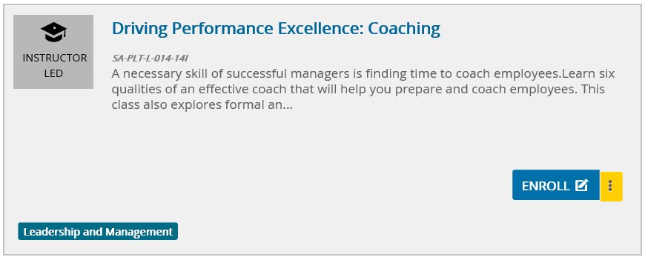

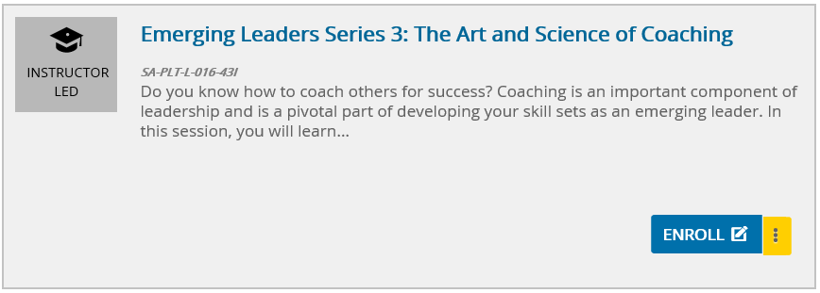

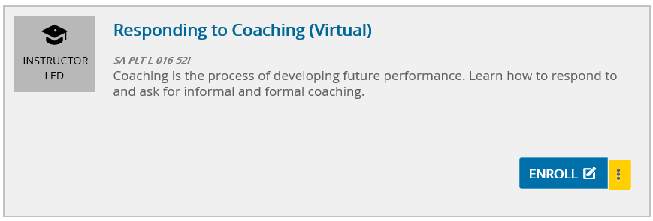

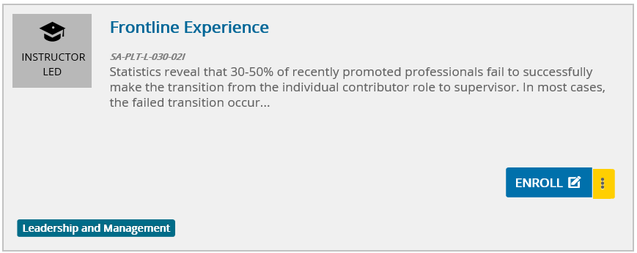

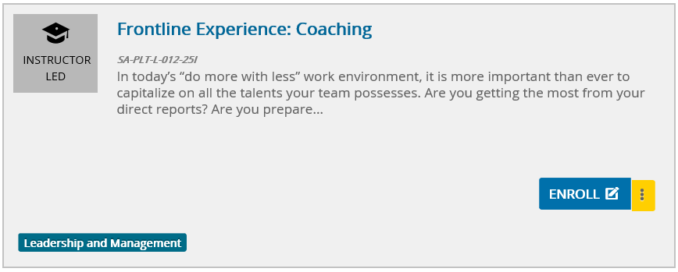

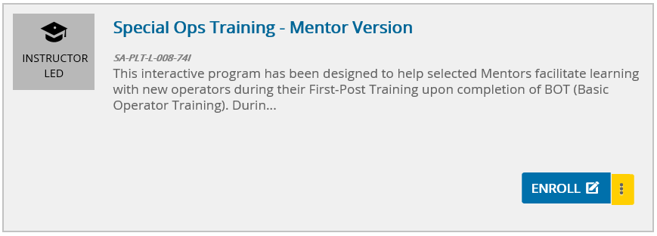

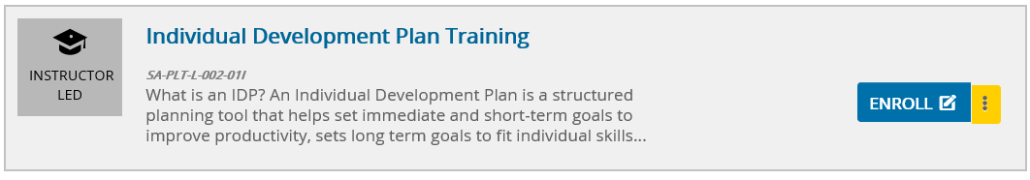

Appendix 2 – Coaching Guide

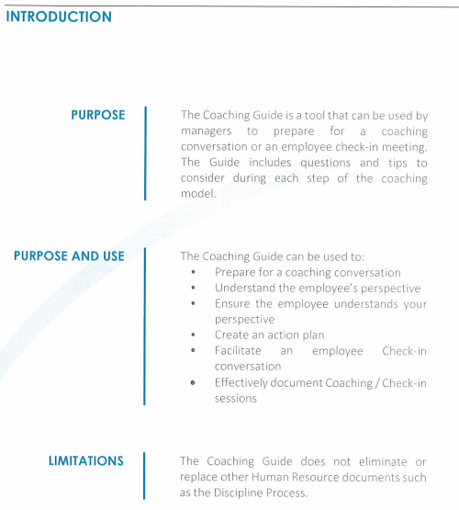

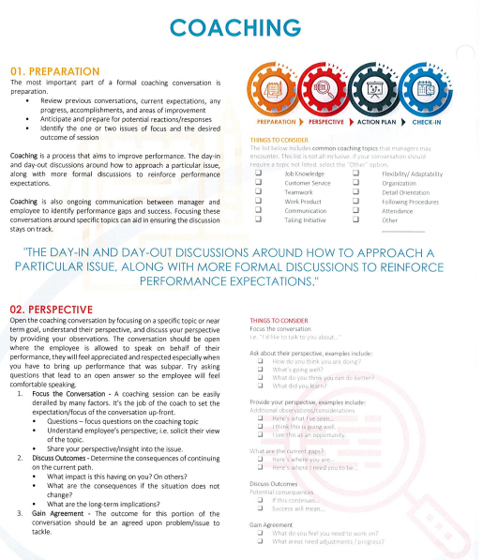

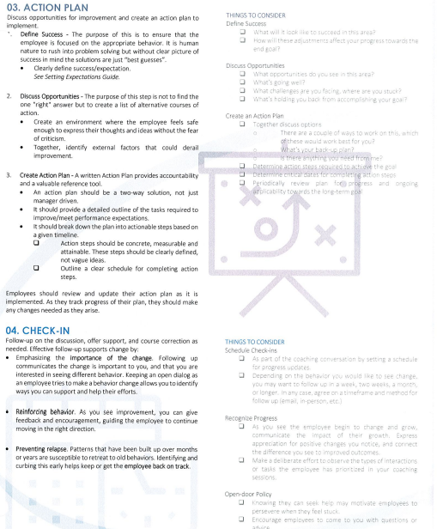

Appendix 3 - Coaching Questions Guide



