BMIH5007
A1 Financial Management for the Hotel Industry
Business Report -
Comparison of Two
Hospitality Organisations

Student name:Andrei Curelaru
Student ID:1918109

Table of Contents
Introduction 3
1.Total Revenue of Mandarin Oriental Hotel Group and Premier Inn 3
2. Market Position: 5
3. Growth Potential: 7
4. Financial Commitment to CSR 8
Conclusion 9
References 11

Introduction
In the ever-evolving landscape of global hospitality, the Mandarin Oriental Hotel Group and Premier Inn stands as a paragon of luxury, renowned for its opulent resorts, hotels, and residences strategically located across the world. Mandarin Oriental, a symbol of luxury and distinction in the hospitality sector, has always looked for new ways to increase its brand recognition and increase profitability and shareholder value (Chawla et al., 2021). Due to the pandemic, Premier Inn experienced severe financial losses in FY21; a large percentage of its operations were closed for the whole of the year. The subsequent sections will examine the demographic differences between the patrons of Mandarin Oriental and Premier Inn, analysing the elements that contribute to their diverse consumer profiles and travel inclinations. In addition, we will evaluate both organisations' potential for growth, looking at collaborations, exporting, and licensing as well as any roadblocks to their growth.

1.Total Revenue of Mandarin Oriental Hotel Group and Premier Inn
Mandarin Oriental Hotel Group is a leading global ownership which possesses luxury resorts, hotels and residences which upscales lodging in popular locations all across the globe. The Group originated from the roots of Asia nearly 60 years ago and they have operated 36 hotels and 9 residences in nearly 24 countries which portrays the background and local culture and unique design (Martin Roll 2020). In an effort to enhance profitability and shareholder value Mandarin Oriental maintains the position as an innovator in the luxury hospitality industry by carefully pursuing chances to increase the brand visibility.

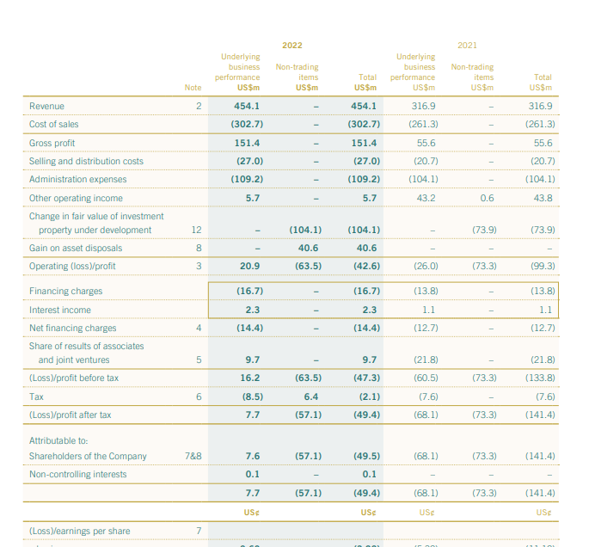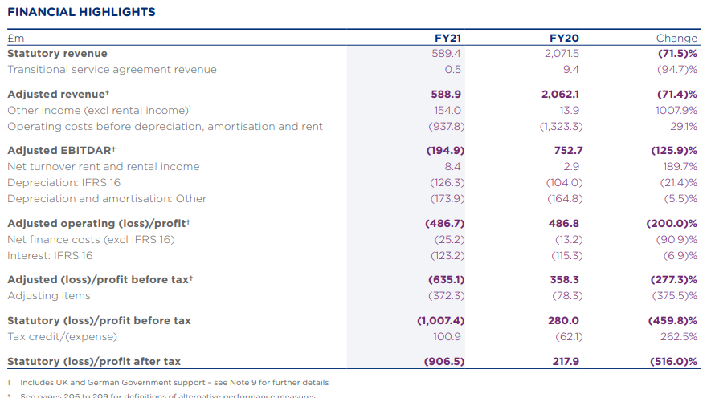
The revenue of the Mandarin hotel is ＄454.1 in 2022. The gross profit is about ＄151.4. The administrative expenses are ＄ 190.2. The hotel group revenue generated from the the various operating activities have increased from US ＄ 26 million 2021 to US＄56 million in 2022 (Annual Reports, 2022). The previously owned companies have led to the increase in sales of the company. In connection with the company's investment operations and the sale of Washington, D.C. for US$131 million, net cash inflows have been generated. The $30 million invested in the Causeway Bay site under construction helped to mitigate this to some extent. The Group has committed to spending an additional US$500 million on the project between 2023 and 2025, which will be financed by a combination of existing cash reserves and external debt. The company's liquidity is still strong, with its current cash position of US$226 million and undrawn facilities of US$471 million (Annual Reports, 2022).In contrast to 2.1 years in 2021, the median maturity among the Group's financing was 1.8 years in 2018. A significant amount of the Group's performance comes from its ownership stake in 14 hotel buildings, which it acquired after selling Mandarin Oriental in Washington, D.C. Due to a strong rebound, especially in London, Bangkok, and Singapore, the owned hotels' estimated EBITDA of US$77 million in 2022 marked a significant improvement above the US$24 million reported in 2021.
Compared to US$41 million in government financial support and US$9 million in other revenue recorded in 2021, EBITDA in 2022 contained US$5 million in governmental monetary support and US$3 million in other income, mostly from premium proceeds (Annual Reports, 2022). The Group employs a range of strategies and tools to control its vulnerability to financial risk. The major goal is to control foreign exchange and interest rate risks and to offer some degree of cost predictability. By the end of the year of 2022, more than 40% of the Group's gross financing had rates of return that were fixed or capped.
Premier Inn financial results for FY21 were impacted by the shutdown of the majority of its operations in the year, which was accompanied by a which, following operations in both months with over 50% of the market of the UK being occupied, market demand began to decline sharply in November due to the imposition of increasingly stringent COVID-19 regulations in both the UK and Germany (Annual Report of White bread Plc, 2021) . There was an adjusted loss before tax of £635.1 million as a result of the notable drop in revenue. Other forms of payment deterioration charge of £348.0 million is included in the mandated loss before tax of £1,007.4 million.
The monetary performance was enhanced by approximately £270 million in government support programmes tied to COVID-19, such as the UK Job Retention Scheme and British economy rates relief (Annual Report of White bread Plc, 2021). The organisation's £1 billion rights issue, which concluded successfully in June 2020, and the £550 million issuing of environmentally friendly bonds in February 2021 have strengthened its financial sheet and liquidity position. The company ended the year with £1,256.0 million in financial assets and liabilities as well as an undrawn £950.0 million Revolving Credit Facility. £46.5 million in net debt as opposed to £322.9 million at year's end. Additionally, funds from the Green Bond sales were used to pay down £200 million in private placements debt prior to March 2021.

2. Market Position:
Mandarin Oriental Hotel Group consistently earns honours and awards from all over the world for the superior customer services and commitment to quality management. As of December 31st December 2022, the Group had adjusted the net assets worth nearly US$4.9 billion and equity interests (Martin Roll 2020). The company's profitability improved significantly during the year, with the combined total revenue of the hotels it manages reaching US$1.6 billion in 2022—a notable rise from 2021 and a rise of 17% over 2019.
The following are the Mandarin Oriental Hotel Group's (MOHG) client demographics:

Factors | Mandarin Oriental | Premier Inn
Age | The average age of a customer at Mandarin Oriental is 45 years old. | The average age of a Premier Inn customer is 35
Gender | Mandarin Oriental's clientele, 43% are women and 57% are men. | 7% of customers are male  53% of customers are female
Income | Mandarin Oriental customers earn over $250,000 on average per household. | A Premier Inn patron's household income typically hovers around £25,000.
Nationality | Although Mandarin Oriental's clientele is international, Americans, Chinese, and Britons make up the majority. | The customers of Hotel Premier Inn locations are mainly Britons but they have worldwide presence

Regarding their inclinations for travel, both Mandarin Oriental and Premier Inn clients
Leisure travellers: The bulk of Mandarin Oriental's clientele consists of leisure travellers. Usually, these tourists are searching for an opulent and restful vacation (Roberts, 2020). They can be going as a couple, with family, or with friends.
Business travellers: A sizable section of Mandarin Oriental's clientele consists of business travellers. When travelling for work, these visitors usually want a warm and practical place to stay (Patterson et al., 2021). They might also be interested in making use of the conference and meeting spaces at the hotel.
Group visitors: Mandarin Oriental welcomes a variety of group visitors, including guests of conferences, wedding parties, and business groups. Usually, these groups are searching for an opulent and unique experience.
Customer demographics of Premier Inn regarding inclination for travel
Cost-conscious: A Premier Inn guest's average household income is approximately £25,000.
Family-friendly: A lot of Premier Inn patrons are households with little children. Family-friendly features provided by the company include connecting rooms and family dinners (Pang, 2021).
Leisure travellers: Leisure travellers make up the bulk of Premier Inn patrons. But the group also draws a good number of corporate tourists (Patterson et al., 2021).
Value-driven: Guests of Premier Inn hotels are searching for the greatest deal on low-cost lodging. They value the group's family-friendly amenities, reasonably priced rooms, and spotless accommodations.

3. Growth Potential:
Licencing and franchising: Licensing permits the transfer of intangible assets such as trademarks, patents, and production methods. Less money is needed from the new business as the licensee pays the licensor the royalty (Alon et al., 2016). Another method that permits the franchisee to use the brand name, goods, and services is franchising. Global markets grow as a result, making it easier to balance supply and demand. Mandarin Hotel Group can open new groups of hotels by licensing and franchising in order to increase the market share. It can benefit from the growing demand for luxury travel in China and India.
In order to guarantee consistency across all franchise locations, the franchisor frequently provides ongoing marketing, support, and training. Transferring intangible assets like patents, trademarks, and industrial techniques is made possible by licensing. Less money is needed from the new company since the licensee pays the licensor the royalty. This leads to the opening up of global marketplaces in order to balance supply and demand. Premier Inn can also increase their growth by investing in unique and memorable experiences for travellers. Premier Inn could benefit from Germany, a new market which has strong economies and growing demand.
Exporting: Exporting is the process of sending manufactured goods directly to foreign countries. It is among the more well-known techniques for creating global marketing plans (Martín et al., 2022). It is very affordable because it is made in the home market. There are limitations on the delivery and management of goods that come with exporting, including high taxes and transportation expenses. By exporting, companies can reduce their reliance on a single market and diversify their sources of income. By diversification into multiple overseas markets, businesses can spread their risks and mitigate the consequences of financial volatility or changes in domestic market situations.
Partnerships and collaborations: A type of partnership that allows for multi-enterprise commercial cooperation with local enterprises and partners (Rosado-Serrano and Navarro-García, 2023). All participating businesses with like objectives will benefit from the merger. A joint venture is when two or more companies form a special legal entity to go after a specific business opportunity. In addition to contributing resources, expertise, and funding, each partner additionally participates in the venture's risks, rewards, and decision-making. Joint ventures are often used to enter new markets, develop new products, or combine complementary skill sets. MOHG has already partnered with Ritz Calton to handle the various number of hotels under the Ritz Carlton Reserve brand. Premier Inn has already had a partnership with Whitebread to operate Costa coffee cafes in their hotels. Premier Inn competes with other chains such as Travelodge and Ibis.
The various barriers to growth are:
Global concord and peace: This makes it possible for companies to interact with people globally and exchange knowledge about the feelings and customs of one another. Benefits of globalisation include fostering international understanding, promoting the idea of harmony, and fostering continuous discussions about economic alliances.
Flow of opportunities: Because of worldwide marketplaces, a sizable portion of the population, including both residents and those living abroad, has more opportunities. There won't be as many risks because it promotes successful businesses.
Global: The businesses start out in global markets, necessitating wise choices at different points throughout the globe (LOWE et al., 2020). With the aid of R&D, outsourcing, and funding, the functions are often decentralised, but the headquarters serves as the main hub.
Joint ventures: Business managers can better understand the dynamics of market strategies by working together with new companies and local markets. Yang and Gabrielsson (2018) claim that local markets will be less threatened by new entrants and that the launch of new product lines will thrive in the new market base.

4. Financial Commitment to CSR
The core value of Mandarin Oriental's philosophy is "acting with responsibility," thus every choice made by the Group takes sustainability into account (Business Profile, 2023). Our strategy for ecology and our goal of smoothly integrating it into our business processes and procedures, from daily purchasing choices to Group-wide pledges, are driven by our desire to "do the right thing." Our approach to sustainability is made to help Mandarin Oriental follow the Sustainable Development Goals of the UN, which are a valuable guide as we expand our global brand and do the right thing for the environment, guests, employees, and communities.
As a pioneer in opulent hospitality for more than half a century, the Mandarin Group is widely acknowledged for providing exceptional customer service and managing its lodging establishments and homes in an ecologically responsible and conscientious manner. In addition to further lowering our consumption of energy, water, waste, and carbon emissions—all of which they offer—they are also using our enhanced governance structure to gradually phase out single-use plastics in our hotels and developing a programme for ethical sourcing. The company's most recent Sustainability Report details more projects, all of which are made possible by the commitment and diligence of Mandarin Oriental's 12,500 employees, who are always looking for meaningful ways to address the needs of humanity and the surroundings.
Maintaining our Force for Good pledges and ambition at the forefront of our approach to the worldwide pandemic has been extremely vital to Premier Inn Whitbread's comprehensive conservation plan, Force for Good, guarantees that being an environmentally conscious company is integrated across Whitbread's operations (Annual Report of White bread Plc, 2021). This year, diversity and inclusion were a key component of our strategy, and we have since released eight commitments to promote significant advancements in this field. This year, we have made it a priority to meet our goal of reducing food waste. They didn't let the COVID-19 problems stop us from pursuing our carbon-related goals; in fact, we seized the chance to strengthen and expand them. Whitbread established a science-based goal in 2018 to cut its carbon footprint severity by 84% by 2040 and 50% by 2025 (Annual Report of White bread Plc, 2021). We are comfortably on our way to reaching the first target because we have already reduced it by almost 40%.

Conclusion
The Mandarin Hotel Group has the opportunity to grow through a number of initiatives that enable them to access new markets and consumer segments, such as exporting, exporting, franchising, and licensing. They must, however, negotiate possible obstacles like world harmony and peace as well as the flow of possibilities, which may have an effect on their attempts to expand internationally. Furthermore, the Premier Inn dedication to Corporate Social Responsibility (CSR) is praiseworthy, emphasising environmental footprint reduction, ethical sourcing, and sustainability. The Mandarin Hotel Group is committed to conducting business responsibly and having a beneficial influence on the environment, visitors, staff, and communities as they develop their worldwide brand. Both the organisations must focus on sustainability in order to grab more attention from customers.

References

- Alon, I., Apriliyanti, I.D. and Parodi, M.C.H., 2020. A systematic review of international franchising. Multinational Business Review, 29(1), pp.43-69.
- Annual Report of White bread Plc, 2021. Premier Inn Accounts and Reports [online] Available at: https://cdn.whitbread.co.uk/media/2021/05/05141427/23076_Whitbread_AR2020_web.pdf (Accessed on 19 September, 2023)
- Annual Reports, 2022. Mandarin Oriental International Limited [online]. Available at :https://photos.mandarinoriental.com/is/content/MandarinOriental/corporate-business-profile (Accessed on 19 September, 2022)
- Business Profile, 2023. Our vision: A World of Fans [online]. Available at :https://photos.mandarinoriental.com/is/content/MandarinOriental/corporate-business-profile (Accessed on 19 September, 2022)
- Chawla, G., Lugosi, P. and Hawkins, R., 2021. Food waste drivers in corporate luxury hotels: Competing perceptions and priorities across the service cycle. Tourism and Hospitality, 2(3), pp.302-318.
- LOWE, RKENYON, A. and DOOLE, I. (2019) International Marketing Strategy: Analysis, Development & Implementation. 8th Ed. Cengage.
- Martin Roll 2020. Mandarin Oriental – An Iconic Asian Luxury Hotel Brand [online]. Available at: https://martinroll.com/resources/articles/asia/mandarin-oriental-a-leading-asian-hospitality-brand/ (Accessed on 19 Septe,ber 2023)
- Martín, O.M., Chetty, S. and Bai, W., 2022. Foreign market entry knowledge and international performance: The mediating role of international market selection and network capability. Journal of World Business, 57(2), p.101266.
- Pang, B., 2021. Beyond hypervisibility and fear: British Chinese communities’ leisure and health-related experiences in the time of coronavirus. Leisure Sciences, 43(1-2), pp.111-117.
- Patterson, I., Balderas-Cejudo, A. and Pegg, S., 2021. Tourism preferences of seniors and their impact on healthy ageing. Anatolia, 32(4), pp.553-564.
- Roberts, K., 2020. Locked down leisure in Britain. Leisure Studies, 39(5), pp.617-628.
- Rosado-Serrano, A. and Navarro-García, A., 2023. Alternative modes of entry in franchising. Journal of Business Research, 157, p.113599.
- Yang, M. and Gabrielsson, P., 2018. The interface of international marketing and entrepreneurship research: review, synthesis, and future directions. Journal of International Marketing, 26(4), pp.18-37.

