MODULE CODE/ COD Y MODIWL: BMSK4004
PROBLEM SOLVING AND DECISION MAKING

STUDENT NAME | DENNIS ALDHAIR CALERO ANDRADE
STUDENT NUMBER | 1810249
MODULE NO: | BMSK4004
MODULE TITLE: | PROBLEM SOLVING AND DECISION MAKING
LECTURER | AFZAL MANNUA

Table of Content
Topic | Page no:
Introduction | 03
Background of the company | 03
The problem of leadership process and style in M&S, its nature, scope and impact | 04
Gather and interpret information to solve a leadership problem of M&S | 05
The options that can be used to make a decision in M&S | 07
Plan, monitor and review the implementation and communication of decisions of M&S | 09
Fishbone Analysis | 10
Conclusion | 12
References | 13

Introduction
In the growing phase of business, it has multiple ad important effect on the environment and culture of the organization. Due to the changes in the technology and other elements of the business environment, the structure and direction of the organization is also hampered in several ways. Many problems can be created while adopting with the changing phase of the business context. A large number of problems are responsible to lower the efficiency of the organization which results the lower productivity and also leads to the shortage of capital and revenue as well. On the basis of these aspect of the problems management of the organization should take steps to solve the problems and also initiative so that there may be minimum possibilities to be happened the same problem again. According to the brief of the report, a company should be taken as the example of which an organizational problem will be discussed. Here, Marks & Spencer is taken as the company to be discussed on this topic and in this following report, the lack of leadership efficiency of Mark & Spencer will be explained briefly. Lack of leadership efficiency has a great negative impact on the direction and control of the organizational structure as it is directly related with the allocation of the resources within the organization that speedup the production of the company. The growth of the business, decision making, setting further objectives and goals, selecting skilled and professional personnel and allocation of the resources all are dependent on the proper leadership process of the business. The impact of the problems regarding leadership on the decision making process will be also highlighted and solutions for these problems will be also discussed in brief.
Background of the Company
Mark & Spencer is a British multinational public limited company and it headquarter is situated in Westminster, London. It has almost 1463 stores all over the world. M&S deals with the several brands such as, Per Una, autograph, limited edition, Rosie, blue harbor, M&S collection, M&S Bank which is owned by HSBC. The revenue of M&S is £ 10.377 million, The amount of operating income of M&S is almost £ 601.5million and net income is £ 37.3 million in 2019. M&S was the first British retailer to achieve the recognition of being the maker of pretax profit owner of over £1 billion (Mark & Spencer, 2019).

The problem of leadership process and style in M&S, its nature, scope and impact
Leadership is the process of directing and controlling the organizational resources to smooth the production of good and service. From the setting of organizational goals to management of the all functional activities to achieve the goals are included in the responsibility of the leadership function. Leadership challenge is the most important aspect in the business context all around the world as it is the only way to make proper use of organizational resources toward production. Lack of efficiency in leadership process has a negative impact on the development of the business on the basis of profitability. According to the different type of leadership approaches, there can be created different type of problems. Autocratic leadership approach helps leaders to lead and direct the organization on the basis of their own decision as it is a leader oriented process. All decisions are taken by the leaders and he does not consult with his subordinates. Democratic leadership takes into consider the employees and subordinates while making any decision. Employees get also the chances to express their thinking while making any important decision. In M&S generally the blend of both types of leadership approaches is applied. It helps to direct ad control the personnel within the organization according to the situational demand. But a numerous problems can be also occurred while applying the approach. A leader must have the patience to handle all critical situation effectively and fruitfully. He should have the ability to manage the manpower of the organization toward the achievement of the goal. Sometime leader of the organization fails to lead the track due to the over flow of responsibility and work. To make proper use of their skills and ability they should be given the environment where they can perform the best. A great change comes with the great resistance. So, the leader must have the resistance power of handling critical situation. Doubt on different issue is the road block to the resistance. So, leader also should be confident for what step he is taking. The lack of leadership efficiency also creates the lack of communication within the people and department of the organization. Communication is needed to collect and store important data about the market, product and competitor which will help the organization to achieve competitive advantage and set an organizational goal. With the gap of communication, the business proposition will be also delayed. Lack of leadership is also the reason of lack of motivation for the employees of the Mark & Spencer. Motivation is needed to push the employees to be responsible and work according to the expectation of the management of the M&S. greater level of stress and pressure can be seen within the people when M&S is failed to follow the roper leadership approach within the organization. As a result, dissatisfaction can be seen within the people they may be turn into less productive asset for the organization. Lack of leadership also decreases the level of responsibility of the M&S employees as they become de-motivated due to the proper leadership approach. Even a conflict within the department and employees can be happened due to the weak leadership control over them (Corporate Watch, 2019).
Most of the multinational company like M&S, is decorated and organized with the team of managers and subordinates who are responsible to operate functional activities. Lack of leadership within them can result incompetency of M&S as many business aspects will be hampered at the same time. Decision making is one of the most important issues of the organizational function. Lack of making proper and immediate decision on the basis of the critical situation of the organization also creates misallocation of the resources and manpower within M&S. It also causes the lower productivity and ends up with severe loses. While the leadership skills of individual are greater than, the decision making processed boos up with the effective contribution of the leaders and all plans are success with the appropriate direction of the leaders. While a higher emphasize is given to the decision making process, creative thinking is developed and strategic plan are done by the employees effectively (Raza, 2019). Appropriate leadership style helps leader to create positive vibes for the employees. This encourages employees doing work happily and confidently. To meet the various task and responsibility of the M&S, management needs to establish proper leadership approach so the employees and other resources of the organization can be directed and controlled toward the achievement of organizational goal and objective (Future Business Journal, 2016).
Gather and interpret information to solve a leadership problem of M&S
No organization can be run and organized without the effective direction. Leadership is taken into consideration to make proper use of resources of the organization and make proper decision on the basis of resource available. Decision making is the most crucial function to be considered by the organization. While making an effective decision make must focuses on the resources, manpower and their ability to accomplish the goal. In M&S, in overall leadership process problems are created with the decision making process. While making a leader for the organization the management must need some decision making sills of the individual. Decision making starts with the determination of expected outcome from the activities. Leader should have the ability to identify the outcomes of the specific decision so that the impact of the outcome can be measured quickly. The lack of ability of determining the expected outcome hinders the decision making process of the leader. When leader is unable to know what will be happened after making a decision and taking steps according to it, the result of the decision can be tremendously negative. Negative impact of any decision harms the operational function of an organization (Kenne and Zysman, 2017).
Proper decision making is also dependent on the proper data and information about the subject. Leader should have the ability to collect data and information from the valid source and the information should be in proper quality. Valid information is needed to analyze the cause and effect of the decision that is taken on the basis of some critical situation. For example, if, the sales management of M&S wants to make it sales greater that previous month it must needs to greater information amount the market and the product as well as also about the competitors so that they can identify their range of sales and which affect the sales of the product. After gathering proper information management will be able to take necessary decision regarding development of sales (Kenne and Zysman, 2017).
Before making decision, leader must have to analyze the strengths, opportunities, weaknesses and threats of the organization. Strengths are those that help the organization to achieve the competitive advantage of the company. Opportunity helps organization to achieve the target market quickly. Lower product demand is the weakness of the organization and competitors are the threats for the M&S. Leadership process requires having the ability of analyze the SOWT of an organization to take proper decision. If the management of M&S wants take any promotional and branding effort for its products, at first it must need to know the strength such as price competitiveness that will attract customers to buy their product. Then they need to analyze the opportunity such as the growth of the new market. They also deal with the weakness that may be their poor quality of the product and should know the offerings that their competitors are giving. After knowing all these elements leader is able take a decision. Lack of analyzing SOWT, can lead to a poor decision making process for the M&S (Ikor, 2012).
The decision making process fully depends on the mannerism of the problem for which an initiative is going to be taken. The decisions on the development and the creation of the strategies for the planning of the business are done with efficacy with the aid of leadership (Turban et al., 2010). Thus, to enhance the decision making process the barriers and the problems faced in the leadership should be effectively found out. When a problem is raised within an organization the whole team is engaged with the creation of the solution. A good leader is enough to lead the whole team toward the actual solution. Analysis of the critical situation is another factor that helps a leader to take immediate decision on the basis of the situation (Adair, 2013).
There can be number of possible outcomes from any decision. Leadership requires having the ability to know the possibilities regarding the outcomes and also the manner of how to react to these outcomes. Proper skills and ability to identify related outcomes should be achieved by a leader because without knowing the cause and effect of the decision it is impossible to select the best solution for the problems. Sometimes, due to fail to identify several outcomes from one taken decision and select the best one, the organization can face a huge lose.
Another important factor that affect negatively on the decision making is to create proper mission and vision for the organization. Basic company decisions are mainly taken on the basis of the objective and goals of the business. Objective and goals are also set on the basis of the mission and vision that a company wants to achieve within a given period of time. Company needs to make proper vision and mission of its own that can be achieved by the company at a given time. To fulfill company’s vision organization set a milestone and leaders of the different department of the company takes their own steps to set the objectives and goals that will be accomplished to achieve the vision point. Sometime decision making process is also interrupted badly for not being able to set a vision for the company (Adair, 2013).
The options that can be used to make a decision in M&S
A real option refers to the decision alternatives for specific problems. On the basis of the decision making problems of Mark & Spencer there can be also some alternative that can be chosen by the leader and management of the organization. A real option can be used by the M&C to examine the possible outcomes from the solution. In this report there is already discussed about the problems regarding decision making process of M&S. The possible option for M&S to make decision and the options are given below:
By reviewing risk: A comprehensive real option can be identified and analysis of the risk of the possible outcome. Every decision requires some risk of failing at any level. For example, while a decision is taken to increase the sales level than before organization may start collecting information and data about the demand of the product in the market. These information collection procedures require a huge investment and time also. Leader of the team who is responsible to find a way to solve the sales increase problem needs to identify the cause and effect of the information collection procedures to the problem of decreasing sales. If the information fails to meet the necessity of solving problem, then all investment of money and time will go in vain. So before taking any step to make decision individual needs to analyze and identify the risk regarding the steps taken for the solution of the problem (Maund, Schriek, and Tinkler, 2017).
Amount of investment: While taking any decision regarding any problem organization must need to know or assume how much it will cost to identify the problems. If management want to take any decision for solving any problem at first, they need to identify the invest amount to find out the problem and the reason behind it. Once, the reason is identified for the problems then individual who is in charge of making decision is also responsible to show a chart of the investment at different level of solution of the problems. It is necessary to identify the cost because the outcome should be compared with the expenses of the whole problem solving process (Turban, Sharda, and Delen, 2010).
Using the same concept of solution, a problem: If the problem is similar enough to the previous any problem regarding decision making process, management can use the same alternative to solve the problem again. In that case some modification can be happened if it I necessary to make a decision on the problem (Turban, Sharda, and Delen, 2010).
A decision making process is also given below:
Decision making steps
Recognizing of the issues
Emphasizing on the problem
Developments of solutions
Development of alternatives
Selection of the best form of alternatives

Plan, monitor and review the implementation and communication of decisions.
While taking a decision regarding a solution to a problem the information needs to be communicated and delivered to the employees and all department of the organization. Without making they know about the data and information that has been used to take a decision it is impossible to make proper use of the steps. The way of communicate all the decision to the employees and other departments are given below:
Communicate the objective: When a problem is happened regarding the decision making process of course the related parties need to find out a solution for the problem. There must be an objective of identifying the solution for the problem. Objective should be described to the each and every person related to the decision making process. They should also identify the worthy of the objective whether is related to the solution of the problem or not. If the objective of making a solution for a specific problem is really valuable and has the positive impact on the decision making process, then the overall plan should be made to achieve the objective. This objective should be clear and understandable to everyone in the organization who need the solution badly (Kirsch, 2019).
Determine the role of the employee: After making an objective and communicate all the information regarding the decision making process the next step is to divide the roles and responsibility within the employees of the organization. Management is aware of the skills and proficiency of the people of the organization. So, it is easy for them to identify the roles and divide them into the people who are able to do the work. To achieve the objectives of the solution to the problem regarding decision making process it is necessary to perform each and every function carefully so further there should not be happened any error that can create another problem. Roles should be divided among the employees according to the skills and ability of them. If they are not giving the responsibility according to their skills and job specification, then there is another chance of creating more problems regarding decision making process. So, from the very beginning it should be keep in mind that, people who are playing role in achieving objectives of any specific decision making strategy should be given properly responsibilities and work (Savery, 2015).
Reevaluate the performance goals of the employees: After giving those proper roles and responsibility according to their skills and ability the whole process is not going to be end here. The next step is to evaluate and measure the performance of the employees to the solution of problems. This is also called performance appraisal of the employees. It is needed to know whether the level of effort is enough to solve a problem or there is needed further effort and steps to the solution. Even after the performance of the employees to the solution of the problems the outcome of the solution is also should be measured by the organization as if it does not match to the objective of the solution to the problem, then other option of decision making should be taken immediately. As a result, it is very important to evaluate the outcomes of every activity done by the employees and also reevaluate them within a given period of time to make the best result from the process (Somantri, 2019).
Review the outcomes: Outcome of each and every possible solution for the problems should be measured and review time to time. It is possible of crating same type of problem in the organization in any business year. In that case, if the management has the proper record of the previous problem and information about the solution then it becomes easy to take necessary steps to solve the problem again. For this reason, the outcome of the solution of the specific problems should be reviewed properly time to time. It also helps to find efficient employees list that has been work for the solution of the problems at that time (Somantri, 2019).
It is necessary to plan for a solution of a specific problem, related party needs to gather and collect a wide range of data and information from various sources. They need to communicate all the information that are collected for same purpose and also communicate the objective for which the solution is needed to be originated immediately.
Fishbone Analysis
Fishbone analysis or fishbone diagram is known as the cause and effect diagram. The cause and effect of specific event, subject or situation is analyzed and presented through the fishbone analysis or diagram. When any problem happens in an organization to identify the reason and measure the effect of that problem on specific area a fishbone diagram is used by the management. It probably shows the reason for which a problem is created and it also shows the extent to which the effect of the problem can go. It is mostly helpful for the management to track the reason behind any failure, imperfection, variation or defects. When a problem is occurred in the organization it causes several problems in the same manner. Fishbone diagram is used in that manner when the problem is created; the reason behind the problem will give its own branch from the same spine. This branch can also show the other branch of problems so that related party can understand which is caused for the problems that have been created. A proper fishbone diagram looks like a fish and some arrows are used to show the direction of the causes that results the problems generally. Arrows that are pointing to spine mainly shoes the underlying problems of the organization. The whole diagram is decorated in a manner so that related parties can understand how the causes are related to each other. After understanding the reason it becomes easy to analyze the relation between the several causes and the problems created by them. It will also show that the problems are whether high priced expensive with the causes (Alcocer, 2019).

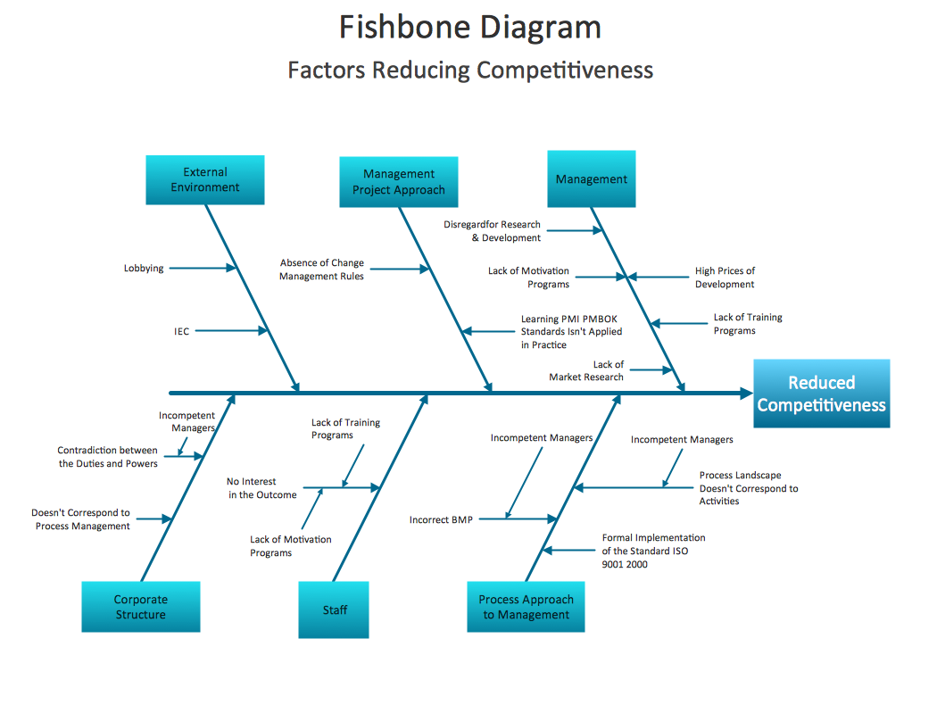
Figure: Fishbone Diagram

The fishbone analysis for the leadership procedures of M&S, finally shows that, Eternal environment such as lobbing and IEC and absent of management rules can hinder the development of human resource of the organization. On other hand, proper management system, adequate motivation for employees can turn the productivity higher than ever. Even corporate structure is also responsible for the positive and negative effect of the leadership process on the employees (Alcocer, 2019).

Conclusion
To lead and direct an organization in w proper way to achieve its goals leadership has no option to be adapted by the management. Leadership is the only way to understand the people and culture of the organization and make proper use of the resources. A good leader is able to identify the required task to be maintained to achieve the goals and he knows who the best to perform the related responsibility is. In this report M&S has been taken to discuss the leadership problems of the organization so that related parties will able to see the practical scene of the organization and understand the procedures to be followed. This report also covers the area like analyzing the information of the particular problem of M&S which will help in reducing the issues arising in the making of the decisions. In this report decision making problems are discussed as the main leadership problem which is the present scenario of the most of the large organization like M&S. Different solutions are also explained here as the learners and related parties of the report also need to understand the way of solving the decision making problems. It will help them to identify further leadership problems and decision making barriers if they want to be a part of a business organization or personally open their own business.

References
- Corporate Watch. (2019). Tesco Company Profile. [Online]. Available from: https://corporatewatch.org/tesco-company-profile/ [Accessed on 14th March, 2019].
- Clark. T. & Chan. P. S. (2014). A history of Tesco. [Online]. Available from: https://www.telegraph.co.uk/finance/markets/2788089/A-history-of-Tesco-The-rise-of-Britains-biggest-supermarket.html [Accessed on 14th March, 2019].
- Raza. A. (2019). Leadership style. [Online]. Available from: https://wisetoast.com/12-different-types-of-leadership-styles/ [Accessed on 14th March, 2019].
- Kenney. M. and Zysman. J. (2017). Entrepreneurial Finance in the Platform Economy Era: What Consequences for Labor? [Online]. Available from: https://static1.squarespace.com/static/5910ee5d1e5b6ca37f0a53b0/t/5a84991ee2c4835ce8cfe21b/1518639391895/Ken+%26+Zys+trimmed+final.pdf [Accessed on 14th March, 2019].
- Business Dictionary. (2019). Employee Performance. [Online]. Available from: http://www.businessdictionary.com/definition/employee-performance.html [Accessed on 14th March, 2019].
- Ikor. F. (2012). Leadership style and employee performance. LAP LAMBERT Academic Publisher.
- Maund, A. Schriek, M. and Tinkler, P. (2017). Certificate in Higher Education: Skills for the Workplace Student Yearbook. Sage Publications
- Adair, J. (2013). Decision making and problem solving strategies. 2nd end. London: Kogan Page.
- Proctor, T. (2009). Creative problem solving for managers: Developing skills for decision making and innovation. 3rd edn. New York: Routledge.
- Future Business Journal. (2016). Impact of leadership style on employee performance. Volume: 2, Page: 54-64, [Online]. Available from: https://www.sciencedirect.com/science/article/pii/S2314721016300032 [Accessed on [Accessed on 14th March, 2019].
- Turban. E., Sharda. R. and Delen. D., (2010). Decision support and business intelligence systems (required). Google Scholar.
- Somantri. M. (2019). Identification of the Leadership Potential of the Post Graduate Students in the Field of Educational Management. In International Conference on Educational Sciences and Teacher Profession (ICETeP 2018). Atlantis Press.
- Savery. J.R. (2015). Overview of problem-based learning: Definitions and distinctions. Essential readings in problem-based learning: Exploring and extending the legacy of Howard S. Barrows, 9, pp.5-15.
- Kirsch. M. (2019). How to Communicate Your Roadmap to Stakeholders. [online] Productplan.com. Available at: https://www.productplan.com/communicate-roadmap-stakeholders/ [Accessed 3rd September. 2019].
- Alcocer. Y. (2019). What is fishbone diagram? [Onine]. Available from: https://study.com/academy/lesson/what-is-a-fishbone-diagram-definition-purpose-examples.html [Accessed on 5th September, 2019].

