ECAD4001
Part B An individual reflective response to the Professional Teaching Experience
Within this assignment I will aim to reflect on my feelings regarding my first professional teaching experience (PTE 1). From reflecting on the three weeks of my PTE I believe that I have made great progression as a trainee teacher from observing the class teacher, planning and teaching a variety of lessons. In the book A Handbook of Reflective and Experiential Learning it quotes “We reflect in order to learn something, or we learn as a result of reflecting” (Moon, 2004, p. 80) Following discovering a reflecting strategy that suited me, daily and weekly reflecting enabled me to set targets for future practice. (http://oregonstate.edu/instruct/pte/module2/apps.htm) Target-setting is a skill and in the book Successful Teaching Placement it advised “the more precise you can be in stating what you want to achieve the easier it will be for mentors and tutors to help…measure your achievements.” (Medwell, 2007, p. 94) I have learnt different approaches to take in regard to practical lesson planning, behavior management, teaching and learning strategies.
Within the first stage of PTE I was assigned to the year 5 class of my school and throughout my time on placement I have developed many aspects of teaching. Each week I set targets from the qualified teaching standards (QTS) document and I fulfilled the targets by researching a verity of strategies that would improve that aspect of teaching. From my first week the standard I became very familiar with was S3.1; teaching, planning, expectations and targets. The standard expresses ‘ to plan a range of lessons from the curriculum’. (Welsh Government,2009) The book a guide to teaching practice states “..effective learning has to be planned.” (Louis Cohen, 2004, p. 124) On first week of practice I focused on planning and expectations as I wasn’t experienced in planning for daily lessons and I was unclear of what to expect from the children. For the primary hours of teaching I was extremely ambitious and planned detailed lessons that were full of great activities however I expected too much from the children in the time we had. To address this target I spoke to my class teacher and she suggested from experience that I could set a written task and then carry out one of the activities that I had planned for the introduction. By taking the class teacher up on this plan it meant that the learners weren’t getting an overload of information and I interacted with the learners throughout the lesson and also they were a lot more engaged. I kept the pace of the lesson up and this enabled me to cover all of the activities planned and also it give me enough time to carry out the plenary. The Plenary was an important part of my lesson as it give me time to assess what the learners had learnt from the lesson and an idea of what to plan for in future lessons. In the book Monitoring, Assessment, Recording, Reporting and Accountability it states “assessment provides detailed information about the learning of one or more pupils” (Headington, 2003, p. 23)￼ this highlights the importance of the plenary. Now I have a strategy that enables me to cover all aspects of my lesson plans and also time to assess the learners before I undertake planning for future lessons.
During my time on PTE 1 another aspect that was highlighted from feedback, ARC reflections and end of week reviews was behavior management. (See appendix A and B In the book Effective Primary Teaching it conveys “Good behavior is a necessary condition for effective teaching and learning.. (OFSTED,1993,p1)”(Hastings, 1996, p. 74) This became a significant target for me as the class that I was placed in were very challenging and discipline was key, the first step I had to undertake was to observe the class teachers approach to behavior management. From the observation I discovered that the learners would get rewarded for good behavior, the learners reward was 10 minutes of ‘teachers choice’ on a Friday afternoon, after every session the teacher would either reward the learners with the 10 minutes or explain why they haven’t been rewarded it this way minutes were never deducted. If an individual pupil is misbehaving and is disrupting the class the class teacher would give 2 warnings, 2 minutes, 5 minutes and then keep the pupil in for the whole of play. When discussing this target with the class teacher we both realized that we can’t observe every pupil and sometimes we are often oblivious to what is going on due to the ratio of adults to learners, in the book taking care of behavior it clearly supports this when it states “additional staffing can reduce the number... who disrupt.” (Dix, 2009, p. 111) The next step I undertook was discussing the whole school approach towards behavior management, they used positive reinforcements. The book a Kit Bag for Promoting Positive Behavior in the Classroom states “Positive reinforcements encourage positive behavior”. (Ellis, 2011, p. 34) .
After spending time researching different behavior strategies, I soon had the opportunity to put my research into practice. A learner wouldn’t get on with their work and was disrupting the table throughout the introduction. I had given the learner a warning however he carried on and didn’t engage with the introduction. I then set the task and I approached the learner and encouraged him to stay on task, however no improvements were made so a clear firm and final warning was given. 10 minutes into the lesson no work was completed, and his table were complaining. I decided that I needed to apply the strategy that the class teacher applies to situations like this. I give him 2 minutes of time out during last play, the unacceptable behavior continued so I the time went up to 5 minutes. During the time out myself and the teacher explained what the pupil had done wrong and how he could have not got himself into the situation again. After this he then apologized and realized that his actions came with consequences. As you can see from appendix B I felt in control but on the other hand I felt nasty keeping the pupil in, however the pupils did learn from this incident and stayed on task in future lessons.
A task that I was not experienced in was planning differentiated lesson plans that would suite my class needs. In the book Reflective Teaching in Schools a quote form Ausubel is used, he states that “.. the most important single factor influencing learning is what the learner already knows. Ascertain this and tach him accordingly.” (Asubel, 1968. Vi, cited in Hettie, 2012, reading 16.5). From observing learners through whole class lessons and with working with small groups I had learnt that within the class there was a wide range of learners, working at different speeds and require support in different arears. After working with the more able and talented pupils I had gained knowledge of the level they were working at in guided reading so when it came to planning the guided reading lessons I refreshed my skills and knowledge so that I could ask questions that would challenge the pupils. On the other hand I also observed and worked with the lower attaining pupils during my first week and I discovered that if they had to do lots of reading and writing then they wouldn’t engage with the task or even attempt it as it was ‘off putting’. I related to one of Vygotsky quotes whilst leading these group activities “What a child can do in cooperation today, he can do alone tomorrow.” (Vygotsky,1934) An example of this is when the MAT pupils knew what a biography was however the lower attaining pupils didn’t know what was needed in a fact file.
For the following week I decided that I was going to plan my lessons using the Vygotsky approach to Zone of Proximal Development (ZAD), I had to find the ‘sweetspot’ of everyone within the both groups. I catered the needs for the majority of learners during group work however it became more difficult to differentiate when teaching whole class lessons. One learner was working at a year 2 level in some subjects and this was challenging for me adjust the task at hand to meet the learners needs and so the surrounding learners wouldn't question the work he has. I met the needs of this learner by allowing him to complete his work on the sheet rather than in his book like the rest of the class. This example of differentiation was a success for me and when the learner completed all of his work, I was thrilled and he was so proud that he had finished his work within the lesson and to a high standard. See appendix C for the piece of work completed.
From reflecting on different experiences of PTE1 I have learnt new strategies for behavior management, lesson planning, differentiation and how important observations are and getting to know the pupils inside and outside of the classroom. In the book ‘an introduction to class room observation’ I learnt that observation was “the matter of deciding what should be the focus of attention.” (Wragg, 1999, p. 5) this enabled me to have a focus and personal target for each lesson. The Welsh Government state that good practitioners “...evaluate their practice, drawing out strengths and areas for development.” (Government, 2015, pp. 3-4) I agree with this statement because if I didn’t reflect on behavior management I wouldn’t have known the procedure to take during the following sessions I had to teach. From the skills I have learnt and developed in key stage 2 I can now transfer them to foundation phase. Due to key stage 2 being in the early stages of adopting Donaldson's new curriculum it has given me some experience of planning for foundation phase as I will need to plan more child led activities and tasks for the enhanced arears. My personal target going into the foundation phase is to change my style of teaching by using a story, personal experience or bag and box to simulate my lessons to help the children engage with the lesson.

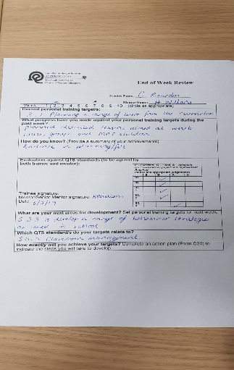
Appendix

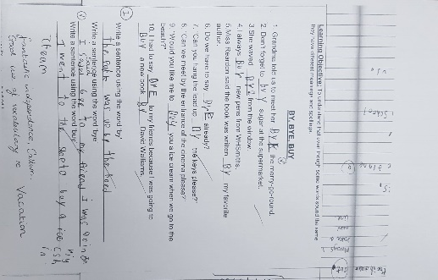
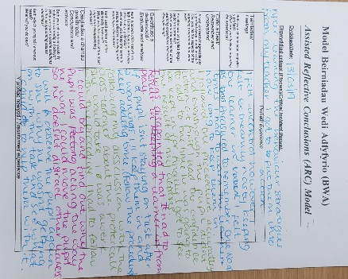
C
Pupils work
B
ARC Reflection

ARC
A
End of week review

References
Dix, P. (2009). Taking Care of Behavior . Edinbrugh: Pearson Education Limited.
Ellis, N. S. (2011). A Kit Bag for Promoting Positive Behaviour in the Classroom. London: Jessica Kingsley Publishers.
Welsh Government (2009) available at: https://gweddill.gov.wales/legislation/subordinate/nonsi/educationwales/2009/3220099/?lang=en
Government, W. (2015). Reflective Practice. wales.
Hastings, P. C. (1996). Effective Primary Teaching. London: David Fulton Publishers Ltd.
Headington, R. (2003). Monitoring, Assessment, Recording, Reporting and Accountability. New York: David Fulton Publishers.
Louis Cohen, L. M. (2004). aguid to teaching practice . Hong Kong: Routledge.
Medwell, J. (2007). Succeessful teaching Placement primary and early years. Glasgow: Learning Matters.
Moon, J. A. (2004). A Handbook of Reflective and Experiential theory and practice . London: RoutledgeFalmer.
Wragg, E. C. (1999). An Introduction to Classroom Observation. London: Routledge.
Davies. S (2006) The Essential Guide to Teaching. Harlow:Edinbrugh Gate.
Wright. T(2009) How to Become a Brilliant Teacher. Canada:Routledge
Cole.Mike(2005)Professional Values and Practice Meeting Standars.London:David Fluton Publishers

