
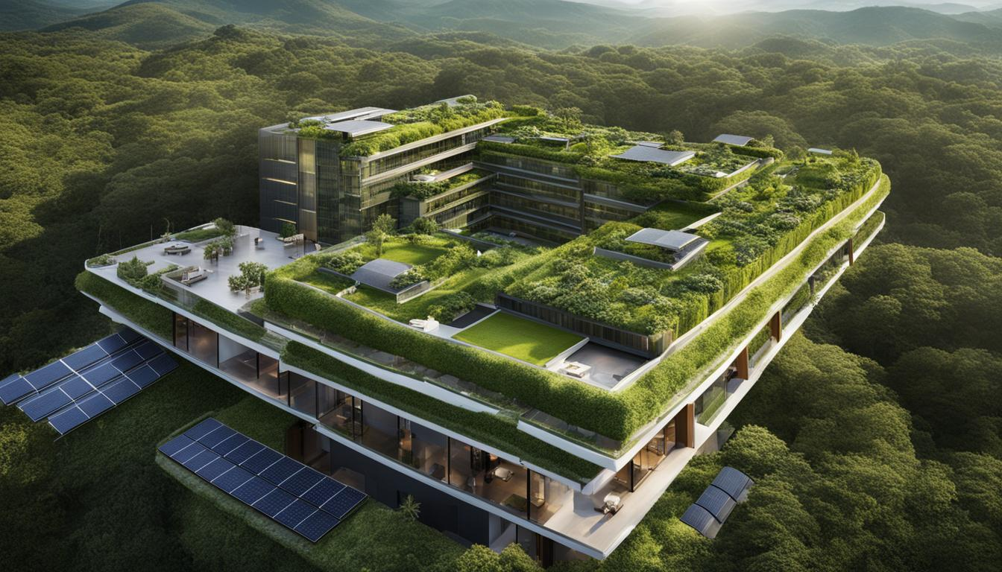 | Augusta Roxana Toth (2226559)  Module Handbook Autumn Term 2024  BMIH5006  Sustainable Hospitality & Tourism  Management  LEVEL 5
IHG Hotels and Resorts
Green Practices
Module Lead: Lisa-Marie Bassler
Word Count: 1908

1. Executive Summary
This report analyses the IHG Hotels Green Engage program, an environmental initiative by InterContinental Hotels Group (IHG) designed to minimize the brand’s environmental impact while enhancing operational efficiency. Green Engage guides IHG hotels in reducing energy consumption, conserving water, managing waste, and promoting sustainable sourcing. Structured in four certification levels, the program allows properties to progressively adopt greener practices suited to their resources and goals (Legrand, 2024).

Key findings highlight significant benefits for IHG, including cost savings, enhanced brand image, and alignment with regulatory standards. Although the program requires substantial initial investment and staff training, the long-term financial and environmental gains affirm its value. This report also recommends expanding the program across all IHG properties, focusing on guest engagement, and prioritizing ongoing employee training.
IHG’s Green Engage program positions the brand as an industry leader in sustainable hospitality. It aligns business objectives with environmental responsibility and sets a high standard for future-focused hospitality practices.

Table of Contents
1. Executive Summary 1
2. Introduction 3
3. Main Body 4
3.1 Central heating gas emissions image 5
3.2 What Does the Greener Practice Initiative Entail? 5
3.2. 1. Energy Management 5
3.2.2. Water Conservation 5
3.2.3. Waste Management 6
3.2.4. Sustainable Sourcing 6
3.3 Benefits and Challenges of Integrating Sustainability into Daily Operations 6
3.3.1 Benefits 6
3.3.2 Challenges 7
3.4 Is the Initiative Cost-Effective? 8
3.5 Low Carbon Pioneer Image 8
3.6 Is the Initiative Realistic? 9
3.7 Environmental Benefits of the Initiative 9
4. Conclusion 10
5. Recommendations 11
6. References 12

2. Introduction

The World Tourism Organization noted that hotels are responsible for a tiny portion of global emissions. As the demand for accommodations rises, hospitality establishments must adopt sustainable practices to mitigate their negative impacts.
Sustainable practices can also reduce their environmental impact and attract new clients. According to a report released by Booking.com, 68% of its clients are interested in finding environmentally friendly hotels. Also, 87% of travelers worldwide are eager to travel sustainably (Lacalle, 2021).

A sustainable hotel is a business that uses green practices in its operations and supplies to reduce its environmental impact. The core elements of this concept include energy conservation, waste minimization, and water optimization.
A hotel can make its facilities more sustainable by implementing various steps. Some of these include replacing its HVAC system, which can be a major expenditure (Air Supply, 2024). Going green helps a hotel earn guests' goodwill and reduce its environmental impact.
The importance of sustainability is acknowledged by businesses to achieve growth and satisfaction of their customers. Due to the increasing number of consumers looking for eco-friendly services and products, the travel industry is also taking note of this trend.
For instance, TripAdvisor has launched a program that provides travelers with information about hotels that are going green (Werntz, 2015):
- The TripAdvisor GreenLeaders program- hotels can voluntarily report their efforts toward sustainability. This information is then validated by random audits and by TripAdvisor's reviewers, who are also asked to flag any discrepancies.

IHG is a global hospitality organization that operates over 5,900 hotels all across the world. It is committed to providing its guests with exceptional services and environmental sustainability. To achieve this, the company has adopted various green initiatives that involve minimizing waste, conserving resources, promoting energy efficiency, and making the environment more sustainable (Carey, 2019).
These include energy-efficient appliances, sustainable building materials, and strategies to cut down on waste.
IHG has made significant progress toward a more sustainable approach by launching programs such as Green Engage, which helps hotels monitor and manage their environmental impact. This tool can assist them in implementing various practices such as waste minimization and water conservation. In addition, the company's framework aligns with the SDGs, which underscore its dedication to responsible hospitality (Macpherson, 2024).

3. Main Body
The Green Engage program of IHG is designed to help its members implement sustainable practices in their daily operations. It offers four certification levels that allow them to progressively improve their environmental performance. In addition to reducing their environmental impact, adopting green practices can also help IHG attract more eco-conscious customers (Gulf Business, 2024).
The Green Practice of IHG is the foundation for comprehending how it contributes to the company's operational effectiveness and environmental sustainability. It serves as an example for other hospitality organizations.
IHG Hotels has taken the lead in addressing the rising demand for eco-friendly practices within the hospitality industry by launching several initiatives to cut down on its environmental impact and promote sustainability in all its territories. The Green Engage program is the foundation of these efforts (Akkam, 2022).
Through the Green Engage program, hotels can monitor and reduce their environmental impact. It also provides them with the necessary tools and strategies to enhance their guest experience and efficiency. This section will talk about the various benefits and challenges of the program (Smart Energy Decision, 2020).

3.1 Central heating gas emissions image
The image below illustrates the various outputs and inputs that a hotel's operational processes and business activities generate when it comes to environmental pollution. It also shows the steps that the hotel must take to become more sustainable.
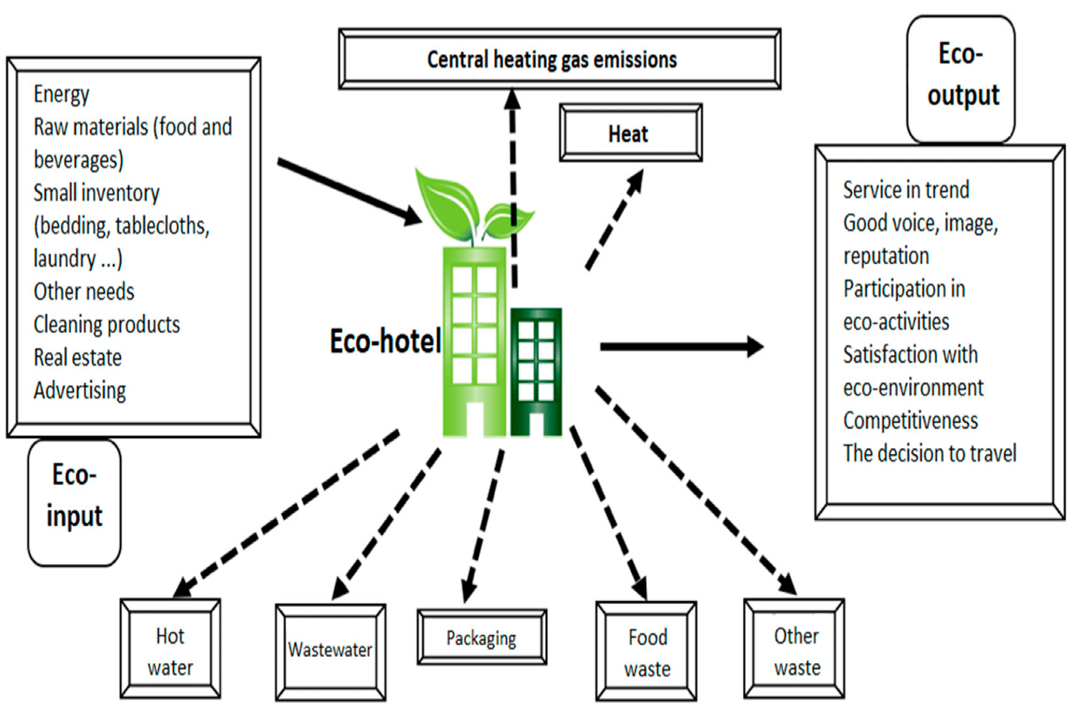(Duric, Topler 2021).

3.2 What Does the Greener Practice Initiative Entail?
The IHG Green Engage platform helps hotels establish goals and implement actions to reduce their environmental impact. It allows them to monitor and set targets for waste reduction and energy consumption. The platform is divided into four levels and features various actions that can be taken to achieve sustainable results (IHG, 2024).
3.2. 1. Energy Management: Monitoring energy consumption, installing energy-efficient lighting, and optimizing heating, ventilation, and air conditioning (HVAC) systems.
3.2.2. Water Conservation: Implementing water-saving measures, such as low-flow fixtures and encouraging guests to reuse towels and linens.
3.2.3. Waste Management: Reducing waste through recycling programs, minimizing food waste, and offering digital alternatives to paper where possible.
3.2.4. Sustainable Sourcing: Sourcing products that meet sustainability standards, including eco-friendly cleaning supplies, recycled materials, and locally sourced food.
Other Hotels and Businesses Implementing Similar Initiatives
- Marriott International has launched its Serve 360 sustainability initiative, focusing on reducing energy and water consumption, minimizing waste, and building eco-friendly hotel properties (San Segundo, 2024).
- Hilton’s Travel with Purpose program aims to cut the company's environmental footprint in half by 2030 by reducing energy consumption, water use, and waste (Otley, 2022).
- Hyatt Thrive is another similar initiative that focuses on energy efficiency, sustainable building design, and promoting health and wellness within local communities (Hospitality, 2022).

3.3 Benefits and Challenges of Integrating Sustainability into Daily Operations

3.3.1 Benefits
Reduced Operational Costs- Implementing sustainable practices can result in lower costs for a hotel overall. For instance, energy-efficient equipment and fixtures can help lower utility bills. The Green Engage program of IHG helps establishments identify opportunities to reduce their energy consumption (Elliott, 2024).
Enhanced Brand Image- Due to the increasing number of people aware of the environment, more people are staying at hotels that are sustainable. This can help IHG maintain its reputation as a leader in the hospitality industry. By supporting sustainable practices, the company can attract more eco-conscious customers and improve its guest loyalty.
Regulatory Compliance- As the environment becomes more stringent, hotels must adopt sustainable practices. Doing so helps them comply with the new regulations and avoid penalties (Mirza, 2024).
Employee Engagement- The more sustainable practices that an organization adopts, the more engaged and satisfied its employees will be. This can lead to better service for guests and a more positive work environment.

3.3.2 Challenges
High Initial Costs- Before a hotel can adopt sustainable practices, it must first make the necessary investments. This includes the installation of energy-efficient equipment and water-saving technologies.
Operational Complexity- It can be challenging for large hotel chains like IHG to implement sustainable practices in their operations. This can involve training employees on how to manage new equipment and follow eco-friendly guidelines. In addition to time and resources, continuous education is also required for employees (Price, 2022).
Balancing Guest Expectations- While many travelers prioritize sustainability, some may choose to stay in hotels that cater to their convenience and luxury needs. To accommodate these preferences, a hotel must find ways to balance its eco-friendly practices with the comfort of its guests.
Supplier and Vendor Limitations- It is not always feasible to source sustainable services and goods in certain regions, especially when there are limited options for eco-friendly vendors. The lack of accessible alternatives may lead to higher costs and the implementation of harmful practices (Mittal, 2024).

In summary, IHG’s green practices benefit the environment by reducing resource consumption, minimizing pollution, and fostering biodiversity. For the hotel, these initiatives cut costs, enhance brand reputation, and attract customers who prioritize sustainability, creating a competitive advantage.

3.4 Is the Initiative Cost-Effective?
Although the Green Engage program involves upfront costs, it is cost-effective in the long term:
Utility Savings: Reduced energy, water, and waste expenses provide long-term savings that help offset the initial costs.
Attraction of Eco-conscious Customers: A reputation for sustainability attracts guests who are willing to pay a premium for green practices, increasing revenue.
Operational Efficiency: Streamlined processes reduce costs associated with waste disposal, energy inefficiency, and overuse of resources (IHG Hotels Resorts,2024).

3.5 Low Carbon Pioneer Image
Below I will show you how IHG, a global hospitality company, has launched the Low Carbon Pioneer program, which aims to help its members reduce their greenhouse gas emissions. Through this initiative, the company aims to connect its members with renewable energy and energy-efficient hotels.

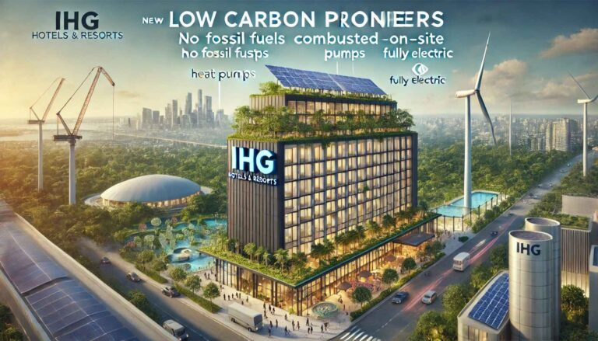
(TTW, 2024

3.6 Is the Initiative Realistic?

Scalability: The program is designed to be scalable, allowing each hotel to work at its own pace through various levels of certification.
Employee Engagement: IHG actively involves its employees in sustainability practices, providing training and resources to help them implement these initiatives effectively.
Flexibility: IHG offers flexible options for each property based on local needs and resources, making it easier for hotels in diverse regions to adopt the practices (Campbell, 2023).

3.7 Environmental Benefits of the Initiative
Through the Green Engage program, hospitality organizations can address some of the most critical environmental issues faced by the industry.
- IHG's hotels help reduce carbon emissions by making use of renewable energy and adopting more energy-efficient practices.
- Through the use of water-efficient fixtures and programs, hospitality organizations can help reduce their water consumption.
- The management of waste reduces the amount that goes to landfills, and it encourages recycling and reuse, which can lessen pollution and conserve resources.
- The preservation of natural resources is achieved through the use of sustainable practices. These include sourcing materials that are made from renewable resources (Otley, 2021).

4. Conclusion
This report has examined the IHG Hotels Green Engage program, a sustainability initiative that helps hotels reduce their environmental footprint by optimizing energy, water, and waste management. The program, structured across four certification levels, offers a range of eco-friendly practices that benefit both the environment and hotel operations. Through measures like energy-efficient lighting, water conservation, and sustainable sourcing, IHG has positioned itself as a leader in sustainable hospitality.
IHG's Green Engage program is an innovative approach to sustainability within the hospitality industry. It aims to help hotels become more sustainable by implementing green practices that minimize their environmental impact and enhance their customer service. Through the program, IHG can demonstrate its dedication to the environment and provide tangible cost savings.
The program's flexibility and scalability allow it to meet the diverse needs of IHG's global portfolio. Even though initial investments can be challenging, the solution is still practical.
The Green Engage program is a step toward becoming a leader in the sustainable hospitality industry. It helps IHG Hotels establish a positive image and place itself among the industry's elite.
IHG Hotels continues to demonstrate its commitment to the environment by implementing sustainable practices. This will help contribute to a greener future for all.

5. Recommendations
Recommendations in line with the findings suggest that IHG should:
- Continue expanding Green Engage across all properties, focusing on gradually reaching the highest levels of certification.
- Invest in staff training to ensure smooth implementation and build a culture of sustainability.
- Leverage guest engagement programs to increase awareness and support for eco-friendly initiatives.
- To effectively promote its Green, Engage program, IHG needs to develop a consistent and clear marketing strategy. This will help the brand attract more eco-conscious customers and distinguish itself from the competition.
- Franchisees should collaborate with suppliers that are certified eco-friendly, as well as encourage their partners to source locally. These partnerships can help strengthen the chain of supply and provide guests with sustainable experiences.
- During their stay, travelers should be educated about the use of sustainable practices, such as reducing the use of linens and towels and participating in programs that minimize waste. A positive atmosphere created by clear communication can help guests become more eco-conscious.
- To achieve sustainable energy sources, such as wind and solar power, you should explore opportunities. You can also make use of smart water systems and energy management systems to cut down on pollution and improve operational effectiveness.

6. References
- Air Supply (2024) What Is Included in an HVAC Replacement? Available at: https://airsupplyinclv.com/2024/what-is-included-in-an-hvac-replacement/ (Accessed 26 Oct. 2024).
- Akkam, A. (2022) Hospitality Brands Take Initiative on Sustainability. Available at: https://hospitalitydesign.com/news/wellness-sustainability/hospitality-brands-take-action-sustainability/ (Accessed 28 Oct. 2024).
- Campbell, K. (2023) The Green Hotel: The Future King of Hospitality. Available at: https://www.cvent.com/en/blog/hospitality/green-hotel/ (Accessed 28 Oct. 2024).
- Carey, I. (2019) Understanding Hotel Giant IHG. Available at: https://skift.com/2019/06/20/understanding-hotel-giant-ihg/ (Accessed 26 Oct. 2024).
- Cvent ( 2024 ) Sustainable Hotel Ideas: 25 Ways to Go Green. Available at: https://www.cvent.com/uk/blog/hospitality/eco-friendly-hotel-ideas/ (Accessed 28 Oct. 2024).
- Duric, Z. and Topler, J. P. (2021) The Role of Performance and Environmental Sustainability Indicators in Hotel Competitiveness. Available at: https://www.mdpi.com/2071-1050/13/12/6574 (Accessed 28 Oct. 2024).
- Elliott, C. (2024) IHG Hotels & Resorts Chases Sustainability With Low Carbon Plan. Available at: https://www.forbes.com/sites/christopherelliott/2024/08/25/ihg-hotels--resorts-chases-sustainability-with-low-carbon-plan/ (Accessed 28 Oct. 2024).
- Gulf Business (2024) IHG unveils industry-first Low Carbon Pioneers programme. Available at: https://gulfbusiness.com/ihg-unveils-new-low-carbon-pioneers-program/ (Accessed 28 Oct. 2024).
- Hospitality (2022) Hyatt unveils global corporate responsibility program, ‘Thrive’. Available at: https://hospitality-on.com/en/statistics-trends/hyatt-unveils-global-corporate-responsibility-program-thrive/ (Accessed 28 Oct. 2024).
- IHG (2024) IHG Green Engage™ system. Available at: https://www.ihg.com/content/gb/en/support/green-engage/ (Accessed 28 Oct. 2024).
- IHG Hotels Resorts (2024) IHG Hotels & Resorts launches industry's first ‘Low Carbon Pioneers’ program as CEO calls for broader support from governments to accelerate positive change at scale. Available at: https://www.ihgplc.com/en/news-and-media/news-releases/2024/ihg-launches-industry-1st-low-carbon-pioneers-programme-as-ceo-calls-for-broader-support-from-govt/ (Accessed 28 Oct. 2024).
- Lacalle, E. (2021) The best sustainability trends and initiatives for hotels. Available at: https://www.mews.com/en/blog/sustainability-in-hotels/ (Accessed 28 Oct. 2024).
- Legrand, W. (2024) Behind the Quote: Driving a Sustainable Future: IHG Hotels & Resorts Calls for Industry Collaboration to Champion Responsible Business Practices. Available at: https://www.hospitalitynet.org/btq/4122043.html/ (Accessed 10 November 2024).
- Mirza, Z. (2024) IHG unveils low carbon program, targets energy efficiency in hotels. Available at: https://www.esgdive.com/news/ihg-unveils-low-carbon-program-targets-energy-efficiency-hotels/721780/ (Accessed 28 Oct. 2024).
- Mittal, S. (2024) IHG Hotels & Resorts: Low Carbon Pioneers programme for hotel energy usage. Available at: https://www.edie.net/case-study/ihg-hotels-resorts-low-carbon-pioneers-programme-for-hotel-energy-usage/ (Accessed 28 Oct. 2024).
- Macpherson, K. (2024) Kenneth Macpherson’s Post. Available at: https://www.linkedin.com/posts/kenneth-macpherson-12057719_a-great-example-of-important-work-happening-activity-7236731638842372099-X7Hx/ (Accessed 28 Oct. 2024).
- Otley, T. (2022) How sustainable is Hilton? Available at: https://www.businesstraveller.com/features/how-sustainable-is-hilton/ (Accessed 28 Oct. 2024).
- Otley, T. (2021) IHG Hotels and Resorts launches sustainability program. Available at: https://www.businesstraveller.com/business-travel/2021/02/16/ihg-hotels-and-resorts-launches-sustainability-programme/ (Accessed 28 Oct. 2024).
- Online Bureau (2024) IHG launches industry-first 'low carbon pioneers' programme. Available at: https://travel.economictimes.indiatimes.com/news/hospitality/ihg-launches-industry-first-low-carbon-pioneers-programme/111854770/ (Accessed 28 Oct. 2024).
- Price, K. (2022) Market challenges ‘driving the argument’ for ESG investments, says IHG boss. Available at: https://www.hospitalityinvestor.com/brands/market-challenges-driving-argument-esg-investments-says-ihg-boss/ (Accessed 28 Oct. 2024).
- Smart Energy Decision (2020) IHG'S Green Engage Program. Available at: https://www.smartenergydecisions.com/energy-management/2020/07/13/ihgs-green-engage-program (Accessed 28 Oct. 2024).
- San Segundo, I. (2024) This Is How Marriott Associates Prioritize Sustainability, One Small Action at a Time. Available at: https://life.marriott.com/blog/sustainability-stories/ (Accessed 28 Oct. 2024).
- TTW (2024) IHG Launches Pioneering Low Carbon Hotel Program, Seeks Industry Change. Available at: https://www.travelandtourworld.com/news/article/ihg-launches-pioneering-low-carbon-hotel-program-seeks-industry-change/ (Accessed 28 Oct. 2024).
- Weinstein, J. (2024) IHG ups sustainability ante with low carbon program. Available at: https://www.hotelinvestmenttoday.com/Change/ESG/IHG-ups-sustainability-ante-with-low-carbon-program/ (Accessed 28 Oct. 2024).
- Werntz, K. M. (2015) TripAdvisor scheme helps travelers select a sustainable bed for the night. Available at: https://www.theguardian.com/sustainable-business/2015/jan/07/tripadvisor-travel-sustainable-bed-green-hotels-holiday/ (Accessed 26 Oct. 2024).

I confirm that I have not used any AI tools in the research and creation of this
assignment. I confirm that I have not presented any AI-generated materials as my
work. I confirm I have copies of my drafts, notes, and other resources I used, which I
may be asked to provide in evidence.

