
Student Name: | Ali Miah
Student Number: | 1709388
Module No: | BMSK4006
Module Title: | Managing Enterprise in 21st Century
Lecturer Name: | Abdullah Al Mamun
Skills for the Workplace
Module Assignment Submission
Assessment-2

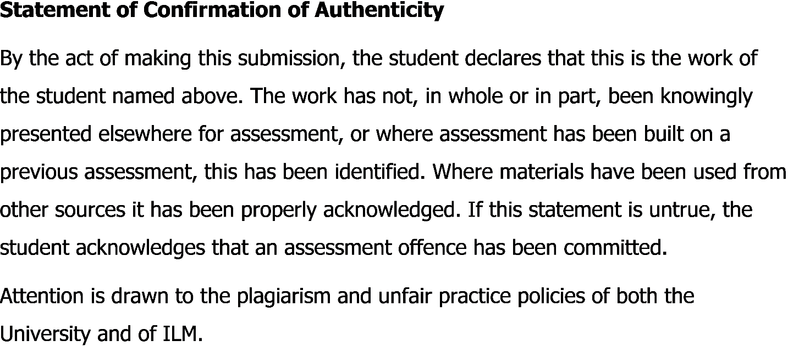

Reflective Essay
Introduction
Starting a business is not an easy task, there need hard work and brainstorming for becoming successful. In the world of competition, it's becoming tough to handle all or manage other people in the business (Tinkler, 2017). Proper dedication and doing all the things in a planned way helps a person to reach the goal. I really don’t have any business plan before doing this and all the things I have gathered is from working on this business plan. This report is going to reflect on my journey to becoming self-employed with my other group members and we have really worked hard on this project. We have started a partnership business along with five members which are for a restaurant named Heavenly Hand Made Indian Food and Handmade Cake. Our business plan is to open an Indian restaurant and take away service. We have also taken the plan to open branch all over the London in five years. I have done the finance part and all the members have invested in the business from their self-savings. I have learned how to collect money and use them in proper planning from this project and I am really happy to share my experience in this report.

Reflection
To share the experience of what I have done in this business project was really interesting. I have done different things of financial terms, I have to plan accordingly before doing anything. It's important to find out overall costing before doing any project and it helps to measure the profit or loss. The experience I have gathered from the project will help me in the future to do something different and helped to increase my creativity level. Finance is the most difficult part of any work because the way of expenditure is important to maintain the profit margin. There needs proper planning before purchasing any material or other staffs that are related to the restaurant. from choosing the place till the marketing of the restaurant to sell it to the consumer there needs finance. I have learned how to organize something, manage other people, brainstorm before doing any project, make proper planning so that it becomes successful. For example, I have planned with their business members regarding the business project, we have analyzed the risk factors, other competitors, our strengths, weakness point, opportunities and threats that can come from this business. There are different types of an Indian restaurant in the market but we always have planned that we must need to do something different than others that will increase the market demand and we can make a profit from the business. I have found out different ways of financing that are related to purchase materials, investment for the location, break-even point for the profit margin, advertisement cost, salary of employees, overall production cost, and others cost that are related with the business. I have learned how to minimize the cost of production that’s a really important factor for any restaurant business. Working experience with my partners was really interesting, I have learned how to work cooperatively by making friendly environment. I have motivated others to perform faster, that helped my employees to work hard and give the best for the restaurant. I have learned to make mission and vision for the restaurant that helped me to go through the path that is important for becoming successful.
My business is making healthy Indian food and cake for the people that can help people to increase their nutrition. The strength of the business is to give people healthy food at low cost than others. My job was to follow up all the financial task that is related with the business and make a profit from the business. I have acquired different skills from an educational institution that helped me a lot to do the financial tasks. Business is all about making the best strategy that helps to beat other competitors. In the restaurant business, there always competition and have to look after what are other competitors are doing and what kind of offers they are making to become the market leader. I have to set up the price of the foods keeping in mind of all the cost so that we can make some profit and fulfill our mission. The skills and experiences I have gathered from the business will help me a lot to make all strategical decisions. Using a digital platform and other equipment’s I have learned how to use these things. There was software in the restaurant that keeps all the record of selling, input materials and output on their usage. These helped to keep on track of the materials and make sure that they all are properly used. I have learned the proper use of technology from this business, using social media as a marketing tool helped me to gather the feedback from customers. Advertising on social media are really cost beneficial and helps to advertise on efficient way. I have advertised the restaurant on different social media like Facebook, Twitter, YouTube and others to promote and reach customers attention. Customers are the most important part of the restaurant, when customers are satisfied, the restaurant becomes successful automatically. To gather customer attention, I have made the best price of the food item, cost-effective advertisement, social programs, and many other promotional activities. I always have to keep my eyes on the price of different products and their effect in business. I have worked as a team and have to look after other tasks as well, different members have a different task to do. When we all make our internal meeting, there was an update of different works and make a collaboration of all the work accordingly. I have to work as a team and make better communication with all the team members so that we can achieve our goal to enrich our branches in different locations. To manage the product and service quality, I have to communicate with the different personalities and that helped me to work with other people.
There needs proper motivation from the seniors so that all the employees do their best for the organization (Adair, 2009). I have to motivate others to work as per the instructions were given to them, making working friendly environment helps a lot to work without hesitation. Before doing this business project, I really don’t have any idea of working with different people and motivating them to do work efficiently. All have helped me a lot by following all the instructions properly, their efficient working increased overall performance of the restaurant. I have learned how to make a financial plan in an efficient way, there always need to make a plan on different tasks. Planning and organizing all the resources is the key to success that I have learned from the business project practically.
I have to follow up all the sales margin, cost margin, daily input sheet of different materials, purchase of materials, and many other things practically. Then I have to make a plan for increasing the sales or make different promotional activities. There needs proper financing for the successful marketing project, otherwise, it won’t become successful (Tinkle, 2011). I have set up media, campaign, and all the other relevant things for marketing of the restaurant. I have to manage other people to work properly for the marketing campaign. Following up the marketing campaign and the response rate are the important task that I have done in the project. This is a part of the financing, as the response rate impacts on selling. When sales are increases, business profit margin automatically increases. I have learned how to make salary sheet for the employees maintain the labor rules and regulations that have given by the government. There are different types of laws are must need to be followed by the organization to show respect to government laws. Otherwise, the government has the right to take necessary actions against the organization. I really have plenty of idea regarding laws, this project helped me to learn different terms and conditions and law impalement of government.
For the successful financial task, there need to analyze the internal and external environment of the organization (Blythe, 2005). Internal analysis is related with the strengths, weakness, opportunities, and threats that are called SWOT analysis. It helps to find out the internal resources of the organization and make the best strategical financial decisions. I have learned how the external environment also impacts the business. The external environment is the political, economic, social, technological, legal, and environmental analysis that means PESTLE analysis. I have learned how strategical analysis is important to beat other competitors. By following up different data, I have learned how to analyze and make the best decision than other competitors. After making the price less than other competitors, I have faced some problem because competitors made the same price. I have to look after another way to reduce the cost and make the best food than others. That’s why I have gone through market analysis by collecting different information and lacking other competitors to use these as an advantage of my restaurant. this helped me to learn the competitive advantage practically.
Team working is the best practice that I have learned during my business project. A successful team can do anything they want, there just need proper motivation, team bonding, clarity among all and proper unity (Morgan, 2016). Clarity means everyone must need to be in the same page if there is a lack of information to anyone it will impact on whole business. We all have planned to sit on a regular basis on time, that helped to discuss different issues and make the best solution. I have also shared my opinion on different problems and others figured out the solution easily. Its regular that all the people don’t have the same quality or same power of thinking, there can be lacking on something and that’s why it's important to discuss the problem with others on the team to find out solutions. I have gathered experience in using technology and different tools that are related to business. This is the world of technology and that’s why it’s important to have proper ideas on using of technology. It will really help me in future to operate different things on my own business.

Conclusion
Managing other people is a really difficult task if there is a lack of knowledge. Otherwise, proper planning and motivation help to inspire other people to manage (Angelia, 2014). I have learned a lot of things practically from this project. Before doing this project, I only have conceptual ideas but I don’t have any idea how to use these ideas in the professional field. I really enjoyed the whole working with my team members and they really helped me a lot to learn different things they have done separately. Finance is a really risky department of any business, there need proper concentration and analysis before making any financial plan. I always have to look after and analyze different data before making any financial plan for the restaurant business. To finalize the report, it can be said that, I really have gathered proper practical knowledge that is important for my future business.

References
Adair, J.E. (2009) Effective Teambuilding: How to make a winning team. London: Pan Books.
Angelia N. (2014). The Digital Marketing in this Modern World. 2nd Edition. Eden Publications.
Blythe, J. (2005). Essentials of marketing communications. 2nd Edition. Harlow: Financial Times/ Prentice Hall
Maund, A. Schriek, M. and Tinkler, P. (2017). Certificate in Higher Education: Skills for the Workplace Student Yearbook. Sage Publications.
Morgan, P. (2016). The Business Student’s Guide to Study and Employability. Sage Publications.
Tinkle, S. (2011) Employability Skills, Business Education Publishers Ltd; 2nd ed.

