Module: Understanding and Engaging Stakeholders
Module Code: LCLM5001

Understanding the Importance of Stakeholder Engagement in the Successful Commencement and Completion of Project
  - Academic Report

Student Name: Xenia- Giorgiana Anghel
Student ID: 2438527

Executive Summary
This report is designed to outline the importance of stakeholder engagement in ensuring the successful design and implementation of ConnectPlus, Amazon UK’s proposed customer loyalty platform, and subsequent international roll out. The new customer loyalty program will utilize elements of artificial intelligence and big data, including customer analytics, as well as providing customers with personalized recommendations and offering rewards via mobile and in store. ConnectPlus will look to create stronger customer engagement and improve operational decision making in an effort to drive retail advantage globally (Freeman, 1984; Bryson, 2018).
The report then moves on to look at the internal and external stakeholders who will be required to support the project throughout the project lifecycle. Using various stakeholder mapping tools and models, such as the Interest–Influence Matrix and the Salience Model (Mitchell, Agle and Wood, 1997; Mendelow, 1991) the report identifies and analyses the key stakeholders of Amazon UK’s proposed ConnectPlus customer loyalty project. In addition to identifying the stakeholders of ConnectPlus, the report also looks at the roles that they will play, the responsibilities that they will have, the ways in which they will be able to add value and the challenges that they are likely to present to the project.
The report proceeds to propose an appropriate approach for the organization’s stakeholders, to be utilized throughout the various stages of the ConnectPlus project. It includes methods of communication, uses of RACI charts, a stakeholder engagement plan, and a number of approaches for dealing with conflict. The report also concludes by discussing and evaluating how sustainable stakeholder engagement can add value to an organization by increasing customer trust and enabling innovation, boosting the commitment of employees and minimizing risk, ultimately leading to long-term business value (Bourne, 2016; PMI, 2021; Harrison, Barney, Freeman and Phillips, 2019).
Thus, this report has highlighted the importance of effective stakeholder engagement as a key strategic capability necessary to support Amazon UK’s proposed ConnectPlus customer loyalty project to design, deliver and roll out successfully and deliver long-term organisational value.

Contents
Executive Summary 2
1. Introduction 4
2. SMART Objectives 5
3. Stakeholder Identification and Analysis 5
3.1 Introduction 5
3.2 Internal Stakeholders 5
3.3 External Stakeholders 6
3.4 Stakeholder Analysis Using Mendelow's Interest–Influence Matrix 7
3.5 Stakeholder Analysis Using the Salience Model 8
4. Roles, Responsibilities, Benefits and Challenges of Key Stakeholders 8
4.1 Roles and Responsibilities 8
4.2 Benefits of Stakeholder Engagement 9
4.3 Challenges Faced by Stakeholders 10
5. Stakeholder Engagement Strategy and Conflict Management 10
5.1 Introduction 10
5.2 Stakeholder Engagement Plan 11
5.3 Communication Plan 11
5.4 Application of the RACI Matrix 12
5.5 Applying the 4Cs Model 12
5.6 Conflict Management 13
5.7 Monitoring Stakeholder Engagement 14
6. Sustainable Stakeholder Engagement and Business Performance 14
7. Recommendations and Conclusion 16
Harvard Reference List 17

1. Introduction
Amazon is one of the world’s largest retail and e-commerce organisations and operates in many international markets through a unified digital platform with support from logistics, cloud computing, and artificial intelligence technologies (Amazon, 2025). Investments in digital innovation allowed the company to enhance its customer experience, reinforce operational efficiency and remain competitive within a more turbulent global marketplace (Porter, 1985; Laudon and Laudon, 2022). To sustain this competitive advantage, Amazon UK intends to introduce ConnectPlus, an AI-driven customer loyalty and engagement platform designed to deliver personalised product recommendations, mobile-based rewards and data-driven customer insights.
While Amazon UK ConnectPlus is a technological development, its successful implementation is dependent on stakeholders’ engagement throughout the entire project life cycle. The stakeholders affect the project planning, allocation of resources, decision-making, the implementation of a new business project and the subsequent adoption by the organisation (Freeman, 1984). Therefore, the identification of stakeholders’ expectations, their interests and the subsequent communication with them is crucial in order to minimize risks and to improve the organisation’s performance (Bourne, 2016).
In order to address the changes and challenges that projects encounter while operating in different international environments, stakeholder engagement has become increasingly important within international organisations. In addition to the stakeholders from within an organisation, projects are often to involve a range of external stakeholders including partners, regulators, suppliers and customers. These stakeholders will typically be from different departments within an organisation and will operate in different cultural, legal and commercial environments. The lack of engagement with stakeholders can result in project changes being resisted and failure in communication, budgetary and project implementation (PMI, 2021). The positive effects of stakeholder engagement include facilitating collaboration, innovation, trust and commitment to the organisation’s goals and objectives (Harrison, Barney, Freeman and Phillips, 2019).
This report will explore in detail the importance of Stakeholder Engagement, specifically during the implementation of Amazon UK’s ConnectPlus platform, identifying and analysing key internal and external stakeholders, including their roles and responsibilities. It will go on to apply various Stakeholder Engagement models, before concluding on how sustainable Stakeholder relationships can aid the successful implementation and delivery of a project, and in turn enhance a company’s performance in an international retail environment.

2. SMART Objectives
The ConnectPlus customer loyalty project aims to design, develop and implement Amazon UK’s ConnectPlus customer loyalty platform in selected international markets within six months. It will aim to (1) Identify and engage all key internal and external stakeholders before implementation (2) Facilitate effective Stakeholder Collaboration through structured communication and engagement (3) Increase customer participation and customer loyalty after launch (4) Mitigate risks associated with Stakeholder Conflict or resistance to change (5) Deliver business value through increased customer retention, greater operational efficiency and data driven decision making (PMI, 2021; Kerzner, 2022).

3. Stakeholder Identification and Analysis

3.1 Introduction
Early identification of stakeholders that will be affected by the project and the involvement of stakeholders throughout the project lifecycle are key determinants to the successful implementation of ConnectPlus in Amazon UK’s selected international markets. There are a number of individuals, groups and organizations that could be considered as stakeholders of ConnectPlus (Freeman, 1984). Project managers are able to gain insight into the key stakeholders, involving them in the project and gain their input and cooperation by identifying stakeholders early on in the project lifecycle. ConnectPlus is to be a global platform, with the intention of being implemented in a number of different markets around the world. Consequently, the project manager will need to consider the influence, legitimacy and urgency that stakeholders have in order to manage stakeholders effectively (Mitchell, Agle and Wood, 1997). Using Mendelow’s Interest–Influence Matrix (Mendelow, 1991) and the Stakeholder Salience Model (Mitchell, Agle and Wood, 1997), the report seeks to categorize the stakeholders of ConnectPlus and to develop appropriate strategies for engaging with stakeholders of ConnectPlus.

3.2 Internal Stakeholders
Many internal stakeholders will be directly involved in the development of ConnectPlus and/or its subsequent implementation. It is important that all of the Executive Team are fully committed to the project, as they are responsible for guiding Amazon’s overall strategy and ensuring that ConnectPlus supports the organization’s longer-term goals. Senior Managers including Project Managers will be required to develop a project plan, manage a budget, identify, assess and manage risks as well as communicate with all other stakeholders to ensure that the project remains on track and that the objectives are being met. Software developers, AI specialists and the IT department will be required to develop the platform, manage the organization’s cyber security and manage the day-to-day running of the system in order to provide the best possible customer experience (Laudon and Laudon, 2022).
The role of the marketing and customer relationship management (CRM) department will be to promote the ConnectPlus program and implement personalized customer loyalty initiatives. Customer service representatives will engage with customers in real time and gather feedback on service delivery in order to make improvements. The legal, compliance and data protection department will ensure that Amazon’s use of customer data complies with UK GDPR requirements as well as adhering to ethical AI practices (ICO, 2025). Finally, the human resource department will assist with change within the organization by providing training to employees and ensuring that the workforce is ready to meet customer needs (Cameron and Green, 2020).

3.3 External Stakeholders
The most important external stakeholders of Amazon ConnectPlus are its customers. The platform will successful when customers are willing to accept then and visualizes their privacy, security and a personalized experience clearly (Payne and Frow, 2017). Technology vendors, cloud providers, business partners and logistics providers are also important to ensure reliable service provision and enabling Amazon’s fulfilment opportunities (Christopher, 2016; Slack and Brandon-Jones 2023). In the role of government regulators which enforce adherence to consumer and data protection legislation (European Commission, 2024) Long run profits (Harrison et al., 2019) are of interest for investors, business stands to gain from the weight of local communities, sustainability lobby and consumer protection groups in Amazon´s reputation and alleged misuse of customer data (Elkington, 1997; Carroll and Brown, 2018).

3.4 Stakeholder Analysis Using Mendelow's Interest–Influence Matrix
A Stakeholder Analysis using Mendelow’s Interest–Influence Matrix consists of assessing stakeholders based on their interest and their influence (Mendelow, 1991).
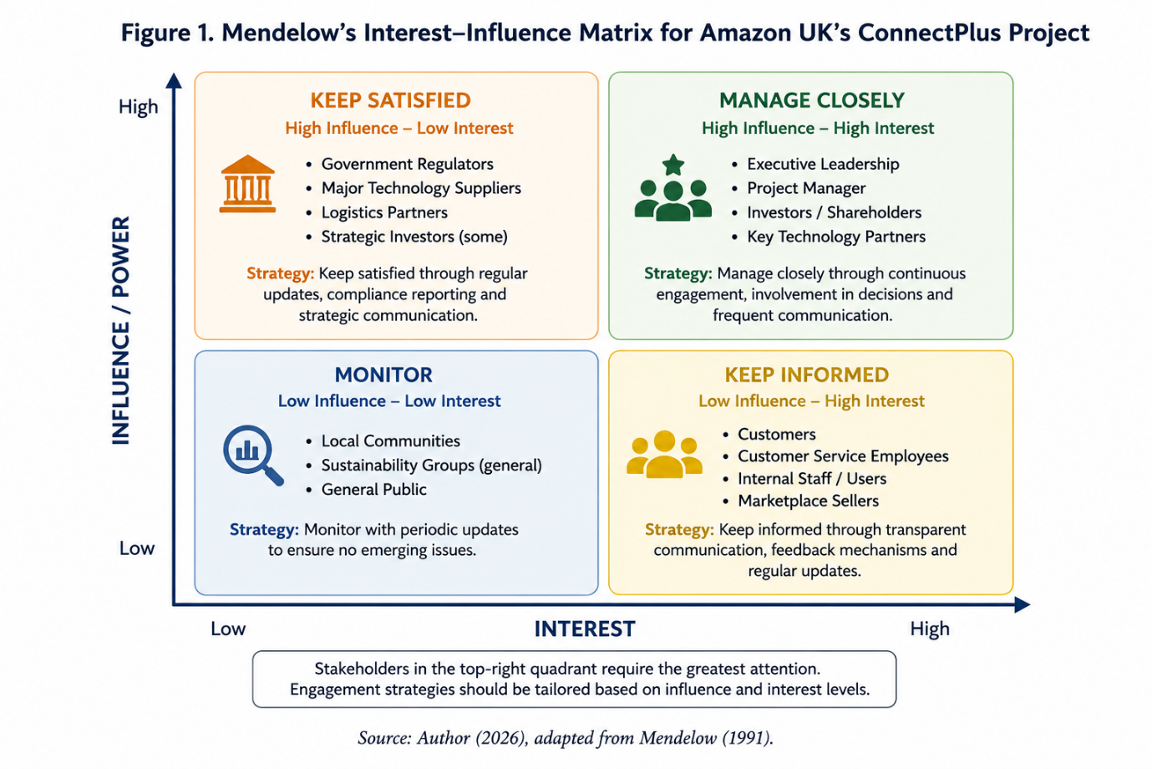
Involving executive leadership, project managers and investors from the very beginning of a project requires close management in order to ensure their interests are being met. Software development teams, marketing departments and most of all customers have high interest in projects because their work and experiences are influenced by the outcomes of the project. Strategic suppliers have high influence on a project, but lower interest on a day-to-day basis and need to be kept satisfied by means of regular reports and updates on compliance with their specifications. Employee stakeholders such as customer service employees, local communities and consumer advocacy groups have high interest but lower influence. As a result, they need to be kept informed by means of transparent communications and feedback opportunities. The remaining external and internal stakeholders with lower interest and influence should be monitored from time to time in order to identify potential problems in advance.
Government regulators and strategic suppliers have a high degree of influence but have lower interest in project delivery on a day-to-day basis. Thus, the management of ConnectPlus must report to them on a regular basis and ensure that they are satisfied with the level of compliance. Customer service employees, local communities and consumer groups have a high degree of interest in ConnectPlus. Although they have lower influence on project delivery, Amazon must keep them informed of the development of the project and provide them with opportunities to provide feedback on the issues that ConnectPlus will be addressing. Even stakeholders with lower influence and interest must be monitored for issues that could affect project delivery in the future.

3.5 Stakeholder Analysis Using the Salience Model
The Stakeholder Salience Model (Mitchell, Agle and Wood, 1997) categorizes stakeholders on three dimensions: power, legitimacy and urgency. Viewed through this lens, the key stakeholders are the definitive stakeholders of the Executive leadership of Amazon. As already mentioned, the Customers of ConnectPlus are becoming more and more legitimate to be considered as important and their urgency is increasing, as service delivery online is expected to be of high quality and Customers’ data to be used responsibly. The other stakeholders, such as Regulatory authorities and Technology suppliers, have power and legitimacy. Also, they are becoming more important, as the expertise of the Technology suppliers is crucial for the quality of the implementation of the ConnectPlus platform and for the timescales of the project.
Using both the Mendelow model and the Stakeholder Salience Model helps Amazon to identify the most important stakeholders, allocate resources to communicate with stakeholders, and develop a specific approach to engage with stakeholders in order to achieve a successful implementation of the ConnectPlus platform.

4. Roles, Responsibilities, Benefits and Challenges of Key Stakeholders

4.1 Roles and Responsibilities
The successful implementation of the ConnectPlus platform depends on the clear definition of all stakeholders involved in the process and their respective roles and responsibilities. Senior executives are responsible and ensure the ConnectPlus project is strategically aligned with the company’s long-term goals of Amazon UK. They approve investments and are responsible for the overall governance of the project by ensuring that all parties are pulling in the same direction.
The project manager is responsible for coordinating the activities of the project and managing the issues of time, money, risk and communication with stakeholders. The project manager must also manage the objectives of the project to ensure that they are aligned to the strategy of the business and that the various departments within the business and external stakeholders are working together effectively to achieve the objectives of the project (PMI, 2021).
The software developers, the artificial intelligence specialists and the IT infrastructure teams are responsible for designing, testing and maintaining the ConnectPlus platform (Laudon and Laudon, 2022). Marketing and CRM teams are responsible for developing promotional messages, customer engagement campaigns and customer specific loyalty offers that drive adoption of ConnectPlus by customers.
Within the organization, the various departments of Marketing and the CRM function will create and communicate a promotional strategy and individual customer engagement campaigns within the ConnectPlus platform to generate relevant loyalty and retention behaviour (Kotler, Keller and Chernev, 2022). The Customer Service function will engage with customers during the adoption process and post-implementation to handle any customer queries, resolve any problems experienced by customers using the technology and gather user acceptance test data to continually improve and update the service being delivered to customers (Kotler, Keller and Chernev, 2022; Ashcroft, 2017).
Externally, customers will adopt the new platform, provide behavioural data and offer feedback that supports future development. Technology suppliers will provide the necessary software and technology such as cloud-based systems and cyber security solutions. Finally, regulatory bodies such as the Information Commissioner’s Office (ICO) will ensure that Amazon complies with all relevant laws and regulations that protect the interests of consumers and ensure that all data held by the company is kept safe and secure (ICO, 2025).

4.2 Benefits of Stakeholder Engagement
Effective stakeholder engagement generates significant benefits throughout the project lifecycle. Early collaboration enables stakeholders to contribute specialist knowledge, improving decision-making and reducing implementation risks (Bryson, 2018). Continuous communication strengthens trust, encourages transparency and increases stakeholder commitment towards shared project objectives (Bourne, 2016).
Stakeholder participation by employees will improve organization’s readiness to implement new technologies, by reducing uncertainty and increasing ‘buy in’. Customer involvement will also increase customer satisfaction through more personalized services (Payne and Frow, 2017). Supplier involvement will improve organization’s innovation, flexibility and service, when operating in global markets (Christopher, 2016).
In addition, Amazon UK needs to maintain good relations with a range of other stakeholders such as those from the regulatory community, investors and local communities. These relations are vital to ensuring that the organization maintains its legitimacy and goes on to achieve sustainable growth and development over the long term (Freeman, Harrison, Zyglidopoulos and Phillips, 2021).

4.3 Challenges Faced by Stakeholders
There are also many negative aspects of stakeholder engagement, because of the differences in their interests. Their different expectations can create tension, and lead to conflicts. A number of examples are differences in project scope, budget, time and objectives (Eskerod and Jepsen, 2016). In order to overcome the employees’ resistance to change, Senior Managers must take account of employees’ fears of new technologies, job insecurity and increased workload (Cameron and Green, 2020).
However, as ConnectPlus is being deployed to international markets, there are a number of additional challenges that Senior Managers and Project Managers will have to manage, particularly where there are differences in culture, language, as well as legal and customer requirements across various global markets (Hofstede, Hofstede and Minkov, 2010). Many of these challenges will revolve around the company’s responsibility to manage customer data, an area where Amazon UK faces increasing public concern around privacy, and the use of AI and other technologies in order to ensure that any implementation is carried out in a manner that meets customers’ expectations as well as maintaining high levels of ethics and compliance with all relevant regulations (European Commission, 2024).
Addressing these challenges requires proactive leadership, transparent communication and continuous stakeholder engagement throughout the entire ConnectPlus project lifecycle.

5. Stakeholder Engagement Strategy and Conflict Management

5.1 Introduction
The involvement of effective stakeholders is crucial for the successful implementation of the ConnectPlus platform of Amazon UK. While the identification of stakeholders defines who should be involved in the project of Amazon UK, the engagement of stakeholders reaches throughout the entire project lifecycle of ConnectPlus. Effective stakeholder engagement fosters collaboration and communication as well as trust and commitment of the stakeholders. By contrast, failed stakeholder engagement can cause resistance, delay and increased project risk (Freeman, 1984; Bryson, 2018; PMI, 2021). As Project Manager of Amazon UK, a structured engagement strategy for the stakeholders will be developed in order to inform stakeholders of relevant information, to involve them in the decision-making process and to win over their commitment in the course of the project lifecycle. This section sets out the Stakeholder Engagement Plan, the Communication Plan, the RACI Matrix and the 4Cs Model. Conflict management approaches are also discussed.

5.2 Stakeholder Engagement Plan
A Stakeholder Engagement Plan is a document that outlines the structure that is placed on Stakeholders to ensure their involvement throughout the Project Lifecycle (Bourne, 2016). The nature of the engagement with each individual Stakeholder should reflect their level of Influence upon the Project, their level of Interest in the Project and their ability to add Value to the Project.
During the project initiation stage the project team would receive confirmation of the strategic objectives of executive leadership together with the project funding and organizational priorities. During the project planning stage there would be collaboration between IT, marketing and customer service, legal and operations in order to make informed decisions about the ConnectPlus project. Also customers would be able to participate through surveys, pilot programs and usability testing in order to ensure that ConnectPlus meets the needs of the user (Kerzner, 2022; Payne and Frow, 2017).
During the implementation phase of the implementation of the measures of the ConnectPlus project the progress of the project can be monitored and problems can be solved quickly in weekly meetings with all stakeholders. In addition, stakeholders can be kept informed of the progress of the project by means of a project dashboard and in stakeholder sessions. After the implementation of the measures of the ConnectPlus project, customer feedback, performance reviews and also stakeholder evaluations can be used to continue to improve the project and to implement other digital change projects within Amazon UK (PMI, 2021; Bourne, 2016).

5.3 Communication Plan
Communication is vital and projects fail because stakeholders (including customers and employees) have not received the information they need in a timely manner (PMI, 2021). Poor communication often results in misunderstanding and stakeholder dissatisfaction.
Communication with stakeholders must be adapted to their needs. The project team needs a weekly meeting with an overview of work in progress and also use of collaborative software to keep up to date with each other’s work. The executive leadership team need regular reports on progress, risks and expenditure.
Communication with the customer must also reflect the way in which they are used to receiving information from Amazon. So, customers would receive updates regarding loyalty benefits and data privacy through the Amazon website, the Amazon mobile app, by email and on social media. Transparency regarding the use of artificial intelligence and personal data will help to ensure customer confidence is maintained (ICO, 2025). Technology suppliers, logistics providers and other regulators and governing bodies will require regular scheduled updates on progress as well as detailed compliance reports to ensure that ConnectPlus is being managed in an appropriate manner (Christopher, Payne and Ballantyne, 2013).

5.4 Application of the RACI Matrix
The RACI Matrix clarifies project responsibilities by identifying who is Responsible, Accountable, Consulted and Informed for each activity (PMI, 2021).
The Software developers & AI specialists are responsible for the development and testing of the ConnectPlus system. The Project Manager is accountable for the overall delivery of the project and is responsible for the co-ordination and the management of the risks. The Executive leadership are consulted on strategic issues relating to investment. The marketing teams are responsible for customer promotion of the ConnectPlus system prior to launch.
Legal and compliance departments must ensure that ConnectPlus is delivered in line with UK GDPR and other privacy legislation. Customers will be involved in the pilot and post-launch evaluation of ConnectPlus. Clearly defining roles and responsibilities will reduce role ambiguity and increase accountability and collaboration between stakeholders (Kerzner, 2022).

5.5 Applying the 4Cs Model
The 4Cs Model for stakeholder engagement includes Communication, Consultation, Collaboration and Commitment (Bourne, 2016).
By communicating with stakeholders, they will receive the relevant and constant information about the project. Consultation with employees, customers and business partners can take place before major decisions are made and therefore increased stakeholder acceptance is achieved (Bryson, 2018).
Collaboration - This will allow departments like IT, marketing, legal and customer service to work better together to increase innovation and to combat silo mentalities within organizations (Christopher, 2016).
Commitment - This is when stakeholders have been made aware of a project’s objectives and trust the project manager. They will then work to implement the project in the best possible way (Freeman et al., 2021).
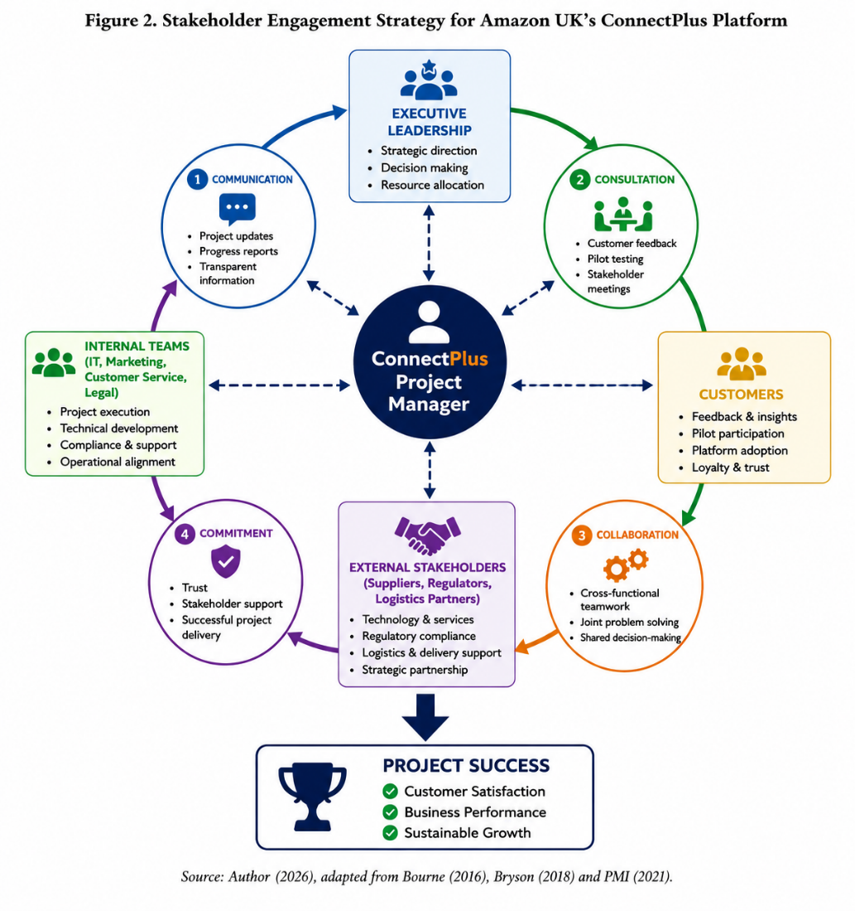

5.6 Conflict Management
In projects of high complexity conflicts among stakeholders and employees will occur frequently because of different objectives and expectations (Eskerod and Jepsen, 2016). In ConnectPlus for example budget, schedule, technology and customer data protection conflicts might occur. Also, employees might resist against changes if these changes are affecting their tasks negatively (Cameron and Green, 2020, Ashcroft, 2017). The project manager must recognize problems in time to be able to handle them adequately before they are having a negative impact on the rest of the project.
Thomas and Kilmann described five different strategies or styles that a person uses when dealing with a conflict. These five conflict styles are collaborating, compromising, accommodating, avoiding and competing (Thomas and Kilmann, 1974). A collaborating conflict style is the most favourable when dealing with stakeholders because it strives for the best possible solution that satisfies both of the conflicting stakeholders and supports long-term relationships. To deal with conflict effectively it is beneficial to have regular meetings with stakeholders and use active listening to better understand the other parties’ needs and points of view. If necessary, a compliance specialist should be consulted to check that any decisions or actions will comply with the relevant laws and regulations as well as protect customers’ rights and ensure their privacy is not compromised (European Commission, 2024).

5.7 Monitoring Stakeholder Engagement
After the project has been successfully implemented, Stakeholder engagement is to be continued in order to ensure successful implementation of the project in the long run. The project manager can check the degree of satisfaction of the stakeholders and also check if the communication is working as desired and also check the degree of satisfaction with the overall project performance (PMI, 2021).
Key performance indicators for this dimension are customer satisfaction, employee engagement, participation of stakeholders, the achievement of project milestones and the degree of adoption of the platform by customers and employees. Customer surveys, employee feedback and performance reviews provide valuable information for continuous improvement (Payne and Frow, 2017).
By monitoring the stakeholder relationships and lessons learned, Amazon can use this to strengthen organizational learning and to improve the trust of stakeholders to maximize the long-term success of ConnectPlus (Argyris and Schön, 1996).

6. Sustainable Stakeholder Engagement and Business Performance
Sustainable stakeholder engagement is key to improving organizational performance as it fosters long term relationships based on trust, transparency and mutual value as opposed to short term project success (Freeman, 1984). For Amazon UK, maintaining continuous engagement with stakeholders throughout the ConnectPlus project will create added value by increasing operational efficiency and customer loyalty that in turn will generate sustainable competitive advantage in a retail environment that increasingly is becoming digital (Harrison et al., 2019).
The primary benefit of long-term stakeholder engagement is increased customer satisfaction leading to higher customer retention. Involving customers during the design, testing and evaluation of ConnectPlus ensures that the highest quality of service is provided to customers, and that all current and future customer needs and expectations are being met. By providing the highest level of customer service, customers are more likely to be retained leading to stronger brand loyalty. Studies have found that higher levels of customer satisfaction can lead to greater long-term profits for organizations (Payne and Frow, 2017; Kotler, Keller and Chernev, 2022).
Involving stakeholders in a project can also strengthen the commitment of employees to an organization and, as a result, the performance of that organization. There are a number of factors that influence employee commitment including the amount of communication that employees receive regarding a project, the training that they are provided with in order to deliver the changes that are introduced as part of a project, and the level of influence that employees have regarding the decisions that are taken by a project team. Employees who are involved in a project and feel that their contributions are valued are more likely to be motivated to support change in an organization. Employee engagement is a key factor in relation to collaboration between employees, innovation and productivity within an organization, and resistance to change (Cameron and Green, 2020; Bryson, 2018).
Relationships with Suppliers, Technology Partners and third-party Logistics Providers, all enhance business performance through the sharing of knowledge, by driving innovation and by allowing greater flexibility within operations. Collaborating with Amazon’s Technology Partners allows the Company to stay abreast of the latest technological advancements, helping the organization to react to rapidly changing markets (Slack and Brandon-Jones, 2023; Christopher, 2016).
It is also an important part of effective corporate governance and regulatory compliance to have sustainable engagement with key stakeholders. Amazon must have an open conversation with regulators, investors and consumer groups so that it can be kept on one. Also, it must comply with general laws in government and industry, including data privacy requirements and ethical AI practices to keep the organization safe from risk or damage to its brand reputation. In doing so, it will also generate confidence in the ConnectPlus platform among all stakeholders (European Commission, 2024; ICO, 2025).
Even with the greatest efforts, sustaining stakeholder engagement on an ongoing basis will continue to require the commitment of considerable investment of time and effort by means of communication, monitoring and relationship management. The expectations of stakeholders will change over time due to a host of reasons which could include current technological developments, changing legislation and customer preferences. It will be necessary therefore for Amazon to monitor on an ongoing basis the level of satisfaction that it has been able to achieve with its various stakeholders and review its own approach to engagement with stakeholders as required in order to be able to ensure that adequate levels of satisfaction are being achieved with all stakeholders in order to maintain their trust of Amazon and, therefore, to secure successful outcomes from its projects (PMI, 2021; Bourne, 2016).
In summary, by creating sustainable stakeholder engagement Amazon can develop further successful projects. Stakeholder engagement can build up collaboration and, by identifying and reducing risks, can create value in the long run for Amazon and all other stakeholders. If Amazon integrates stakeholder engagement into everyday business practice, its organizational resilience and market position can be strengthened while supporting future digital transformation initiatives in the global retail industry.

7. Recommendations and Conclusion
To maximize the success of the ConnectPlus project, Amazon UK should implement a structured and ongoing Stakeholder Engagement approach throughout the project life cycle. Firstly, open communication will need to be established and maintained with all Stakeholder groups to ensure information is up to date, relevant and for them to be able to contribute as required. Secondly, continuous customer feedback will need to be collated from surveys, pilot programs and analysis of the ConnectPlus platform. This will enable on-going amendments and development to ensure the highest levels of customer satisfaction and therefore customer loyalty (Payne and Frow, 2017). Thirdly, all employees who will be using new technology as part of ConnectPlus will require appropriate training and change management support to gain confidence in using new systems and to minimize resistance to change (Cameron and Green, 2020). Finally, Amazon UK must review the engagement with all Stakeholders on an ongoing basis by using measured indicators such as customer satisfaction, employee engagement and other project metrics (PMI, 2021).
In summary, effective stakeholder engagement is key to the successful implementation of Amazon’s ConnectPlus platform. By identifying stakeholders, establishing their roles and ways of engagement, using the most suitable methods of engagement and building sustainable relationships, the organization can minimize project risks, enhance collaboration and improve overall organizational performance. The long-term approach to stakeholder engagement can support Amazon’s drive for innovation, compliance and customer trust thereby ensuring competitive advantage in UK’s retail market. A proactive stakeholder management approach will therefore aid in ensuring the successful delivery of the ConnectPlus project and the subsequent business growth (Freeman, 1984; Bryson, 2018).

Harvard Reference List
Amazon (2025) About Amazon. Available at: https://www.aboutamazon.com/ (Accessed: 18 July 2026).
Ashcroft, J. (2017) The relational lens: understanding, measuring, and managing stakeholder relationships. Cambridge: Cambridge University Press. Available at: https://www-cambridge-org.ezproxy.uwtsd.ac.uk/core/books/relational-lens/value-and-importance-of-relationships/718C31032061BDFA3F480BA2A53F45D4#CN-bp-1
Argyris, C. and Schön, D.A. (1996) Organizational Learning II: Theory, Method and Practice. Reading, MA: Addison-Wesley.
Bourne, L. (2016) Stakeholder Relationship Management: A Maturity Model for Organisational Implementation. 2nd edn. London: Routledge.
Bryson, J.M. (2018) Strategic Planning for Public and Nonprofit Organizations. 5th edn. Hoboken: John Wiley & Sons.
Cameron, E. and Green, M. (2020) Making Sense of Change Management. 5th edn. London: Kogan Page.
Carroll, A.B. and Brown, J.A. (2018) Corporate Responsibility: The American Experience. Cambridge: Cambridge University Press.
Christopher, M. (2016) Logistics & Supply Chain Management. 5th edn. Harlow: Pearson.
Christopher, M., Payne, A. and Ballantyne, D. (2013) Relationship Marketing: Creating Stakeholder Value. Oxford: Butterworth-Heinemann.
Elkington, J. (1997) Cannibals with Forks: The Triple Bottom Line of 21st Century Business. Oxford: Capstone.
Eskerod, P. and Jepsen, A.L. (2016) Project Stakeholder Management. 2nd edn. London: Routledge.
European Commission (2024) Artificial Intelligence Act. Available at: https://digital-strategy.ec.europa.eu/ (Accessed: 18 July 2026).
Freeman, R.E. (1984) Strategic Management: A Stakeholder Approach. Boston: Pitman.
Freeman, R.E., Harrison, J.S., Zyglidopoulos, S. and Phillips, R.A. (2021) Stakeholder Theory: Concepts and Strategies. Cambridge: Cambridge University Press.
Harrison, J.S., Barney, J.B., Freeman, R.E. and Phillips, R.A. (2019) The Cambridge Handbook of Stakeholder Theory. Cambridge: Cambridge University Press.
Hofstede, G., Hofstede, G.J. and Minkov, M. (2010) Cultures and Organizations: Software of the Mind. 3rd edn. New York: McGraw-Hill.
Information Commissioner's Office (ICO) (2025) Guide to UK GDPR. Available at: https://ico.org.uk/for-organisations/uk-gdpr-guidance-and-resources/ (Accessed: 18 July 2026).
Kerzner, H. (2022) Project Management: A Systems Approach to Planning, Scheduling and Controlling. 13th edn. Hoboken: Wiley.
Kotler, P., Keller, K.L. and Chernev, A. (2022) Marketing Management. 16th Global edn. Harlow: Pearson.
Laudon, K.C. and Laudon, J.P. (2022) Management Information Systems: Managing the Digital Firm. 17th Global edn. Harlow: Pearson.
Mendelow, A.L. (1991) 'Stakeholder Mapping', Proceedings of the 2nd International Conference on Information Systems, Cambridge, MA.
Mitchell, R.K., Agle, B.R. and Wood, D.J. (1997) 'Toward a Theory of Stakeholder Identification and Salience', Academy of Management Review, 22(4), pp. 853–886.
Payne, A. and Frow, P. (2017) Strategic Customer Management: Integrating Relationship Marketing and CRM. Cambridge: Cambridge University Press.
Porter, M.E. (1985) Competitive Advantage. New York: Free Press.
Project Management Institute (PMI) (2021) A Guide to the Project Management Body of Knowledge (PMBOK® Guide). 7th edn. Newtown Square, PA: Project Management Institute.
Slack, N. and Brandon-Jones, A. (2023) Operations and Supply Chain Management. 11th edn. Harlow: Pearson.
Thomas, K.W. and Kilmann, R.H. (1974) Thomas-Kilmann Conflict Mode Instrument. Tuxedo, NY: Xicom.

