

Certificate of higher education in employability skills
Module: Academic skills for Digital Era(BMSW4013)
TITLE: THE FUTURE OF AI-ASSISSTED WRITING SUPPORTING CREATIVITY.
Module Lead: Scott James
STUDENT NUMBER:2432847
EMAIL: 2432847@student.uwtsd.ac.uk.

Introduction:
Many aspects of education have been revolutionized under Artificial Intelligence (AI) technology. Its greatest impact upon schooling, perhaps, is seen in academic writing: increasingly frequently, tools which take advantage of AI are employed by teachers and students. These aids go beyond mere correction of formal aspects like grammar or structure; they also contribute significantly to creativity in writing as well as expression of self. Supported by literature, here i discuss how AI supports academic writing students and promotes outcomes with greater creativity. AI-assisted Grammar In turn, grammar-checking aids like Grammarly have become indispensable for today's students. Such web-driven platforms provide immediate feedback on not just grammaticality but also sentence structure and even choice of words. Grammarly, for instance, makes suggestions to improve clarity, engagement and delivery (Grammarly: They also offer no limitation on the speed at which (or how fast), can input content). This instant feedback enables students to learn as they write by recognizing for themselves mistakes made--thus leading to a deeper understanding of how language works as well, researchers Wang et al. (2023) reported. Fostering Creativity and Voice Rather than simply checking faults AI tools provide encouragement for students to be creative and expressive in work for credit. For example, tools like Sudo write (previously Textop.com) and five different examples from Jasper create prompts, suggest new ways to phrase things, offer inspiration in other areas of writing projects--even may open wholly novel lines of essays (New York Times, Next Avenue 3 June). Li, Wang and Liu (2022) discovered that students using AI-based thinking aid products generated better ideas and more fresh perspectives in essays than those who didn't use them. AI generated comments can break through writer's block for students and give them new ways to express their thoughts, thereby strengthening their capacity for creation.
Fostering Creativity and Voice
AI tools do more than correct errors; they encourage creativity and self-expression. Applications like Sudo write and Jasper generate prompts and suggest alternative phrasings, providing inspiration that can lead to new ideas and perspectives in writing projects (New York Times, Next Avenue, 2022). Research by Li, Wang, and Liu (2022) indicates that students using AI-based brainstorming tools produce more innovative ideas compared to those who do not. These tools can help overcome writer's block and enhance students' ability to express their thoughts creatively
Supporting Revision and Self-Reflection:
Supporting Revision and Self-Reflection Many readers may refer to the same material in an essay as both preaching and pleading, without seeing that preaching tends to be logical while pleading can continue on indefinitely. Content like this, an extremely sloppy copy of the Tolstoy piece you read Translation and trying to figure in the role of voice-overs was like stopping a car at 80 miles per hour; if you didn't swerve suddenly then something would go wrong. Facilitating Academic Integrity and Ethical Writing AI tools promote academic integrity by detecting and reporting plagiarism and other improper citation practices. Turnitin and similar platforms check students' work against extensive databases of their own, drawing attention to instances where students have failed to cite sources. Not only does this act as a preventive measure against academic dishonesty, however, it also teaches students about the importance of doing their own research and expressing

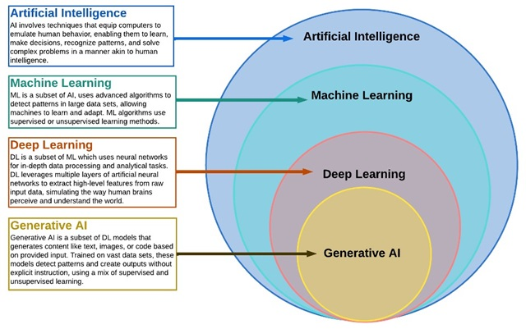
themselves in ways unrelated to merely rote repetition., though, these tools can help students grow into effective and confident writers, capable of producing truly original work.
Summary:
AI tools have changed the foremost indispensable way of supporting by providing students with feedback, propelling creation, require for revisions and promulgating justice when the scribe is not around bringing is not so regarding future eras at the same times they fit into learning mode well. These high-tech tools not only enhance professional writing; they can also drive teachers' ideological development and inspire better academic outcomes.

References
Grammarly. (n.d.). How Grammarly Can Help You. Retrieved from https://www.grammarly.com/ Li, X., Wang, Y., & Liu, Z. (2022). Impact of AI-Based Brainstorming Tools on Student Creativity in Academic Writing. Journal of Educational Technology & Society, 25(1), 40-51. Sahu, P., & Waghmare, S. (2022). Artificial Intelligence in Higher Education: Ethical Considerations and Academic Integrity. Journal of Academic Ethics, 20(3), 367-375. Turnitin. (n.d.). Feedback Studio. Retrieved from https://www.turnitin.com/products/feedback-studio Wang, Y., Li, J., & Chen, R. (2023). AI-Powered Writing Tools and Their Impact on Non-Native English Speakers. Computers & Education, 191, Article 104662. Include Here is comprehensive treatment of the topic "How AI tools enhance academic writing by promoting for students' creativity and expression leading to better academic outcomes: by providing ample references on." Title: How AI Tools Enhance Academic Writing: By Supporting Students and Irone Deluge.
Conclusion
AI technologies have ushered in a new era for academic writing, providing students with tools that enhance both technical quality and creative expression. By integrating these technologies into educational practices, students can navigate their writing journeys with greater ease and creativity, ultimately leading to improved academic outcomes. However, ongoing discussions about the equivalence of AI-generated outputs to human writing remain essential in shaping the future of academic integrity and creativity.

