I confirm that I have not used any AI tools in the research and creation of this assignment. I confirm that I have not presented any AI generated material as my own work. I confirm I have copies of my drafts, notes, and other resources I used, which I may be asked to provide in evidence.

Component: Digital Scrapbook

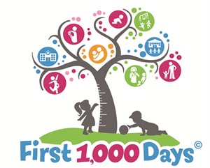
(Source: The Boston Foundation, 2021)

This scrapbook will be a document to support a parent in the first one thousand days. The topics that will be looked at are: What is the first 1000 days and why it is important, caregiving, professional partnerships, challenges and activities to help caregivers to have a better understanding of child development.
WHAT IS THE FIRST 1000 DAYS?
This first 1000 days of life is from conception in the womb, to birth and to the age of two (House of Commons, 2019, p. 3). These days are the pivotal phase as it is the foundation that is laid for a child’s development (The Health and Social Care Committee, 2019, p. 3). The child’s cognitive, physical and emotion develop starts while in the womb. It is considered the utmost critical time as the child is in a vulnerable state (The Early Years Healthy Development Review Report, 2021, p. 13). According to Parent Infant Foundation (2021, p. 1) it is the environment and experiences that shape the life of the baby and is important as this will affect the future development of the child holistically. The first 1000 days are split into three categories in a child’s life. Pregnancy is 270 days which is 9 months. Infancy is 180 days this is from birth up to 6 months. The toddler years which are 550 days which is from 7 month to 24 months (UNICEF Philippines, 2015).
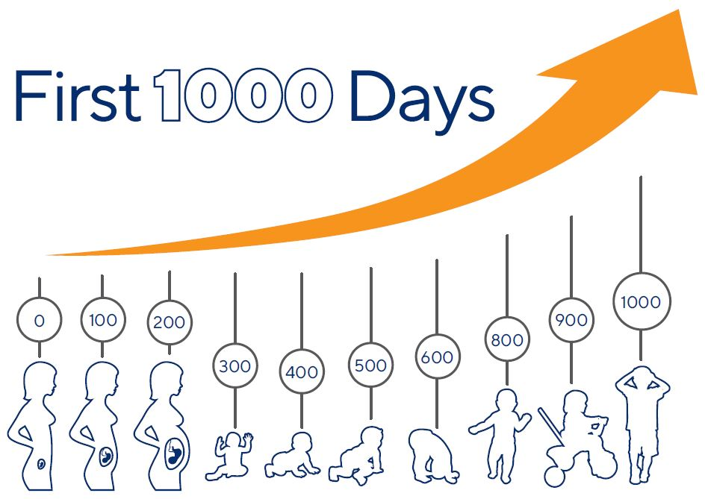
(Source: Ausnutria Nutrition Institute, no date)

CHALLENGERS TO FIRST 1000 DAYS
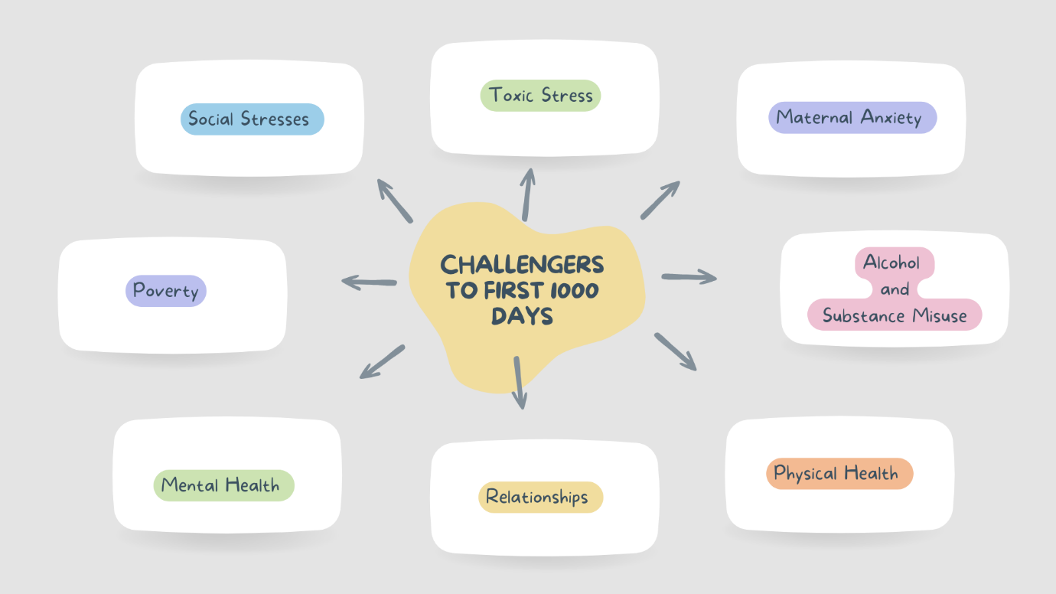
Parliament United Kingdom (2017) shares that the challenges that a child faces are influenced by the parents’ decisions. These challenges arise and often have a life long lasting effect as one cannot repair the damage once it has occurred as the body holds trauma. According to Parliament United Kingdom (2019) there are many challenges that impact a child’s development in the first 1000 days. Below is a map of some challenges (Parliament United Kingdom, 2019).
I will be focusing on toxic stress and maternal anxiety.
TOXIC STRESS
Rose, et al. (2016, p. 43) shares that for an infant to create a good sense of well-being is experiencing positive stress. This is activated when they are hungry, feeling insure or cold. When the needs are met in a nurturing environment and supported by a reliable caregiver their vagal circuitry system regulates and begins to build their vagal tone. However, according to de Magalhaes-Barbosa (2021, p. 14) toxic stress is occurrence of threating situation repeatedly for a long period of time and the failure of the body regulating stress from lack of support or no support from the caregiver for example abuse and fights between parents. The effect of this is delayed disruption of brain development, cognitive impairment and can lead to a higher risk of disease. This will affect the future of learning, health and behaviour (de Magalhaes-Barbosa 2021, p. 17).
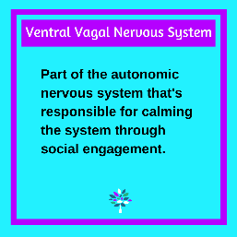
(Source: Lord, 2021)

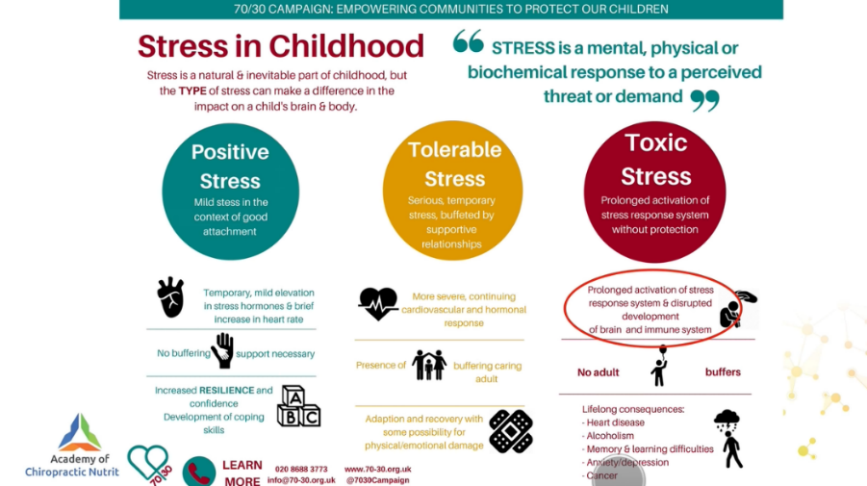
(Source: Academy of Chiropractic Nutrition, 2021)

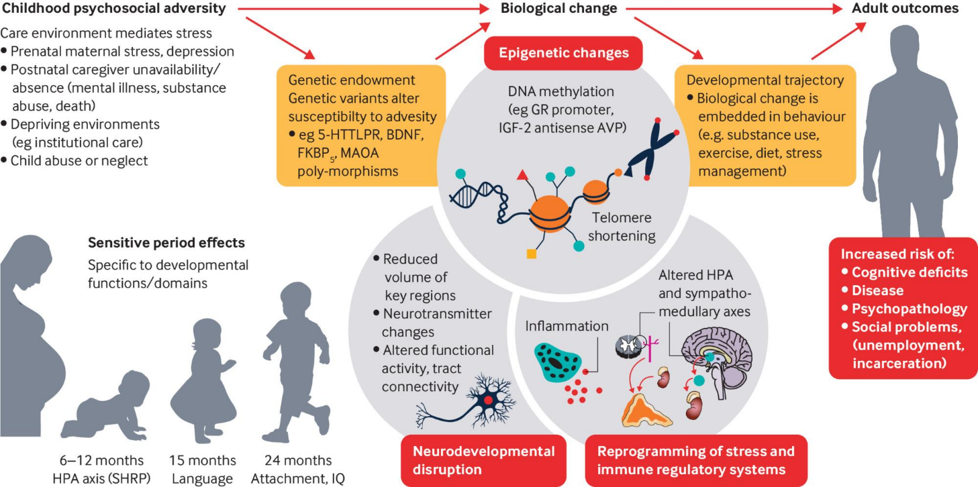
(Source: Nelson, et al., 2020)
STRATEGIES
Kansas State University (2016, p. 3) explains that toxic stress can be bearable by having a strong support system around the infant. The following are strategies to support according to Kansas State University (2016, p. 3).
- Stability/Consistency – Be sensitive, warmly when responding and consistence when the baby cries, reassurance to infant that you are there and able to help and create a routine.
- Safe Environment – Create a place where an infant feels warm and safe in knowing there is no danger and safe from harm.
- Model Coping Mechanisms – Show by walking away to calm down before responding, breathing deep breaths and listen to different viewpoints.

MATERNAL ANXIETY PREGNANCY
Araji, et al. (2020, p. 47) states that depression and anxiety impact complications during pregnancy. Women already effected by mental health, anxiety disorder and mood tend to emerge or worsen midst pregnancy. A few of the worries that appear during pregnancy is maternal illness, fatal wellbeing, financial support and social. These affect function impairment over a mother’s life (Araji, et al., 2020, p. 47). Kiyak (2024, p. 1) shares that when a mother is experiencing anxiety and depression it effects the maternal and infant outcomes such as preterm birth, preeclampsia and the bonding between mother infants.
Signs of maternal anxiety (Maternal Mental Health Alliance, 2025)
- Emotions/Mood – a sudden change either big, small or constant.
- Thoughts/Images – intrusive thoughts of self-harm or harm towards your baby.
- Overwhelmed – feeling ashamed, hopelessness or guilt.
- Cannot Relax/Sleep – impossible to relax or sleep.
- Expectations – not good enough or thinking your baby is better off without you.
- Body Image – constant fear or worry over food and changes in the body.

STRATEGIES/ HOW TO PREVENT
Fisher and Lombardi (2025, p. 2), share that theorist Bronfenbrenner (1970) created a concept of framework for human development called Ecological Systems Theory. This means that it is not just the parent who shapes a child but the environment around.
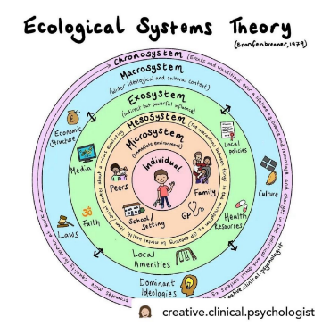
(Source: Map the System Canada’s Post, 2026)
Map the System Canada’s Post

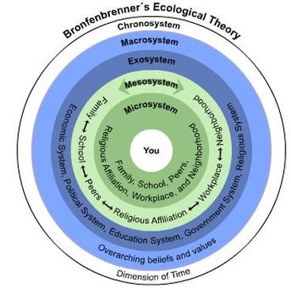
(Source: Gray, No Date)
Map the System Canada’s Post

McCarthy, et al. (2021, p. 1) suggests that creating a good support system for a mother will help reduce anxiety during and after pregnancy in the first 1000 days. This support system includes support from the partner, family and peer.

Parliament United Kingdom (2019) states that a child’s environment at home influences their development and health in the future. The reason being is that it is the place where habits and learning take place ruing early years.

WHY IS IT IMPORTANT?
Stead (2024) states that the first 1000 day are crucial as a newborn has the most brain cells that they will have in their life approximately 100 billion. According to Williams (2025, p. 1) the fundamental building blocks of the nervous system is present in a newborn’s brain. These are called neurones which connections need to be created using synaptogenesis. Imagine these neurones as landmarks but the pathways to the landmarks have not been developed. Stead (2024) shares that these pathways are formed through experiences and surroundings. When a baby is touched, rocked or engaged with a care giver, these pathways are being formed. Construction is taking place and developing the brain’s architecture and creating strong pillars to equip a child to absorb and make sense of information, experiences and skills all throughout their life. These pillars will support the child’s development in ‘learning abilities, promotes positive social-emotional development, cultivates crucial self-regulation abilities, supports improved mental health, and even contributes to robust physical well-being,’ (Stead, 2024).
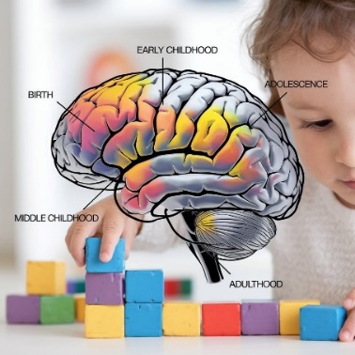
(Source: Jannatkhan, 2024)
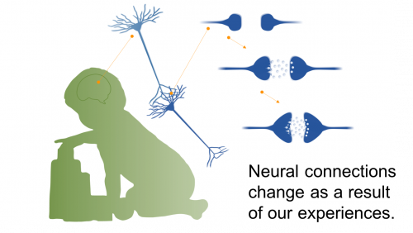
(Source: University of Washington 2018)

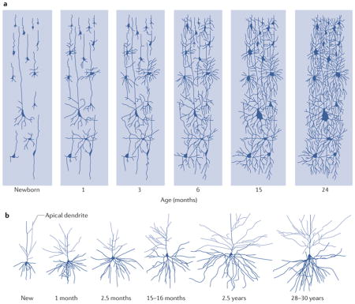
(Source: Gilmore, J.H, et al., 2018)

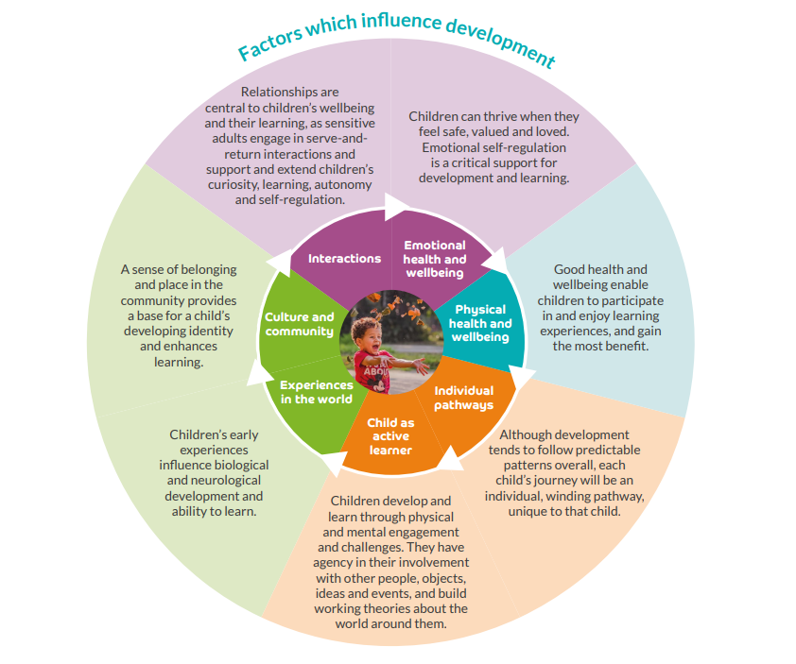
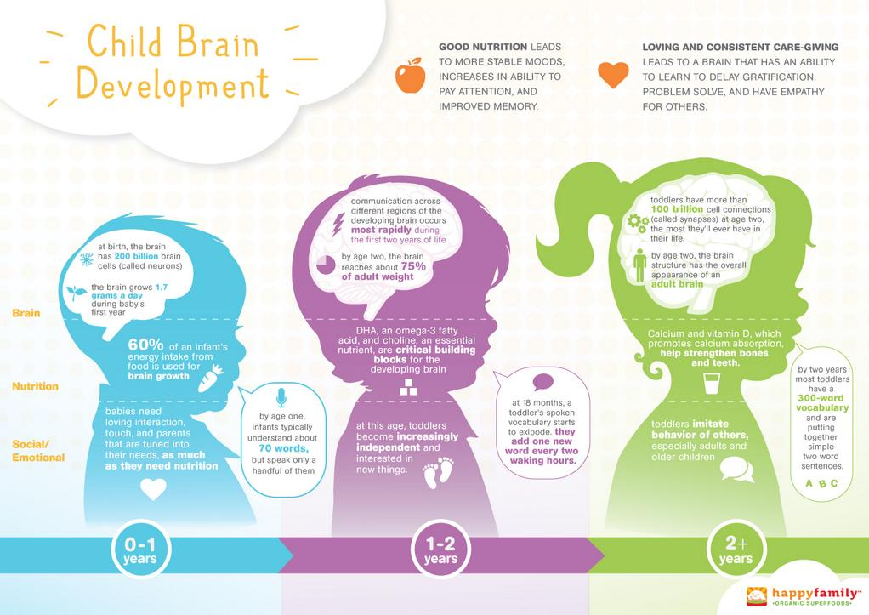
(Source: Birth to 5 Matter, 2021)
(Source: Home Remedies and Natural Treatments,2016)

HOW TO SUPPORT YOUR NEWBORN?
Holding, Peek-a-Boo, Mirroring
According to Sharma and Cockerill (2014, p. 3) a newborn has an extensive repertoire of perceptual skills and motor. These are the skills that allow a newborn to form attachments that are secure and build relationships.
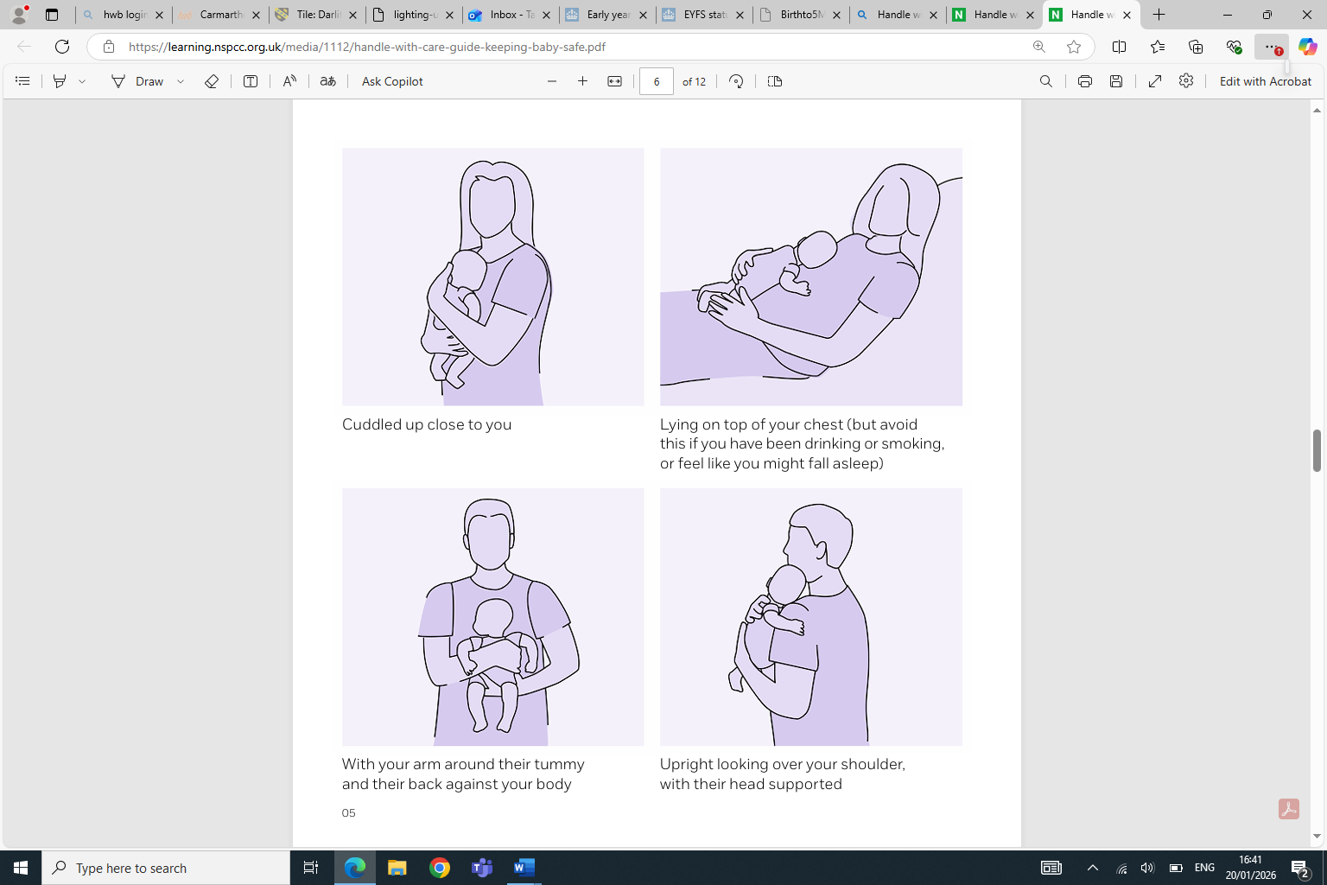
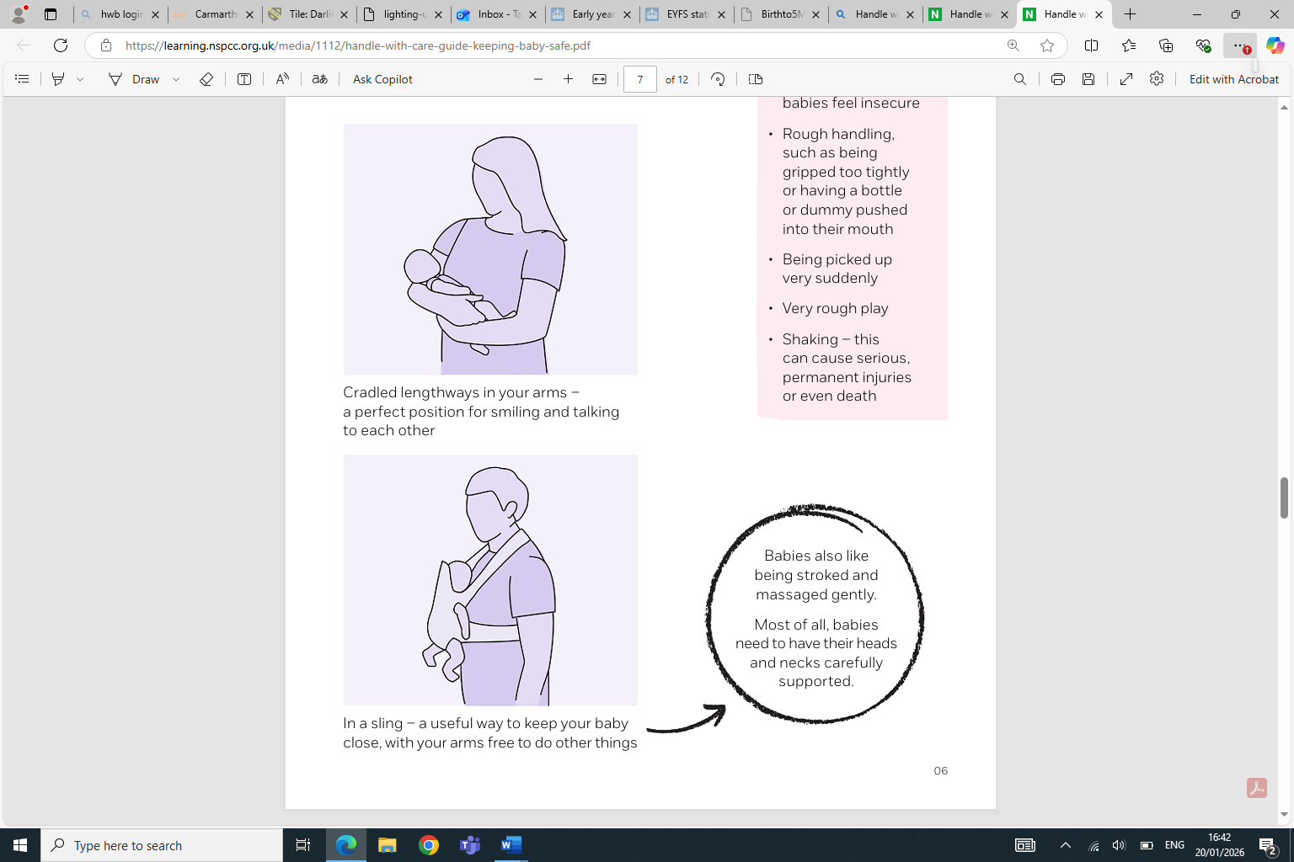
(Source: NSPCC, 2019)

Finnegan and Lawton (2016, p. 11) share how one can build a newborn’s brain as a parent. It is simply by talking to them right away and playing games such as peek-a-boo or making faces at your baby. These actions help the growth for brain development. Another activity that they suggest is to echo the infant’s noises and have a try in understanding by speaking out loud what you think. Even though the newborn does not understand, the time together is creating a bound between the caregiver and newborn. This will support the future of language skills as this supports the brain development which is linked to language skills (Finnegan and Lawton, 2016, p. 8).
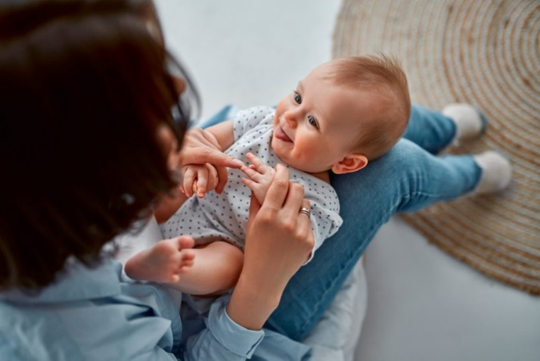
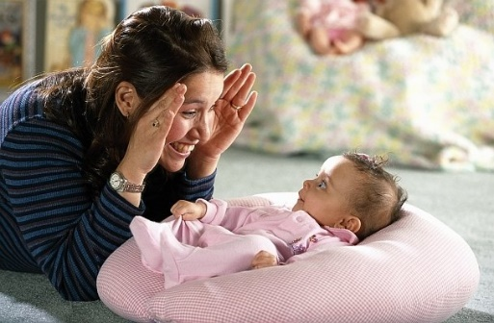
(Source: Imom, 2026)
(Source: Artofit, No Date)

HOW TO SUPPORT YOU INFANT?
Tummy Time

According to National Day Nursery Association (2024, p. 2) infants learn by being active which creates a sense of wellbeing. Create a space where an infant can practice tummy time. Rodger and Harvey (2025, p. 302) suggests that at the beginning to do 3 to 5 minutes between 2 to 3 sessions a day and increase to roughly 30 minutes a day with the goal of 1 hour by 3 months of age. Rodger and Harvey (2025, p. 302) state that it has health benefits and strengthens mobility. The experience enhances motor development, sensory and visual development which is important to the development of the infant.
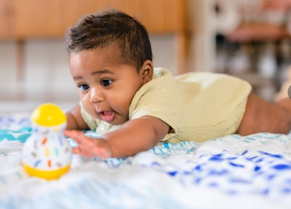

(Source: CanDo Kiddo, 2021)
(Source: Little Baby Gear, 2023)

HOW TO SUPPORT YOUR TODDLER?
Sensory Play

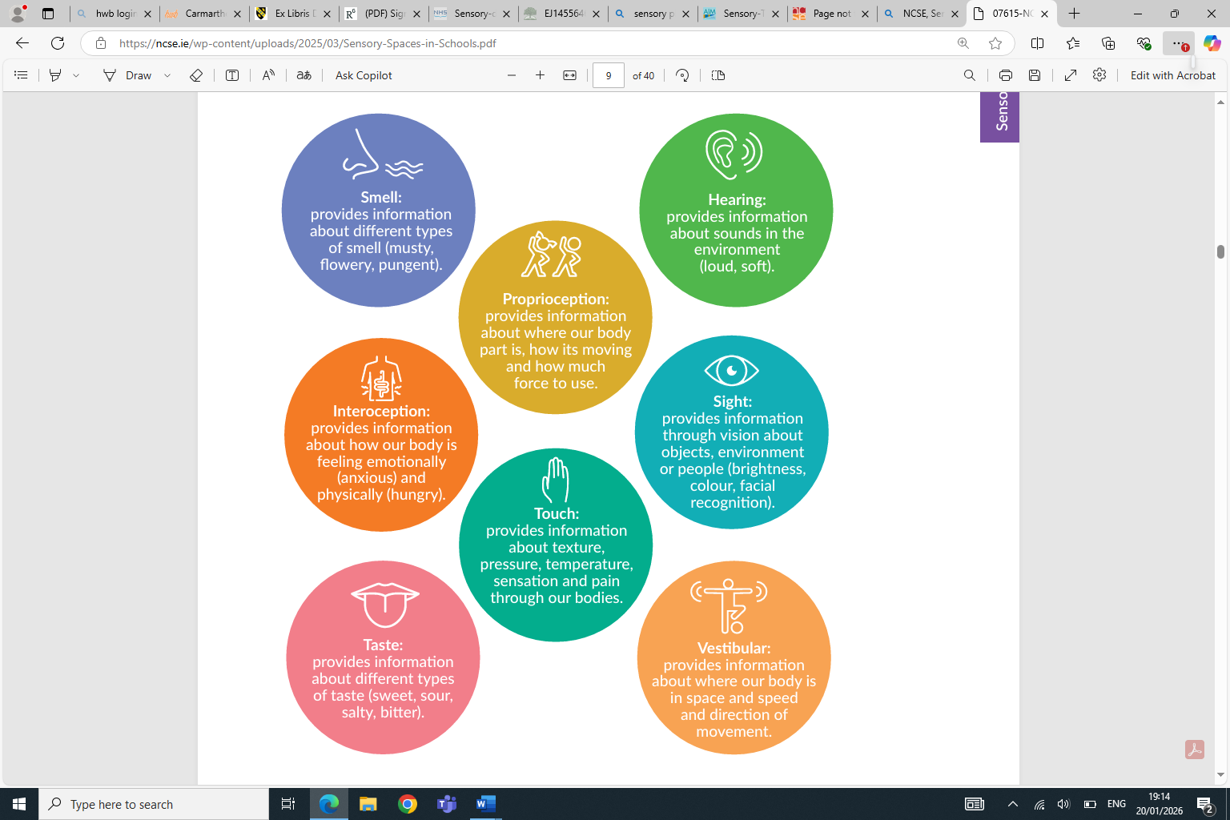
The National Council for Special Education (2025, p. 7) suggests there are eight sensory systems that help navigate the environment and understand the world. The sensory processing is where the brain uses the sensory information from the environment which integrates, organises and interprets it to understand the experience and react with them (The National Council for Special Education, 2025, p. 7). See image below for a brief understanding for each sense.
(Source: National Council for Special Education, 2025)

According to Prendiville and Fern (2017, p. 121) sensory play is the engagement of one or more senses. Theses senses are ‘tactile, auditory, visual, olfactory, gustatory, kinaesthetic, vestibular, proprioceptive or interceptive. Sensory play encourages problem solving, body awareness, helps with self-regulation and builds language according to Leadership for Inclusion in The Early Years (2020). As a parent you can create this by using dry rice and cooked rice with different colours. It creates an understanding between the textures and develop language by encouraging between soft, hard, sticky and naming colours.
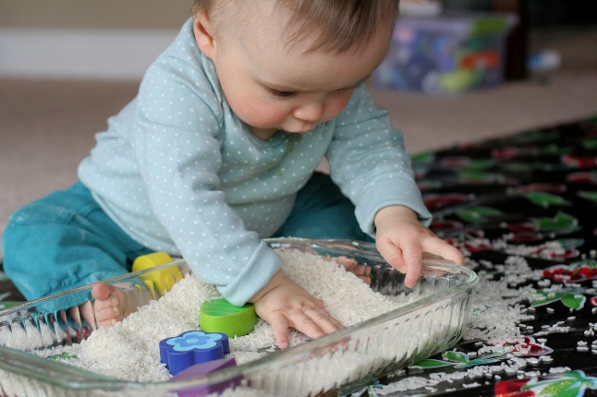
(Source: Fun at Home with the Kids, 2013)

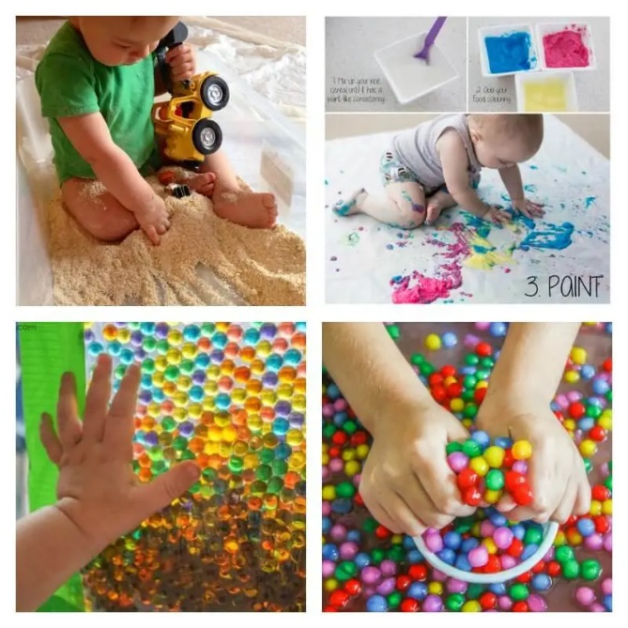
(Source: Mama Instincts, No Date)

EXCEPTIONAL CAREGIVING
Exceptional care is taking care of a child’s physical needs and social needs. Maslow’s theory takes in consideration of the child. This theory works in a step-by-step process; physical needs, safety, social/belonging, ego and self-actualisation (Children’s Commissioner, 2024). Additional information can be found at Children's Commissioner (2026): Hierarchy of needs for care experienced young people | Children's Commissioner for England.
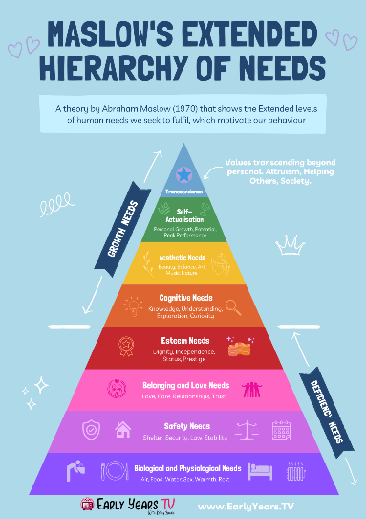
(Source: Early Years TV, 2026)

(Source: Early Years TV, 2026)

Below is a concept map that gives a brief outline of what is involved in exception care.
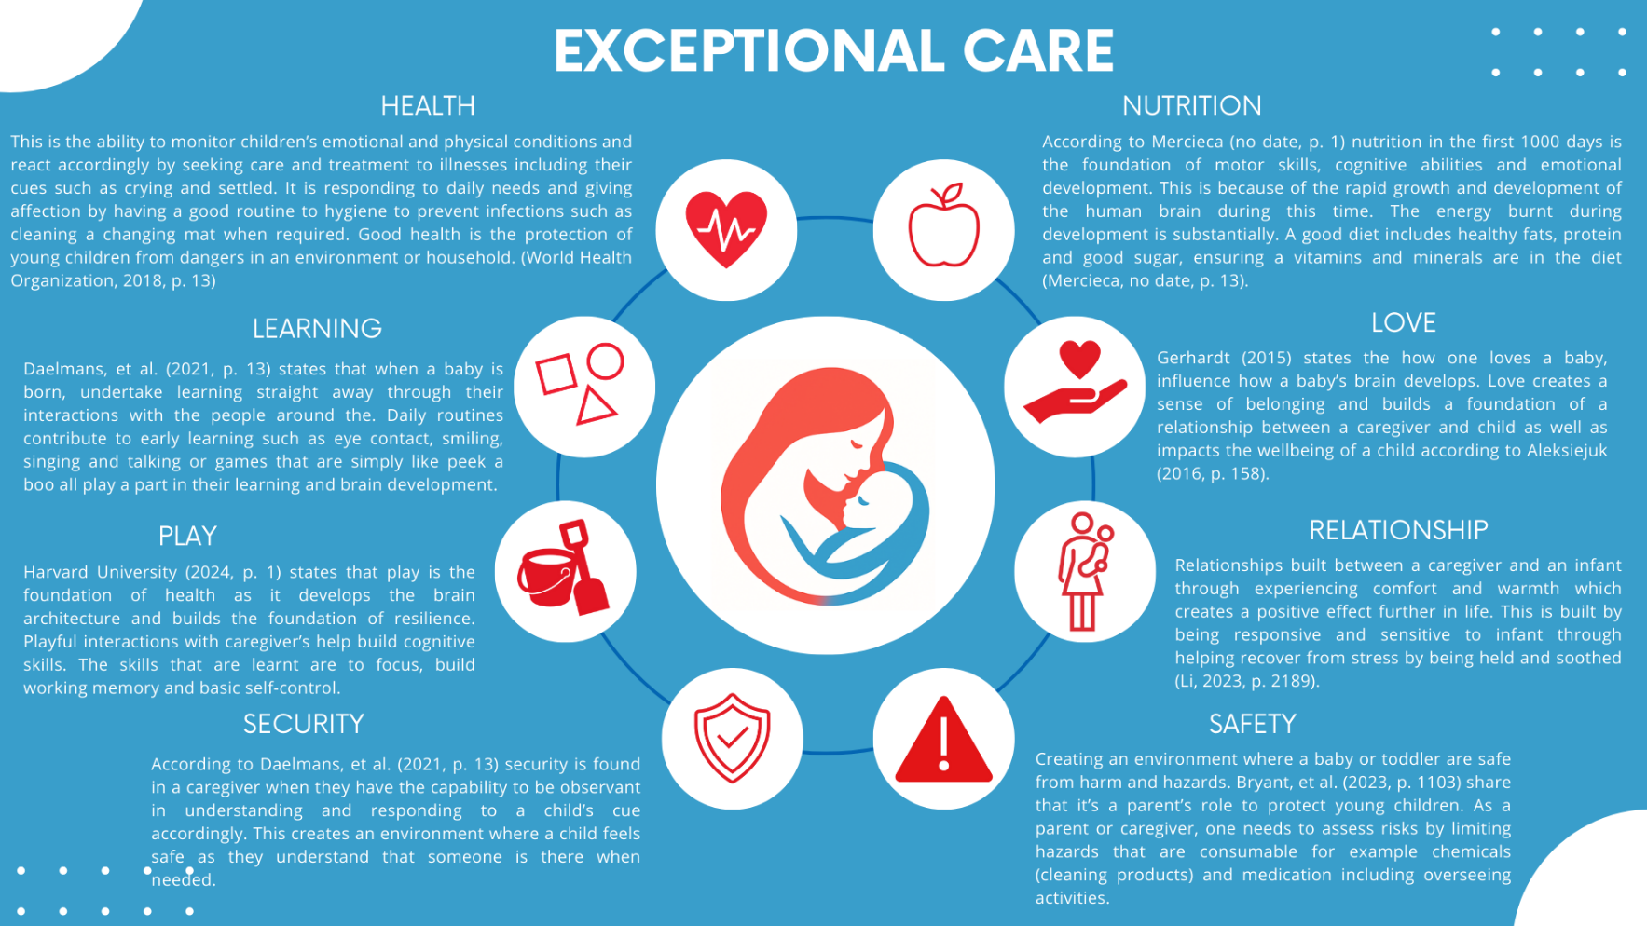
Personal images create: Ogilvy, 2026.

PROFESSIONAL PARTNERSHIP
The role of an early year’s practitioner is to support families and children by working alongside. To create an environment where one feels heard and support when or where challenges arise.
According to The Early Years Foundation Stage (EYFS) (2025) a practitioner role is to:
- Encourage Development.
- Support Parents/ Caregivers
- Positive Environment
- Promote Healthy Connections.
- Collaborate Families Facing Any Challengers.
Birth to 5 Matter (2021, p.8) shares that there are four principles to Early Years Foundation Stage Statutory Framework. Below is a diagram with a brief outline. 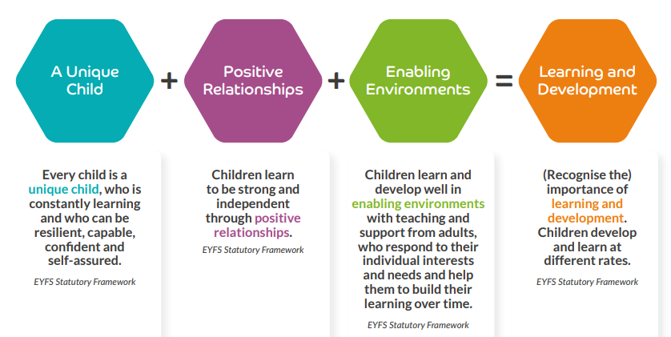
(Source: Birth to 5 Matter, 2021)

PRACTITIONER
As a practitioner with an understanding that each child is unique (Birth to 5 Matter,2021, p.8). According to Birth to 5 Matter (2021, p.8) a practitioner should observe a child’s development, learning and understanding that the best learning practice for that child by assessing their progress, to creating an action plan to help with development. It continues to suggest that a practitioner should create an environment where babies and children develop a positive sense of identity and culture of their own. Practitioners should assess if any additional support is needed and create a plan to support, and to ensure child safety, value and respect children and their families (Birth to 5 Matter,2021, p.8).

POSITIVE RELATIONSHIPS
Birth to 5 Matter (2021, p.8) suggests for a practitioner to create positive relationships one should create a warm, loving and a sense of belonging with interactions and environment. It continues to suggest that a practitioner should be responsive and sensitive to a child’s feelings, interests and individual needs. An environment that is positive and supports the independence and efforts of the child with clear and consistent boundaries. (Birth to 5 Matter,2021, p.8).

ENABLING ENVIRONMENT
Birth to 5 Matter (2021, p.8) states that an environment should value learning, development and understand how each person is unique, in additionally inside and outside of the environment should be stimulation and relevant to each child regarding community and cultures. The learning environment has freedom of play and thought-out playful teaching to promote development. A sense positive risk taking to explore the environment around. (Birth to 5 Matter,2021, p.8).

LEARNING AND DEVELOPMENT
The learning environment of a practitioner should be engaging, challenging and have playful opportunities to promote key development and milestones according to Birth to 5 Matter (2021, p.8). They suggest that the characteristics of a learning environment should fostered is exploring, active learning, critical and creative thinking.

EFFECTIVE PARTNERSHIP
(Source: Gray, No Date)
Map the System Canada’s Post

To create an effect partnership between caregivers and practitioners. Theorist Bronfenbrenner created a system called Ecological System. The emphasises of this theory is, the environment significantly influences a child’s development (Paterson-Young, et al., 2025, p. 3).

MICROSYSTEM
This is the closest interactions that shape the child development. These are beliefs, personality and daily relationships (Paterson-Young, et al., 2025, p. 3). The partnership that is built for parents that are immediate are families, practitioners, health visitors and midwives (Stanley and Kuo, 2022, p. 2). These relationships will ensure parents have a consistent and secure relationship with a child ensuring the proper caregiving is provided as well as attachments are being created between the child and caregiver.
MESOSYSTEM
The system which connects with the microsystem to work together (Paterson-Young, et al., 2025, p. 3). According to Paterson-Young, et al. (2025, p1), when the partnership between the microsystem and child are strong and information is shares and collaborated this creates innovation in ways too better support the child. For example, a baby is struggling with feeding, a health visitor will communicate with a lactation consultant and an early year’s practitioner will check on the parent to support by guiding them.
ECOSYSTEM
The environment the directly influences the development of the child (Paterson-Young, et al., 2025, p. 3). These could be family friends, government policies, community resources, social services and mass media (Cherry, 2025). According to Kantar Public (2022, p. 4) being connected to local authorities who partnership with local services allows vulnerable families with support by building resilience while supporting financially to prevent escalation. This is important as it helps reduce burdens on families.
MACROSYSTEM
The social structure which surrounds the individual (Paterson-Young, et al., 2025, p. 3). According to Cherry (2025) a few of these factors are traditions, values, social normalities, cultural beliefs and ideology.
CHRONOSYSTEM
The sense of time here maturing and aging happens (Paterson-Young, et al., 2025, p. 3). These are historical events, life transitions and personal experiences (Cherry ,2025).

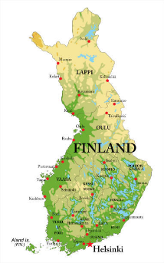
INTERNATIONAL APPROACHES
(Source: Istock, 2026)
FINLAND
According to Finland Way (2025) education is not based on academic achievement but to build a foundation that is sold for life. Children are active participants and just leaners where the system is equity, inclusive and emphasis on wellbeing (Finland Way,2025). Finland’s approach to early childhood education is that play is learning and should not be separated but instead integrated into learning. According to Kangas, et al., (2020, p. 76) play is suggested to create pleasure and joy which is an activity to motivate and not to achieve learning milestones. Play is a way of learning new, different skills and grow knowledge (Kangas, et al., 2020, p. 77).

CORE PRINCIPLES
Finland Way (2025) shares the core principles in Early Education:
- Resources of a blend of instruction, care and education.
- Pedagogy that is adaptive and systematic.
- Holistic development is supported.
- Regular evaluations to ensure wellbeing and learning is being supported.

ROLE OF PARENTS
The Finnish National Agency for Education (2022, p. 4) states that it the caregiver’s responsibility for child’s development. A partnership between caregivers and practitioner to encourage holistic development will help achieve this (Finnish National Agency for Education, 2022, p. 11).
- Participate in planning of the child’s education and care (p. 8).
- Build trust, interaction and cooperation with practitioners (p. 32).
- Active participation in transitions such as starting ECDC (p. 32).

GLOBAL LESSONS TO LEARN FORM
According to Opetus- ja kulttuuriministeriö (2023) shares how Finland is changing the approach to Early Years Education and Care around the world by:
- All children have the right to education regardless of caregiver’s financial situation.
- Fees are kept affordable and low-income families pay no fees at all.
- Play is highly promoted as a key aspect to development, learning and for a child to stay healthy and happy.
- Staff are highly qualified and are required to upstand high quality of education.
- Equal opportunities for all children including those with special needs take part in Early Years Education.

The Early Years Education in Finland is building a foundation for development, respect and care in a child’s life. It promotes curiosity and holistic as the foundation to life by prioritising wellbeing, children’s right and collaboration with families (Finland Way, 2025).

REFERENCES
Aleksiejuk, A. (2016) ‘The Significance of Experiencing Parental Love for a Child's Development and Upbringing’, in Nová sociálna edukácia človeka IV. Prešov: Prešovská univerzita v Prešove, pp. 158-166.
Araji, S., Griffin, A., Dixon, L., Spencer, S.K., Peavie, C. and Wallace, K. (2020) ‘An Overview of Maternal Anxiety During Pregnancy and the Post-Partum Period’, Journal of Mental Health & Clinical Psychology, 4(4), pp. 47-56. Available at: https://www.mentalhealthjournal.org/articles/an-overview-of-maternal-anxiety-during-pregnancy-and-the-post-partum-period.pdf (Accessed: 14 January 2026).
Birth to 5 Matters (2021) Birth to 5 Matters: Non-statutory guidance for the Early Years Foundation Stage. Early Education 2021. Available at: https://birthto5matters.org.uk/wp-content/uploads/2021/04/Birthto5Matters-download.pdf (Accessed: 21 January 2026).
Bryant, L., Barbara A. Morrongiello, B.A and Cox, A. (2023) ‘Parents’ Home-Safety Practices to Prevent Injuries During Infancy: From Sitting to Walking Independently’, Journal of Child and Family Studies, 32, pp. 1102-1112. Available at https://doi.org/10.1007/s10826-022-02320-2 (Accessed: 13 January 2026).
Cherry, K. (2025) ‘The Bronfenbrenner Ecological Model and Its 5 Systems,’ Verywell Mind, 15 October. Available at: https://www.verywellmind.com/bronfenbrenner-ecological-model-7643403#toc-the-5-systems-in-the-bronfenbrenner-ecological-model Accessed: 21 January 2026).
Children’s Commissioner (2024) ‘Hierarchy of Needs for Care Experienced Young People’, Children’s Commissioner, 10 December. Available at:https://www.childrenscommissioner.gov.uk/resource/hierarchy-of-needs-for-care-experienced-young-people/ (Accessed: 14 January 2026).
Children's Commissioner (2026) Hierarchy of Needs for Care Experienced Young People. Available at: https://www.childrenscommissioner.gov.uk/resource/hierarchy-of-needs-for-care-experienced-young-people/ (Accessed: 22 January 2026).
Daelmans, B., Manji, S.A. and Raina, N. (2021) ‘Nurturing Care for Early Childhood Development: Global Perspective and Guidance’, Global Perspective n Nurturing Care, 58(1), pp. 11-15. Available at https://link.springer.com/content/pdf/10.1007/s13312-021-2349-5.pdf (Accessed: 12 January 2025).
de Magalhaes-Barbosa, M.C., Prata-Barbosa, A. and da Cunha, A.J. (2021) ‘Toxic stress, epigenetics and child development’, Jornal de Pediatria, 98(S1), pp. S13-18. Available at: https://doi.org/10.1016/j.jped.2021.09.007 (Accessed: 14 January 2026).
Department of Education (2025) Early Years Foundation Stage Statutory Framework for Group and School-Based Providers. Available at: https://assets.publishing.service.gov.uk/media/68c024cb8c6d992f23edd79c/Early_years_foundation_stage_statutory_framework_-_for_group_and_school-based_providers.pdf.pdf (Accessed: 20 January 2026).
Department of Levelling Up Housing and Communities (2022) Supporting Families Programme: Qualitative research. Available at: https://assets.publishing.service.gov.uk/government/uploads/system/uploads/attachment_data/file/1064758/Supporting_Families_-_Effective_practice_and_service_delivery_-_Learning_from_local_areas.pdf (Accessed: 21 January 2026).
Finland Way (2025) Finland's Holistic Early Childhood Education. Finland Way, 18 May Available at: https://finlandwayschools.com/finlands-holistic-early-childhood-education/ (Accessed 21 January 2026).
Finnegan, J. and Lawton, K. (2016) Lighting Up Young Brains. Save the Children. Available at: https://moodle.uwtsd.ac.uk/pluginfile.php/726110/mod_resource/content/1/lighting-up-young-brains.pdf (Accessed: 22 January 2026)
Fisher, P.A. and Lombardi, J (2025) The New Ecology of Early Childhood: Revisiting Bronfenbrenner’s Theory in the Context of Contemporary Challenges and Opportunities, Stanford Center on Early Childhood, Stanford University, pp.1-23. Available at: https://earlychildhood.stanford.edu/sites/g/files/sbiybj27426/files/media/file/the-new-ecology-of-early-childhood-final.pdf (Accessed: 16 January 2026).
Gerhardt, S. (2015) Why Love Matters. 2nd edn. Routledge.
Harvard University (2024) Brain-Building Through Play. Available at: https://developingchild.harvard.edu/wp-content/uploads/2024/12/5-Games-to-Play-with-Toddlers_12_months.pdf (Accessed: 12 January 2026).
House of Commons Health and Social Care Committee (2019) First 1000 days of life. Available at: https://publications.parliament.uk/pa/cm201719/cmselect/cmhealth/1496/1496.pdf (Accessed: 10 December 2025).
Kangas, J., Harju-Luukkainen, H., Brotherus, A., Kuusisto, A. and Liam Gearon, L. (2020) ‘Playing to Learn in Finland: Early Childhood Curricular and Operational Contexts’, in Garvis, S. and Phillipson, S.(eds) Policification of Early Childhood Education and Care Early Childhood Education in the 21st Century Volume III. Routledge, pp.71-81.
Kansas State University (2016) Buffering the Brain from Toxic Stress. Available at: https://bookstore.ksre.ksu.edu/pubs/building-babys-brain-buffering-the-brain-from-toxic-stress_MF3329.pdf (Accessed: 16 January 2026).
Kiyak, S. (2024) ‘The Relationship of Depression, Anxiety, And Stress with Pregnancy Symptoms and Coping Styles in Pregnant Women: A Multi-Group Structural Equation Modelling Analysis’, Midwifery, 136 (July) article 104103. Available at: https://doi.org/10.1016/j.midw.2024.104103 (Accessed: 14 January 2026).
Leadership for Inclusion in The Early Years (2020) Sensory Play. Available at: https://lincprogramme.ie/wp-content/uploads/2020/09/Sensory-Play.pdf (Accessed: 20 January 2026).
Li, Y. (2023) ‘How does attachment style influence early childhood development’, Journal of Education, Humanities and Social Sciences, 8, pp. 2185-2191. Available at: https://www.researchgate.net/publication/368381485_How_does_attachment_style_influence_early_childhood_development (Accessed: 13 January 2026).
Maternal Mental Health Alliance (2025) Signs and Symptoms - Maternal Mental Health Alliance - Information Centre. Available at: https://www.youtube.com/watch?v=uNeMBYq7PTA (Accessed: 16 January 2026).
McCarthy, M., Catherine Houghton, C. and Matvienko-Sikar, K. (2021) ‘Women’s Experiences and Perceptions of Anxiety and Stress During the Perinatal Period: A Systematic Review and Qualitative Evidence Synthesis’, BMC Pregnancy and Childbirth, 21(811), pp. 1 -12. Available at: https://link.springer.com/content/pdf/10.1186/s12884-021-04271-w.pdf (Accessed: 19 January 2026).
Mercieca, L. (no date) The Importance of The First 1000 Days: Nutrition and Movement. Smalltalk.
National Council for Special Education (2025) Sensory Spaces in Schools. Available at: https://ncse.ie/wp-content/uploads/2025/03/Sensory-Spaces-in-Schools.pdf (Accessed: 20 January 2026).
National Day Nursery Association (2024) Everyday Activities to Support Your Baby (Birth to Two Years). Available at: https://ndna.org.uk/wp-content/uploads/2025/01/Everyday-activities-to-support-your-baby-0-2-years-ParentsNDNA-Guide-Sept-24.pdf (Accessed: 20 January 2026).
Opetus- ja kulttuuriministeriö (2023) The Finnish Way – Early childhood education and care, 8 December. Available at: https://www.youtube.com/watch?v=9EDdRLG0qi8 (Accessed: 22 January 2026).
Parliament United Kingdom (2019) The First 1000 Days from Conception to Age 2. Available at: https://publications.parliament.uk/pa/cm201719/cmselect/cmhealth/1496/149605.htm#footnote-156 (Accessed: 19 January 2026).
Paterson-Young, C., Maher, M., Karlıdağ-Dennis, E. and Megan Hogg, M. (2025) ‘“I’d Lost Trust and Having to Tell Everyone the Same Story Again and Again and Again…”: Bottlenecks and Barriers to The Application of Therapeutic Approaches Within Care Services’ Ecological Systems’, Children and Youth Services Review, 172, pp. 1-9. Available at: https://doi.org/10.1016/j.childyouth.2025.108252 (Accessed: 22 January 2026).
Prendiville, S. and Fern, M. (2017) ‘Coming alive: Finding Joy Through Sensory Play’, in E. Prendiville, E. and Howard, J. (eds) Creative Psychotherapy: Applying the Principles of neurobiology to play and expressive art-based practice. Routledge, pp. 121-138.
Rodger, J. and Harvey, K. (2025) ‘Exploring the Use of Tummy Time Guidelines to Improve Infant Development in Rural Primary Care’, Journal of Neonatal Nursing, 31, pp. 302 – 307. Available at: https://www.sciencedirect.com/science/article/pii/S1355184124002199?via%3Dihub (Accessed: 20 January 2026).
Rose, J., Gilbert, L. and Richards, V. (2016) Health and Well-being in Early Childhood. Sage.
Sharma, A. and Cockerill, H. (2014) Mary Sheridan’s from Birth to Five Years Children’s Developmental Progress. 4th edn. Routledge.
Stanley, K. and Kuo, N. (2022) ‘“It Takes a Village”: Approaching the Development of School-Family-Community Partnerships through Bronfenbrenner’s Socio-Family-Community Partnerships through Bronfenbrenner’s Socio-Ecological Perspectives Ecological Perspectives’, Journal of Human Sciences and Extension, 10(1), pp. 1-14. Available at: https://doi.org/10.54718/CQBW6379 (Accessed: 21 January 2026).
Stead, C. (2024) ‘Unlocking potential – Investing in the first 1000 days for brain development and school readiness’, Nursery Management Show, 11 June. Available at: https://nurserymanagementshow.co.uk/blog-2/guest-blog-unlocking-potential-investing-first-1000-days-brain-development-school-readiness (Accessed: 10 December 2025).
The Early Years Healthy Development Review Report (2021) A Vision for the 1,001 Critical Day. Available at: https://assets.publishing.service.gov.uk/media/605c5e61d3bf7f2f0d94183a/The_best_start_for_life_a_vision_for_the_1_001_critical_days.pdf (Accessed: 10 December 2025).
The Finnish National Agency for Education (2022) National Core Curriculum for Early Childhood Education and Care. Available at: https://www.oph.fi/sites/default/files/documents/National%20core%20curriculum%20for%20ECEC%202022.pdf (Accessed: 22 January 2026).
UNICEF Philippines (2015) The First 1,000 Days of Life. Available at: https://www.youtube.com/watch?v=mpyD19SIiaw (Accessed: 10 December 2025)
Williams, O. (2025) ‘Neonatal Brain Development: From Birth to the First Year’ Journal Neonatal of Biology, 14(1) pp. 1. Available at: https://www.walshmedicalmedia.com/open-access/neonatal-brain-development-from-birth-to-the-first-year.pdf (Accessed: 8 January 2026).
World Health Organization (2018) Nurturing Care for Early Childhood Development. Available at: https://iris.who.int/server/api/core/bitstreams/781de51d-4cef-482e-bb3b-c2b3becf3c9f/content (Accessed: 14 January 2026).

IMAGES SOURCES
Academy of Chiropractic Nutrition (2021) Why Adverse Childhood Events Matter. Available at: https://academyofchiropracticnutrition.com/why-adverse-childhood-events-matter/ (Accessed: 14 January 2026).
Artofit (No Date) Image Gallery For: Brain Encyclopedia on Early Childhood Development. Available at: https://www.artofit.org/image-gallery/870813277926732010/brain-encyclopedia-on-early-childhood-develop (Accessed: 20 January 2026).
Ausnutria Nutrition Institute (no date) Gentle Nutrition for Natural Growth and Development of Infants. Available at: https://ausnutria-nutrition-institute.com/knowledge-base/gentle-nutrition/ (Accessed: 10 December 2025).
Birth to 5 Matters (2021) Birth to 5 Matters: Non-statutory guidance for the Early Years Foundation Stage. Early Education 2021. Available at: https://birthto5matters.org.uk/wp-content/uploads/2021/04/Birthto5Matters-download.pdf (Accessed: 21 January 2026).
CanDo Kiddo (2021) Tummy Time Milestones for Babies. Available at: https://www.candokiddo.com/news/tummy-time-milestones (Accessed: 21 January 2026).
Early Years TV (2026) Maslow’s Hierarchy of Needs: Complete Guide to 5 Levels of Human Motivation. Available at: Maslow's Hierarchy of Needs: Complete Guide to 5 Levels of Human Motivation (Accessed: 21 January 2026).
Fun at Home with the Kids (2013) Super Easy Sensory Play: Rice Play. Available at: https://www.funathomewithkids.com/2013/02/rice-play-infant-we-introduced-x-to.html (Accessed: 21 January 2026).
Gilmore, J.H., Santelli, R.K. and Gao, W. (2018) ‘Imaging Structural and Functional Brain Development in Early Childhood’, Nature Reviews Neuroscience, 19(3), pp. 1-36. Available at: https://doi.org/10.1038/nrn.2018.1 (Accessed: 8 December 2025)
Gray, K. (no date) Who Am I. Available at: https://190522558930221519.weebly.com/ecological-systems-theory.html (Accessed: 19 January 2026).
Home Remedies and Natural Treatments (2016) Brain Development – Various Stages and Growth Process. Available at: https://www.homenaturalcures.com/brain-development-stages/ (Accessed: 21 January 2026).
Imom (2026) 10 Games to Play with Your Baby That You’ll Both Love. Available at: https://www.imom.com/games-for-babies-youll-both-love/ (Accessed: 20 January 2026).
Istock (2026) Lapland Map. Available at: https://www.istockphoto.com/illustrations/lapland-map (Accessed: 21 January 2026).
Jannatkhan (2024) How Kid’s Brain Development. 2 November. Available at: https://jannatkhan54.medium.com/how-kids-brain-development-38be7ae91a5f (Accessed: 8 December 2025).
LinkedIn (2026) Map the System Canada’s Post. Available at: https://www.linkedin.com/posts/map-the-system-canada_mapthesystem-systemthinking-activity-7161053531192315904-YGdJ (Accessed: 19 January 2026).
Little Baby Gear (2023) What If My Baby Hates Tummy Time? – 8 Solutions & Positions to Try. Available at: https://www.littlebabygear.com/what-if-my-baby-hates-tummy-time/ (Accessed: 20 January 2026).
Lord, C. (2021) ‘Ventral Vagal Nervous System’, Trauma Therapy SD, 3 February. Available at: https://colettelordphd.com/ventral-vagal-nervous-system/ (Accessed: 14 January 2026).
Mama Instincts (No Date) 28 Baby-Safe and Toddler Approved Sensory Play Activities. Available at: https://mamainstincts.com/baby-safe-sensory-play-activities/ (Accessed: 21 January 2026).
National Council for Special Education (2025) Sensory Spaces in Schools. Available at: https://ncse.ie/wp-content/uploads/2025/03/Sensory-Spaces-in-Schools.pdf (Accessed: 21 January 2026).
Nelson, C.A., Bhutta, Z.A., Burke Harris, N., Danese, A. and Samara, M. (2020) ‘Adversity in Childhood is Linked to Mental and Physical Health Throughout Life’, British Medical Journal, 371(October) article 3048. Available at: https://doi.org/10.1136/bmj.m3048 (Accessed: 14 January 2026)
NSPCC (2019) Handle with care How to keep your baby safe. Available at: https://learning.nspcc.org.uk/media/1112/handle-with-care-guide-keeping-baby-safe.pdf (Accessed: 20 January 2026).
The Boston Foundation (2021) Time well spent: Doctors collaborate with community partners in First Thousand Days. 4 November. Available at: https://www.tbf.org/blog/2021/november/first-1000-days-highlights-pauley-20211104 (Accessed: 10 December 2025).
University of Washington (2018) How Connections Develop. Available at: https://uw.pressbooks.pub/eeducdbb/chapter/2-2-stages-of-brain-development/ (Accessed: 8 December 2025).

