Student Name: Ella Williams
Module Name: Strategic Management and Sustainability
Student ID Number: 1707424
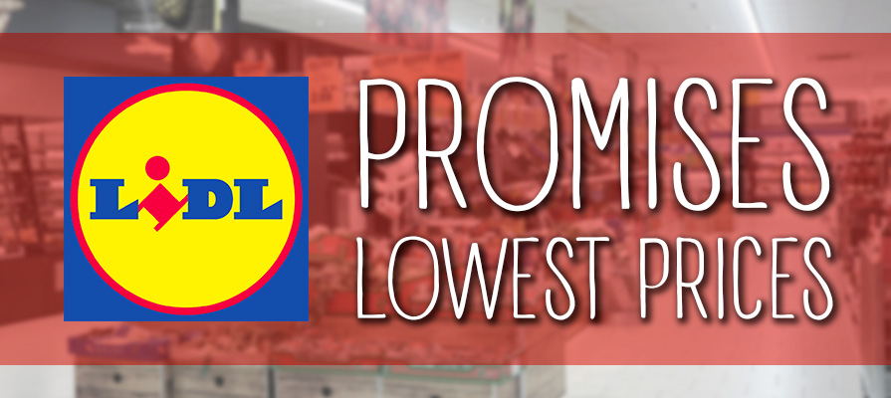
Lidl: German discounter gaining market share
Contents Page
- Executive Summary………………………………………………………………….2
- Introduction…………………………………………………………………………4-7
  - Report Remit
  - Background of Lidl
  - Definitions of major concepts
- Main Body………………………..……………………………………………………8-11
  - Implementation of the strategy
  - Advantages and Disadvantages of the Strategy
- Conclusion……………………………………………………………………….……12
  - Recommendations

Table of Figures
Figure 2.2.1: UK Lidl's turnover throughout 2012-2018………………………………4
Figure 2.3.2: Porter's Generic Strategies……………………………………………….7

- Executive summary
This report makes the reader aware of what strategy Lidl use and if it works well or not. Lidl is one of the largest UK supermarkets, providing consumers with high quality products at the lowest prices possible. The Porters Generic Strategy Model will be used to show which strategy Lidl uses and if it works well for its organisation.
The purpose of this report is to explain to the reader how Lidl have not spent a lot of money on their organisation to make it grow. Instead, within the report it shows you how Lidl are very money conscious and do not spend any of the organisations if they do not need to.
However, the reader will find that although there are a lot of advantages to this strategy it does have its downsides as consumers may not be as loyal as you would like them to be which is why Lidl need to understand the risks to this strategy and adapt on them in the future.

- Introduction
  - Report Remit
This report describes what type of Porters Generic Strategy Lidl are using and why it is working well for their organisation. A critical evaluation will be undertaken throughout the report to show the reader that there are also limitations to this strategy, which Lidl will need to adapt so they can change their current development situation in order to continue to stay successful in the future.

  - Background of Lidl
In the 1930s a small independent grocery wholesaler was created in Germany, called Lidl. Three stores were opened during that year. During the 1980’s everyone would have an item bought from Lidl in their household. By the year 1990 Lidl started to branch outside of Germany and can now be found across Europe. In twenty-first century, Lidl is now one of the largest grocery retailers in Europe, has over 640 UK stores open and almost 20,000 employees just in the UK. Internationally, there are 10,000 stores and 210,000 employees (Lidl, 2017).
Lidl was awarded the ‘Best Supermarket’ at the 2016 Good Housekeeping awards. Not only do Lidls sell products from Germany, but the supermarket sells products from Poland, Italy, the South of France, and Cornwall. However, although the supermarket was originally based in Germany, the UK Lidl would like to work with British manufacturers. Today, the two-thirds of the supermarket’s products are sourced from the UK (Lidl, 2017).
Lidl’s (2019) vision statement is to “enhance the lives of our customers, by providing quality products at a market leading value, whilst ensuring that customer satisfaction is at the heart of everything we do”. The supermarket also has a lot of missions which are, to deliver outstanding customer satisfaction, to make sure the marketing leading value and quality by continuously innovating and optimising the efficient processions, driven by people and technology. Another mission is to work with their business partners and have a sustainable relationship, whilst contributing to local communities. The last mission is to achieve a successful long-term organisation by investing in the recruitment, development, and training of its employees (Lidl, 2019). This shows how serious Lidl is about their organisation.
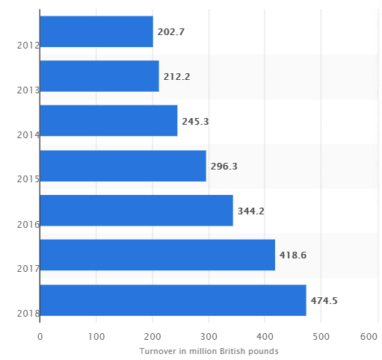

Figure 2.2.1: UK Lidl's turnover throughout 2012-2018. Source: (Wunsch, 2019)

In Figure 2.2.1. shows how the UK Lidl has made an increasing large profit every year. This is because of its high-quality products at low prices. People would prefer purchasing products that they could get from other competitive supermarkets from Lidl instead as they would be able to get the products at the lowest prices possible, saving them a lot of money.
  - Definitions of major concepts
A Strategy is a long-term direction of an organisation, which is usually measured over the years, but for some organisations long-term strategies can last up to over a decade. A long-term strategy is usually set out to achieve advantages in the changing environment through its arrangement of resources and skills with the aim of meeting stakeholder expectations (Johnson, et al., 2017).
As strategies involve managing people, resources, and relationships the subject might sometimes be called ‘strategic management’. Within strategic management there should be an understanding of the position of an organisation, managing the strategy in action, and making strategic choices for the future. A strategy in action is where organisational strategies make sure that they are working in practice (Johnson, et al., 2014).
The strategic position is always concerned with the influences and expectations of the stakeholders of the organisation, strategic capability, and the external environment, due to how it may have an impact on the strategy. Therefore, organisations must keep up to date by checking if their strategy is working well with these factors (Johnson, et al., 2017).
When an organisation has a strategy plan, it must provide an explicit statement, defining the purpose of the organisation as it is a formal requirement by corporate governance. Corporate values define the way an organisation operates, setting boundaries within which strategies are developed. Organisations must also have a mission and vision statement to show more depth of the purpose of the organisation’s strategic direction. For example, a mission statement is concerned with providing stakeholders and employees an overall purpose of the organisation. However, a vision statement aims to show people what an organisation seeks to be, by looking into the future. An organisation must also set out objectives, showing what the outcomes they would like to achieve look like. Usually organisations include financial statements such as profit levels, share valuations and the rates of growth. However, there may be market-based objectives within their statements showing market shares and customer service (Johnson, et al., 2008).
Sometimes within the objectives organisations focus on their competitive advantage. For example, RyanAir airline is a low-cost organisation who set their objectives on a turnaround time as it is the core of the organisation and makes their airline stand out to all their competitors due to their low-cost advantage (Johnson, et al., 2017). This is similar to Lidl, the low-cost supermarket attracts their customers because of their low costs.
Organisations worldwide now use Porter’s Five Forces Framework to helps to analyse the industry they are working in by analysing the level of competition and business strategy development (Johnson, et al., 2017).
The Porter Five Forces Framework was created in the 1980s by a man called Professor Michael Porter who argued that there were only four fundamental strategic options which were available to every organisation; Porter’s Generic Strategy Options. This framework has been challenged; it can help in developing market-based opportunities. Porter makes it clear it is important for organisations to establish their costs and prices of their organisation, in comparison to their competitors. Doing this gives you a competitive advantage as organisations can work out what prices they want to sell their products or services to they get customers to purchase their products instead of the competitors Porter’s argued that if an organisation wanted to improve their performance they must undertake his five forces before they can make any decision or change, as it would contribute to making their organisation successful (CMI, 2019).
There are three generic strategies which are set for the organisation to achieve above-average performance within the industry; cost leadership, cost focus, and differentiation focus. The focus strategies have two variants; cost focus and differentiation focus (Porter, 1985). Shown in Figure 2.3.2.

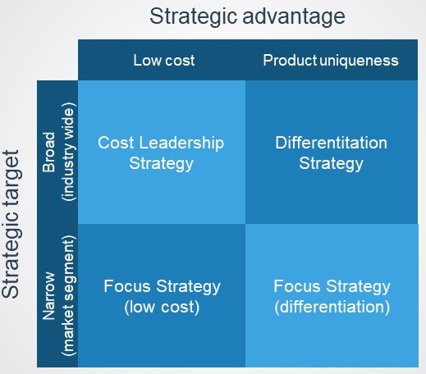
Figure 2.3.2: Porter's Generic Strategies

Figure 2.3.2, it shows the four primary sources that determine the strategy of an organisation within the industry. This helps an organisation understand whether their firm’s profitability is above or below the industry average. The differentiation and cost leadership strategies look for competitive advantage in a ‘broad range’ part of the industry segments, whilst the focus strategies focus on the differentiation or cost advantage in the narrow segment section (Porter, 1985).

- Main Body
Cost leadership is the clearest strategy to understand. If an organisation has the strategy of cost leadership, they set themselves an aim to become the lowest-cost producer in the industry they are working in. They also focus on reducing their cost expenditure and increasing their profits. A cost advantage within this strategy is an economy of scale which organisations undertake by expanding their scale of production. This will reduce the average costs of production. If an organisation uses the cost leadership strategy, they do not need to set the lowest prices in the industry, they just need to make sure they are making a reasonable profit on each sale if they reduce the costs (Porter, 1985).
It is clear that out of all of the strategies considered, Lidl’s have adapted the most to the cost leadership strategy due to the organisation’s incredible efficiency (Morschett, et al., 2006). However, for Lidl to preserve competitiveness the organisation must diversify its strategies (Tomasevic & Spasojevic, 2018). Although Lidl is a huge low-cost producer, other supermarkets are now trying to sell their products at low prices to attract consumers, making sure they do not all shop at Lidl. This means Lidl must be confident that they can uphold the number one spot.

  - Implementation of the strategy
Lidl has adapted well to the cost leadership strategy as they are now 9% cheaper than the largest grocery store in the US; Walmart. The products are 50% cheaper than its rival stores, meaning the organisation is popular and is causing price wars within some of the largest supermarkets (Hanbury, 2017). This could be a huge problem as competitors will try and lower their prices, so they do not lose customers to Lidl.
The supermarket is different, as 90% of the products instore are private-label brands, which are manufactured just for Lidl, giving them an advantage as the competitor supermarkets sell the same branded items. This also means Lidl does not have to pay an additional cost from a supplier as there is no middleman, as Lidl is the wholesaler. Lidl is saving a lot of money within the strategy and from this cut. The organisation is able to set their own prices as they have control over the manufacturing costs, meaning that products can be sold for higher margins compared to national brands, due to initial costs being much lower (Hanbury, 2017).
Lidl is also clever, as they sell a limited amount of selection for each product. This gives Lidl a lot of buying power with their suppliers as they order a large quantity of fewer products. According to a retail analyst, Schott Mushkin (2017), “there is a lot of volume through a limited number of items”. The suppliers who work with Lidl will be loyal as Lidl will purchase large amounts of their products continuously (Hanbury, 2017). If Lidl is purchasing their products on a large scale, the cost of the bulk buy will cost less as suppliers usually do deals so organisations purchase more. This purchasing structure allows for the economies-of-scale to occur as Lidl can afford to pay for a more unit of goods, especially from their loyal suppliers. Lidl can also make sure that the price of the goods they purchase off their suppliers will remain the same so they can keep their price promise (Rennack, 2018). Within their product selection Lidl also make sure that they sell low-cost products for a limited time only that will create customer interest and bring customers to Lidl. The main supermarkets such as Tesco and ASDA do not do this which gives Lidl a competitive advantage. To advertise this the organisation, create a brochure which contains products which will be on sale in the following week or month and display the brochure at the end of the checkout by the door. This is a cheap and simple way of promoting their products.
The everyday items that are bought often by consumers are favoured by Lidl, which means that the products can be limited due to fast sales. This gives the supermarket a competitive advantage as they are up to date on what sells the most and the quickest which means they know their consumers and what attracts them. Having higher-velocity products means that Lidl does not have items stocked up in the inventory, saving the organisation a lot of money and space within the organisation (Hanbury, 2017).
Lidl’s stores measure on average 20,000 square feet, holding 6 aisles, which is not big at all. However, this means Lidl does not have to pay for a large property when they are purchasing a store and they do not have to pay to fill their store with a lot of products. For small stores, Lidl’s can keep their labour costs down by not employing a lot of employees and they make sure all their staff are cross-trained, enabling them to work every section. Customers are required to bag and weigh their own produce independently, saving the organisation on money on plastic packaging (Hanbury, 2017). Since 2017, Lidl has reduced the amount of plastic product packaging by 8%. This keeps Lidls costs low and sustainability high due to the global purchasing power as people now choose to use less plastic (Hartnagel, 2018) .
Lastly, Lidl only advertises the supermarket to the locals, using smaller-scale marketing through local radio stations and local social media pages. Although Lidl does a lot of marketing other than Christmas advertisements, what attracts people to shop at Lidl’s more than anything is knowing that there is a store just down the road from consumers. According to The Guardian’s Makortoff (2019), “sales at the discount retailer increased by 7.7% in three months due to a lot of stores opening, attracting over 500,000 customers”. Porters (Porter & Competitive, 1980, p. 36) stated how “a low overall cost position should require a high market share”. This shows how Lidl is successfully undertaking the strategy. Lidl has also succeeded within the cost leadership strategy as they are the UK’s cheapest supermarket. Lidl has shown the public how they can build and maintain a successful low-cost leadership strategy (Roger, 2019).

  - Advantages and Disadvantages of the Strategy
Although the cost leadership strategy sounds successful, there are advantages and disadvantages to it as well.
For example, an advantage would be how it enables organisations to outperform their rivals. Lidl has proved that even though Tesco is a huge successful supermarket since 1919, consumers in the modern world we live in today want to purchase low-costing products and get better deals. However, Tesco has noticed this trend and is adapting to it as they have launched a new discount chain called Jacks, which according to Tesco’s chief executive Jack Cohen (2018), “it is the cheapest in town”. This shows how it is difficult to be the leading low-cost supermarket as competitors will change their strategy if they can see another supermarket doing better than them (Butler & Wood, 2018).
Also, if an organisation is using this strategy they will have a competitive advantage to new competitors as the barriers to entry benefit existing organisations as it protects their profits and revenues. Some barriers of entry include tax benefits to existing organisations. However, new organisations have to purchase licenses and undertake regulatory clearance and pay high start-up costs before they work in the industry. This is to prevent new competitors from entering a working industry quickly, giving current organisations a chance to increase success in their business (Hayes, 2019). However, undertaking a low-cost leadership strategy means those organisations will have lower customer loyalty in comparison to a business who is branded. This is because people only purchase from low-priced organisations to get deals which are a disadvantage (Jorgenson, 2015).

- Conclusion
To conclude, the low-cost leadership strategy Lidl uses to run their organisation has been successful. Lidl have grown an outstanding amount since the start of their journey and are only getting stronger. Competitor supermarkets have now started to adapt to try and match some of the low prices Lidl do as they feel they are some competition. However, there are risks to this strategy which Lidl cannot ignore otherwise the organisation may struggle in the future.

  - Recommendations
For the future, I would like to recommend Lidl some improvements to help them continue their successful organisation.
I would like to recommend Lidl to continue to keep their low costs as consumers only know Lidl as a low-cost supermarket. If Lidl were to change and increase their prices consumers may not shop at their supermarket anymore because their organisation would be exactly the same as their competitors.
Another recommendation I would like to make is for Lidl to earn their customers loyalty. To do this the supermarket could create their own loyalty program, letting their customers earn some points every time they spend money in their store, in which they could then be rewarded at the end of the month or year. This system works will with Tesco, Morrisons, and Sainsbury’s, so it is more than likely to work well with Lidl and may attract more consumers to shop at their store.

References

Butler, S. & Wood, Z., 2018. Tesco opens discount store Jack's to take on Lidl and Aldi. The Guardian, p. 1.
CMI, 2019. A selection of useful resources, London: Chartered Management Institute.
Hanbury, M., 2017. A German grocery chain that's coming to America is already dominating Walmart on prices - here's why it's so cheap. [Online]
Available at: https://www.businessinsider.com/how-lidl-keeps-its-prices-down-2017-6?r=US&IR=T
[Accessed 1 November 2019].
Hartnagel, C., 2018. The Good Food Report, s.l.: Lidl .
Hayes, A., 2019. Barriers to Entry. [Online]
Available at: https://www.investopedia.com/terms/b/barrierstoentry.asp
[Accessed 3 November 2019].
Johnson, G., Scholes, K. & Whittington, R., 2008. Organisational Purposes: Values, Mission, Vision. In: Exploring Corporate Strategy. Harlow: Pearson Education Limited, pp. 163-164.
Johnson, G. et al., 2014. The exploring strategy model. In: Exploring Strategy. Harlow: Pearson Education Limited, p. 10.
Johnson, G. et al., 2017. The Competitive Forces. In: Exploring Strategy. Harlow: Pearson Education Limited, p. 64.
Johnson, G. et al., 2017. The purpose of strategy: mission, visison, values and objectives. In: Exploring Strategy. Harlow: Pearson Education Limited, p. 8.
Johnson, G. et al., 2017. What is strategy?. In: Exploring Strategy. Harlow: Pearson Eduction Limited, p. 4.
Jorgenson, E., 2015. Why Low-Cost Operations Build Powerful Businesses, and Why it Always Matters. [Online]
Available at: https://medium.com/evergreen-business-weekly/how-cost-leadership-builds-powerful-businesses-and-why-it-always-matters-83685eb1c55e
[Accessed 3 November 2019].
Lidl, 2017. A Lidl Bit of History. [Online]
Available at: https://careers.lidl.co.uk/en/our-history-1819.htm
[Accessed 25 October 2019].
Lidl, 2017. About Lidl UK. [Online]
Available at: https://careers.lidl.co.uk/en/lidl-as-an-employer-1257.htm
[Accessed 27 October 2019].
Lidl, 2019. Vision and Mission Statement. [Online]
Available at: https://www.lidl.co.uk/about-us/vision-and-mission-statement
[Accessed 27 October 2019].
Makortoff, K., 2019. Lidl attains its biggest UK grocery market share at 5.9%. [Online]
Available at: https://www.theguardian.com/business/2019/aug/20/lidl-attains-biggest-uk-market-share
[Accessed 2 November 2019].
Morschett, D., Swoboda, B. & Schramm-Klein, H., 2006. Journal of Retailing and Consumer Services. Competitive strategies in retailing - an investigation of the applicability of Porter's framework for food retailers, Issue 4, pp. 275-287.
Porter, M. E., 1985. Competitive Stratey: The Core Concepts. In: Competitive Adavantage. s.l.:The Free Press, p. 11.
Porter, M. E. & Competitive, S., 1980. Techniques for analysing industries and competitors. Free ed. New York: Competitive Strategy.
Rennack, S., 2018. 10 Reasons Why Lidl Wins Against National Grocery Leaders. [Online]
Available at: https://www.linkedin.com/pulse/10-reasons-why-lidl-wins-against-national-grocery-leaders-rennack
[Accessed 2 November 2019].
Roger, J., 2019. The UK's cheapest supermarket officially revealed - and it's a surprise. [Online]
Available at: https://www.birminghammail.co.uk/whats-on/shopping/uks-cheapest-supermarket-officially-revealed-16549881
[Accessed 2 November 2019].
Tomasevic, N. & Spasojevic, M., 2018. Lidl's Modern Business Operations in the Domestic and International Markets. In: I. K. M. N. Khalid Hammes, ed. Economic and Social Development: Book of Proceedings. Belgrade: Varazdin Development and Entrepreneurship Agency, p. 355.
Wunsch, N.-G., 2019. Turnover of Lidl in the United Kingdom (UK) from 2012 to 2018. [Online]
Available at: https://www.statista.com/statistics/919806/lidl-turnover-in-the-united-kingdom/
[Accessed 1 November 2019].

