

Name of the Programme: Master of Business Administration
Module Name: Marketing Management
Module Code: LCMB7024
Student Name: Devarshsinh Manharsinh Solanki
Student ID: 2428526
Word Count: 2,518

Table of Contents
Introduction 3
New Brand Extension Concept 3
Segmentation, Targeting, and Positioning (STP) 4
Customer Persona Profile 7
Marketing Mix Strategy (7Ps Framework) 9
Conclusion 13
Reference 14

Introduction
This portfolio is an exploration of a strategic brand extension through which the wellness mobile application is introduced, which facilitates Nike in its entry into the digital health and lifestyle market. Nike is an athletic footwear and apparel company that is well known for being an innovatively driven, motivated brand and for using sport to empower people. In the post-pandemic era, consumers’ curiosity about holistic health, mental health and fitness is increasing, which makes this a good supporting time for Nike to introduce itself as a digital wellness solution provider with this app.
The proposed Nike Wellness App will help users with personalised fitness routines, mindfulness exercises, sleep tracking, and nutritional guidance as a digital companion. At the same time, it intends to draw on the success of presently existing platforms such as Nike Training Club but introduce a more all-inclusive, lifestyle-focused app. Aligning with Nike's mission to inspire and innovate for every athlete, this extension acknowledges that wellness matters as much as performance. In this portfolio, the key marketing strategies of segmentation, targeting, positioning and the marketing mix will be critically examined to show how such a brand extension can enrich the value it can generate and long-term customer engagement.

New Brand Extension Concept
Brand Extension Concept:
The globally well-known sportswear leader Nike plans to launch its new brand extension in the form of a wellness app. The demand for wellness apps has gradually been increasing. Consumers define "wellness" in different ways, and these can roughly be grouped into six dimensions such as better health, better fitness, better appearance, better nutrition, better sleep and better mindfulness (Callaghan et al., 2021). The dimension of better health extends beyond medicines and supplements and includes personal health trackers. Customers have been found to increasingly take personal health into their own hands with the help of data-driven apps. Nike aims to fulfil these consumers' needs by providing its wellness app. Fitness became a source of major concern during the COVID-19 pandemic and nationwide lockdowns when people couldn't go outside. During this time, the wellness apps got more popular as these helped health-conscious consumers to track their fitness levels at home. The pandemic has been over for a few years now, but people's fitness goals persist. Better nutrition has always been a goal for health-conscious consumers for whom consuming food is not only about food but also about nutrition and keeping oneself fit. Better appearance involves apparel that helps one remain fit. Better sleep is possible through sleep trackers embedded within the app. Better mindfulness can be achieved through mediation-related features available in the app (Callaghan et al., 2021). Hence, Nike can aim to extend its product portfolio by introducing a wellness app and complementing its apparel and sportswear-based fitness motto. The wellness app, therefore, will be designed in a way that could help people remain physically and mentally sound, adopt a healthy diet, remain mindful and have better sleep.
Rationale:
- Market Trends: Health and wellness apps experienced 3.6 billion downloads in 2024, which was an increase of 6% as compared to 2023. The in-app purchase revenues reached 3.9 billion USD in 2024, which was an increase of approximately 500 million as compared to 2023 (Statista, 2025). This indicates a significant demand for wellness apps in the market that Nike could exploit.
- Competitive Advantage: Nike could gain a competitive advantage over its competitors through this wellness app as it would be able to get a wide range of existing Nike customers. This is because Nike’s customers are health-conscious consumers for whom this particular app will also be very appealing.

Segmentation, Targeting, and Positioning (STP)
Segmentation
Nike Wellness divides its market through a mix of demographic characteristics along with psychographic and behavioural variables to deliver better customer service.
The demographic segmentation strategy targets people between 20 and 45 years old who work in cities and includes professional workers along with students and amateur athletes. The target groups possess digital fluency and social engagement while accepting mobile applications for wellness management (AlSlaity et al., 2022). The psychographic consumer group consists of people who care about their health while being tech-savvy and showing loyalty to their preferred brands. Users want complete wellness beyond fitness outcomes because they strive to reach mental clarity combined with emotional stability and enhanced productivity.
Behavioural segmentation evaluates user behaviour patterns when interacting with wellness products (Lee and Kim, 2023). Nike Wellness specifically targets users who use fitness apps together with gym members, running club participants, and wearable technology users for tracking wellness metrics. Users who seek betterment for themselves, along with community connections and practical benefits, make up this segment.
Targeting
The main customer base includes urban people from the Millennial and Gen Z generations who focus on customised tech-friendly sustainable branding experiences. The target group uses their social media accounts frequently while adopting wellness mobile applications after the pandemic for stress management and health purposes (AlSlaity et al., 2022).
Nike should focus on working with organisations that provide wellness programs to their staff members as a secondary target segment. The B2B market segment enables Nike to support professional performance through its brand identity that empowers athletes as well as business professionals.
Positioning
Nike Wellness presents itself as an upscale wellness application that unites physical exercise with mental health and emotional wellness services for active individuals in contemporary society. The Nike Wellness platform combines AI-generated workout content with meditation guides, along with nutrition features and, mind-body transformation approaches and rest improvement to create a single platform distinct from standard fitness tools (such as Fitbit) or single-focused mindfulness applications like Calm and Headspace. The wellness program brings Nike's brand mission of maximising peak performance outside sports to deliver complete life balance and wellness for all customers.
Nike Wellness functions as a digital wellness partner that provides motivation and support through personal tracking features of user transformation (Dhesi, 2021). The app uses Nike's worldwide reputation and leading mark as well as product development focus to deliver premium service which attracts devoted Nike users and wellness novices alike. Through its brand extension, Nike became the leader of athletic excellence while also establishing itself as an industry pioneer in lifestyle and health-tech innovation, which connects sports with self-care practices.
Positioning Statement
“Nike Wellness – Your ultimate companion in mastering mind, body, and motivation.”
Positioning map
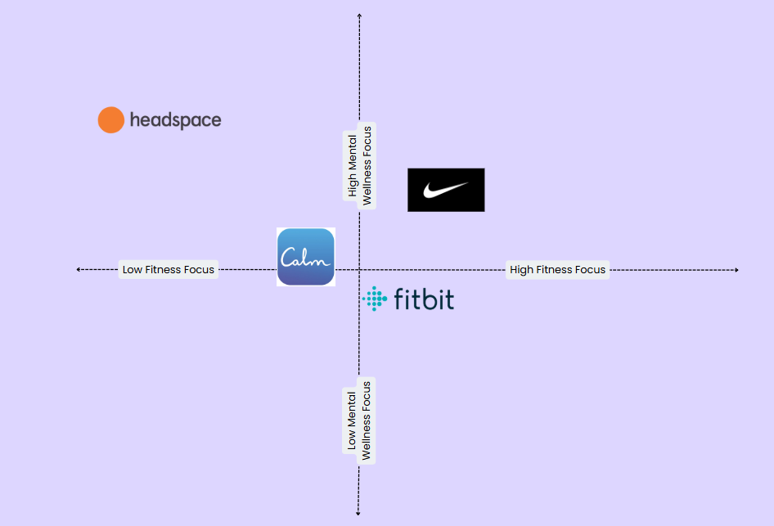
Figure: Positioning Mapping
(Source: Created by Author)
The perceptual map shows Nike Wellness positioned in the upper right corner because it delivers high fitness as well as mental wellness advantages. Nike Wellness serves as a complete wellness solution for contemporary life by providing balanced, holistic benefits since it focuses on mindfulness through Calm and Headspace and physical health through Fitbit and targets the top-right segment of the perceptual map.

Customer Persona Profile
Persona Name: Alex Morgan
Age: 27
Gender: Female
Location: Cardiff, Wales
Occupation: Marketing Executive
Income Bracket: £35,000–£45,000
Education Level: Undergraduate Degree (BA in Media and Communication)
Demographic Profile:
Alex embodies a major part of a growing demographic of health-conscious, digitally engaged young professionals located in urban places. Living independently, she owns a smartphone and a smartwatch and engages frequently with digital platforms designed to support her well-being. She belongs to the millennial cohort that prioritises lifestyle quality and other personal development.
Psychographic Profile:
Holistically, Alex sees wellness in two ways: Mental clarity, physical fitness, balanced nutrition and getting good sleep. She is ambitious and proactive, and she believes in evidence-based guidance in her health routine, she identifies as. She engages with health-related digital content, follows wellness and diet influencers as well, and likes community-owned brands that suit her ethical norms and lifestyle choices.
Goals and Aspirations:
- To keep up with a busy professional schedule and maintain a more structured wellness routine
- To reduce stress via mindfulness and meditation.
- To measure progress in wellness across multiple areas, all at once, in one online platform
- To be part of a supportive, motivated, health-focused community
Challenges and Pain Points:
- Digital wellness experiences that are disconnected from each other and are spread across multiple platforms
- No tailored advice or integration between physical and mental well-being
- Overwhelming app interfaces and unclear value for money
App’s Relevance:
Alex is provided with a smart, intuitive platform that combines mental, physical, and nutritional wellness into a single ecosystem by the app. Her focus, motivation, and balance in her everyday life can be directly addressed by it, integrating with Nike’s current apps and data-driven features based on the pain points.
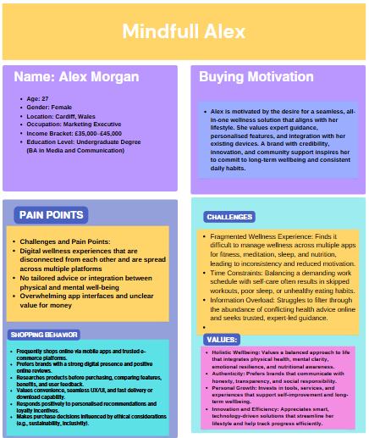
Figure: Consumer Persona
Source: Self-Made

Marketing Mix Strategy (7Ps Framework)
Nike, one of the world's most recognised brands in the athletic wear and sports innovation spaces, is expanding the brand by rolling out a new wellness app that seeks to push holistic health, fitness, and well-being forward. Given the rising demand of consumer demand for digital health solutions, this strategic extension aligns well with Nike extending into a more integrated lifestyle brand. To be successful in the launch and sustained existence of this app, Nike can utilise a comprehensive marketing mix based on the 7Ps which are the Product, Price, Place, Promotion, People, Process, and Physical Evidence.
Product
As a premium digital product, the Nike Wellness app will include features like guided workouts, meditation sessions, sleep tracking, personalised wellness plans, advice from experts, and community challenges. This product is unlike generic fitness apps because they will bring in the Nike brand and use their athlete ambassadors to create a different experience. The app can provide paid tiers (Nike Wellness Premium tier) with advanced analytics, live sessions, and personalised coaching as opposed to free basic features (Leng and Zhang, 2023). It should also synchronise with such popular wearables as well as Nike's digital ecosystem including Nike Run Club and Nike Training Club.
Price
It will certainly be a case of a freemium pricing strategy. The basic app version will be free, and the features will be enough to get users and build engagement. It could offer a premium tier at a relatively competitive price, i.e. $9.99 a month or $99 a year with exclusive content and features. In addition, Nike can also provide bundle deals (discounts that are awarded if Nike products are purchased or access comes with membership to Nike stores or partner gyms). In the user case scenario, the app can provide occasional discounts and student/pricing and family packages to make the app both more accessible and not too close to the perceived value (Dally, Sinaga, and Mohd, 2021). They have to be competitive in a saturated wellness market that is as well needed to reflect the superior nature of Nike's brand.
Place
The app will become a digital product that will be launched on Apple App Store, Google Play Store, and Nike's official site globally. Nike can also use the app as it already uses an app like the Nike app, Run Club, or SNKRS. Offline can be extended through collaborations with fitness centres, sports teams, or universities. Drive downloads with in-store promotions and QR codes on the package or in Nike retail stores. The app is most likely to go global and thus, features, languages, and content of wellness have to be localised for various regions.
Promotion
The app’s promotion will make use of Nike’s big brand name and storytelling prowess. To drive the launch campaign, high-profile athletes, influencers, and wellness experts should showcase their routines using the app, all of which will be promoted on social media (Instagram, TikTok, YouTube) for short-form content such as workout snippets, behind-the-scenes training, and mindfulness tips (Johnston, 2024). Similarly, push notifications, email campaigns, and in-app gamification are all instances that Nike can leverage for their purposes. You can also use virality by partnering with fitness influencers and sponsoring wellness events (or challenges such as a 30-day health challenge) for example. What typically works for user acquisition and retention is early access or reward incentives (such as Nike points or discounts).
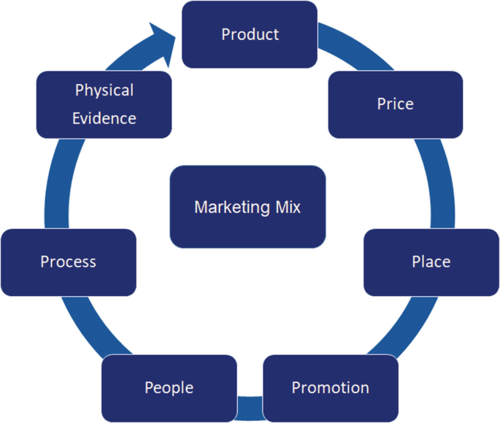
Figure: 7Ps of Mix Marketing
(Source: Helmold, 2022)
People
The lack of people behind it and people using it can make the app not so successful. Nike should invest in certified trainers, a mental health coach, nutritionists, and tech experts in hopes of producing credible, high-quality content. The technical queries, subscription issues, and user feedback must be responded to by the customer support teams within the stipulated time. Additionally, community building is also important using forums, group challenges, and wellness leaderboards, the users can come together and support each other (Kilpatrick et al., 2022). Furthermore, promoting real users’ and athletes’ testimonials and reviews will make it more trustworthy and relatable.
Process
Experience for customers will be smooth and user-centric. The app must have a clean user experience, fast loading times, and easy onboarding (including personalised assessments and goals). All the data privacy and security must be taken into account, bearing in mind that the app will deal with sensitive health information (Alhammad et al., 2023). They should put in feedback loops that allow users to give feedback and rate sessions. Every time there are analytics and user behaviour updates, it can be used to optimise the app constantly. Wearables integration, as well as with other Nike products, can offer a more holistic health view aligned with Nike's vision of connected fitness.
Physical Evidence
The app itself is digital, yet it needs to provide some evidence of effectiveness and brand quality. It includes user progress dashboards, wellness reports, achievement badges, and testimonials. The design language of Nike should be seen in Nike’s app’s visual identity. Along with the swoosh of Nike, inserting streaks of their athlete endorsements throughout the interface can help create brand trust. Branded merchandise or gear that extends wellness (think yoga mats, water bottles, and mindfulness journals) also extends into the physical experience of the app by way of Nike's product ecosystem.

Conclusion
The rebranding of the Nike Wellness App to function as a key brand extension that showcases how a brand can evolve to meet consumer demands is the only forward-thinking development in recent times. As interest in holistic health, mindfulness, and fitness rises, Nike can cement itself as the leader in sportswear and the pioneer in the digital wellness industry. With the 7Ps: Product, Price, Place, Promotion, People, Process, and Physical Evidence, Nike is highly prepared to give an experience of value to both existing and new customers that is seamless, immersive, and engaging. Also integrated with the existing digital ecosystem of Nike which involved personalisation features and the use of certified wellness professionals, the app is more credible and usable. With brand equity and story excellence, strategic segmentation, and targeting of tech-savvy urban professionals, Nike Wellness has a good market position.
Additionally, data security, user feedback, and innovation are given special attention making updates relevant to the competition and doing it in a really fast space. In summary, Nike Wellness not only enhances brand loyalty and customer engagement but its initiation represents Nike's willingness and ability to enable athletes and everyone in the process to be well. However, this is no ordinary product launch; this is a benign extension of Nike's mission of its support of every athlete's body and mind.

Reference
Alhammad, N., Alajlani, M., Abd-alrazaq, A., Epiphaniou, G. and Arvanitis, T. (2023). A systematic review of patients’ perspectives on data confidentiality, privacy, and security of mobile health applications (Preprint). Journal of Medical Internet Research, [online] 26. Available at: https://doi.org/10.2196/50715. [Accessed: 21 April 2025]
AlSlaity, A., Suruliraj, B., Oyebode, O., Fowles, J., Steeves, D. and Orji, R., (2022). Mobile applications for health and wellness: a systematic review. Proceedings of the ACM on human-computer interaction, 6(EICS), pp.1-29. Available at: https://www.researchgate.net/profile/Alaa-Alslaity/publication/361040008_Mobile_Applications_for_Health_and_Wellness_A_Systematic_Review/links/62992568a3fe3e3df8566ee1/Mobile-Applications-for-Health-and-Wellness-A-Systematic-Review.pdf [Accessed: 21 April 2025].
Callaghan, S., Lösch, M., Pione, A. and Teichner, W., (2021). Feeling good: The future of the $1.5 trillion wellness market. URL: https://www. mckinsey. com/industries/consumer-packaged-goods/our-insights/feeling-good-the-future-of-the-1-5-trillion-wellness-market (Accessed: 06.11. 2022). Available at: feelinggoodthefutureofthe15trilliondollarwellnessmarket.pdf [Accessed: 21 April 2025].
Dally, D., Sinaga, O. and Mohd (2021). The Impact Of 7p’s Of Marketing on The Performance of The Higher Education Institutions. Rigeo, [online] 11(3). Available at: https://doi.org/10.48047/rigeo.11.3.26. [Accessed: 21 April 2025]
Dhesi, A.S., (2021). Sustaining Digital Transformation in the Post-COVID Era: Nike Case Study (Doctoral dissertation, Massachusetts Institute of Technology). Available at: https://puiij.com/index.php/research/article/download/77/52 [Accessed: 21 April 2025].
Helmold, M. (2022). Marketing Mix. Management for Professionals, [online] pp.95–103. Available at: https://doi.org/10.1007/978-3-031-10097-0_9. [Accessed: 21 April 2025]
Johnston (2024). #Bloompartner: The use of Influencer Marketing in the Growth of Health and Wellness Products. Available at: https://doi.org/10.22215/etd/2024-16067. [Accessed: 21 April 2025]
Kilpatrick, S., Emery, S., Farmer, J. and Kamstra, P. (2022). Wellness Impacts of Social Capital Built in Online Peer Support Forums. International Journal of Environmental Research and Public Health, 19(23), p.15427. Available at: https://doi.org/10.3390/ijerph192315427. [Accessed: 21 April 2025]
Lee, J. and Kim, J.J., (2023). A study on market segmentation according to wellness tourism motivation and differences in behavior between the groups—focusing on satisfaction, behavioral intention, and flow. International Journal of Environmental Research and Public Health, 20(2), p.1063. Available at: https://www.mdpi.com/1660-4601/20/2/1063/pdf [Accessed: 21 April 2025].
Leng, H.K. and Zhang, J.J. (2023). Emerging Trends in Sport Sponsorship and Branding. Routledge eBooks, pp.1–18. Available at: https://doi.org/10.4324/9781003458890-1. [Accessed: 21 April 2025]
Statista (2025). Topic: Health and fitness apps. [online] Statista. Available at: https://www.statista.com/topics/9204/health-and-fitness-apps/. [Accessed: 21 April 2025]
‌

