Anderson Esteban Calle Chancay (2133889)

IMPACT OF VIRTUAL LEARNING ENVIROMENT
DIGITAL SKILLS AND research
ASSESMENT 2 RESEARCH REPORT

Contents
1.0 INTRODUCTION 2
2.0 background 3
3.0 positive and negative of VLE in educational institutions in the UK. 6
4.0 Method 6
5.0 results 7
6.0 discussion 11
7.0 conclusion 12
References 13
Appendix: 14

INTRODUCTION

OVERVIEW OF THE REPORT (VLE)

Virtual Learning environment is the most useful and innovated platform used by teachers and students to share interactions and activities by any good device and internet. (Evans, 2021).
The concept of VLE (virtual learning environment) was introduced in the mid- 1990s to develop the teaching and learning way on the internet
Even though, many people use this technology mainly teachers and student are in contact with this tool.

For teachers help set lessons or training no matter where the student is and allow the lecturer work remotely, and for student being more in contact with the lecturer and classmate or share opinions and homework if they missed a lesson.
Gradually the technology is replacing some traditional methods of communication and currently everything that before used to be a huge amount of physical effort now most of the procedure is by online form.

2.0 background

United Kingdom has been using technology for learning time ago, but in early 2000 what we known as VLE started to be set in all computers, 10 years after the E-learning platform started to expand around the world. By the other side what nowadays is Moodle began to be introduced in 2001 and the main goal was to help teachers create online course with a participation and collaboration of the users since 2008 the figure of VLE in UK has increased.

There are some services that VLE provide like distance learning degree programs, professional certification courses, instructional videos, video or audio lecture, books, articles and other writings, podcasts, webinars or high school or university classes.
Using VLE have benefits for students and lecturer like.
- Teachers:
- Administration and organisation
- Planning and resources management
- Assessment and monitoring students
- Personalised learning
- Discussion, support and mentoring

- For students:
- Access to course from anywhere
- Effective time management
- Discussion with classmates
- Immediate feedback on tests
- Sharpened digital skills

- For institution:
- Cost savings
- More diverse student group
- Reaching out a large number of students around the world

But by other hand there’s challenge of VLE for students, teacher and admin like:
- Limitations
- Lack of social interactions
- Inaccessible for others
- Cheating is unavoidable
- Focuses more on theory
- Requires self-motivation

The technologies required for VLE are:
- LMS (Learning Management Systems) is a software app that let students and teachers through a cloud-based deliver course materials, assigning quizzes, tracking students’ progress and sharing announcements. (Craing, et al., 2012)
- Reliable computer is an essential required technology for digital learning, otherwise there’s a high risk of disruptions in the virtual classroom.
- Podcasts and streaming this are one of the benefits of the VLE the capacity to record videos and sessions. Students can rewatch classroom that they missed.
- Internet based software is provided by a remote server.

What type of risk are associated with this technology?
In VLE there’s a many threats and risk.
Threats:
Confidentiality violation
Malicious program
Masquerade
Integrity violation
Illegitimate use

Risks:
Author risk - author’s lecture notes may be modified or destroyed by hackers’ attacks.
Teacher risk - any examination would be modified.
Manager risk - the duty of the manager is controlling the authorisation to the students and other participant to avoid masquerade people and writing test on behalf of enrolled students and the same time keep the server in a secure mode.
Student risk - being a user of E-learning include need to login information to the system and be vulnerable to cyber-attacks for that reason is recommendable share the minimal info.
other risk like computer bug, power outage, handling error, etc-

Virtual Learning Environment has associated some legislation

Registration: to access VLE staff and student must have an account to set the profile. Doing so the account holder will have access to all the info about module.

Responsibilities and acceptable behaviour staff: respect ideas, views and interpretations from other users and also make sure that none of their actions or activity may be concerned, defamatory or discriminatory to the other users.

Confidentiality must be an essential role to guarantee the perfect communication and check any issue with the platform to make sure there’s no security vulnerability, viruses, malware or any malicious action.

Responsibilities and acceptable behaviour student: Access to VLE with the intention to enhance the learning experience and
engage in communication associated with learning and not to engage in any activity associated with financial, political, or commercial purpose.

Also report any issue experienced with the system. Keep the password and any info private and secure, the same way uses the material provide by the lecturer and all the documents they upload in a fair and lawful manner.

Monitoring procedures: VLE will be subjected to regular monitoring to identify any problem with the use of the platform, introducing any new update or innovate methods or to check the impact of the Virtual Learning Environment in the student process knowledge.

Security and recovery: users should make sure info provided remain in private, changing password periodically and make it strength according to platform standards, accounts will be reviewed time to time for safety no other outside people or expired user has access to VLE.
Any incident who involves any user will be suspended until further news.

VLE policy implementation: any misuse is taken seriously as they are affecting students learning, support provide by staff, creating inappropriate environments for all users. Any student or lecturer will be subject to student conduct & disciplinary regulations.

3.0 positive and negative of VLE in educational institutions in the UK.

In 2008, UK government evaluated colleges to know the development of the Virtual Learning Environment and the result was this concept was new, and the school were using the traditional methods.

Years later British education conclude that E-leaning achieve more benefits than face to face classes. In the report they found 2 key factors first the preparation for learning another factor was integration of students onto the flexible access to resources.

In conclusion the positive impact in UK institutions is student choice and autonomy, personalised research, learn from home and communication between the schools.
By other side there’s negatives impact like lack of structured environment, not social interactions that it will make feel the student isolation and leads to mental health issues like anxiety, stress and negative thoughts, and not every individual are used to the new technology and still prefer traditional methods and student complain that impulse more theory than practice skills.

For that reason, there’s some ways to improve VLE services
- Make personal connections and user receive the help or support that they need.
- Easy navigate and make it functional
- Shorten and precisely theory and add some breaks.

4.0 Method

To do my research I did a deep searching in introduction and background to know better what VLE is, when was introduced and why is important to do research in this topic and also which services is Virtual Learning Environment providing, the benefits, any challenges, technologies, risk, legislation and opportunities.

With the help of some website where I can find journal, articles at the Moodle I had the chance to go to the online library and find some documents which can help me to do better research and the teacher provide info for more better understanding and polish our knowledge.

To understand better and have info about how VLE was working in the campus I prepare a survey about the E-learning environment and the student’s relationship with 10 questions and share it and sent it by E-mail to all my classroom mate to know their feedback analyse their answer and see the result of the survey.

5.0 results

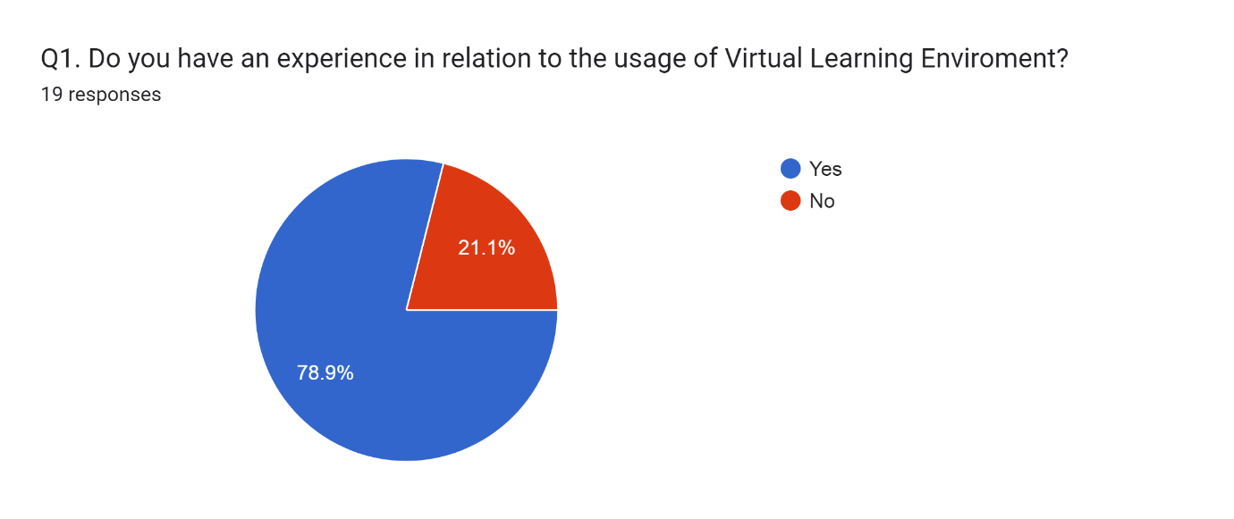As we can see in the first question of the survey the majority of people with a 78,9 % in blue had experience in the usage of Virtual Learning Environment that means than more than the half student knows about VLE but the other 21,1% not.

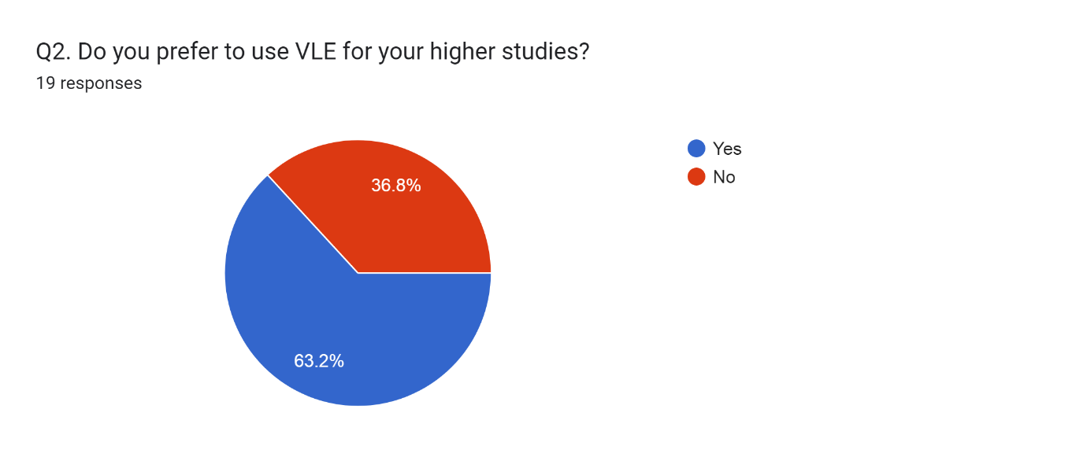
For the Q2 the graphic show us that most of the students with a 63,2% in blue in higher academic will prefer a virtual learning instant of the 36,8% that will prefer a traditional method.

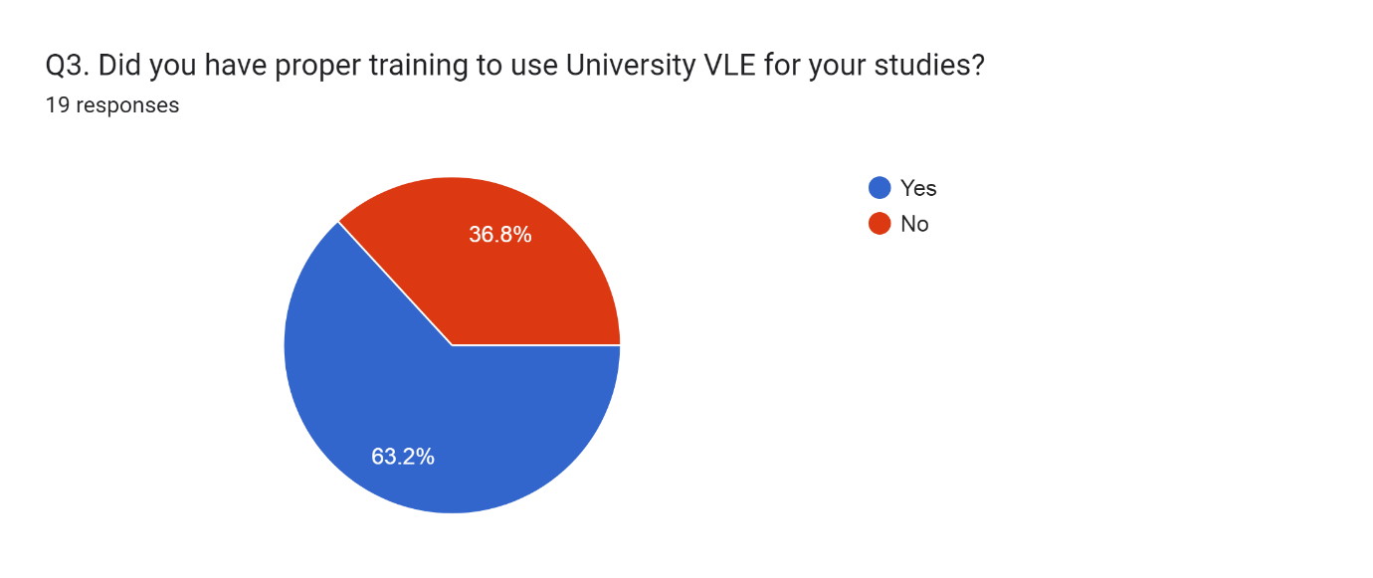
In Q3 about university training in VLE the 63,2% has been instructed in online platform and will have a better knowledge in the E-learning area instead of the 36,8% that the will face some issue for studies online environment.

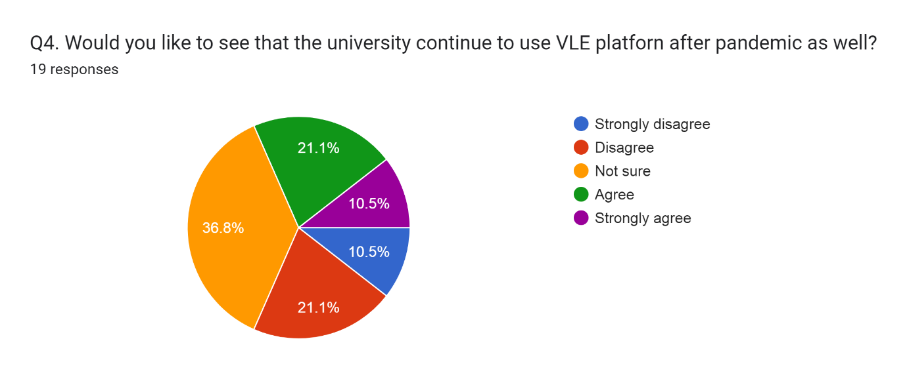
In the Q4 we can see multiples answers for a specifically question, with 10,5% that by one side students are strongly agree and the other side they are strongly disagree, same happen with 21,1% some of the students are agreed and some of them disagree.
And the majority with a 36,8% are not sure about if this platform will work in the university teaching.
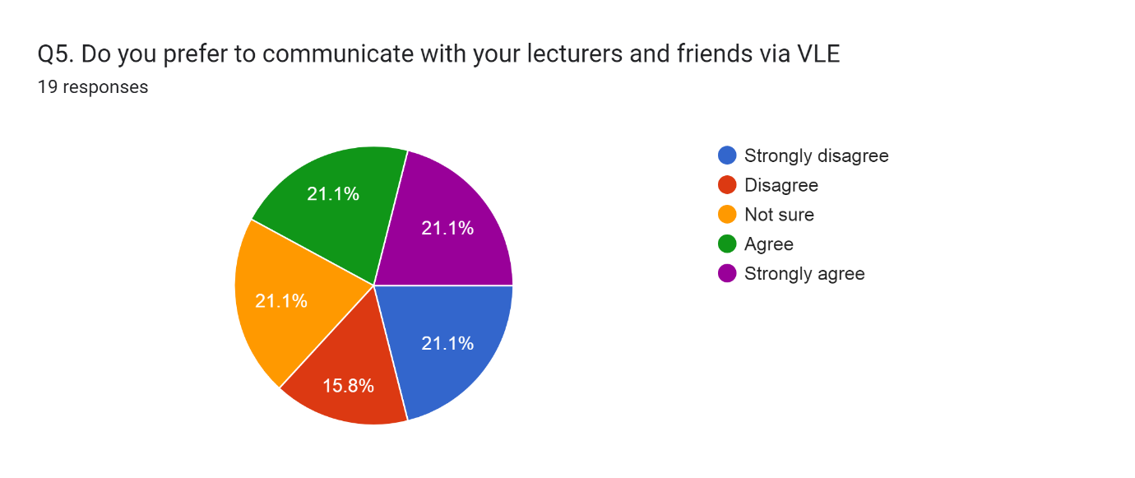
In Q5 about the communication between student and lecture by Virtual Learning Environment we see divided reactions and one percentage that is highlighting with a 21,1% but the graphic show us clearly less but with a 15,8% are disagree with this tool in communication.

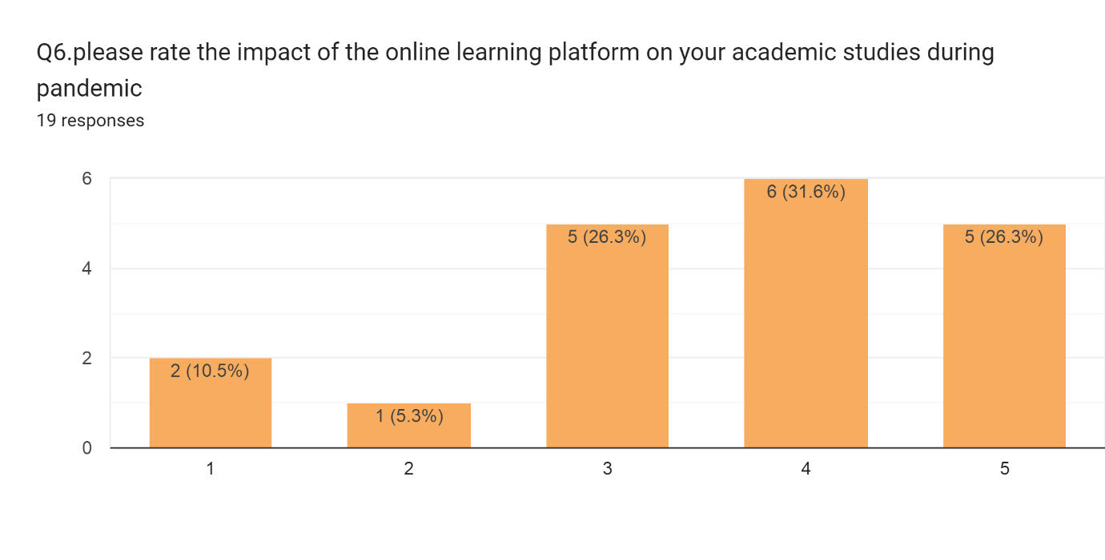due the pandemic most of the face-to-face lessons went by online learning so, in this Q6 we want to see how useful VLE in this time and we can see most of the student rate with a very positive answers with a 31,6% and 26,3% meanwhile only few of them not like it or not like at all.

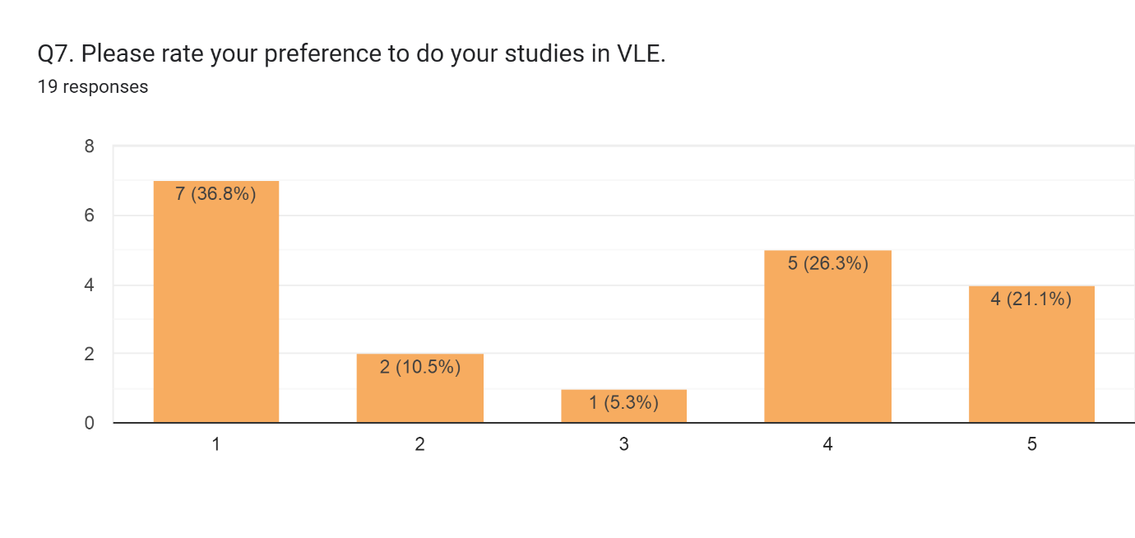
In Q7 most of the student are not supporter about to do the studies by VLE with a 36,8% instead of this 26,3% that will have preference in apply VLE in their studies.

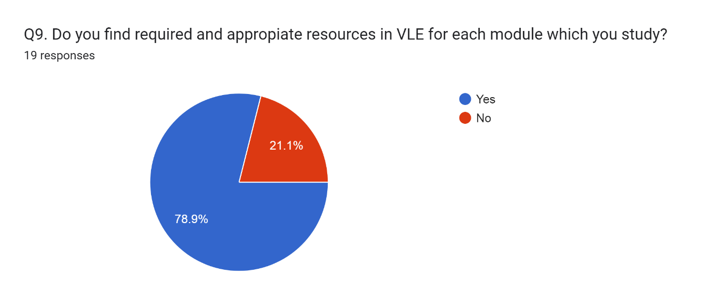
In Q9 the amount of the students that find appropriate resources in Virtual Learning Environment in every module is very big with a 78,9% by other side we see that the 21,1% don’t find any valid sources that can help them in every module.
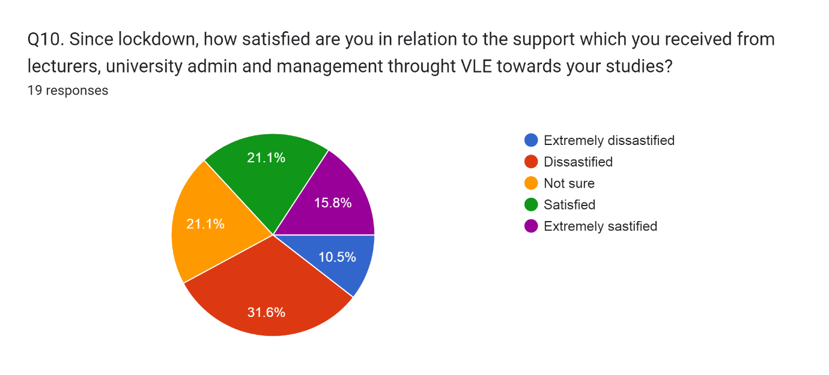
In Q10 with 21,1% some students are not sure or dissatisfied about the support they received from teachers and university admin, by closely but not clear with 15,8% are extremely satisfied with the support they received instead of the 10,5% and 31,6% they are not satisfied at all with the services provide by university.

6.0 discussion

At this point I will analyse according to what I obtained in the survey result, the positive and negatives point and which aspect of VLE will needs to improve and my own experience with this platform and of course what I learn from this module.
I can say that most of them have experience and know to use the E-learning tools, and the same time I can analyse that the university provide the students a good training for this platform.

But in terms of they will like it to use online environment I see many of them or are not sure are disagree at all and would say is because they lack of proper training in this area and some of them prefer the traditional methods instead of studies and communication.

To provide a better services VLE needs to according to my experience is try to improve the communication through any better chat or simply the interactions to have a clear contact between users, other point to improve is organization I feel needs a better management to have a structured lessons doing so the users can obtained a closely study class and the last one the process of join or sign into a meeting classroom which sometimes is a bit hard or confuse to proceed and enjoy the online classroom.

7.0 conclusion

I can say to conclude my digital skills and research module and preparing this report is know more about what VLE is, even using sometime this month for the lessons and tried to understand how it works, experiencing some issues gave me the idea for future meeting that use this platform and of course preparing for news tools in this aspect that can appear.

References

baker, J. & Gossman, P., 2013. The Learning Impact of a Virtual. [Online]
Available at: https://core.ac.uk/download/pdf/29422368.pdf
[Accessed 11 august 2022].
Craing, A., Beekhuyzen, J. & Coldwell-Neilson, J., 2012. A review of E-learning technologies. Deakin University's Research Repository, p. 5.
Evans, M., 2021. learning ladders. [Online]
Available at: https://www.learningladders.info/news/what-is-a-vle/
[Accessed 25 july 2022].
leary, P. G.-. & Turnock, C., 2008. Risk management your VLE: strategy implications for learning providers. [Online]
Available at: file:///C:/Users/user1/Downloads/Risk_Managing_Your_Vle_Strategic_Implications_For_.pdf
[Accessed 11 august 2022].
Pappas, C., 2017. 8 Ways To Continually Develop Your eLearning Skills And Knowledge. [Online]
Available at: https://elearningindustry.com/ways-continually-develop-elearning-skills-knowledge
[Accessed 11 08 2022].
Tamm, S., 2022. 10 Biggest Disadvantages of E-Learning. [Online]
Available at: https://e-student.org/disadvantages-of-e-learning/
[Accessed 11 august 2022].

Appendix:



