Applied Leadership and Management in the Workplace
Module Assignment Submission
Student Name: | Mallori Bray
Student Number: | 2209666
Module No: | BMSK5011
Module Title: | Knowledge & Information  Management skills

Statement of Confirmation of Authenticity
By the act of making this submission, the student declares that this is the work of the student named above. The work has not, in whole or in part, been knowingly presented elsewhere for assessment, or where assessment has been built on a previous assessment, this has been identified. Where materials have been used from other sources it has been properly acknowledged. If this statement is untrue, the student acknowledges that an assessment offence has been committed.
Attention is drawn to the plagiarism and unfair practice policies of both the University and of ILM./
Knowledge & Information Management Skills
Table of Contents
1. Introduction 3
2. Evaluation of the Concept of Knowledge Management 3
2.1 Relationship between Data, Information, and Knowledge 3
2.2 Relationship between Individual and Organisational Knowledge 5
3. Key Knowledge Management Processes for Organisational Development 6
4. Framework for Establishing a Knowledge Management Culture 8
4.1 Business Case for Collection and Distribution of Knowledge 8
4.2 Requirements to Create, Store, and Implement Knowledge 9
4.3 Key Performance Indicators (KPIs) for Knowledge Management 11
5. Applying Knowledge for Efficiency 13
6. Conclusion 14
References 15

List of Table
Table 1 Individual vs. Organisational Knowledge 5
Table 2 Knowledge Assets Inventory 10
Table 3 Data Protection Systems 12
List of Figure
Figure 1 DIKW Pyramid 4
Figure 2 Knowledge Management Process Cycle 8

1. Introduction
Management of such knowledge is important to create data and expertise that can help an organisation elevate its performance and competitiveness especially in the dynamic bakery sector. It plays a crucial role in product quality for Greggs, a UK based bakery Chain Company with over 2,600 outlets and £2 billion turnover in 2024 to maintain product quality and standardisation of supplies and services to its customers. By creating and storing knowledge then sharing it systematically, Greggs is placed in a position to maintain its market dominance and meet market requirements. Knowledge management drives actions from raw data, improving decision-making and innovating factors including upgrading recipes, like sausage rolls, and optimisation of inventory.
This process can be described by using the data information knowledge wisdom (DIKW) model. Data, for example daily figures from Greggs point of sales being processed into information such as peak trading times. It becomes know-how when it is utilised in altering the production calendar and know when incorporated into the strategic planning processes such as product launching (Jeje, 2020). Since it deals with 33,000 employees and a large volume of customer feedback via the Greggs App, this model is especially suitable for Greggs.
The aims and objectives of this report are as follows: To review knowledge management concepts, to outline the knowledge management processes to establish the knowledge management best practices at Greggs, with regard to the protection of recipes as IP, and; GDPR compliance of customers’ data. This report is divided into the following sections: The assessment of knowledge management concepts based on the DIKW model is made in section two, the roles and importance of processes in OD are discussed in section three while in section four a framework with KPIs is suggested.

2. Evaluation of the Concept of Knowledge Management

2.1 Relationship between Data, Information, and Knowledge
DIKW model is a process of management that is organised to transform raw data that is obtained into useful information within a company like Greggs, UK bakery chain with over 2,600 stores. The model starts with input data which are in an unrefined form that can be collected from the point of sale systems of Greggs or the quantity of ingredients in store. These are still in a raw form of data and turn into information once they have been analysed to discover that sausage rolls are more popular during the weekends than in the weekdays. Knowledge is realised in usage, as it’s the case in the case of improving the production plan to manufacture of sausage rolls on Fridays. Thus, the fifth aspect of AI consciousness is knowledge for strategic decisions that range from obtaining better contract terms from the suppliers to investing in automation to meet the increase and other strategic purposes (Mohamad et al., 2020).
DIKW is implemented in a business organisation as a hierarchy and in Greggs it is implemented by utilisation of its systems such as SAP and Oracle OBIEE in capturing and analysing sales data from over 2600 shops. For example, the details of customer’s purchase of one thousand sausage rolls per day in a particular store become information once condensed in terms of regional sales. This includes information, for instance, the best ways to handling storerooms to avoid wastage. for instance manner of opening other outlets in popular areas. The model ensures that data is not just accumulated but leveraged for achieving those outcomes that would make the organisational processes more effective and the customers happier.
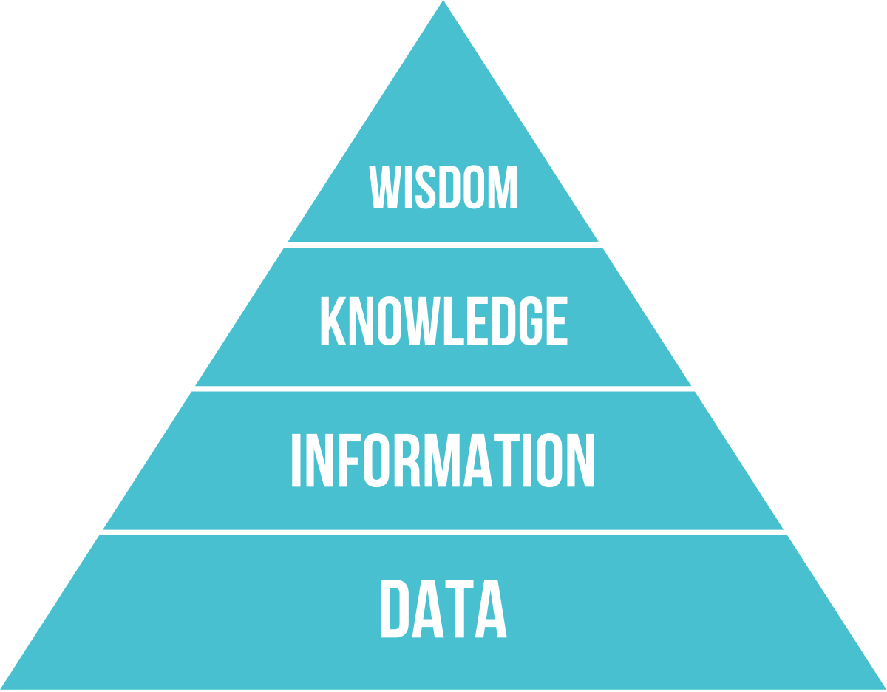
Figure 1 DIKW Pyramid
Source: (Mohamad et al., 2020)
The use of the DIKW model in an organisational setting can be attributed to the fact that enables decision-making processes that are backed by data. By performing the model for Greggs, it helps to minimise costs of numerous stocks, guarantee product availability, and foster innovation in the form of the addition of vegan products due to customer inclinations. With the help of the sales data and the knowledge of the employees, Greggs can ensure that it is controlled and equipped with nine regional bakeries and be in tendency with the changes in the market that occurs in the bakery industry (Koval et al.,2021).

2.2 Relationship between Individual and Organisational Knowledge
Organisation knowledge having its source in experience and understanding of workers play a large role in creation of knowledge at Greggs, a UK bakery retail chain with staff of over 33 000 and over 2 600 shops. Firstly, bakers have lot of knowledge such as the proper way of baking sausage roll pastry while store managers know many factors such as peak trading period. This knowledge escalates to organisational knowledge provided it has been documented in the process manuals, training manuals or data bases, towards standardisation of its outcome in Greggs’ operations. For example, a procedure of improving the quality of dough in a bakery may be recorded and disseminated through the Greggs’ Success Factors platform, making sure the organisation’s more than 16 000 employees learn about it (Arsawan et al., 2020).
Knowledge sharing is essential for the firm to use in the growth of Greggs and expand its operations and products. At this time, it is also crucial for Greggs to integrate individual expertise with the help of IT systems like SAP and KPS software to share the most effective practices like effective inventory management for nine regional bakeries. Sharing also powers harmony, and this reduces on the number of mistakes and increases on product quality. For instance, feedback received through the Greggs App can be utilised by the marketing team to improve food offering or by the human resources to enhance working conditions as well which may have an impact on achieving £2 billion turnover in the year 2024. Effective knowledge sharing transforms individual expertise into a collective asset, supporting Greggs’ expansion and digital transformation, including delivery services (Azeem et al., 2021).
Table 1 Individual vs. Organisational Knowledge
Aspect | Individual Knowledge | Organisational Knowledge
Nature | Tacit, experience-based | Explicit, documented
Example | Baker’s pastry technique | Standardised sausage roll recipe
Storage | Personal memory, skills | SAP, Success Factors, KPS systems
Management Strategy | Mentorship, training sessions | Knowledge bases, centralised databases
(Azeem et al., 2021)
The interplay between individual and organisational knowledge strengthens Greggs’ ability to maintain quality and adapt to market demands. By fostering a culture of sharing, Greggs leverages its workforce’s expertise to drive operational excellence and sustain its competitive edge in the bakery industry.

3. Key Knowledge Management Processes for Organisational Development
Knowledge management processes are vital for Greggs, a UK bakery chain with over 2,600 stores and £2 billion in turnover in 2024, to enhance organisational development. These processes recipe creation, inventory storage, staff training, and customer feedback application enable Greggs to maintain product consistency, optimise operations, and drive growth. By leveraging IT systems like SAP, Oracle OBIEE, and KPS software, Greggs transforms raw data into actionable knowledge, supporting its scalability and competitive edge in the bakery industry (Greggs, 2024).
Recipe Creation is a cornerstone of Greggs’ knowledge management. Standardised recipes, such as for sausage rolls, are developed by expert bakers and codified in centralised databases, likely within SAP. This ensures uniformity across nine regional bakeries, maintaining brand quality. The process involves capturing tacit knowledge from skilled employees and converting it into explicit knowledge for widespread use. For instance, a new vegan sausage roll recipe is tested, documented, and shared to ensure consistent production, contributing to product innovation and customer satisfaction (Cillo et al., 2021).
Inventory Storage relies on knowledge management to optimise stock levels and reduce waste. Greggs uses SAP for forecast and replenishment, analysing sales data to determine ingredient needs. For example, data showing higher sausage roll sales on weekends informs inventory adjustments, minimising overstocking. Oracle OBIEE provides business intelligence, enabling Greggs to store and retrieve sales trends efficiently. This process enhances supply chain efficiency, ensuring ingredients are available without excess costs, critical for a chain serving millions weekly (Dias et al., 2023).
Staff Training is essential for disseminating knowledge across Greggs’ 33,000 employees. Through the SuccessFactors platform, over 16,000 staff receive training on recipes, customer service, and operational procedures. This codifies individual expertise, such as a baker’s technique, into organisational knowledge accessible to new hires. Training ensures consistent product quality and service, supporting Greggs’ expansion into delivery and extended trading hours. Knowledge sharing via mentorship and digital modules also reduces onboarding time, boosting operational agility (Chang et al., 2023).
Customer Feedback Application leverages insights from the Greggs App to refine products and services. Feedback on popular items, like sausage rolls, or demand for vegan options is analysed to inform product development. This process involves accumulation of raw data, exercising a set of operations on it in order to generate information and applying the knowledge so produced to modify the offerings. For instance, customers’ changed perception on healthy foods, forced companies to bring new foods to market to help boost their sales. This means feedback which is stored in central locations within CRM systems can be used to support cross-departmental innovation as well as customer retention (Greggs, 2025).
These processes have a greatest impact on the efficiency and growth of the company, namely, Greggs. This controls food quality across all 2,600 stores worldwide, which in turn strengthens consumers’ confidence in the brand. Overhead stock must be avoided as much as possible and through the use of SAP Analytics, costs are cut low, especially in a highly active organisation. Training accentuates service delivery to empower Greggs to upscale its operations and others such as delivery services. The customer feedback application is possible with inspiration from the insights provided by the apps leading to a 10% sales boosting by 2024 (Greggs, 2025). Together, these processes improve the operational functions and increase error and cost avoidance as it relates to other strategic initiatives such as market expansions.
It also makes a company flexible especially in the clothing industry since any design pattern can easily be copied. By centralising knowledge in systems like KPS software, Greggs ensures rapid issue resolution, such as IT support for 1,400+ branches. This scalability supports growth, as seen in Greggs’ digital transformation, including SD-WAN implementation for efficient data transfer across stores. Moreover, these processes align with Industry 4.0 trends, where data-driven insights and automation, such as smart inventory systems, position Greggs for future growth (Melesse and Orrù, 2025).
However, challenges like staff turnover can disrupt knowledge transfer. Greggs mitigates this through robust training and digital knowledge bases, ensuring continuity. The integration of these processes creates a feedback loop, where customer insights inform recipes, training refines execution, and inventory data optimises production. This holistic approach drives Greggs’ ability to serve diverse markets, from Scotch pies in Scotland to vegan options nationwide, sustaining its leadership in the bakery sector (Sassanelli et al., 2021).
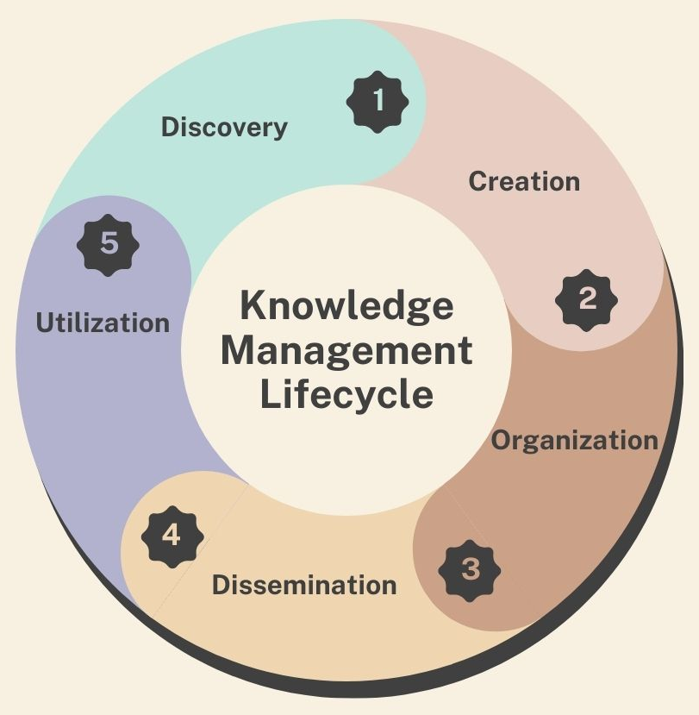
Figure 2 Knowledge Management Process Cycle
Source: (Rezaei et al., 2020)

4. Framework for Establishing a Knowledge Management Culture

4.1 Business Case for Collection and Distribution of Knowledge
The collection and distribution of knowledge are critical for Greggs to maintain its market leadership. Effective knowledge management ensures recipe consistency, enhances customer satisfaction, and drives operational efficiency. By centralising knowledge through systems like SAP and KPS software, Greggs can leverage its 33,000 employees’ expertise and customer data to support growth and innovation (Kpsol, 2017).
A primary benefit is improved recipe consistency. Standardised recipes, such as for sausage rolls, are stored in centralised databases, ensuring uniformity across nine regional bakeries. This consistency reinforces brand trust, as customers expect the same quality whether in London or any other country, Knowledge collection captures bakers’ tacit expertise, which is codified and distributed via training platforms like Success Factors, enabling consistent production even in high-volume settings (Lam et al., 2021).
Another key benefit is enhanced customer satisfaction. By collecting customer feedback through the Greggs App, Greggs gains insights into preferences, such as demand for vegan options. Distributing this knowledge to product development teams allows for tailored offerings, contributing to a 10% sales increase in 2024. Centralised knowledge sharing ensures that customer-driven innovations, like new menu items, are implemented swiftly across stores, boosting market share (McKenna, 2017).
However, challenges like staff turnover, common in the bakery industry, can disrupt knowledge retention. With 33,000 employees, frequent departures risk losing tacit knowledge, such as baking techniques. Additionally, inconsistent knowledge sharing across stores can lead to operational discrepancies. To address these, Greggs employs solutions like robust digital knowledge bases. KPS software centralises IT support knowledge for 1,400+ branches, ensuring continuity despite turnover. Similarly, Success Factors delivers training to over 16,000 staff, codifying expertise into accessible formats. Regular mentorship programs and knowledge-sharing sessions further embed a culture of collaboration, mitigating the impact of staff changes (Andrushkiv, 2022).
By investing in knowledge collection and distribution, Greggs enhances efficiency, reduces costs, and fosters innovation. These benefits position the company to adapt to market trends, such as digital delivery, while maintaining its competitive edge in the bakery industry.

4.2 Requirements to Create, Store, and Implement Knowledge
Effective knowledge management at Greggs, requires robust systems and processes to create, store, and implement knowledge. This ensures operational efficiency, product consistency, and customer satisfaction across its £2 billion turnover business. By leveraging IT infrastructure and defining key knowledge assets, Greggs can sustain its competitive edge in the bakery industry (Rezaei et al., 2020).
Identifying Current Systems for Storing Information.
Greggs employs advanced IT systems to store information critical to its operations. Point-of-sale (POS) systems capture daily sales data, such as sausage roll transactions, across 2,600+ stores, feeding into centralised databases for analysis. These solutions are compatible with SAP, an acronym for Systems, Applications and Products in details; specifically for planning in areas of finance, procurement and supply chain. The SAP HANA and IS-Retail modules have sections to store products and sales information, providing client-side updates about the stocks and the sales frequency. This data is processed by Oracle OBIEE, a business intelligence tool, to produce sales patterns’ reports that aid in strategic decisions such as production changes. Also, KPS ensures that solutions to all the technical issues affecting IT support are provided by centralising all branch information and reaching 1,400+ branches for continuity. This means, the implementation of SD-WAN improves on transfer of data across stores to ensure efficient storage of information and retrieval when required. These systems collectively ensure that data, from customer transactions to inventory levels, is securely stored and accessible, supporting Greggs’ ability to maintain consistency and efficiency in its high-volume operations (Belova and Yusupova, 2022).
Defining Current Knowledge Assets within Greggs
Greggs’ knowledge assets are critical to its success and include baking techniques, sales data, and customer preferences. Baking techniques, such as methods for crafting sausage roll pastry, represent tacit knowledge held by skilled bakers. These are codified into standardised recipes stored in secure databases. Sales data, collected via POS systems and analysed through Oracle OBIEE, provide insights into top-selling products and peak hours, informing inventory and production decisions. Customers’ data from the Greggs App shows the trends for products such as vegan items, which influence new product development. Other tangible resources include policies and guidelines on SuccessFactors, which reflects best practices of human resources operation for the 33,000 strength. These are categorised under intellectual property (e.g. recipes as a trade secret) and controlled to be retrievable and secure at the same time (Liu et al., 2021).
Table 2 Knowledge Assets Inventory
Asset Type | Description | Accessibility
Baking Techniques | Expert methods for recipes | Restricted, via training
Sales Data | Transaction and trend insights | Accessible via Oracle OBIEE
Customer Preferences | App-based feedback on products | Stored in CRM systems
Training Materials | Manuals for staff training | Available via Success Factors
(Liu et al., 2021)

4.3 Key Performance Indicators (KPIs) for Knowledge Management
KPIs are important when determining the efficiency of knowledge management at Greggs, Understanding these knowledge needs and integrating comprehensive data and knowledge protection measures into its management can help Greggs to support efficiency and creativity while aligning the firm’s systems and processes with IP and GDPR rules. KPIs help users to set targets on how knowledge is created, stored, and can be applied in its functioning (Leon et al., 2023).
Information Required by Greggs
It is now understood that Greggs relies on this kind of specific information for effective running of its bakery business, which is key to retaining its market dominance. Material costs are a strong factor for managing profitability since price changes of flour or of meat and fillings affect cost of sales. SAP provides information on costs in relation to all procurements, thereby eliminating every chance of overemphasising cost while sourcing at the same time guaranteeing value. Documents from point-of-sale (POS) systems and Oracle OBIEE give insights into sales of products in the restaurant such as the observation that sausage rolls are sold more during the weekends. It assists in the determination of what inventory to hold and when to produce it to avoid the accumulation of stock and to meet the needs of client. Furthermore, the choice of products given from the Greggs App help in gauging customers’ favorite meals, extensions such as vegan meals influencing product creation. Staff performance metrics, tracked through Success Factors, highlight training completion rates for 33,000 employees, ensuring consistent service quality. These information types enable Greggs to make data-driven decisions, enhancing operational efficiency and customer satisfaction. For example, analysing sales trends led to a 10% sales increase in 2024 by aligning production with demand. KPIs related to this information include the frequency of data updates in SAP and the accuracy of sales forecasts, ensuring timely and reliable insights for strategic planning (Nansubuga et al., 2024).
Systems to Protect Confidentiality, Integrity, and Availability
Protecting the confidentiality, integrity, and availability (CIA) of knowledge assets is paramount for Greggs, given its reliance on proprietary recipes and customer data. Secure recipe storage safeguards intellectual property, as recipes like the famous sausage roll are likely protected as trade secrets. These are stored in encrypted SAP databases with restricted access, limited to authorised personnel such as senior bakers and product development teams. Encryption ensures that even if data is intercepted, it remains unreadable, preserving Greggs’ competitive advantage. Access controls, implemented through role-based permissions, prevent unauthorised access, ensuring only relevant staff can view or modify recipes (Ivanchenkova et al., 2025).
GDPR-compliant customer data management is critical, as Greggs collects personal information via its app, including purchase histories and preferences. GDPR compliance involves anonymising data where possible, obtaining explicit consent for data use, and maintaining audit trails to track access. Greggs employs encryption for data at rest and in transit, protecting customer information from breaches. Regular security audits, supported by SD-WAN infrastructure, ensure system vulnerabilities are addressed, maintaining data integrity. Data availability is ensured through redundant storage systems, such as cloud-based backups, allowing Greggs to recover critical information during outages. For example, KPS software ensures IT support knowledge remains accessible across 1,400+ branches, minimising downtime (Nikoliuk et al., 2024).
Table 3 Data Protection Systems
System | Purpose | Compliance Aspect
SAP Encryption | Secure recipe and financial data | IP protection, GDPR
Access Controls | Restrict data to authorised users | GDPR, IP protection
SD-WAN | Ensure secure data transfer | Data availability, GDPR
Audit Trails | Track data access and modifications | GDPR compliance
Source: (Nikoliuk et al., 2024)
These systems align with KPIs to measure their effectiveness. Confidentiality KPIs include the percentage of data encrypted (target: 100%) and the number of unauthorised access attempts (target: zero). Integrity KPIs track the frequency of data audits (target: quarterly) and error rates in recipe or sales data (target: <1%). Availability KPIs measure system uptime (target: 99.9%) and recovery time after outages (target: <1 hour). These metrics ensure Greggs’ knowledge assets, from recipes to customer data, are protected while remaining accessible for operational needs. For instance, secure storage of sales data enables accurate forecasting, while GDPR compliance builds customer trust, supporting app-based engagement. By integrating these systems, Greggs mitigates risks like data breaches or IP theft, which could cost millions in a competitive industry. The CIA triad, supported by robust IT infrastructure, ensures knowledge management processes are secure and reliable, fostering a culture of trust and innovation (Polova and Bondarenko-Berehovych, 2021).

5. Applying Knowledge for Efficiency
Applying knowledge to identify patterns is critical for enhancing operational efficiency at Greggs, a UK bakery chain with over 2,600 stores and £2 billion in turnover in 2024. By leveraging data analytics through systems like Oracle OBIEE and SAP, Greggs transforms sales and operational data into actionable insights, optimising production and resource allocation. Pattern identification, such as recognising peak sales times, enables Greggs to streamline processes, reduce waste, and improve customer satisfaction, reinforcing its market leadership (Medeiros et al., 2024).
A subset of such patterns is peak sales time which is established after analysing the POS data. Specifically, it has been noted that their sales increase during lunch time that is between 12PM and 2PM and on weekends as deduced from the Oracle OBIE analysis of Sausage Roll. From this knowledge, Greggs is able to change its production plans by increasing output of sausage rolls before these occasions in order to provide adequate supply without overstocking. This optimisation reduces ingredient waste, critical for managing costs in a high-volume business. Another pattern involves regional product preferences, such as higher demand for Scotch pies in Scotland. Greggs uses this insight to tailor inventory at its nine regional bakeries, ensuring efficient stock allocation and enhancing customer satisfaction (Melesse and Orrù, 2025).
Examples from Greggs’ operations demonstrate the impact of knowledge application. By analysing customer feedback from the Greggs App, Greggs identified a growing demand for vegan options, leading to the introduction of the vegan sausage roll. This data-driven decision boosted sales by 10% in 2024, showcasing how knowledge informs product innovation. Also, staffing levels are adjusted according to sales volume to facilitate quick service delivery since customers do not like to wait for a long time. The utilisation of SD-WAN guarantees real-time data flow across stores hence a swift change in production or staffing depending on the sales rate for the day. All these applications of knowledge contribute to operation flexibility to ensure that it meets its customer needs in its operations while at the same time controlling costs.
Through integrating pattern identification with the firm’s knowledge management processes, Greggs realises a considerable improvement in efficiency by focusing resources to strengthen its competitive position in bakery industry.

6. Conclusion
This report is intended to illustrate the kind of impact knowledge management can play for Greggs – a British bakery chain outlet which has more than 2,600 outlets and £2 billion of net annual sales by 2024. Using the example of DIKW model in action – About Greggs, transforming the raw sales data into an effective production plan as well as to improve its ability to cater to customer needs and demands. Some of the critical goals involve recipe formulation, inventory management, employee training and handling of customer feedback to guarantee uniformity and effectiveness in its nine branch bakeries. The use of KPIs within the proposed framework encourages sharing of best practice, improving quality and innovation like launching the vegan sausage roll which increased sales by 10%.
Patent protection especially for private or trade secrets such as the recipe in supplying sausage rolls is significant to the success of Greggs. Loose storage of this information in SAP databases ensure that such secrets are safe from the reach of rivals. Similar to this, GDPR policies for the customers’ data obtained through the Greggs App seek to protect such info to foster loyalty, permit personalisation, and augment applicable products and services.
Further ahead, thorough systematic knowledge management processes like employing AI analytical tools shall be invested or adopted to improve on the pattern’s recognition in production and staffing. To eliminate risks resulting from staff turnover among its 33’000 employees, it is recommended that Greggs increases training through Success Factors which fosters knowledge sharing. The process of checking the compliance of an organisation’s data protection system frequently will maintain GDPR compliance and protect intellectual property as companies advance into the use of digital platforms. Also, the development of mentored working relationship can enhance knowledge from bakers thereby enhancing organisational resources. With due focus on such strategies, Greggs can maintain market dominance, address novel developments such as delivery services, and further provide value for clients within a competitive bakery industry.

References
Abbas, J. and Khan, S.M. (2022). Green knowledge management and organisational green culture: an interaction for organisational green innovation and green performance. Journal of Knowledge Management. doi:https://doi.org/10.1108/jkm-03-2022-0156.
ANDRUSHKIV, R. (2022). IMPROVEMENT OF MARKETING ACTIVITY OF BAKERY INDUSTRY ENTERPRISES. Herald of Khmelnytskyi National University. Economic sciences, 306(3), pp.148–156. doi:https://doi.org/10.31891/2307-5740-2022-306-3-21.
Arsawan, I.W.E., Koval, V., Rajiani, I., Rustiarini, N.W., Supartha, W.G. and Suryantini, N.P.S. (2020). Leveraging Knowledge Sharing and Innovation Culture into SMEs Sustainable Competitive Advantage. International Journal of Productivity and Performance Management, [online] 71(2), pp.405–428. doi:https://doi.org/10.1108/ijppm-04-2020-0192.
Azeem, M., Ahmed, M., Haider, S. and Sajjad, M. (2021). Expanding Competitive Advantage through Organisational culture, Knowledge Sharing and Organisational Innovation. Technology in Society, 66(1), p.101635. doi:https://doi.org/10.1016/j.techsoc.2021.101635.
Belova, Y.N. and Yusupova, L.R. (2022). The Use of Intelligent Knowledge Modeling Technologies to Control The Manufacturing Process of Support Frames of Refrigeration Units for Bakery Factory. Intellekt Sist Proizv, 20(2), pp.41–49. doi:https://doi.org/10.22213/2410-9304-2022-2-41-49.
Chang, T.-C., Lee, S.-N. and Tsai, Y.-C. (2023). Development of Team Leaders’ Management Skills - Evidence from Taiwan’s Bakery Industry. Advances in Management and Applied Economics, pp.1–18. doi:https://doi.org/10.47260/amae/1341.
Cillo, V., Gregori, G.L., Daniele, L.M., Caputo, F. and Bitbol-Saba, N. (2021). Rethinking companies’ culture through knowledge management lens during Industry 5.0 transition. Journal of Knowledge Management, 26(10). doi:https://doi.org/10.1108/jkm-09-2021-0718.
Dias, A., Medeiros, G., Bastos, B., Victoria, M. and Nilo (2023). Demand forecasting and inventory management as requirements for quality assurance in a bakery company. GeSec, 14(9), pp.15680–15694. doi:https://doi.org/10.7769/gesec.v14i9.2832.
Greggs (2024). Greggs Corporate | about Us. [online] corporate.greggs.co.uk. Available at: https://corporate.greggs.co.uk/about-us/.
Greggs (2025). Greggs Corporate | Our strategy. [online] corporate.greggs.co.uk. Available at: https://corporate.greggs.co.uk/about-us/our-strategy.
Jeje, K. (2020). KNOWLEDGE MANAGEMENT AND PERFORMANCE OF SMALL AND MEDIUMSIZED ENTERPRISES: LESSONS FROM TANZANIAN BAKERIES. Eurasian Journal of Business and Management, 8(2), pp.75–93. doi:https://doi.org/10.15604/ejbm.2020.08.02.003.
Koval, V., Trokhymets, O. and Brovkina, J. (2021). FACTORS ANALYSIS OF INFLUENCE ON THE EFFICIENCY OF BUSINESS MANAGEMENT OF BAKERY ENTERPRISES. State and regions. Series: Economics and Business, (4(121)). doi:https://doi.org/10.32840/1814-1161/2021-4-19.
Kpsol (2017). Greggs uses KPS to fulfil their Knowledge Management Solution. [online] Kpsol. Available at: https://www.kpsol.com/greggs-knowledge-management-software/.
Lam, L., Nguyen, P., Le, N. and Tran, K. (2021). The Relation among Organisational Culture, Knowledge Management, and Innovation Capability: Its Implication for Open Innovation. Journal of Open Innovation: Technology, Market, and Complexity, 7(1), p.66. doi:https://doi.org/10.3390/joitmc7010066.
Larysa Ivanchenkova, Nataliia Lagodiienko, Larysa Skliar and Oleksandr Bohdanov (2025). Comprehensive approach to risk management on the example of bakery enterprises in ukraine. Ukrainian Journal of Applied Economics and Technology, 2025(1), pp.122–127. doi:https://doi.org/10.36887/2415-8453-2025-1-20.
Leon, R.-D., Raúl Rodríguez-Rodríguez and Juan-José Alfaro-Saíz (2023). Preparing for Industry 5.0: a methodology for avoiding corporate amnesia. Industrial Management and Data Systems. doi:https://doi.org/10.1108/imds-03-2023-0159.
Liu, G., Tsui, E. and Kianto, A. (2021). Knowledge-friendly organisational culture and performance: A meta-analysis. Journal of Business Research, 134(1), pp.738–753. doi:https://doi.org/10.1016/j.jbusres.2021.05.048.
Loureiro MEDEIROS, R., De Oliveira MEDEIROS, A., Vitório LIMA, V. and Matos da SILVA, P. (2024). ANALYSIS OF INVENTORY MANAGEMENT IN A BAKERY INDUSTRY. RINTERPAP - Revista Interdisciplinar de Pesquisas Aplicadas, 1(1), pp.109–130. doi:https://doi.org/10.47682/2675-6552.a2024v1n1p109-130.
McKenna, B. (2017). Greggs bakes in business change programme with SAP. [online] ComputerWeekly.com. Available at: https://www.computerweekly.com/news/450420896/Greggs-bakes-in-business-change-programme-with-SAP.
Melesse, T.Y. and Pier Francesco Orrù (2025). The Digital Revolution in the Bakery Sector: Innovations, Challenges, and Opportunities from Industry 4.0. Foods, [online] 14(3), pp.526–526. doi:https://doi.org/10.3390/foods14030526.
Mohamad, A.A., Ramayah, T. and Lo, M.C. (2020). Sustainable Knowledge Management and Firm Innovativeness: The Contingent Role of Innovative Culture. Sustainability, 12(17), p.6910. doi:https://doi.org/10.3390/su12176910.
None Shakikah Nansubuga, None Aries Susanty and None Ratna Purwaningsih (2024). Investigation of inventory management practices at m. products bakery and confectionary limited. World Journal of Advanced Research and Reviews, [online] 23(1), pp.1013–1026. doi:https://doi.org/10.30574/wjarr.2024.23.1.2096.
Olena Nikoliuk, Savchenko, T., Volodymyr Lagodiienko and Nataliia Lagodiienko (2024). Modern models of innovative management of bakery enterprises. Actual problems of innovative economy, [online] 2024(6), pp.32–37. doi:https://doi.org/10.36887/2524-0455-2024-6-6.
POLOVA, O. and BONDARENKO-BEREHOVYCH, V. (2021). ECONOMIC SECURITY MANAGEMENT SYSTEM OF BAKERY INDUSTRIES. ‘EСONOMY. FINANСES. MANAGEMENT: Topical issues of science and practical activity’, (1 (55)), pp.85–97. doi:https://doi.org/10.37128/2411-4413-2021-1-6.
Rezaei, M., Jafari-Sadeghi, V. and Bresciani, S. (2020). What drives the process of knowledge management in a cross-cultural setting. European Business Review, 32(3), pp.485–511. doi:https://doi.org/10.1108/ebr-06-2019-0127.
Sassanelli, C., da, S., Rozenfeld, H., Mascarenhas, J. and Terzi, S. (2021). Enhancing knowledge management in the PSS detailed design: a case study in a food and bakery machinery company. Concurrent Engineering, 29(4), pp.295–308. doi:https://doi.org/10.1177/1063293x21991806.

