corporate reporting and social responsibility bmbm6004
Patisserie Valerie

Davood Abbasi
1707099

Table of Contents
Executive Summary 1
Introduction 2
Earnings Management 2
Incentives that Drive Managers towards Earnings Management 3
Altruistic Motivation 3
Pressure from related Parties 4
Speculative Motivation 4
Issues of Earnings Management in the Pattiserrie Valerie Case 5
The Role of the UK Corporate Governance Structure in Constraining Earnings Management 5
Recommendations 7
Conclusion 9
References 10

Executive Summary
This report intends to provide the definition of earning management and will look into patisserie Valerie as a case study. Earnings management is the process of managing earnings in a firm. Managers manage earnings to appeal to potential investors, customers. Earnings management is legal because one does not distort figures but spreads income. Incentives and pressure that drive managers towards earnings management are altruistic motivation, pressured from related parties and speculative motivation. Furthermore, they use techniques that increase the figures for in the year of violation. Managers use earnings management to prevent the effects of poor financial performance on the company’s future. Knowing the role of the board and the role of employees helps in avoiding conflicts of interest. Moreover, it helps the body perform its duties with ease. Another way to improve the UK corporate governance structure is to monitor performance. The management should assess performance to determine areas of strength and weakness. One way of improving the corporate governance structure is understanding that governance is more than compliance. The UK Corporate Governance Structure can be improved by appointing the right chairperson, choosing a competent board, availing information and patience. Weekly meetings to deliberate on issues and find solutions. Maintaining open communication is essential in the growth and improvement of the UK corporate governance structure. Another way to improve corporate governance is to appoint the right chairperson. Earnings management plays a vital role in the management sector and should be employed to improve the accounting process.

Introduction
The main aim of businesses is to make profit. Some people resort to illegal activities to make a financial statement look good (Iqbal, & Strong, 2010 pp. 168). The financial sector has laid tough measures on businesses that give false financial information. Therefore, many businesses opt for earnings management to balance their books. This report defines earnings management, incentives and pressures that push managers towards earnings management, the role of UK corporate governance structure and ways to improve the board.

Earnings Management
Earnings management refers to the use of legal accounting techniques to improve financial statements (Mulyadi, & Anwar. 2015 pp. 363). Acronym WISE (Window dressing, internal targets, incoming Smoothing, and External Expectations) is used to explain earnings management works. Window dressing is a firm’s decision to make its financial statement suitable for potential creditors and investors. The purpose of this is to attract new people by making it seem like the firm is doing great (Vieira, 2016 pp. 190). The firm achieves window dressing by making it seem like it has been making a profit. It can spread its profits across to cover up for times it made losses. A company may choose to use internal targets to balance out the budget (Lara, Juan, Garcia Osma, & Penalva, 2019 pp. 25). A firm can smooth its income in case there was a spike sometimes. Moreover, firms use earnings management techniques to meet external expectations. For example, if a company has projected its profits to investors, they are forced to use earnings management to meet their expectations. The chart below shows earnings spread across several months.
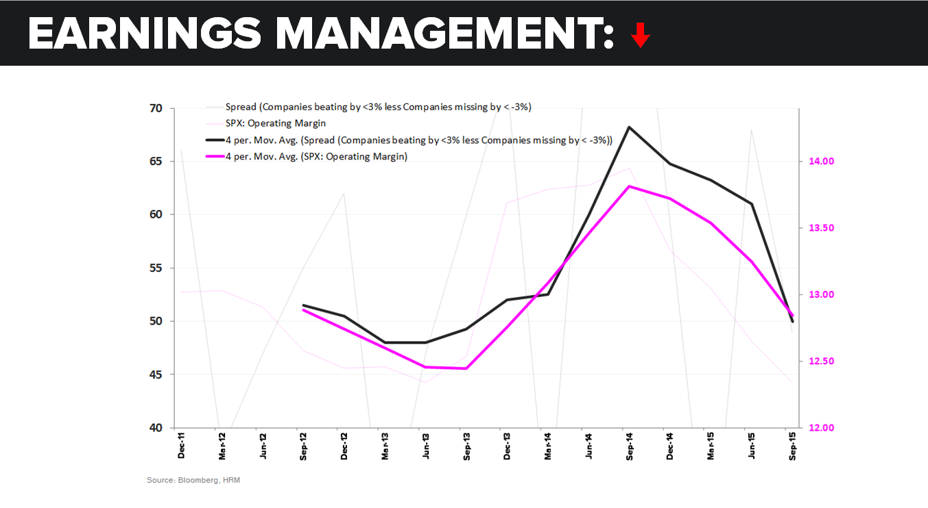

Incentives that Drive Managers towards Earnings Management
Managers are under constant pressure to improve the profit of a company. Some resort to illegal activities to make the financial statement look better (Hill, Korczak, & Wang, 2019 pp. 147). Those who report actual figures fear to lose their jobs because of underperformance. Incentives that drive managers towards earnings management include altruistic motivation, pressure from related parties and speculative motivation.

Altruistic Motivation
Altruistic motivation deals with the interests of other parties. Managers always think of the good of the company. They use accounting techniques to improve the financial outlook (Baatour, Othman, & Hussainey, 2017 pp. 15). The main reason why managers manipulate information on earnings is to increase the confidence of investors and to change income taxation. For example, a manager can choose to manage its earnings to appeal to a new investor who promised to make a huge investment in the firm. Others are afraid of breaching the covenant in the debt contract (Huang, Krishnan, & Lin. 2018 pp. 2158). Companies that violate the debt covenant employ earnings management to avoid financial ruin and letting down investors. Furthermore, they use techniques that increase the figures for in the year of violation. Managers use earnings management to prevent the effects of poor financial performance on the company’s future (Kothari, Mizik, & Roychowdhury, 2016 pp. 559). Firms resort to illegal activities during financial difficulties. Companies also use accounting techniques to reduce the taxation burden. Managers feel the need to manage earnings to deal with taxation issues. Firms with high taxation rates are more likely to reduce earnings than their counterparts.

Pressure from related Parties
Managers use earnings management because of pressure from affiliated parties. They are pressurized to meet external expectations and stakeholders. Stakeholders and the board of directors are the ones that try to achieve the goals of a firm (Almahrog, Aribi, & Arun, 2018 pp. 134). They can choose to use earnings management practices or other accounting techniques. Firms opt to manage earnings when financial statements are monitored by stakeholders. Moreover, established firms manage their earnings to meet the expectations of analysts. However, some researchers dispute the findings that the presence of stakeholders leads to earnings management (Garcia Osma, Gomez-Conde, & Lopez-Valeiras. 2019 pp. 56). They argue that the possibility of managers using earnings management to avoid reporting losses happens when there are outsiders on the board.

Speculative Motivation
Sometimes managers manage earnings for personal gains or to meet internal targets. For example, a manager can manage earnings to make people like him. Every company has internal goals it wants to achieve by the end of a financial year (Zalata, & Roberts, 2017 pp. 152). Managers use manipulative tactics to help them achieve this motive. It involves controlling costs, increasing sales efforts, and using resources efficiently. Moreover, managers engage in earnings management to appeal to potential investors and customers (Zhou, 2019 pp. 12). They know that investors want to be associated with companies that have growth patterns. Hence, the pressure to meet societal expectations pushes managers to manage earnings.

Issues of Earnings Management in the Patisserie Valerie Case
There are several issues in the Patisserie Valerie Case. The first issue is overstating its earnings by a huge amount. Various techniques are used in earnings management to manage earnings. However, Patisserie Valarie employed an illegal strategy to convince stakeholders and the board of directors that it was doing well (Gallery, Hutchinson, Percy, & Erkurtoglu. 2008 pp 65). The firm did not stop overestimating its earnings after being found the first time. On the contrary, it doubled its earnings in 2019. Moreover, the food chain failed to disclose its overdrafts. In March 2019, the firm falsely claimed to have $ 54m (Baatour, Othman, & Hussainey, 2017 pp. 15). The firm did not spread its earnings to appeal to investors. Instead, it used illegal methods to convince the public that it was doing well. Managers use earnings management to deceive potential investors that it is doing okay financially.

The Role of the UK Corporate Governance Structure in Constraining Earnings Management
The element of corporate governance that attempts to constrain the problem of earning management is accountability. In the age of rapid economic growth, corporate governance plays a crucial role in the development of firms. The UK corporate governance structure undertakes certain activities to constrain earnings management (Alford, Luchtenberg, & Reddie, 2018 pp. 2158). Strong leadership of corporate governance constrains earnings management. UK Corporate Governance Structure educates firms on different accounting techniques that can be employed in a bid to constrain earnings management (Katmon, & Al Farooque. 2017 pp. 345). It believes that there are credible methods that give authentic results other than earnings management.
The UK Corporate Governance Structure monitors the use of earnings management. It believes that reporting actual earnings benefits the economy, not only firms. Hence, it reviews financial statements given by firms to determine those that use earnings management (Alhadab. 2018 pp. 45). It does not solely rely on financial information given by firms. On the contrary, the board conducts its research to know the truth. UK Corporate Governance Structure regulates earnings management by comparing financial information of different companies. It has a benchmark and uses it to check the performance of individual firms.

Recommendations
The UK Corporate Governance Structure should be improved to contain accounting scandals in the future. One way of improving the corporate governance structure is understanding that governance is more than compliance (Lo, Ramos, & Rogo. 2017 pp. 1). It does not only involve complying with set rules, and codes of practice. The board needs to have a clear understanding of its roles and mandates to avoid confusion. Moreover, it needs to work with firms to make their work easy (Greiner, Kohlbeck, & Smith. 2017. Pp. 85). The second way to improve corporate governance structure is to distinguish the role of the board and the role of employees to avoid conflicts of interest. Moreover, it helps the body perform its duties with ease. Another way to improve the UK corporate governance structure is to monitor performance. The
third way to improve corporate governance structure is to should assess performance to determine areas of strength and weakness. It will not know whether if it is on the right track unless it monitors its performance. It can do a monthly assessment of individual employees.
Another way to improve corporate governance structure is to give directors information that they need helps them to perform their duties. Therefore, the board should ensure that everyone knows their roles, and avails the necessary information. Moreover, there should be weekly meetings to deliberate on issues and find solutions. Maintaining open communication is essential in the growth and improvement of the UK corporate governance structure. Another way to improve corporate governance is to appoint the right chairperson. The worst thing that can happen to the board is to appoint the wrong person. The management needs to deliberate and find someone suitable for the job. The person should understand his/her responsibilities, be available and hardworking. The corporate governance structure needs a lot of commitment. The board should have competent people. Avoid appointing people who do not know anything about governance structure. Instead, opt for those who can live up to expectations. Improving the UK corporate governance structure will take time and requires patience.

Conclusion
Managers use earnings management for various reasons such as altruistic motivation, pressure from related parties and speculative motivation. Issues of Earnings Management in the Patisserie Valerie Case include overstating earnings and continuing with the lie after being discovered. The role of the UK Corporate Governance Structure in constraining earnings management is to ensure earnings management is done properly and teach firms different techniques of doing it. One way of improving the corporate governance structure is understanding that governance is more than compliance.

References
Alford, R. M., Luchtenberg, K. F., & Reddie, W. D. 2018. Portfolio Management and Earnings Management: Evidence from Property and Casualty Insurers. Journal of Accounting & Finance pp. 2158-3625), 18(4).
Alhadab, M. 2018. Abnormal audit fees and accrual and real earnings management: evidence from UK. Journal of Financial Reporting and Accounting. Pp. 45
Almadi, M., & Lazic, P. 2016. CEO incentive compensation and earnings management. Management Decision. Pp. 134
Almahrog, Y., Aribi, Z. A., & Arun, T. 2018. Earnings management and corporate social responsibility: UK evidence. Journal of Financial Reporting and Accounting. Pp. 134
Baatour, K., Othman, H. B., & Hussainey, K. 2017. The effect of multiple directorships on real and accrual-based earnings management. Accounting Research Journal. Pp. 15
Badolato, P. G., Donelson, D. C., & Ege, M. 2014. Audit committee financial expertise and earnings management: The role of status. Journal of accounting and economics, 58(2-3), pp. 208-230.
Cheng, Q., Lee, J., & Shevlin, T. 2016. Internal governance and real earnings management. The accounting review, 91(4), pp. 1051-1085.
Fang, V. W., Huang, A. H., & Karpoff, J. M. 2016. Short selling and earnings management: A controlled experiment. The Journal of Finance, 71(3), pp. 1251-1294.
El Diri, M. 2017. Introduction to earnings management. Springer. Pp. 13
Gallery, N., Hutchinson, M. R., Percy, M., & Erkurtoglu, L. 2008. An investigation of the association between corporate governance, earnings management and the effect of governance reforms. Accounting Research Journal. Pp. 65
Garcia Osma, B., Gomez-Conde, J., & Lopez-Valeiras, E. 2019. Management Accounting and Control Systems and Earnings Management: Effects on Future Firm Performance. Available at SSRN 3449178. Pp. 56
Greiner, A., Kohlbeck, M. J., & Smith, T. J. 2017. The relationship between aggressive real earnings management and current and future audit fees. Auditing: A Journal of Practice & Theory, 36(1), pp. 85-107.
Hill, P., Korczak, A., & Wang, S. 2019. The use of earnings and operations management to avoid credit rating downgrades. Accounting and Business Research, 49(2), pp. 147-180.
Huang, X., Krishnan, S., & Lin, P. 2018. Tone Analysis and Earnings Management. Journal of Accounting & Finance (2158-3625), 18(8).
Iqbal, A., & Strong, N. 2010. The effect of corporate governance on earnings management around UK rights issues. International Journal of Managerial Finance, 6(3), pp. 168-189.
Katmon, N., & Al Farooque, O. 2017. Exploring the impact of internal corporate governance on the relation between disclosure quality and earnings management in the UK listed companies. Journal of Business Ethics, 142(2), pp. 345-367.
Kothari, S. P., Mizik, N., & Roychowdhury, S. 2016. Managing for the moment: The role of earnings management via real activities versus accruals in SEO valuation. The Accounting Review, 91(2), pp. 559-586.
Lara, G., Juan, M., Garcia Osma, B., & Penalva, F. 2019. Conditional conservatism and the limits to earnings management. Available at SSRN 2165694. Pp. 25
Lo, K., Ramos, F., & Rogo, R. 2017. Earnings management and annual report readability. Journal of Accounting and Economics, 63(1), pp. 1-25.
Mulyadi, M. S., & Anwar, Y. 2015. Corporate governance, earnings management and tax management. Procedia-Social and Behavioral Sciences, 177, pp. 363-366.
Vieira, E. F. S. 2016. Earnings management in public family firms under economic adversity. Australian Accounting Review, 26(2), pp. 190-207.
Zalata, A. M., & Roberts, C. 2017, Managing earnings using classification shifting: UK evidence. Journal of International Accounting, Auditing and Taxation, 29, pp. 152-65.
Zhou, M. 2019, October). Information Disclosure and Corporate Earnings Management: A Textual Analysis Based on the Annual Report. In 4th International Conference on Modern Management, Education Technology and Social Science (MMETSS 2019). Atlantis Press. Pp. 12

