Assessment 2: Data Handling and Business intelligence
Data Analysis and Visualisation

Student’s Name:
Deyvid Petrov
Student’s Number:
2010795
Lecturer Name:
Dr. Gasso Wilson Mwaluseke
Module Title:
Data Handling & Business Intelligence
Module Code:
LCBB5000

Table of Contents
Introduction 3
Part 1 4
1.1 Decline in sales and profits 4
1.2 Use of excel in data pre-processing and analysis 6
LOOKUP 7
PIVOT table 8
IF function 9
1.3 Data visualisation in Excel 10
Part 2 12
2.1 Ice Cream data 12
How many children like vanilla flavour? 12
How many students are Male and Female? 14
Mean and Median of students who prefer chocolate and strawberry flavour 15
2.2 Data mining and text mining methods 15
2.3 Advantages and disadvantages of SPSS over Excel 17
Advantages of SPSS over Excel 18
Disadvantages of SPSS over Excel 19
Conclusion 19
References 20

Introduction
As the business environment is becoming more competitive and the market more unpredictable, many businesses are investing in business intelligence to make accurate and reliable decisions. Business intelligence is the application of different data analytics tools and infrastructure to obtain data-driven insights used in business decision-making. The use of data allows businesses to make more realistic decisions as opposed to when decisions are made through “gut feelings”. It is through business intelligence that businesses can get emerging customer insights; for example, they can collect and analyse customer buying behaviours and use the information to improve and meet the changing customer expectations. In addition, improved BI tools make the data more visible and easier to interpret, thus allowing all organisational members to understand the data and make data-driven decisions easily. As a component of BI, Data mining involves using intelligence methods to extract data and transform it into comprehensible information (Han et al., 2022). Many tools have been developed to help in data mining, but the most common are Microsoft Excel and Statistical Program for Social Science (SPSS). MS Excel is a tool that comes as part of the MS Office package and is the most readily available. It has multiple formulas and commands that help in the analysis and interpretation of data. On its side, SPSS is more advanced with inbuilt formulas and functions and is acquired separately from the basic computer programmes. Based on that background, this report demonstrates and discusses the use of MS Excel and SPSS in basic data mining.

Part 1

1.1 Decline in sales and profits

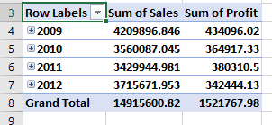
Figure 1.1: A screenshot of a Pivot Table showing the changes in sales and profits for the four years

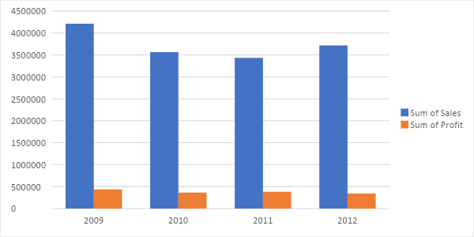
Figure 1.2: A column chart showing the changes in sales and profits for the four years

As shown in Figures 1.1 and 1.2 above, the sales were on a downward trend from 2009 to 2011. They then increased in 2012 but did not reach the initial levels as they were in 2009. Concerning profits, they dropped in 2010 compared to 2009, then they increased in 2010 and declined again in 2012.

Interpretation: Several factors could have led to the decline in sales in the first there years. First, there might have been an increase in prices. Increased prices deter customers from buying the products or reduce the quantity of the purchases. The second factor could have been the entrance of substitutes, competing products, or competitors selling similar products at lower prices. All these could have affected the sales as some customers switched to competitors or to substitutes. Third, the sales may have been declining because of supply problems; when supply is low, the goods to be sold decline. Even if the demand can be high, most customers will lack necessary products in the market resulting in a decline in sales.
Comparing the sales in the last two consecutive years, there is a rise in sales. This aspect can result from several factors such as increased demand, supply, and consumer income. When the demand for a specific product increases in the market, more of the products will be sold. This in turn led to the sales increase between 2011 and 2012. When the supply of products is high, the goods to be sold are available in the market. In return, consumers will be tempted to purchase that product. Therefore the sale between 2011 and 2012 increased due to the increased supply of a given product. The last aspect that could lead to increased sales between 2011 and 2012 is consumer income. When consumers' income increases, they are more likely to purchase more since they have the required resources.
Comparing the profits of the first three consecutive years, it declines from one year to the next. The leading cause of this decline may be the decline in sales. When sales decline, the profit margin of goods sold is low. However, profit in the last two consecutive years increased due to the increment in sales between 2011 and 2012. Therefore it can be concluded that sales are directly proportional to profit realised in a given year.

1.2 Use of excel in data pre-processing and analysis
If raw data is used directly to make decisions, it can be misleading because there is a likelihood of erroneous or incomplete data. Therefore, data preprocessing is a vital step in data mining because it involves removing erroneous data and ensuring that the data is in an understandable format. Data pre-processing includes data cleaning, data reduction, data integration, and data transformation (Mesevage, 2021). MS Excel has various features that help achieve this by removing incomplete, inaccurate, and incorrect data. Missing values can also be identified and replaced. Examples of the functions include IFERROR and COUNTBLANK. IFERROR is used to handle errors such as #REF! #VALUE! and, #NUM! and COUNTBLANK is used to identify the number of blank spaces, thus identifying missing values within a column.
Once the data is pre-processed, it can be analysed, and Excel has a number of functions that are useful in data analysis and reporting the findings. The data can be arranged in rows and columns in a format that suits the user. The user can use formulas such as mean, median, mode, sum and frequency depending on the data analysis's context and objective. When the data is large, complex functions such as LOOKUP, IF, and PIVOT tables are used to get the findings faster and simplified.

LOOKUP
LOOK UP is used to find a specific value that coincides with a value of interest in a second row or column in a single column or row (Support.microsoft, 2022, b). This is helpful when the data is very large to cross-check the values manually. There are two LOOKUP functions- VLOOKUP and HLOOKUP. VLOOKUP (vertical lookup) is used to look for a value in the extreme left column and returns a value from the defined column in the same row (Exceljet, n.d.). On the other hand, HLOOKUP is used to look for a value in a row at the extreme top and return a value from the defined horizontal column in the same row. The general LOOKUP formula is LOOKUP (lookup_value, lookup_vector [result_vector]) (Exceljet, n.d.). Lookup_value is the value that is searched by LOOKUP in the first vector. This value can be a logical value, text, number, value reference, or name. The lookup_vector is the range containing only one column or row. It can be a logical value, number, or text. The resulting vector is optional, but when included, it must be similar to lookup_vector in terms of size. As shown in figure 2.3, using =LOOKUP (17251, B2:B8401;J2:J8401) shows that order ID 17251 matches with 320.98 on the unit price column.

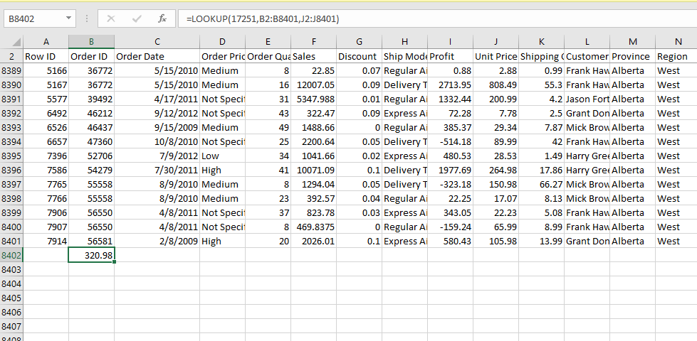
Figure 1.3: an example of LOOKUP use

PIVOT table
A pivot table is an Excel feature used to analyse large, detailed data sets. It makes it simple to extract relevant patterns, trends, and comparisons in a less complicated way (Support.microsoft, 2022, a). It does not require a lot of expertise to create a Pivot table. It starts by clicking any cell in the data sheet and clicking the Pivot Table on the insert tab (Support.microsoft, 2022, a). A dialog box appears with an option of creating the table on a new worksheet or within an existing worksheet. However, the default and the recommended is the new worksheet. There are four panes (Filters, Columns, rows, and values), into which the items of interest are dragged. The results can be in tables or Pivot charts, which give a clear visualisation. Below is an example of a Pivot table derived from the superstore data.
Figure 1.4: Example of a Pivot Table.

IF function
The IF function is used to conduct a logical test of values for either being true or false (Support.microsoft, 2022, c). Generally, the IF function in excel is used for comparison. More than a single condition can be compared by Nesting IF functions. It can be combined with other logical functions of AND and OR to come up with a more logical interpretation. The first result of the IF function is true, whereas the second result is false (Support.microsoft, 2022, c). For instance, if the result in cell C2 has an IF (C2=”Yes,” 1,2), then IF of C2=YES returns to a one or otherwise returns to 2. Using the IF function, one is not limited to checking whether one thing is equal to another or returning to a single result. It can also be used in performing mathematical calculations by adding operators. That means the IF function can be used to perform several comparisons. Following is an example of using IF
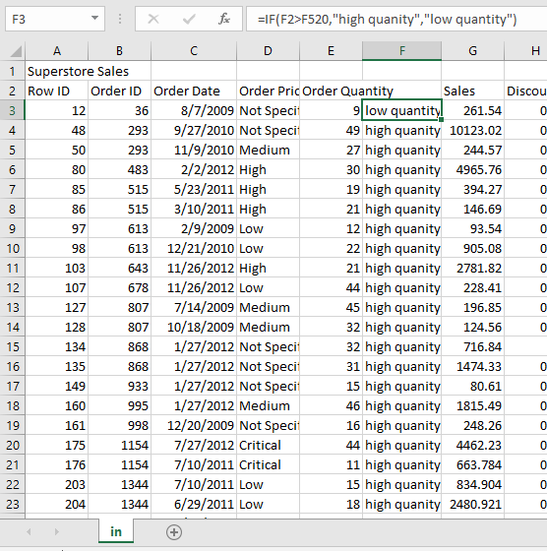
Figure 1.5: A screenshot showing the use of IF function

1.3 Data visualisation in Excel
Data visualisation is communicating using graphical features (Miller, 2021). It includes the use of charts, graphs, and other forms of infographics. Visualisations help amplify the message and create attention to the information. Data that is presented in graphs can last longer in the user’s mind than that presented in a table or narrative format. There are several visualisation features in Excel, including graphs, charts, and tables. Examples include pie charts, bar charts, histograms, line graphs, scatter charts, and column graphs.
Charts and graphs are almost the same; however, some distinctions exist. Charts include tables, diagrams, and graphs, and on the other hand, graphs are charts that show mathematical associations in the data set. In other words, graphs are part of charts. They can stand alone in presenting the information. However, most of the charts are used to support text information. Depending on the intended information or number of variables, different charts can be used for the same data. Apart from relationships between data sets, they are used to show patterns, trends, and quantities.

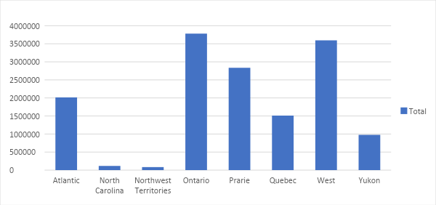
Figure 1.6: a column graph showing total sales per region

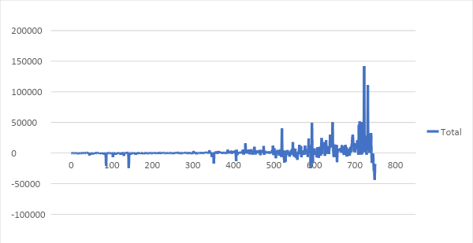
Figure 1.7: Line graph showing the relationship between unit price and profit

Part 2

2.1 Ice Cream data

How many children like vanilla flavour?
Out of the 200 children sampled, 47.5 % (n=95) like vanilla.
Table 2.1: Ice cream flavour preference by the children
Flavour | Frequency | Percent (%)
Vanilla | 95 | 47.5
Chocolate | 47 | 23.5
Strawberry | 58 | 29.5
Total | 200 | 100

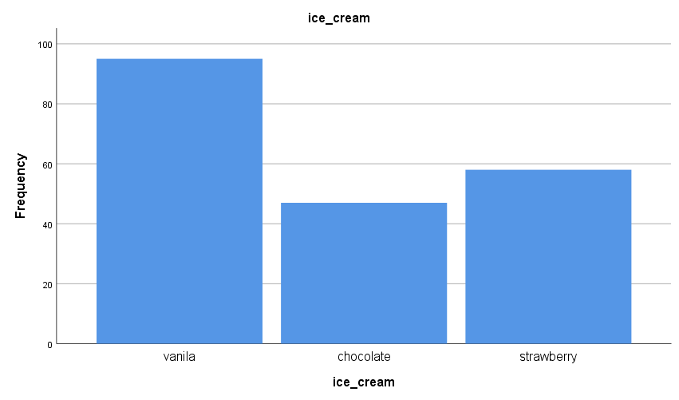
Figure 2.1: number of children who like different ice cream flavours

How many students are Male and Female?
As shown below, 54.5% are females (n=109) and boys are 45.5% (n=91).

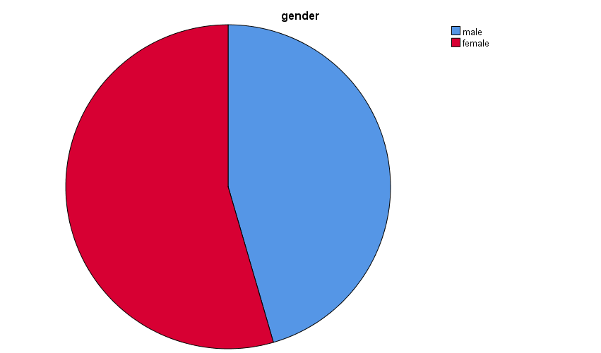
Figure 2.2: gender of the children

Mean and Median of students who prefer chocolate and strawberry flavour

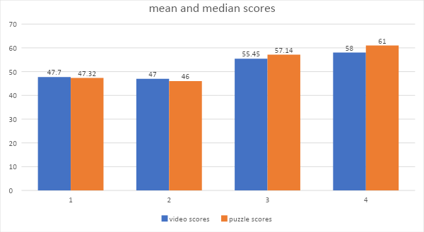
Figure 2.3: Mean and Median of students who prefer chocolate and strawberry flavour

2.2 Data mining and text mining methods
There are several data mining methods, and the choice of one method over the other depends on the user's objective. Data mining involves using intelligence methods to extract and transform data into comprehensible information (Stedman and Hughes, n.d). On the other hand, text mining is the process of getting meaningful and high-quality information from textual data sources. The five most common data mining and t3ext mining methods include clustering, classification, outlier detection, association, and regression.

Clustering: clustering involves putting data sets together based on their share characteristics. There is no one particular algorithm for cluster analysis (Alton, 2017). Instead, it is a multi-objective process involving different algorithms depending on the context and the definition of a cluster in the context of the given data sets. However, most clustering is influenced by the distance between members of a cluster, data density, and expected clusters (Han et al., 2022). In business, clustering can be used to group customers based on their geographic distribution, brand or product type, and incomes. In text mining, clustering is used to organise textual information into relevant groups before the final analysis.

Classification: Classification is categorising items based on their attributes into more conclusive sub-categories (Alton, 2017). It is mainly used when there is a large data pool where discernable information needs to be drawn. Businesses use classification to categorise their customers based on their transactions and financial histories; for example, financial institutions categorise customers as high, medium, and low risk based on their financial and transactional histories. Then, they use the classification information to understand more about the customers.

Outlier detection: It is hard to detect anomalies in data by simply looking at it, especially when dealing with large data sets (Alton, 2017). If the anomalies go undetected, they can cause misleading results, which can have regrettable consequences for an organisation and those involved. For example, suppose a customer’s bank account accumulates abnormally large amounts of money with a very short time. In that case, if it goes undetected and later it is realised that it was money laundering proceeds, the bank may get a bad reputation and the bank manager may face hard questions. Therefore, outlier detection is a critical component of data mining to understand the data pattern and investigate whenever there is a significant deviation.

Association: Association shows how data variables are related and linked (Alton, 2017). It is not necessarily about patterns but how different variables depend on others. For example, a retail store, using association analysis, may realise that the people who buy noodles also buy bottled water. Based on such findings, the store puts the bottled water on the shelves next to the noodles’ shelves.

Regression: Regression is used to understand the probability of another data variable or pattern based on the present data variables (Alton, 2017). It is about understanding the relationship between variables within a data set. For example, companies use regression to understand how prices of certain products would be affected by other factors like competition, substitutes, and consumer demand.

2.3 Advantages and disadvantages of SPSS over Excel
Excel and SPSS are essential programmes in data analysis, which most data analysts have interacted with. However, Excel is the most known by non-technical individuals because it comes alongside Microsoft’s Office package. On the other hand, SPSS may not be as popular because it was acquired separately.

Advantages of SPSS over Excel
Easier and more thorough statistical analysis: Both programmes are useful in data analysis, but SPSS is more powerful and easier to use, especially when dealing with large data. This is because SPSS has built-in functions and was specifically developed for statistical analysis (IBM, 2018). In Excel, one has to insert functions such as COUNTIF to get the frequency of a specified item in a range of cells. However, with SPSS, one only clicks the appropriate tab and selects the data item of interest; one does not have to enter the formula. This makes it easy even for non-expert users to use and takes a shorter time.

Detecting missing values: It is common for some values to miss either during data entry or when collecting the data. Analysing the data using SPSS will automatically indicate the number of missing values, and there is a function that allows one to specify how to deal with the missing values. On the other hand, Excel does indicate the missing values in the results, and one has to use some formula such as COUNT to get the missing values. This makes SPSS more reliable.

Error detection: SPSS rejects specific variables that are not entered in the correct format. This is done in the variables’ window, where erroneous variables are rejected. Excel has no such feature, making it possible to enter values in the wrong formats (IBM, 2018).

Separate results sheet: SPSS automatically creates a separate results sheet; thus, data and results are less likely to overlap. In excel, one has to create or indicate whether they want to create a new sheet or not. Therefore, the data and results can overlap in Excel.

Charts: SPSS has a wide range of detailed charts (IBM, 2018). Unlike in Excel, where one has to add more details manually, SPSS does that automatically once the appropriate variables are selected.

Disadvantages of SPSS over Excel
The first disadvantage of SPSS is that it is bought separately from the basic computer programmes. This is unlike Excel, which comes as part of MS Office. In other words, Excel is almost free compared with SPSS. This has made many people not familiar with SPSS compared with Excel.
The disadvantage is about charts. Although SPSS has a wide range of charts, they are not as “presentable” as Excel charts. In addition, they do not give one an option of changing format or details once transferred into a word document.

Conclusion
Data mining is an essential part of the modern business that aims to make data-led decisions. Through this assessment, it has been shown that Excel is a powerful tool of data mining. It includes functions such as LOOKUP, PIVOT Table, IF, which make data pre-processing and analysis easier. Also, it has several great charts and graphs that amplify the results to make the message clear. In the second part, it has been demonstrated that SPSS is more advanced than excel but it is the easiest to use for those who are familiar with the two data mining programmes.

References
Alton, L., 2017. The 7 Most Important Data Mining Techniques - DataScienceCentral.com.
[online] Data Science Central. Available at: https://www.datasciencecentral.com/the-7-most-important-data-mining-techniques/
Exceljet, n.d. How to use the Excel LOOKUP function | Exceljet. [online] Exceljet.net. Available
at: https://exceljet.net/excel-functions/excel-lookup-function
Han, J., Pei, J. and Tong, H., 2022. Data mining: concepts and techniques. Morgan kaufmann.
IBM, 2018. The risks of using spreadsheets for statistical analysis. [online] Ibm.com. Available
at: https://www.ibm.com/downloads/cas/7YEX9BKK
Mesevage, T., 2021. What Is Data Preprocessing & What Are The Steps Involved?. [online]
Available at: https://monkeylearn.com/blog/data-preprocessing/
Miller, K, 2021. WHAT TO KEEP IN MIND WHEN CREATING DATA
VISUALIZATIONS IN EXCEL [online] Available at:
https://online.hbs.edu/blog/post/data-visualizations-in-excel
Stedman, C. and Hughes, A., n.d. Data mining [Online] Available at:
https://www.techtarget.com/searchbusinessanalytics/definition/data-mining
Support.microsoft, 2022, a. Create a PivotTable to analyze worksheet data. [online]
Support.microsoft.com. Available at: https://support.microsoft.com/en-us/office/create-a-pivottable-to-analyze-worksheet-data-a9a84538-bfe9-40a9-a8e9-f99134456576
Support.microsoft, 2022, b. LOOKUP function. [online] Support.microsoft.com. Available at:
https://support.microsoft.com/en-us/office/lookup-function-446d94af-663b-451d-8251-369d5e3864cb
Support.microsoft, 2022, c. IF function. [online] Support.microsoft.com. Available at:
https://support.microsoft.com/en-us/office/if-function-69aed7c9-4e8a-4755-a9bc-aa8bbff73be2#:~:text=The%20IF%20function%20is%20one,if%20your%20comparison%20is%20False.

