

Program: Master of Business Administration

Module: Financial Management
Module code: LCMB7002
Lecturer: Shengfeng Mei
Patrick Yeboah

Assignment Title: Assessment component: Financial performance and
Management

Organization company: Compass Group

Student Name: Zalak Patel
Student ID Number: 2526278
Word Count: 5236 Words
Submission date: 12-08-2026

Table of content

1. Financial Health Check 4
1.1 Five-Year Financial Statement Analysis 4
1.1.1 Income Statement Analysis 4
1.1.2 Statement of Financial Position Analysis (Balance Sheet) 4
1.2 Financial Ratio Analysis 5
1.2.1 Gearing Ratios 5
1.2.2 Profitability Ratios 6
1.2.3 Efficiency Ratios 8
1.2.4 Liquidity Ratios 9
1.2.5 Investment Ratios 10
1.2.6 Cash Flow Ratios 12
1.3 Industry Benchmark Comparison based on the liquidity ratio 13
1.3.1 Liquidity Ratio Comparison 13
1.3.2 Performance of the company compared to sector 13
2. Working Capital Management Analysis 15
2.1 Cash Operating Cycle Analysis 15
2.1.1 Receivables Collection Period 15
2.1.2 Inventory Holding Period 15
2.1.3 Payables Payment Period 16
2.1.4 Cash Conversion Cycle Assessment 16
2.2 Identification of Working Capital Issues 16
2.3 Strategies to enhance Liquidity Performance 17
2.3.1 Optimize Accounts Receivable 17
2.3.2 Extending its Accounts Payable 17
2.4 Evaluation on Alternative Financial Options 17
2.4.1 Short-Term Financing 17
2.4.2 Long-Term Financing 18
2.4.3 Comparative Evaluation between sources of Finance 18
3. Strategic Financial Restructuring Plan 19
3.1 Financial Restructuring Options 19
3.1.1 Divestiture 19
3.1.2 Merger or Acquisition 19
3.1.3 Equity Injection 19
3.2 Impact of Financial Restructuring 19
3.2.1 Restructuring Effect on Shareholder Value 19
3.2.2 Restructuring Effect on Debt Structure 20
3.2.3 Restructuring Impact on Operational Flexibility 21
3.3 International Considerations 21
3.3.1 Taxation Considerations 21
3.3.2 Currency Risk 21
3.3.3 Inflation Risk 22
3.4 Ethical Considerations 23
3.4.1 Corporate Social Responsibility 23
3.4.2 Environmental Sustainability 23
3.4.3 ESG Reporting 23
4. Investment Appraisal and Capital Budgeting 25
4.1 Overview of Proposed Investment Projects 25
4.2 Investment Appraisal 25
4.2.1 Project A 25
4.2.2 Project B 28
4.2.3 Project C 31
4.3 Recommended Project 33
4.4 Assessing Financial Justification 33
4.5 Non-Financial Risk Assessment 34
4.6 Capital Rationing Analysis 34
5. Critical Reflection on AI Usage 36
5.1 AI Tool Disclosure 36
5.2 Critical Evaluation of AI-Generated Outputs 36
5.3 AI Contribution and Original Analysis 36
5.4 Ethical and Professional Reflection 37
References 38

1. Financial Health Check

1.1 Five-Year Financial Statement Analysis

1.1.1 Income Statement Analysis
The income statement provides details regarding the revenue growth achieved by the organisation from its business operations. Compass Group has improved its product sales by 19.5% due to higher guest volume in 2025 (Compass Group, 2025). Compass Group has improved its customer loyalty score to around 71% in 2025 (Comparably, 2025). In addition, the organisation has also observed growth in its net income by 412.2% from $367m in 2021 (Compass Group, 2021).
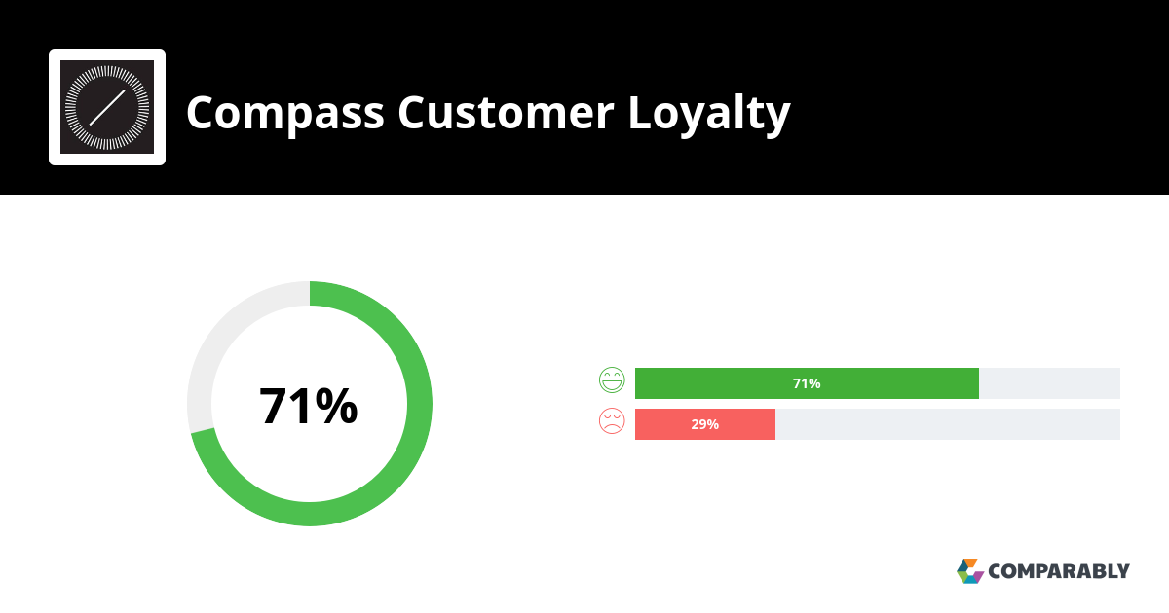 Figure 1: Customer Loyalty Score
(Source: Comparably, 2025)

1.1.2 Statement of Financial Position Analysis (Balance Sheet)
In financial analysis, the balance sheet highlights the financial position of the company by assessing assets and liabilities. Compass Group has grown its total assets to about $13.6B in 2021 to $26.7B during 2025 with a GAGR rate of 96.32% (Yahoo Finance, 2025). Reliable asset growth is driven by “high capital” expenditure and regional demand for catering services in the market. In 2022, the total liabilities is about $14.34B in 2021 with $18.96B during 2025 with GAGR rate 32.22% due to high rises of debt (Yahoo Finance, 2025)

1.2 Financial Ratio Analysis

1.2.1 Gearing Ratios
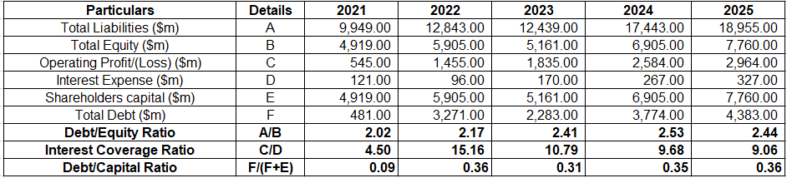

Table 1- Gearing rations
(Source: Compass Group, 2021; Compass Group, 2023; Compass Group, 2025)

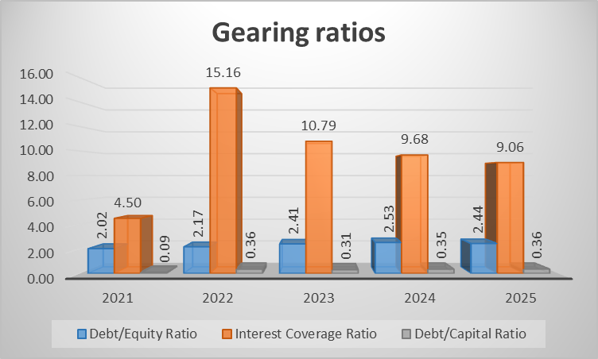
Figure 2: Gearing Ratios
(Source: Compass Group, 2021; Compass Group, 2023; Compass Group, 2025)
Trend Analysis
Compass Group has significantly increased its Debt/Capital value by 75% from 0.09 in 2021 (Compass Group, 2025). The improvement in the internal financial resources has provided opportunities for the company to achieve market growth. For instance, Compass Group has developed “Compass Group Foundation” to social grants worth £50,000 from the UK government in 2025 (Hinchilla, 2025). The organisation has increased its debt/equity levels to 2.44 signifying high involvement of external capital in its business projects. In addition, Compass Group has also reduced its interest coverage value by 40.5% due to a lowering of operating profits from 15.16 in 2022. Thus, the fluctuating gearing performance has lowered the solvency level of the organisation.
Strength
The improvement in the debt/capital value has assisted Compass Group Plc in enhancing its internal financial resources and overcoming market uncertainty.
Threat
The availability of a higher debt/equity value has hampered the ability of the company to improve internal investments and enhanced risk level within its business operations.

1.2.2 Profitability Ratios
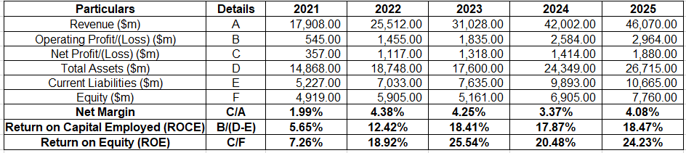
Table 2: profitability ratios
(Source: Compass Group, 2021; Compass Group, 2023; Compass Group, 2025)

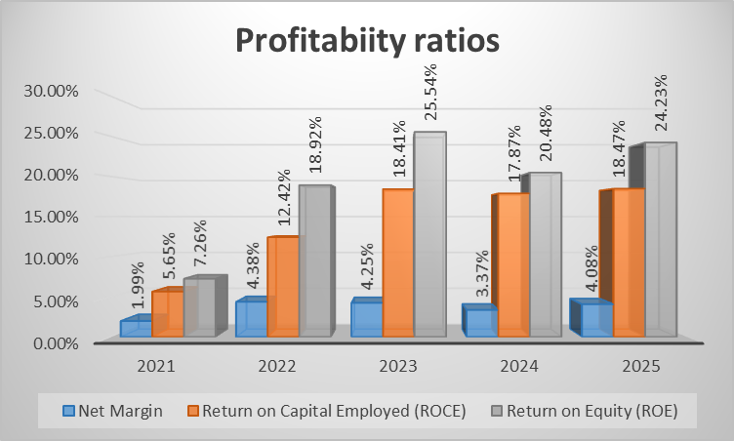
Figure 3: Profitability Ratios
(Source: Compass Group, 2021; Compass Group, 2023; Compass Group, 2025)
Trend Analysis
Compass Group demonstrates its profitability through accessing net profit, ROCE, and ROE fueled organic revenue growth. The Net Profit Margin of the Compass Group is figured through increases to 105.3%. The increase in net profit is due to a high rise in revenue of about $2,964m, with its growth of 9.7%, due to regional demand for catering services (Compass Group, 2025). ROCE of the Compass Group is calculated through increases by about 226.90%. This leads to a rise in the operating margin, which improved 11.7% and tends to increase its organic growth (Compass Group, 2025). The ROE of Compass Group is figured out through increasing to 233.75% to enhance the income, addressing changes in “catering price mechanisms".
Strength
Compass Group enhances its revenue generation through reliable demand for catering services.
Threat
Compass Group reduces its profit through complex pricing mechanisms that reduce consumer demand.

1.2.3 Efficiency Ratios
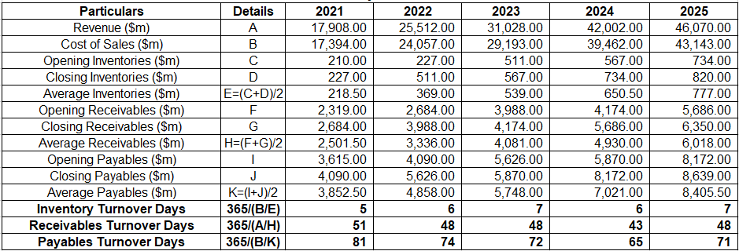

Table 3 – efficiency ration
(Source: Compass Group, 2021; Compass Group, 2023; Compass Group, 2025)

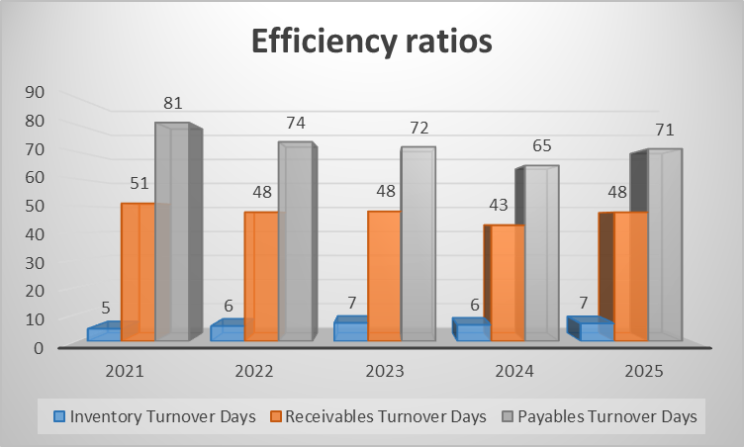
Figure 4: Efficiency ratios
(Source: Compass Group, 2021; Compass Group, 2023; Compass Group, 2025)
Trend analysis
The efficiency ratio is generally illustrated about the key potentiality of organization in utilise assets for managing liabilities and overhead expenses associated in a business (Kenton, 2026). Inventory turnover days is generally increased 20% in 2022 from 5 days while its declining -14.3% in 2024. After that in 2025 16.7% higher inventory period also be recognised that illustrated excessive caring cost of stock management. “Receivables turnover days” is calculated through decline in -5.9% in 2022 and 11.6% in 2025 within 48 days (Compass Group, 2023).
“Payables turnover days” also rose 9.2% with approximately 71 days in 2025 calculated as indicating strengthening supplier relationships.
Strength
The improved position of receivable collection accelerated cash inflows that enhance liquidity with better customer credit management.
Threats
Rising inventory days increased holding costs, reducing inventory efficiency and constraining working capital utilization over time.

1.2.4 Liquidity Ratios
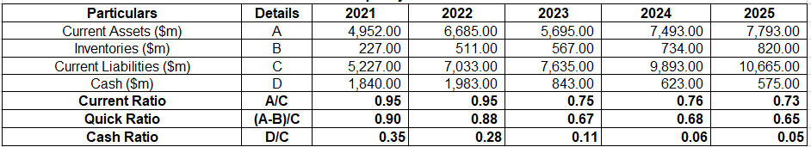

Table 4: Liquidity ratios
(Source: Compass Group, 2021; Compass Group, 2023; Compass Group, 2025)

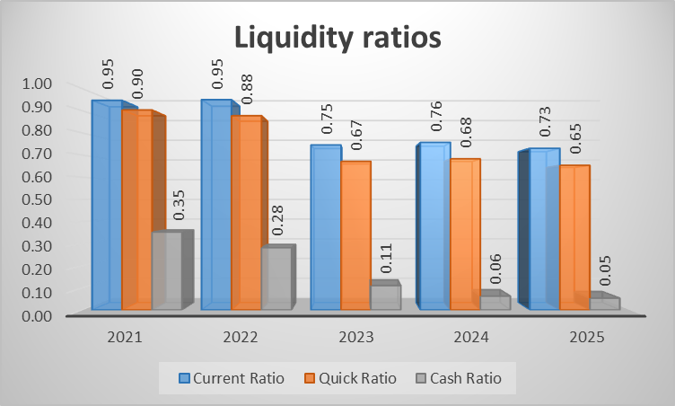
Figure 5: Liquidity ratios
(Source: Compass Group, 2021; Compass Group, 2023; Compass Group, 2025)
Trend Analysis
Compass Group holds strong liquidity metrics, including current, cash, and quick ratios that address the operational stability of the business. Current ratio is calculated through which decreases by 23.16%. In 2025, decreases in Cash equivalence were about 87%, which led to sustainable investment and technology adoption(Compass Group, 2025). The Quick ratio at Compass Group is calculated through decreases 27.78%. Compass Group's decrease in the quick ratio is due to rising debt, which depletes cash reserves. Cash ratio at Compass Group is calculated through and decreases by 85.17%. This decrease in cash is due to high-quality M&A, which drives the growth of catering services.
Strength
Compass Group highlights its financial stability through reliable investment in sustainability and tech
Threat
Compass Group decreases its current ratio through insufficient cash flow, which becomes a major threat in achieving shareholder value.

1.2.5 Investment Ratios
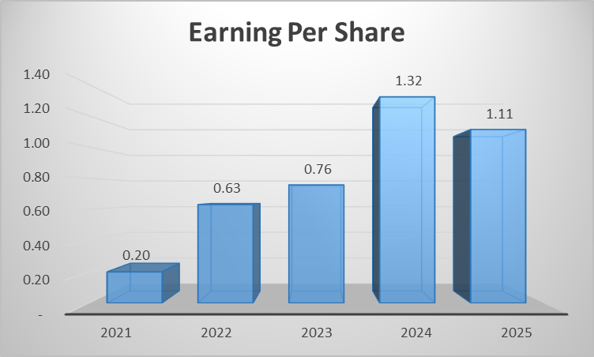
Figure 6: Earnings Per Share
(Source: Compass Group, 2021; Compass Group, 2023; Compass Group, 2025)
Trend Analysis
The investment ratio analyses the market growth achieved by the organisation through the growth of its shares. Compass Group has achieved consistent enhancement in its EPS by 520% from 0.20 in 2021. On the other hand, the value has declined to 1.11 due to investor withdrawals in 2025 (Compass Group, 2025). Compass Group has observed a lowering of its shares to 2050p due to a reduction in its investment by 10% in 2025 (Yahoo Finance, 2026). The availability of inferior market performance has hampered the investor sentiments of the organisation.
Strength
The decline in the EPS value has provided opportunities for Compass Group to acquire new investors in its business operations.
Threat
The reduction in the share growth has also hampered the market value of the company.

1.2.6 Cash Flow Ratios
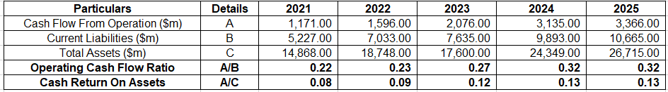
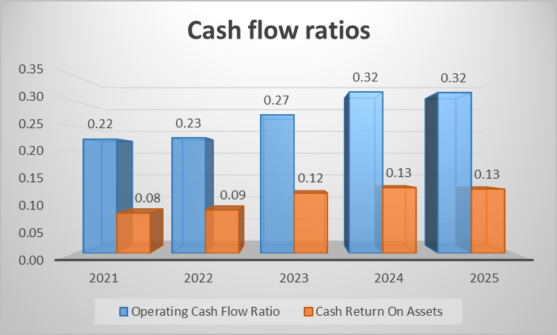
Figure 7: Cash flow ratios
(Source: Compass Group, 2021; Compass Group, 2023; Compass Group, 2025)
Trend Analysis
The cash flow ratios also illustrate the key potentiality of an organization in managing liabilities by utilizing cash in an effective manner (Seretidou, Billios and Stavropoulos, 2025). The operational cash flow ratios calculated by also have a mixed trend that abruptly rises in 2022 by 4.5% while it stabilizes in 2024 and 2025 with the ratio value 0.32. As this is due to the increasing current liabilities position $10,665 million in 2025 (Yahoo Finance, 2025). However, operational cash improvement ensures better management of the short term position of organization
Cash ROA is also rectified by indicating an increasing trend with peak value in 2023. However, in 2025 Cash ROA was also made stable with approximately ratio value 0.13 indicating both cash value and asset increased effectively.
Strength
The cash generation capacity improved liquidity, supported asset efficiency, and strengthened financial stability for long-term business growth.
Threats
Rising liabilities and stable cash flow ratios also increase future liquidity pressure that enable financial risk of Compass Group Plc.

1.3 Industry Benchmark Comparison based on the liquidity ratio

1.3.1 Liquidity Ratio Comparison
Ratio | Compass Group (2025) | Industry Benchmark | Performance Assessment
Current Ratio | 0.73 | 1.00–1.20 | Below industry benchmark
Quick Ratio | 0.65 | 0.80–1.00 | Below the industry benchmark
Cash Ratio | 0.05 | 0.20–0.30 | Significantly below the industry benchmark
Table 5: Comparison with industry benchmark
(Source: Self-developed)
The above table is also indicated current ratios position also be below ranking of average benchmark associated with hospitality organization levels as 1.0 to 1.20. Hence, this ratio also be indicated below industry benchmarks need more assessment to improve assets and liabilities position. Further, quick ratios of 0.65 are also below 0.80 to 1.0 benchmark, indicating a lower level of managed liquidity assets. However, Cash ratio position 0.05 as compared to 0.20 to 0.30 indicated holding potential of minimal cash balance in Compass group.

1.3.2 Performance of the company compared to sector
The liquidity ratio of the Compass Group has declined in comparison to the industry standard of 2.0 that has been adopted by the hospitality company. In addition, the company has also reduced its cash value to $575m due to limited business volume in 2025 (Compass Group, 2025). The hospitality sector has diversified its financial resources to expand its operations. As an instance, the industry has adopted the “business rates relief scheme” that has reduced its tax expenses by 40% in 2025 (Panjwani et al., 2025). Thus, Compass Group needs to lower its expenses and achieve market growth effectively.

2. Working Capital Management Analysis

2.1 Cash Operating Cycle Analysis

2.1.1 Receivables Collection Period
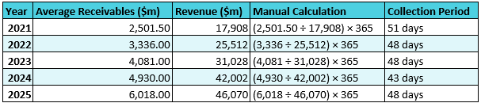
Table 6: Receivable Collection Period
(Source: Compass Group, 2021; Compass Group, 2023; Compass Group, 2025)
Compass Group has reduced its “receivables collection period” by 5.8%, signifying strong debtor relations from 51 days in 2021. The company has reduced its bad debt value to $8m due to improvements in its payment recovery system in 2025 (Compass Group Plc , 2026). Thus, the existence of flexible debtor relationships has increased the operational flexibility of the organisation.

2.1.2 Inventory Holding Period
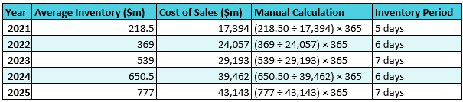
Table 7: Inventory Holding Period
(Source: Compass Group, 2021; Compass Group, 2023; Compass Group, 2025)
Compass Group leads to a rise in its inventory period, which increases by about 40% due to reliable acquisition and enhanced improvement in inventory maintenance of the business. The company's enhanced improvement in venture capital through targeted investment of about $1m to $5 million for “Compass Digital Ventures” leads to enhanced business growth (Waveup, 2025).

2.1.3 Payables Payment Period
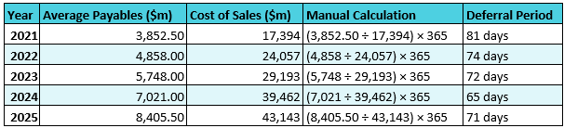
Table 8: Payable Holding Period
(Source: Compass Group, 2021; Compass Group, 2023; Compass Group, 2025)
The “payable payment period” for Compass Group has improved by 4.22% from 74 days in 2022. The company has developed the “Compass Group Supplier Portal” for providing regular payment updates to the creditors in 2025 (Carman, 2026). Thus, the improvement in the motivation level of the suppliers has helped Compass Group in increasing its operational efficiency.

2.1.4 Cash Conversion Cycle Assessment
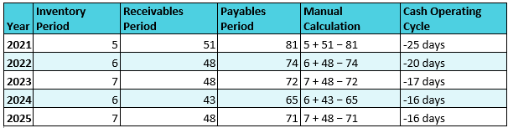
Table 10: Cash Conversion Cycle
(Source: Compass Group, 2021; Compass Group, 2023; Compass Group, 2025)
“Cash Conversion Cycle” increases by about 36% due to conversion of sales to cash which creates pressure in managing corporate liquidity. The company reinvests its cash acquired by Vermaat Group in the Netherlands by investing $1.7bn in 2025 (Compass Group, 2025). This investment has been utilised through reliable "cash flow generation” which drives reliable expansion of business.

2.2 Identification of Working Capital Issues
In the current situation, the existence of higher operational cost lowers the ability of the organisation to increase its product demand level among customers. For instance, Compass Group Plc has enhanced its current liability by 9% to $391m due to higher food expenditure in 2025 (Mahlangu, 2026). The improvement in the commodity cost has also lowered the service acceptance level of the company. Hence, the availability of higher liability for Compass Group Plc has also reduced its operational stability.

2.3 Strategies to enhance Liquidity Performance

2.3.1 Optimize Accounts Receivable
Compass Group enhances its operational performance, through an 'A' credit rating and an unsecured debt for robust expansion of business. The impact of “A” credit rating is through EBITDA and organic growth (Spglobal, 2026). The company enhanced its revenue growth by about 11% in 2024 due to the favorable market conditions of Compass Group's expansion and demand for reliable dining services. This leads to high rates of client retention, about 96%, underpinning the growth of “high-quality frozen meals” disposal in the Brazilian market (Spglobal, 2026).

2.3.2 Extending its Accounts Payable
Compass Group enhances its working capital through “Supply Chain Financing,” more reliable for supporting suppliers. This leads to the strengthening of the value creation of the business by serving “Compass food support“ services in following sustainable principles. Although the company in 2023 has been funded with $1 billion to support local suppliers, it leads to enhanced reliable resilience in supply chains through community investment. This leads to a strategic outflow of cash by reliable negotiation with vendors.

2.4 Evaluation on Alternative Financial Options

2.4.1 Short-Term Financing
- Trade credit is the most effective financing option for an organisation in managing its short term financial position (Kagan, 2026). Thus, inclusion of a negative cash operational cycle associated with -16 days in 2025 and higher payable days indicated the need for dependency on the supplier credit system. Hence, this borrowing through trade credit ensures reduced dependency on credit with stable liquidity position of Compass group Plc.
- Commercial paper is another most flexible method for managing cash potentiality in organisations (Hayes, 2025). As it is directly supported through enabling generated operating cash flow of $3,366 million in 2025 and its continuous improvement from 2021. Overall strong cash generation capacity raises low cost short term borrowing and reduces reliance on borrowing through banks.

2.4.2 Long-Term Financing
- Corporate bond is effective financial recognition that raises funds through fixed income debt securities (Chen, 2025). As it is a suitable choice for Compass group plc in a managed position with stable revenue growth about $46,070 million in 2025. Overall, it ensures flexible debt service capacity with long term expansion opportunities for business.
- Equity financing another m method that raises capitalise through enabling partial ownership of organization shares (Banton, 2026). Strong current asset measurement about $7,793 million indicated major shareholders interest for a long term capital improvement opportunity. Hence, new share allocation strengthens the capital base while reducing external debenture value of organizations.

2.4.3 Comparative Evaluation between sources of Finance
The key comparative evaluation also identified commercial paper as the most suitable short-term option as it directly supported through $3,366 million operating cash flow initiating a 16-day cash operating cycle in 2025. Further, Equity financing is also suitable for long term financing options with support through revenue potentiality that attract investors in investment of Compass Group Plc.

3. Strategic Financial Restructuring Plan

3.1 Financial Restructuring Options

3.1.1 Divestiture
Compass Group has adopted the “divestiture” option for evaluating the performance of its business units. The company has divested its subsidiaries such as “Compass Coffee” to Cafe Nero worth $4.75m in 2025 (Brown, 2026). Hence, the adoption of the selling activities has assisted Compass Group in strengthening its funding operations.

3.1.2 Merger or Acquisition
Compass Group has acquired the services of companies such as “Zero Procure” for strengthening the business operations of its suppliers Foodbuy in 2024 (Dealroom, 2024). The acquisition has also assisted the organisation in meeting the raw material requirements of its business operations. Overall, the improvement in the inventory operations has helped Compass Group in enhancing its productivity.

3.1.3 Equity Injection
Compass Group Plc has included the "equity injection” strategy for monitoring the growth of its internal business resources. As an example, the company has achieved an EPS growth of 11% due to the acquisition of Vermaat Group in 2025 (Yahoo Finance, 2025). Hence, the improvement in the share value has provided opportunities for Compass Group in achieving financial stability.

3.2 Impact of Financial Restructuring

3.2.1 Restructuring Effect on Shareholder Value
The inclusion of equity fencing also be helpful to raise key potentiality of shareholders towards raising capital through issuing new shares. The rise of dividend per share 245% enhanced from 19.1 cents in 2021 indicating return generation capability that made more interest among shareholders. Also, a total of $2.3 billion share buyback opportunity creates investors confidence with supported long term value creation (Compass Group, 2025).
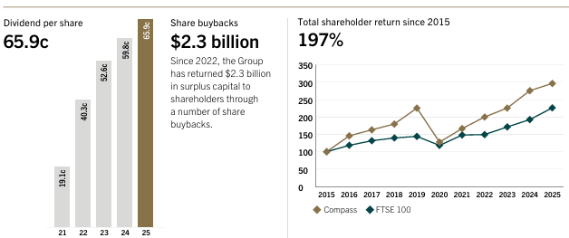
Figure 8: Share Buyback
(Source: Compass Group, 2025)

3.2.2 Restructuring Effect on Debt Structure
The organization's restructuring process is also helpful to raise a more sustainable debt structure for supporting financial growth. Hence, total debt value rose by from $5.44 billion to $6.99 billion indicated reliance external funding. However, a strong equity base of about $7.76 billion also enables it to strengthen its capital raising potential for diversified funding credit resilience (Yahoo Finance, 2026).
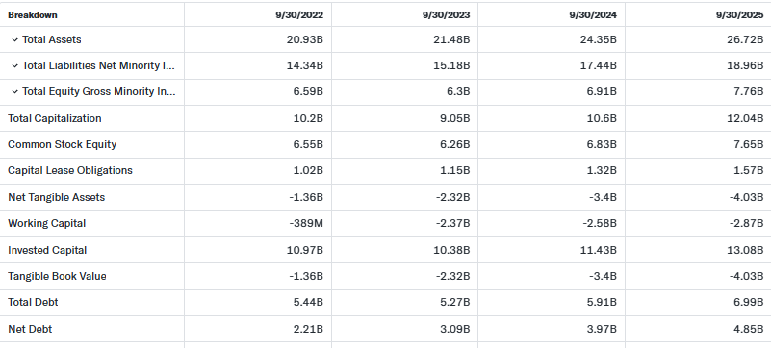
Table 11: Debt value
(Source: Yahoo Finance, 2026)

3.2.3 Restructuring Impact on Operational Flexibility
The operational flexibility also be properly increased due to restructuring strength resource optimisation for long term growth. As asset value increased by about 27.7% and 19.2% invested capital rose from $10.97 billion to $13.08 billion to strengthen operational capability in business (Yahoo Finance, 2026). Overall, restructuring is helpful to diversified capital lease obligations $1.57 billion, enabling better optimisation in business.

3.3 International Considerations

3.3.1 Taxation Considerations
Financial restructuring has an impact on the tax profile of a company by triggering with accumulated losses and debt maintenance. Compass Group has an equivalent tax rate of about 27.2% due to a reliable reduction of expenses (Compass Group, 2025). The collaboration with Vermaat Group has strengthened the catering services of Compass Group Plc.

3.3.2 Currency Risk
Financial restructuring is able to manage currency risk through reliable cash outflow and inflow, which protects the overall profit of the business. Compass Group highlights its progress in different regions with its international growth of about 15% of operating profit (Goulart, 2026). The organisation predicts its growth due to reliable demand for workplace dining and operational excellence through use of AI (Compass Group PLC, 2025)
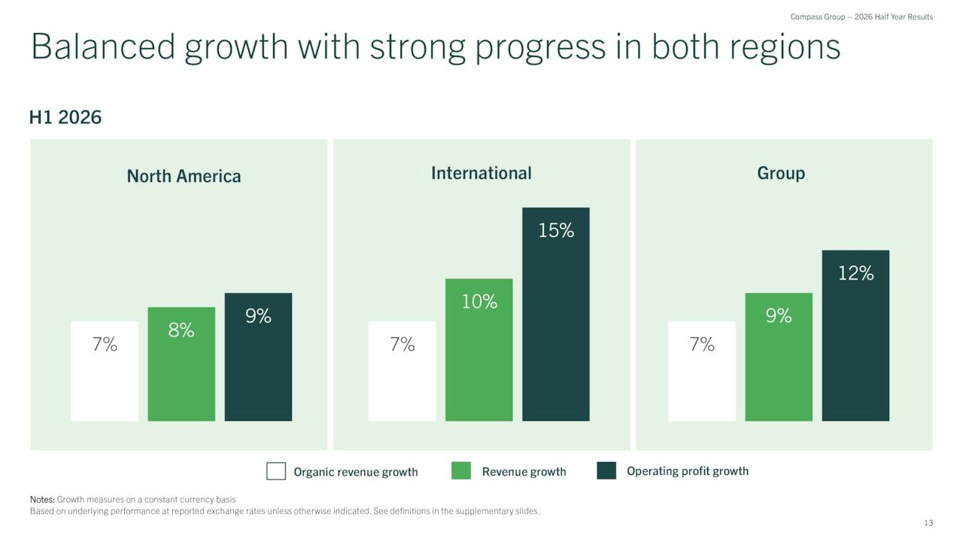
Figure 9: Balanced growth in different regions
(Source: Goulart, 2026)

3.3.3 Inflation Risk
The Financial restructuring is affected due to inflation, leading to high risks of debt, which is shrinking the profit of the business. Total debt of Compass Group is about $5.611 B, which increases by 25.96% (Compass Group, 2025b). Although the company enhances its debt that aligns with contract pricing influenced by inflation risk.
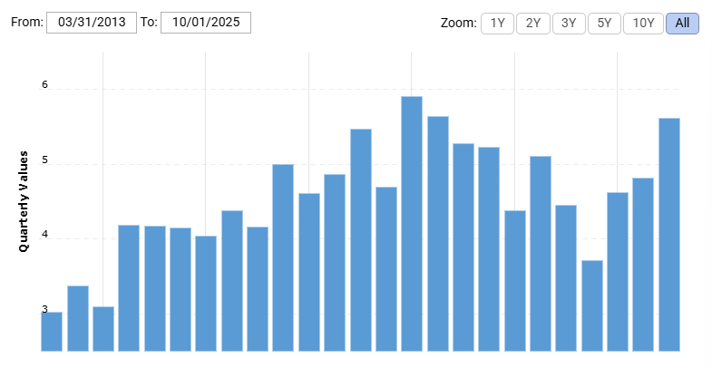

Figure 10: Long-term debt of Compass Group
(Source: Compass Group, 2025)

3.4 Ethical Considerations

3.4.1 Corporate Social Responsibility
CSR of the Compass Group has a direct impact through financial restructuring by balancing the stakeholder obligations of the business. The company in 2025 have donated $3.1million for “Compass Group Foundation” by providing job opportunities to the suppliers (Compass Group, 2025). This leads to enhanced improvement in the supply chain by the ability to expand its "food waste tracking” in 1000 sites.

3.4.2 Environmental Sustainability
In the competitive era, financial restructuring enhances overall spending of the business through philanthropic programmes. The company's ability to invest $2 billion for the adoption of "sustainable bonds” which are aligned with sustainable improvement in business operations (Compass Group, 2025). Thus, operational restructuring responds with reliable changes in the organization to achieve sustainable targets.

3.4.3 ESG Reporting
The financial improvement reshapes ESG protocols, which affect the operational footprint of the business. Compass Group enhances shifts through the adoption of green bonds, rises of capital expenditure and sustainability in the supply chain. Apart from that, the company has invested funds of about $1m for the reliable reduction of waste which leads to enhanced overall ROI of the business (LinkedIn, 2025). This ongoing investment enhances operational efficiency.

4. Investment Appraisal and Capital Budgeting

4.1 Overview of Proposed Investment Projects
The investment appraisal methods have provided opportunities to the organisations in strengthening its financial decision-making activities. As stated by (Andon, Baxter and Wai Fong Chua, (2023), the technique evaluates the income of the companies from carrying out funding initiatives in business projects. In the current scenario, Compass Group Plc will utilize tools such as “Net Present Value”, “Payback Period”, “Internal Rate of Return”, “Average Rate of Return” and "Profitability Index” to analyse the potential income of three projects that have an investment worth £50m. In addition, the organization will also evaluate the cash flow value of the business plan for ensuring regular fund supply in its operational activities. Hence, the adoption of the appraisal techniques have assisted Compass Group Plc in improving the security level of its business investments effectively.

4.2 Investment Appraisal

4.2.1 Project A
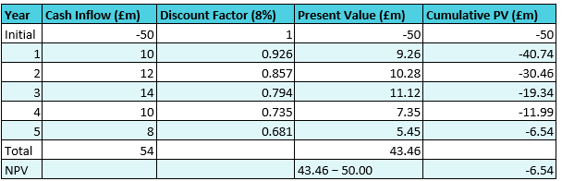
Table 12: NPV
(Source: Self-Developed)
NPV encounters reliable differences between present cash inflow and outflow through reliable investment planning. As the discount factor is 8% the total cash inflow of Project A is £54m, and the present value is £43.46m. NPV value of Project A is -£6.54m, which is high have its ability to cover reliable initial investment of the business.
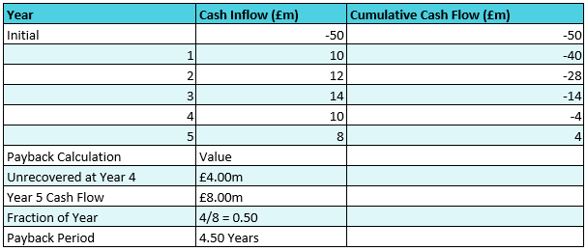
Table 13: PBP
(Source: Self-Developed)
PBP signifies profitability by ignoring “long-term cash” through market fluctuation. The payback period is 4.50 years which leads to rising “high financial risk” addresses through initial cash flow of the business. Uncovered payback period is £4.00m in Project A due to high capital expenditure and Year 5 cash flow is about £8.00m through investment in business.
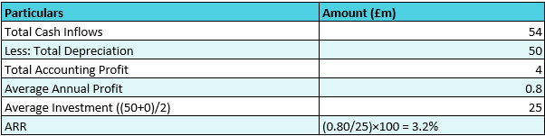
Table 14: ARR
(Source: Self-Developed)
ARR is the capital budgeting technique that measures the overall profit gathered through investment. Total capital inflow of Project A is about £54m with its accounting profit 4%. The ARR rate is about 3.2% which achieves good return by relying on overall profit of the Project. Reasons for IRR increase through positive capital inflow and manage overall asset maintenance of business.
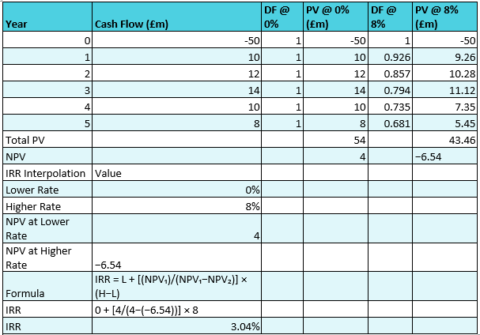
Table 15: IRR
(Source: Self-Developed)
IRR is the investment appraisal technique that projects initial cash flow of a business by ability to measure profitability. The total PV with discount rate 0% is £54m and in 8% it is £43.46m with high rise of investment risk affecting the Project. IRR rate is about 3.04% measured through high cost and long-term cash flow of the business.
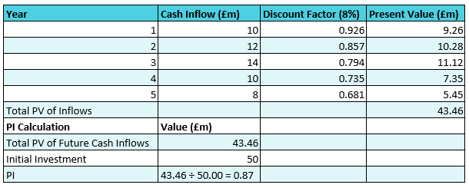
Table 16: PI
(Source: Self-Developed)
Profitability index is an investing technique that analyzes the future cash flow through initial investment. PI value of project A is about 0.87 due to inefficient cash maintenance at a high discount rate. Thus, this PI leads to enhanced overall revenue of the Compass group.

4.2.2 Project B
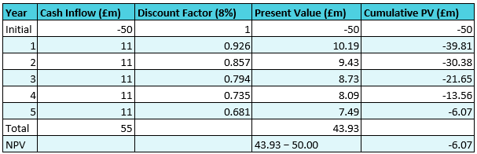
Table 17: NPV
(Source: Self-Developed)
The “Net Present Value” of Project B has declined to £-6.07 due to the consistent decline in the present value of £7.49m in year 5. According to Larsen (2024), the existence of a negative NPV decreases the income of the investors and hampers the popularity of the business plan. Thus, the decline in the investments has reduced the growth of the project.
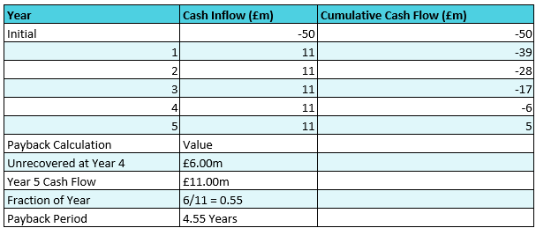
Table 18: Payback Period
(Source: Self-Developed)
The project B has a higher “Payback Period (PBP)” of 4.55 years due to the existence of unrecovered investments of £6m in year 4. In addition, the business plan also has a low cumulative cash flow value of £5m that has also the recovery of funds invested by the organisations.
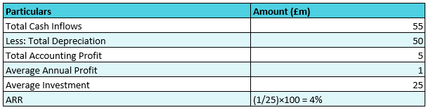
Table 19: ARR
(Source: Self-Developed)
The execution of investments within project B will provide an ARR of 4% that will adversely influence the income growth of Compass Group Plc. In addition, the accounting profit of the business plan has also been reduced to £5m that will take time in recovering the investment value of £25m for the organisation. Hence, the lowering of the scope for revenue growth will reduce the viability of the project.
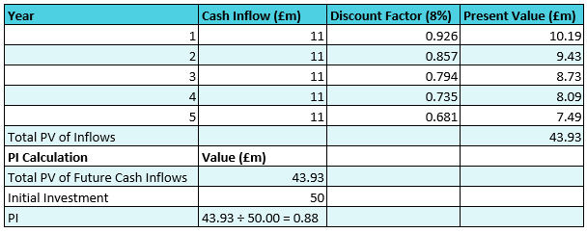
Table 20: PI
(Source: Self-Developed)
The PI value of project B is 0.88 that has been lower to the industrial standard of 1 adopted by the company. In addition, the decline in metrics mentioned above has also lowered the income growth associated with the completion of the investment activities associated with the business plan.
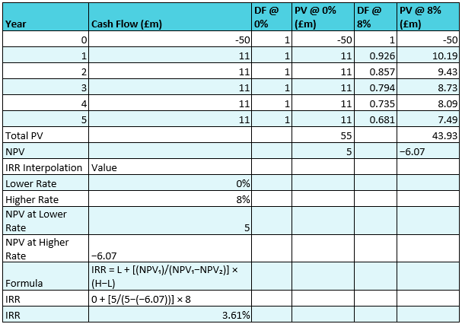
Table 21: IRR
(Source: Self-Developed)
The project has a lower IRR value of 3.61% due to the presence of a higher interpolation rate of 8% that has reduced its income value. In addition, the metrics is also inferior to the standardised value of 11% in the sector. Thus, the decline in investment value has reduced the popularity of the project among investors.

4.2.3 Project C
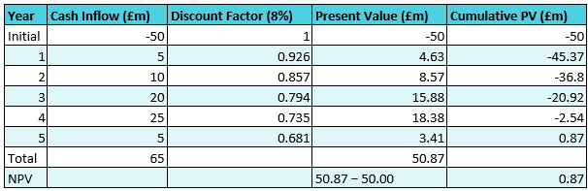
Table 22: NPV
(Source: Self-Developed)
The project C is generally considered NPV value of positively £0.87 million illustrated standard level with lower risk adherence to the project. The initial invested value deduction of about £50 million form an overall cash flow of £50.87 million. Overall, positive NPV value makes it advantageous for shareholders to generate more return value within a fixed 8% dissolution rate of project C.
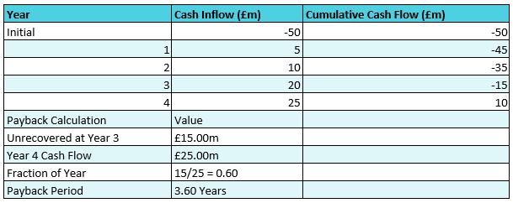
Table 23: PBP
(Source: Self-Developed)
The PBP value is also moderate in case of project C associated with 3.60 years for recovering initial investment value. Hence, maximum invested value also be recovered at the end of the third consecutive year with £35 million. However, considered £15 million also take additional two quarters for full recovery of the initial invested value.
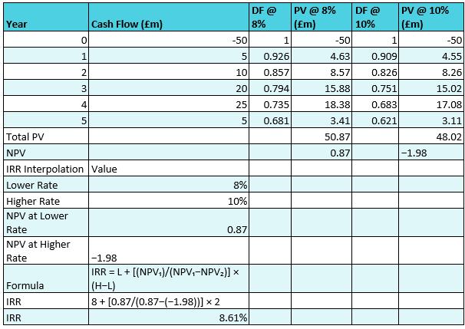
Table 24: IRR
(Source: Self-Developed)
The ARR value associated with project C is 12% indicated most suitable return through a time period of five years. Hence, in this case total accounting profit of about £15 million generates each year annual profit of £3 million.
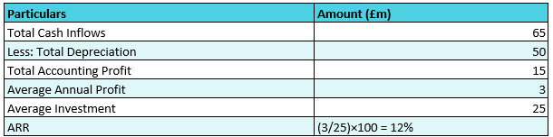
Table 25: ARR
(Source: Self-Developed)
The IRR value of 8.61% is also determined due to adjudication of discounting rate between 8% and 10%. Hence, 8% also raised £0.87 million while 10% also indicated negative return associated with -£1.98 million. Overall, 8% discounting rate most suitable for generating positive return from project C.
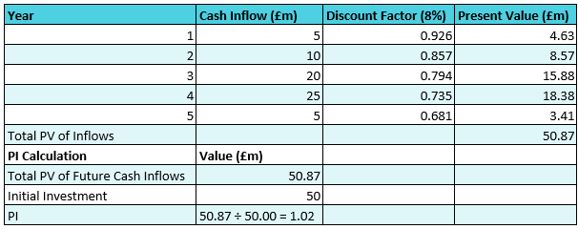
Table 26: PI
(Source: Self-Developed)
The PI value of 1.02 indicated above industry benchmark also generated a total inflow of £50.87 million. Thus, exceeding value 0.02 indicated every £1 also generates £1.02 in present value effectively.

4.3 Recommended Project
As per the above evaluation, Project C will be recommended to Compass Group for carrying out investments due to high NPV and IRR value. The PI score of the business plan is also higher as compared to the industrial standards adopted by organizations.

4.4 Assessing Financial Justification
Profitability Justification
The investments in project C will assist Compass Group in improving its profits through higher IRR of 8.6% and lower PBP value of 3.86 years. In addition, the company will also be able to reduce its debt value by carrying out funding activities in the business plan. Compass Group has lowered the value of its external loans to $0.211bn in 2025 (Macrotrends, 2025). Thus, the execution of investments in project C will strengthen the capital structure of the company.
Liquidity Justification
Project C has achieved a steady cash inflow value from £5m in “year 1” to £25m in “year 5”. This will also help Compass Group Plc in improving its financial resources and meet business expenditure. The company has increased its market value to $360.1bn due to revenue growth in 2025 (Compass Group PLC, 2025). Thus, the adoption of the business plan will assist Compass Group in improving its brand loyalty.

4.5 Non-Financial Risk Assessment
Political risk
Project C is the reliable choice for Compass Group with geopolitical risk in the emerging market, which affects the reputation of the business. The impact of geopolitical risk leads to rises of debt and limits in corporate credit. The debt of Compass Group is about- $ 0.265B, which increases 16.2.82% due to high rises of loan and rises of supply chain disruption in business (Compass Group, 2025). This leads to high rates of borrowing due to ineffective capital control.
Customer loyalty
Project C highlights its positive NPV and predictable cash flows, enhancing its share value of business. The project helps Compass Group by developing long-term relations with clients through initial facility upgradation and innovation in business. Compass Group monitors client retention through “96% contract renewal” which leads to enhancing overall sales of the business (Yahoo Finance, 2026). This shift in client due to predicting overall profit of business.

4.6 Capital Rationing Analysis
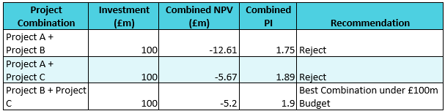
Table 27: Capital Rationing Strategy
(Source: Self-Developed)
The capital rationing method focuses on evaluating and selecting suitable business plans with an intent to strengthen the monetary position of the organisation (Cowling and Wilson, 2024). In the current scenario, the combination of project b and c will be ideal for meeting the £100m investment budget of Compass Group Plc. In addition, the combined efforts of the business plan will also increase the profitability index score to 1.9 that will provide stability to the company. Overall, the adoption of the projects will also assist Compass Group Plc in improving its capital structure.

5. Critical Reflection on AI Usage

5.1 AI Tool Disclosure
During the completion of the task, the use of AI tools is more reliable for financial calculations by refining the brainstorming concept of data. Using Google Gemini, Claude serves reliable information and delivers reliable results by accessing real-time results (Wójcik et al., 2025). Adoption of these tools serves real-time information which enhances accuracy, leading to reduced human calculation. Although complex calculations have been accessed through the use of AI, which serve static information by reduction of hallucinations. Completing tasks enhances transparency by prohibiting academic integrity through the research and “AI policy” during formatting. The research uses “excel “ calculation and " human-centric "review, which is more reliable for the execution of the research. Apart from that, the authenticity of the articles is ensured through the collection of data from annual reports, newspapers, and company reports access authenticity of the research. Thus, uses of these tools serve structured information to carry out results that are linked with transparency.

5.2 Critical Evaluation of AI-Generated Outputs
The availability of diversified AI tools have increased my ability to improve the accuracy of the company evaluation report. In the current investigation programme, I have adopted the artificial intelligence technologies for strengthening the clarity of the formulas of the ratios included for depicting the financial performance of Compass Group Plc. According to (Riley et al. (2025), the verification of the contents through AI techniques has increased the value of the research work. The existence of accurate ratio calculations and formulae has helped me in understanding the business position of the company. On the other hand, I also observed fluctuation in the value of data in the MS excel file and compared to the AI verification report that caused variations in my analysis. Thus, the inclusion of the technologies has helped improve the quality of my investigation process.

5.3 AI Contribution and Original Analysis
In order to carry out “Human-generated structure” and “AI-generated structures,” there are differences based on raw information. In “AI-generated content”, the summarisation of the data generated through the use of an “AI-driven model” serves “real-time information” by eliminating complexity (Li, Chen and Demartini, 2026). In “Human-generated structure”, the information incorporated is from peer-reviewed journals and reports to draw out unique conclusions. I think that the differences analyzes in human and AI-driven contexts vary based on the generation of text, which affects the reliability of the research. The use of AI tools serves to provide proper guidance regarding financial decisions by following accountability and transparency (Aldemir and Uçma Uysal, 2025). Although the financial professionals serve reliable information from the large dataset which is processed through human capability. Thus, “human-generated structure” is more reliable to accomplish research through reliable decisions of the professionals.

5.4 Ethical and Professional Reflection
The inclusion of artificial intelligence techniques has a significant impact on the quality and efficiency of the financial reports. According to Hua et al. (2025), the technique reduces the volume of the human contents and hampers the quality of the research work. In the current investigation process, I have limited the use of AI tools to improving the structural lay out and formulae verification activities. The initiative has also helped me in improving the ethical standard of my research work. On the other hand, I have also included the guidelines of the Copyright Act 1988 in maintaining the authenticity of the journal articles included in the evaluation programme (Government of UK, 1988). The inclusion of the statutory laws has also improved the ethical standards of my investigation process. Overall, the regulated use of artificial intelligence techniques has strengthened the viability of my research for future analysis processes.

References
Aldemir, C. and Uçma Uysal, T. (2025). Artificial Intelligence for Financial Accountability and Governance in the Public Sector: Strategic Opportunities and Challenges. Administrative Sciences, [online] 15(2), pp.58–58. doi:10.3390/admsci15020058.
Andon, P., Baxter, J. and Wai Fong Chua (2023). Affect and reason in uncertain accounting settings: The case of capital investment appraisal. doi:10.1111/acfi.13185.
Banton, C. (2026). How Equity Financing Works. [online] Investopedia. Available at: https://www.investopedia.com/terms/e/equityfinancing.asp
Brown, N. (2026). Caffè Nero’s $4.7 Million Bid Leads Compass Coffee Chapter 11 Auction. [online] Daily Coffee News by Roast Magazine. Available at: https://dailycoffeenews.com/2026/02/20/caffe-neros-4-7-million-bid-leads-compass-coffee-chapter-11-auction/.
Carman, T. (2026). U.K.-based Caffè Nero buys Compass Coffee assets in auction. [online] The Washington Post. Available at: https://www.washingtonpost.com/food/2026/02/19/compass-coffee-caffe-nero-bankruptcy/.
Chen, J. (2025). Corporate Bond Definition. [online] Investopedia. Available at: https://www.investopedia.com/terms/c/corporatebond.asp
Comparably (2025). [online] Available at: https://www.comparably.com/brands/compass.
Compass Group (2021). FUTURE A SUSTAINABLE. [online] Available at: https://www.compass-group.com/content/dam/compass-group/corporate/ar-updates-2021/annual-report-pdf/CompassGroupPLC_AnnualReport2021.pdf.
Compass Group (2023). [online] Available at: https://www.compass-group.com/content/dam/compass-group/corporate/oar-2023/annual-report-2023.pdf.
Compass Group (2025). [online] Available at: https://www.compass-group.com/content/dam/compass-group/corporate/oar-2025/oar-page/annual-report-2025.pdf.
Compass Group (2025). Annual Report 2025 | Compass Group. [online] Available at: https://www.compass-group.com/content/dam/compass-group/corporate/oar-2025/oar-page/annual-report-2025.pdf.
Compass Group (2025). Compass Group Long Term Debt 2012-2025 | CMPGY. [online] Macrotrends.net. Available at: https://www.macrotrends.net/stocks/charts/CMPGY/compass-group/long-term-debt Compass group (2025). Compass Group Net Current Debt 2012-2025 | CMPGY. [online] Tmacrotrends. Available at: https://www.macrotrends.net/stocks/charts/cmpgy/compass-group/net-current-debt
Compass Group (2025). Half Year Results Announcement for the six months ended 31 ... [online] Available at: https://www.compass-group.com/content/dam/compass-group/corporate/Investors/Results-presentations/2026/Compass-Group-Half-Year-2026-Press-Release.pdf.downloadasset.pdf.
Compass Group (2025). Web resultsSustainability Report 2025 - Compass Group. [online] Available at: https://www.compass-group.com/content/dam/compass-group/corporate/oar-2025/website-updates/sustainability-report-2025.pdf.
Compass Group (2025d). Full-year results announcement for the year ended 30 September 2025. [online] Compass Group Corporate Website. Available at: https://www.compass-group.com/en/media/news/2025/full-year-results-announcement-for-the-year-ended-30-september-2.html
Compass Group (2025e). Strong start to the year, Vermaat acquisition completed. [online] Available at: https://www.compass-group.com/content/dam/compass-group/corporate/Investors/Results-presentations/2026/Compass-group-first-quarter-trading-update-press-release-2026.pdf.downloadasset.pdf.
Compass Group PLC (2025). Annual Report 2025. [online] Compass Group Corporate Website. Available at: https://www.compass-group.com/en/investors/annual-report-2025.html.
Compass Group PLC (2025). Compass Group PLC. [online] Available at: https://www.reuters.com/markets/companies/CPG.L/.
Compass Group Plc (2026). [online] Available at: https://s27.q4cdn.com/379551815/files/doc_financials/2026/q1/Compass_Q1_2026_Combined_Press_Release_v2.pdf.
Cowling, M. and Wilson, N. (2024). The Puzzle of UK (Under‐) Investment: Is Investment Short‐Termism Just a Supply‐Side Problem in Capital Markets? British journal of management. doi:10.1111/1467-8551.12833.
Dealroom (2024). Dealroom.co. [online] Dealroom.co. Available at: https://app.dealroom.co/news/feed/compass-uk-acquires-zero-procure-firm.
Goulart, P. (2026). Compass Group: Why This Compounder Giant May Not Outperform The Market In 2026. [online] Seeking Alpha. Available at: https://seekingalpha.com/article/4913790-compass-group-why-this-compounder-giant-may-not-outperform-the-market-in-2026
Government of UK (1988). Copyright, Designs and Patents Act 1988. [online] Legislation.gov.uk. Available at: https://www.legislation.gov.uk/ukpga/1988/48/contents.
Hayes, A. (2025). Commercial Paper. [online] Investopedia. Available at: https://www.investopedia.com/terms/c/commercialpaper.asp .
Hinchilla (2025). The Compass Group Foundation. [online] Hinchilla.com. Available at: https://www.hinchilla.com/funder-directory/the-compass-group-foundation.
Hua, J., Wang, R., Hu, Y., Chen, Z., Chen, L., Osman, A.I., Farghali, M., Huang, L., Feng, J., Wang, J., Zhang, X., Zhou, X. and Yap, P.-S. (2025). Artificial intelligence for calculating and predicting building carbon emissions: A review. Environmental Chemistry Letters, 23. doi:10.1007/s10311-024-01799-z.
Kagan, J. (2026). Trade Credit. [online] Investopedia. Available at: https://www.investopedia.com/terms/t/trade-credit.asp
Kenton, W. (2026). Efficiency Ratio: Definition, Formula, and Example. [online] Investopedia. Available at: https://www.investopedia.com/terms/e/efficiencyratio.asp .
Larsen, J.E. (2024). Education Briefing: A review of problematic investment selection issues associated with IRR and NPV benchmarks. Journal of Property Investment and Finance, 42(6). doi:10.1108/jpif-04-2024-0051.
Li, S., Chen, T. and Demartini, G. (2026). The Impact of AI‐Generated Content on Decision Making for Topics Requiring Expertise. Human Behavior and Emerging Technologies, 2026(1). doi:10.1155/hbe2/3410621.
LinkedIn (2025). Compass Group India. [online] Available at: https://www.linkedin.com/posts/compass-group-india-pvt-ltd_25by25-stopfoodwaste-compassgroupindia-activity-7267847216990478336-IPqI.
Macrotrends (2025). Compass Group Net Long-Term Debt 2012-2025 | CMPGY. [online] Tmacrotrends. Available at: https://www.macrotrends.net/stocks/charts/cmpgy/compass-group/net-long-term-debt.
Mahlangu (2026). Compass: The Upside Opportunity Is Unsettling At This Price Level. [online] Seeking Alpha. Available at: https://seekingalpha.com/article/4865631-compass-the-upside-opportunity-is-unsettling-at-this-price-level.
Panjwani, A., Murray, A., Masala, F., Sandford, M. and Ward, M. (2025). Government support for the hospitality sector. [online] House of Commons Library. Available at: https://commonslibrary.parliament.uk/research-briefings/cdp-2025-0147/.
Riley, R. D, Ensor, J., Snell, K.I.E., Archer, L., Whittle, R., Dhiman, P., Alderman, J., Liu, X., Kirton, L., Manson-Whitton, J., Maarten van Smeden, Moons, K.G., Krishnarajah Nirantharakumar, Cazier, J.-B., Denniston, A.K., Calster, B. Van and Collins, G.S. (2025). Importance of sample size on the quality and utility of AI-based prediction models for healthcare. The Lancet Digital Health, [online] pp.100857–100857. doi:10.1016/j.landig.2025.01.013.
Seretidou, D., Billios, D. and Stavropoulos, A. (2025). Integrative Analysis of Traditional and Cash Flow Financial Ratios: Insights from a Systematic Comparative Review. Risks, [online] 13(4), pp.62–62. doi:10.3390/risks13040062.
Spglobal (2026). Compass Group PLC “A” Ratings Affirmed On Strong | S&P Global Ratings. [online] Spglobal.com. Available at: https://www.spglobal.com/ratings/en/regulatory/article/-/view/type/html/id/3223922
Waveup (2025). Healthtech & Wellness VC Funds. [online] Waveup Copilot. Available at: https://hub.waveup.com/funds/sector/healthtech-wellness?page=13
Wójcik, D., Adamiak, O., Czerepak, G., Tokarczuk, O.T. and Szalewski, L. (2025). A bi-linguistic comparative analysis of ChatGPT-4, Gemini, and Claude performance on Polish medical–dental final examinations. Scientific Reports, [online] 15(1). doi:10.1038/s41598-025-17030-0.
Yahoo Finance (2025). Compass Group PLC (CMPGF) (Full Year 2025) Earnings Call Highlights: Strong Profit Growth and ... [online] Yahoo Finance. Available at: https://finance.yahoo.com/news/compass-group-plc-cmpgf-full-150035246.html.
Yahoo Finance (2025). Compass Group PLC (CMPGY) Balance Sheet. [online] Available at: https://finance.yahoo.com/quote/CMPGY/balance-sheet/.
Yahoo Finance (2025). Compass Group PLC (CPG.L) Income Statement - Yahoo Finance. [online] Yahoo Finance. Available at: https://finance.yahoo.com/quote/CPG.L/financials/
Yahoo Finance (2026). Compass Group falls as guidance left unchanged. [online] Yahoo Finance. Available at: https://uk.finance.yahoo.com/news/compass-group-falls-guidance-left-081900267.html.
Yahoo Finance (2026). Compass Group PLC (CPG.L) Balance Sheet - Yahoo Finance. [online] Yahoo Finance. Available at: https://finance.yahoo.com/quote/CPG.L/balance-sheet/
Yahoo Finance (2026). Compass Group Q1 Earnings Call Highlights. [online] Yahoo Finance. Available at: https://finance.yahoo.com/news/compass-group-q1-earnings-call-100638046.html

