

An Introduction to Microsoft Word 2007:
Citations & Bibliography
Angela Masurier


Introduction
In any academic document it is vital to reference the sources that have been used in the main body of the text. A vast number of references styles exist for the multitude of research disciplines. This document aims to show how to use the Citation and Reference features available in Microsoft Word.
In Microsoft Office Word 2007, you can automatically generate a bibliography/reference list based on the source information that you provide for the document.
Each time that you create a new source, the source information is saved on your computer, so that you can find and use any source you have created.
Select the References tab
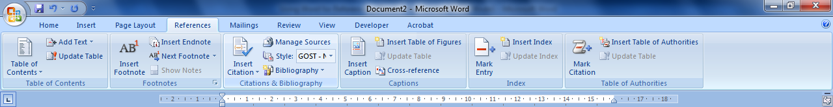

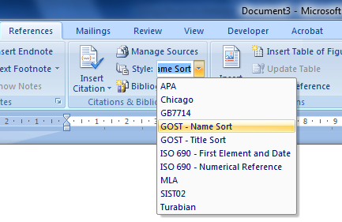
Click the style you can use ‘APA’ or ‘Gost name sort’ these both adopt the Harvard style.

Add a new citation and source to a document
When you add a new citation to a document (within the text), you also create a new source that will appear in the bibliography (at the end of the document).
- Click at the end of the sentence or phrase that you want to cite (place your cursor where you want to insert the citation).

- On the References tab, in the Citations & Bibliography group, click Insert Citation.

- Click Add New Source.

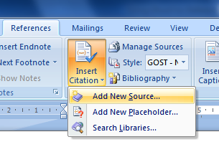

- Begin to fill in the source information by clicking the arrow next to Type of source.
Once you select a type, you are only asked for the details for that type.
For example, your source might be a book, a report, or a Web site.
Fill in the bibliography information for the source.
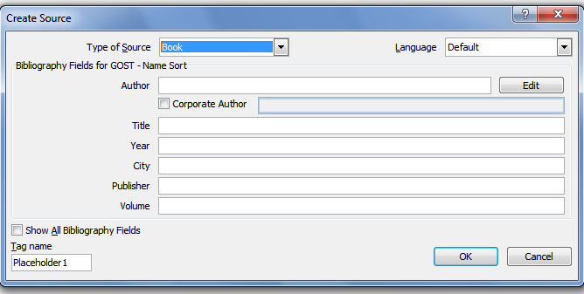

- References can be edited anytime using the Manage Sources option

Editing Citations
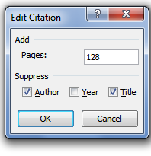
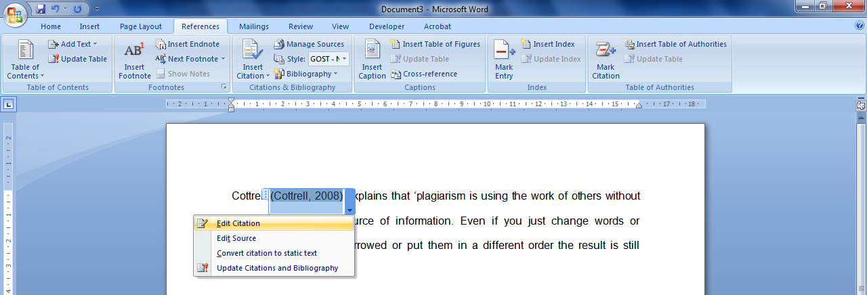
You make want to incorporate the author’s name into your writing, or you could be using direct quotes and will need to include page numbers within the citation. Click on the citation in the body of your text – click the drop down arrow and select Edit Citation

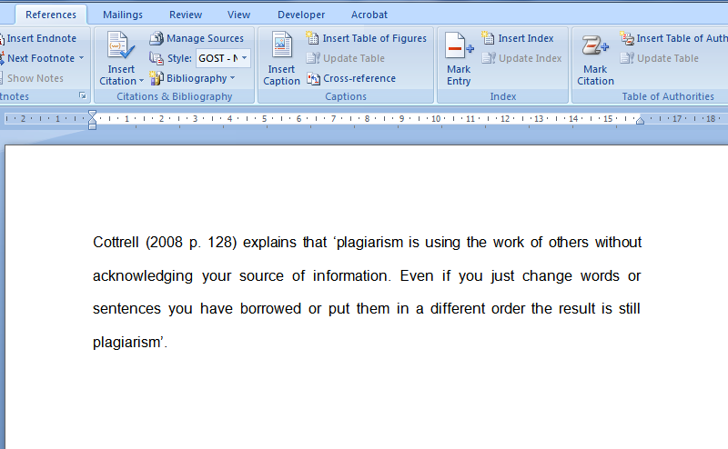
You can then add page numbers to your citation - you can also suppress author’s name (always suppress title) just the year will be displayed in brackets.

Editing References
Click References tab Manage Sources
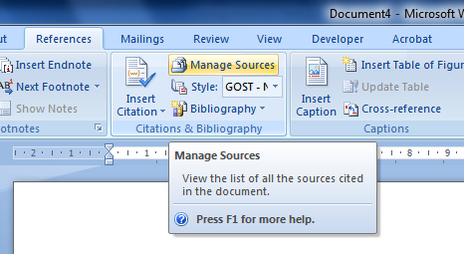

Highlight the source you want to edit and then click Edit
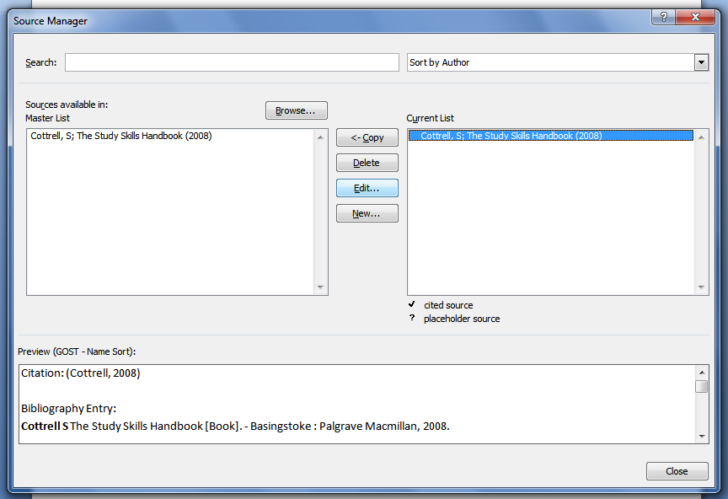

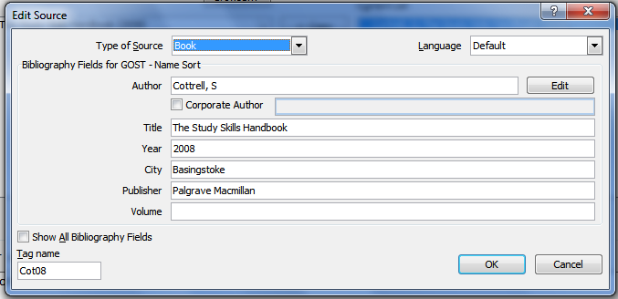

Create a Reference List / Bibliography
You can create a reference list/ bibliography at any point after you insert one or more sources in a document.
- At the end of the document, insert page break.
- At the top of the final page add the heading References.
- Select the References tab.
- From the Citation and Bibliography section click on the button and Insert Bibliography.
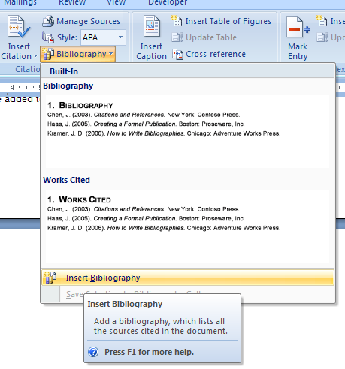

If you make any changes within the document, you can update the bibliography by right-clicking on the bibliography and selecting ‘update field’.

Activity
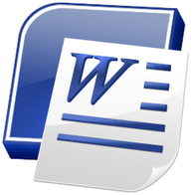

Using the internet and library resources write a short paragraph on Plagiarism use citations in your text from a book, a journal and website to support your writing. Insert a Reference List on a new page demonstrating the full details of the sources used.

