

A Lightweight and Explainable Machine Learning-Based Intrusion Detection System for IoT Networks

MSc Postgraduate Research Proposal

Assessment - Research Proposal

Name: Harsh Valand

Enrollment: 2437861

Table of Contents
Section | Title | Page No
1 | Introduction | 3
1.1 | Context and Background | 3
1.2 | Research Problem | 3
1.3 | Research Aim and Objectives | 4
1.4 | Significance of the Research | 4
2 | Literature Review | 6
2.1 | IoT Threat Surface and IDS Requirements | 6
2.2 | Benchmark Datasets and Data Quality | 6
2.3 | Machine Learning and Deep Learning for IoT IDS | 6
2.4 | Lightweight and Edge-Based Detection | 7
2.5 | Explainability, Generalisation and Drift | 7
2.6 | Summary of Reviewed Studies | 8
2.7 | Position of the Present Study | 8
3 | Research Design and Methodology | 9
3.1 | Research Design | 9
3.2 | Research Methods and Materials | 9
4 | Expected Outcomes | 12
5 | Timeline | 13
6 | Overall Presentation of the Proposal | 14
7 | References | 15

1. Introduction

1.1 Context and Background
The Internet of Things (IoT) now includes everything from domestic cameras and thermostats to medical sensors and industrial controllers. Connecting these devices makes them easier to monitor and manage, but it also gives attackers more opportunities to enter a network. The problem is made worse by the fact that many IoT devices have limited processing power, remain in service for years and do not receive security updates consistently. NIST therefore treats cybersecurity state awareness - the ability of a device to record and communicate its security condition - as a basic IoT security capability [1]. A network intrusion detection system (IDS) supports this by looking for signs of misuse or compromise that other controls have missed.
Machine learning (ML) is often proposed for this task because it can recognise combinations of traffic behaviour that would be difficult to capture with fixed rules alone. There is now enough public data to test such systems in a controlled way. CICIoT2023, for example, contains traffic from 105 devices exposed to 33 attacks [2]. N-BaIoT records Mirai and BASHLITE activity against nine commercial devices [3], while Kitsune shows that a collection of small autoencoders can perform online anomaly detection on gateway-level hardware [4]. These are encouraging results. However, doing well on a benchmark is not the same as being ready for use on a real network.
That difference between benchmark performance and practical performance is central to this proposal. BoT-IoT [5], TON_IoT [6] and Edge-IIoTset [7] were collected with different devices, attack scenarios, feature extractors and class balances. A model trained on one of them may learn details that belong to the dataset rather than the attack. It may also be too large or slow for an IoT gateway once the cost of extracting features is included. Finally, an analyst needs to know why an alert was raised. That is especially important when a false alarm could interrupt a home, healthcare or industrial system.

1.2 Research Problem
The main research problem is that IoT intrusion detectors are commonly judged by randomly splitting a single dataset into training and test rows. Results above 99% accuracy are often reported, yet flows from the same capture may appear on both sides of the split. This can make the task easier than it would be in practice. It also says very little about what happens when the device mix or traffic pattern changes. D'hooge et al. found that supervised intrusion detectors could lose a considerable amount of performance when they were moved between similar benchmark datasets [8]. A useful study must therefore look beyond internal accuracy and test whether a compact model still performs acceptably in a different environment.
Several studies address parts of this problem, but fewer bring the parts together. Alani and Miri investigate a smaller, explainable feature set [9]. Javed et al. test embedded detection on a smart thermostat [10], while Chen et al. use SHAP explanations to guide feature selection [11]. More recently, Alhalangy et al. show that a compact model with an excellent internal F1-score can still struggle with a malware scenario it has not seen before [12]. Building on this work, the proposed study asks three practical questions: which lightweight model gives the best balance between detection and resource use; how much of its performance carries over to another dataset; and whether its explanations still make security sense after that change?

1.3 Research Aim and Objectives
Aim: to develop and evaluate a lightweight, explainable ML-based IDS for an IoT gateway. The study will examine whether a small set of common flow features can support useful detection, understandable alerts and low resource use in both internal and cross-dataset tests.
Objectives:
- O1. Review the main research on IoT intrusion detection and turn its findings into clear requirements for detection, generalisation, explainability and gateway resource use.
- O2. Prepare CICIoT2023 and TON_IoT through a leakage-resistant pipeline, using 12-15 flow features that can be represented consistently in both datasets.
- O3. Train logistic regression, decision tree, random forest and LightGBM/XGBoost models under the same conditions, including class weighting and controlled hyperparameter tuning.
- O4. Reduce the input feature set through ablation tests and SHAP analysis, then examine whether the most influential features remain stable across datasets.
- O5. Test the chosen model against full-feature and simpler baselines, measuring detection quality as well as latency, throughput, memory, CPU use and model size on a Raspberry Pi gateway.
- O6. Study the model's failures and the effects of dataset bias, class imbalance and changing traffic, and document the work well enough for another researcher to reproduce it.

1.4 Significance of the Research
The value of this research lies in the way the model will be judged. Instead of treating accuracy as the only result that matters, the study will consider whether the detector transfers to unfamiliar data, how much it costs to run and whether its alerts can be understood. Strict scenario-level splits and an external test should give a more realistic view of performance than a random row split. For practitioners, the intended outcome is a small gateway prototype and a feature set that can be inspected before an alert is acted upon. If the model performs poorly outside its training dataset, that finding will still be useful because it will show where retraining or additional monitoring is needed.

2. Literature Review
For this proposal, the literature review is limited to network-based intrusion detection for IoT, the datasets used to test it, and work on lightweight or explainable ML. Source-code malware classifiers and systems that depend entirely on powerful cloud infrastructure are outside the scope because the proposed detector is intended to work with flow metadata at a gateway.

2.1 IoT Threat Surface and IDS Requirements
Although IoT networks contain many types of devices, an individual device often follows a fairly regular pattern. A camera, thermostat or environmental sensor usually contacts a small number of services and sends similar amounts of data at similar times. Scanning, brute-force attempts, command-and-control traffic, data theft and denial-of-service attacks can disturb those patterns. N-BaIoT models the normal behaviour of each device with deep autoencoders and uses the reconstruction error to find Mirai and BASHLITE activity [3]. Kitsune takes a related online approach and was shown to run on a Raspberry Pi [4]. Both studies demonstrate why behaviour-based detection suits IoT, but they also show that the detector must fit the local traffic and remain light enough for the gateway that hosts it.

2.2 Benchmark Datasets and Data Quality
The choice of dataset can have as much influence on an IDS result as the choice of algorithm. CICIoT2023 provides broad, recent coverage through 33 attacks in a network of 105 real devices [2]. BoT-IoT includes botnet, denial-of-service, reconnaissance and data-theft scenarios [5]. TON_IoT combines network records with operating-system and sensor telemetry [6], and Edge-IIoTset adds IoT and industrial protocols for centralised and federated experiments [7]. These datasets are useful, but they do not use the same features or label structure. D'hooge et al. show why this matters: models that perform well on one intrusion dataset may not transfer successfully to another [8]. Identifiers, timestamps and flows from the same capture must therefore be handled carefully so that they do not leak information into the test set.

2.3 Machine Learning and Deep Learning for IoT IDS
For tabular flow data, established models such as logistic regression, decision trees, random forests and boosted trees remain strong candidates. They train relatively quickly and, in the case of tree models, can represent non-linear relationships without a large neural network. Autoencoder systems such as N-BaIoT and Kitsune have the advantage of learning normal traffic without needing examples of every attack [3], [4], although their internal representations are harder to explain. Li and Yao use self-supervised learning and knowledge distillation to reduce the need for labels and compress a more complex model [13]. That approach is promising, but this project first needs a reliable and understandable baseline. A careful comparison of lighter tabular models is therefore more appropriate for the available time and the gateway deployment goal.

2.4 Lightweight and Edge-Based Detection
A detector is not truly lightweight simply because its model file is small. The gateway must also calculate every input feature and return a decision quickly enough to keep up with traffic. Alani and Miri show that reducing the feature set can shorten prediction time while maintaining strong results across several datasets [9]. Javed et al. go further by placing the first stage of an IDS on a microcontroller-based thermostat; their XGBoost model detected the tested MITM and DoS traffic in 3.51 ms with 97.59% accuracy [10]. Li and Yao reduce a learned model through distillation [13], while Alhalangy et al. identify LightGBM as a useful compromise between performance and size [12]. These studies support testing on actual edge hardware rather than estimating efficiency from a desktop computer.

2.5 Explainability, Generalisation and Drift
Explainability is useful here because it can expose what the model has really learned. SHAP assigns a contribution to each feature for a particular prediction and can also summarise which features matter across the dataset [14]. An alert based on unusual packet rates or connection behaviour may be credible; one driven mainly by an address or a dataset-specific port is more doubtful. Cross-dataset work is difficult, however, when every benchmark uses a different schema. Sarhan, Layeghy and Portmann address this with standard NetFlow-based feature sets [15]. Traffic also changes after deployment as devices, software and attacks change. Nitish et al. argue that class imbalance and concept drift need to be considered together in an online IoT-edge detector [16]. For that reason, this study will examine both performance shift and explanation shift.
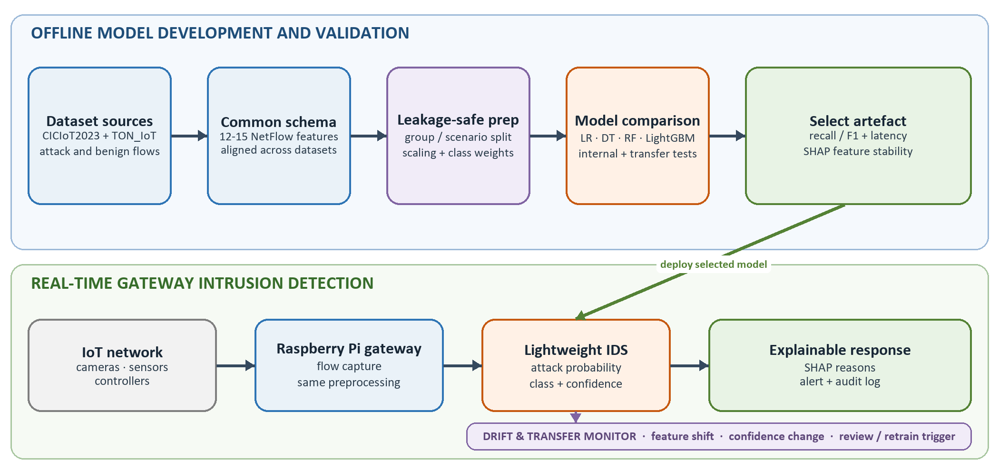
Fig. 1. Proposed lightweight and explainable ML-based IoT intrusion-detection architecture.

2.6 Summary of Reviewed Studies
The studies in Table 1 are the ones that have the clearest influence on the design of this project. The final column notes the part of each study that the proposed evaluation will either reuse or test more strictly.
Study | Focus | Why it matters to this project
Meidan et al. [3], 2018 | N-BaIoT botnet detection | Shows that device-level autoencoders can identify Mirai and BASHLITE, but does not centre on transfer to a different environment.
Mirsky et al. [4], 2018 | Kitsune online anomaly detection | Demonstrates practical online detection on a Raspberry Pi, although the resulting alerts are not easy to explain.
Neto et al. [2], 2023 | CICIoT2023 benchmark | Provides broad coverage through 105 devices and 33 attacks, but the traffic and attack classes are unevenly distributed.
D'hooge et al. [8], 2020 | Cross-dataset generalisation | Shows directly that strong internal performance may fall when a model is tested on traffic from another dataset.
Alani & Miri [9], 2022 | Universal explainable features | Supports the use of a smaller SHAP-explained feature set and tests it beyond the dataset used for development.
Javed et al. [10], 2024 | Embedded smart-home IDS | Provides real hardware evidence: XGBoost detects the tested MITM and DoS traffic in 3.51 ms, although the attack range is limited.
Chen et al. [11], 2024 | SHAP-guided feature selection | Shows that ten selected features can retain over 98% accuracy and reduce cost, but the experiments remain offline.
Li & Yao [13], 2024 | Lightweight knowledge distillation | Addresses label scarcity and model size through self-supervision and distillation, at the cost of a more complex pipeline.
Alhalangy et al. [12], 2026 | Stability-centred lightweight IDS | Finds that excellent internal scores can hide weak external stability and identifies LightGBM as a useful compact baseline.
Table 1. Summary of studies most directly relevant to the proposed IoT IDS.

2.7 Position of the Present Study
Taken together, the literature gives a fairly consistent picture. ML can identify important IoT attacks, including botnet and denial-of-service traffic, when training and testing take place in the same environment [2]-[4]. Small models and feature sets can also run close to constrained devices [9], [10], [12]. The weak point is transfer. Differences in datasets, minority classes and changing traffic can make an internal score look more reassuring than it should [8], [15], [16]. The contribution of this project is therefore not a claim to have invented the most accurate classifier. It is a practical evaluation process in which a model is only selected after internal testing, an external dataset test, explanation checks and direct resource measurement on gateway hardware.

3. Research Design and Methodology

3.1 Research Design
Design Science Research Methodology (DSRM) is suitable for this project because the work is not limited to describing a security problem; it also involves building and testing a proposed solution [17]. The artefact is the gateway IDS shown in Fig. 1. It includes common-flow feature extraction, preprocessing, a lightweight classifier, drift monitoring and an explanation for each alert. The project will move from defining the problem and design requirements to development, demonstration on public data, evaluation on a second dataset and gateway hardware, and final communication. A controlled comparison is included so that the design decisions are supported by results rather than by the fact that the prototype works.
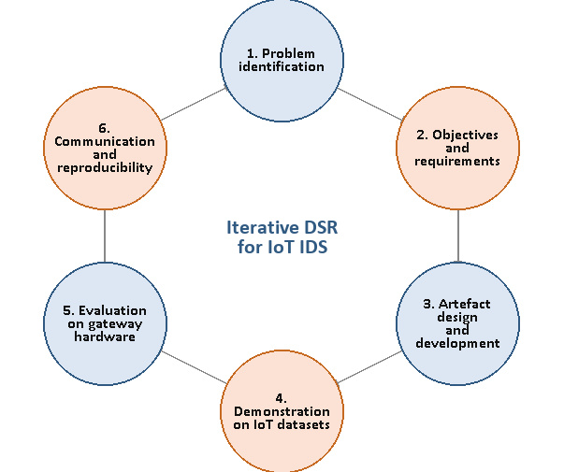
Fig. 2. Design Science Research cycle applied to the proposed IoT IDS.

3.2 Research Methods and Materials

3.2.1 Methods
Two linked evaluations are planned. The first will use grouped cross-validation within CICIoT2023. Flows belonging to the same capture or attack run will stay in the same fold, which reduces the chance of near-duplicate traffic appearing in both training and testing. The second evaluation will train on the features shared with CICIoT2023 and test the fitted model on the compatible part of TON_IoT without retraining it. Results will be reported for a binary benign-versus-attack task and, where the labels genuinely match, for grouped attack classes. Imputation, scaling, weighting and feature selection will be fitted using training data only. Addresses, timestamps, row identifiers and obvious label proxies will be removed.
The model comparison will be deliberately straightforward: logistic regression, decision tree, random forest and LightGBM or XGBoost will be trained under the same conditions. A majority-class predictor and an untuned full-feature tree will act as sanity checks. Tuning will use either nested cross-validation or a separate validation fold, depending on the size of the final data subset. Ablation tests will compare all common features with the reduced set and class weighting with no weighting. Main scores will include 95% bootstrap confidence intervals. Where scenario-level paired results allow it, a Wilcoxon signed-rank test will be used, with a correction for the small set of planned comparisons.
In use, mirrored traffic or a packet capture will be converted into short flow records at the gateway. After the same preprocessing used during training, the selected features will be passed to the chosen model. An alert will contain the predicted class, its confidence and a short SHAP explanation showing the features that pushed the result towards or away from an attack. A rolling monitor will watch for changes in the feature distribution and in prediction confidence. It will flag the model for review rather than retraining it automatically on unverified traffic, which would introduce a separate poisoning risk.
No model will be judged by accuracy alone. Detection will be measured with macro-F1, class-level precision and recall, balanced accuracy, binary PR-AUC, confusion matrices and false positives per 1,000 benign flows. The Raspberry Pi tests will record median and 95th-percentile latency, throughput, peak memory, average CPU use, model size and the time needed to extract features. Explanations will be reviewed for sparsity, agreement between folds and consistency with the underlying traffic. The final choice will be made from the overall trade-off: a small gain in F1-score will not justify a much higher false-alarm rate or resource cost.

3.2.2 Materials
CICIoT2023 will be the main development dataset because it covers a wide range of attacks in a large real-device topology [2]. The network portion of TON_IoT will provide the external test environment [6]. Labels will first be reduced to benign and attack. They will only be mapped into shared groups, such as denial of service, reconnaissance or brute force, when the original definitions are sufficiently close. The common feature set is expected to contain 12-15 NetFlow-style fields, including protocol, duration, packet and byte counts, rates and connection state where available. Every mapping and exclusion will be recorded in a data dictionary rather than being decided silently during modelling.
No human participants are involved, but the project still needs careful data handling. Only public, research-licensed datasets will be used, and their terms will be checked before downloading. Raw captures will be kept on an encrypted project drive and processed in an isolated environment. Malware will not be executed, and attack traffic will never be replayed onto a public network. The dissertation will explain defensive detection methods without turning them into instructions for attacking IoT devices. An institutional ethics and data-management review will be completed before the experiments begin.
The work will be carried out in Python. pandas and NumPy will be used for data preparation, scikit-learn for the baseline models, LightGBM or XGBoost for boosted trees, and SHAP for explanations. If a small sample of raw captures needs to be checked, Zeek, CICFlowMeter or a similar exporter will be used to reproduce the required flow features. Random seeds, software versions, model settings and data-processing decisions will be stored with the code so that the reported results can be rebuilt later.
Model development should be possible on a workstation with at least 16 GB of memory and enough storage for the selected data subsets. The deployment experiment will use a Raspberry Pi 4 or 5 with 4 GB RAM as a passive gateway monitor. An isolated host will replay traffic at controlled rates, and measurements will be repeated after a warm-up period. A GPU is not required. Keeping the hardware modest is part of the research design, since the proposed system is intended to be affordable and reproducible.

4. Expected Outcomes
The expected output is more than a trained classifier. It should include a working gateway prototype, a documented common-flow schema, saved models and a set of experiments that can be repeated. Tree-based models are likely to offer a good balance between detection and efficiency, but the study will not assume this in advance. The preferred model will depend on minority-class recall, false alarms, external performance and the measurements collected on the Raspberry Pi, not just on its internal F1-score.
Ideally, the reduced feature set will keep most of the detection performance while lowering both feature-extraction and prediction cost. The explanations should also point to a small number of features that make sense in terms of network behaviour. A less positive result would still answer the research question. If the model's performance falls sharply on TON_IoT, or if its explanations change to dataset-specific features, this would be evidence that local calibration, retraining or domain adaptation is needed before the detector can be trusted.
Some limitations cannot be removed completely. CICIoT2023 and TON_IoT do not describe attacks or features in exactly the same way, and neither can represent every future zero-day attack. A Raspberry Pi is also only a stand-in for the wide range of commercial gateways and embedded devices. In addition, SHAP explains how the model reached a prediction; it does not prove that the relationship is causal. These limits will be addressed through transparent exclusions, sensitivity checks and careful wording that separates the measured findings from broader claims about IoT networks.

5. Timeline
The work is planned over 10 weeks. To keep the schedule achievable, the scope is tightly controlled, documentation is maintained throughout, and the data, modelling, external evaluation and Raspberry Pi tasks use clear review points.
Phase | Weeks | Planned work and output
Phase 1 | Weeks 1-2 | Confirm the scope, complete a focused literature review, and finalise the ethics and data-management documents.
Phase 2 | Weeks 2-3 | Obtain the approved dataset subsets, record their provenance, and build the common-feature preparation pipeline.
Phase 3 | Weeks 4-5 | Train baseline models, tune the leading candidates, and complete class-weighting and feature-ablation tests.
Phase 4 | Weeks 6-7 | Run grouped and cross-dataset evaluation, produce SHAP explanations, and assess feature stability.
Phase 5 | Weeks 8-9 | Deploy the selected model on the Raspberry Pi and measure latency, throughput, memory use and CPU load.
Phase 6 | Week 10 | Integrate the results, write and proofread the dissertation, document limitations, and archive code and configurations.

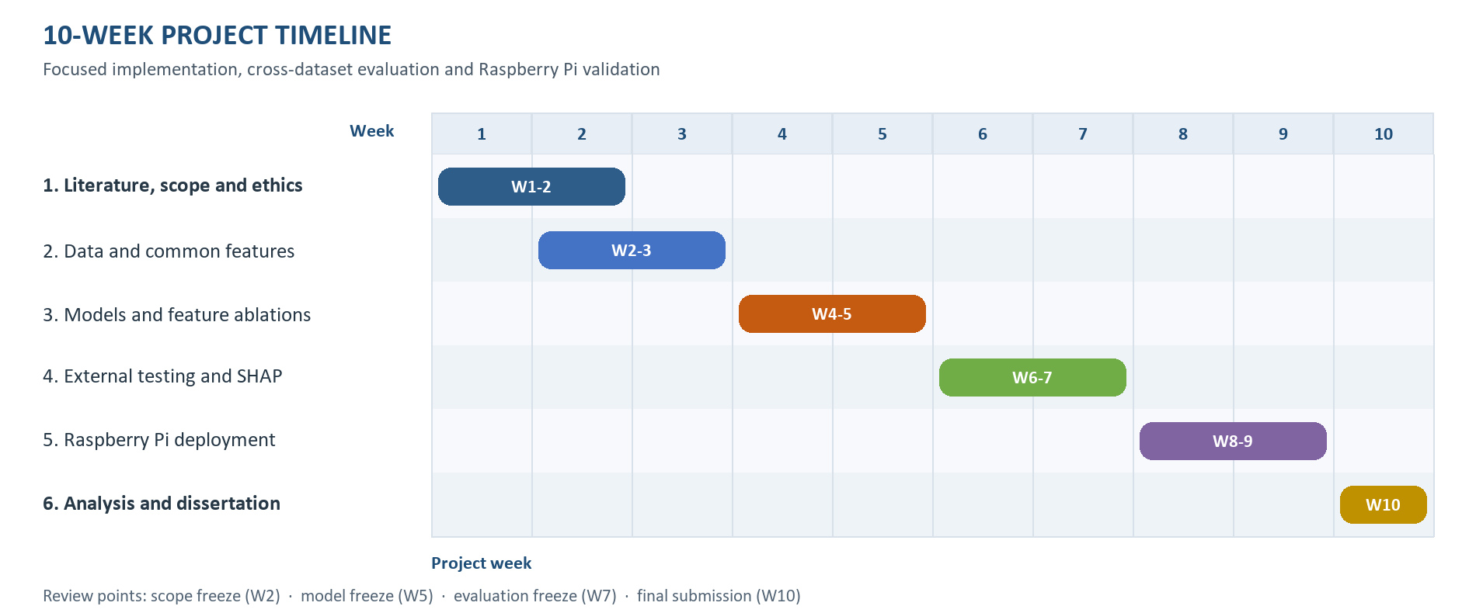
Fig. 3. 10-week project timeline Gantt chart.

6. Overall Presentation of the Proposal
The proposal is organised in the same order as the planned research: the problem and supporting literature come first, followed by the design, evaluation method, expected outcomes and schedule. Numbered objectives make it possible to trace each part of the method back to the aim. The architecture, research cycle and timeline are shown as figures so that the main decisions are not left entirely in prose, while the literature table makes the research gap easier to compare. References follow IEEE style and each in-text citation has a corresponding entry. As the research has not yet been carried out, the outcomes in Section 4 are presented as expectations rather than as completed experimental findings.

7. References
[1] M. Fagan, K. N. Megas, K. Scarfone, and M. Smith, IoT Device Cybersecurity Capability Core Baseline, NISTIR 8259A. Gaithersburg, MD, USA: National Institute of Standards and Technology, May 2020, doi: 10.6028/NIST.IR.8259A.
[2] E. C. P. Neto, S. Dadkhah, R. Ferreira, A. Zohourian, R. Lu, and A. A. Ghorbani, "CICIoT2023: A real-time dataset and benchmark for large-scale attacks in IoT environment," Sensors, vol. 23, no. 13, art. no. 5941, 2023, doi: 10.3390/s23135941.
[3] Y. Meidan, M. Bohadana, Y. Mathov, Y. Mirsky, D. Breitenbacher, A. Shabtai, and Y. Elovici, "N-BaIoT - Network-based detection of IoT botnet attacks using deep autoencoders," IEEE Pervasive Computing, vol. 17, no. 3, pp. 12-22, 2018, doi: 10.1109/MPRV.2018.03367731.
[4] Y. Mirsky, T. Doitshman, Y. Elovici, and A. Shabtai, "Kitsune: An ensemble of autoencoders for online network intrusion detection," in Proc. Network and Distributed System Security Symposium (NDSS), San Diego, CA, USA, 2018, doi: 10.14722/ndss.2018.23204.
[5] N. Koroniotis, N. Moustafa, E. Sitnikova, and B. Turnbull, "Towards the development of realistic botnet dataset in the Internet of Things for network forensic analytics: Bot-IoT dataset," Future Generation Computer Systems, vol. 100, pp. 779-796, 2019, doi: 10.1016/j.future.2019.05.041.
[6] A. Alsaedi, N. Moustafa, Z. Tari, A. Mahmood, and A. Anwar, "TON_IoT telemetry dataset: A new generation dataset of IoT and IIoT for data-driven intrusion detection systems," IEEE Access, vol. 8, pp. 165130-165150, 2020, doi: 10.1109/ACCESS.2020.3022862.
[7] M. A. Ferrag, O. Friha, D. Hamouda, L. Maglaras, and H. Janicke, "Edge-IIoTset: A new comprehensive realistic cyber security dataset of IoT and IIoT applications for centralized and federated learning," IEEE Access, vol. 10, pp. 40281-40306, 2022, doi: 10.1109/ACCESS.2022.3165809.
[8] L. D'hooge, T. Wauters, B. Volckaert, and F. De Turck, "Inter-dataset generalization strength of supervised machine learning methods for intrusion detection," Journal of Information Security and Applications, vol. 54, art. no. 102564, 2020, doi: 10.1016/j.jisa.2020.102564.
[9] M. M. Alani and A. Miri, "Towards an explainable universal feature set for IoT intrusion detection," Sensors, vol. 22, no. 15, art. no. 5690, 2022, doi: 10.3390/s22155690.
[10] A. Javed, A. Ehtsham, M. Jawad, M. N. Awais, A.-u.-H. Qureshi, and H. Larijani, "Implementation of lightweight machine learning-based intrusion detection system on IoT devices of smart homes," Future Internet, vol. 16, no. 6, art. no. 200, 2024, doi: 10.3390/fi16060200.
[11] X. Chen, M. Liu, Z. Wang, and Y. Wang, "Explainable deep learning-based feature selection and intrusion detection method on the Internet of Things," Sensors, vol. 24, no. 16, art. no. 5223, 2024, doi: 10.3390/s24165223.
[12] A. Alhalangy, S. A. Alkhamis, and E. Abouelkheir, "A stability-centric framework for lightweight and explainable intrusion detection," Future Internet, vol. 18, no. 6, art. no. 305, 2026, doi: 10.3390/fi18060305.
[13] Z. Li and W. Yao, "A two stage lightweight approach for intrusion detection in Internet of Things," Expert Systems with Applications, vol. 257, art. no. 124965, 2024, doi: 10.1016/j.eswa.2024.124965.
[14] S. M. Lundberg and S.-I. Lee, "A unified approach to interpreting model predictions," in Advances in Neural Information Processing Systems 30, 2017, pp. 4765-4774.
[15] M. Sarhan, S. Layeghy, and M. Portmann, "Towards a standard feature set for network intrusion detection system datasets," Mobile Networks and Applications, vol. 27, pp. 357-370, 2022, doi: 10.1007/s11036-021-01843-0.
[16] A. Nitish, J. Hanumanthappa, S. P. S. Prakash, and K. Krinkin, "Class imbalance and concept drift invariant online botnet threat detection framework for heterogeneous IoT edge," Computers & Security, vol. 141, art. no. 103820, 2024, doi: 10.1016/j.cose.2024.103820.
[17] K. Peffers, T. Tuunanen, M. A. Rothenberger, and S. Chatterjee, "A design science research methodology for information systems research," Journal of Management Information Systems, vol. 24, no. 3, pp. 45-77, 2007, doi: 10.2753/MIS0742-1222240302.

