Sophie Evans (2108843)

Economics of Sustainability (BMSP6007)
[Document subtitle]

Table of Contents
Introduction 2
Market Failures of the Tobacco Industry 3
Solution One – Indirect Taxation 6
Market Performance after Indirect Taxation 8
Solution Two – Negative Advertising Campaign - Standardised Packaging for Tobacco Products 9
Market Performance after standardised packaging for Tobacco Products 11
Substitutes for the Tobacco Industry 13
Conclusion 14

Introduction
This essay examines the tobacco industry, how its negative externalities have been addressed through the implementation of solutions, and the effectiveness of these policies. In order to understand the damage that smoking does to society, the essay will also address the risks associated with cigarette consumption, the health hazards of smoking, and the pollution produced by cigarettes.
The tobacco industry has been around for decades and according to Statista (2024) in the UK, the smoking tobacco industry brought in a sum of 8.5 billion in revenue in 2024. According to Trenda (2023) it was projected that the tobacco products market in the United Kingdom will generate 3.1 billion GBP in sales in total between 2023 and 2027, a rise of 13.29 percent.
According to the NHS (2022) In the UK, smoking is one of the leading causes of illnesses and fatalities. In the United Kingdom, smoking causes the deaths of approximately 76,000 individuals annually, and many more suffer from the illnesses linked to smoking. The NHS (2022) states that due to its spillover effects, such as second-hand smoke, which can expose nonsmokers to the same ailments as smokers, cigarette smoking has a detrimental impact on society.
According to Hilton (n.d.) as stated by historian Jordan Goodman there is a culture of dependence in communities where tobacco has been introduced. Because of the personal and social benefits that smoking offers, people—and society at large—continue to smoke despite knowing that it is hazardous. This reliance is one of the reasons behind this. Millions of individuals continue to smoke even though it is irresponsible, and they are ignorant of the harmful externalities that come with cigarette usage.
The tobacco business will be analysed, focusing on its negative externalities and costs to society, including third parties. This study will be conducted before examining the government's implementation of indirect taxes and public health campaigns. This will be demonstrated through illustrative diagrams in order to provide a comprehensive comprehension of the market failure resulting from smoking. This analysis will examine the impact of implementing indirect tax and public health campaigns on mitigating the consequences of smoking in this industry.

Market Failures of the Tobacco Industry
According to Cancer Research UK (n.d.) In the UK, tobacco smoking is the leading avoidable cause of cancer and death, and it's among the leading causes of illnesses and fatalities globally. In the UK, tobacco smoking is thought to have contributed to 125,000 deaths in 2019; this is around one person every five minutes. An estimated 55,000 cancer deaths were attributed to it in the UK in 2019. The Office for National Statistics (ONS) (2023) reports that in 2022 in the UK 6.4 million adults were smokers. Action on smoking and Health (ash) (2020) state that an estimated 2,700 deaths per year among those aged 20 to 63 and an additional 8,000 deaths per year among those aged 65 and above are attributed to exposure to second hand smoke in the UK. According to the CDC (2022) exposure to second-hand smoke, can have detrimental consequences on the health of nonsmokers. Adults who do not smoke can get lung cancer, coronary heart disease, stroke, and other diseases from second-hand smoke. Women may also experience negative impacts on their reproductive health, such as low birth weight. In newborns and young children, second-hand smoking can result in respiratory infections, ear infections, sudden infant death syndrome (SIDS), and asthma episodes. NHS England (2022) states that the resources of the NHS are severely strained by illnesses associated with smoking. Smoking is thought to have cost NHS England £2.6 billion annually.
In the case of tobacco, market failure is evident in the form of negative externalities. Arihiliam & Arihilman (2019) state that a type of pollution known as "anthropogenic pollution" is one that is directly caused by human activity. Consumption of cigarettes associates with anthropogenic pollution as smoking cigarettes draws attention to their detrimental effects on one's health and because their spillover effects result in costs to third parties. A negative externality occurs when according to Pettinger (2019) when a third party suffers harm by the consumption of a product. The societal benefit in this instance is not as significant as the private benefit.
Tobacco use can cause several negative effects, as according to Truth Initiative (2023) in addition to its detrimental effects on human health, tobacco use also jeopardises environmental health. Cigarette waste has the potential to enter the environment, contaminating water, air, and land with harmful substances, heavy metals, and remaining nicotine. Bonanomi (2021) states that a few trillion cigarette butts are discarded annually, making them the most frequently littered object on Earth. According to Earthday (2024) the plastic component of butts, or cigarette filters, can take up to ten years to entirely break down, but the chemicals they emit can linger in the environment for an extended period of time. Research from GOV.UK (2021) states that Local governments in the UK presently spend approximately £40 million a year cleaning up cigarette butt waste.
As there are more benefits for the individual smoker than for society as a whole, there are perceived negative externalities associated with the consumption of cigarettes.
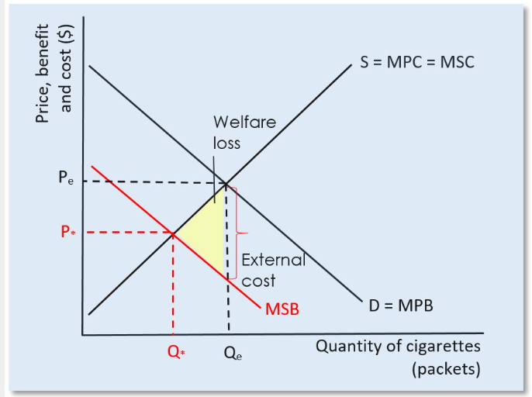
Fig 1 – Negative externalities of consumption MSB<MPB (AP Microeconomics, n.d.)

The negative externalities of smoking are illustrated in Figure 1 above. It is possible to view the negative externalities from the diagram as detrimental to the environment and society. The marginal social benefit (MSB) is less than the marginal private benefit (MPB) as the marginal benefit to the consumer is significantly greater than the benefits to society. The negative externalities of cigarette consumption are illustrated by the vertical difference between marginal social benefits (MSB) and marginal private benefits (MPB), which is labelled as "external costs." The equilibrium point in the figure Q* is the point at which the marginal social costs (S=MPC=MSC) and the optimal amount of cigarette consumption meet. However, the overconsumption of goods (too many cigarettes consumed) at Qe is attributed to the negative externalities and is recognised as a possible welfare loss.

Solution One – Indirect Taxation
Market failures can be rectified by government intervention, According to Legislation.gov.uk (n.d.) the government imposed an excise duty in 1976 on tobacco products made in the UK or imported into the country. GOV.UK (2023) states that all tobacco products were subject to a tax rate increase in November 2023 of 2% over RPI inflation due to the tobacco duty escalator. In order to keep up with RPI inflation, the tax rate on hand-rolled tobacco increased by an extra 10%. Maintaining high tobacco tax rates is the primary objective for the government, which is an effective approach to lower the prevalence of smoking and guarantee that tobacco taxes continue to generate income for the state.
According to Partos et al., (2020) it has been demonstrated that raising tobacco taxes is the most economical and efficient strategy to lower the prevalence, consumption, commencement, and disparities in tobacco use. The UK has among of the highest real tobacco costs in the world, and the World Health Organisation has recognised tobacco taxation as a very essential tobacco control measure.
Reducing consumption could potentially alleviate some of the negative externalities associated with smoking, which is the government's response to the indirect tax on tobacco products. Due to inelastic demand, the indirect tax does have limitations. Inelastic demand refers to as stated by Hussain (Hussain, 2022) is when the quantity demanded for a product maintains constant irrespective of whether its price increases or decreases. Gallo (2015) states that these products are necessities for customers, in this instance the inelastic demand can refer to the addiction of smoking.

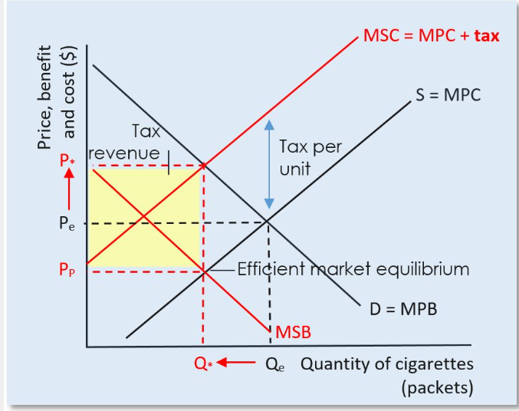
Fig 2 – An indirect excise tax on demerit goods (AP Microeconomics, n.d.)

Figure 2 hypothetically demonstrates the effect of indirect tax on cigarettes. Because cigarettes have an inelastic demand curve due to their addictive nature, consumers will suffer the greatest percentage of the indirect tax burden, while manufacturers are additionally bearing some of burden. Following the imposition of an indirect tax on cigarettes, a new equilibrium was reached that brought the demand curve (D=MPB) and marginal societal costs (MSC = MPC + TAX) aligned. The imposition of a tax on cigarettes causes the price that consumers pay to increase (P*), while the price that producers receive decreases (PP). The allocatively efficient quantity of the product is produced and consumed at a higher cost. As a result, consumption's negative externality has been internalised.

Market Performance after Indirect Taxation
According to Tobacco free Kids (2012) cigarette prices in the United Kingdom rose by more than 200% between 1992 and 2011. In the same time frame, government revenue from tobacco taxes climbed by 44% while cigarette sales fell by 51%. From 27% in 2000 to 20% in 2010, the percentage of adults who smoke decreased.
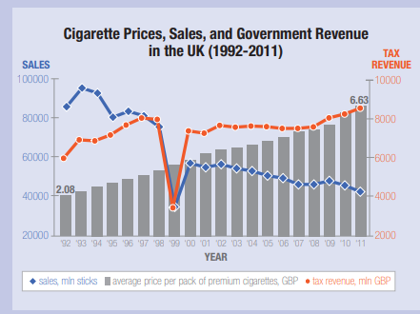
Fig 3 – Tobacco free Kids (2012)

The implementation of an indirect tax on cigarettes has been seen to provide positive outcomes, as evidenced by the diagram (Fig 3) and statistical data. This intervention has resulted in a decline in consumer consumption of cigarettes, leading to a corresponding fall in cigarette sales.
According to GOV.UK (2023) the current duty rate for cigarettes stands at £316.70 per 1,000 cigarettes plus 16.5% of retail price, this rate then impacts consumers by an additional 66p to a packet of 20 cigarettes.

Solution Two – Negative Advertising Campaign - Standardised Packaging for Tobacco Products
The second solution to resolve the negative externality was negative advertisement using standardised packaging. According to Moodie et al., (2021) the United Kingdom standardised tobacco product packaging, which went into effect for hand-rolled and factory-made cigarettes in May 2017. Haighton et al., (2017) states that implementing standardised tobacco packaging has the capacity to diminish the appeal of tobacco products, particularly among young individuals, enhance the effectiveness of health warnings, and reduce the possibility for misleading information on the relative danger of different variants of a tobacco brand. According to the Department of Health & Social Care (2021, p. 8) retailers, producers, and distributors are required to adhere to tobacco packaging requirements, which include the inclusion of specific health warnings in the form of pictures and text on cigarette packages.
The objective of this strategy is to prevent individuals, especially the younger generations, from consuming tobacco products. Its goal is to warn and educate individuals about the health risks associated with smoking, as well as the detrimental impact it has on them and society. This might potentially lower the marginal private benefit. However, inelastic demand may also be considered using this approach.

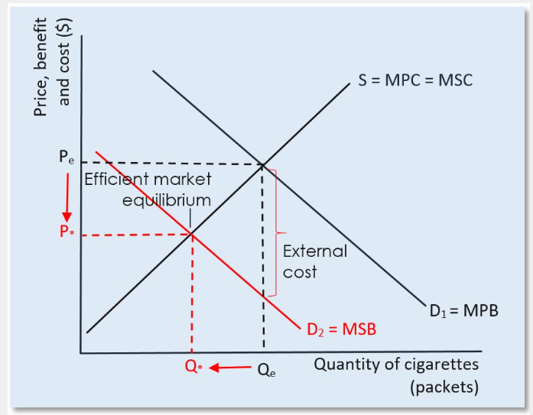
Fig 4 – Government regulations and advertising (AP Microeconomics, n.d.)

This diagram (Fig 4) hypothetically represents the effect of health campaigns and advertisements would have on the reduction of cigarette consumption. The solutions implemented involve halting the demand curve; in this case, the method is a negative advertising campaign using standardised cigarette packaging. As a result, the demand curve will decrease from D1=MPB until it overlaps with the desired demand curve, D2=MSB, at which point the externalities associated with cigarette consumption will begin to be eliminated. The demand for cigarette use will decline, causing the Qe on the diagram to drop to Q*.

Market Performance after standardised packaging for Tobacco Products
According to Breton (2021) between the implementation of standardised cigarette packaging and 2019 Studies conducted on the adoption of standardised packaging in England have shown that its implementation has been linked to significant increases in the cost of tobacco products, a shift towards less costly options, and a rise in the usage of e-cigarettes among smokers.
Hiscock et al., (2020) states that sales of tobacco products and tobacco industry profits significantly declined in the UK when MET and standardised packaging were implemented. Before implementation, there was a monthly average decline in tobacco sales of seven million sticks. However, after implementation, the monthly average decline in sales was thirteen million less sticks. Companies' monthly net revenues decreased from an estimated £229 million in May 2015 to an estimated £192 million in April 2018, mostly due to declining FMC sales, which caused this rapid reduction.
According to Moodie et al., (2021) two studies conducted found that when warnings appeared on standardised packs, young people found them off-putting. They believed that the warnings were credible, obvious, and clear, and that they made smoking less appealing. Warnings were characterised as being extremely unpleasant, with some causing visceral emotions. Smokers who never or seldom smoked were believed to be more vulnerable to the warnings than those who do.
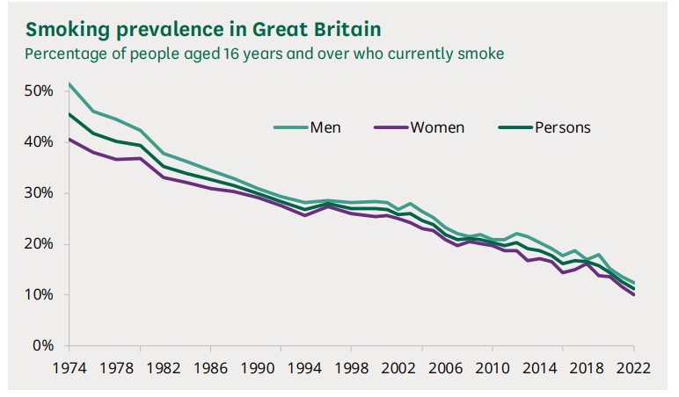
Fig 5 – Smoking prevalence in Great Britain (Harker, 2023, p. 11)

The smoking prevalence in Great Britain from 1974 to 2022 is shown in the chart (Fig. 5) above. In accordance with the data on the graph from the implementation of standardised cigarette packaging in 2017, there has been a decrease in smoking, suggesting that the government's strategy is effective. The government's approach to address the negative externalities, which have driven the negative externalities of consumption to equilibrium, is reflected in the research's assertion that warnings and visuals of tobacco products discourage younger generations from smoking. The Statista Research Department (2024) research discovered that at 14.7 percent, the smoking prevalence in the United Kingdom (UK) is at its lowest point in history.

Substitutes for the Tobacco Industry
According to Statista Research Department (2024) in the UK, e-cigarettes, often known as vapes, have grown in popularity. Initially, the emphasis of these devices was to help people stop smoking. As of 2021, about five percent of people were daily users of e-cigarettes. The majority of people who use e-cigarettes claim to be vaping in order to quit smoking.
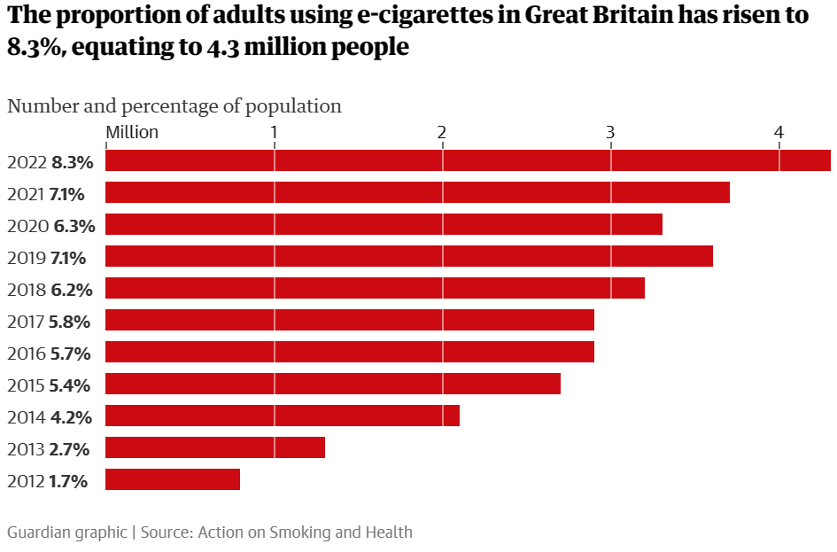
Fig 6 - (Hall, 2022)

From the above chart (Fig 6) Hall (2022) states that out of the 4.3 million e-cigarette users 350,000 have never smoked a cigarette, 1.5 million are present smokers, and around 2.4 million are former smokers. According to NHS (2022) with the aid of e-cigarettes, thousands of individuals in the UK have already quit smoking. While there are certain risks associated with vaping, they are far lower than those of smoking cigarettes.
According to ASH (2023) vaping is prevalent particularly among the younger generation and since 2021, the percentage of people who vape now is higher than the percentage of people who smoke (7.6% against 3.7% in 2023).
By substituting conventional cigarettes with e-cigarettes/vapes reduces the harmful effects of smoking consumption to both the consumer and society. Which subsequently resolves the negative externalities as demonstrated on FIG 4. However, this is based on the fact that e-cigarettes/vapes are less harmful than cigarettes, and according to the NHS (2022), the potential long-term risks of vaping remain undetermined.

Conclusion
In conclusion, the tobacco industry's failure has been attributed to the negative externalities it generates, which manifest in the form of costs to society and adverse health impacts experienced by consumers. Solutions were implemented to influence consumer behaviour and perceptions regarding cigarette consumption. These solutions included the implementation of indirect taxation and the utilisation of negative advertising through standardised packaging. Whilst statistics revealed that demand decreased as a result of these solutions, and government-implemented solutions proved effective, they were constrained by inelastic demand.
E-cigarettes have become a popular alternative for conventional cigarettes and have been proven to decrease conventional cigarette usage while carrying less health risks, hence reducing the negative externalities of cigarette consumption.

