STUDENT: Nurul Huqe
STUDENT ID: 1815082
MODULE: Developing Relationship and Workplace Achievement
MODULE: BMSW5102
LECTURER: Sujeewa Herath

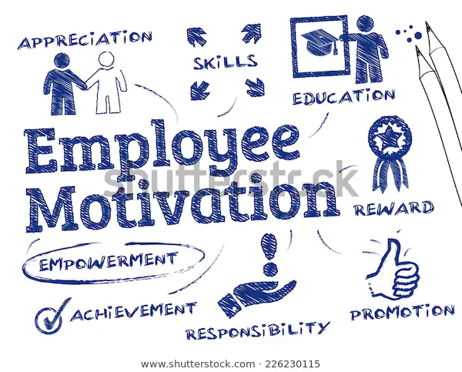

Table of Contents
1: Introduction 3
2: Development Vehicle 4

2:1 Motivation 4

2:2 Employee Engagement 5

2:3 Can HR Performance Drive Employee Engagement 6

3: McDonald HR 7

3:1 Feedback………………………………………………………………………………………….8

3:2 History: McDonald……………………………………………………………………………….8

3:3 How Reward Impact on Organizational Performance……………………………………….9

3:4 Negative Reaction of Rewards………………………………………………………………10

4: Primary Finding: Working In McDonald………………………………………………………11

4:1 Jamal – SWOT & PDP……………..…………………………………………………………12

5: Conclusion………………………………………………………………………………………..13

6: Reference…………………………………………………………………………………………14
.
1: INTRODUCTION

In this assignment it explains that using development vehicles can help employees working benefit an organisation in increasing productivity. Employees working for a successful business hopes to start from the beginning of their career ladder and eventually climb to the top. Like all successful business McDonald gives the opportunity to individual to join them through recruitments and different job roles. This report looks at how McDonald’s human resource management help the business to manage people and help the business to grow. It focuses on how human resource engages with their employee, improving team spirit, mental health and wellbeing. Human resource show how they process in employing people, how they build policies and strategies? The report also looks into what motivates the employee’s working in McDonald and the workplace relationship. At a workplace if employers give their workers incentives like bonus, praises and other rewards, how it impacts an organisation. To evaluate on how these development vehicle works, secondary and primary data will be used.

2: DEVELOPMENT VEHICLES
Development vehicle is a tool used for employees to learn and advance their skills to improve their knowledge in their career and in their personal life. This can be motivation, employee engagement, commitments, rewards and feedback. This tool can be used to recognise which employee requires further training, use the information on appraisals and employees reports.

2:1: MOTIVATION
Motivated employees will show energy, commitment, loyalty and take initiatives to accomplish something, they will not sit back and wait, but will be decisive and will take charge. Workers who are motivated will challenge their management if they feel their views are different or if they feel the management decisions will jeopardise the organisation. They are willing to help their colleagues by supporting and helping them, look after their colleagues no matter what and believe in achieving their goals together. Motivated employees will take care of their duties meticulously and their work is in good quality, employee will feel like waking up in the morning and go to work. Motivated workers will avoid being late for work, avoid absenteeism and not worried about work related stress. This will help an organisation the increase their productivity and profit, (Anthony, R,2017)
There are theorise of motivation which explain the way people think and recognise what is happening and it can influence their motives. There are several motivations theorise available relating to employees’ incentives, sport and others that effect how human behave.
Maslow’s Theory of the Hierarchy of Needs
‘’The body of man is a machine which winds its own spring’’, (J, O,De La Mattrie)
The most common theory for motivation is Maslow’s theory; this explains how motivation through satisfaction for needs is done in hierarchical order. The theory shows when an individual feel they are dissatisfied they feel the need to move towards their achievements.

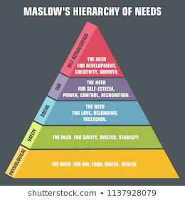

2:2 EMPLOYEE ENGAGEMENT
‘’When people are financially invested, they want a return. When people are emotionally invested, they want to contribute’’, (Sinek, S)
Employee engagement is based on trusting each other, good connection and good communication between the worker and employer. It is considered that if employees are happy the business performance will be better, so employers have to go out of their ways to hire people with excellent skills. It is challenging for employers to maintain their workforce by actively engaging with their employees, this skill is required mainly for management level and gives them opportunity improve their development.
means that leaders need to make it safe enough for employees to speak openly of their experiences at work’’. (William Kahn, Organisational Psychologist)

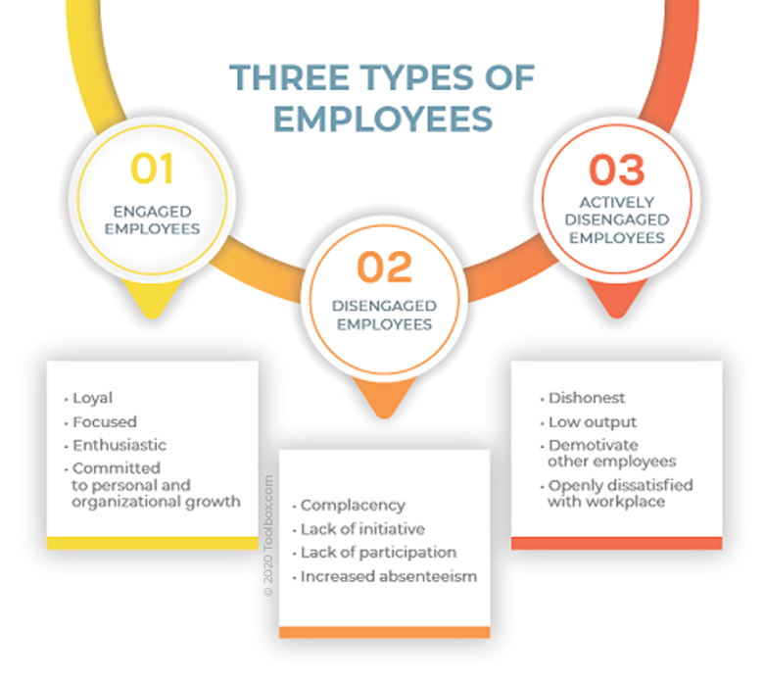

Fig 1. Employee traits based on the three types of engagement in an organization

In 1990 a Dr. William Kahn introduced a theory on employee engagement; he recommended that people are engaged in their work at three levels – physically, cognitively, and emotionally. Dr Kahn was able to identify why some employees can be engaged at fewer levels, or even disengaged or actively disengaged. Kahn researched involved 2 workplace studies, first with a summer camp and 2nd with an architecture firm. He found diligent employee will tackle all tasks willingly without being asked, they will be loyal and show ownership and believe their effort will benefit their workplace. Dr Kahn also found that when employee behaviour changes on different matter it can cause an impact their engagement. Employers can use this opportunity to create a setting at a workplace to include more engagement and continue to flourish.

‘’Approach employees as true partners, involving them in continuous dialogues and processes about how to design and alter their roles, tasks and working relationships which means that leaders need to make it safe enough for employees to speak openly of their experiences at work’’. (William Kahn, Organisational Psychologist

2:3 Can HR Performance Drive Employee Engagement?
Alongside the employer the Human Resource, (HR) can also promote employee engagement; they can create a programme of reward and recognition at the company they are recruiting for. HR serves both employer and employee and they act as a mediator for both sides, so it is important that HR know the plans and goals for employee engagement. Research done by Aon Hewitt shows that managers suggests that they cannot influence action plans to improve employee engagement, but it is down to HR professionals to engage with managers to build their engagement capabilities, (Dib, E, 2016).

3 Ways to Boost Employee Engagement Level:

- Focus on business outcome: To deliver a positive impact on performance for a company the HR has to understand that by enhancing employee engagement from the beginning. Not to rely on management on delivering the employee engagement, but start to implement initiatives such as monitoring employees, set out meetings, keeping data, get reviews and keeping information to see the outcome.
- Communicating with leaders and managers: Act as the voice for employees and also for managers so both parties do not feel overwhelmed with employee engagement plans. Annually meet managers and leaders to monitor employee engagements and keep track on how things are going. Encourage and support managers to understand and manage any challenges arise.
- Develop Management Strength: Frequently meeting with management and supporting them with action plans given to them for employee engagement. Make managers aware that this is also helping to develop their skill in leadership, this can help to accept challenges and they can show what they have achieved.

The Society for Human Resource Management shows a research done to show 44 features of job satisfaction and 38 elements related to employee engagement. The topics covered are career development, relationship with management, benefits, compensation, work environment, opinions and engagement behaviour. This discusses the leading job satisfaction, the importance, satisfaction, implication and recommendation for improvement.
The research has shown that 89% of U.S employees reported that they are satisfied with their job and a moderate amount of workforce is engaged. The result show that trust between employees and senior management has increased by 6% compared to 2015, it also shows the importance and satisfaction of bonuses. Out of 5 employees, 2 employees, (40%) stated that although they are happy with their job, they still seeking employment outside their organization and this were due to pay.

3: McDonald’s HR
Human resource for McDonald’s is involved in staff recruitments, selections, employees, job designing, reward and recognitions. They focus on training their employees, so they have the right skill to work in production line and for their job role. The operation management for McDonald’s support HR to engage employees and encourage to their organizational culture.
There are various reasons on why people want to work in McDonald, in their website their employees working there have stated several reasons. The first one is flexibility, this is due to employees of certain age who apply can choose the working pattern and still deal with other activities, like going to college or university. They get support from the management to create a schedule that works around their life, for someone who may have caring responsibilities. Employees can take responsibilities on making decisions in what roles they would like to take so it suits their need. Have opportunity to train and gain skills, developing further so they get a chance in moving up their career ladder.
McDonalds have the early career opportunity for employees who may be a student, undergraduate or an apprentice. Student who left school at 16 and not have any work experience can apply for the Student Work Experience Programme, they can join a McDonald restaurant and learn new skills like planning, communication, working in teams and decision making. This opportunity gives training development, free meals during shift and future opportunities. The undergraduate career is given for people who want to work in farming industry and get to meet the food suppliers of McDonald for meat, dairy and fresh produce. The apprenticeship programme at McDonald gives opportunity to young people in the hospitality industry where they can earn and study. They gain work experience, learn new skills and other abilities in dealing with customers and making decisions.

3:1 FEEDBACK
Feedback is when someone gives constructive suggestions by someone in management or higher level and from peers. This process is to encourage individual to improve their performance and it is recognised for their dedication in doing their job. Some employers make mistake in not providing enough feedback to their employees, this may be due to negative attitudes by the employees and not praising when it should be done. (Samuel 2019).

Examples of positive employee feedback
- Models good behaviour
- Meets or exceeds good goals
- Does minor, but worthy things
- Help colleagues or customers
- Goes extra mile
- Takes initiative
- Overcome obstacles
- Needs a confidence b
3:2 HISTORY: McDonalds
A successful restaurant owned by two brothers Dick and Mac McDonald; they had limited items in their menu. In 1954 a man named Ray Kroc found the opportunity to be the new franchising agent, he founded McDonald’s system and later bought the exclusive right to the McDonald’s name. Now McDonald is one of the world’s leading food businesses with over 36,000 restaurants in more than 100 countries, (McDonald.com).
‘’If I had a brick for every time, I’ve repeated the phrase Quality, Service, Cleanliness and Value, I think I’d probably be able to bridge the Atlantic Ocean with them’’, (Ray Kroc).
HOW REWARD IMPACT ON ORGANIZATIONAL PERFORMANCE
Employees like to be appreciated of their work they do and when employer offer rewards like vouchers, gift cards, extra leave and other monetary value to employees can help the business to have a positive impact. A study by a UK recruiting company Genesis Associate was done in 2018 for engineers, sales and creative sectors; found that 85% of employees felt they wanted to do well at their work, so they receive extra incentives. Also 73% added that the office environment was from good to very good while they worked during incentive period. Due to the incentive the business profits had increased and the employee relationship with each other was very harmonious.
Genesis Associates also surveyed about what kind of employee incentives the workers prefer and 40% preferred was such as bonus. Then 29 percent preferred free holiday or travel and the 23% preferred extra time off. There were other preferences like free meal, free drinks and early finish from work.
There is other employee incentive programme available to workers by their employers that may not include monetary value, but recognition like ‘employee of the month’, that help to lift the workers morale in the workplace. The Incentive Research Foundation found from 1996 to 2016 the non-cash rewards increased from 26% to 84%, (Higuera, V). Incentives with bonuses and other financial rewards can be given for 100% attendance, top sales target and friendly competition within the workplace. The employers can also consider profit-sharing incentive on top of their wages to their employees can ensure employees to be loyal to the company and this impact on increased productivity. Incentives include travelling and free holiday trips can be expensive for the employer to cover, however the employee can use this opportunity to achieve their targets and increase productivity and loyalty. Employers can offer wellness incentive programme this helps employees to relax and face stressful situation and mental health issues.
Company can arrange employees to involve in activities incentives like team days, out of work, team building and other team bonding venture with their colleagues and management. They can have learning and development incentives where employees can have opportunities to get training and shadow senior workers, so they get chance to apply for high level roles. This scheme helps employees to refine their skills and move their career forward; employers can customise an incentive for employees around their requirements and their necessity.
Working in McDonald’s restaurants offers various programmes for their workers to feel motivated and engaged with the organization. They have won ‘Employee Benefits Awards’ in 2012, they still make sure they do not lose their focus on this business strategy, (Crawford, R, 2015).
‘’We have made sure that reward is never out of alignment. If it was, it would need changing and we have not made significant changes for a good number of years now, but it is more of an evolution process. (Neal Blackshire, reward manager at McDonald and winner 2014).
McDonald offers bonuses to their employees working in the top 10% of their restaurants, they get extra 50p for each hour they have worked in two- week period and is scored by mystery shoppers.
Bonus scheme is also available for McDonald restaurants managers where they are given quarterly; this is worked out by their performance on sales growth, profits and scores given by mystery shoppers.
McDonald states that their reward structure makes its communication more important and their employee portal have helped to improve understanding between employer and employees. In 2015, 74% staff had answered that they are satisfied with benefits given by McDonald, this result was 23% better compared to other organisations.
There are 1,200 McDonald’s restaurants in UK and have around 100.000 employees and they had 1.9 million people working for them around the globe. Their employees are mostly people under the age of 25 and they have equal gender fairness. They offer family-friendly benefits like childcare vouchers, flexible working patterns, job sharing, maternity and paternity facilities. Other incentives for healthcare and wellbeing like dental care, eye care and private medical insurance. Recognition scheme like employee of month, quarter and yearly, holiday award, service award for employee working from 5 to 30 years, restaurant and consultant of the year. Employees also get performance related bonus in monthly, quarterly and yearly, paid annual leave and receive free meals while at work.

3:4 Negative Reactions of Rewards
Reward incentives at work can be positive for the workplace, however it can have a negative impact as well, causing the incentive to backfire and create malice between the workers, (Higuera, V). Another negative impact of getting incentives may be due to when employee feel that their co-workers is getting more notice on their performance and they have not been given the opportunity to show theirs. Reward for team performance related can cause hostility towards their colleague if they feel they have performed better than them and feel that unproductive workers should not get the same reward.

4: PRIMARY FINDING: Working in McDonald
My friend’s son, Jamal works in McDonald at Birmingham City Centre from the age of 16. He has works for them for 2 years and still in employment, he states that the job is suitable for him as he is a full-time student attending college studying Business course. McDonald has given the opportunity to be flexible in his working hours which is ideal for him when he has assignment to submit. When Jamal applied for this job in McDonald, he remembers going thru a selection of interview process. The first part is to phone the recruitment line and was asked few questions, it was based on what I would recommend on doing certain action when situation arise. Fortunately for Jamal, he had given the right answers and was taken thru the next step of selection process. He applied for customers assistant job, which is based in frontline, this job stated that required good communication skill and to observe this, McDonald invited him for a group play role activity. There were group of people who have also applied for the same roles, in the same room there were 2 staff from HR. They conducted the activity and observed how each applicant contributed to the play role. After few days McDonald’s HR notified Jamal that he was successful on his job application and to start his job in the next few week.
At the age of 16 and with no other experience, Jamal was excited to start his first job in McDonalds. He stated that he had no expectation from McDonald as he did not know what he had to do; he met the manager in charge of the restaurant and was introduced to other workers. A staff member was allocated to show me the ropes and started my training on the first day of work. Jamal stated that he felt overwhelmed while he was training; he felt that he was pushed into roles as it was busy that particular day and everyone working there was very busy. Jamal did not complain or showed any hesitations and carried on with him job and when he was not sure with something he would always ask. Main focus of this job was to serve customers, and this did require good communication skill, Jamal agrees with himself that he is a confident young lad and that may be the reason he got job.
I asked Jamal if he had any HR Employee Engagement or if the management involved in employee engagement at work. He answered that the only time he remembered HR is when the staff was at interview selection and later document given by them to sign and return back to them. The management employee engagement was only when he was asked to approach the manager if he needs assistant or look at working hours. There were no rewards given but free meal was given in working hours, no praises given if working hard, but the environment was friendly. There were other young, aged workers in the same restaurant, so Jamal felt connected with them; most workers were students like him. Jamal stated the only reason he chose to work for McDonald is due to the flexibility available and he can work around his studies. He is aware that their opportunities available in McDonalds in training and developing his skills, but he is not sure is he want a permanent career. When asked about if HR has ever approached him for further training or any kind of interaction between employee and management, he said there was none. The final question that is included in this assignment is if he was satisfied with his job, he answered that it was not a simple yes or no. He states that he is grateful he had a job and was given the opportunity to join them, but the job itself feels like temporary and he cannot see someone doing this job throughout the lifetime.

4:1 JAMAL’S SWOT & PDP
Jamal has kindly agreed to share his plan on SWOT and identifying his personal development plan, as a student and an employee he stated he understand the need of doing this. He has aims and goals to achieve and by doing this he can reflect on his strengths and weaknesses and what is required for him to help his future career.
SWOT
STRENGTHS  Good communication  Enthusiastic  Flexible | WEAKNESS  Not enough time  Too much homework  Balancing work & Study
OPPORTUNITY  Getting degree  Developing skills  Financial Benefit  Ideal Career | THREATS  Not submitted assignment  No time for social time  Loosing ‘drive’

PDP

GOALS | HOW? | SUPPORT/RESOURCE | TARGET DATE
Part time work | Have correct approach, take more training, get or involved | Ask for feedback from colleagues and management | 3 months
Education | Complete my studies and get good grades | Support from college teachers to university tutors | 3 Years
Career | Finishing my degree in Business, move from McDonald and work in management at ideal organization | Apply for jobs in management, show my degree and my skills | 3 years
Social | Be helpful and friendly in work and home | From family and fellow student and colleagues. | Weekly

5: CONCLUSION
Job satisfaction is vital for an individual working for any organisation and it suggested by surveys and various finding that it help business increase the productivity and profits. In the assignment it covers how employee motivation can be measured, the impact of motivation at work and what development vehicle is available to motivate workers. It has also covered on how Human Resource (HR) can help a business with employee engagement, the positive and negative of employee incentive and feedbacks. It briefly explained about working in McDonald and a review from Jamal, who works in a McDonald branch. If an employee enjoys working in their workplace and look forward to going to work, they will have good relationship with management and their colleagues. Receiving reward and incentive shows appreciation for employees by their employer and loyal employee will treat their organisation as their own.

6: REFERENCE

Linkedin.com. 2020. 7 Indicators of High Employee Motivation. [online] Available at: <https://www.linkedin.com/pulse/7-indicators-high-employee-motivation-ray-anthony/> [Accessed 28 October 2020].
2020. [online] Available at: <https://www.business2community.com/human-resources/the-pros-and-cons-of-employee-incentive-programs-02153490> [Accessed 11 November 2020].
Bean, S., 2020. Lack of Motivation at Work Impacts Both Performance and Mental Health - Workplace Insight. [online] Workplace Insight. Available at: <https://workplaceinsight.net/lack-of-motivation-at-work-impacts-both-performance-and-mental-health/> [Accessed 16 November 2020].
Businessnewsdaily.com. 2020. [online] Available at: <https://www.businessnewsdaily.com/8506-employee-productivity-incentives.html> [Accessed 01 November 2020].
Businessnewsdaily.com. 2020. [online] Available at: <https://www.businessnewsdaily.com/9240-engaging-employee-incentives.html> [Accessed 09 November 2020].
Corporate | McDonald’s Careers. 2020. Corporate | Mcdonald’S Careers. [online] Available at: <https://careers.mcdonalds.com/us-corporate#!> [Accessed 09 November 2020].
Crawford, R., 2020. The Employee Benefits Offered by Mcdonald’S Restaurants - Employee Benefits. [online] Employee Benefits. Available at: <https://employeebenefits.co.uk/issues/june-2015/the-employee-benefits-offered-by-mcdonalds-restaurants/> [Accessed 11 November 2020].
Verywell Mind. 2020. 6 Key Ideas Behind Theories of Motivation. [online] Available at: <https://www.verywellmind.com/theories-of-motivation-2795720> [Accessed 14 November 2020].
Linkedin.com. 2020. Impact of Employee Motivation on Performance (Productivity). [online] Available at: <https://www.linkedin.com/pulse/impact-employee-motivation-performance-productivity-anar-nesibov> [Accessed 09 November 2020].
Jahan, S., 2020. What Is Reward System In HRM? | Human Resource Management. [online] Hrmpractice.com. Available at: <http://hrmpractice.com/what-is-reward-system-in-hrm/> [Accessed 15 November 2020].
Small Business - Chron.com. 2020. Differences Between Monetary and Non-Monetary Incentives. [online] Available at: <https://smallbusiness.chron.com/differences-between-monetary-nonmonetary-incentives-26139.html> [Accessed 02 November 2020].
Mcdonalds.com. 2020. Mcd Corporate. [online] Available at: <https://www.mcdonalds.com/us/en-us/mcd_corporate.html> [Accessed 05 November 2020].
Statista. 2020. McDonald’s: Brand Value 2020 | Statista. [online] Available at: <https://www.statista.com/statistics/326059/mcdonalds-brand-value/> [Accessed 11 November 2020].
Spacey, J., 2020. 25 Examples of Job Satisfaction. [online] Simplicable. Available at: <https://simplicable.com/new/job-satisfaction> [Accessed 10 November 2020].
The Balance Careers. 2020. Top 10 Ways to Show Your Appreciation to Employees. [online] Available at: <https://www.thebalancecareers.com/top-ways-to-show-appreciation-to-employees-1916807> [Accessed 10 November 2020].
UK, M., 2020. McDonald’s Careers UK Home. [online] McDonald's Careers UK. Available at: <https://people.mcdonalds.co.uk/> [Accessed 12 November 2020].
The Balance Careers. 2020. What Is A Human Resource. [online] Available at: <https://www.thebalancecareers.com/what-is-a-human-resource-1918144> [Accessed 12 November 2020].
BambooHR. 2020. What Is Employee Engagement In HR? | Bamboohr. [online] Available at: <https://www.bamboohr.com/hr-glossary/employee-engagement-in-hr/> [Accessed 13 November 2020].
Toolbox. 2020. What Is Employee Engagement? Definition, Measurement, Drivers, And Strategies, With Examples | Toolbox. [online] Available at: <https://www.toolbox.com/hr/engagement-retention/articles/what-is-employee-engagement/> [Accessed 13 November 2020].
Peakon. 2020. William Kahn: The Founding Father of Employee Engagement - Peakon. [online] Available at: <https://peakon.com/blog/future-work/william-kahn-employee-engagement/> [Accessed 08 November 2020].

