
APPENDIX GA36c

LEVEL 6 ASSESSMENT SPECIFICATION

Student name: | Elizabeth Watt | Student ID number: | 1803104
Programme: | Primary
Module: | Principles of Pedagogy
Module code: | M6X01438/C | Contribution to Overall Module Assessment (%): | 100%
Lecturer: | Siân Brooks | Internal Verifier: | Siân Brooks
Assignment Title: | ‘Describe a learning event which has happened during your recent school experience. Reflect upon what took place, connecting events to theories of learning and teaching. Make recommendations about how you could improve your own practice in the light of this. Produce a poster to illustrate how you would develop the elements of an effective learning environment.’ | Word count (or equivalent): | 5,000 or equivalent.
Submission deadline: | 17/10/18 (23.59) | Return date of provisional marks & written feedback: | 14/11/18
Submission method: | All written assessments, where practical and possible, must be submitted via Turnitin unless otherwise instructed by the Lecturer. (Please DO NOT put this assessment specification into Turnitin or it will match many similarities with other students’ submissions.)  Alternative submission method (if applicable):  Late submission of the assessment will result in a late penalty mark. Penalties for late submission: Up to one week late, maximum mark of 40%. Over one week late, 0%. Only the Extenuating Circumstances Panel may approve a change to submission dates.
Academic honesty / referencing: | Academic honesty is required. In the main body of your submission you must give credit to authors on whose research and ideas your work is based. Append to your submission a reference list that indicates the books, articles, etc. that you have used, cited or quoted in order to complete this assessment.

‘Describe a learning event which has happened during your recent school experience. Reflect upon what took place, connecting events to theories of learning and teaching. Make recommendations about how you could improve your own practice in light of this. Produce a poster to illustrate how you would develop the elements of an effective learning environment.’
Word Count: 5,483

Introduction:
One of the leading problems in school is pupil behaviour (Howard, 2009). Reward systems are very prominent when trying to get children to behave and one of the newer techniques is known as a ‘ClassDojo’. ClassDojo is a communication app which is used in classrooms to give children points (ClassDojo, 2017), whether it’s to a child individually or a group. The point giving system encourages and reinforces children’s behaviour. The specific learning event observed was the use of ClassDojo in a year 5 class for control and to increase engagement while watching an educational video.
The school in which this occurred in was a large urban English medium school on the outskirts Swansea. The school has identified that 52% of pupils have additional learning needs and around 39% are eligible for free school meals, which is above the national average (Estyn, 2014). This could be due to the area of school, which according to the local authority is in one of the most deprived areas of Swansea (Estyn, 2008). There are just under 400 pupils with there being 384 pupils in 2017 (Welsh Government, 2017) where the ages of children ranges from 3 – 11 years. It is important to mention that there will be ethical consideration throughout this essay in which the school, teachers and students will not be named. This is in accordance to BERA guidelines, especially in regards to point 40 where by ‘the confidentiality and anonymous treatment of participant’s data is considered the norm for the conduct of research’ (BERA, 2008: 21). This essay will also look at two other aspects. One being behaviourist theories including the works of Watson, Pavlov and Skinner and how ClassDojo can be linked to behaviourist ideas, and the other being a poster showing my ideal learning environment in which I will explain why I have included certain elements and justify the pedagogical principles underpinning my vision.
Observation:
On Wednesday 19th September, I had the opportunity to visit a school to observe for the day as part of a bridging experience organised by University of Wales Trinity St David. I was placed in a year 5 class of 30 children for the day where I helped out but also observed with the aim to find a specific learning event.
The research method used for the purpose of this assignment was observation. McBurney (1994) describes observational research as a study method in which behaviour is recorded and observed and the researcher does not attempt to change it. Observation is a qualitative method, which means it concentrates on the meaning and interpretation of events, in comparison to quantitative methods which focus more on numerical data (Wragg, 1994). The method of classroom observation I used, has been defined by Montgomery (2002, p.36) as ‘by gazing about’, in which I sat with pupils while the teacher taught and then once the pupils had been set a task, I wondered around observing what children were doing and offered help where I could. To record my observation I recorded written notes. This was due to audio and video recordings of the children not being permitted, as well as notes being quick, flexible and less obtrusive, which are benefits of this chosen method (Foster, 1996). However, one of the main negatives of observation, especially within a school setting, is the influence an observer can have. Both teachers and children may change the way they behave because they behave because they are being observed (Foster, 1996), in which the presence of an additional person who is not normally present may influence behaviours. This limitation of observation links with the learning event I witnessed because the children could have been better behaved and compliant due to me being there.

The learning event that I observed was the use of ClassDojos to encourage behaviour and engagement of students. The first version of ClassDojo was launched in August 2011 in America and was founded by Sam Chaudhary and Liam Don. ClassDojo is used in 90% of elementary-middle schools use it within the US and it has expanded to 180 countries. ClassDojos aims to connect teacher, students and parents in a bid to build ‘amazing’ classroom communities. A way in which they do this is via the downloadable app, which allows parents to track their child’s points and provides a platform for teachers and parents to communicate with each other (ClassDojo, 2017). Teachers use ClassDojo as tool of encouragement and to control behaviour, rewarding children for being kind, sitting quietly and working hard, to name a few. Each child has an avatar and points can be awarded individually to children, to class tables, or to the class as a whole. Figure 1 shows ClassDojo avatars.

Figure 1: ClassDojo Avatars. Taken from: www.classdojo.com

In the year 5 class I was placed in, pupils were beginning to get restless due to it being the last lesson of the day. The teacher asked all the pupils to come and sit on the carpet to watch an educational video. The first few children that were set ready to watch, were awarded a Dojo point each. This encouraged the other children to go to the carpet and sit up straight, ready to watch the video. The video that the teacher put on was Newsround, which is an education news programmed designed for children which has aired the night before. Looking around the class, it was clear to see that some children were not interested, with a few exclaiming “Do we have to? That’s boring!” This was when the teacher told the class that they must focus on the programme because at the end of the programme there was going to be a question and answer session to see who was listening and those that answer the questions right were going to be rewarded with Dojos. This had an immediate effect with the children now focusing on the video. Once the video was over, the teacher then asked questions and rewarded those who answered them. There was a high level of engagement with many children putting up their hand to answer, in the hope to earn themselves a Dojo. To further check their level of engagement and understanding, the teacher asked the children to think what other questions could be answered from watching the video. Those children that put forward their questions were praised for their engagement and awarded a Dojo point.
The children were enthusiastic about earning Dojo points because the pupil with the most Dojo points at the end of the week gets a small prize. As well as this, the teacher has set a challenge for the class to get 800 ClassDojo point as a class by October half term and if they do the whole class will get a reward. This resulted in the pupils encouraging each other as well as self-regulating their behaviour, by telling others to behave, because they want to earn this reward.
This event shows how ClassDojos can be used to encourage engagement and promote idealistic behaviour. This links with the theory behaviourism, in which Skinner states how behaviours can be reinforced by a positive reinforcer, which in this example is a Dojo point. Nye (1979) believes that the idea of reinforcement is one of Skinner’s most important behavioural concepts. Reinforcement is the idea that a strengthening effect occurs when behaviours have certain consequences, meaning the probability of a certain behaviour will increase in likelihood when it’s reinforced. Despite the words ‘reward’ and ‘reinforcement’ often being spoken about with similar meaning, they are not the same. According to Skinner, reinforcement strengthens behaviour and so if what is being done doesn’t have that effect, than reinforcement isn’t happening. Whereas with rewards, they acknowledge a certain behaviour but do not necessarily strengthen behaviour (Nye, 1979). For example, within my observation, it was clear to see that ClassDojo points were strengthening behaviours of certain students but not all. There were students that immediately went to the carpet and waited for the teacher, whereas other students only behaved once they had realised that those who were behaving were getting a Dojo point and thus, they changed their behaviour in an attempt to get a reward.
Although the link to behaviourist theories in this observation is the most profound, it can be argued that there are some social constructivist aspects. Vygotsky’s ‘cultural-historical social activity theory argued that learning was done when children thought for themselves (Aubrey and Riley, 2016). In defining ‘good behaviour’ the class had their class rules which they designed at the start of the year. ClassDojos are awarded to those that comply with these rules and those that do not are reminded that these are the rules that they agreed too. Therefore, although children are told to behave and motivated by Dojos, they were the ones that constructed the class rules, not the teacher, suggesting there is some form of social construction happening.
Despite ClassDojos being used as a tool to encourage good behaviour and being used by children to self-regulate their behaviour, it has faced criticism. Some parents have had concerns about how publicly displaying points to an entire classroom may impact students negatively, especially those that are particularly sensitive (Bishop, 2014). However, teachers do see it as having more positives than negatives. For example, in an article in the Guardian a teacher states how when she sets her students on a task and then picks up the iPad, even children that are normally disinterested try in the hope that they will get a dojo (Buchanan, 2013).
Therefore, in conclusion, after my observation, it can be seen that ClassDojo can act as a tool for behaviourism. It is a modern, technological way of giving children points which moves away from the traditional point giving method, points on paper or a white board, which has been used for years. Due to technological advancement, the use of ClassDojo entices children more as they have their own avatar and makes earning points more of a game and thus can act as a key tool for controlling behaviour in the classroom.
Connection
Pedagogy, as defined by Child Australia (2017: 1) is ‘a term concerned with what a teacher does to influence the learning in others’. Teachers can use theories to assist them in this because they provide a different scope in which teachers can learn to make sense and respond to (Child Australia, 2017). I have already mentioned some aspects of behaviourism, this next section aims to divulge deeper into the theory of behaviourism focusing on who the main behaviourists were and how they can be related to education and linked to the uses of ClassDojo.
Behaviourism is a worldview that believes that learners are passive and react to environmental stimuli (Watson, 2013). One of the first experiments exploring this was done by Ivan Pavlov, who trained dogs to salivate to the sound of a bell. Pavlov was a Russian physiologist who developed the term ‘Pavlovian Conditioning’, which is otherwise known as classical conditioning. Classical conditioning is learning that occurs as a result of an association between a naturally occurring stimuli and an environmental stimulus (Aubrey and Riley, 2016).
In classical conditioning, the subject has no control over the response, which can be seen as reflexive response, because it is uncontrollable and natural (Nye, 1979). In Pavlov’s experiments, salivation is the dog’s response when it sees food. Eventually, the bell alone triggered the salivation and the food stimulus was no longer required (Aubrey and Riley, 2016). Therefore, the food which caused the reflexive response initially was no longer needed for the reflexive response to occur. Therefore, this suggests that an initially neutral stimulus became a conditioned stimulus (Nye, 1979) and that Pavlov had showed how reflexes could be modified by experience (Rachlin, 1970).
John B. Watson also believed in classical conditioning. His experiment involved conditioning a young boy ‘little Albert’ to be afraid of white rats. He believed that emotional responses, such as being scared, can be explained using Pavlovian conditioning. At the start of the experiment, Albert initially showed no fear when presented with a white rat, rabbit and other stimuli. However, he was scared of loud noises. Over a period of two months the white rat was presented again but this time with a loud noise and this process was repeated, resulting in Albert crying each time (McLeod, 2018). Eventually, it only took the white rat to be presented on its own for Albert to show a phobia to it due to the rat being associated to a loud noise. Therefore Albert has been conditioned to behave a certain way when he saw the white rat. However, Watson’s method has been criticised due to the ethical issues surrounding scaring a child.
Both Watson and Pavlov experimented with observable behaviour and believed that humans had no free will, instead, they are shaped by the environment. Burrhus Frederic Skinner on the other hand, although he acknowledges the significance of Pavlovian condition in regards to reflexive responses to neutral stimuli, believed that responses could be shaped through operant conditioning (Aubrey and Riley, 2016). This is because he believes active responses are more important because they make up most of the activities we engage in such as writing, learning, reading and many more. He argues that these do not consist of reflex actions shown in Pavlov work, but instead consists of operants (Nye, 1979).
Operant conditioning is when the behaviour of the subject determines the response to the subject’s actions (Jordan, Carlile and Stack, 2008). It is called this because behaviour operates upon the environment causing consequences (Bigge, 1976). Conditioning is distinct from training because there is no need for intellectual activity to occur to achieve a desired result (Winch and Gingell, 1999). Skinner believed that when something reinforces a behaviour, the chances of that behaviour being repeated will increase (Bigge, 1976).
Skinner tested his theory using animals and a soundproof clear box, known as ‘Skinner box’. The box being soundproof enabled Skinner to ensure scientific objectivity because the animals were isolated from interfering influences which could have affected the experiment. The main focus animals for this experiment were rats and pigeons. Both animals had to apply pressure for food to be dispensed, a rat pressed a lever whereas a pigeon pecked a small disk (Nye, 1979). Both animals quickly learnt that when a specific amount of pressure was applied food would be dispensed. Therefore the dispensing of food led to the action being repeated (Aubrey and Riley, 2016).
It could be argued that Skinner’s work was influenced by American psychologist Edward Thorndike idea of law of effect, developed in 1898. His studies showed that a behaviour followed by a pleasurable consequence would be more likely to be repeated (Aubrey and Riley, 2016). Thorndike used cats, dog and chickens to test this. In the experiment, Thorndike placed food outside a box, known as a puzzle box, where the animal could see it and to escape the box, they had to pull a bolt or step on a lever. Thorndike found that after repeating the experiment with animals, there was a negative correlation between the length of time it took to escape and the number of time the animal escaped (Rachlin, 1970). This meant that the more trials done resulted in the animal escaping the box sooner. This approach has also been seen as trial and error learning (Bigge, 1976)).
Skinner went beyond the repetition of an activity and went on to look at how these behaviours are reinforced. He believed that when a behaviour is reinforced, it is repeated which results in the behaviour being strengthened. In applying Skinner to the classroom, his theory suggests that the likelihood of ideal children behaviour occurring depends on the positive or negative reinforcers in place. Low level disruption is the most common type of misbehaviour causing distraction from the lesson (Grigg, 2015). This has an impact on other children’s education. Previously, to get children to conform to the idealistic behaviour, some teachers used corporal punishment. However, after this was abolished in the UK by 1998 (Aubrey and Riley, 2016), schools use alternative methods such as detentions, exclusions and loss of privileges such as golden time, in an attempt to manage behaviour.
However, Skinner’s theory sees this as counterproductive because it is only managing the behaviour temporarily and focusing more on the punishing aspect (Aubrey and Riley, 2016). Many schools, have been impacted by Skinner’s idea of positive reinforcement and use reward systems, such as ClassDojo to moderate behaviour. Many teachers are applying these systems to reduce unwanted behaviour through rewarding positive behaviour, and those children who seek approval from their teacher are likely to comply so that they receive reinforcement or praise. This can be linked with the learning event I observed, some children went and sat on the carpet immediately and waited for the teacher to start the video, in a bid to seek approval from the teacher and potentially gain a dojo point.
Negative reinforcement is different to punishment. When a child is misbehaving, punishment aims to stop the behaviour straight away by issuing a detention or taking away privileges. If a child is misbehaving and is told off, they have received the attention they desire and therefore they are not going to adapt their behaviour (Aubrey and Riley, 2016). Whereas negative reinforcement focuses on changing and strengthening behaviour. For example, sometimes if a child is misbehaving, it is better to ignore them, because eventually they will learn they will not receive attention until they behave in the correct manner.
Humanists often react negatively to Skinner’s ideas because he shows little respect for freewill and inner meaning which humanists see as vital to human actions. Carl Rogers is a humanist who believes that we seek fulfilment, growth and meaningful relationships. He focuses on inner experiences such as feelings and thoughts, whereas Skinner focuses on objective behavioural determinants. Both Roger and Skinner have further differences when it comes to the structure of education (Nye, 1979). Roger believes learning should happen in an unstructured setting in which resources are available for the learner and allows them to pursue their own personal interests. People are naturally curious and so allowing them to choose their own learning path is likely to encourage learning (Nye, 1979). Jerome Bruner further supports this suggesting at the core of learning is motivation, interests and culture, emphasizing the importance of children actively constructing their knowledge. They are influenced by their own experiences, the environment and the experiences of others (Aubrey and Riley, 2016). Thus, this creates a type of learning in which they choose how their learning develops, creating a more student centred education.
Skinner, on the other hand, believes that education should be more structured. His view consists of the idea that students should be given work in small units and that each unit should be taught sufficiently so students can master it. Skinner favours planned, systematic presentations of materials with opportunities for student progress to be reinforced. By learning this way, effective learning has taken place and students feel positive (Nye, 1979).
Overall, it can be suggested that behaviourist theories are linked to education. Through the development of behaviourism methods throughout the years by various theorists, it can be seen that repetition, conditioning and both positive and negative reinforcement are used in the classroom to promote learning. Whether this is by encouraging certain behaviours or in everyday learning such as the repetition of times tables.
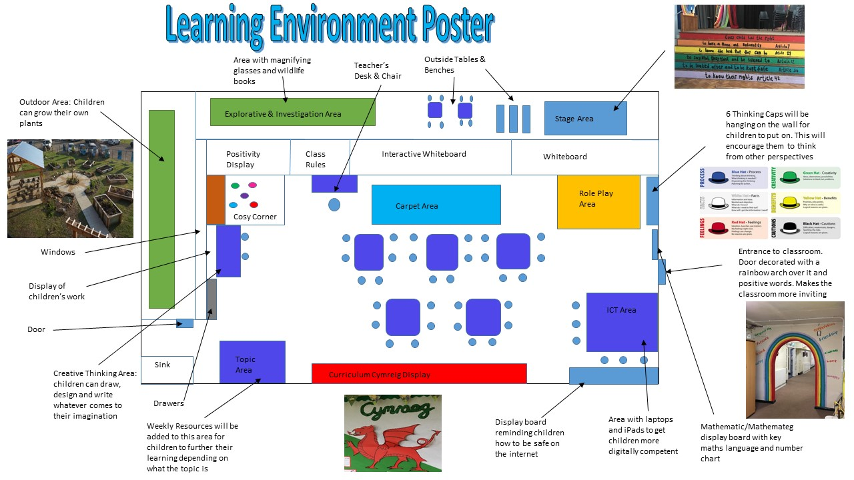
Reflect and Innovate

Play is one of the main means of learning in childhood. Through play children can learn to explore and develop experiences; practice and create ideas and skills as well as think imaginatively (Drake, 2001). Donaldson developed a new term for play known as experiential learning, which is the idea that children learn through doing and then reflection (Brigley, 2016). That is why in my learning environment poster above I have aimed to keep learning creative in the hope that it will fuel children’s imaginations. I have based the learning environment poster on a Year 5 classroom to coincide with my learning observation. The following section discusses reasons for certain aspects in the learning environment, including outdoor learning, curriculum, motivation and digital competence.
An outside area enables planned play to take place inside and outside and is one of the key ways that children learn with enjoyment (Drake, 2001). Specifically in my poster I have created an outdoor area which is dedicated to science and wildlife. Children will be able to grow their own plants from seeds and will have to look after their plant throughout the year. This will show the growth and development that can be achieved if they look after it. In the outdoor area, there will also be magnifying glasses and wildlife books. Children will be encouraged to use the magnifying glasses to find insects and plants and then use the wildlife book to investigate what they have found. This area puts emphasis on explorative and imaginative learning.
Both of these activities link to the key stage 2 Science curriculum in the section referring to ‘interdependence of organisms’ in which children learn about animals and plants in local environments, identifying them and also finding about their nutrition. Children would be able to create food chains, as well as looking at environmental factors that affect what grows and lives, such as sunlight, water and temperature (Welsh Government, 2008). The outdoor area could also be used for many aspects of maths. For example, children could count how many insects and plants they find and categorise them. This links to the using data skills section in the key stage 2 maths curriculum that states the learners need to be able to represent date using tally charts, tables and frequency tables. They could also use the data to work out mode, mean, median and range (Welsh Government, 2014).
In the outdoors area, there will also be a stage present in which children can perform shows and develop their role play skills. In the stairs up to the stage there will be the human rights of a child painted along the panels for the children to have a constant reminder of what they are. One of Graham Donaldson’s areas of learning and experience is expressive arts. In his work Successful Futures, Donaldson highlights how through expressive arts children can be encouraged to develop their creative appreciation and performance skills (Donaldson, 2015). The literacy and numeracy framework for year 5, also highlights how children should practice speaking cleanly and projecting their voices to audiences, in which having a stage would allow them to practice this (Welsh Government, 2014).
Role play is a widely used teaching method which encourages effective learning (Journal of Interactive Learning Research, 2018). The stage would become a useful tool in enabling the children to achieve this. A dress up box would also be provided to children which would have costumes in depending on what theme was being studied. For example, a gas mark, if the theme was World War 2 evacuation. The box would be kept inside, to allow the children to get involved in roleplay both inside and outside. Through role play, dress up and hot seating, children could learn about different eras of History creatively as well as being given the opportunity to play and talk in role, strengthening their language skills (Leimanis-Wyatt, 2010). This results in children having experiences which would make history interesting, enjoyable and promote curiosity about the past, which is one of the outcomes of the History curriculum in key stage 2 (Welsh Government, 2008). In the role play area there would also be 6 thinking hats, as shown in figure 2, which is a tool developed by Edward de Bono, aiming to encourage children to think from different perspectives (Project Management Academy, 2016).
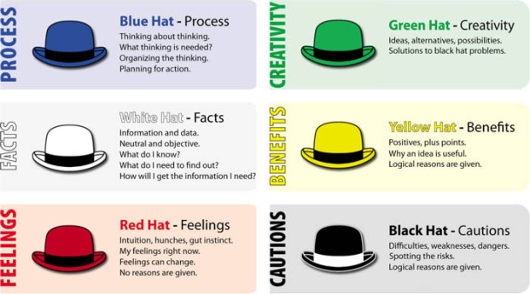 Figure2: 6 Thinking Hats. Taken from: https://projectmanagementacademyweb.wordpress.com/2016/12/27/6-thinking-hats/
An interactive whiteboard will be in front of the carpet on the central wall of the classroom so that children will be able to see the board from all areas of the classroom. One of the main benefits of using an interactive white board is students engagement increases (Giannikas, 2016). There are many uses of an interactive whiteboard, such as projecting resources, interactive games, and using it as a writing tool with the electronic pen. Children can be more engaged when an interactive whiteboard is used because learning becomes more creative and fun. Using the interactive whiteboard to show ClassDojo can be an example of this, in which the children can see their cartoon character and there are sound affects when points are added or deducted. Whereas previously points were given on a whiteboard next to students names, which is not as enticing as being given a point interactively.
The use of an interactive whiteboard links to Donaldson’s idea of Digital competency in which digital competency is becoming increasingly important in children’s lives for communication, information and entertainment. The ability to use digital skills in the workplace is becoming more and more common in the modern work place and so children need to leave schools being digitally competent (Donaldson, 2015). This is the reason why I have an area dedicated to laptops and iPads, so children can further their knowledge in subject area, while also becoming more efficient using technology.
I have also included a whiteboard. The whiteboard will have important information and reminders for the children, as well as the date because these can be left there constantly. Whereas on an interactive whiteboard, the screen constantly changes as the resources change. Also, a whiteboard is needed because it is quicker to write a sum or spelling on the board than it is to wait for a computer and projector to start up.
In front of the interactive whiteboard there is a carpet area. A carpet area has various uses in which it can be used as a whole-class gathering area, a teaching space and a presentation area (Leimanis-Wyatt, 2010). Juliet Desailly (2015) further supports the idea of a carpet area highlighting how some children find it hard to sit at a table for a long period of time and so the option for children to take work to the carpet can be effective and result in more engagement.
Next to the carpet is a cosy book corner where there will be a library full of different genres and various types of fiction and fact books. I would try to change the books every term and relate the fact books to a certain theme. For example if the theme was the jungle, I would create a banner which would state ‘wild about books’ and for a sea theme it could say ‘Dive into a good book’ (Leimanis-Wyatt, 2010). Changing the theme and look of the book area would hopefully be effective in keeping the children engaged in their reading. I would also include Welsh medium books for the children to practice their Welsh and there will also be an English version available, so children can compare the language and further their knowledge. The area is next to the teacher’s desk and carpet so that the books are easily accessible for the teacher and students if they were to read a book together as a class. There will also be bean bags in the book corner, so children can relax while reading.
Around the room there will be various display boards showing children’s work and their progression. Display boards celebrate achievement, stimulate interest and can extend children’s knowledge (Drake, 2001). There will be a display dedicated to ‘Curriculum Cymreig’, which will focus on children understanding and celebrating their Welshness in a bid to make them feel a sense of belonging to their community. The display would also make links to promoting global citizenship and focus on how the children can help create a sustainable development (Welsh Government, 2003). Around the classroom there would also be key vocabulary to encourage children to speak Welsh. This would include days of the week, months, numbers, food, emotions, weather, sentence starters and much more.
On the display board next to the teacher’s desk is where the class rules will go. These will be created by the students and each child will put their handprint round the rules to create a circle to symbolise that they are united and all agree to these class rules. Class rules are very important because every child has the right to be in classroom and go to school without worrying about being bullied, and that they can learn without the disruption from another child. Rules in a classroom make boundaries clear and protect children’s rights (Wright, 2005). To reinforce these use I would use Skinner’s idea of positive reinforcement and also the use of ClassDojos to promote good behaviour. As a reminder of the ClassDojo points, the children’s avatars would be printed out and displayed round the classroom.
Above the book corner, there would be a display board promoting mindfulness and positivity, to help creative a positive classroom vibe. This is because children who feel good about themselves are more likely to want to behave and want to learn (Wright, 2005). This links to Maslow’s hierarchy of needs, shown in figure 3, in which basic needs need to be filled and the individual needs to work up the hierarchy to reach a sense of fulfilment. Once all the hierarchical needs are met then students will have a desire for self-fulfilment. Praise can help children achieve however, it must be sincere as children can become aware of praise that is dishes out meaninglessly (Jordan, Carlile and Stack, 2009).
The display board will also promote a growth mindset. This idea was created by Carol Dweck, who came up with the terms fixed mindset and growth mindset to describe beliefs about learning and intelligence. For example, when children believe they can get smarter, they understand the effort needed to achieve this and once they put the effort in it is likely to leave to achievement (Mindset Works, 2017). Therefore, those students that think positively and put in effort, will get the results they desire. This links to Maslow’s hierarchy of needs, in the sense that those with a growth mindset are more likely to strive for excellence, resulting in praise and increased self-esteem.
Overall, my ideal learning environment is one that promotes learning, positivity and curiosity. It will have strong links to the curriculum in a creative way and strive to focus on Donaldson’s areas of learning. Not only this, I want my ideal learning environment to be somewhere children want to go, to develop their learning in an enjoyable engaging way, as well as a safe place for children to enhance their knowledge and achieve the best they can.
Conclusion
This essay has aimed to look at three key aspects, a learning event, theories, and an ideal learning environment. The learning environment witnessed showed how children can be encourage to behave and become engaged through positive reinforcement and the reward system ClassDojo. This linked to behaviourist theories and by divulging deeper into the theories of Pavlov, Thorndike and Skinner allowed an understanding to be established on how behaviourist theories can be adapted for use in the classroom, in order to control and regulate behaviour. The final part of this assignment included a poster and commentary on my ideal learning environment for future students. It focused on curriculum, motivation, digital competency and outdoor learning and how these aspects of a classroom can be designed in an innovated and creative way to engage and develop learners.

Bibliography:
- Aubrey, K. and Riley, A. (2016) Understanding and Using Educational Theories. Sage Publications UK
- BERA (2018) Ethical Guidelines for Educational Research. 4th Ed. Available at: file:///C:/Users/User/Downloads/BERA-Ethical-Guidelines-for-Educational-Research_4thEdn_2018.pdf (Accessed 30th September 2018)
- Bigge, M.L. (1976) LEARNING THEORIES FOR TEACHERS. 3rd Ed. Harper and Row Publishers
- Bishop, A. (2014) A Parents Review of ClassDojo. Available at http://www.gettingsmart.com/2014/08/parents-review-classdojo/ (Accessed 4th October 2018)
- Brigley, J. (2016) Donaldson & Pedagogy: blended learning and experiential learning. Available at: http://www.judebrigley.co.uk/donaldson-and-pedagogy/ (Accessed 15th October 2018)
- Buchanan, S. (2013) An apprehensive teacher’s guide to ClassDojo. Available at https://www.theguardian.com/teacher-network/teacher-blog/2013/nov/28/teacher-guide-classdojo-behaviour-management (Accessed 4th October 2018)
- Child Australia (2017) What is Pedagogy? How does it influence our practice? Available at https://childaustralia.org.au/wp-content/uploads/2017/02/CA-Statement-Pedagogy.pdf (Accessed 9th October 2018)
- ClassDojo (2017) About Us. Available at: https://www.classdojo.com/about/ (Accessed 29th September 2018)
- Desailly, J. (2015) CREATIVITY in the PRIMARY CLASSROOM. 2nd Ed. Sage Publications
- Donaldson, D. (2015) Successful Futures: Independent Review of Curriculum and Assessment Arrangements in Wales. Available at: https://gov.wales/docs/dcells/publications/150225-successful-futures-en.pdf (Accessed 14th October 2018)
- Drake, J. (2001) Planning Children’s Play and Learning in the Foundation Stage. David Fulton Publishers
- Estyn (2008) A Report on the Quality of Education in Cadle Primary School. Available at: https://www.estyn.gov.wales/provider/6702008 (Accessed 29th September 2018)
- Estyn (2014) A report on Cadle Pimary School. Available at: https://www.estyn.gov.wales/provider/6702008 (Accessed 29th September 2018)
- Foster, P. (1996) Observing Schools – A Methodological Guide. Sage Publications UK
- Giannikas, C.N. (2016) The use of interactive whiteboards: enhancing the nature of teaching young language learners. Available at: https://files.eric.ed.gov/fulltext/ED572117.pdf (Accessed 15th October 2018)
- Grigg, R. (2015) BECOMING AN OUTSTANDING PRIMARY SCHOOL TEACHER. 2nd Ed. London: Routledge
- Howard, P. (2009) Restorative Practices in Schools. Available at: http://learning.gov.wales/docs/learningwales/publications/121129restorativepracticeen.pdf (Accessed: 29th September 2018)
- Jordan, A. and Carlile, O. and Stack, A. (2008) Approaches to Learning: A GUIDE FOR TEACHERS. Open University Press
- Journal of Interactive Learning Research (2018) Vol. 29. NO.2 2018
- Leimanis-Wyatt, M. (2010) CLASSROOM DIY: A practical step-by-step guide to setting up a creative learning environment. London Routledge
- McBurney, D.H. (1994) Research Methods. 3rd Ed. Pacific Grove, Calif, Brooks/Cole Pub. Co.
- McLeod, S. (2018) Classical Conditioning. Available at: https://www.simplypsychology.org/classical-conditioning.html (Accessed 10th October 2018)
- Mindset Works (2017) Decades of Scientific Research that Started a Growth Mindset Revolution. Available at: https://www.mindsetworks.com/science/ (Accessed 16th October 2018)
- Montgomery, D. (2002) Helping Teachers Develop through Classroom Observation. 2nd Ed. David Fulton Publishers
- Nye, R.D. (1979) WHAT IS B.F. SKINNER REALLY SAYING? Prentice-Hall, Inc., Englewood Cliffs, New Jersey
- Project Management Academy (2016) 6 thinking hats. Available at: https://projectmanagementacademyweb.wordpress.com/2016/12/27/6-thinking-hats/ (Accessed 15th October 2018)
- Rachlin, H. (1970) Introduction to Modern Behaviourism. 1st Ed. W. H. Freeman and Co
- Watson, J.B. (2013) Behaviourism. West Press
- Welsh Government (2003) Developing the Curriculum Cymreig. Available at: http://learning.gov.wales/docs/learningwales/publications/130424-developing-the-curriculum-cymreig-en.pdf (Accessed 15th October 2018)
- Welsh Government (2008) History in the National Curriculum for Wales. Available at: http://learning.gov.wales/docs/learningwales/publications/130424-history-in-the-national-curriculum-for-wales-en-v2.pdf (Accessed 14th October 2018)
- Welsh Government (2008) Science in the National Curriculum for Wales. Available at: http://learning.gov.wales/docs/learningwales/publications/140624-science-in-the-national-curriculum-en-v2.pdf (Accessed, 13th October 2018)
- Welsh Government (2014) National Literacy and Numeracy Framework, Available at: http://learning.gov.wales/resources/browse-all/nlnf/framework?component=numeracy&year=6938368_2&selectedYear=col_11&lang=en (Accessed 13th October 2018)
- Welsh Government (2017) My Local School: Cadle Primary School. Available at: http://mylocalschool.wales.gov.uk/School/6702008?lang=en (Accessed 29th September 2018)
- Winch, C. and Gingell, J. (1999) Key Concepts in The Philosophy of Education. London: Routledge
- Wragg, E.C. (1994) An Introduction to Classroom Observation. London: Routledge
- Wright, D. (2005) There’s no need to shout! The Primary’s Teachers Guide to Successful Behaviour Management. Nelson Thornes Ltd.

Picture References:
- Available at: ww.classdojo.com (Accessed 29th September 2018)
- 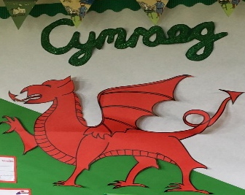 Authors own photo. Taken 19th September 2018
- 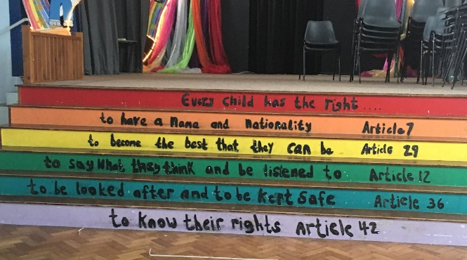 Authors own photo. Taken: 19th September2018
- 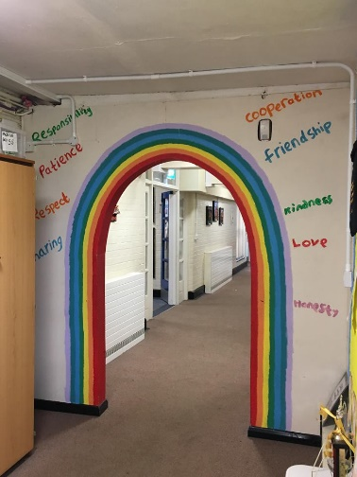 Authors own photo. Taken: 19th September 2018

Available at: https://projectmanagementacademyweb.wordpress.com/2016/12/27/6-thinking-hats/ (Accessed: 15th October 2018)

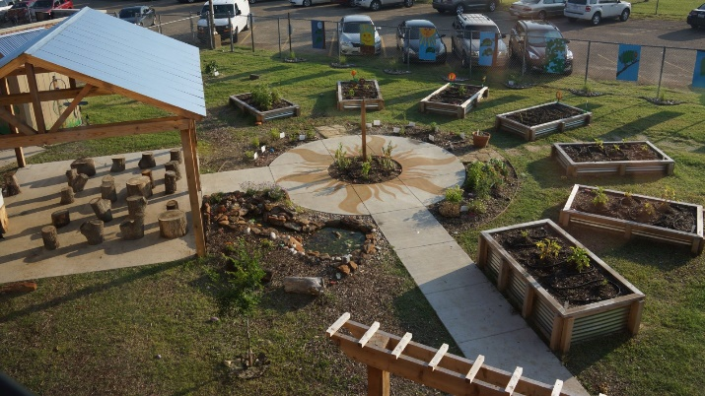 Available at: https://edition.cnn.com/2015/08/14/health/healthy-school-gardens/index.html (Accessed 15th October 2018)

Photo Permission Form:


