Student name: Hannah Thomas

P number: 1802545

Programme of study: Surface pattern for interiors

Tutors: Julia Lockheart and Gwenllian Beynon

Word count: 1466

My exhibition will take place at Birkenau (Auschwitz) camp. The women’s barracks will be my chosen area within the whole camp to place the exhibition. The viewers must take in the building and its surrounding area is like and visit the chosen place where they will see the exhibited work in the following week. On week two, the day will arrive where they will be attending the exhibition. The objects being shown in my exhibition will be that of daily textiles with a range of different colours and textures. I will be exploring colour theory and the psychology of colour and the effects it has on individuals. This exhibition will take place at the Auschwitz camp as I have knowledge on what took place here and the holocaust. It is a dark, grey and dull place with an eerie feel to it. The viewers must be mixed because in the two categories they will both have different feelings towards the place due to their knowledge and understanding of the past. Those whom had great understanding of the events taken place at the Birkenau camp would have different feelings and emotions to those who aren’t educated quite as much on the topic.
Empathy is the capacity to understand and enter into another person’s feelings and emotions or to experience something from the other person’s point of view (Colman, 2015). When the exhibition is coming to an end and the viewers have observed the colours and space; Empathy will pay a role in how they feel.
The world is surrounded by space. Space is the dimensions of height, depth, and width within which all things exist and move (Oxford Dictionaries | English, n.d.). The space that is chosen will have an impact on each individual which visits. That is why I chose to focus it on the Auschwitz camps.

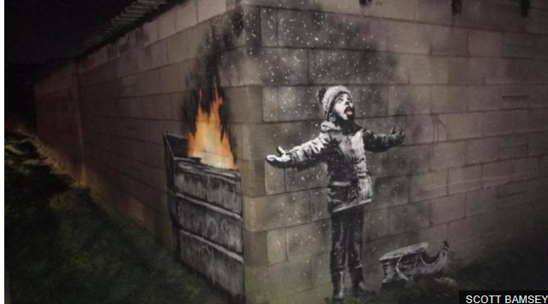
Figure 1: Banksy graffiti artwork on garage in Port Talbot, 2019.
Banksy’s work is based on politics. The work he produces send off a very important message similar to my idea of the exhibition. He has a well thought plan of where his work will be placed. His latest piece at Margam, Port Talbot is an example of this. He was trying to spread the important message of the steel works polluting the area, the world in which we live and the kids that have got to inhale. He placed his work near the steel works for more of an effect.
The image is of a child playing in the ‘snow’ which is ash from a skip and stuff being burnt within it. The location of his work makes it that little bit more intriguing. Port Talbot is a heavily polluted town. Just like Banksy’s work, in the exhibition because where it is taking place I feel like it will have a greater impact on the viewers emotions than if I were to do the same exhibition but in an old, abandoned building. ‘Moreover, exhibitions such as the present one have been undertaken to bring these reactions uncompromisingly to the public eye’. (Bohm-Duchen, 1995).
What is colour psychology?
“Colour is a powerful communication tool and can be used to signal action, influence mood, and even influence physiological reactions’ (Cherry, 2019) which is what I am looking into for my exhibition, is the reactions emotionally that individuals get from colour. The colours chosen will have to have more than one meaning and feeling behind it. The colours will be mixed so popular ones such as red and green and the not so popular like white. ‘choosing the right colours, can affect the feel and look of our homes and surroundings.’ (Curtis, 2019). By adding the colour it will hopefully change peoples outlook on the chosen space in the barracks.
The colour chart below shows the affects that colour can have on people’s moods.

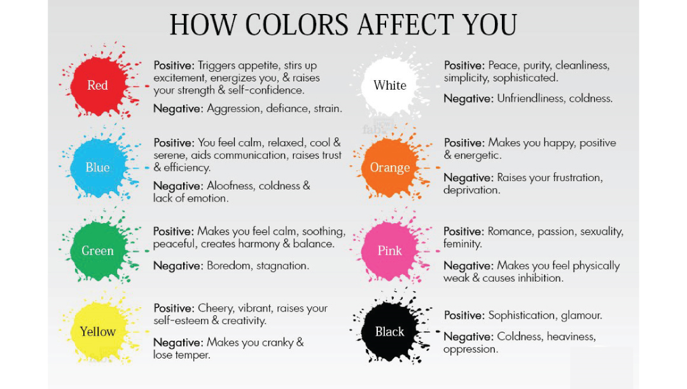
Figure 2: How colours affect you (Love nest design, 2019).
I want to use textile objects and decorate the interior of the barracks using the colour psychology theory. ‘Colour is powerful; it can alter a space, enhance a particular mood and excite the senses.’ (Mcloed, 2016). I got taught about this during a lesson workshop by ‘Andrea Curtis’. Andrea had done a presentation explaining colours and the affects they have on your mood. She explained that using colours such as yellow could have both a positive and negative impact on your mood. She later went on to explain that it depends on events such as a childhood trauma that you may respond to a certain shade of a colour differently to another person viewing the same colour as yourself.

Within the exhibition the focused colours are White, Orange, Red, Blue, Green and pink. I want to explore these colours because they have both positive and negative effects. The barracks are a negative space, but I want to explore colour to see if it could be brightened up by the colours triggering the viewers emotions; or if, in fact it has more of a negative effect towards the way they each see the camp.
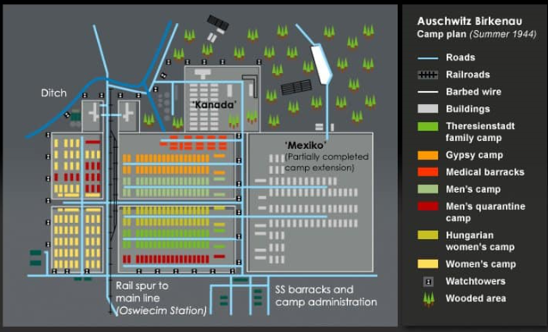
Figure 3: Auschwitz Birkenau summer camp plan, n.d.
This space was chosen due to the Birkenau camp known as ‘Auschwitz’ was a spacious, complex yet those occupying the space had none of the space (see figure 5). The space would perfectly work for the intended exhibition as I want to explore proxemics and colour with emotions (Discover Cracow, 2018).
The prisoners did not have much space so within the exhibition the textile, bight objects will be rather close to one another so when exhibition is visited, the viewers whilst looking at the work will realise how close they are to one another. They will be in the same close proximity or similar to those whom were in the Birkenau women’s camp (Discover Cracow, 2018).
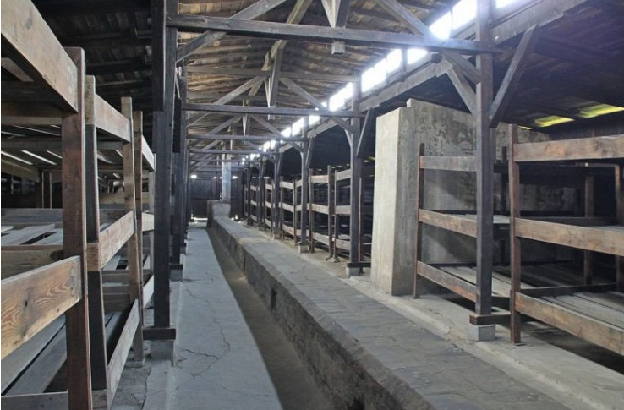
Figure 4 :Barracks from inside (Discover Cracow, 2018)
Above is a modern-day image of the barracks from the Birkenau camp. As you can see it is a rather dull, grey place where the victims from the holocaust slept. It looks like a very cramped place which is what I intend my viewers to feel whilst visiting my exhibition. I want the viewers to feel a connection to the history of the place as well as the colours. That’s why when the exhibition takes place you have to visit once before the 5 chosen colours are put into the room on various textiles, shapes and sizes. The first visit will mostly be about the past and then the viewer. The second visit is more about the person and their own emotions and reactions to colour.

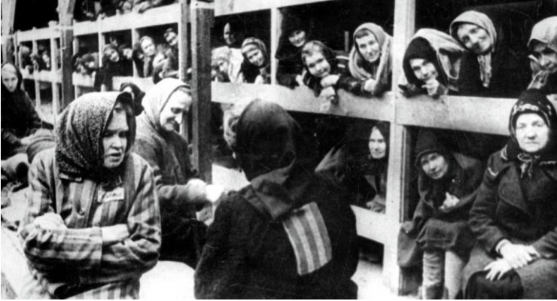
Figure 5 : Crowded barracks (Discover Cracow, 2018)
The image above from the women’s barracks in the concentration camps Birkenau demonstrating their personal space. Although there were Barracks made for the Jews at the Auschwitz camp, it has been stated that originally they were made to house 40 prisoners but often 700 would be placed in each of them (Theholocaustexplained.org, n.d).
That leads me onto personal space. The prisoners at Auschwitz got stripped of everything, clothes, money, Jewellery, family etc; even their personal space. ‘his ship’s sanitary arrangements could only cope with 700 prisoners. But that morning in the Bay of Lubeck we were nearly 4,500’ (Pivnik, 2013) shows how little space they always had. Their human rights were taken away along with their freedom and space.
At the end of the exhibition I will get feedback from the people that visited and question them on the differences in their mood from the first then the second visit. Then they will be asked what colours they were drawn to and ones that negatively and positively impacted their experience. ‘The artists had different goals: to document, to memorialise, to express a personal reaction, to understand and to draw moral lessons’ (Bohm-Duchen, 1995). My goal will be getting a range of feedback from the exhibition. I want the personal reaction from my viewers; it will be personal to each of them as the colours being exhibited will all have different meanings to the viewers. Some may react differently to the blue as demonstrated in figure two (Love nest design, 2019). A person educated on the Holocaust may see the blue as an emotionless colour and may connect it with a bad experience which they were focused on the colour blue whereas another person may see the blue and think that it uplifts the once dark, lifeless, grey room and bring a efficiency, calm and relaxed feel to it. Some viewers may just feel no other emotion than anger which in figure 5 is stated as the colour red. They may feel like this due to their knowledge on the place and colours may then still not interfere and play a role with their emotions at this present time.

Bibliography
Auschwitz Birkenau summer camp plan. (n.d.). [image] Available at: https://www.theholocaustexplained.org/the-final-solution/auschwitz-birkenau/living-conditions-and-sanitation/ [Accessed 7 May 2019].
Banksy graffiti artwork on garage in Port Talbot. (2019). [image] Available at: https://www.bbc.co.uk/news/uk-wales-47338314 [Accessed 7 May 2019].
Bohm-Duchen, M. (1995). After Auschwitz. Sunderland: Northern Centre for Contemporary Art, p.75.
Cherry, K. (2019). Can Color Affect Your Mood and Behavior?. [online] Verywell Mind. Available at: https://www.verywellmind.com/color-psychology-2795824 [Accessed 6 May 2019].
Colman, A. (2015). A dictionary of psychology. 4th ed. London: Oxford University press.
Curtis, A. (2019) ‘colour and you’, Andrea Curtis all about colour [blog]. 11 February. Available at : https://www.andreacurtis.co.uk/blog (Accessed 6 May 2019)
Discover Cracow (2018). Barrack from the inside. [image] Available at: https://discovercracow.com/auschwitz-photos/ [Accessed 6 May 2019].
Discover Cracow (2018).Crowded barracks. [image] Available at: https://discovercracow.com/auschwitz-photos/ [Accessed 6 May 2019].
Love nest design (2019). How colours affect you. [image] Available at: http://lovenestdesign.ca/function-aesthetics-colour/ [Accessed 6 May 2019].
Mcloed, J. (2016). Colour Psychology Today. [online] Google Books. Available at: https://books.google.co.uk/books?id=W-ydDQAAQBAJ&printsec=frontcover&dq=colour+psychology&hl=en&sa=X&ved=0ahUKEwja25uF5oLiAhXDSBUIHeYSDREQuwUIMDAB#v=onepage&q=colour%20psychology&f=false [Accessed 6 May 2019].
Oxford Dictionaries | English. (n.d). space | Definition of space in English by Oxford Dictionaries. [online] Available at: https://en.oxforddictionaries.com/definition/space [Accessed 7 May 2019].
Pivnik, S. (2013). Survivor. London: Hodder and Stoughton, p.214.
Theholocaustexplained.org. (n.d.). Living conditions and sanitation – The Holocaust Explained: Designed for schools. [online] Available at: https://www.theholocaustexplained.org/the-final-solution/auschwitz-birkenau/living-conditions-and-sanitation/ [Accessed 7 May 2019].

