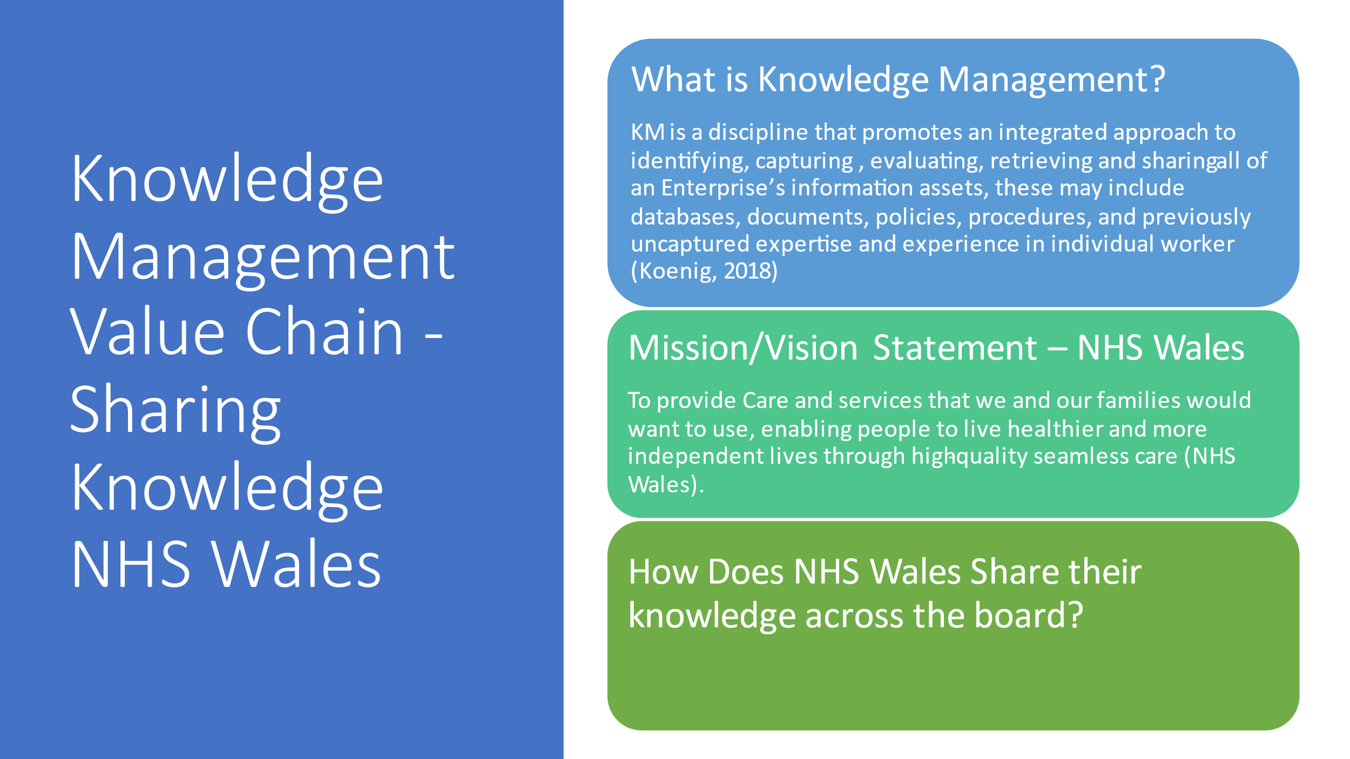
NHS Wales is a publicly funded National Health Service of Wales, providing healthcare to some 3 million people who live in the country. The NHS has a key principle which is that good healthcare should be available to all regardless of wealth, (NHS Wales about us,2022). David Lloyd George and Aneurin Bevan were key figures in the creation of a “Healthcare for all Culture”, (Carradice,2015).

How does the Mission and Vision statement of NHS Wales link to the Knowledge Management Value Chain?
NHS has transformed the dissemination of Health information as guided by its Mission and vision statement. Their vision statement determines their future goals, whilst their mission the mission statement brings the strategies to achieve it. Their Vision statement is all about being a dependable source of health information, and their mission statement emphasises on the applicability of the services they provide. The NHS have carefully chosen core values to ensure the organisation is able to achieve its mission and vision statements based on the values that they demonstrate in collecting valid and reliable information (NHS Wales core principles,2022).

How Does NHS Wales Share their knowledge across the board?
NHS share information in many ways some examples are:
The NHS website, a website that individuals can access all kinds of Health information
A newly appointed Nurse shadowing a Veteran Nurse who can share her vast experience
Sharing crucial information such as covid updates on intranet platforms for staff to access and implement relevant safety measures.

Knowledge sharing can be described as either push or pull. The latter is when the knowledge worker actively seeks out knowledge sources e.g., data portals, expert/specialist, collaborating with a co-worker etc. While knowledge push is “pushed onto” the user e.g., newsletter, unsolicited publications etc. Knowledge sharing depends on the habit and willingness of the knowledge worker to seek out and/or be receptive to these sources. The right culture, incentives and so must therefore be present, (KMT,2022).

There are Two types of transferrable knowledge, Tacit Knowledge, and Explicit knowledge.
An example of explicit knowledge of the NHS would be their data portals of patient records and medical staff across the board having access to these records enabling a much faster process of updating and accessing a patient’s medical record.

An example of Tacit Knowledge that would be shared would be a Collaborative meeting of Specialist Consultants from different fields e.g., lung specialist, liver specialist, bowel specialist, meeting to discuss a cancer patient with cancer in these organs, with each individual’s tacit expertise knowledge in their field.
Through the collaborative meeting the transition process of the 4 c’s the knowledge of Specialist Consultants and combining their expertise they improve their knowledge together of the patients needs resulting in a far more informative decision on possible treatment and action plan for the patients’ needs therefore ensuring the best care for the patient. This example also demonstrates the application of a Quinn typology the advanced skills of the knowledge workers working together sharing their knowledge in their specialist areas, it’s also demonstrating an application of the Nevis typology combining tacit and explicit knowledge for discussion in their meeting, this from the data collected e.g., the patients medical record, to knowledge workers with their specialist skills conducting a collaborative meeting to share the combined knowledge.
References
Carradice,P 2015 Healthcare in Wales before the NHS
Available at: https://www.bbc.co.uk/blogs/wales/entries/ee3858cf-074e-42a4-b4df-ac5afcc4e962
(Accessed 21/5/2022).
KMT, 2022 Knowledge Sharing
Available at: https://www.knowledgemanagementtools.net/knowledgesharing.html (Accessed 20/5/2022).
M,Koenig, 2018, What is knowledge Management
Available at: https://www.kmworld.com/about/What_is_knowledge_management (Accessed 21/5/2022).
NHS Wales, 2022, About us
Available at: https://www.wales.nhs.uk/nhswalesaboutus/ (Accessed 20/5/22).
NHS Wales ,2022, The Core Principles of NHS Wales
Available at https://www.wales.nhs.uk/nhswalesaboutus/thecoreprinciplesofnhswales (Accessed 20/5/22).

