

Designing a Data Processing Solution for the NHS Wales e-Library

by
John Dunkley-Williams (1903715)

Supervisor: Divya Chidambaram
Second Marker: Nik Whitehead

Project submitted as part of the requirements for the award of
BSc (Hons) Computing (Data Information Systems)

July 2023

Abstract

This project looks at developing a digital solution to the problem of data processing for a national e-Library service. The NHS Wales e-Library service collates and provides access to high quality evidence which professionals working across the wider service know they can trust. These services include a variety of resources, products and platforms, which each generate different data types and formats to measure the success and needs of products and services.
For NHS Wales, the national service provision includes e-Journals, e-Books, databases, Evidence Summary tools, e-Learning resources and professional guidelines. The data generated and the measures of each of these resource types achieving positive value for money differs. Data is collected in a multitude of formats, compiled into Excel spreadsheets, and processed manually as and when the need arises by staff, be that for procurement activity, contract reviews, or to inform marketing and engagement. This creates an increasingly large inefficiency for the service in terms of data availability and staff resource usage, as the time it takes to process and provide this data increases as the data volume does; continually.
This project investigates Business Intelligence being used in the wider market, by both e-Library and non-e-Library services, and explores the use of Power BI specifically, as a BI tool which was already purchased and deployed nationally for NHS Wales for its suitability to meet the e-Library requirements.
The project proceeds to design an easy to use dashboard which is accessible for all staff members throughout NHS Wales that might benefit from the use of e-Library data, with the goal being to have a working dashboard to act as a deployable prototype and template for future dashboards, until all e-Library data can be efficiently processed, accessed and utilised with a minimum of manual requirements on the e-Library team to maintain the solution.
Usability testing is carried out with the solution, and further feedback collected which informs the goals and priorities beyond the conclusion of this independent project, with the long-term goal being a full deployment of Power BI that includes the full breadth of e-Library data.

Contents

- Introduction
  - SMART Objectives
  - Coming up in this report
- Literature Review
  - Data Analysis
  - Data Processing in a National e-Library Setting
  - National Health Libraries
  - Business Intelligence Solutions
- Methodology
  - BI Tool
  - Requirements
  - Power BI
  - Advantages & Disadvantages
- Design
  - Technical Design
  - Design Decisions
  - Meeting Requirements
  - Usability Testing
  - Implementation
  - Design Phase 2
- Evaluation
- Conclusion
- Reflections
- References
- Appendices

Introduction

The NHS Wales e-Library provides a national service to all staff members of NHS Wales, Social Care Wales, select Welsh Government departments and other partner organisations. Within the remit of the e-Library, the service provides a great breadth of resources including:
- E-Journals
- E-Books
- Guidelines
- Databases
- Evidence Summary Tools
- e-Learning
These resources cover the wide range of professions within NHS Wales, from practicing clinicians requiring evidence to support medical decisions, to HR and managerial support resources, to professional guidelines that underpin accepted best practice of medical care provision and the adjacent roles which support that.
As part of this provision, the e-Library team are responsible for the procurement and contract management of all these resources, and within that is the requirement to evidence that each resource will provide a good value for money to NHS Wales. This has involved the development of several formulae to benchmark each type of product.
For example, when evaluating an e-Journal, the total cost of an e-Journal is examined, then that number divided by the number of times it was used over a year, across NHS Wales. If the resulting figure is less than the cheapest price of Inter-Library Loan for articles to be requested from the British Library, they are considered good value for money, while if the resulting figure is greater than the highest cost of the ILL, it would be cheaper to request an ILL when required than to maintain the access for NHS Wales. Where the resulting figure lands between these benchmarks, the resource is reviewed, and professional feedback sought to provide additional supporting information to assure that the resource is of good value to NHS Wales.
Cost per use = e-Journal Cost
Usage
This data can equally be used by the individual Health Boards, Trusts and Special Authorities within NHS Wales. In the case that a product is not producing good value for money nationally, but there is a particular hospital or Health Board that uses that resource heavily, the data could then be used to evidence and support a local Health Board purchase as opposed to a national one. For this reason, the introduction of a data processing solution for NHS Wales would be to the benefit of all of NHS Wales as opposed to just the national e-Library.
Currently, all this data is collected manually from a variety of different platforms in varying formats. This might be downloaded from a publisher platform, provided in regular reports directly, or may require manual request from the account manager. The data is then stored in simple Excel spreadsheets, one for national data, and one for each individual Health Board. When information from data processing is required, this usually involves a process of filling in blanks within the data before the process of manual calculation. Needless to say, this is a time intensive process for a team of 3, who are also responsible for a website, technical implementations and maintenance, engagement activities, procurement, budget management and much more.

SMART Objectives

Specific
The objective of this project is to find and implement a solution to this data processing problem for the NHS Wales e-Library, to improve the efficiency of data collection, cleaning, processing and presentation in a way that minimises staff workload. For this first stage, the objective will be to have a working Business Intelligence dashboard for a single NHS Wales e-Library resource type, which will form a working prototype for subsequent dashboards; for e-Journals, e-Books, etc. to be modelled after.
Since each type of resource is measured in slightly different ways, the KPI data will vary, and thus each resource type will require an individual dashboard.
The steps to achieve this will be as follows:
- Identify a suitable software solution
- Establish a data format compatible with the identified solution
- Pre-process data
- Design an interface to display the processed data
  - This Dashboard will need to be usable by non-IT staff across NHS Wales who might benefit from access to the data
  - It will need to be possible to drill-down in the data to at least the following parameters
    - Health Board
    - Resource
    - Time Period
- The interface will need usability testing with the intended audience
- The interface will be reviewed and updated according to feedback
- The Dashboard will be ‘published’ and made available to NHS Wales for use

Measurable
For this project to succeed the aim is to have one working dashboard for a single e-Library resource type within the limited time period, which can then be used as a template for the additional resource dashboards.

Achievable
While the long term goal will be to have a fully implemented data processing solution for NHS Wales, within the time limitations of this project, a single working dashboard which can be made available to NHS Wales has been deemed an achievable outcome.
With the first dashboard in use, feedback can be actively collected to refine the data processing solution throughout the development period to work towards a BI solution made available and easy to use to all those who would find benefit.

Relevant
The processing of e-Library data is essential to the running of the NHS Wales e-Library. Evidencing the value-for-money of each resource underpins the whole procurement practice of NHS Wales. The resources provided by the e-Library are vitally important to NHS Wales, from the Guidelines that underpin clinical professions, to Evidence Summaries that provide quick summarised evidence that clinicians can trust in an instant, to evidence and case studies of medical practices and more from around the globe, trust-worthy evidence is a vital component of treating the patients of Wales.
Budget is however finite, and in order to evidence the effectiveness of these resources so that they might continue to be funded, the evidence provided in the data is essential. Beyond the procurement process, this data can also inform strategic target areas for improvement, whether through engagement or training, or by local area. The data should be available to all those who could benefit across NHS Wales, in an easy-to-use format, to quickly obtain the answers sought from said data, all while freeing up the e-Library team from the manual and time-consuming process by putting the data in the hands of other interested parties.

Time
With this project set for submission in July 2023, the goal is to have a working prototype of the first data dashboard for submission at this point.

Coming up in this report
This report focuses on the initial steps of finding an appropriate BI solution through research and investigation, establishing the requirements of the solution, and developing a route through design to implementation, ending with the production of a working prototype dashboard which is ready, or as near as possible to being ready for deployment in NHS Wales.
The implementation process intends to include usability testing of the prototype, and scoping areas for development moving forwards.
This report will then evaluate and reflect on the process to this point, and conclude the project with the intention for the work to continue to the full deployment of a usable BI solution for the NHS Wales e-Library for a drastic increase in the efficiency of data collection and processing for NHS Wales and the e-Library team.

Project Plan
Phase 1 - Proposal
02/01/2023 | 16/01/2023 | 23/01/2023
Identify potential product solutions | Arrange product demonstrations for stakeholders | Seek approval from NHS Wales e-Library Service Board to proceed

Phase 2 - Investigation
06/02/2023 | 13/02/2023 | 20/02/2023
Begin literature review | Begin testing dashboard ideas for Power BI | Begin initial prototype build

Phase 3 – Data cleaning
27/02/2023
Clean and format e-Library data

Phase 4 – Progress report
13/03/2023 | 13/03/2023 | 03/04/2023 | 17/04/2023
Demonstrate initial prototype to e-Library team | Update Project Plan | Consolidate Literature Review so far | Produce Interim Viva

Phase 5 – Refining and reporting
08/05/2023 | 19/06/2023 | 04/07/2023 | 17/07/2023
Continue to develop prototype | Usability testing | Write up and refine assignment for submission | Produce assignment poster

Phase 6 – Product launch
25/07/2023 | 08/08/2023 | 04/09/2023
Publish the first completed dashboard | Continue to collect user feedback, refine where possible, and prioritise future development plans | Present final product at Viva

Literature Review

Data Analysis
“Data is a very powerful ally, and difficult to ignore when used to craft and promote one’s makerspace story, support strategic decisions, measure and validate metrics, and gauge impact.” [1]
Data is a driving force in the modern world, whether a business is driving profits, conducting research, or merely to self-reflect. It is a valuable currency and informs strategic decisions in board rooms. [2]
So much has the utilisation of data analysis increased, laws and policies have had to be developed continually in an attempt to keep the wide use of data within some ethical boundaries, starting with the 1995 The European Data Protection [3] – followed in 2011 by ‘A comprehensive approach on personal data protection in EU’ – the marked beginning of the creation of the commonly known and globally recognised General Data Protection Regulations (GDPR). [3]
Data can come an incredible wide variety of formats, from tens of thousands of numbers in a spreadsheet, to an image captured on camera, however, it will need to be processed to be made meaningful. AI is being used increasingly to sort and process this data [4], and the resulting information gain has become increasingly accessible for businesses big and small as the technology continues to develop, to the point where now, a business would struggle if it wasn’t doing some kind of data analysis. Even this point can be evidenced with data; according to a study referenced by Harvard Business School, data analysis can improve productivity by 64%, improve decision making by 56%, improve financial performance by 51%, and at the time of the study, 65% of global enterprises were planning to increase their spending on analytics. [5]
The term “Big Data” has come into common use, which, by definition contains an increasing volume of data, arriving in a variety of formats and with greater velocity. [6] Some use case examples are:
- Product development - To anticipate customer demand and concentrate development on rising areas of interest.
- To review and improve customer experience by collecting from wider ranging formats, such as social media, call logs and website traffic.
- Security – To identify data patterns and discrepancies in them, to even predict a security breach ahead of time.
- To improve operational efficiency, using evidence in data to make strategic decisions with more data driven predictions and patterns.
Big data, or rather the ability to effectively process big data into meaningful information, has opened great opportunities to improve operational and financial value [4]. For government funded Health Library services, this means the opportunity to vastly improve cost-efficiency, better using finite budgets to procure the best, most effective, and most well used resources, finding better alternatives to less used products, and being able to inform such actions and decisions with solid evidence in data.

Data Processing in a National e-Library Setting
An integral part of a national e-Library Service is to provide the best possible value from a finite budget, by means ranging from the consolidation of multiple contracts, to being able to effectively review how successful each resource in deployment is by being able to see it on a national scale.
“Success is a highly subjective concept.” [7] – The measure of success is often given a numeric value; how much money was generated or a promotion of position, which in turn generates an increased numeric value. In the case of libraries, success is not measured in the generation of profit, but rather by high usage of the products purchased with government funding. [8] In a public library, the quantitative data available would be a high number of loans on an item. [9] For the NHS Wales e-Library, the number of times an e-Journal, e-Book, database or guideline is used, or the length of time spent on an e-Learning platform. The better the usage, the more value for money is being achieved by these resources (as calculated with the aforementioned Cost Per Use calculation). High usage statistics alone evidence that a resource is well used, popular or even essential, but further to that, the Cost Per Use calculation gives a numeric value that can be used to benchmark against such things as the cost of an inter-library loan or an article request, and by extension demonstrate value obtained.
The practice of collecting and examining the data to evidence these measures of success, is data analysis. Data analysis, as digital forward as we now see it, has long existed. As just one example, an entire book was written on it in 1962 by John Tukey, who talks about how the “future of data analysis can involve great progress, the overcoming of real difficulties, and the provision of a great service to all fields of science and technology.” [10]
The data collected and processed by health libraries differs somewhat from that of public libraries, being more closely comparable to that of academic libraries, where the existence of reference material is integral to the function of the institution. There is often even crossover with the staff working at these two types of institution; Clinical Librarians whose time is shared between service to University and NHS libraries for example. [11] In a Health Library setting, the provision of good quality health information enables practicing medical staff to confidently make informed decisions with regards to the treatment of patients. [12] This is comparable to the role of academic libraries, where students must also be able to evidence their research and decision making processes as part of the academic experience. [13]
By this same situation, the data collected and the use of that data is also comparable between health and academic libraries. All libraries require some mechanism for reporting, and some example scenarios for those reports include:
- Negotiations with publishers
- Informing collection management decisions
- Measuring turnaways* to inform future purchases
- To evidence good budget application [14]
- To highlight training needs
- To inform more targeted marketing campaigns
*a “turnaway” is an access denial to a resource for any reason; the user or institution does not have access, or license use limitations have been exceeded for example.
“The first step in Learning from Data is to define the problem” [15] The Cost Per Use algorithms used by the e-Library to provide benchmarks by which to measure the success of each e-Library resource, varies slightly from resource to resource. For an e-Journal we look at the number of published articles viewed, for an e-Learning resource we look at time spent in learning and number of completed modules. By assigning a numerical value to active user engagement with a resource, we can evaluate if each resource is achieving “Value for Money” by comparing it to similar products, thus justifying the spending of public money to acquire and maintain these resources. This is once again to the academic library practice of using the same data and techniques to calculate a Return on Investment (ROI) figure. [14]
Once the numerical value has been obtained from a Cost Per Use calculation, that number is placed against a pre-set benchmark to determine the success of the product. Taking e-Journals as an example, the benchmark thresholds are based on what it would cost to obtain the article from the British Library by Inter-Library Loan. If the Cost Per Use as calculated by the algorithm (journal cost divided by number of uses) returns a value lower than the cheapest possible cost of an interlibrary loan, this is determined as good value for money, and the resource is being provided in the cheapest and most effective way. There is a middle ground threshold for review, where the resource CPU has been calculated to be more than the lowest inter-library loan cost, but lower than the highest possible cost. In this case the protocol would be to collect additional supporting evidence to assure the purchase of the resource was still providing good value for money, such as by collecting statements of support from the professionals using the resource, or some evidence as to how the CPU could be improved with a continued subscription. Lastly, where the CPU is calculated to be higher than the highest potential cost of an inter-library loan, it would be cheaper to procure the articles required this way, and therefore the resource subscription or purchase is cancelled.

National Health Libraries
NHS Libraries around the UK, and library services beyond, use COUNTER (Counting Online Usage of NeTworked Electronic Resources) as the accepted standard data format for the usage data Health Libraries collect. [16] COUNTER looks at decided interactions on particularly e-Journals and databases, and breaks those down in to passive and active categories, otherwise; Investigations and Requests.
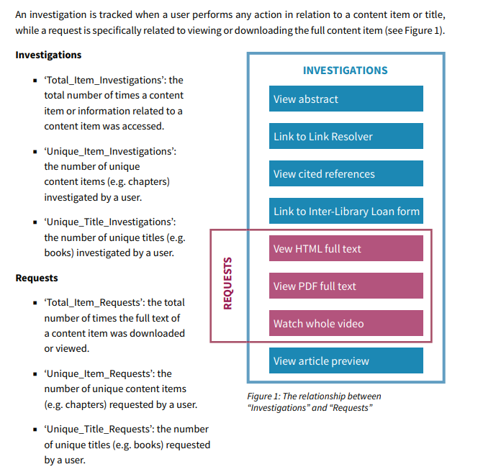 [16]
This is the basis of the metric data used by NHS Libraries across the UK. [17] While the benchmarking systems varies from NHS England to NHS Wales or Scotland, and not every supplier reports in the COUNTER format, this forms the baseline of e-Library data collected. However, while there is an established format and baseline to this point, the process of turning all of this raw data into useful information is still a manual task on Librarians. [18]
COUNTER data arrives in an Excel spreadsheet:
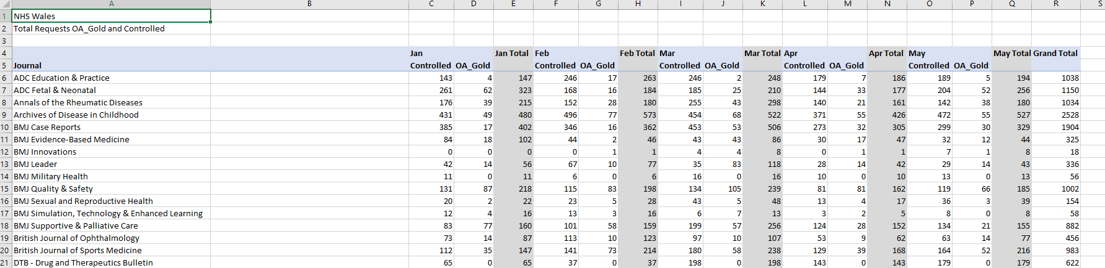
[2021 data for reference]
From here, the task is on the responsible librarian to process this data, perform any necessary cleaning, and extract the required information manually, be that for a stakeholder report, a business case for a procurement, or a contract review for example. For the NHS Wales e-Library the usual process is:
- Request/download data from suppliers/platforms
- Copy all separated data into a single Excel spreadsheet
- Format data into a uniform state
- Make calculations using the raw data to obtain necessary information
- Create visualisations and reports to present the data
This process often takes weeks, to collect all of the required data, and to find enough time to do all of the required processing. NHS Wales procures and manages thousands of e-Journals, hundreds of e-Books, 23 databases, as many Guidelines and an e-Learning resource besides that each need to be reviewed at least annually.
In this regard, libraries around the world are well behind the curve when it comes to data analysis, untrained and unexperienced in the often technical Business Intelligence solutions available, the large e-Library suppliers have already begun to move in to this gap in data analysis functionality across library services, and at 2023 Library conferences, succeeded in exciting librarians with demonstrations of tools such as EBSCO’s Panorama [19] to fulfil this clear need for data processing solutions in library services. Librarians – long used to processing COUNTER data manually and having thus far not considered the available BI tools such as Power BI or Tableau, were easily excited by the “new” presented, albeit first generation concepts compared to other BI tools, but being marketed specifically for librarians. The suppliers offering these solutions already provide a range of e-Resources to library services, and so could easily plug some real data into a dashboard display, and to their favour, in doing so they remove the barrier of the significant technical knowledge and expertise required to set up a solution such as Power BI. However, these newly developed solutions still pale in comparison to the technology otherwise available.

Business Intelligence Solutions
The NHS Wales e-Library is a very real example of Excel being insufficient to deal with the high data volumes of a national service. [20] Business Intelligence tools, such as Power BI, Tableau and Oracle, are a solution to this problem, providing data visualisation capabilities that can quickly process data, and produce meaningful visuals to present to managers, co-workers and stakeholders.
Business Intelligence, or BI is the use of software to combine business analytics, data mining, data visualisation, data tools and infrastructure, and best practices to help organisations make more data-driven decisions. [21]
There are any number of Business Intelligence solutions on the market. SelectHub ranks 863 BI tools out of 100, placing Power BI at the top, followed by Oracle, MicroStrategy, Spotfire and Qlik behind it. [22] Power BI totes a simple interface born as an Excel add-on. It integrates seamlessly with other Microsoft products as one might imagine, with other highlights are data connectivity, visualisation and functionality, but pricing and processing speed are points against it.
There are success stories with regards to the deployment of Business Intelligence the world over, unsurprisingly given how BI use is now normalised business practice, but for some specific examples:
- Amazon uses BI systems to, among many other things, optimise logistics. BI tools use predictive analysis to choose the best shipping schedules and routes. [23]
- Coca Cola used BI tools to collate more than 200 million lines of data from 100 different systems into a single data analysis dashboard.
- Starbucks uses BI software to drive the loyalty card program, to collect individualised data to predict preferences and generate individualised offers for each customer. [24]
With BI being used globally by businesses big and small now, applied in multiple ways across organisations from processing financial data and being able to quickly view that against marketing and sales data, to being used specifically for marketing, to track the metrics of a campaign but also to provide data that can be used to make the best targeted, or even individualised campaigns, to processing KPI data and even maximizing logistic efficiency. BI systems allow businesses to make informed decisions based on historical, current and predictive data to maximise the success of a company. [25] – it is only natural that there would be ways that library services, specifically a national health e-Library service in this case, would benefit from the deployment of such software. A Business Intelligence tool deployed for the NHS Wales e-Library would drastically reduce the manual data processing time when reviewing contracts and procuring resources, would inform marketing and engagement strategies across the country, would be used more readily as evidence in reporting and further inform budget decisions on a national scale.
“…the advancements in ICT tools and services are changing the way businesses’ decisions can be made, and therefor enhance organizational strategic planning. Indeed, this has also created the need for libraries and information centres to develop innovative and creative services to keep pace with a fast-changing society” [26]
Libraries need information about resource consumption and feedback on service quality in order to fulfil their roles in the most effective way. With so many studies clearly evidencing the significant positive effect business intelligence deployment and usage has on all kinds of businesses around the globe, Hamad [26] provides a strong use case for the use of business intelligence in an academic library setting. As previously mentioned, the correlation between academic and health library services would suggest the same benefits to BI application in the health library environment also.

Methodology

BI Tool
As the literature review demonstrated, there is a very wide range of potential Business Intelligence solutions available, each with their own advantages and disadvantages. The likes of Power BI, Oracle and Tableau have seen some use within the organisation already, and part of the selection process will take in to account software that might already be implemented within NHS Wales. Depending on pre-existing software licenses and deployments, it may be possible to save a great deal of time and effort by using a pre-existing solution within the NHS Infrastructure, not to mention a potential cost saving, so long as that solution can meet the e-Library requirements.

Requirements
While a case can be made for budgetary allowance for the acquisition and deployment of a Business Intelligence solution, the optimal solution would be available at low cost, or even already purchased by NHS Wales. The solution, in addition to the below requirements for input and output, will need to be one that can be reasonably implemented and managed by the e-Library team, and post-implementation should serve to reduce the team work-load, rather than increase it with software that would require a lot of hands-on management.

Data input requirements
COUNTER Format | Any BI solution will need to be capable of reading COUNTER data format. This is presented in an Excel file, but an ideal solution will be capable of reading in the data with minimal pre-processing.
Google Analytics | Before this project is considered complete, the solution will also need to be capable of visualising data generated from website traffic. To this end, the BI solution will need compatibility with Google Analytics.
Wide-ranging Format Compatibilities | Smaller, independent suppliers of e-Library resources might not be COUNTER compliant, and so present data in simple Excel format, or even on PowerPoint slides or in Pdf format. The wider the range of compatible data formats the better.

Output requirements
Usage Analytics | The data visualisation will need to demonstrate usage data by resource, by time period, and by Health Board, Trust or Special Health Authority.
Cost-per-use | The optimal solution would be programmable to automatically calculate resource Cost-per-use analytics based on the relevant e-Library algorithms.
Drill Down | Data will need to be visualised in a way that specific resources, time periods or geographic areas can be quickly compared. The capacity for a GIS output would also be a nice to have option.
e-Learning | The BI tool will need to visualise all e-Library KPIs, specifically the ability to visualise time spent in a learning module, and number of learning modules started and completed, not just e-Journal and Database usage data.

Usability
Ease of use | The BI solution will need to have an easy-to-use dashboard. Once completed, the intended users for this software will be the breadth of stakeholders, managers and otherwise interested parties across NHS Wales, regardless of technical ability.
Stakeholders | Stakeholders and company directors will require fast and clear visualised data, with which they can easily drill down to their specific areas of interest within the data, and use that to support decision making at a high level.
e-Library Users | The visualised data should be suitable for marketing purposes also, producing attractive graphics to support with engagement and marketing tasks.

Power BI
After some investigation, it was discovered the Power BI is already fully licensed for NHS Wales within a standing Microsoft contract. In addition to this, a team of specialists exist to assist with departmental implementation throughout the organisation.
A meeting was arranged with product experts to discuss the requirements of the e-Library, and it was assured that Power BI could meet these requirements.
Designating Power BI for the solution meant that there would be no cost to the e-Library for either a product, or an implementation, and work could immediately begin to learn the software and begin building the solution.

Advantages & Disadvantages

Advantages
- No cost to the e-Library
- Already fully implemented
- Capable of producing the required data visualisations
- Capable of reading a wide range of data formats, including anything the e-Library currently works with
- Capacity to drill-down/filter on selected fields to compare data
- Frequently updated [27]
- Customisable dashboard design and visualisations

Disadvantages
- A steep learning-curve
- Excel sheets need to be pre-processed into a specific column and row format for the required data calculations
- Dashboards are limited in what they can display given the data volume. For optimal usability it may be necessary for separate dashboards to drill down by resource, time period and location
- Quite rigid in terms of visualisation options, dashboard interactivity and real time data manipulation.
The disadvantages of using Power BI will present some challenges to overcome, but these will be addressed in the design and build phases, not affecting usability of the end-product where users are concerned. Overcoming these challenges during the design phase will take some time, but will still be preferable to a full product implementation, even disregarding the cost that would be involved with acquiring an alternative solution.
Power BI might not be the best available option, given just how many options there are, but with no cost, no implementation and infrastructure already in place, it still proves the best solution choice given its capacity to meet all of the data processing requirements of the e-Library.

Design

One of the key objectives of this project is to improve efficiency within the e-Library team by reducing the necessary manual workload required for collecting and analysing e-Resource data, not only for the essential demands of procurement and contract review, but also to reintroduce the circulation of this data regularly to be used the stakeholders and librarians across NHS Wales, as once was the case when the service was a smaller one. With the success of this project, the service would even be a step beyond this in that the data would be readily available to users and stakeholders on demand from the platform which they would each have access to.
While the ideal position of automated data collection and display will not be realised with the introduction of Power BI, the objective remains to improve the efficiency of data analysis and presentation of e-Library data.
Of the potential e-Library resource types that will require individual dashboards, databases are the most popular, as evidenced through e-Library website data.
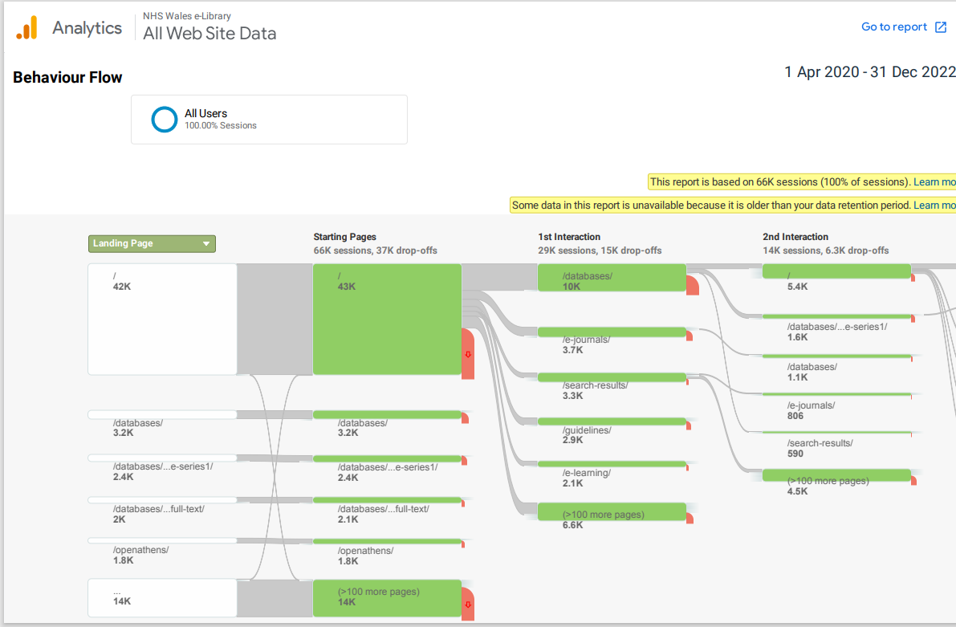
Databases are the most popular resource accessed on the website by quite a margin, and so this will be the first dashboard created to present the dashboard first which data suggests would be the most popular.

Technical Design
e-Library data arrives in a variety of formats, even among COUNTER reports.
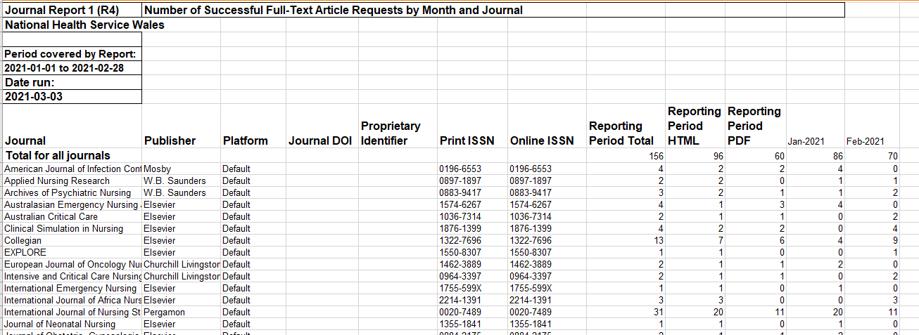
At present, this data is copied into a master Excel sheet for all e-Library resources.
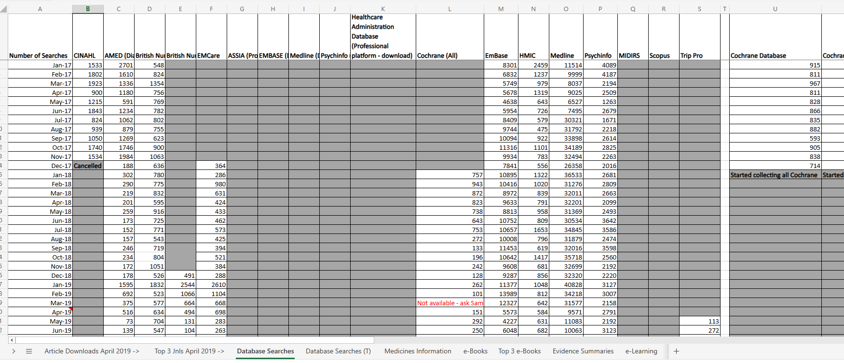
Each resource type has an individual sheet, but plugging these sheets in to Power BI as they are did not yield the desired results. After some further investigation and experimentation, Power BI responded best to inverting the rows and columns; having the resources as rows and the dates as columns. It also proved best to label these effectively for the Power BI dashboard while still in Excel. This process involved the production of new templates for Excel for data to be collected in to, so that collected data will in future be entered in a format immediately readable to Power BI.
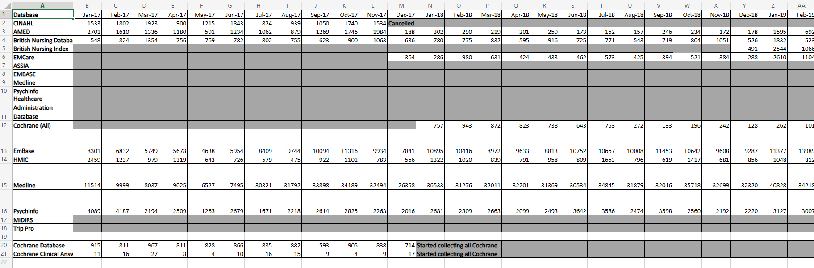
With this pre-processing change, it was much simpler to visualise the data in Power BI and begin exploring options for the dashboard design. Much of this early design process and decision making was done while learning to use Power BI through online tutorials [28] and video introductions [29] to this complex software, and even as problems were being solved and designs improved, the potential to push the software further with more practice and expertise was still felt.
Tardiness in the e-Library data became all the more obvious once the data had been visualised. Gaps where data had not been collected displayed as broken lines, and where there was a change-over of resource; ending the contract of one nursing database to implement an alternative solution for example, also proved to be something to address within the visualisation options to make the data readable. These issues were addressed, and data gaps filled in conjunction with the format updates to the e-Library datasets for Power BI readability.
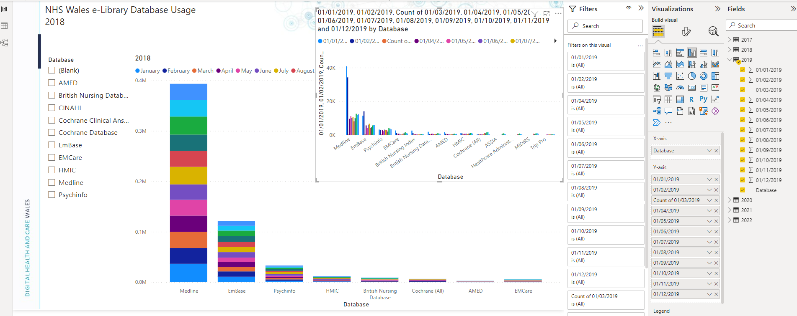
The Slicer tool within Power BI made for a simple, user-friendly solution to drilling down by product, but initial exploration suggested this would be fixed to that single axis. Time periods can be manually selected through using the fields on the right, according to how it exists in the Excel spreadsheet, but this solution is less elegant, and not the user-friendly solution hoped for. Additionally, since regional data is held in separate files to national data, consideration will have to be given to either:
- Produce a separate dashboard for each Health Board to give regional views
- Restructure Excel files to include national and regional data for each resource type as separate files; e.g. an Excel file for database, a separate one for e-Journals, etc.
With either solution, the task is one of pre-processing to structure Excel files accordingly.

Design Decisions
Design decisions will remain user centred, and take consideration of Nielsen’s Heuristics to assure the design process takes constant consideration of those specified usability guidelines [30]. It will not be enough to have Power BI capable of creating the desired outputs, if doing so requires expertise with the software. It will be important that the user understands everything they can see on the dashboard, that it makes sense in real world terms, rather than seeming too technical, and that the users feel like they are in full control of the dashboard.
As for the display, consideration was given to keeping the dashboard readable at a glance. If a user was to attempt to look at data for all databases at once over the period of a year, the range in usage between the products alone already make a single display difficult to read, even before the inclusion of more data visualisations within a single dashboard.
With Power BI, it is possible to quickly change the choice of graph displayed by selecting a visualisation on the right. With some amount of staff training for interested users, the potential of Power BI does increase. Effort will remain however on keeping the dashboard as clear and simple as possible, with hopes that users can use it to a reasonable degree without training. The intended target is that at least 50% of the information available in a data dashboard should be accessible without the need for additional training or support.

Meeting Requirements
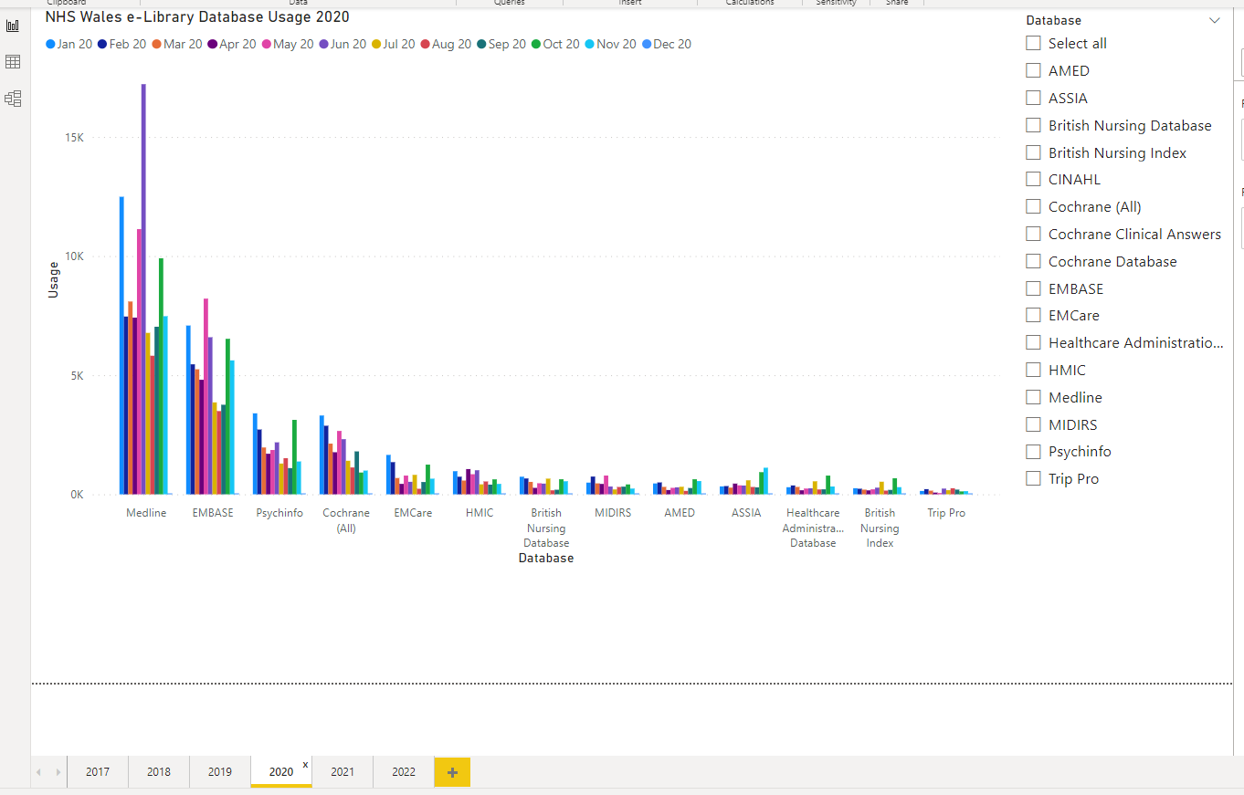
By creating separate queries for each year of data, it was possible to overcome the usability challenge of having to manually edit queries to customise date range displayed. Instead, setting tabs up in the dashboard to move between years with a simple button push proves an easier to use alternative. At this stage, two of the three original output requirements are met:
- Users can drill-down by resource
- Users can quickly select a time period
It is possible to drill down further – by month, with some additional training in the use of field selection. Likewise, it is still possible to change the visual display of the data to a preferred graphic for readability.
While the visualisations will be customisable, consideration must also be given to Accessibility Guidelines (WCAG 2.1) [31] – these guidelines have been compiled, reviewed and refined over time by experts in the field of accessibility, testing with every conceivable kind of user impairment, including blindness, low vision, deafness, motor function, speech impediments, photosensitivity and combinations of these. These are considerations that must be given, particularly in a public serving organisation such as NHS Wales, to ensure usability by any and all kinds of users. To this end, the display in the following screenshot has proven the best so far in terms of readability (as tested with users). While some work remains to be done on aspects of font size, the user of a single visualisation in the default display, and in the stacked bar format, proved the most clear and readable for an all-databases view. Further room for development remains; in addition to font size, options for alternate read modes will be considered, as well as ways to improve the contrast of the view for the default display. Customisation options will remain for any and all users to manipulate the visualisations to individual preference.
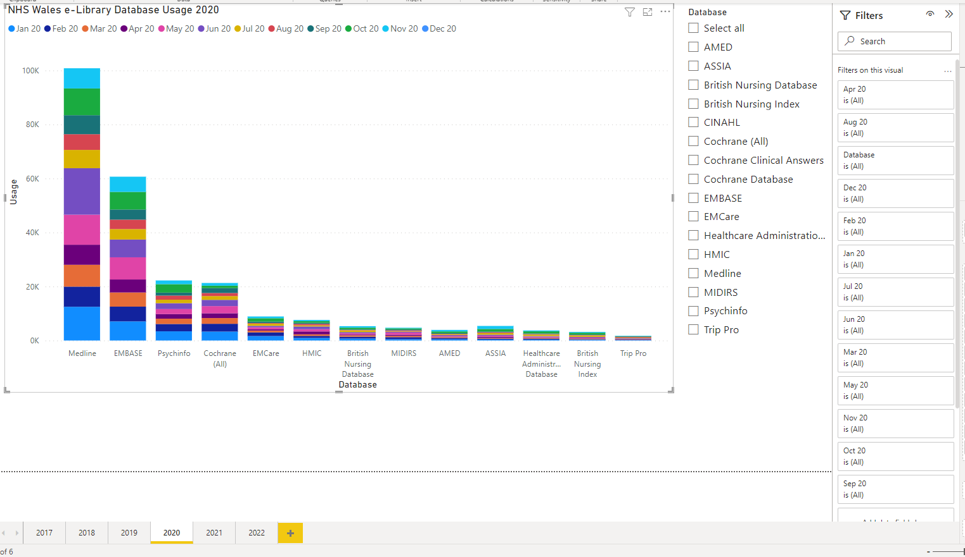
The design has not yet managed to neatly incorporate regional data selection, since this would require further time spent on data pre-processing. Given the nearing deadline, in order to allow reasonable time for usability testing, the project will move to the testing phase with two out of the three parameters met, and look to refine the current dashboard for deployment, with the allowance that regional data and displays will be a future development.
The current version of the NHS Wales e-Library Databases Dashboard is not quite at the point anticipated by this stage in the timeline, but it was more important that users be immediately presented with a product they can easily use. Developing in line with Nielsen’s Heuristics [30] users will be far more likely to return later for anticipated feature and filter developments if they are confident in using the first product they encounter, rather than being presented with something which they do not understand and losing confidence and interest in what the solution might do for them.

Usability Testing
The e-Library team were given the prototype Power BI Dashboard without instruction. The hope is that a user can pick up the dashboard and gain some information without training, and that with an hour-long training session the potential of Power BI data manipulation and visualisation could be realised.

Initial reactions
- The first user began quite quickly to look for a means to filter on Health Board
  - This was anticipated, and indeed one of the early objectives for the 3 key data filter options included the ability to filter on Health Boards. This is definitely the first thing to look at developing in the next project phase. Since data by Health Board is collected separately and in individual Excel files for each Health Board, the data will need to be collated into a single place to accomplish this.
- A user looked to compare data across years
  - While the option to filter by year existed, at present there is no option to directly compare or overlay years in a single visualisation. This is another thing that can be investigated early in the next development phase, as these filter options will be key to ensuring users can obtain the sought-after data.
- Changing data visualisations wasn’t straight forward
  - This may change when the dashboard moves from being in “build mode” to being published for users to interact with. (At the time of testing, the authorisation to “publish” the dashboard into a user-accessible state had not yet been approved by NHS Wales.) In the current state, additional Power BI expertise is required, to know to select the graph that you wish to customise the visualisation of.
- Questioned regarding the ability to filter on authentication route
  - This is not data currently held by the e-Library, but it could be collected and incorporated in future to add the option to display a data visualisation on users authenticating either by IP address or by Single Sign-on

Positive Feedback
“I can see the data I would want to see when reviewing a product right away”
Initial testing showed that the dashboard was indeed as easy to pick up and use as hoped. While the team searched for some additional data parameters to filter on, they enjoyed being able to clearly see the usage data for databases over the years. Everyone quickly found their way to the available filter options and enjoyed being able to hover over the graph to display numerical values.
After initial reactions, some instruction was offered to demonstrate the full potential of the dashboard, such as by bringing up the table view, and some instruction as to using different visualisations for different information clarity, since these were questions raised in the usability testing. As expected, with some user training, it is possible to maximise the effectiveness of Power BI as a solution.

Implementation
The immediate challenge presented with the implementation of this dashboard was obtaining the necessary approvals within NHS Wales to do so. While all of NHS Wales has access to Power BI through the web app, to be able to publish dashboards to that space for colleagues to use was a process that was not anticipated. This caused delays with the launch of usability testing and resulted in it needing to be done in a more controlled environment than originally planned, carried out by sharing control of the desktop application through Microsoft Teams, and giving the e-Library team access to the build version. This would have several implications.
Firstly, the usability testing could not be as far ranging as planned. The original plan would have been to give access to the dashboard to a variety of users; members of the e-Library team, other NHS Wales librarians and stakeholders. This would have increased the scope and technical ability range of the users providing feedback, giving a better representation of the target user group for this project and more feedback to work from.
The second issue this presented was finding a way that anybody would be able to test the dashboard. While the work-around of using Microsoft Teams to share control would work as an idea, this would limit the test in several ways. The dashboard could only be shared with one person at a time, so I would need to be present for each test. The testers would need to be from within the organisation in order to have access to the necessary Teams channel.
A bigger problem again would be that testers would only have access to the version of the dashboard being built. This will not only look different to the published version but would give testers access to all of the customisation options of Power BI, and potentially result in the breaking of the dashboard from too much experimentation. In this regard, the one-to-one situation would actually benefit, but was nonetheless not the intended way that the testing would be carried out.
Lastly, this delay has meant that the original objective of having a published dashboard by the time of project conclusion has also not been possible.
Once these procedures have been navigated, actual deployment will be immediate. A link can be provided to the published data dashboard and any interested user in NHS Wales could use that link to access the published dashboard and investigate and interrogate the database usage data in its entirety. The remaining work to be done will simply be the publicity surrounding the dashboard launch, the engagement exercise, and conducting the training required to maximise the dashboard potential, which can subsequently be added to the e-Library website in video form, along with a webpage detailing what the dashboard is and how one might take advantage of this new data provision.

Design Phase 2
At the point in time that this report is written, some initial requirements remain not met, owing mostly to time constraints and delays caused by the organisation policies and processes. These, informed and supported by usability testing will be the priorities for the next phase of development.

Requirements met
- Data input formats
- Data visualisations
  - Filter by product achieved
  - Filter by date achieved
- Usability
  - Ease of use
Although not all of the planned requirements for visualisation options were met in phase one, a high degree of usability and ease-of-use was achieved and maintained.

Priority Developments
- Data visualisations
  - Filter by Health Board
  - Cost-per-use display

Evaluation

The original aims of this project were
- To identify a solution to the data processing from of the NHS Wales e-Library
- To clean the dataset in order to produce useful results
- To design a user-friendly interface to be used across NHS Wales by any interested stakeholder or staff member
- To be able to drill down within the results of the processed data, to focus on:
  - Health Board/Trust
  - Resource
  - Time Period
- To test the dashboard design with users
- To review and make possible updates based on feedback
- To publish the dashboard for active use in NHS Wales
- To plan to move forward for future developments and expansion of the project
83.75%

Within the time constraints of this independent project, it was possible to meet 83.75% of these objectives.
At present, it has not been possible to publish the dashboard for use across NHS Wales, owing to internal delays with the authorisation required by the NHS Wales organisation to do so, therefore it has not been possible to reach a state of full deployment within the time frame.
The project largely proceeded according to plan, excepting the third of three intended drill down options and also reaching a point of publication. Both of these can be reached in the near future as development continues after the submission of this report.
As evidenced by the literature review, Power BI was indeed a practical solution to the e-Library data problem. It was applied and used to accomplish all of the original objectives, so far as time allowed, and can continue to be developed to meet all of those as yet unmet needs. The user-focused design worked well, and the feedback gathered in the usability testing was as was expected, supporting the already made plans for development priority.
Given all of these facts, the only realistic improvement that could have been made should the project be repeated would be to work to an achievable timescale. Given the outcome, with hindsight a slightly reduced target for the time allowance would have yielded a one hundred percent successful outcome.

Conclusion

Power BI was identified as the best solution. The literature search provided clear evidence that a Business Intelligence system was precisely the solution to the NHS Wales e-Library problem, enabling the processing of the large amount of e-Library data that up to this point was being manually collated and calculated from Excel spreadsheets. Power BI specifically was selected over alternative options on the basis that the software was already licensed and deployed throughout NHS Wales, saving a great deal of time and money to purchase and implement an alternative solution.
Databases were selected as the resource for the first dashboard created based on them being the most popular resource type provided by the e-Library. The dataset for these resources was then cleaned, blanks filled in and the spreadsheet reformatted based on learning and experimentation with the software to work best with Power BI.
The dashboard was designed with a user focus and Nielsen’s Heuristics [30] in mind. Rather than declaring success when the dashboard could produce the desired information, development was continued until the dashboard reached the desired easy to use, user friendly outcome. This included designing the dashboards with simple, clear, clickable customisation options, as well as choosing the best default graphic display to clearly display the volume of data from the collective e-Library database usage.
The dashboard has been successfully developed to a point where it is possible to drill down on data based on the resource/database, and also on time period, as was listed in the original requirements, while maintaining the accessible and user-friendly dashboard. It was not however possible within the given time frame to successfully incorporate the ability to drill down based on Health Board, owing to the volume of data pre-processing that would be required and the time limitations of the independent project.
Usability testing was carried out, and the feedback was as anticipated, further reinforcing the intended direction for future developments of this and future dashboards. In addition to the early reactions to look to filter on Health Board, some additional suggestions came through, such as the ability to compare across years, which is not straight forward on the current dashboard.
Unfortunately, it was also not possible to publish the database on schedule to make this prototype version accessible to NHS Wales, to continue to collect feedback while beginning to circulate data, owing to organisational constraints within NHS Wales, and being unable to obtain the necessary authorisation within the time frame of the project.

Suggestions for further work
At this current stage, the development priority beyond the conclusion of this project will be on developing the dashboard to report on data by Health Board and Trust, as was in the original requirements. Usability testing also provided feedback and suggestions as to ways in which the dashboard might be further developed to allow the comparison of data for selected products between years.
Further research, practice and exploration with Power BI will go into this in order to continue to work towards the desired outcome of a user-friendly dashboard for each e-Library resource, which can be used to drill down on data that users would require, in a manner that best works for them. Ideally, the dashboard would develop to include the capacity for these three original requirements and perhaps more as more user feedback is collected, without the need for additional dashboards to be developed.
While research continues in how to make best use of Power BI to include these requirements, the dashboard is intended for publication at the earliest opportunity. This will allow users to access at least some of the data that would so greatly aid them in their daily roles, while also giving the opportunity to both train invested users in using the Power BI dashboards, and also collecting continuous feedback from users so that the end product might be continuously developed in a user-focused way, to meet their needs as best as possible.
In terms of implementation, once authorisation from NHS Wales has been obtained for the publication of the Power BI dashboard, it will be available soon after. The next steps of the implementation following this will be deploying the regular e-Library release communications plan to inform users via the usual channels that this new resource is available, and where they can learn more about it. Training sessions will be organised and recorder, afterwards being made available on the e-Library website for new and reviewing users to get the most from the new resource.

Reflection

On starting this project, I was very aware of the organisational barriers NHS Wales might present, having worked for the NHS Wales e-Library for four years. When setting the goals of the project, I did so based on what I believed I could personally achieve with these considerations in mind, but it was not particularly surprising for delays to appear where organisational approvals and assurances were needed.
The element I did not fully grasp however, was the learning curve involved approaching the new Power BI software, and how much time it would take to clean and reformat e-Library data to fit the tool. I had naively assumed that I could fill in the blanks and then do the majority of the data manipulation within Power BI, when in reality, the Excel spreadsheets would need to be completely redesigned to effectively read in to Power BI in the best way. I had taken for granted the sample data I had used in the past with the likes of Power BI and Tableau, compared to using real world data from multiple and varied resources, and this quickly became the most time-consuming part of the task. When planning time allocation working with new software and ideas, even greater time should be allowed for experimentation and failure within the development process to create achievable goals, and also, I now have more experience working with real world data in this scenario. While I was aware that there would be a difference from my professional experience, with this being my first time actually working in a data processing engineer scenario, the impact that made when working so specifically with data, took much longer than anticipated.
I am happy with the outcome and what was achieved within the scope of the project, and it has still laid the intended groundwork to continue as intended beyond the conclusion of the independent project until all e-Library data can be visualised and made use of quickly and across NHS Wales. It was always known that this would likely be a project that would take several years to reach the intended final state of full deployment for all e-Library resources.
I still have much to learn with regards to data processing and visualisation, and Power BI specifically, but using this starting point and prototype I can continue to develop into the future, until I have the best possible, user-centred data processing system, that perhaps the other Health Library services around the UK might also take notice of, and look to implement themselves. All of this ties back to the NHS Wales methodology of patient centred care, as we all work, however directly or indirectly, to improve the systems and technologies used in healthcare, and by extension the quality of care provided by NHS Wales.

References

[1] | M. N. &. C. I. C. Cooke, “The Value of Data, Metrics, and Impact for Higher Education Makerspaces,” vol. 1, no. 1, 1 April 2021.
[2] | Deloitte, “Data valuation: Understanding the value of your data assets,” Deloitte, 2020. [Online]. Available: https://www2.deloitte.com/content/dam/Deloitte/global/Documents/Finance/Valuation-Data-Digital.pdf. [Accessed 9 August 2022].
[3] | European Data Protection Supervisor, “The History of the General Data Protection Regulation,” EDPS, [Online]. Available: https://edps.europa.eu/data-protection/data-protection/legislation/history-general-data-protection-regulation_en. [Accessed 9 August 2022].
[4] | S. Akter, “Transforming Business Using Digital Innovations: The Application of AI, Blockchain, Cloud and Sata Analytics,” University of Wollongong, 2020.
[5] | M. Gavin, “Business Analytics: What it is & why it's important,” Harvard Business School, 16 July 2019. [Online]. Available: https://online.hbs.edu/blog/post/importance-of-business-analytics. [Accessed 12 July 2023].
[6] | Oracle, “What is Big Data?,” Oracle, 2023. [Online]. Available: https://www.oracle.com/uk/big-data/what-is-big-data/. [Accessed 6 June 2023].
[7] | S. Cottrell, Skills for Success Personal Development and Employability, London: Palgrave, 2015.
[8] | E. MAcevicute, “How libraries create value and help diminishing the digital divide,” 2018. [Online]. Available: https://www.diva-portal.org/smash/get/diva2:1278548/FULLTEXT01.pdf. [Accessed 12 July 2023].
[9] | A. e. a. Million, “Proving Your Library's Value,” September 2012. [Online]. Available: file:///C:/Users/jo208947/Downloads/cmr13-007.pdf. [Accessed 12 July 2023].
[10] | J. Tukey, The Annals of Mathematical Statistics, JSTOR, 1962.
[11] | J. B. V. Harrison, “Clinical librarians, a new tribe in the UK: roles and responsibilities,” Health Information and Libraries Journal, vol. 27, no. 2, pp. 123-132, 11 May 2010.
[12] | D. Gilroy, “Health literacy and health information literacy, and the role of librarians,” Health Education England, 18 October 2019. [Online]. Available: https://library.hee.nhs.uk/about/blogs/health-literacy-and-health-information-literacy-and-the-role-of-librarians#:~:text=Role%20of%20librarians,-Maimonides%2C%20a%20Spanish&text=People%20benefit%20from%20having%20access,safely%20(16%2D18).. [Accessed 12 July 2023].
[13] | F. J. Friend, “Mission and Purpose of Academic Libraries in the 21st Century,” University College London, [Online]. Available: https://www.ucl.ac.uk/scholarly-communication/articles/beij.htm. [Accessed 12 July 2023].
[14] | J. Wang, “Usage Statistics in libraries,” SPARC, 2023. [Online]. Available: https://sparcopen.org/our-work/negotiation-resources/data-analysis/usage-statistics/#:~:text=Libraries%20collect%20usage%20statistics%20for,requirements%20for%20high%2Dlevel%20reporting.. [Accessed 12 July 2023].
[15] | R. L. &. L. M. Ott, An Introduction to Statistical Methods & Data Analysis, Cengage Learning, 2016.
[16] | T. Mellins-Cohen, “The Friendly Guide to Release 5 For Librarians,” 7 March 2018. [Online]. Available: https://www.projectcounter.org/wp-content/uploads/2018/03/Release5_Librarians_PDFX_20180307.pdf. [Accessed 20 June 2023].
[17] | Health Education England, “e-Resources Usage Statistics,” Health Education England, 15 June 2021. [Online]. Available: https://library.hee.nhs.uk/resources/content-and-usage/eresource-usage. [Accessed 20 June 2023].
[18] | CILIP, “Data Science,” CILIP The library and information association, [Online]. Available: https://www.cilip.org.uk/general/custom.asp?page=DataScience. [Accessed 20 June 2023].
[19] | EBSCO, “Panorama - Insights for Library Analytics,” EBSCO, 2023. [Online]. Available: https://www.ebsco.com/products/panorama. [Accessed 20 June 2023].
[20] | P. Baker, “The Best Self-Service Business Intelligence (BI) Tools,” PC MAG, 15 March 2019. [Online]. Available: https://uk.pcmag.com/cloud-services/74173/the-best-self-service-business-intelligence-bi-tools-for-2019. [Accessed 18 April 2023].
[21] | Tableau, “What is Business Intelligence?,” Tableau, [Online]. Available: https://www.tableau.com/en-gb/learn/articles/business-intelligence. [Accessed 21 April 2023].
[22] | SelectHub, “Best Business Intelligence Software Tools,” SelectHub, 18 April 2023. [Online]. Available: https://www.selecthub.com/c/business-intelligence-tools/. [Accessed 18 April 2023].
[23] | J. Broth, “What some of the best business intelligence examples can teach you,” Real Business, 19 September 2019. [Online]. Available: https://realbusiness.co.uk/best-business-intelligence-examples. [Accessed 27 June 2023].
[24] | R. Eugene, “Examples of Business Intelligence Systems for Improving Decision Making,” Nix, 16 March 2022. [Online]. Available: https://nix-united.com/blog/examples-of-business-intelligence-systems-for-improving-decision-making/. [Accessed 27 June 2023].
[25] | A. Morris, “23 Case Studies and Real-World Examples of How Business Intellgience Keeps Top Companies Competative,” Oracle, 16 April 2021. [Online]. Available: https://www.netsuite.com/portal/resource/articles/business-strategy/business-intelligence-examples.shtml. [Accessed 27 June 2023].
[26] | F. e. a. Hamad, “Business intelligence in academic libraries in Jordan: Opportunities and challenges,” IFLA Journal, vol. 47, no. 1, pp. 37-50, 2021.
[27] | Absent Data, “Microsoft Power BI Pros and Cons,” Absent Data, 2020. [Online]. Available: https://absentdata.com/power-bi-pros-and-cons/. [Accessed 27 June 2023].
[28] | Microsoft, “Tutorial: Get started creating in the Power BI service,” Microsoft, 17 November 2022. [Online]. Available: https://learn.microsoft.com/en-us/power-bi/fundamentals/service-get-started. [Accessed 7 February 2023].
[29] | Microsoft Power BI, Getting Started with the Power BI Desktop, YouTube, 2021.
[30] | J. Nielsen, “Ten Usability Heuristics,” 2005. [Online]. Available: https://pdfs.semanticscholar.org/5f03/b251093aee730ab9772db2e1a8a7eb8522cb.pdf.. [Accessed 18 July 2023].
[31] | W3C, “Web Content Accessibility Guildelines (WCAG) 2.1,” 2018. [Online]. Available: https://www.w3.org/TR/WCAG21/. [Accessed 4 July 2023].

Appendices

Declaration and Form of Consent

