Project Proposal
(BMSW6009)

Name: Georgiana Strugaru
Student ID: 2222489
Word count: 1,409 words
Date submitted: 24th February 2026

Exploring how supervisor leadership influence employee motivation in the housekeeping departments in hotels
Introduction
The hospitality industry relies heavily on the performance and motivation of its employees, as service quality affects customer satisfaction, retention and the overall success of an organisation (Ali, B.J., & Anwar G. 2021). Whitin hotels, the housekeeping department plays an important and critical role in maintaining cleanliness standards, preparing rooms efficiently and ensuring that guests always have a positive experience (A. Bharadwaj, 2022). But despite this, because the housekeeping staff work behind the scenes, their contributions can often be underappreciated compared to staff that face’s customers directly.
Supervisors in the housekeeping department are usually responsible for organising daily room allocations, checking completed rooms, handling staff shortages, responding to guests’ complaints and ensuring cleanliness standards are met within strict timeframes, thus taking on a leadership role. Because supervisors work directly with room attendants on daily basis, their behaviour, communication style and approach to managing important and pressuring stuff can influence how the room attendants feel about their work (Eva et al., 2019). When supervisors provide clear instructions, recognise the room attendants’ efforts and offer their support, especially during busy periods, the room attendants tend to feel valued and motivated (Mayfield & Mayfield, 2018; Zhu, Obeng, A.F. & Azinga, 2023). However, when the communication is unclear, their feedback is too critical and their support is limited, the room attendants tend to feel frustrated, and it reduces their motivation. Understanding the relationship between supervisor and room attendants is important in hospitality settings where employee performance directly affects quality and satisfaction.
Although leadership and motivation are well-researched in general management literature, there is limited qualitative research focusing specifically on supervisor leadership in the housekeeping departments. Most studies focus on upper management or adopt quantitative surveys that may not capture the depth some employees experience (Hospitality Institute, 2024.
Therefore, this study proposes to explore how the leadership of a supervisor influences employee motivation within a hotel and their department. By focusing on employee perceptions and lived experiences, the research aims to gain deeper insights into how day to day leadership behaviour affect motivation, providing practical recommendations for improving a supervisor’s role in operational hospitality settings (Angela, Chris, Dennis & Eli, 2014).
Aims and objectives
Aims
To explore how leadership practiced by supervisor’s influence employees to be more motivated within their department.
Objectives
- To examine the leadership behaviours demonstrated by supervisors in a housekeeping department.
- To explore how the housekeeping staff sees the leadership used by the supervisors.
- To analyse how the leadership style influences employee motivation and morale.
- To identify leadership approaches that enhance or reduce employee motivation in hotel settings.
Literature review
Contemporary leadership theory
Recent leadership research emphasises rational and behavioural approaches rather than purely positional authority. Transformational leadership continues to be widely discussed in hospitality research, particularly in relation to employee engagement and job satisfaction (Abdullah, 2024; Xian et al., 2020). Transformational leaders are characterised by inspirational motivation, individual consideration and intellectual stimulation. In operational environments such as hotels, these behaviours tend to foster a stronger team based on their motivation (Kim, Yang & Lee, 2023; Wardani, Baihaqi & Nohong, 2025).
Research shows that transactional leadership, based on contingent rewards and performance monitoring, has also been examined in hospitality environments. And white it might improve short term efficiency, research suggests that it may not sustain long term performance and motivation as effectively as more supportive styles (H. Osahon & Osazevbaru, 2024).
More recently, authentic leadership and servant leadership has also gained attention. Authentic leadership focuses on transparency ethical behaviour and self-awareness, which has been linked to increased trust and emotional regulation among frontline hotel staff (M. Almutairi, 2024). Servant leadership emphasises prioritising employee wellbeing and development (L. Boutell, 2025). Both approaches may be particularly relevant in labour intensive departments such as housekeeping, where emotional support and fairness are equally important.
Despite these developments, much of the literature examines leadership at upper management level rather than a supervisor level. Supervisors in housekeeping departments tend to operate in highly practical and fast-paced environments, and their leadership style tend to differ significantly from strategic leaders.
Employee motivation in hospitality
Research shows that motivation remains central to organisational performance. Contemporary research often distinguishes between intrinsic and extrinsic motivation. The self-determination theory (SDT) suggests that employees are more motivated when their needs for autonomy, competence and relatedness are fulfilled (Ali et al., 2021; Ryan & Deci, 2020).
In hospitality settings, intrinsic motivation has been linked to improved job satisfaction and reduced turnover intention. Recognition, fair treatment and supportive leadership are frequently identified as key motivational drivers.
Aleksandra Grobelna (2020) highlights that hospitality employees often experience emotional labour, physical strain and time pressure, and in such contexts, the supervisors support tends to act as a motivational resource.
However, research focusing specifically on housekeeping employee remains limited still. Xenia Chela-Alvarez (2020) states that the housekeeping roles involve repetitive tasks, productivity levels to be meet and inspection pressure from upper management or audits. Understanding how supervisors and their leadership shape motivational experiences in this context is therefore valuable.
Leadership and motivation: identified gap
Although there is significant literature linking leadership style to employee outcomes, there’s still three gaps present.
- Limited qualitative exploration of employee lived experiences.
- Limited focus on supervisors’ leadership.
- Limited research specifically within the housekeeping departments.
Most hospitality studies rely on quantitative surveys, which measure variables but does not capture experiences. A qualitative study can provide richer insight into how employees interpret leadership behaviours and how their interpretations influence motivation.
This project seeks to address this gap by focusing specifically on a supervisor’s leadership by using in depth qualitative methods.
Methodology
Research philosophy
This study adopts interpretivist research philosophy. Interpretivism assumes that reality is socially constructed and that meaning is shaped through individual experiences (University of Nottingham, 2023; C. Nickerson, 2024). Since the study aims to understand how employees perceive and interpret leadership, this philosophical position is appropriate.
Research design
A qualitative research design will be employed, as qualitative methods are more suitable for exploring complex socials situations such as leadership and motivation, where subjective experiences are central.
Data collection
The data will be collected by using semi-structured interviews. This method provides a balance between structure and flexibility, allowing participants to speak openly about their experiences while still focusing on key themes related to the research. As this study aims to understand employees lived experiences, interviews are considered the most appropriate method.
The interview guide will explore what kind of experiences do room attendants have when supervisors express their leadership style, perceptions of fairness, support and communications, examples that increased or reduced the motivation and how leadership influences effort, morale and job satisfaction.
Each interview will last approximately 10-15 minutes and will take in the housekeeping office, where it will be quiet. With the participants consent, the interviews will be written to a good standard to ensure accuracy during analysis.
Sampling strategy
Purposive sampling will be used to select participants with direct experiences of working in the housekeeping department. Six to eight room attendants who have worked in the department for at least three months will be invited to participate (K. Nikolopoulou, 2022).
The sample size is appropriate for qualitative research, which focuses on depth rather than large numbers.
Data analysis
Data will be analysed using thematic analysis, an approach described by Braun and Clarke (2006) and Gibbs (2007). This approach allows patterns to emerge from participants experiences.
The process will include transcribing the interviews, reading transcripts for familiarity, coding key points, grouping codes into themes, interpreting themes in relation to leadership and motivation theory.
Research quality and trustworthiness
To enhance credibility, interview will follow a consistent structure, and participants will be encouraged to share honest views; The research process will be clearly documented to maintain transparency using Gibbs’ Reflective Cycle (1988). Confidentiality and anonymity will be emphasised throughout.
Ethical considerations
Ethical approval will be sought before data collection. Participants will receive an information sheet explaining the study purpose, voluntary participation and their right to withdraw at any time. Written information consent will also be obtained. The ethical procedures will align with the ASET good practice guide for work based and placement learning in higher education (2022).

Conclusion and need for further research
Supervisors’ leadership plays a crucial role in shaping employee motivation within the housekeeping department in hotels. Yet there is limited qualitative research exploring this relationship from the perspective of frontline employees.
This project will provide in depth insights into how a supervisor’s behaviour towards their employees influences their motivation, their engagement and their morale in work settings. Findings also may explore how a supervisor’s training, and support helps organisational performance.
Future research could expand the study across multiple hotels, compare departments or explore cross cultural leadership practices in hospitality settings.
Gantt chart
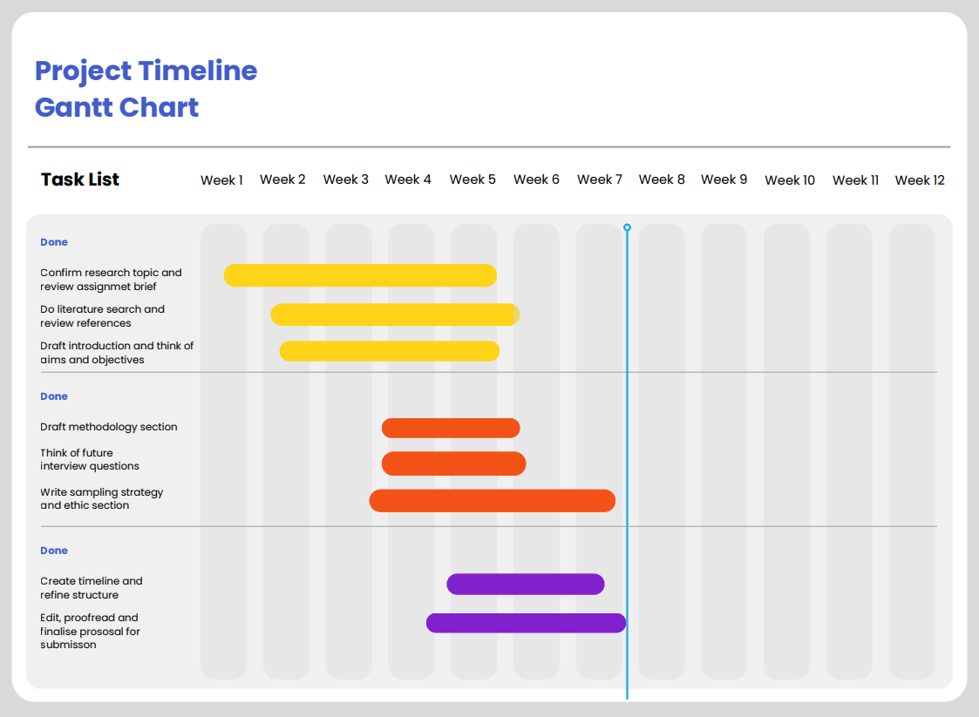

Reference list

‌ Ali, B.J. and Anwar, G. (2021) ‘An empirical study of employees’ motivation and its influence job satisfaction’, International Journal of Engineering, Business and Management, 5(2), pp. 21–30. [online] Available at: https://www.researchgate.net/publication/350582297_An_Empirical_Study_of_Employees'_Motivation_and_its_Influence_Job_Satisfaction (Accessed: 12 February 2026).
Ali, B., Gardi, B., Othman, B.J. and Ahmed, S.A. (2021) ‘Hotel service quality: The impact of service quality on customer satisfaction in hospitality’. [online] ResearchGate. Available at: https://www.researchgate.net/publication/351780048_Hotel_Service_Quality_The_Impact_of_Service_Quality_on_Customer_Satisfaction_in_Hospitality (Accessed: 12 February 2026).
Almutairi, M., Timmins, F., Wise, P., Stokes, D. and Alharbi, T. (2024) ‘Authentic leadership—A concept analysis’, Journal of Advanced Nursing, [online] 81(4), pp. 1775–1793. Available at: https://pmc.ncbi.nlm.nih.gov/articles/PMC11896828/ (Accessed: 22 February 2026).
Andrie Wardani, Baihaqi Baihaqi and Mursalim Nohong (2025) ‘The effect of transformational leadership on employee performance with employee engagement and job satisfaction as moderator variables’, Journal Research of Social Science Economics and Management, [online] 5(2). Available at: https://www.researchgate.net/publication/395451450_The_Effect_of_Transformational_Leadership_on_Employee_Performance_with_Employee_Engagement_and_Job_Satisfaction_as_Moderator_Variables (Accessed: 23 February 2026).
ASET (2022) Good practice guide for work based and placement learning in higher education: Integrating work and learning. [online] Available at: https://www.asetonline.org/wp-content/uploads/2024/04/ASET-Good-Practice-Guide-Work-based-and-Placement-Learning.pdf (Accessed: 21 February 2026).
Bharadwaj, A. and Sharma, A. (2022) ‘The impact of housekeeping on guest satisfaction: A critical evaluation’, IJFANS International Journal of Food and Nutritional Sciences, [online] 11, p. 2022. Available at: https://ijfans.org/uploads/paper/5c0ae8e08f97d8e53a2d2b928253dd14.pdf (Accessed: 02 February 2026).
Braun, V. and Clarke, V. (2006) ‘Using thematic analysis in psychology’, Qualitative Research in Psychology, 3, pp. 77–101.
Boutell, L. (2025) ‘Servant leadership: The executive’s guide to leading through service’. [online] Quarterdeck.co.uk. Available at: https://quarterdeck.co.uk/articles/servant-leadership (Accessed: 10 February 2026).
Eva, N., Robin, M., Sendjaya, S., van Dierendonck, D. and Liden, R.C. (2019) ‘Servant leadership: A systematic review and call for future research’, The Leadership Quarterly, 30(1), pp. 111–132. Available at: https://www.sciencedirect.com/science/article/pii/S1048984317307774?via%3Dihub (Accessed: 20 February 2026).
Gibbs, G. (2007) Analyzing qualitative data: 4. Thematic coding and categorizing. London: Sage.
Grobelna, A. (2020) ‘Emotional exhaustion and its consequences for hotel service quality: the critical role of workload and supervisor support’, Journal of Hospitality Marketing & Management, 30(4), pp. 1–24. Available at: https://www.tandfonline.com/doi/full/10.1080/19368623.2021.1841704#:~:text=Limitations%20and%20conclusions-,ABSTRACT,to%20deliver%20high%20service%20quality (Accessed: 24 February 2026).
Helalat, A., Sharari, H., Alhelalat, J. and Al-Aqrabawi, R. (2024) ‘Transformational leadership and employee performance: A further insight using work engagement’, Economics, [online] 13(1). Available at: https://reference-global.com/download/article/10.2478/eoik-2025-0015.pdf (Accessed: 20 February 2026).
Hospitality.Institute (2024) ‘Qualitative vs quantitative research: When to use each method in marketing’. [online] Available at: https://hospitality.institute/bha509/qualitative-vs-quantitative-research-when-to-use-each/ (Accessed: 24 February 2026).
Kim, J.-K., Yang, J. and Lee, Y.-K. (2023) ‘The impact of transformational leadership on service employees in the hotel industry’, Behavioral Sciences, [online] 13(9), pp. 731–731. Available at: https://www.mdpi.com/2076-328X/13/9/731 (Accessed: 05 February 2026).
Knox, A., Warhurst, C., Nickson, D. and Dutton, E. (2014) ‘The international journal of human resource management publication details, including instruction’. Available at: file:///C:/Users/account/Downloads/Knoxetal.2014.pdf.
Mayfield, J. and Mayfield, M. (2018) Motivating language theory: Effective leader talk in the workplace. [online] Available at: https://www.perlego.com/book/3494450/motivating-language-theory-effective-leader-talk-in-the-workplace-pdf?irclickid=W-Z2tSQ6yxycRFgUtYR6M0eMUku2k1xVk0xrwI0&utm_source=OCLC&utm_medium=affiliate&utm_campaign=Online%20Tracking%20Link&utm_content=ONLINE_TRACKING_LINK&discount=&irgwc=1&afsrc=1 (Accessed: 24 February 2026).
Nickerson, C. (2024) ‘Interpretivism paradigm & research philosophy’. [online] Simply Psychology. Available at: https://www.simplypsychology.org/interpretivism-paradigm.html (Accessed: 20 February 2026).
Nikolopoulou, K. (2022) ‘What is purposive sampling? | Definition & examples’. [online] Scribbr. Available at: https://www.scribbr.co.uk/research-methods/purposive-sampling-method/ (Accessed: 21 February 2026).
Osazevbaru, H., Osahon and Chukwunalu, H. (2024) ‘Transactional leadership style and employee satisfaction in hospitality firms in Delta State, Nigeria’. [online] Available at: https://isrgpublishers.com/wp-content/uploads/2024/09/ISRGJEBM1902024.pdf (Accessed: 22 February 2026).
Ryan, R.M. and Deci, E.L. (2020) ‘Intrinsic and extrinsic motivation from a self-determination theory perspective: Definitions, theory, practices, and future directions’, Contemporary Educational Psychology, [online] 61(1), pp. 1–11. Available at: https://www.sciencedirect.com/science/article/abs/pii/S0361476X20300254 (Accessed: 15 February 2026).
University of Nottingham (2023) ‘Understanding pragmatic research’. [online] University of Nottingham. Available at: https://www.nottingham.ac.uk/helmopen/rlos/research-evidence-based-practice/designing-research/types-of-study/understanding-pragmatic-research/section02.html (Accessed: 20 February 2026).
Xian, J., Li, B. and Huang, H. (2020) ‘Transformational leadership and employees’ thriving at work: The mediating roles of challenge-hindrance stressors’, Frontiers in Psychology, 11, p. 1400.
Zhu, Y., Obeng, A.F. and Azinga, S.A. (2023) ‘Supportive supervisor behavior and helping behaviors in the hotel sector: Assessing the mediating effect of employee engagement and moderating influence of perceived organizational obstruction’, Current Psychology. Available at: https://pmc.ncbi.nlm.nih.gov/articles/PMC9918823/#CR82 (Accessed: 11 February 2026).

