Director’s Statement

For my final major project I would like to create a narrative that focuses primarily on hitchhiking and the dangers that can arise from doing so. The story consists of a young man hitching a ride with an older woman. The narrative would play out through conversation between the two characters with the scene becoming more uncomfortable and tense until it reaches the final act where our protagonist tries to escape and ultimately fails to do so.
The genre would fall under the category of horror and so when producing this film I would ensure that the style of the shots as well as the pacing can be contrasted to the themes of horror and ensure that the film qualifies as an independent horror film. I would like to create this film, to emphasise the dangers that hitchhiking can present and I also feel that it is a topic that hasn’t been commonly explored and so my film would be a breath of fresh air in the film industry.
My target age demographic would be primarily aimed at students as the main character is one himself, although it is only eluded too in the narrative. I feel that choosing students as my age demographic fits the film well and would also allow me to explore more sinister themes and make the overall tone of the film quite dark in the third act.
The directing style I would like to adopt for this film would be the ‘Confrontationlist’ style of directing. I believe this style of directing would be most suited for this project as it will allow me to discuss with the crew the best way to shoot the scene whilst also chatting with the actors about what I want from them in the scene and allowing them to present suggestions on how they would do the scene. This directing style would allow the shoot to flow in an efficient manner and would allow the film to be a lot more creative due to the added freedom I would be bestowing onto my cast and crew.
The performance from the actors would need to be very intense. This is largely due to how I want the atmosphere of the film to be of unease and tension and so the way the actor’s commune their characters to the audience will be key in achieving this. Our protagonist would have to be somewhat shy and innocent and so the driver would have to parallel this by being direct and assertive.
Stylistically I would want my film to be as dark as possible whilst still being light enough for the viewer to see the characters. I want the film to appear like this as it is a metaphor for the atmosphere the protagonist is in, with the overall tone of the film being dark to mirror this.
The editing for this film would be rather simple, as the film is primarily set in a car so there isn’t a lot of options available to make the scenes dynamic. These scenes will be heavily reliant on the writing as well as the actor’s ability to perform. The final act will be much more dynamic as it would involve a chase scene in a forest. For this scene I would want it to be edited in a fast manner to give the audience the impression of panic. This fast editing style would have to conclude with a more slower one when the protagonist is caught as I want the final shot to be a long take, to allow the audience to know what is happening and realise they are powerless to help.

Crew List

Director:
For this creative piece I will be taking the mantle of director. I have chosen this as I believe that I have the firmest grasp of my narrative and what I want to portray with it and by passing on the role to someone else, I feel the end result would not come out in the same way as I envisioned. Also by being the director I would be able to ensure that the film is shot in the style that I like, meaning that when I bring it into post production the film will allow me to better show my editing and thus allow it to strengthen my show reel for the future.
Cinematographer:
The ideal candidate for my production would need to be comfortable shooting in low light conditions. This is a must as the film is shot at night throughout its entirety and so the individual would need to be able to adapt to this when working on my shoot.
Lighting:
Lighting is a crucial role in my production. As the film is shot at night and completely outdoors, I would need an individual who would be able to paint my scenes with light, allowing the cinematographer to easily pick up the actors and their surroundings on film.
Sound:
For this role, I would need someone who is comfortable with the audio recording equipment. This individual would also need to be able to produced Foley for the final scene as this scene involves a chase and so I would be looking at shots that isolate the protagonist which means that the individual would be captured on film. This means that the audio for the scene would need to be done by Foley and the individual that I would hire for the role would need to be comfortable doing so.



Financial Plan and Budget

As this film is a student film, without the backing of a major production company to produce the funds for the film, a secure financial plan and budget would need to be created. To acquire funds for this film, a potential route to go down would be crowd funding sites such as ‘Kickstarter’ and ‘Gofundme’. This a typical route that students can go down to fund their films and so by starting up a page to promote my short film, there is a good chance that I may be able to secure a high proportion of my funds through this medium.
As this is a student film the crew would consist of my fellow students. This means that I would not have to pay them for their assistance, as I would also be assisting them on the films that they would be looking to film. This is incredibly beneficial and keeps the cost of the film down
The main funds for this film would be primarily centred on the two actors. This is due in part to the fact that I would not have to be paying money to rent out locations for my film as the narrative is centred on a conversation in a car followed by a chase in a forest. I believe a figure between £75- £100 would be sufficient to pay the actors.
I would also be investing money into supplying food for the actors and crew, primarily focusing on hot beverages such as coffee and tea. This is due to the late time that we would be filming and so it is very likely that the actors and crew would begin to tire and so by catering to them, this should allow the film to carry on running as planned and keep my actors and crew throughout the time that we are filming.
As the film is shot in a car, there is a high chance that the actor’s car would slowly become depleted of petrol. This is understandable as we would be spending a lot of time in the car, especially during the first day of shooting. To get around this I would be looking to pay the actor for any of the petrol that is depleted. Upon the beginning of the shoot I would observe how much petrol the actor has in his car and replace what we have used. To ensure I’m not paying too much however, I would be looking at hiring actors from Swansea as so I would not be needing to pay them for commuting. This however may change during the casting period, as I may not find the right actor for the job and so I may have to look at hiring actors from Cardiff. If I did have to hire an actor from Cardiff, there would be the possibility of having to pay for their petrol, but this could be avoided if negations were made.

These prices are only estimates however and a full understanding of the price would only be available closer to shooting.
.
Breakdown:
Actors: £150- £200
Food and Refreshments: £30
Petrol: £30- £35

Schedule

For my film I believe I would need a two day shoot.
The first day would consist of shots that comprise of the first half of the film. These scenes would involve the protagonist being picked up by the driver and the conversations that follow whilst he is still in the car. These shots are quite simple as they are primarily still and is focused on the two characters and so I believe that these scenes should be completed in a fast and proficient manner. I believe that the ideal time to shoot this would be between the hours of 22:00- 02:00. I chose this time as due to how late it is the roads should be pretty much deserted and so there should not be any interference from the general public and so the shoot should run with little interruptions. I also chose this time as it would be quite dark as well and so would allow my crew to be creative with the lighting and really bring out the characters and draw all attention to them.
The second day would comprise of the final shots of the film. These would be the scenes where the protagonist escapes the car and is trying to escape. These shots will prove to be more challenging then the first day as they are typically involving a lot of motion and the location of a wooded area/forest Due to the isolated area I believe the ideal shooting time would be between 20:00- 02:00. I’ve chosen to make this shoot longer as I feel like due to the low lighting conditions and the fast paced manner of the shots it may take a couple of attempts to perfect the shots and ensure they are adequate. I’ve chosen to do it earlier as well as I believe there should be little interference from the public as the location would be secluded and so by starting the shoot earlier, this would allow me to ensure that the last half of the narrative is completed to a professional standard.

Day 1: 22:00- 02:00
Day 2: 20:00- 02:00



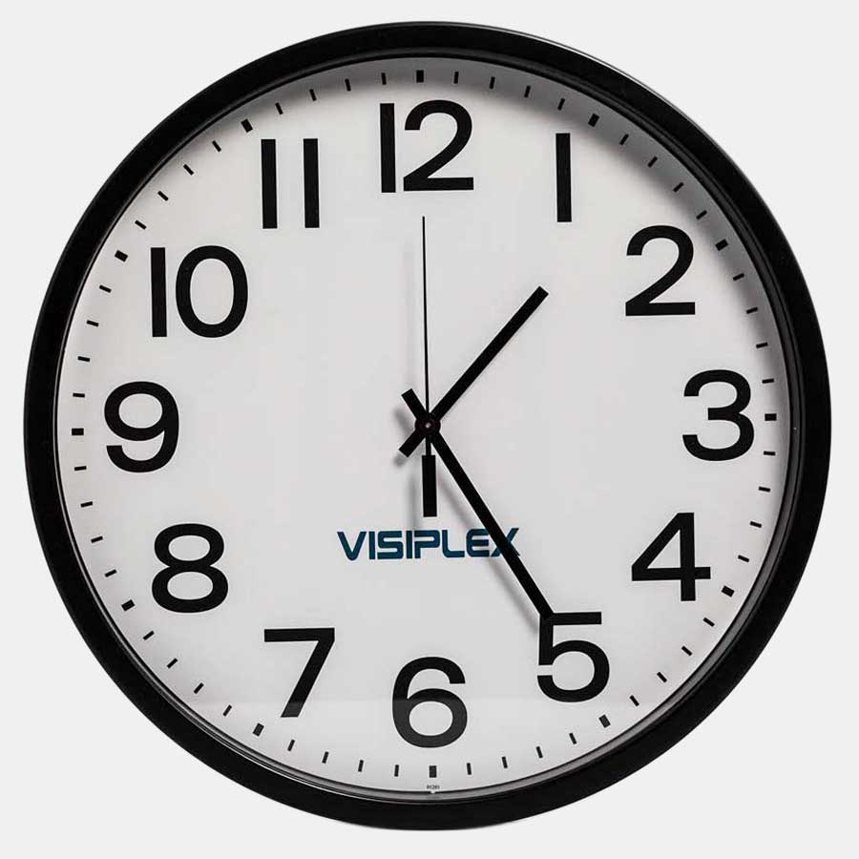

Location Reports
The location for where the protagonist gets picked up would ideally be a secluded area with a long road. For this I believe Pantycelyn Road in Townhill would be a good shout. The road is typically quite during the times of filming and so any issues shouldn’t arise.
For the final act I would need a wooded area that has access for cars to drive down. I am unaware of any locations that match this but by asking local knowledge I shouldn’t have an issue finding an appropriate location. As the final location would be focused in a more city-esque area, it would again need to be a secluded area. Ideally I would want to present him being in the city through his surroundings, with shops and signs present in the scene. This aspect may need to be changed due to the violent end to the scene and so an alternative would be a neighbourhood area. The main element of the location I would need would be a long straight road, which will allow a long take and for the killer to make his approach slowly. I believe an ideal shooting location would be any of the roads on Constitution Hill as they should be quiet during filming and do comprise of long straight roads. This location can be revised.
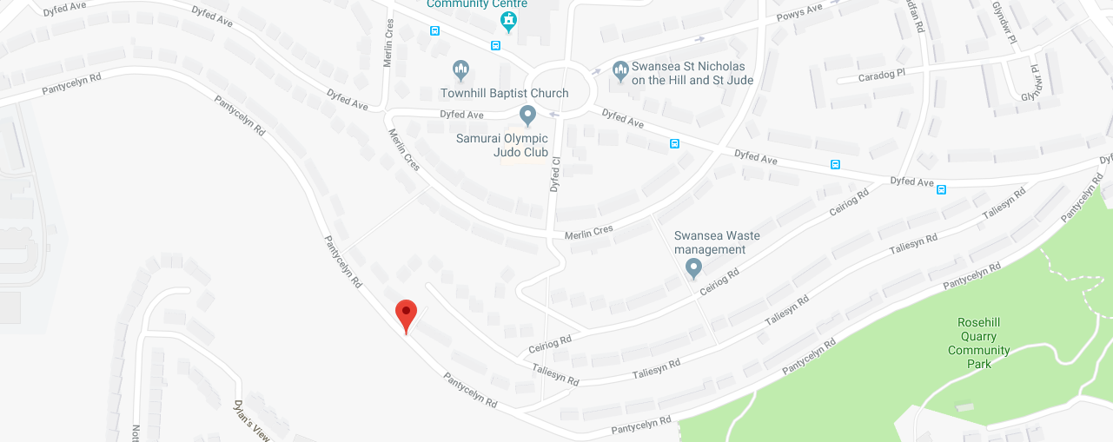

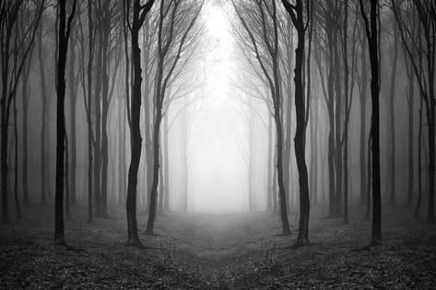

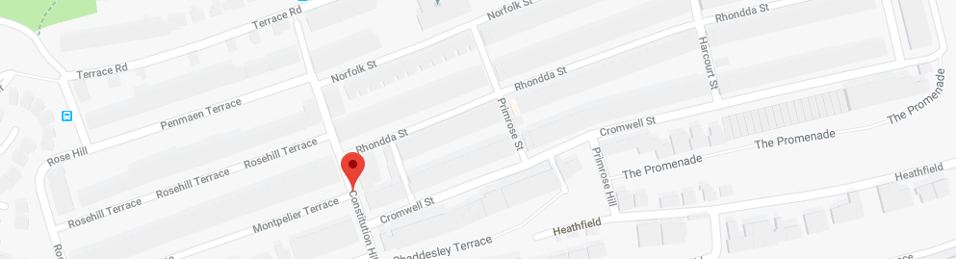

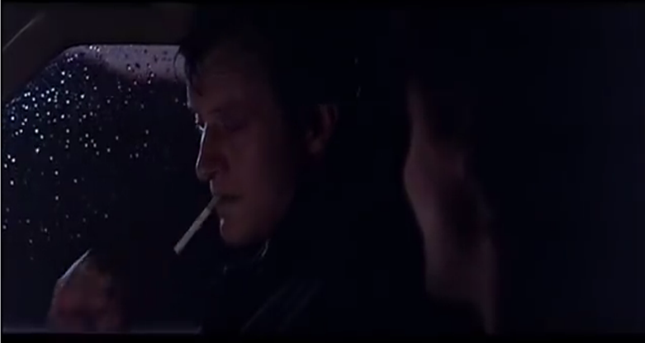
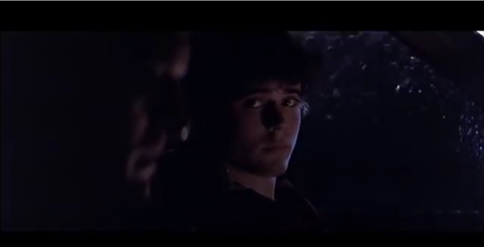

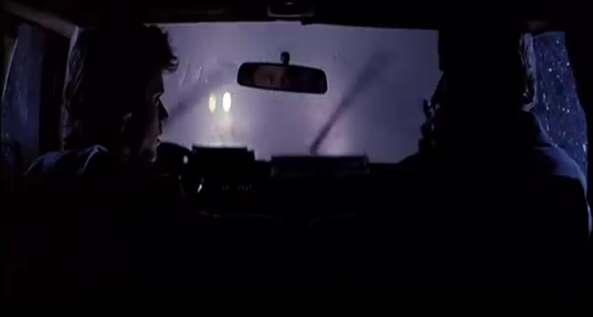
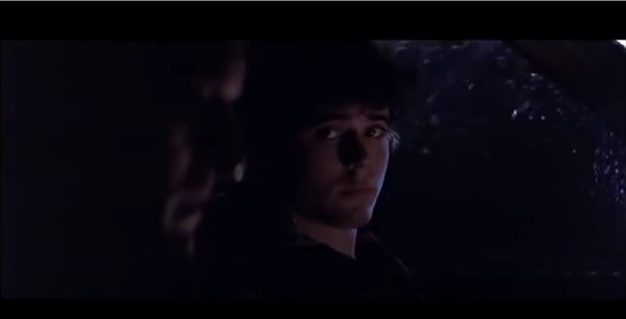
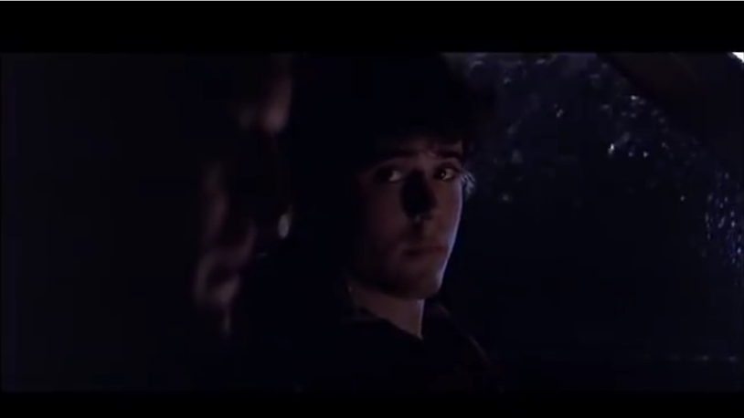
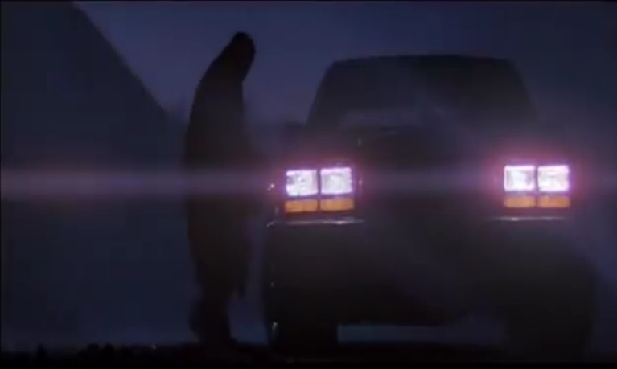
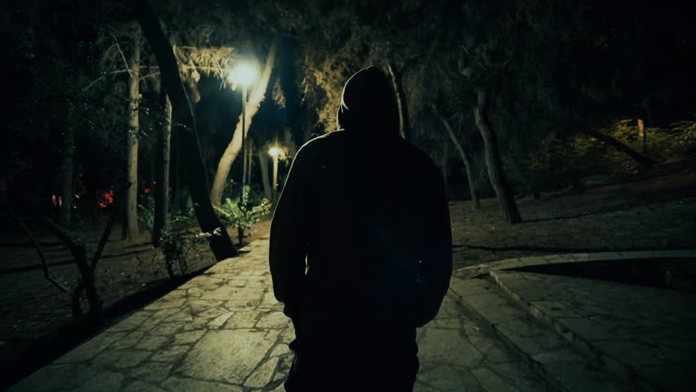
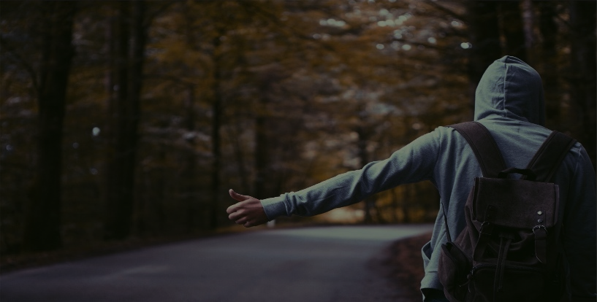
LUCY: “Yes, that’s fine I’m heading to Cardiff anyway”
Jason walks down the street. The street is empty and he is the only person to be seen
Jason sees a car in the distance, he outstretches his arm and raises his thumb.
LUCY: “Tired are we”

JASON: “Just a bit yeah, think the alcohol has caught up with me”
JASON: “Not far, Neath if you don’t mind”
LUCY: “So Jason, where are we headed”
The car pulls over and Jason gets in
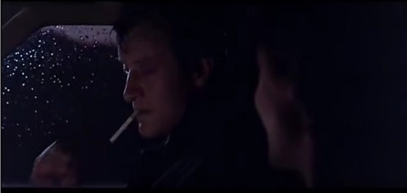
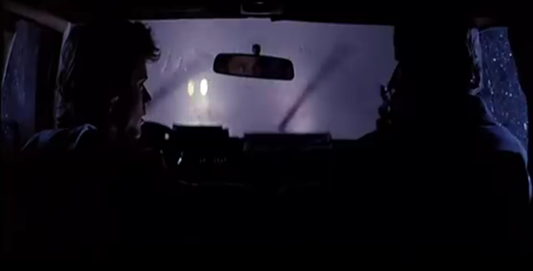
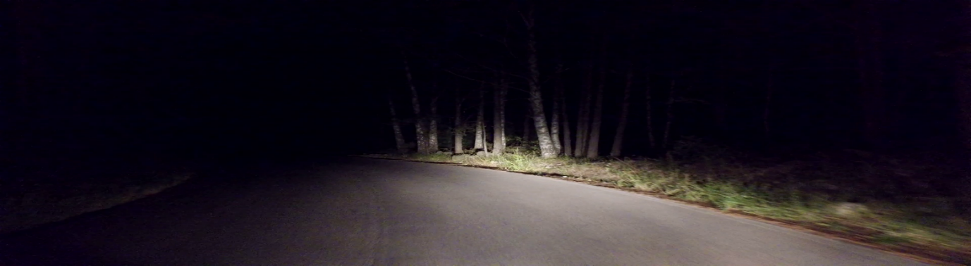
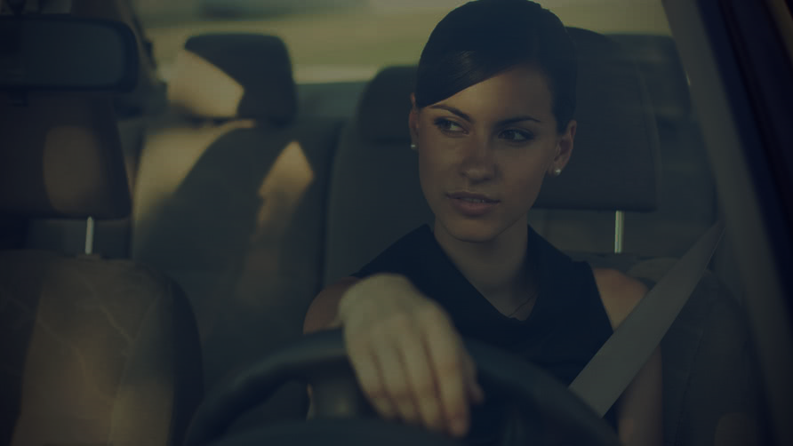
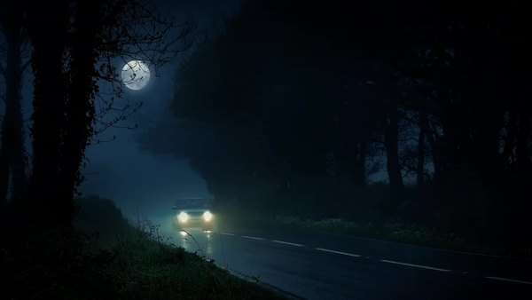
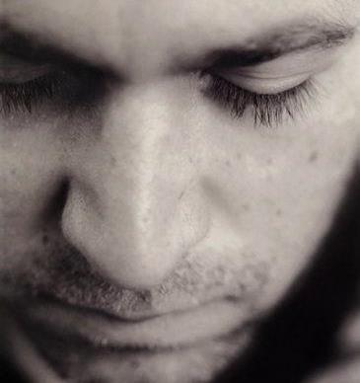
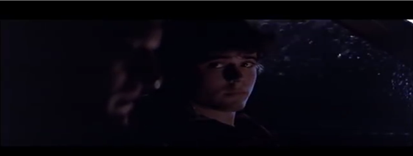
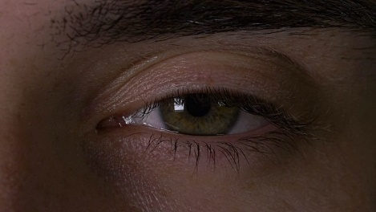
LUCY: “Why. Don’t you trust me?”
JASON: “Where are we?”
LUCY: “Go back to sleep Hun, we’ve still got quite a way to go
Lucy gases over at Jason, contemplating what she is going to do
JASON: “I’d rather not
LUCY: “If you want to have a kip, you can. I’ll wake you when we get to Neath”
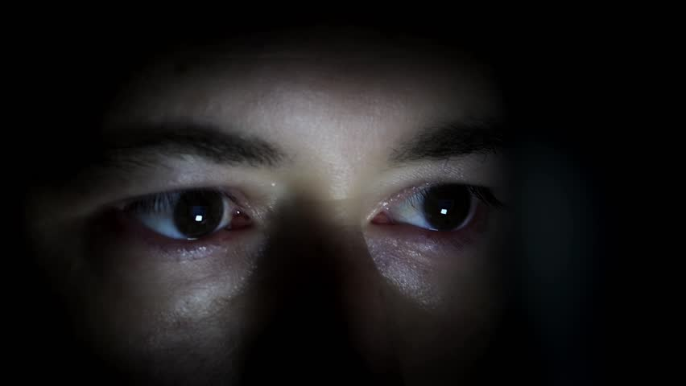
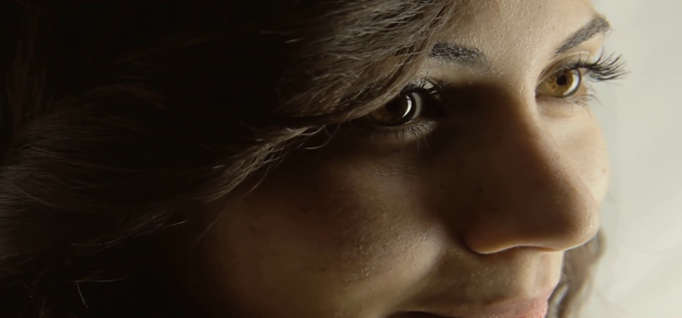
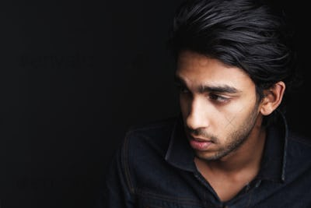
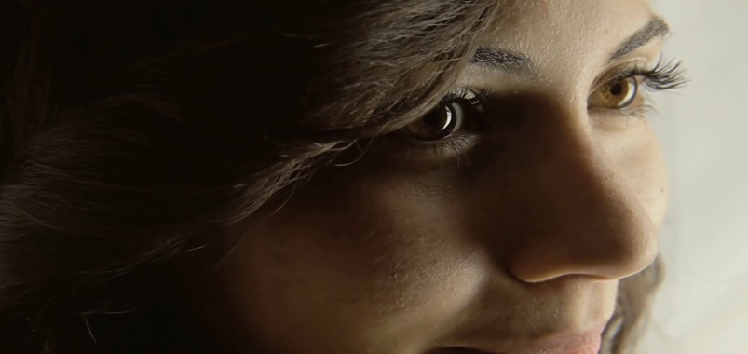
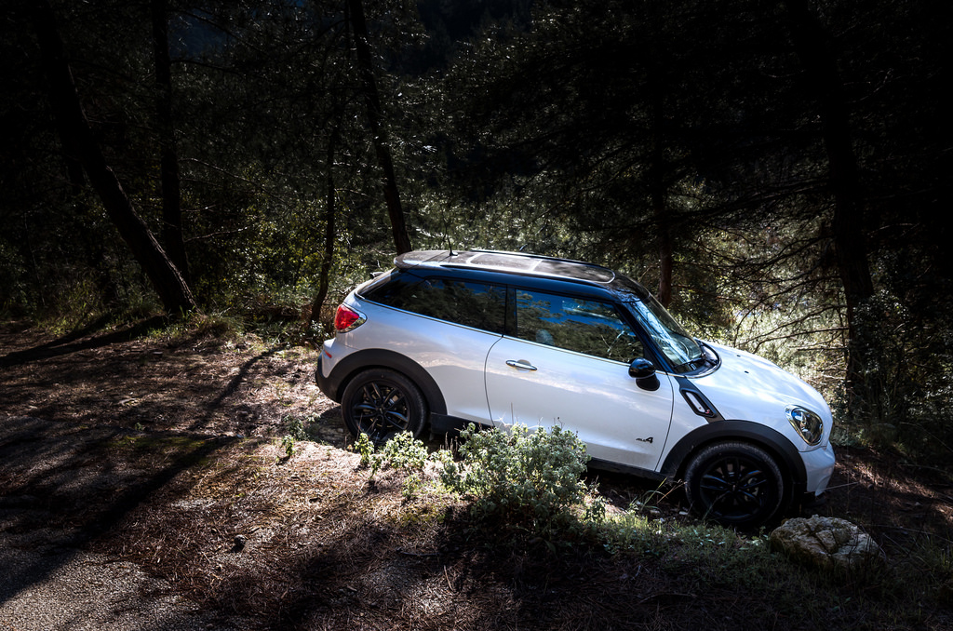
LUCY: Have you ever been with an older woman Jason?”
JASON: “No really, where are we?”
Lucy: “There’s no need to be afraid Jason. Mother’s going to take care of you”
LUCY: “I could satisfy you Jason”
JASON: “Um”
LUCY: “I bet she didn’t satisfy you”
Lucy pulls the car over and stops the vehicle
LUCY: “Hey, want to know why I’m single?”
LUCY: “Not far now”

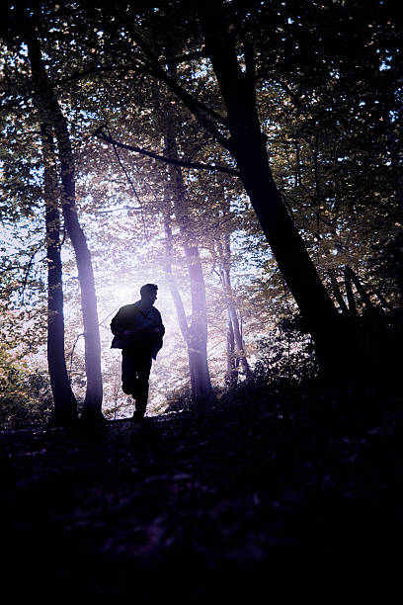

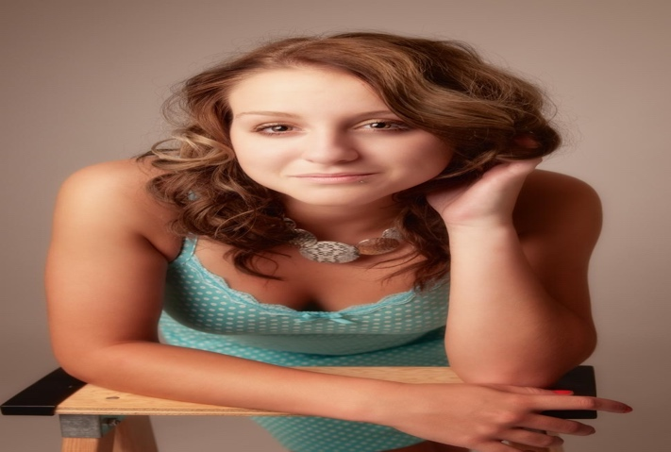
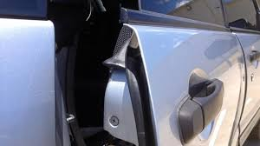

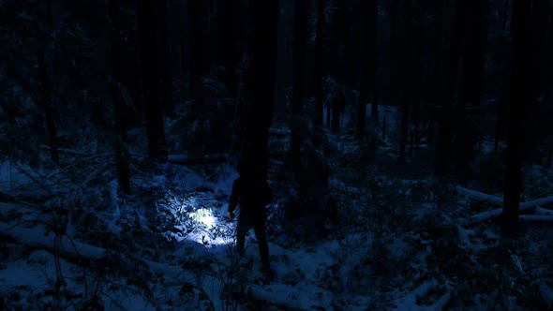
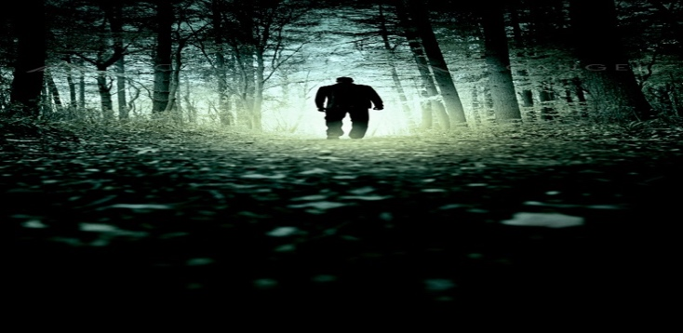
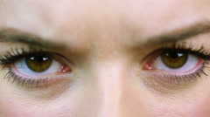
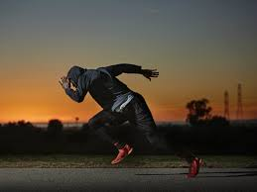

LUCY: “Baby if you wanted to play hide and seek you should have said
LUCY: “Jason, where are you”
Jason begins to run towards the woods, putting as much distance between him and Lucy
JASON: “Leave me alone”
LUCY leans over to Jason as she attempts to come onto him
Jason’s door opens and he falls out
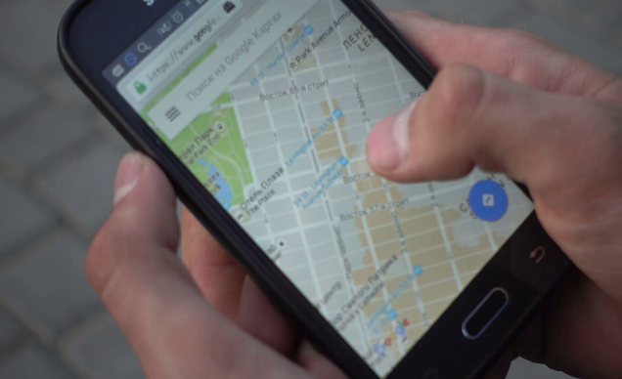
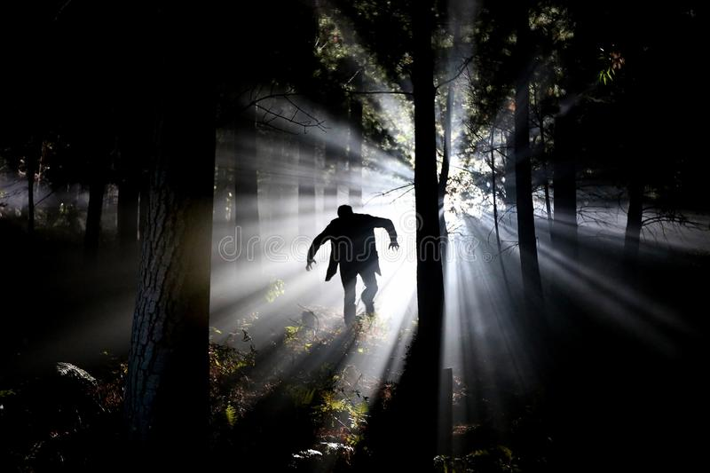
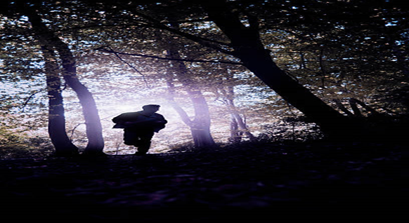


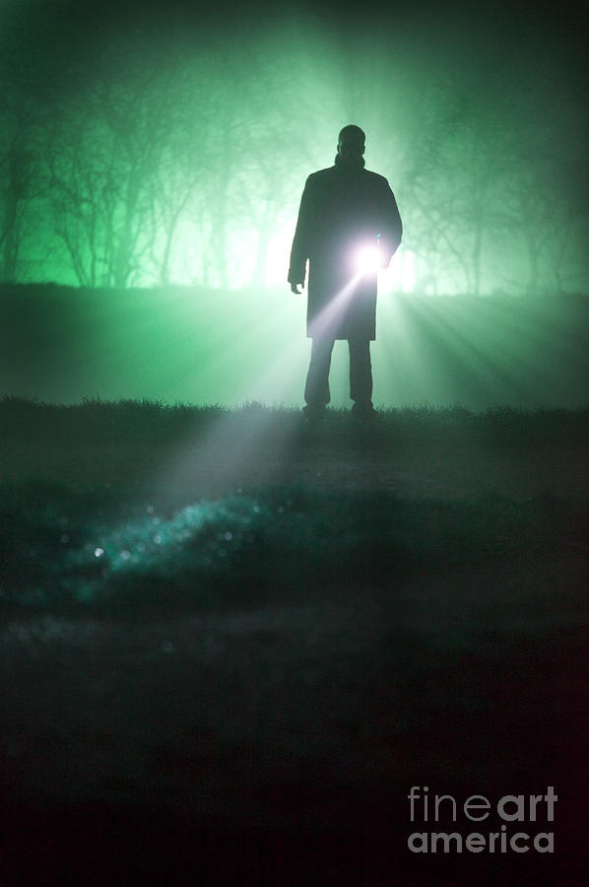
LUCY: “Found you”
Jason waits a while before leaving in the direction of the city
Lucy’s light is fully on Jason and he is clearly visible. A branch snaps in the distance
LUCY: “I will find you Jason”
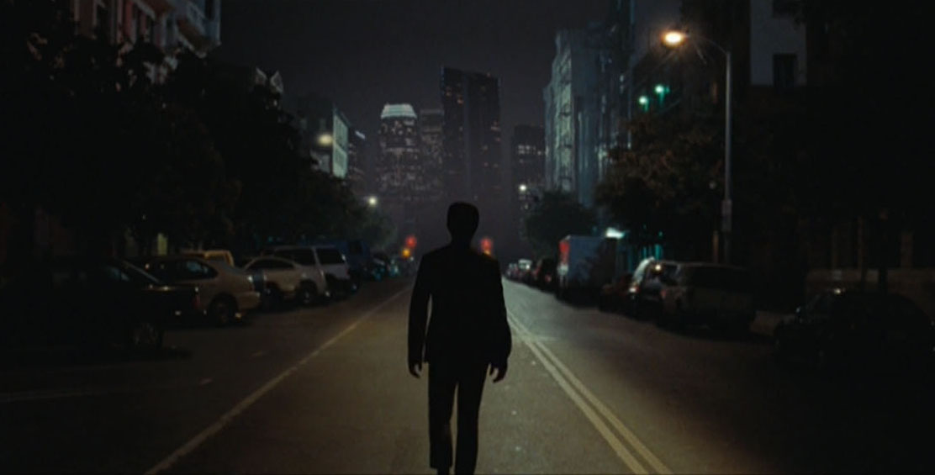
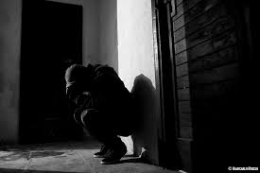
Jason walks down a long empty street, gasping and walking very slowly
He collapses against a wall, resting to catch his breath before continuing down the road

The figure catches up to Jason and puts a rag up to his nose. Jason struggles but eventually succumbs to it.
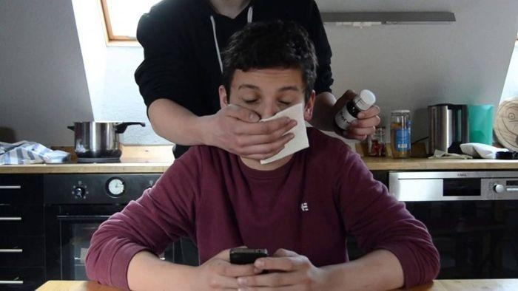
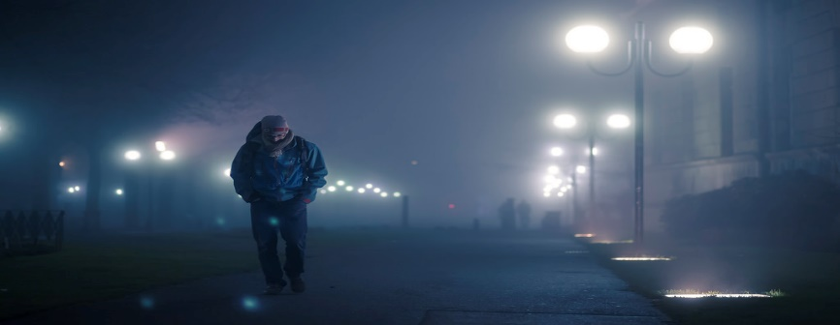
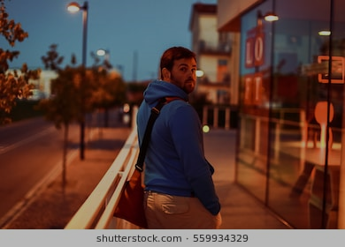
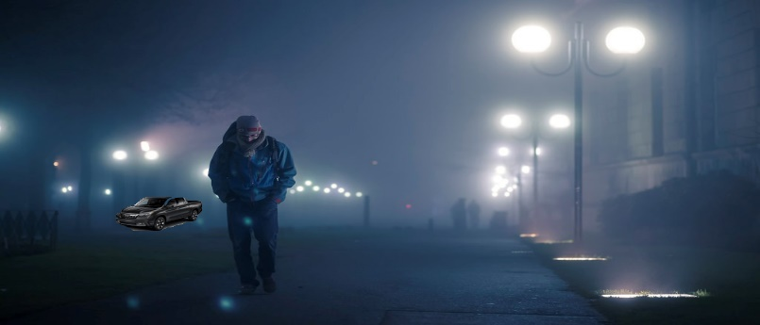
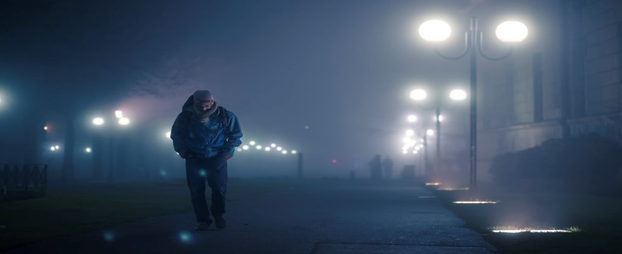
A figure can be seen walking towards Jason, out of focus until the figure catches up with Jason
Jason looks back at the car, but dismisses it and continues his walk
A car can be seen in the distance but it is too far to make out its features
Jason walks down the road, not checking his surroundings

Upon starting the pre-production stage of this product, I had to decide upon what I wanted from the project. Initially I wanted to specialise in editing and contribute to other projects to build up my show reel, but upon writing the first draft for this film I decided that I wanted to create this film. I chose to be the director for this film to challenge myself and to ensure that my vision was created in a manner that would allow me to produce a film that I am proud of, whilst also producing something that would strengthen my editing show reel for future employers. This meant that whilst writing my scripts my goal was to write it so that it had a scene that would let my editing skills and own style show within the finished product.
My script started off as a mix of a ‘coming of age’ and ‘horror’ film. I chose this as I felt that by taking elements from a ‘coming of age’ film this would allow for my film to have a coherent start as my target audience would be students and young adults. I felt that having the first act start at a house party it would give context as to why the protagonist is hitchhiking. Upon reviewing this I decided that this was not needed and thus by eliminating the ‘coming of age’ aspect of the narrative, it would make the cost of the shoot substantially lower and would allow me to focus on creating a true horror film. This creative decision had a knock-on effect with my script. By eliminating the house party scene from my narrative, I had to rewrite the narrative for the film. This change, although necessary proved to be tiresome as I had to start afresh. This did allow my script to be strengthened as I had to ensure that the dialogue between the two characters worked as the majority off the film would be placed in a car and so if the writing was poor, the film would be poor. I believe that my latest script is significantly stronger then my initial draft, and so this change proved to be beneficial.
After writing my first draft of the film I set out to accompany it with a visualisation. I chose to do this so when explaining my narrative, I could draw attention to my visual storyboard to allow my audience to have a visual reference as to what my narrative was about. As I changed the script this meant that my visualisation had to change as well, to adapt to the new story. This proved to be a challenge as it meant searching for new images that would correlate to how I would like the film to end out. I believe the final product is efficient in explaining what the film is about and is a good aid to my story and will allow me to visualise my film, as well as what shots need to be done during production.
Once my first draft was completed I went out to write a rough summary of what I believed the costs for the film would be, as well as how I would fund these costs. Upon reviewing my film, I decided to scrap the house party scene which made me realise that I could cut the costs of the film. Instead of hiring extras and potentially renting a building to film in, I had made it so only two actors and a car was required. This was both a good move financially and appropriate for the time scale as it would be easier to organise then had I kept the ‘coming of age’ elements in my narrative. In my finance and budget, I had incorporated costs to cover petrol as well as providing food for the cast and crew. I had decided that it would be beneficial to offer petrol to the actors as they would be spending a great deal of time filming in a car and so a lot of petrol would be used and so by incorporating petrol into my overall costs I can keep my actors happy and ensure that the shoot is a success.
My schedule has also changed since my first draft. I had initially planned for a three-day shoot. These three days would have covered the original three acts of my narrative. As I removed the house party from my narrative this removed the need for a three-day shoot and so allowed for all filming to be done in two days instead. The first day would be covering the conversations in the car up until the protagonist falls asleep and the final day would consist of all the scenes that occur once he has woken up. The times at which I filmed didn’t change but the amount of days spent filming did and so by filming in a shorter time, I would be able to save money and get all the content I needed in a much a faster time.
My locations have a very high chance of changing by the time production starts. This is largely in part to whether or not the locations I have decided upon would work on camera and if a new location arises that is better than the one I have chosen. The location that I am certain will change is the wooded area. As I am not from the area I am unaware of the best location to film this and so by the time production comes around it is highly likely that I would find a more suitable location to film, by speaking to people who are more familiar with Swansea.

