

Program Name: MBA International Business
Topic:
A Post-Pandemic Consumer Adoption of Online Shopping in the Retail Sector: A Comparative Case Study of Amazon India and Amazon UK
Student Name: Sahil Thakarshibhai Lakhani
Student ID:2433103
Supervisor Name: Dr. Charles Oham



Master’s Degrees by Examination and Dissertation
Declaration Form.

Declaration Form.

I, Sahil Thakarshibhai Lakhani , declare that this dissertation has been composed by myself, that the work contained herein is entirely my own except where explicitly stated otherwise in the text, and that this work has not been submitted for any other degree or qualification, in whole or in part, except as specified.

Signature: …………

Date: 5th June 2026

AI use Acknowledgements
I declare that this dissertation was not prepared, written, analyzed, interpreted, or completed using an artificial intelligence (AI) tool. I carried out all phases of the research myself, such as literature search, data collection, thematic analysis, discussion, conclusions and recommendations. Any ideas, interpretations, arguments and findings in this study have been my own academic work, critical thinking and evaluation of relevant scholarly and industry sources.
Acknowledgement
I would like to express my sincere gratitude to my supervisor, lecturers, and academic institution for their continuous guidance and support throughout this research. I also feel obliged to thank all the authors, researchers, and industries that have contributed immensely to this research work through their research findings and literature.

Abstract
Chapter one has provided the background on the extent of online shopping adoption after the pandemic in the retail market of Amazon UK and Amazon India. The chapter presented the theoretical and practical basis, the gaps in existing literature, and how TAM and TPB is relevant for consumer behaviour in developed and emerging markets. In addition, the research aim, objectives, questions, and dissertation outline were logically structured to provide a clear basis for the research study in general.
Chapter two critically reviewed the literature on the subject that has already been published and provided the context of the post-pandemic situation, where online shopping has been embraced in both the Amazon UK and Amazon India markets. The chapter reviewed key topics such as online shopping trends, comparative consumer behaviour, challenges facing consumers and recommendations for strategies that impact consumer adoption behaviour. In addition, the chapter examined and assessed relevant theories that could account for the difference in consumer acceptance between developed and developing markets, like Dynamic Capabilities Theory, Technology Acceptance Model, and Theory of Planned Behaviour. Further, this chapter also revealed substantial gaps in the literature, created a conceptual framework and laid a solid theoretical basis for the empirical research of the research study.
The methodological approach used to investigate the adoption of online shopping after the COVID-19 pandemic in Amazon UK and Amazon India was explained and justified in Chapter three. The chapter discussed the interpretivism philosophy, inductive approach, comparative qualitative case study strategy, and qualitative research design. Moreover, the chapter provided the justification for using secondary qualitative data and thematic analysis as a method to systematically interpret the consumer behaviour and differences in each market. Further, the quality of the research, ethics, data collection process, and time horizon planning were also highly discussed to ensure the research was credible, transparent, and methodologically rigorous throughout the research.
The findings regarding online shopping adoption after the pandemic for Amazon UK and Amazon India have been detailed in Chapter four. There is a critical analysis of the growth trend, behavioural differences among consumers, operational barriers, trust-related concerns, and recommendations affecting online shopping adoption. Additionally, there were also differences identified between developed and emerging retail environments in terms of the level of digital maturity, infrastructural support, affordability, localisation, and consumer trust. These findings are based on comparative data, and they meet the research objectives set out in this study.
The findings related to the post-pandemic adoption of online shopping by Amazon UK and Amazon India were critically analysed in Chapter five. These findings have been linked to the relevant literature and theory, and also relate to the purpose of this research project. Moreover, the results indicated considerable disparities between the developed and emerging retail environments regarding trust, infrastructure, affordability, localisation, and digitisation.
The research was summarised in Chapter six, which included major findings, theoretical implications, research objectives, recommendations, limitations and future research scope. The chapter substantiated the findings that the adoption of online shopping differed widely between the two countries, Amazon UK and Amazon India, due to differences in trust, infrastructure, maturity of the online ecosystem, affordability, localisation and consumer behaviour between developed and emerging retail markets.
Table of Contents
List of Abbreviations 13
Glossary 14
Chapter One: Introduction 16
1.1 Research Background 16
1.2 Research Rationale 17
1.2.1 Theoretical Justification 17
1.2.2 Practical Justification 18
1.3 Theoretical Framework 21
1.3.1 Theoretical Framework and Significance in Marketing 21
1.3.2 Technology Acceptance Model 22
1.3.3 Theory of Planned Behaviour 22
1.4 Research Aim, Objectives, and Questions 22
1.4.1 Research Aim 22
1.4.2 Research Objectives 22
1.4.3 Research Questions 23
1.5 Dissertation Structure 23
1.6 Chapter Summary 23
Chapter Two: Literature Review 24
2.1 Introduction 24
2.2 Methodological Overview of Literature Review 24
2.2.1 Research Strategy 25
2.2.2 Evidence of Searching 25
2.2.3 Boolean Search 26
2.2.4 CRAP Method 26
2.2.5 PRISMA Flow Diagram 27
2.3 Thematic Analysis of the Literature 28
2.3.1 Post-pandemic consumer adoption growth patterns of online shopping in India and the UK 28
2.3.2 Comparative analysis of consumer behaviour between the UK and India 30
2.3.3 Key challenges faced by consumers in post-pandemic online shopping environments 32
2.3.4 Strategic recommendations to improve consumer adoption in India and the UK markets 33
2.3.5 Theoretical Foundation and Contribution to Cross-Market Online Shopping Consumer Behaviour 35
2.4 Conceptual Framework 37
2.5 Research Gap 39
2.6 Chapter Summary 39
Chapter Three: Research Methodology 41
3.1 Introduction 41
3.2. Research Philosophy, Approach, and Design 41
3.2.1 Research Onion 41
3.2.2 Research Philosophy 42
3.2.3 Research Approach 42
3.2.4 Research Strategy 42
3.2.5 Research Design 43
3.3 Justification for selecting secondary data 43
3.3.1 Strength and Appropriateness of Secondary Data 43
3.3.2 Acknowledge limitations 43
3.4 Data Sources and Data Collection 43
3.5 Data Analysis Approach 44
3.6 Research Quality and Rigour 45
3.7 Ethical Considerations 45
3.8 Time Horizon 45
3.9 Chapter Summary 46
Chapter Four: Data Findings 47
4.1 Introduction 47
4.2 A Comparative Case Study on Amazon UK and Amazon India 47
4.2.1 Overview of the Amazon 47
4.2.2 Post-Pandemic Growth of Online Shopping Adoption in India and United Kingdom 48
4.2.3 Comparative Consumer Adoption Behaviour Between Amazon India and Amazon United Kingdom 51
4.2.4 Post-Pandemic Consumer Challenges Affecting Online Shopping Behaviour on Amazon 54
4.2.5 Strategic Recommendations Influencing Consumer Online Shopping Adoption Across Retail Markets 58
4.3 Chapter Summary 62
Chapter Five: Discussion 63
5.1 Introduction 63
5.2 Data Analysis 63
5.2.1 Expansion of Post-Pandemic Online Shopping Trends in India and the United Kingdom 63
5.2.2 Cross-Market Consumer Behaviour Differences Between Amazon India and Amazon UK 64
5.2.3 Consumer Barriers and Behavioural Challenges Influencing Post-Pandemic Online Shopping Adoption 65
5.2.4 Strategic Factors Enhancing Consumer Adoption of Online Shopping Across Retail Markets 66
5.3 Discussion of Findings and Analysis 67
5.4 Chapter Summary 69
Chapter Six: Conclusion 70
6.1 Overall Conclusion 70
6.2 Linking with Objectives 70
6.2.1 Linking with Objective 1 70
6.2.2 Linking with Objective 2 71
6.2.3 Linking with Objective 3 71
6.2.4 Linking with Objective 4 71
6.3 Recommendations 72
6.4 Conceptual framework contribution to knowledge 73
6.5 Research Limitations 73
6.6 Future Scope of the Study 74
Reference List 75
Appendices 86
Appendix 1: CRAP Method Table 86
Appendix 2: Key Literature Summary Table 90
Appendix 3: Time Horizon 99

List of Figures
Figure 1: Global Retail E-Commerce Market Size 15
Figure 2: Companies’ top priorities in 2024 18
Figure 3: The Growth in Retail E-commerce Sales Worldwide 2022-2027 (in trillions) 19
Figure 4: Worldwide Digital Business Strategies 2024 Top 10 Predictions 20
Figure 5: Structure of this study 22
Figure 6: Evidence of Search 24
Figure 7: PRISMA flowchart 27
Figure 8: The Dynamic Capabilities theory 29
Figure 9: Digital Maturity Model 32
Figure 10: Technology Acceptance Model 34
Figure 11: Theory of Planned Behaviour (TPB) 36
Figure 12: Conceptual Framework 38
Figure 13: Research Onion 41
Figure 14: Online Net Sales of Amazon 48
Figure 15: How India Shops Online 2025 49
Figure 16: Online retail values 50
Figure 17: UK Retail E-commerce sales 51
Figure 18: How India Shops Online 52
Figure 19: Top ten organisations visited by UK online adults on smartphones, tablets or computers 53
Figure 20: UK Online Retailing Market Analysis 54
Figure 21: Payment Trust issues in India 55
Figure 22: UK secures action from Amazon to tackle fake reviews 56
Figure 23: Transactional Delivery and Refund Issues 57
Figure 24: Amazon Cost of Sales 57
Figure 25: Invent the Nest Inflections 58
Figure 26: Amazon India creates 150,000 seasonal jobs 59
Figure 27: What Britons expect from retail & delivery 60
Figure 28: Personalisation through Gen-AI application 60
Figure 29: Indian E-retail Market 61

List of Tables
Table 1: Search Strategy 24
Table 2: Boolean Search Table 25
Table 3: Data Collection Method 43

Chapter One: Introduction

1.1 Research Background
After COVID-19, the global retail industry has rapidly shifted towards digital platforms, with Amazon being at the centre of this change. In 2024, Amazon earned $638 billion, which demonstrates the high demand in the world, as well as the domination of the platform (Amazon Annual Report, 2024). However, compared to Amazon India, Amazon UK has a different business environment. The UK market is mature and has stable logistics and high digital penetration, whereas India has regulatory constraints and infrastructure gaps, which form opposing competitive dynamics (JPMorgan, 2025).
Post-pandemic adoption of online shopping is the manifestation of the changing consumer behaviour in markets. According to McKinsey (2025), more than three-quarters of consumers worldwide made more purchases online after COVID-19. However, UK consumers are found to be more consistent and habitual in their online behaviour and, in comparison, Indian consumers are price-sensitive and trust local retail. This has strategic importance to managers and policymakers in comparing Amazon UK and India.
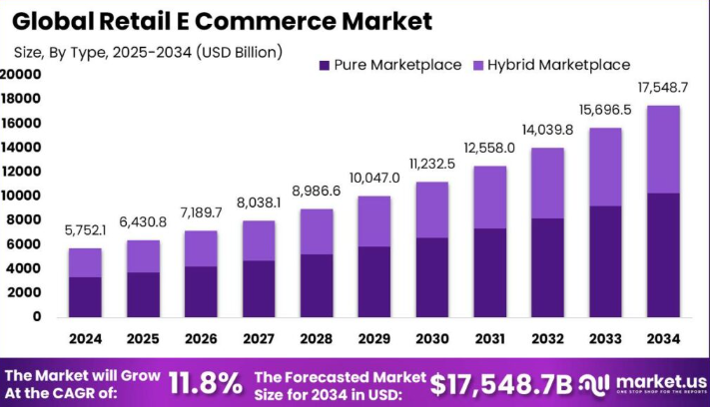
Figure 1: Global Retail E-Commerce Market Size
(Source: Market.us, 2025)
The relevance of this topic is supported by strong market data. Market.us (2025) records that the global e-commerce industry will take 21% of the retail sales, and it highlights the fast development of mobile commerce, particularly in such developing countries as India. However, Kaur (2024) noted that in the UK and India, persistent challenges of data privacy in the former and reliability of delivery in the latter, respectively. This implies an imbalanced adoption in the face of general growth.
The research problem arises from these cross-market differences. Amazon UK also enjoys the advantages of a developed infrastructure and customer confidence, allowing stable adoption trends (Amazon Annual Report, 2024). Conversely, in India, Amazon is growing at a rapid rate, though the usage is not consistent because of regulatory restrictions and the digital divide. Amazon's approach of quick delivery and convenience is to make the experience similar worldwide, but its success in these markets is not consistent (Amazon Annual Report, 2024).
While prior studies have analysed online shopping behaviour, they concentrate on single-country environments. However, cross-comparative analysis across developed and developing countries is still inadequate (Charles et al., 2025). In contrast, international reports indicate consistent growth in all regions, but the reasons behind such adoption vary. Hence, this research aims to fill this void by analysing the post-pandemic comparison between Amazon UK and Amazon India.

1.2 Research Rationale

1.2.1 Theoretical Justification
There is a broad explanation of the adoption of online shopping in the existing literature based on well-established behavioural models like the Technology Acceptance Model (TAM) and the Theory of Planned Behaviour (TPB). According to these models, the perceived usefulness, ease of use, attitudes, and behavioural intentions play a crucial role in consumer adoption (Sasidharan and Venkatakrishnan, 2024). Ciucan-Rusu et al. (2022) prove that, after the pandemic, consumers are more and more dependent on the digital platform because of its convenience and accessibility. Moreover, Esfahbodi et al. (2022) portrayed that the constructs of trust, efficiency of delivery, and price value are mentioned as the determinants of e-commerce adoption. But conversely, these models mostly make the assumption of rational and homogeneous consumer behaviour in various situations, which can be simplistic in the real world. However, Oki et al. (2021) stated that the prevailing argument is that the perception of technology and behavioural intention are significant drivers of online shopping adoption in the retail markets around the world.
Despite strong theoretical foundations, several inconsistencies remain in the literature. Although Cavalcanti et al. (2022) state that convenience and digital availability are the driving factors in adoption across all markets, on the contrary, Lep et al. (2022) emphasise that trust, cultural values, and offline preferences, especially in emerging markets, remain significant. Furthermore, the majority of the studies are related to the situation in one country only, which constrains cross-cultural knowledge and comparative data. On the contrary, Dabija et al. (2025) noted that consumer expectations have shifted in response to rapidly changing conditions after the pandemic, but most studies use a static or pre-pandemic frame, which poses a theoretical constraint. Also, small sample sizes and the absence of longitudinal analysis are methodological limitations that limit generalisability. As a result, despite a solid foundation offered by TAM and TPB, the contextual differences between developed and emerging markets remain under-represented, which means that critical behavioural mechanisms have not been thoroughly studied.
Building on these limitations, there is a definite research gap in the comprehension of the variations in the uptake of online shopping, post-pandemic, in the developed markets and emerging markets in a comparative context. Particularly, the available literature is scanty in terms of exploring the varying differences in TAM and TPB constructs in the context of Amazon UK and Amazon India. But conversely, the literature tends to presuppose homogeneous behavioural drivers and dismisses the contextual aspects of infrastructure, regulatory environment, and socio-economic diversity. This is a theoretical gap since it limits the generalisability of current models and restricts the knowledge of boundary conditions influencing consumer adoption. Moreover, Khaled et al. (2025) advise conducting increasingly comparative and context-dependent research to optimise behavioural theories in digital retail. Comprehensively, the respective research study fills a major theoretical gap by juxtaposing the adoption of online shopping after the pandemic in Amazon UK and India, which helps to improve the external validity of the model and the knowledge of the context-specific factors that impact consumer behaviour.

1.2.2 Practical Justification
Lack of knowledge about differences in consumer behaviour between Amazon UK and Amazon India makes it difficult for managers to make decisions, as there is a need for different strategies because of different consumer behaviour and regulations in these two areas. While managers may have assumed consistent consumer behaviour for digital commerce, on the contrary, according to McKinsey (2024), there are major differences in consumer expectations in different parts of the world.
Secondly, it is a strategic concern, with the global growth of Amazon requiring the company to adjust its business model to both developed and emerging markets, to continue to grow and remain competitive.
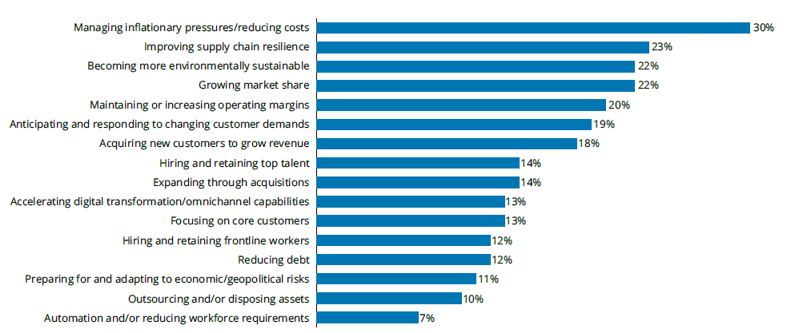
Figure 2: Companies’ top priorities in 2024
(Source: Deloitte, 2024)
According to this visual representation, businesses put cost-cutting, resiliency, sustainability, and digital transformation in 2024 to enhance efficiency, growth, and competitiveness in evolving markets. Deloitte (2024) states that the transformation of retail digitally demands ongoing technological and customer experience investment. On the contrary, the new markets like India have regulatory barriers and infrastructure constraints, as compared to the stable UK market. This brings about a pressing necessity for market-specific strategies as opposed to global standardization.
Thirdly, evidence from industry reports further supports this challenge. For example, Amazon cited $638 billion in revenues and highlighted that quicker delivery leads to more buying, which proves that the success of strategies is based on their matching operations to consumer behaviour (Amazon Annual Report, 2024).
According to the Financial Times (2024), 70% of the digital transformation projects do not achieve anticipated results because of inadequate alignment with consumer behaviour.
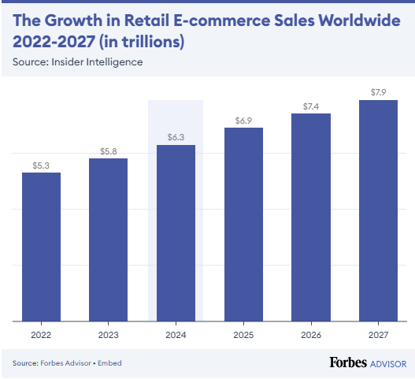
Figure 3: The Growth in Retail E-commerce Sales Worldwide 2022-2027 (in trillions)
(Source: Forbes, 2026)
On the other hand, Forbes (2026) reveals that the e-commerce retail sales in the world have been growing in terms of continuous and significant growth as the sales stood at $5.3 trillion in 2022 and are projected to reach $7.9 trillion by 2027. This implies that there is a swift rise in online shopping adoption, which is proving to be of growing significance to businesses and necessitates the necessity to comprehend evolving consumer behaviour. But, conversely, IDC (2024) notes that it is not only the investment in digital infrastructure, but also a mismatch between strategy and implementation.
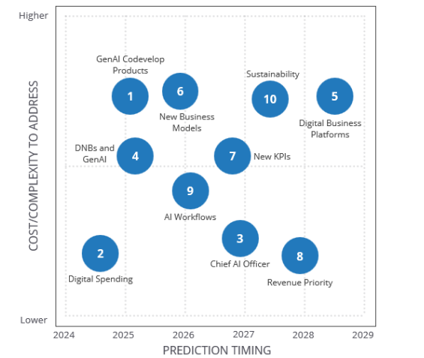
Figure 4: Worldwide Digital Business Strategies 2024 Top 10 Predictions
(Source: IDC, 2024)
Fourthly, managers face significant operational pain points due to this gap. These areas are related to issues surrounding the balance between globalization and localization, calculating return on investment (ROI), and managing efficiencies in supply chains. Sorooshian et al. (2022) portrayed that although Amazon wants to ensure standardized fast delivery worldwide, issues like last-mile deliveries in India prevent this compared to the UK.
Finally, there is a high opportunity cost of not considering these differences. According to the Economist Intelligence Unit (2026), companies that do not localize their strategies can lose market share in the high-growth areas. Conversely, knowledge of these distinctions can establish a competitive edge, enhance customer satisfaction, and long-term profitability.

1.3 Theoretical Framework

1.3.1 Theoretical Framework and Significance in Marketing
This research shows that the Technology Acceptance Model and the Theory of Planned Behaviour are important for marketers. These theories provide insight into why consumers choose to shop online by considering usefulness, ease of use, attitude and intention. This study explains that these variables are affected by market variables like infrastructure, trust and regulation. It says that consumer behaviour varies in different countries, as seen in the comparison between Amazon UK and Amazon India. This allows marketers to create more effective strategies in line with market and consumer demands.

1.3.2 Technology Acceptance Model
The Technology Acceptance Model gives reasons as to why users accept and use new technology. It is concerned with two variables, the perceived usefulness and the perceived ease of use. This is the level of ease and utility of online shopping platforms such as Amazon to consumers. The rationale behind adopting TAM is due to the fact that online shopping is a technology-oriented tool, and people will only embrace it when it is easy and advantageous (Ho, 2022). TAM assists in the analysis of the motivation of consumers in Amazon UK and Amazon India to use or shun online shopping behaviour in this research study. It also facilitates comparison since variations in digital literacy and platform usability between the two countries affect user behaviour and adoption behaviour in the post-pandemic period.

1.3.3 Theory of Planned Behaviour
The Theory of Planned Behaviour describes the effects of attitude, social pressure and perceived control on behaviour. It reveals that individuals embrace online shopping depending on their belief, peer pressure, and their digital capabilities. Nguyen et al. (2023) noted that the Theory of Planned Behaviour can be helpful in this research since consumers make their decisions based not only on technology but also on trust, social trends and confidence in the online systems. Comparing Amazon UK and Amazon India, TPB can be used to determine the influence of cultural differences, level of trust, and social influence on online shopping behaviour. It aids comprehension of how consumer adoption in various market settings is influenced by external and individual factors.

1.4 Research Aim, Objectives, and Questions

1.4.1 Research Aim
This research aims to examine post-pandemic consumer adoption of online shopping by comparing influencing factors in Amazon UK and Amazon India retail markets.

1.4.2 Research Objectives
- To assess the way consumer adoption of online shopping increased in India and the UK after COVID-19
- To conduct a comparative analysis of consumer adoption of online shopping between Amazon UK and Amazon India post-pandemic
- To examine the challenges faced by consumers post-pandemic while shopping online from Amazon UK and Amazon India
- To provide recommendations to retailers like Amazon to influence customers towards online shopping in India and the UK

1.4.3 Research Questions
- How did consumer online shopping adoption change in UK and India post-COVID?
- What differences exist in consumer adoption between Amazon UK and Amazon India?
- What challenges do consumers face when shopping online on Amazon platforms?

1.5 Dissertation Structure
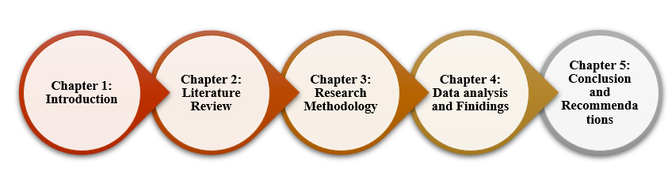
Figure 5: Structure of this study
(Source: Self-Created)
The dissertation consists of five chapters, each of which covers the important points of the research to provide a logical and clear flow. Chapter one presents the introduction, which will cover the research background, rationale, aims, and objectives. Chapter two will examine the literature on online shopping behaviour, theoretical frameworks, and the available literature. Chapter three will describe the research methodology, such as design, data collection, and analysis methods. Chapter five will provide and discuss the results with comparative data between Amazon UK and India. Lastly, Chapter six will cover conclusions, implications, and give recommendations on future research and practice. Overall, this structure provides a logical analysis flow, which facilitates comprehension, critical analysis and successful attainment of the research objectives.

1.6 Chapter Summary
This chapter introduced the research by outlining the background of post-pandemic online shopping growth and how Amazon India and Amazon UK are playing an increasingly significant role in the global retail industry. It identified some of the major distinctions between the developed and emerging markets with respect to consumer behaviour, infrastructure, and regulatory environment. The study was well guided by the research aim, objectives and questions. Lastly, the overall structure of the dissertation was provided to make sure that the research flow was logical and systematized. Building on Chapter one, Chapter two will review key literature on post-pandemic online shopping and connect theory and evidence in explaining consumer behaviour variations between India and the United Kingdom.

Chapter Two: Literature Review

2.1 Introduction
Based on the first chapter, which discussed research background, objectives, and gaps, the second chapter presents a critical review of the literature on post-pandemic online shopping behaviour in India and the UK. This chapter presents an extensive literature review to understand how consumers are likely to adopt online shopping in the UK and Indian markets after the pandemic. A literature review is a critical analysis of existing research that identifies key themes, theories, and gaps to support and justify a specific study topic (Chigbu et al., 2023). The areas discussed in the review include the uptake of e-commerce, consumer participation, e-commerce maturity, and suggestions on how to improve online shopping experiences. Other studies that are not relevant to offline retail trends are not included in this review. An integrated conceptual framework of TAM and TPB is provided in order to comprehend the most crucial factors influencing consumer adoption. The chapter follows the following structure, including a methodological overview followed by thematic discussions of growth patterns, comparative consumer behaviour, challenges, and strategic recommendations.

2.2 Methodological Overview of Literature Review
The literature review was conducted using a structured search and selection strategy to make sure that only relevant and high-quality sources were included. Studies concerning post-pandemic online shopping and consumer behaviour were identified by using academic databases like Google Scholar and ScienceDirect. The Boolean search method was used with keywords such as online shopping adoption, consumer behaviour, India and the UK, coupled with the operators AND and OR to narrow down the results. The studies were chosen on their relevance, the year they were published, and the aspects of the research, and all the duplicates and irrelevant studies were eliminated to give the review process a sense of accuracy and consistency.
The PRISMA flowchart gives the systematic procedure for the literature review study selection. It starts with finding the records in databases (Google Scholar and Science Direct) and then eliminating duplicates and irrelevant studies. The screening and eligibility of the 609 reports were done, and 15 studies were taken. This flowchart provides transparency as every step of the process is recorded, and the exclusion criteria are developed on relevancy, publication year, and context, and eventually, high-quality studies are included.

2.2.1 Research Strategy
Database | Keywords
Google Scholar | 'Post-pandemic online shopping adoption' AND 'Consumer behaviour' AND 'Digital transformation' AND 'E-commerce adoption' AND 'UK market' AND 'India market'
Science Direct | 'Technology Acceptance Model' OR 'Consumer motivation' AND 'E-commerce adoption' AND 'Digital maturity' AND 'Cross-market comparison' AND 'Consumer trust'
Table 1: Search Strategy
(Source: Self-Created)

2.2.2 Evidence of Searching
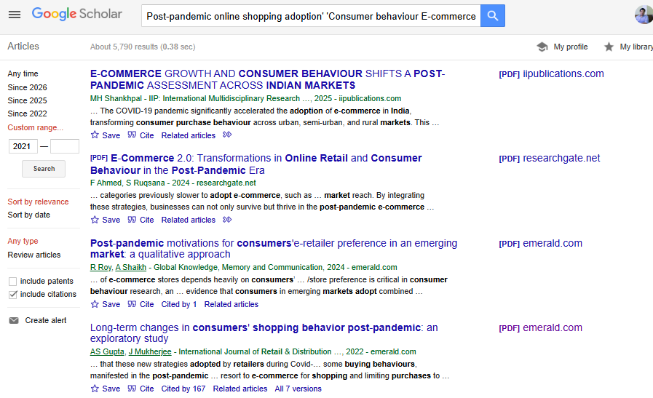
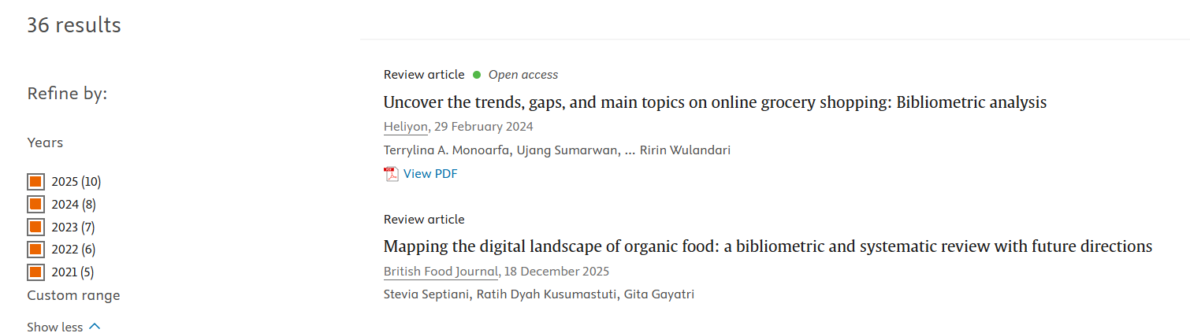
Figure 6: Evidence of Search
(Source: Snipping by self)

2.2.3 Boolean Search
Objective 1 | Objective 2 | Objective 3 | Objective 4
'Consumer adoption' AND 'online shopping' AND 'post-pandemic' | 'Consumer behaviour' AND 'online shopping' AND ('India' OR 'UK') | 'Challenges' AND 'consumer barriers' AND 'online shopping' | 'Recommendations' AND 'Amazon' AND ('India' OR 'UK') AND 'consumer adoption'
AND 'COVID-19' OR 'digital adoption' | OR 'Digital transformation' AND 'consumer engagement' | AND 'consumer behaviour' AND 'post-pandemic' | AND 'customer experience' AND 'retail strategies'
'India' OR 'UK' AND 'e-commerce growth' | AND 'cultural differences' OR 'online shopping trends' | AND 'hybrid shopping' AND 'consumer trust' | OR 'personalized marketing' AND 'online shopping'
OR 'UK market' OR 'India market' | OR 'consumer satisfaction' AND 'digital maturity' | OR 'retail barriers' AND 'delivery issues' | AND 'market-specific strategies'
Table 2: Boolean Search Table
(Source: Self-Created)

2.2.4 CRAP Method
(CRAP Method table attached in Appendix 1)

2.2.5 PRISMA Flow Diagram

Previous Studies
Identification of new studies via databases
Identification of new studies via other methods
Studies included in previous version of review (n=0)
Reports of studies included in previous version of review (n=0)
Records identified from*:
Google Scholar: 5790
ScienceDirect: 36

Records removed before screening:
Duplicate records removed (n = 523)
Records marked as ineligible by automation tools (n = 2,132)
Records removed for other reasons (n = 1,523)

Records identified from:
Websites (n = 0)
Organisations (n = 0)
Citation searching (n = 0)

Records screened (n=1648)
Total studies included in review (n=15)

Reports sought for retrieval (n=609)
Reports assessed for eligibility (n=127)
New studies included in review (n=15)
Reports of new included studies (n=15)
Records excluded (n=1039)
Reports not retrieved (n=482)
Reports excluded:
Reason 1 Articles published before 2020 (n = 32)
Reason 2 Studies not related to Topic (n =37)
Reason 3: Out of context (n = 43)
Identification
Screening
Included

Figure 7: PRISMA flowchart
(Source: Self-Created)

2.3 Thematic Analysis of the Literature
In a literature review, thematic analysis is a method that is applied to define, examine, and categorize prominent trends or themes in the current studies. The first step in the thematic review process has involved identifying and analysing the academic articles to build understanding of the key concepts and research questions. The findings, patterns and key concepts were then systematically categorised into broad themes for critical analysis and interpretation (Christou, 2022). Such themes are subsequently reviewed and narrowed down to make them clear and relevant to the topic of the research. The themes are then compared and contrasted in the various studies to determine any similarities, differences and gaps. Lastly, the results are made into sections, which assists in providing a clear and critical understanding of the research field.
The literature review is divided into four themes, they are:
1. post-pandemic consumer adoption growth patterns of online shopping in India and the UK
2. Comparative analysis of consumer behaviour between the UK and India
3. Key challenges faced by consumers in post-pandemic online shopping environments
4. Strategic recommendations to improve consumer adoption in India and the UK markets
5. Theoretical Foundation and Contribution to Cross-Market Online Shopping Consumer Behaviour

2.3.1 Post-pandemic consumer adoption growth patterns of online shopping in India and the UK
Post-pandemic consumer adoption refers to the increased use of online shopping platforms following COVID-19, driven by safety, convenience, and digital access. This theme is significant because it clarifies the way in which consumer behaviour changed across different markets, such as the UK and the emerging markets, such as India, to influence retail strategies. This theme helps achieve Objective 1 through studying post-pandemic growth in adoption rates, which helps understand behavioural changes in both markets.
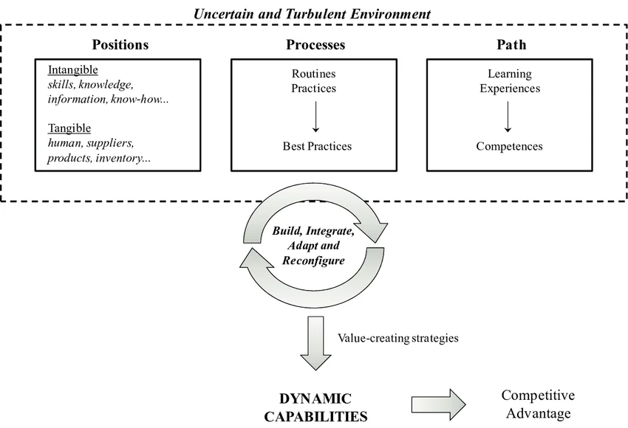
Figure 8: Dynamic Capabilities theory
(Source: Pereira et al., 2015)
The concept of post-pandemic adoption can be explained using Dynamic Capabilities, which suggests firms adapt to environmental changes by sensing, seizing, and reconfiguring resources. As Čirjevskis (2022) notes, companies that successfully implement digital technologies have an opportunity to adapt to evolving consumer needs and ensure a competitive edge. Dynamic Capabilities theory presupposes that organizations are able to constantly adjust to such disruptions as COVID-19. However, this might not be true in all markets, with up-and-coming economies, such as India, having infrastructural and regulatory restrictions, which restrict the application of the digital transformation on par with developed markets, such as the UK. Thus, although businesses are flexible to change, market-related restrictions restrain the usefulness of digital transformation in various economic settings.
Recent research has provided conflicting evidence on consumer adoption after the pandemic. Adopting a mixed-method approach of UK retail data and interviews, Nanda et al. (2021) state that COVID-19 had enduring, accelerating effects on the adoption of e-commerce because of digitalization and mobility limitations. This shows that the structural change in retail markets in the long run could be achieved due to pandemic-induced digital adoption. In a comparable study, Ghodture et al. (2025) discovered extensive expansion in online shopping owing to health consciousness and online interactions through a secondary study of 30 articles. This implies that the issue of health and internet connectivity played an instrumental role in adopting online shopping in the long term across the world. However, Diaz-Gutierrez et al. (2024), in a quasi-longitudinal survey with SEM, discovered that despite 75% of new users intending to continue with online shopping, 63%-85% of them are planning to revert to in-store shopping, indicating hybrid behaviour. This means that consumer behaviour is also moving towards hybrid shopping as opposed to total reliance on online shopping. Agarwal and Kandpal (2025) observed that in India online adoption is highly sensitive to price, and customers are more inclined to buy products in a way that is discounted as compared to the UK where convenience and quality are more important factors of purchase than price. This implies that the UK consumer behaviour is an indicator of the increased purchasing power and preference on shopping experience rather than on price reduction. Conversely, PLS-SEM based on 327 participants, Kaur et al. (2023) state that the hedonic motivation and habit are more likely to affect adoption, as opposed to necessity, which points to the possibility that growth after the pandemic will not be increasing but stabilising in India. On the same note, Diaz-Gutierrez et al. (2024) emphasize that physical stores do not undergo a complete digital transformation, leading to a reflection of online shopping as a supplementary resource. Overall, these studies contribute marginally to a more in-depth understanding of behaviour change over time, but cross-sectional studies can lead to a reduced level of generalisability. Thus, most of the studies are in agreement on higher adoption, but they differ on whether it is a sustainable adoption in the long term and its consistency in different contexts.
There is an evident gap in the literature in terms of comparative and context-specific knowledge in the adoption of online shopping after the pandemic in various markets. Moreover, a key gap in the literature is the emphasis by Nanda et al. (2021) on significant digital expansion while largely considering developed countries, which limits the ability to compare data across different nations. Similarly, the research conducted by Diaz-Gutierrez et al. (2024) indicates inconsistent long-term usage trends, although it is location-dependent. In contrast, Kaur et al. (2023) discuss the importance of human behaviour in adopting technology without including information about the post-COVID era. Thus, this gap underscores the necessity of cross-country studies that are integrated and cover behavioural and contextual variations in post-pandemic adoption.

2.3.2 Comparative analysis of consumer behaviour between the UK and India
Comparative consumer behaviour explains how attitudes, intentions, and actions differ across markets like the UK and India. Comparative consumer behaviour explains how attitudes, intentions, and actions differ across markets like the UK and India (Tarka et al., 2022). This study is significant as the adoption of online shopping after the pandemic is different based on the cultural, economic, and technological disparities, which affect the way consumers in both settings engage with online platforms like Amazon. This theme contributes to objective 2 through the comparative study between UK and India consumers’ behaviour, which highlights the major differences that contribute to the acceptance of online purchasing.
Consumer behaviour differs across UK and India due to variations in attitudes, social influence, and perceived control in online shopping contexts. The Theory of Planned Behaviour (TPB) explains consumer behaviour based on attitudes, subjective norms and perceived behavioural control as factors that affect purchase intention. Theodorou et al. (2023) demonstrate that TPB can be used to reveal that positive attitudes and control are strong drivers of online shopping, and the decision-making process is influenced by social influence. TPB, however, is based on rational behaviour, which is not necessarily a complete description of cultural and economic differences in countries. Perceived behavioural control in the UK is enhanced with the presence of stable infrastructure, and in India, behaviour is influenced by social norms and affordability. Therefore, although TPB offers a powerful foundation, it needs to be contextualized in order to account for the cross-country variations in the adoption of online consumers effectively.
Comparison between India and the UK consumer behaviour reveals contradictory trends of consumer behaviour. Mallick et al. (2024) state that with mixed-method analysis of Amazon data, the shift to online shopping by Indian consumers was strong based on the safety factor and convenience, which means high digital adoption of the company. It means that the issues of safety and convenience played a critical role in boosting the rate of Indian consumer adoption of digital. Similarly, the analysis of secondary data by Jain (2022) revealed that Indian customers were more focused on basic items, purchases with good value, and digital payments, which are sensitive to the economy. This shows that Indian consumers are very price-sensitive and are mindful of affordability and necessities. But to the contrary, Aguirre and Menon (2024), with a mixed-method UK survey of retailers, concluded that the UK consumers valued sustainability, digital innovation and omnichannel experiences over price sensitivity. This is an indication of more mature consumer behaviour. Similarly, based on the bibliometric analysis of findings, Lim et al. (2023) suggest that the consumer behaviour in India is being influenced by ethical consumption and ESG issues more frequently, particularly in developed economies. This shows that consumers in the developed markets are becoming more focused on sustainability, ethics and socially responsible buying choices.
There is also a definite gap in comparative studies of consumer behaviour under varying market conditions in various market contexts around the globe. A significant gap exists as Mallick et al. (2024) focus only on Indian consumer behaviour as well as Aguirre and Menon (2024) study UK consumers using independent variables, which do not allow direct cross-country comparison. None of these studies, however, combine behavioural, cultural and economic factors. Thus, the comparative studies investigating the differences in the post-pandemic consumption rates of Amazon UK and India are lacking, which leaves an evident gap in the need to conduct multi-market research context-specifically. Accordingly, this gap indicates the necessity of multi-market research of consumer behaviour differences after the pandemic.

2.3.3 Key challenges faced by consumers in post-pandemic online shopping environments
The online shopping conditions post-pandemic have brought some key challenges to the consumers, including the navigation of the online platform, privacy and delivery, and adaptation to the novel forms of e-commerce. Retailers need to understand such challenges in designing strategies to meet new consumer expectations, both in developed and emerging markets such as the UK and India. This theme supports Objective 3 as it reveals some of the major challenges in post-pandemic online shopping, which helps to comprehend the barriers encountered by consumers.

Figure 9: Digital Maturity Model
(Source: Ciruskabiri and Varnaseri, 2023)
In the face of post-pandemic online shopping conditions, businesses are forced to evolve digital capabilities to satisfy evolving customer demands and overcome obstacles to online shopping. Digital maturity theory analyzes the capacity of a company to cope with the changes in technology. Spremic et al. (2022) address the idea that organizations should be able to match digital tools to the needs of consumers to remain competitive. This notion is crucial in post-pandemic shopping when businesses have to age digitally to support the challenges experienced by consumers in changing the e-commerce environment.
Recent research on consumer behaviour after the pandemic offers an idea of the obstacles encountered by consumers in the online world. Conceptual framework analysis and secondary data were utilized by Dali et al. (2020) to expose a range of issues such as data security-related issues, shifting shopping behaviour, and uneven digital accessibility in various geographical areas, especially in emerging economies such as India. According to their study, digital shopping skyrocketed, but the problem of trust and digital competence is still a serious obstacle. Similarly, Anand et al. (2023) discovered that in India, the lack of internet penetration and the lack of infrastructure remain the obstacles to the full potential of e-commerce. This introduces a one-sided shopping experience where convenience can be compromised with the delays of delivery and absence of consumer support, which leads to customer dissatisfaction. However, Chinthala (2022) also observed that UK consumers, who are enjoying the advantages of a well-developed digital infrastructure, have another set of problems, including information overload, security breaches, and the need to experience a more personalized experience. All these contribute to the unwillingness to use new platforms, despite the increase in digital options. On the other hand, Srinivasan et al. (2023), state that companies offering omnichannel services, which are enhanced with personalization via AI, make the issues consumers only need to encounter considerably lower. It observes that this type of approach results in improved customer retention and satisfaction after the pandemic. However, this literature underscores the fact that these innovations need digital maturity, which developing nations such as India have yet to attain. Overall, the challenges related to consumers are different in each of the markets, and in India, there are infrastructure gaps that need to be addressed with a specific approach, whereas in the UK, the issue is digital complexity, and trust, access, and experience have to be enhanced.
A notable gap in the literature is the lack of comparative analysis of sector-specific challenges faced by consumers when engaging in post-pandemic online shopping, especially in developed and emerging markets. Although Dali et al. (2020) are interested in digital barriers in the emerging market, and Srinivasan et al. (2023) emphasize the advantages of omnichannels, the sectoral differences in consumer experiences are not properly studied. Thus, this comparative analysis gap on sector-specific issues indicates that cross-market research on consumer experiences after the pandemic is necessary.

2.3.4 Strategic recommendations to improve consumer adoption in India and the UK markets
The strategic suggestions of how to enhance consumer adoption within the post-pandemic market relate to what the retail businesses can do to mitigate the obstacles and with which to improve the consumer experience. Regarding online shopping, these strategies ought to be consistent with the new consumer demands and capitalize on the digital transformation to enhance engagement and conversion rates. This theme justifies Objective 4 by pinpointing strategic suggestions to increase consumer adoption and contribute to better marketing in the UK and India markets.
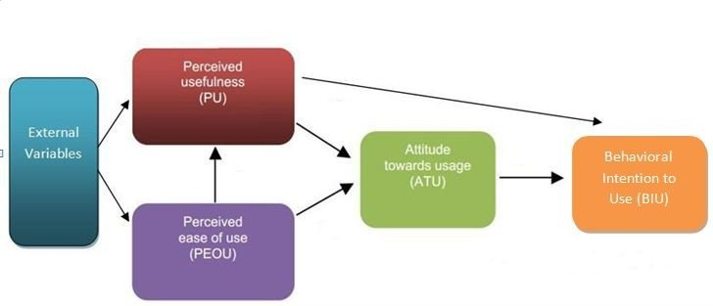
Figure 10: Technology Acceptance Model
(Source: Nikou et al., 2014)
Habib and Hamadneh (2021) observed that the Technology Acceptance Model (TAM) assumes that the major factors that affect the adoption of technology are perceived ease of use and perceived usefulness. When applied to online shopping, TAM effectively implies that the perceived value brought by online platforms motivates consumer acceptance, which will cause them to choose to remain involved with online shopping platforms like Amazon in India and the UK.
Recent research points to the differences in approach that are required in India and the UK in order to boost the uptake of online shopping by consumers. In a conceptual framework, Imschloss and Schwemmle (2024) suggest that retailers develop a value-based customer experience by prioritizing digital activity, technological advancements, and partnerships. This is echoed by Hoang et al. (2023), who state that online customer interaction, especially hybrid models, is central to the long-term growth in the luxury fashion industry. The pandemic has greatly changed consumer expectations, and Kappagantu et al. (2024) highlight that the proactive marketing efforts of Amazon in India, such as localized promotions, have played a key role in making consumers more engaged. Personalized marketing strategies, they say are especially important in developing markets such as India, where online platforms may lack trust on the basis of infrastructural issues. On the contrary, however, Rosario and Raimundo (2021) noted that, as global e-commerce companies, including Amazon, have adjusted to the shift to digital, local rivals, including Flipkart, are also performing well by adopting the human touch in customer service and offline-online hybridization. The study found that in India, consumers still prefer human interaction despite the increasing trend towards digital shopping. On the contrary, Hoang et al. (2023) as well as Imschloss and Schwemmle (2024) emphasize that, in the UK, the approach should be to enhance the online interface and interaction strategies, where the level of digital maturity is stronger, and the rivalry is determined more by value-added services such as personalized recommendations and loyalty programs. Overall, these results suggest that market maturity and consumer expectations require various approaches to consumer adoption.
Despite existing studies, significant gaps remain in comparing market-specific strategies across different socio-economic contexts globally. Imschloss and Schwemmle (2024) concentrate mainly on high-tech and value-based retailing without touching on the infrastructural constraints of new markets. Further, Kappagantu et al. (2024) propose that more efforts should be directed towards localized marketing, yet they do not give the cross-cultural tactics of conducting business, such as Amazon, which has operations worldwide. Thus, additional studies are required to help overcome cross-market strategic variations that have an impact on consumer adoption.

2.3.5 Theoretical Foundation and Contribution to Cross-Market Online Shopping Consumer Behaviour
TPB describes behaviour in terms of attitudes, subjective norms, and perceived behavioural control, which shape intentions that affect actual actions of consumers. The Theory of Planned Behaviour (TPB) stated that human behaviour is motivated by three fundamental constructs: attitude, subjective norm, and perception of behavioural control (Hagger et al., 2022). All these factors combine to form behavioural intention of a person, which determines the actual behaviour.
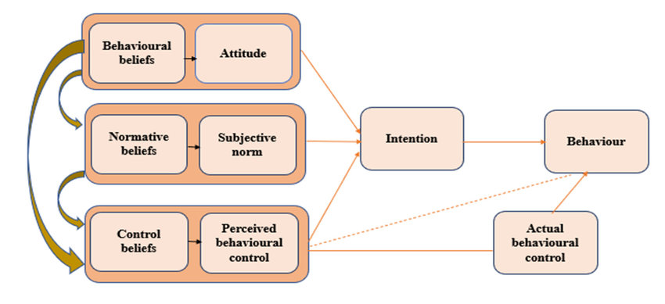
Figure 11: Theory of Planned Behaviour (TPB)
(Source: Omotayo et al., 2020)
However, Leonov et al. (2023) noted that TPB assumes that consumer behaviour occurs through a rational and deliberate decision-making process, which may simplify the complexities of consumer behaviour in the real world. TPB has been perfected over the years; however, Tang et al. (2021) claim that TPB does not consider emotional, unconscious or spontaneous behaviour that may affect online shopping behaviour. This assists in the analysis of the consumer behaviour variation in online shopping adoption in UK and India market.
TPB is valid because it attributes consumer intentions to the attitudes, norms, and control although it has limitations in explaining emotional and contextual factors. TPB is frequently used to understand consumer behaviour, especially in the study of intentions to embrace new technologies such as online shopping (Ruiz-Herrera et al., 2023). It is an attractive framework as it provides a systematic approach to analyze the effect of attitudes, subjective norms and perceived behavioural control on behavioural intention. Instead, Chaudhary et al. (2025) noted that the inflexible assumptions of TPB about rational decision-making fail to take into account the impulse and emotion-based aspects of consumer decision-making, which are especially pertinent in the context of e-commerce. As an example, the extreme social and emotional aspects of online shopping, in particular, during the pandemic, put into question the emphasis on the theory of solely rational factors. In addition, as much as TPB has been used extensively, there has been little cross-country research using it, including comparisons between developed countries, such as the UK, and emerging markets like India, and it does not completely capture the role of infrastructure and regulation in online shopping adoption. This supports analyzing the online shopping adoption differences between UK and India in the post-pandemic setting.

This research is an expansion of TPB to include contextual variables, such as infrastructure, regulation and digital maturity to understand cross-market consumer behaviour differences. This study critically analyses TPB by subjecting it to cross-market consumer behaviour on Amazon UK and India, thereby broadening the scope of the theory to other infrastructural and regulatory contexts. However, the digital divide between these two nations is not entirely fit in TPB; its constructs, such as perceived behavioural control and subjective norms does not reflect the constraints based on infrastructure in India. Conversely, this research will attempt to refine TPB by examining the effect of contextual factors such as regulatory constraints, economic differences and different levels of digital maturity in the two markets on consumer adoption. Overall, it aims at extending the theory by considering hybrid consumer shopping behaviour, where there is an overlap between online and offline behaviours. Such issues are often neglected by TPB due to its linear structure. This justifies the study by describing consumer adoption variations between Amazon India and the UK market.

2.4 Conceptual Framework
The conceptual framework integrates the important constructs used in behavioural theories to inform the study on post-pandemic online shopping adoption. It looks at the differences in consumer behaviour in Amazon UK and India and how they are affected by infrastructure, culture and economic factors in influencing adoption levels of the different markets.

Conceptual Framework for Post-Pandemic Online Shopping Adoption

Technology Acceptance Model (TAM)
• Perceived Usefulness
• Perceived Ease of Use

Consumer Online Shopping Behaviour
• Convenience Perception
• Trust in Platform
• Delivery Experience
• Price
Consumer Adoption of Online Shopping
• Adoption Frequency
• Purchase Intention
• Continued Platform Usage

Theory of Planned Behaviour (TPB)
• Attitude
• Subjective Norms
• Perceived Behavioural Control

Figure 12: Conceptual Framework
(Source: Self-Created)
The framework comprises three elements, including TAM and TPB, which determine Consumer Online Shopping Behaviour, which eventually determines Consumer Adoption of Online Shopping. Perceived Usefulness and Ease of Use have played a role in driving adoption in both markets, but in the UK, these factors are more significant, as infrastructure is stable, and digital adoption is strong. Trust in Platform and Convenience Perception on the other hand, are more important in India because of the regulation issues, poor infrastructure and low digital penetration. Purchase intention is further influenced by Attitude, Subjective Norms and Perceived Behavioural Control, yet these factors differ much in the UK and India based on socio-economic and cultural factors, as identified byNanda et al. (2021) and Mallick et al. (2024). According to Sinha (2021), In India, price plays a major role in online shopping adoption as consumers are very price-sensitive and affordability and discounts are a major concern in their buying decisions. Conversely, Ognjanov et al. (2026) observed that consumers in UK are not so price-sensitive and are more concerned with convenience, quality, and service experience than low prices. Thus, this conceptual framework guides research by describing the effects of various variables on consumer adoption in Amazon UK and India.
This framework organizes the research by directing the analysis of the case in Chapter four and the cross-case synthesis in Chapter five. It concentrates on the differences in consumer behaviours between Amazon UK and India, placing emphasis on the variations in the adoption patterns based on the infrastructure, culture, and socio-economic aspects. The framework allows a more thorough insight into the variables that influence consumer adoption by comparing the two markets. As discoveries emerge in the process of analysing the case, the framework will be improved to make the conclusions drawn more accurate and relevant and offer actionable information to the digital retail strategies of both markets.

2.5 Research Gap
There is a clear lack of comparative and context-specific research on post-pandemic online shopping adoption across developed and emerging markets. The current literature primarily aims at individual country settings, restricting cross-country knowledge. As an example, Nanda et al. (2021) concentrate on the developed markets, whereas Diaz-Gutierrez et al. (2024) demonstrate inconsistent long-term adoption patterns in different locations. Kaur et al. (2023) address behavioural factors without the context of the post-pandemic. In the same vein, Mallick et al. (2024) and Aguirre and Menon (2024) focus on India and the UK individually, without making a direct comparison.
This leaves a gap because these studies have not been combined in terms of behavioural, cultural and economic assets. Dali et al. (2020) emphasize the digital obstacles in the emerging markets, whereas Srinivasan et al. (2023) dwell on the benefits of the omnichannel, but no sector-specific comparisons are provided. Imschloss and Schwemmle (2024) and Kappagantu et al. (2024) do not discuss the differences in cross-market strategies as well. Thus, this research provides a more context-based and integrated comparison of Amazon UK and Amazon India.

2.6 Chapter Summary
The chapter presented an extensive literature review of studies about consumer adoption of online shopping after the pandemic, but specifically in the UK and India markets. Some of the important themes covered were patterns of growth, comparative consumer behaviour, consumer challenges and some suggestions on how to enhance adoption. The review identified the major gaps in the literature, especially in sector-specific issues and cross-country comparisons of consumer behaviour. It also identified inconsistencies in the sustainability of digital adoption and the contribution of infrastructure in the emerging markets, such as India. The literature was synthesized into a conceptual framework, which provided a systematic approach to the analysis of consumer adoption in India and the UK. In general, this chapter condensed the important themes, revealed gaps, and supported the conceptual approach to further empirical research. The conceptual framework remained unchanged since the findings did not question the relations that were proposed between TAM, TPB, consumer online shopping behaviour and consumer adoption. This framework did well to direct analysis for understanding how the four factors such as convenience perception, trust in platform, delivery experience, price played a role in influencing adoption across Amazon UK and Amazon India. These findings confirmed that these relationships hold true, as there is a significant impact of both behavioural and contextual factors on the adoption of online shopping in both markets. Chapter three will describe the empirical methodology of studying this framework by applying secondary data case studies. Chapter three explains the research methodology, focusing on design, data collection, and analysis methods used.

Chapter Three: Research Methodology

3.1 Introduction
Chapter two critically examined the post-pandemic online shopping adoption models based on the Technology Acceptance Model and Theory of Planned Behaviour and found the gaps in the behaviours, infrastructure and cross-market between Amazon UK and Amazon India. Building on the conceptual framework and research gaps determined in Chapter two, this chapter describes the methodology applied to investigate the adoption of online shopping after the pandemic. It describes and justifies the research philosophy, approach, strategy and the design used in this study.
Research methodology is the systematic process adopted to collect, analyze and interpret data to meet the desired research objectives. The qualitative case study method is used to compare consumer behaviour in Amazon India with Amazon UK using secondary data. Data collection procedures, thematic data analysis methods and precautions taken to guarantee research rigour and ethical standards are also described in the chapter and give a clear and systematic basis to the empirical research.

3.2. Research Philosophy, Approach, and Design

3.2.1 Research Onion
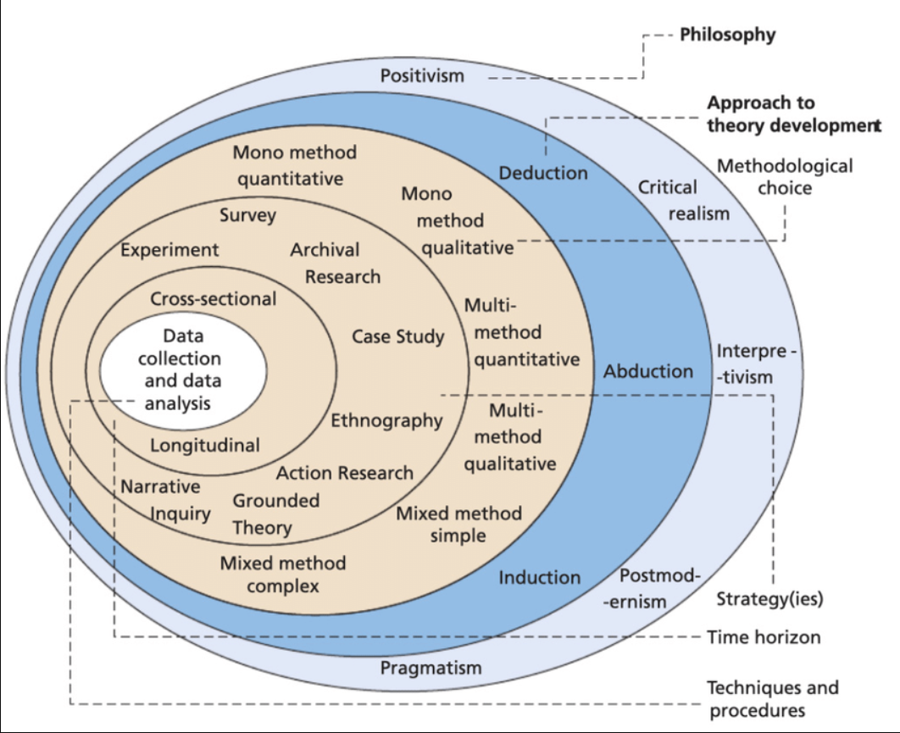
Figure 13: Research Onion
(Source: Saunders et al., 2019)
The methodology has been organized using the research onion by Saunders et al. (2019). The philosophy of interpretivism, abductive approach, case study strategy and qualitative design were chosen. The data was collected using secondary data and thematic analysis. These decisions were explained to make sure that they would fit the objective of the study to analyze post-pandemic consumer behaviour in Amazon India and Amazon UK.

3.2.2 Research Philosophy
The study adopted an interpretivism research philosophy, where the focus is on comprehending phenomena in the social and contextual environment (Pervin and Mokhtar, 2022). Ontologically, the study made the assumption that consumer behaviour is socially constructed, and distinctly different between various market environments like India and the UK. Epistemologically, the development of knowledge was based on the interpretation of secondary data on consumer perceptions and experiences. This philosophy was validated because the study was meant to investigate how people view and interact with online shopping websites such as Amazon, but not to quantitatively assess behaviour.

3.2.3 Research Approach
The research adopted an inductive research approach because it is used to gain an understanding of patterns and insights from the existing data and observations. Secondary research allows a detailed discussion of a phenomenon in a real-world situation, especially where the limits between the phenomenon and the situation are not well defined (Hancock et al., 2021). This method assisted in making comparisons of Amazon India and Amazon UK. Secondary data from Amazon India and Amazon UK was analysed to understand the trends of the post-pandemic consumer behaviour. The inductive approach is different from deductive because one can develop a theory based on findings from observation and interpretation of context. Lim (2025) indicated that an inductive research approach was suitable as it enabled flexibility in exploring consumer behaviour in the real world, and was appropriate for comparative qualitative research.

3.2.4 Research Strategy
This study adopted a comparative qualitative case study strategy because it allowed for an in-depth comparison of the adoption of online shopping, consumer behaviour, and market conditions between Amazon India and Amazon UK, after the pandemic. A case study method is a research approach that is employed to explore a phenomenon in its real-life context by conducting in-depth and detailed analysis (Oranga and Matere, 2023). This was appropriate as it allowed for a systematic comparison of the adoption of online shopping, consumer behaviour, and market conditions of Amazon India and Amazon UK in the post-pandemic era. A case study approach enables a detailed discussion of a phenomenon in a real-life situation, particularly when the boundaries between the phenomenon and the situation are not distinct (Hancock et al., 2021). This method assisted in making comparisons of Amazon India and Amazon UK.

3.2.5 Research Design
This study used a qualitative research design to understand consumer behaviour and perceptions in detail. This was a suitable design since it did not involve quantification of variables; it only entailed interpreting secondary data (Muzari et al., 2022). It facilitated an in-depth insight into the use of online shopping after the pandemic, both in Amazon India and Amazon UK, in various market settings.

3.3 Justification for selecting secondary data

3.3.1 Strength and Appropriateness of Secondary Data
Secondary data proved to be suitable in this study because it allowed obtaining access to a large amount of credible and up-to-date information about post-pandemic consumer behaviour (Rahid et al., 2022). Appropriate data and information for the study come from PWC India, Ofcom, Mintel, Economic Times, Times of India, industry reports and company annual reports, which can be used to analyze the post-pandemic consumer behaviour and online shopping adoption trends comprehensively. The study will analyse data in Amazon India and Amazon UK, the real-world application in various market settings. Moreover, the secondary data also enabled triangulation with several sources, making results more reliable and comprehensive, in addition to the comparison of a comprehensive methodology.

3.3.2 Acknowledge limitations
Despite its advantages, secondary data can also have limitations such as a bias in favour of positive results, a deficiency of process-level details and a limited control on the quality of data (Olipp et al., 2024). Also, the differences in data sources will potentially impact consistency. These limitations have been overcome by the selection of sources and cross-checking to increase credibility and reliability.

3.4 Data Sources and Data Collection
Secondary qualitative data were collected to yield relevant and credible data for comparison. Secondary qualitative data are known to give valid and authentic perspectives from academic, industrial and organizational sources which exist in the real world (Thorne, 2025). The study gathered information from various sources that are reliable for both Amazon India and Amazon UK, such as PWC India, Ofcom, Mintel, Economic Times, Times of India, Industry Reports, Company annual reports, etc. The sources were chosen for relevance, credibility and recent periods of publication (2021-2025) to ensure that the findings are accurate and up-to-date to study post-pandemic consumer behaviour. Overall, the use of secondary qualitative data allowed for a reliable, systematic and context-specific comparison of Amazon India and Amazon UK.

3.5 Data Analysis Approach
The thematic data analysis method was used effectively by the respective study because of its capability to extract, interpret and offer comparisons with the main behavioural patterns and themes from the Amazon India and Amazon UK data. Basarir-Ozel et al., (2022) noted that thematic analysis was suitable because it allowed identifying and interpreting the main trends of qualitative data on consumer behaviour and adoption in a systematized manner. The within-case analysis consisted of triangulation of several sources, whereas the cross-case comparison was used to find the patterns of impact on consumer behaviour and adoption performance in both markets.
Thematic analysis was used to analyse recurring themes and patterns systematically, as Saunders et al. (2023) said that thematic analysis can be used to help thematically interpret and compare qualitative secondary data. In the process of thematic analysis, the study identified, coded, categorised and interpreted the themes that were found in the secondary sources of data (Ahmed et al., 2025). In view of the structured qualitative interpretation, relevant patterns are systematically compared between Amazon India and Amazon UK to generate meaningful findings and support the research objectives with regard to consumer behaviour, adoption of online shopping, and challenges faced during and after the pandemic.
Data Collection Table
Research Onion Elements | Selected Approach
Research Philosophy | Interpretivism Research Philosophy
Research Approach | Inductive Research Approach
Methodological Choice | Qualitative Method
Research Strategy | Comparative Case Study Strategy
Time Horizon | Cross-Sectional
Data Collection Method | Secondary Qualitative Data Collection Method
Data Analysis Method | Thematic Analysis
Table 3: Data Collection Method
(Source: Self-Created)

3.6 Research Quality and Rigour
In order to achieve quality research, several measures of validity and reliability were used. To ensure construct validity, several secondary data sources were used, and variables were clearly defined. In order to ensure internal validity (analytical rigour), thematic analysis with systematic and framework-based guidance was employed, and a clear connection between evidence and conclusions was made. Analytical generalisation and cross-case comparison of Amazon India and Amazon UK ensured external validity (generalisability). Detailed documentation of data sources, selection criteria and analytical procedures supported reliability (transparency and replicability). Ahmed (2024) stated that the trustworthiness in qualitative research was ensured by the credible secondary sources, transparency of analysis, and systematic interpretation. The dependability, confirmability and credibility of this research were enhanced by consistent documentation and cross-case comparison.

3.7 Ethical Considerations
Ethical considerations were relevant when maintaining credibility, transparency and academic integrity in this research study. Saunders et al. (2019) further reported that it is important in the research processes to practice correct data handling, proper referencing and good reporting throughout the study process so that it can be considered as ethical research. No participant consent was required since only secondary data sources were used in this study, and no human beings were involved. To avoid plagiarism and ensure academic honesty, all sources were cited appropriately. Moreover, the results of Amazon India and Amazon UK were not manipulated, selectively reported, or subjected to any sort of reputational bias, guaranteeing a trustworthy and ethically responsible research result. Overall, such ethical considerations contributed to the reliability of the study and helped analyse post-pandemic consumer behaviour.

3.8 Time Horizon
(Time Horizon Gantt Chart attached in Appendix 3)
Time horizon is the time frame where the research activities are to be planned, implemented and completed systematically for the effective attainment of research objectives. Time horizon is important because it can be used as a way to arrange research activities, keep them on track, have them done on time and help to better organise the research project (Rusu, 2021).
The timeline of the research for the completion of the dissertation has been systematically followed as displayed in the Gantt Chart, for a period of twelve weeks. In Weeks 1-2, a topic for research was chosen. The introduction and literature review were completed between Weeks 3 and 6. The methodology was developed in Weeks 5-6, with data findings and data analysis in Weeks 7-8. The conclusion was finished in Weeks 9-10, and the final presentation of the dissertation was in Weeks 11-12. Overall, the chart shows that there was structured planning, time management and logical progression of the research activities during the study period.

3.9 Chapter Summary
In this chapter, the methodological approach followed in the study, such as the philosophy of interpretivism, inductive approach, secondary strategy and qualitative design, was described and justified. Secondary data and thematic analysis provided a rigorous, transparent and systematic way of approaching the research objectives. On the whole, the approach facilitates an extensive comparative analysis, which results in Chapter Four, which provides detailed findings of Amazon India and Amazon UK.

Chapter Four: Data Findings

4.1 Introduction
In Chapter three, the research methodology was explained, which was used to investigate the adoption of online shopping between Amazon India and Amazon UK after the pandemic. Based on the philosophy of interpretivism, an inductive approach, a secondary research strategy and a thematic analysis method, the findings of the secondary qualitative data collected are presented in Chapter four. Data findings are systematic interpretations of research evidence that are gleaned from collected data, which can be used to discover patterns, comparisons, behavioural trends and significant research findings.
The chapter examines the comparative behavioural pattern, consumer adoption trends, operational issues and strategic considerations that affect the online shopping process in both markets, in a critical manner. The findings are created by employing trustworthy secondary sources like Amazon annual reports, Financial Times, Mintel, Reuters, Statista, industry reports, and other reliable databases. Throughout the chapter, comparative and contradictory analysis of consumer behaviour is used to note the differences between consumer behaviour in developed and emerging retail environments. Overall, the chapter gives evidence-based results to answer the research questions and improve understanding of the adoption behaviour of post-pandemic online shopping in Amazon UK and Amazon India.

4.2 A Comparative Case Study on Amazon UK and Amazon India

4.2.1 Overview of the Amazon
Amazon has been continuously growing in the retail industry globally with the constant expansion of its digital business, technological innovation and customer-centric business strategies in developed and emerging markets. Amazon Annual Report (2024) revealed the company's revenue of $638 billion for the year 2024, showcasing robust e-commerce growth and operational expansion in the post-pandemic era. Moreover, the integration of AI, the innovation of logistics, and the expansion of delivery infrastructure contributed to a further rise in total revenue to $717 billion in 2025, as per Amazon Annual Report (2025). Amazon UK is part of an established online business landscape with sophisticated infrastructure, consumers' familiarity and trust, and reliable delivery systems, all of which enable convenience shopping. On the other hand, Amazon India operates in a market that is still in its early stages of growth, and the availability of affordable products, local delivery options, and easy access to digital platforms are crucial factors in consumer adoption. But, the infrastructural inequality, operational complexity, and the difference in digital maturity of consumers create inconsistencies in the online shopping experiences of Amazon UK and Amazon India.
This case study set out to examine post-pandemic online shopping adoption behaviour between Amazon India and Amazon in the United Kingdom. Its goal was to identify and examine the consumer's adoption patterns, the trust, convenience, payment preferences, delivery challenges and strategic responses which impact on consumer online buying behaviour. The study also aimed to uncover the influence of market maturity, digital infrastructure and localisation strategies on consumer adoption and retention in both retail markets.

4.2.2 Post-Pandemic Growth of Online Shopping Adoption in India and United Kingdom
Adoption of online shopping was higher in the post-pandemic phase in India and the UK, but the data shows different adoption rates in the two countries. This theme assesses the pattern of online shopping growth following the pandemic and examines how the shopping habits of consumers differ between Amazon India and Amazon UK.
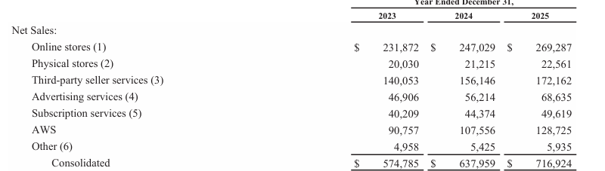
Figure 14: Online Net Sales of Amazon
(Source: Amazon Annual Report, 2025)
Online-store sales (excluding retail sales) at Amazon rose from USD $247.03 billion in 2024 to USD $269.29 billion in 2025, reflecting continued online-store sales growth, even with the shift of online-store sales to become a normal way of doing business during the lockdown (Amazon Annual Report, 2025). This growth varied, however, across markets, as consumer expectations varied by digital maturity, infrastructure and income.
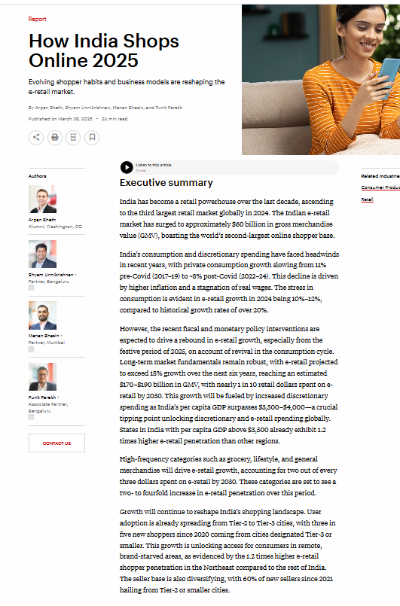
Figure 15: How India Shops Online 2025
(Source: Bain, 2025)
Adoption in India seems to be more of an expansionist and convenience motive. As per Bain's (2025), India's e-retail value has grown to around $60 billion in 2024 and has over 270 million online shoppers, which makes it the second largest e-retail market by number of shoppers. This means that Indian adoption will not just be taking place from repeat mature market behaviour, but also new users, mobile access and broader digital inclusion. However, the UK sees a more developed but less rapid uptake.
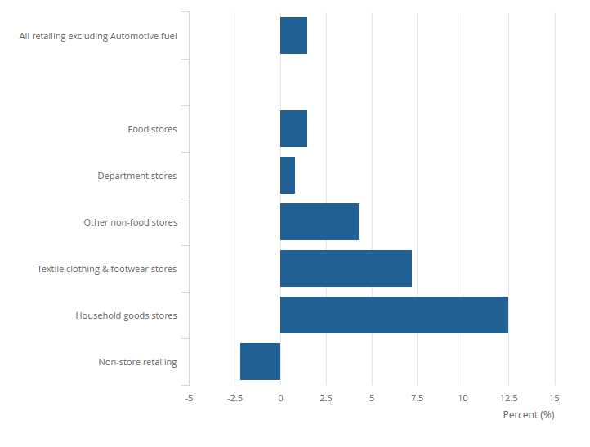
Figure 16: Online retail values
(Source: ONS, 2025)
Digital shopping is already a part of UK retail behaviour, with ONS (2025) reporting that online sales for the December 2024 period accounted for 27.0% of total retail sales. On the other hand, IBEF (2025) estimates that India's online retail market was just 8% in 2024, with the growth projected to be 14% by 2028, suggesting India is structurally underpenetrated. This suggests that the UK consumer is more mature and shopping online regularly, whereas the Indian consumer is a high-growth but still developing online retail customer segment with ample opportunities for future growth.
Amazon India is indicative of this growth, with its adoption being done at a faster pace. According to the annual report (2025), Amazon Now in India has over 360 micro-fulfilment centres, a 25% month-on-month rise in orders and a tripling in the number of Prime members shopping on the platform since their launch. On the contrary, EMarketer (2025) pointed out that UK e-commerce penetration had levelled out at 30.4% in 2024, indicating that UK growth is not so much about getting people started as it is about keeping them engaged, delivering high-quality fulfilment and providing sufficient service differentiation.
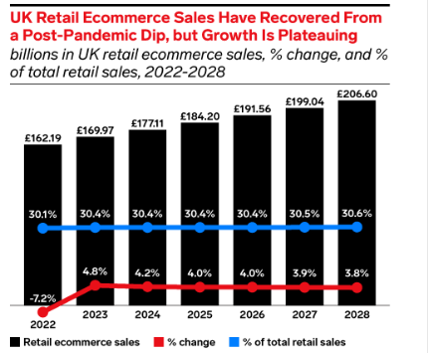
Figure 17: UK Retail E-commerce sales
(Source: EMarketer, 2025)
This suggests that when online platforms address immediacy, trust and convenience challenges, Indian consumers take to shopping online.
Overall, Amazon UK has established a robust logistics system and a high level of digital confidence; however, Amazon India has to build digital confidence and consolidate fragmented and price-sensitive customers with faster delivery and localised infrastructure. Thus, the uptake of adoption after the pandemic is deeper, but less rapid in the UK than in India, which is less penetrated but gaining at a higher rate.

4.2.3 Comparative Consumer Adoption Behaviour Between Amazon India and Amazon United Kingdom
Amazon consumers in the UK adopt based on mature, trust-based and convenience-driven adoption, but Amazon customers in India adopt based on opportunity-led and more cautious adoption. The theme is a comparison of consumer online shopping behaviour, trust, convenience, payment preference, and digital adoption in Amazon India and the United Kingdom. The country-attributed net sales of $37.855 billion of Amazon in the UK in 2024 mean that the online retailer has a developed consumer base, and online shopping is already a part of retail behaviour. According to the 2024 Annual report by Amazon, the consumer reaches Amazon via websites, mobile apps, and Alexa devices, streaming and physical stores, and Amazon competes based on low prices, fast delivery, convenience and customer service. This means that the adoption by UK consumers is more omnichannel and service-based.
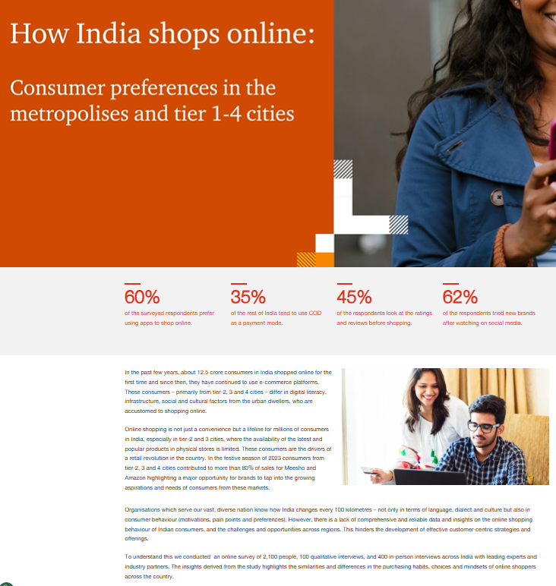
Figure 18: How India Shops Online
(Source: PWC India, 2026)
But Indian adoption is more price-sensitive and mobile-first. PwC India (2026) discovered that online shopping through apps is preferred by 45% of the Indian respondents surveyed, meaning that access to smartphones drives the adoption of online shopping more than access to desktops. Ironically, UK consumers are more digitally confident.
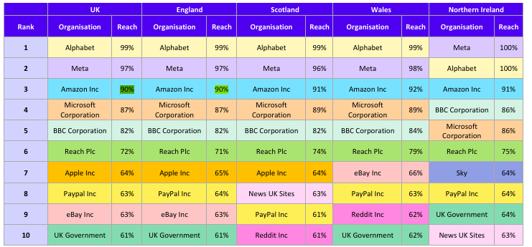
Figure 19: Top ten organisations visited by UK online adults on smartphones, tablets or computers
(Source: Ofcom, 2025)
In May 2025, Ofcom (2025) said that Amazon websites and apps had 90% of online adults in the UK, which implies that the sites and apps are habitually dependent and have high brand recognition. Quite on the contrary, Indian consumers remain cautious with regard to payment. Economic Times (2026) mentioned that almost 50% of online orders in India remain cash-on-delivery, despite the rise of UPI, which is a sign that digital payment infrastructure has advanced at a higher rate than consumer trust in vendors, product quality and returns.
The same report also highlights an increase in shipping costs, from $95.8 billion in 2024 to $102.7 billion in 2025, which mirrors the greater consumer adoption that has been tied to higher promises of fulfillment costs (Amazon Annual Report, 2025). UK consumers believe a regular service yardstick is predictable, fast delivery, while Indian consumers sometimes see reliable delivery as a way of developing trust.
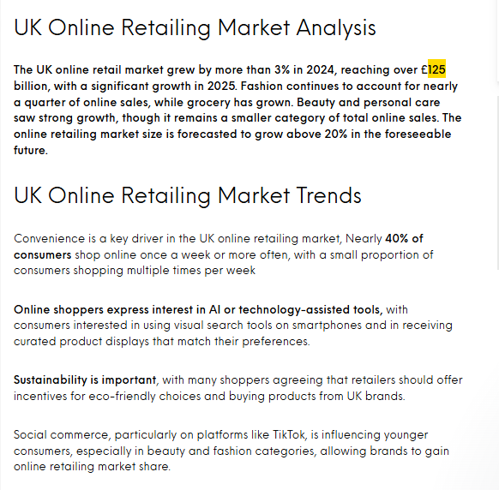
Figure 20: UK Online Retailing Market Analysis
(Source: Mintel, 2025)
Additionally, Mintel (2025) indicated that the UK online retail market was greater than £125 billion in 2024 and highlighted a mature, competitive market where retention and differentiation is key to adoption. On the other hand, Amazon classifies India as being under foreign-ownership restrictions and local regulatory risks, suggesting that institutional factors influence Indian adoption, as well as consumers (Amazon Annual Report, 2025). Hence, the adoption of Amazon UK may be more embedded and regular as compared to Amazon India, which is more mobile and trust-sensitive.
Overall, Comparative results reveal that Amazon UK shoppers' online shopping behaviour is relatively mature and convenience-oriented, while Amazon India shoppers' online shopping behaviour is very price-sensitive and trustworthy. Hence, the adoption in the UK is not only stable, but also more habitual (post-pandemic), whereas the adoption in India is still growing at a fast pace via mobile commerce and localisation strategies.

4.2.4 Post-Pandemic Consumer Challenges Affecting Online Shopping Behaviour on Amazon
The post-pandemic challenges for consumers on Amazon are not the same since Amazon UK is a mature market with trust and regulatory concerns, while Amazon India is experiencing structural, payment and delivery-confidence concerns. This theme examines factors affecting consumer issues relevant to trust, reliability, payment security and buying online following the pandemic in Amazon. According to Amazon Annual Report (2024), limited fulfilment infrastructure, decreased credit-card usage, payment risk, privacy regulations and laws on consumer protection are all challenges that affect Amazon's international operations. This means that the adoption landscape in Amazon India is rather fragile, with consumers relying on the trustworthiness of the delivery service, the security of payment and regulatory certainty.
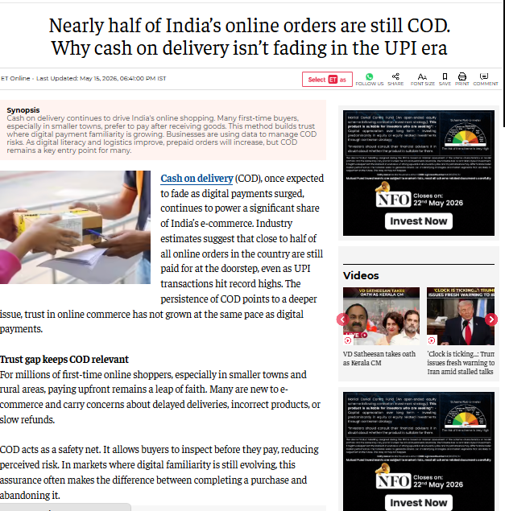
Figure 21: Payment Trust issues in India
(Source: Economic Times, 2026)
Payment trust continues to be one of the major hurdles in the path of Amazon's adoption in India. While UPI growth has been seen, the Economic Times (2026) reported that still half of India's online purchases are cash-on-delivery as consumers are still apprehensive about the quality of products, the delivery process, and the return procedure. The findings suggest that while Indian Amazoners may be interested in e-commerce, they can safeguard themselves by delaying payment until they have received the goods.
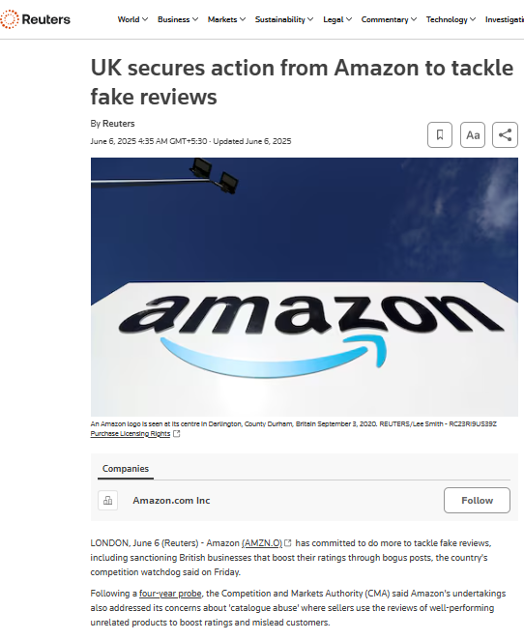
Figure 22: UK secures action from Amazon to tackle fake reviews
(Source: Reuters, 2025)
The consumer challenge facing Amazon UK is thus one of credibility and not access. According to Reuters (2025), Amazon signed an agreement with the UK Competition and Markets Authority to enhance measures against fake reviews, the punishment of businesses with fake ratings, and catalogue abuse. It shows that the authenticity of the reviews plays a significant role in the purchase decisions of consumers in the UK, which makes a strong reliance on the information system in Amazon one of the key prerequisites of such an adoption.
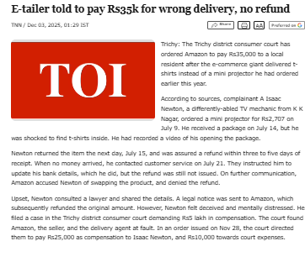
Figure 23: Transactional Delivery and Refund Issues
(Source: Times of India, 2025)
On the contrary, the Amazon India problem is more transactional, as improper deliveries and the inability to provide refunds directly harm the trust of consumers. As an illustration, a consumer court was quoted by The Times of India (2025) that Amazon, a seller and a delivery agent, should compensate a customer due to a wrong delivery and a delayed refund. This implies that the failure of post-purchase services may undermine repeat adoption in India.
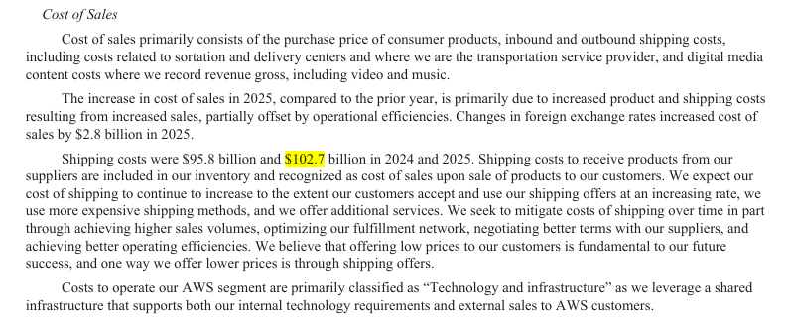
Figure 24: Amazon Cost of Sales
(Source: Amazon Annual Report, 2025)
This challenge is also supported by the evidence of costs at Amazon. Amazon's shipping expenses rose by 2025 to $102.7 billion compared to $95.8 billion in 2025, and fulfillment expenses rose because of higher sales and investment in the fulfillment network (Amazon Annual Report, 2025). This shows that there is increasing pressure on operations due to consumer demands to deliver faster, more accurate and reliable delivery.
Overall, the post-pandemic consumer challenges confronting Amazon UK and Amazon India are opposite due to the focus of UK consumers on the credibility of reviews and transparency of the platforms, and Indian consumers on the effectiveness of payment, reliability of delivery, and effectiveness of refund. Thus, consumer-retention strategies of Amazon should not be globalised but still market-oriented.

4.2.5 Strategic Recommendations Influencing Consumer Online Shopping Adoption Across Retail Markets
The strategic recommendations must acknowledge that Amazon India must be embraced through adoption-building strategies and Amazon UK must be embraced through retention and trust-protection strategies. This theme suggests tactical methods that enhance consumer confidence, convenience, localisation, and digital interaction to enhance online shopping adoption across the world.
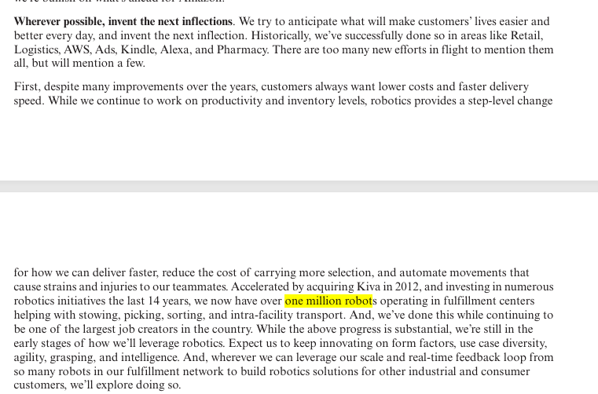
Figure 25: Invent the Nest Inflections
(Source: Amazon Annual Report, 2025)
The 2025 report published by Amazon reveals that the company runs more than one million robots in its fulfilment centres, which points to the fact that automation must be increased to decrease the number of delays in the delivery process and enhance fulfilment accuracy (Amazon Annual Report, 2025). However, the strategy means different things in different markets. Robotics can ensure service reliability in a developed market; in contrast, in India, automation needs to contribute to the reliability of the last mile, where inconsistent delivery remains an issue of adoption.
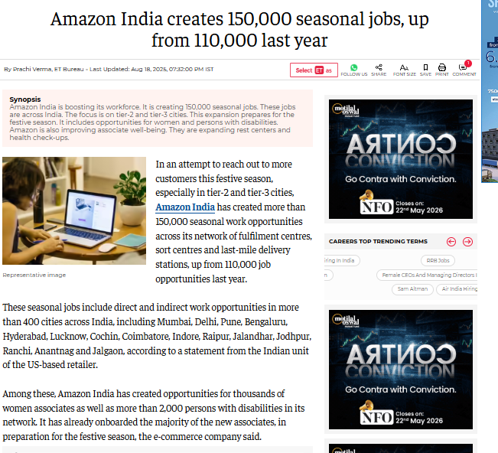
Figure 26: Amazon India creates 150,000 seasonal jobs
(Source: Economic Times, 2025a)
Amazon India needs to focus on the regional expansion of fulfilment in Tier-2 and Tier-3 cities. According to Economic Times (2025a), Amazon India generated 150,000 seasonal positions in 2025, as compared to 110,000 in 2024, primarily in fulfilment, sortation and last-mile delivery network. This implies that the demand is shifting out of metropolitan consumers, and Amazon India must localise logistics capacity to smaller-city adoption, instead of basing it on national-scale infrastructure.
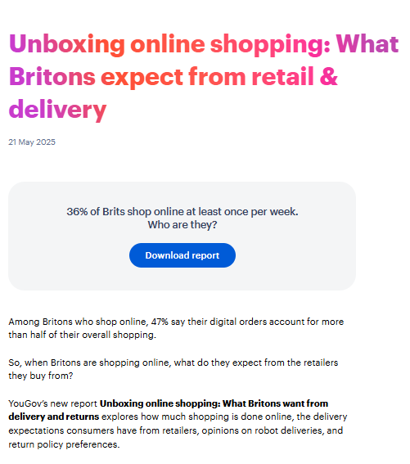
Figure 27: What Britons expect from retail & delivery
(Source: YouGov, 2025)
Conversely, Amazon UK must consider delivery transparency and convenience in returns since the YouGov report on online delivery in the UK (YouGov, 2025) shows delivery and returns policies as defining online shopping expectations of the British online. This shows that online shopping is already practiced by UK consumers, though they might switch to a different retailer when there is a weak delivery control or returns.
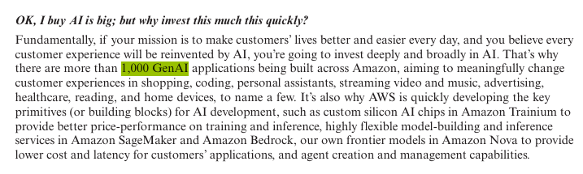
Figure 28: Personalisation through Gen-AI application
(Source: Amazon Annual Report, 2024)
However, personalisation, which Amazon ought to augment through AI, should not be done in both markets in a similar manner. In 2024, the annual report indicated that Amazon was constructing over 1,000 GenAI applications in the field of shopping, advertising, personal assistants and other experiences (Amazon Annual Report, 2024). This shows that AI has the potential to amplify adoption due to enhanced search, product discovery and customer service. But the UK consumers might need transparent AI advice as their expectations on privacy are higher, and the Indian consumers might appreciate AI more, where it can enhance language localisation, price discovery and product trust.
Ironically, Amazon UK needs to invest more in platform governance, whereas Amazon India needs to invest more in accessibility. According to Reuters (2025), Amazon signed an agreement with the UK CMA to enhance measures against fake reviews, which means that the reliability of the rating is a strategic issue in the UK.
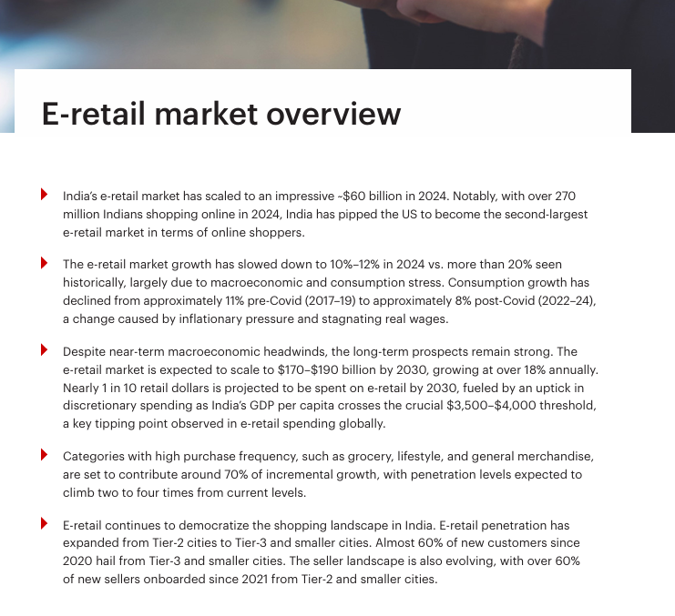
Figure 29: Indian E-retail Market
(Source: Bain, 2025)
On the other hand, the 2025 India e-retail report by Bain emphasizes the swift commerce and emerging-city expansion, which means that Amazon India needs to integrate ultra-fast delivery, localizing interfaces and seller authentication to transform reluctant users into repeat clients. Thus, the adoption strategy ought to be localised as opposed to internationalised.
Overall, strategic suggestions point to the fact that Amazon UK needs more transparency and service-retention strategies, and Amazon India needs more localisation, expansion of trust and fulfilment. Thus, market-specific strategies are better than globalised strategies in maintaining post-pandemic online shopping adoption behaviour.

4.3 Chapter Summary
The data findings of the post-pandemic consumer adoption of Online Shopping between Amazon India and Amazon UK were presented and critically analysed in this chapter. The findings showed that the rate of online shopping adoption has grown markedly since the outbreak of the pandemic in both markets, but there was a significant difference between the consumer behaviour, level of trust, dependency on infrastructure and expectations of operations of the two markets. Comparative analysis revealed that the UK consumers had more mature and convenience-oriented adoption behaviour, while Indian consumers were more price sensitive, mobile inclined and relying on trust. The chapter also highlighted some critical factors that could pose significant problems for Amazon in the years to come after the pandemic, such as delivery reliability, payment confidence, fake reviews and regulatory pressures. Additionally, it was revealed that the findings of the research indicated that strategies designed specifically for the market were more successful than the use of standardised global strategies in order to promote online shopping. Overall, the chapter has achieved the research goals through evidence-based and comparative thematic findings that will be discussed and interpreted in Chapter five, which will critically discuss and interpret the findings and existing literature and theoretical frameworks.

Chapter Five: Discussion

5.1 Introduction
Chapter four discussed comparative results based on the behavioural patterns, challenges faced by consumers, and strategic considerations for the adoption of online shopping between Amazon UK and Amazon India, respectively. Based on these findings, the results are critically discussed and interpreted through the linking of the results with the existing literature, the theoretical approach, the conceptual framework and the research aims as presented in Chapter five. Data analysis is defined as the systematic analysis and interpretation of data to reveal relationships, patterns, contradictions, and theoretical implications in the collected data. A thematic analysis method was used to systematically interpret and compare themes of behaviour that were revealed from secondary qualitative data. For this reason, the results of the findings are discussed, interpreted, justified and aligned with theory through a thematic discussion, comparative interpretation, objective justification and theoretical alignment to explain the factors that affect the adoption of online shopping in developed and emerging retail markets after the pandemic.

5.2 Data Analysis

5.2.1 Expansion of Post-Pandemic Online Shopping Trends in India and the United Kingdom
The results confirmed Section 4.2.2, which showed that there was a significant increase in online shopping after the pandemic. But, the adoption patterns were different due to the maturities of the digital infrastructure, markets and consumer readiness in the UK and India. According to Amazon Annual Report (2025), the e-commerce sales of the Amazon online store rose from USD $247.03 billion (2024) to USD $269.29 billion (2025), indicating that the trend of e-commerce adoption has continued to accelerate globally post-COVID-19. This discovery aligns with Nanda et al. (2021), who stated that the pandemic had a long-term structural impact on retail behaviour, as mobility restrictions and accelerated digitalisation had a positive impact. For instance, Bain (2025) noted that India has more than 270 million online shoppers and close to $60 billion in e-retail value in 2024, and that the growth in adoption in India is fueled by digital inclusion and the growing penetration of the internet and smartphones. This is in line with the findings of Ghodture et al. (2025), which found that health consciousness and digital connectivity are among the factors that led to increased adoption of online shopping post-pandemic.
However, comparative results also show conflicting behaviour of the Indians and the British. ONS (2025) reported that online retail sales accounted for 27% of the total retail sales in the UK in 2024, whereas IBEF (2025) pegged the online retail penetration rate in India at 8%, which is comparatively low. This shows that online shopping has become a regular part of the shopping activity of the UK consumers, the Indian consumers are a fast-growing but structurally underpenetrated market. These findings corroborate the findings of Agarwal and Kandpal (2025), who noted that Indian consumers are still more price sensitive and adoption is more convenience-centric and affordable, as compared to UK consumers. Moreover, the report by EMarketer (2025) pointed out that the penetration of e-commerce in the UK has levelled out at 30.4%, which aligns with Diaz-Gutierrez et al. (2024), who noted that consumers' shopping habits are not solely digital in the post-pandemic era. Thus, the Dynamic Capabilities theory is still pertinent as Amazon has differently adjusted the fulfilment infrastructure, localisation and digital services in both markets to ensure that consumers continue to adopt them, despite the limitations in both contexts.
This analysis specifically addressed Objective 1, which was to critically analyse the growth patterns, behavioural changes and differences in adoption of online shopping in post-pandemic UK and India, directly contributing to the research aim of understanding the evolution of online shopping adoption in developed and emerging retail markets in the post-pandemic era.

5.2.2 Cross-Market Consumer Behaviour Differences Between Amazon India and Amazon UK
The findings were consistent with Section 4.2.3, showing that the adoption behaviour of consumers was very different between the UK and India, mostly due to the different levels of trust, affordability, digital infrastructure and consumer confidence. According to Amazon Annual Report (2024), the net sales of Amazon UK are $37.855 billion in 2024, which means that online shopping is an established and full-fledged retailing activity in the UK market. This is compounded by Ofcom's (2025) findings that Amazon websites and apps were accessible to 90% of online adults in the UK, that they felt confident using digital platforms and that they use the platform regularly. These findings align with the findings of Aguirre and Menon (2024), who stated that the UK consumer is less price sensitive and cares more about convenience, omnichannel experiences and service quality. In the UK online retail market, for example, Mintel (2025) pointed out that the total market is now over £125 billion in 2024 and that while it is essential to get customers on board, it is equally as critical to keep them engaged and make them feel special through the experience.
On the other hand, the results indicate that the Indian consumers are still cautious, mobile-first and price-sensitive. According to PwC India (2026), 45% of Indian respondents preferred online shopping via mobile apps, highlighting the influence of smartphone accessibility on digital adoption practices. This aligns with Mallick et al (2024), who pointed out that online shopping's adoption among Indian consumers was hastened by convenience and accessibility following the pandemic. But Economic Times (2026) found that close to half of all ecommerce transactions in the country are still COD, which confirms that digital payment systems have evolved much faster than consumer confidence towards the quality of products, return policies and delivery guarantees. These results are in accordance with Jain (2022), who stated that Indian consumers are price-oriented and economically sensitive when shopping online. Moreover, the Theory of Planned Behaviour is still applicable as perceived behavioural control varies significantly between the two markets, as UK consumers can rely on the availability of digital infrastructure, while Indian adoption behaviour is driven more by affordability, trust and social factors.
This analysis has effectively explained Objective 2 by comparative analysis of consumer trust, convenience, payment preference and digital behaviours of Amazon UK and Amazon India, which has contributed to the research aim by identifying behavioural and contextual factors that affect the adoption of online shopping after the pandemic in different market contexts.

5.2.3 Consumer Barriers and Behavioural Challenges Influencing Post-Pandemic Online Shopping Adoption
This align with the findings in section 4.2.4 and showed that the challenges faced by consumers during the post-pandemic period were different in the UK and India, with quality of infrastructure, level of digital maturity, trust issues and operational reliability being significant factors to consumer adoption behaviour. According to Amazon Annual Report (2024), fulfilment constraints, payment risks, and consumer-protection regulations are among the key operational risks that impact international online retail performance. These findings are very much in tune with Dali et al. (2020), who found that the attitude of trust, digital accessibility and security are important issues that hinder the continued adoption of online shopping, especially in emerging economies like India. In the same way, the Economic Times (2026) reported that nearly half of the online purchases made in India are still on cash-on-delivery, which is a testament to the relatively low levels of consumer trust in payment systems, delivery security, and refund policies. This discovery correlates with Anand et al. (2023), which emphasised that the limited adoption of e-commerce in India is still hindered by infrastructural limitations and inconsistent customer-service experiences.
On the other hand, the results show that the consumer issues in the UK are not so much about accessibility, but rather digital credibility and platform transparency. Amazon beefed up against fake reviews and catalogue abuse after deals with UK regulators, said Reuters (2025), noting the UK population's reliance on reliable digital information before buying online. The results have aligned with the findings of Chinthala (2022) that in the context of digitally mature economies, consumers are no longer satisfied with being digitally present in their shopping but are now expecting more secure, transparent, and personalised experiences. Moreover, Amazon has seen a rise in shipping and fulfilment expenses as customers' demands for speed and efficiency have risen, as confirmed by their Amazon Annual Report (2025). This finding is further aligned with Srinivasan et al. (2023), who stated that omnichannel integration and AI-supported services boost customer satisfaction, but these services require a high level of digital maturity.
Thus, the analysis effectively justified Objective 3 by critically identifying the barriers that consumers are facing in the post-pandemic environment and affect the adoption of online shopping, and supported the research aim by explaining the different impact that trust, operational reliability and digital infrastructure had on consumer behaviour in relation to both Amazon UK and Amazon India.

5.2.4 Strategic Factors Enhancing Consumer Adoption of Online Shopping Across Retail Markets
This section reinforced the findings of Section 4.2.5 as they showed that marketers' strategies for localizing, optimizing fulfillment operations, and creating a more personalized customer experience were more successful at encouraging consumers to shop online post-pandemic than global strategies. In the Amazon Annual Report (2025), the company mentioned that it has over one million robots deployed at fulfilment centres to illustrate how automation and logistics innovation contribute to enhancing the efficiency and convenience of delivering to customers. These findings align strongly with the call by Imschloss and Schwemmle (2024) for retailers to invest in technological capacity and digital interactions to ensure the ongoing adoption of these technologies. However, the findings also show some market differences in terms of strategic priorities. In the UK, automation mostly enhances service reliability and customer retention as online shopping behaviour is well established. On the other hand, in India, the significance of fulfilment expansion and last-mile logistics has remained unchanged, as infrastructural inconsistencies continue to impact delivery reliability and consumer trust in online shopping experiences.
Additionally, Economic Times (2025a) pointed out that logistics expansion is growing in Tier 2 and Tier 3 cities in India, and that Amazon India is increasingly relying on localisation strategies to ensure access to consumers and build trust. This is consistent with the recommendation of Kappagantu et al. (2024) that localised engagement strategies are more impactful for weaker markets in terms of digital confidence. However, YouGov (2025) saw that UK consumers prefer clear delivery terms and easy return procedures, thereby agreeing with Hoang et al. (2023) that online delivery expectations are becoming more personalised and value-added for digitally mature consumers. Similarly, Amazon's Annual Report (2024) uncovered over 1,000 Gen-AI applications underpinning shopping and customer-service capabilities and released the AI expectations for markets, including the UK, where consumers prioritise privacy and transparency, and India, where they seek localisation and affordability. Hence, the analysis was successful in achieving Objective 4 as it critically identified market-specific strategic recommendations that enhance consumer trust, localisation, fulfilment efficiency, and digital engagement across online retail markets. The outcomes also addressed the research objective by providing an understanding of the different effects of the tailored approaches on the post-pandemic online shopping adoption behaviour of both Amazon UK and Amazon India.

5.3 Discussion of Findings and Analysis
The findings of this section are discussed critically by making a link between the post-pandemic online shopping adoption behaviour and previous literature, theoretical frameworks, research objectives and comparative consumer behaviour differences between Amazon UK and Amazon India. The results highlighted the importance of understanding the factors driving the adoption of online shopping after the pandemic in both Amazon UK and Amazon India, given the differences in digital maturity, infrastructure, and consumer shopping habits. Objective 1 was successfully addressed by critically examining the trends and shifts in behaviour that have driven online shopping adoption in developed and emerging markets since the pandemic. These were confirmed by Amazon Annual Report (2025), Bain (2025) and ONS (2025), which found that the UK was a more mature market with online shopping being a core part of the traditional shopping habits, while India was a fast-growing but structurally under-penetrated market. These results were consistent with the Dynamic Capabilities theory, as Amazon continually adjusted its fulfilment infrastructure, localisation strategies and digital services to meet evolving consumer expectations in both markets. Likewise, Nanda et al. (2021) and Ghodture et al. (2025) established that the COVID-19 pandemic accelerated the digitalisation and transformed the shopping habits for the long term in the global retail sector. Hence, It directly supported the research aim, as it explained the evolution of online shopping adoption after the pandemic in the UK and Indian context of Amazon.
Additionally, the research discovered that trust, affordability, convenience, and digital confidence were very distinct among the two markets in terms of consumer adoption behaviour. In order to justify Objective 2, comparatively analysed consumer trust, orientation towards convenience, payment preferences and digital behaviour between Amazon UK and Amazon India. According to data from Ofcom (2025), Mintel (2025) and PwC India (2026), UK consumers exhibited what was deemed to be ‘mature and convenience driven’ behaviour, with stable infrastructure, while Indian consumers continued to be ‘mobile first, cautious and price sensitive’. The result was consistent with the results of Aguirre and Menon (2024), Jain (2022), and Mallick et al. (2024), who found behavioural differences between developed and emerging retail markets. Moreover, providing a critical identification of the barriers that may have been present in both markets in the aftermath of the pandemic, thus justifying Objective 3. Reuters (2025), Economic Times (2026), and the Amazon Annual Report (2024) all emphasised that platform transparency and review credibility are key concerns for UK consumers, and payment trust, delivery reliability, and refund effectiveness are key concerns for Indian consumers. The findings were in very good accordance with the theory of planned behaviour, as PBC and consumer trust had great differences in both markets due to infrastructural and economic differences.
Finally, the results showed that market-specific strategies were more successful at sustaining online shopping adoption behaviour than standardised global strategies. Findings and analysis of Objective 4 critically identify strategic recommendations related to localisation, fulfilment efficiency, automation and digital engagement. According to Amazon's Annual Report 2024 and 2025, and figures from YouGov (2025), Amazon UK needed more improvement in personalised digital experience, transparency, and retention, whilst Amazon India needed more localisation, fulfilment expansion, and trust building. The results were found to be in line with the Technology Acceptance Model, where perceived usefulness and ease of use significantly affected the adoption behaviours of online shopping.
The comparative case study validated the application of the conceptual framework's explanation of how online shopping has been adopted in the two case studies of Amazon UK and Amazon India, during the post-pandemic period. The study findings showed that the convenience perception and trust were impacted by TAM factors, such as usefulness and ease of use, in different ways in both markets. Indian consumers emphasised affordability, trust and accessibility, while UK consumers had more digital confidence and behaviourally more convenient. Additionally, the constructs of TPB differed considerably across markets due to economic and infrastructural differences. As a result, the proposed conceptual framework was validated by influencing the frequency of use, purchase intention, and platform continued use through the influence of trust, convenience perception, delivery experience, and price sensitivity.
Further, the conceptual structure was confirmed as there were direct links between trust, convenience perception, delivery experience, and price sensitivity and the adoption frequency, purchase intention, and continued use of the platform in both Amazon UK and Amazon India. In general, the study has been able to accomplish the research goal by critically examining the behavioural, operational, and strategic dimensions that are shown to affect the adoption of online shopping following the outbreak of the pandemic in both markets.

5.4 Chapter Summary
In summary, the analysis and discussion critically analysed the behaviour, operational, and strategic factors that affect the adoption of online shopping in the post-pandemic era in Amazon UK and Amazon India. The results demonstrated the significant differences between developed and emerging retail markets in terms of consumer adoption behaviour for the four key drivers of digital maturity, trust, affordability, infrastructure and localisation. Moreover, the theoretical frameworks and thematic analysis were able to aid in the interpretation of comparative consumer behaviour and market-specific strategic needs post-pandemic. The overall conclusion and recommendations, research limitations and future research directions will be presented in a systematic manner in Chapter Six.

Chapter Six: Conclusion

6.1 Overall Conclusion
Overall, this study compared the adoption of online shopping in the Amazon Retail Market in the UK and the Amazon Retail Market in India and critically analysed the former. The study was designed to examine the impact of behavioural, operational and strategic factors on the acceptance of online shopping in developed and emerging retail environments post-COVID-19. This study was supported by some important theories, such as TAM, TPB, and the Dynamic Capabilities theory. In addition, gaps in the literature were discovered in the context of the lack of comparative studies across markets between developed and emerging economies, specifically for contextual factors such as infrastructure, affordability, localisation and regulatory differences affecting the adoption of online shopping behaviour.
The study was based on the interpretivism philosophy, an inductive research approach, a comparative case study strategy, and a thematic analysis method based on secondary qualitative data obtained from credible academic, industrial and organisational sources. The analysis and findings showed that Amazon UK had characteristics of a mature and convenience-oriented online shopping environment facilitated by robust digital infrastructure, transparency, and established consumer behaviour patterns. On the other hand, the Indian market for Amazon is an emerging market with wary trust, where all factors of competitiveness, such as pricing, localisation, delivery, or mobile access, play a significant role.
The findings also pointed to the key issues faced by both markets in the post-pandemic period, such as payment trust, operational reliability, platform transparency and fulfilment restrictions. Moreover, it was identified that market-specific strategies like localisation, fulfilment expansion, AI-driven personalisation, and trust-building strategies are more successful than a globalised strategy. The overall research aim of the study was achieved successfully by the effective accomplishment of all the research objectives using comparative data finding and critical thematic analysis in order to gain an understanding of the post-pandemic adoption behaviour of online shopping across Amazon UK and Amazon India.

6.2 Linking with Objectives

6.2.1 Linking with Objective 1
Objective 1 was completed by critically analysing the growth of online shopping post-pandemic on the Amazon UK and Amazon India platforms. The insights showed that India was seeing rapid adoption growth via smartphone penetration and digital inclusion, while the UK had demonstrated online shopping adoption that was mature and stable. Following the COVID-19 outbreak, Amazon has shown to be very successful in e-commerce, as shown in its 2025 Annual Report. In addition, Pereira et al. (2015) highlighted that Dynamic Capabilities Theory was found to be a good explanatory framework for understanding the different ways in which Amazon's fulfilment infrastructure, localisation, and digital services were developed in developed retail markets and emerging retail markets, respectively, to support consumer adoption patterns.

6.2.2 Linking with Objective 2
Objective 2 has been achieved by the comparative analysis of the difference between the consumer behaviour of Amazon UK and Amazon India. The results showed that UK consumers behaved maturely, as consumers used it for convenience and were digitally confident, while Indian consumers were mobile-first, cautious, and very price-sensitive. Ofcom (2025) noted high digital confidence among UK consumers, and PwC India (2026) pointed to online shopping behaviour facilitated by smartphones in India. Moreover, Leonov et al. (2023) noted that the Theory of Planned Behaviour was found to be a good model to explain the different effects of trust, affordability, and perceived behavioural control on online shopping adoption behaviour for developed and emerging shopping contexts.

6.2.3 Linking with Objective 3
Objective 3 was accomplished by thoroughly understanding the barriers to online shopping adoption by consumers after the pandemic in Amazon UK and Amazon India. The results showed that platform transparency and credibility of reviews were the top concerns for UK consumers, while payment trust, the refund system and delivery reliability were the primary concerns for Indian consumers. The Economic Times (2026) proved that the by far less trusted digital trust in India was a major reason for cash-on-delivery having a significant importance. Ciruskabiri and Varnaseri (2023), consistent with previous research, identified factors such as digital maturity, infrastructure, and operational reliability as key factors in shaping an enduring online shopping behaviour following the pandemic.

6.2.4 Linking with Objective 4
Objective 4 was fulfilled by making critical recommendations for the market, which will affect their online shopping adoption on Amazon UK and Amazon India. The results showed that Amazon UK was in need of more transparency, personalised digital experiences and customer-retaining strategies, while Amazon India needed to localise, expand fulfilment and create strategies for building trust. Amazon has reported on growing efforts to personalise and automate customer interactions, which are enhanced by AI capabilities in its 2024 Annual Report. Moreover, Habib and Hamadneh (2021) showed that the TAM model was suitably applied to understand the factors affecting consumer adoption behaviour in developed and emerging online retail markets, and perceived usefulness and ease of use had a significant effect.

6.3 Recommendations
Strengthen Payment Security and Refund Transparency in Amazon India
Amazon India needs to enhance the security of payments and make the refund process more transparent to boost customer confidence. In this regard, Chowdhury (2025) revealed that the cash-on-delivery system is still in use due to the payment and refund-related issues. All these concerns diminish trust in on-line transactions and deter re-purchases. In turn, these secure verification protocols and clear refund policies can boost customer confidence, customer loyalty, and sustainable online shopping.
Increase AI-Based Personalisation with Market-Specific Adaptation
Amazon could improve their recommendations and customer service with market-specific personalisation made easier by AI. Perez-Vega et al. (2021) identified how AI enhances the customer engagement and shopping experience. The UK's consumers are increasingly interested in personalised services, whereas Indian consumers look towards affordability and localisation. Leveraging AI features to cater to varying user preferences can then enhance user engagement, satisfaction, and retention on the platform, effectively across both markets.
Expand Localised Fulfilment Infrastructure Across Tier-2 and Tier-3 Cities in India
Amazon India needs to increase the number of their fulfilment centres and last-mile delivery networks in developing regions. Dagar (2025) has emphasized the lack of infrastructure and service quality. Delayed and erratic deliveries affect the consumers' confidence and convenience in making online purchases. Enhancing the local logistics system can thus enhance the efficiency of operations, accessibility, and uptake by new consumer groups.
Enhance Platform Transparency and Review Authenticity in Amazon UK
Amazon UK needs to tighten up its practices with regard to bogus reviews, inaccurate product descriptions and seller wrongdoing. Crawford et al. (2023) reported that there is a high level of trust in digital information before consumers are buying online in the UK. False reviews can cause lack of trust and affect reputation on the platform. Hence, enhancing the authenticity and transparency of the review can help to build trust, engagement, and long-term loyalty among consumers.
Develop Market-Specific Consumer Engagement Strategies
Amazon should take a more flexible view into its pricing, marketing and engagement strategies on a market-by-market basis rather than relying on standardised global strategies. According to Purcărea et al., (2022), there is a gap between the consumer expectations of developed and emerging markets. Affordability, trust and digital maturity differ from one country to another and thus call for specific strategic responses. Thus, local solutions can enhance the adoption of consumers, build competitiveness and encourage sustainable online retail.

6.4 Conceptual framework contribution to knowledge
The conceptual framework helped to contribute to the knowledge by introducing the Technology Acceptance Model (TAM) and Theory of Planned Behaviour (TPB) in a comparative developed and emerging market context. The framework indicated that the perceived usefulness, ease of use, attitude, subjective norms, and perceived behavioural control had varying impacts on the consumer's online shopping behaviour on Amazon UK and Amazon India. This gave a better context to understanding the adoption of online shopping beyond the framework of conventional single market studies.
Moreover, the framework built upon the existing knowledge by introducing the factors of trust, convenience perception, delivery experience and price as important behavioural factors that connect theoretical constructs to the adoption outcomes. The results showed that acceptance of technologies was not the only influencing factor for the adoption behavior, but that market specific factors like affordability, infrastructure and localisation also played a role. Thus, this framework provided a more holistic understanding of the adoption of online shopping during the post-pandemic era in various retail settings.

6.5 Research Limitations
Despite providing valuable insights, this study faced several important limitations. Firstly, by relying on secondary, qualitative data only it did not allow for a direct examination of consumer perceptions, which could have led to a reported behaviour being perceived as an institutional interpretation of what occurred rather than a consumer perception. Secondly, the study was limited to Amazon UK and Amazon India, so it was not possible to identify whether the results were platform specific or generalisable to broader ecommerce markets. Additionally, reporting was not standardised across markets and there were regional differences in the data available, which could affect interpretations across markets. Another limitation of the study was that behavioural, operational and strategic factors were the main focus with psychological factors such as emotions, risk perception and personal motivation not explored extensively as this resulted in less behavioural depth. Lastly, the cross-sectional design provided a snapshot of consumer behaviour, which meant that it did not allow for capturing the behaviour of consumers over time as consumer expectations, technology and market conditions continue to evolve.

6.6 Future Scope of the Study
Future studies should also employ primary research techniques like surveys and semi-structured interviews or focus groups to better understand online shopping habits, convenience perceptions, and consumer trust in the future. The platforms can be compared with other marketplaces like Flipkart, eBay, and Alibaba to gain a wider understanding across markets. In addition, a longitudinal study would provide an opportunity to look at changes in behaviour over time. Demographic and psychological aspects, such as age, income, digital literacy and culture impacting on the adoption of online shopping, should also be examined in future studies.

Reference List
Agarwal, D. and Kandpal, A.S. (2025) Analyzing Online Shopping Preferences: A Consumer Behaviour Study. Indian Journal of Agriculture Business, 11(1). https://www.researchgate.net/profile/Disha-Agarwal-15/publication/391130372_Analyzing_Online_Shopping_Preferences_A_Consumer_Behaviour_Study/links/680b3b31bd3f1930dd640779/Analyzing-Online-Shopping-Preferences-A-Consumer-Behaviour-Study.pdf
Aguirre, L. and Menon, F. (2024) Evaluating the post-pandemic recovery strategies in the UK retail fashion sector. The Business & Management Review, 15(3), pp.223-231. https://cberuk.com/cdn/conference_proceedings/2025-01-13-22-17-13-PM.pdf
Ahmed, S.K. (2024). The pillars of trustworthiness in qualitative research. Journal of medicine, surgery, and public health, 2, p.100051. https://doi.org/10.1016/j.glmedi.2024.100051
Ahmed, S.K., Mohammed, R.A., Nashwan, A.J., Ibrahim, R.H., Abdalla, A.Q., Ameen, B.M.M. and Khdhir, R.M., 2025. Using thematic analysis in qualitative research. Journal of Medicine, Surgery, and Public Health, 6, p.100198. https://www.sciencedirect.com/science/article/pii/S2949916X25000222
Amazon Annual Report. (2024) Annual Report 2024. [online] Available at: https://s2.q4cdn.com/299287126/files/doc_financials/2025/ar/Amazon-2024-Annual-Report.pdf [Accessed 9th April 2026]
Amazon Annual Report. (2025) [online] Available at: https://s2.q4cdn.com/299287126/files/doc_financials/2026/ar/Amazon-2025-Annual-Report.pdf [Accessed 18th May 2026]
Anand, B., Chakravarty, H., Athalye, M.S.G., Varalaxmi, P. and Mishra, A.K. (2023) Understanding consumer behaviour in the digital age: a study of online shopping habits. Shodha Prabha (UGC Care J.), 48(3), pp.84-93. https://www.academia.edu/download/108187784/UNDERSTANDING_CONSUMER_BEHAVIOUR_IN_THE_DIGITAL_AGE.pdf
Bain. (2025) How India Shops Online 2025. [online] Available at: https://www.bain.com/insights/how-india-shops-online-2025 [Accessed 18th May 2026]
Bain. (2025) Indian E-retail Market Summary. [online] Available at: https://storiesflistgv2.blob.core.windows.net/stories/2025/03/how_india_shops_online_2025.pdf [Accessed 18th May 2026]
Basarir-Ozel, B., Turker, H.B. and Nasir, V.A. (2022) Identifying the key drivers and barriers of smart home adoption: A thematic analysis from the business perspective. Sustainability, 14(15), p.9053. https://doi.org/10.3390/su14159053
Cavalcanti, D.R., Oliveira, T. and de Oliveira Santini, F. (2022) Drivers of digital transformation adoption: A weight and meta-analysis. Heliyon, 8(2). https://www.cell.com/heliyon/pdf/S2405-8440(22)00199-2.pdf
Charles, K., Hoque, S., Korzenevica, M., Adem, J., Anmol, K.T., Bisung, E., Brewis, A., Bukachi, S., Buses, C., Dickin, S. and Doss, C. (2025) Cross-comparative international, interdisciplinary mixed methods research for development: REACH-WISER Methodology. https://ora.ox.ac.uk/objects/uuid:c69cf22f-9bf0-4458-9fc4-504afb3abae6/files/rm613n099g
Chaudhary, R., Jain, S., Gupta, R. and Aggarwal, V. (2025) Understanding the psychology of impulse buying in e-commerce: A behavioral review. Journal of Marketing & Social Research, 2, pp.102-113. https://jmsr-online.com/article/understanding-the-psychology-of-impulse-buying-in-e-commerce-a-behavioral-review-314/
Chigbu, U.E., Atiku, S.O. and Du Plessis, C.C. (2023) The science of literature reviews: Searching, identifying, selecting, and synthesising. Publications, 11(1), p.2. https://doi.org/10.3390/publications11010002
Chinthala, L.K. (2022) E-commerce 2.0: The evolution of online retail and consumer behavior post-pandemic. Innovative Journal of Business and Management, 11(03). https://doi.org/10.15520/ijbm.v11i03.3539
Chowdhury, J. (2025). Strengthening e-commerce consumer protection in Bangladesh: Legal challenges, regulatory gaps, and reform strategies. International Journal of Research and Innovation in Social Science, 9(1). https://dx.doi.org/10.47772/IJRISS.2025.9010206
Christou, P.A. (2022) How to use thematic analysis in qualitative research. Journal of Qualitative Research in Tourism, 3(2), pp.79-95. https://www.academia.edu/download/104208431/How_to_use_thematic_analysis_in_qualitative_research.pdf
Čirjevskis, A. (2022) Exploring coupled open innovation for digital servitization in grocery retail: From digital dynamic capabilities perspective. Journal of Risk and Financial Management, 15(9), p.411.https://doi.org/10.3390/jrfm15090411
Ciruskabiri, S. and Varnaseri, A. (2023) Digital transformation planning and frameworks. International Journal of Digital Content Management, 4(7), pp.397-433. https://dcm.atu.ac.ir/article_15147_b9c9e3c04efaa18ad74904f26f731bef.pdf
Ciucan-Rusu, L., Vasile, V., Stefan, D., Comes, C.A., Stefan, A.B., Timus, M., Oltean, A., Bunduchi, E. and Popa, M.A. (2022) Consumers behavior determinants on online local market platforms in COVID-19 pandemic—A Probit qualitative analysis. Mathematics, 10(22), p.4281. https://doi.org/10.3390/math10224281
Crawford, G., Crémer, J., Dinielli, D., Fletcher, A., Heidhues, P., Luca, M., Salz, T., Schnitzer, M., Scott Morton, F.M., Seim, K. and Sinkinson, M. (2023). Consumer protection for online markets and large digital platforms. Yale Journal on Regulation, 40, pp.101-146. https://www.yalejreg.com/wp-content/uploads/DRAFT-Consumer-Protection-for-Online-Markets-and-Large-Digital-Platforms.-40-Yale-J.-on-Regul.-Forthcoming.pdf
Dabija, D.C., Câmpian, V., Philipp, B. and Grant, D.B. (2025). How did consumers retail purchasing expectations and behaviour switch due to the COVID-19 pandemic?. Journal of Marketing Analytics, 13(4), pp.1258-1270. https://link.springer.com/content/pdf/10.1057/s41270-024-00344-9.pdf
Dagar, R.S. (2025). Challenges faced by diagnostics companies from Tier 2 and Tier 3 cities during mergers and acquisition in India. Digital Repository of Theses. https://repository.learn-portal.org/index.php/rps/article/download/989/871
Dali, N.R.S.M., Nawang, W.R.W., Nazarie, W.N.F.W.M. and Hamid, H.A. (2020) Post pandemic consumer behavior: Conceptual framework. The Journal of Muamalat and Islamic Finance Research, pp.13-24. https://jmifr.usim.edu.my/index.php/jmifr/article/download/280/196
Deloitte. (2024) Global Retail Outlook 2024. [online] Available at: https://www.deloitte.com/global/en/industries/consumer/analysis/global-retail-outlook.html [Accessed 9th April 2026]
Diaz-Gutierrez, J.M., Mohammadi-Mavi, H. and Ranjbari, A. (2024) COVID-19 impacts on online and in-store shopping behaviors: Why they happened and whether they will last post pandemic. Transportation Research Record, 2678(12), pp.580-598. https://journals.sagepub.com/doi/pdf/10.1177/03611981231155169
Economic Time. (2026) Nearly half of India’s online orders are still COD. Why cash on delivery isn’t fading in the UPI era. [online] Available at: https://economictimes.indiatimes.com/news/india/nearly-half-of-indias-online-orders-are-still-cod-why-cash-on-delivery-isnt-fading-in-the-upi-era/articleshow/131118821.cms [Accessed 18th May 2026]
Economic Times. (2025a) Amazon India creates 150,000 seasonal jobs, up from 110,000 last year. [online] Available at: https://economictimes.indiatimes.com/jobs/fresher/amazon-india-creates-150000-seasonal-jobs-up-from-110000-last-year/articleshow/123365939.cms [Accessed 18th May 2026]
Economist Intelligence Unit. (2026) Industry outlook 2024 | Economist Intelligence Unit (2026). [online] Available at: https://www.eiu.com/n/campaigns/industries-in-2024. [Accessed 9th April 2026]
Emarketer. (2025) UK Retail E-commerce sales. [online] Available at: https://www.emarketer.com/content/uk-ecommerce-forecast-2024 [Accessed 18th May 2026]
Esfahbodi, A., Pang, G. and Peng, L. (2022) Determinants of consumers' adoption intention for blockchain technology in E-commerce. Journal of Digital Economy, 1(2), pp.89-101. https://www.sciencedirect.com/science/article/pii/S2773067022000176
Financial Times. (2024) 70 per cent of transformation projects fail – and everyone’s ignoring the same fix. [online] Available at: https://www.ft.com/partnercontent/teamviewer/70-per-cent-of-transformation-projects-fail-and-everyones-ignoring-the-same-fix.html#:~:text=McKinsey%20reports%20that%2070%20per,meet%20or%20exceed%20their%20targets. [Accessed 9th April 2026]
Forbes. (2026) 35 Top E-Commerce Statistics. [online] Available at: https://www.forbes.com/advisor/business/ecommerce-statistics [Accessed 9th April 2026]
Ghodture, P., Mahajan, A. and Biyani, S. (2025) Post-Pandemic Consumer Behavior: The Rise of Conscious Consumption. Available at SSRN 5904562. https://papers.ssrn.com/sol3/Delivery.cfm?abstractid=5904562
Habib, S. and Hamadneh, N.N. (2021) Impact of perceived risk on consumers technology acceptance in online grocery adoption amid covid-19 pandemic. Sustainability, 13(18), p.10221. https://doi.org/10.3390/su131810221
Hagger, M.S., Cheung, M.W.L., Ajzen, I. and Hamilton, K. (2022) Perceived behavioral control moderating effects in the theory of planned behavior: A meta-analysis. Health Psychology, 41(2), p.155. https://jyx.jyu.fi/bitstreams/a71792b9-4e54-481e-90dc-0f48d88b0981/download
Hancock, D.R., Algozzine, B. and Lim, J.H. (2021) Doing case study research: A practical guide for beginning researchers. https://www.academia.edu/download/53447095/Review_of_Doing_Case_Study_Blank___Wolgemuth_2017.pdf
Ho, V.T. (2022) Motivation impulses customers' online shopping intention via cashback and rewards mobile applications. Independent Journal of Management & Production, 13(5), pp.1235-1255. http://www.paulorodrigues.pro.br/ojs/ijmp/index.php/ijmp/article/download/1740/2214
Hoang, D., Kousi, S. and Martinez, L.F. (2023) Online customer engagement in the post-pandemic scenario: a hybrid thematic analysis of the luxury fashion industry: D. Hoang. Electronic Commerce Research, 23(3), pp.1401-1428. https://link.springer.com/content/pdf/10.1007/s10660-022-09635-8.pdf
IBEF. (2025) Indian E-commerce Industry Analysis. [online] Available at: https://www.ibef.org/industry/ecommerce-presentation [Accessed 18th May 2026]
IDC. (2024) IDC FutureScape: Worldwide Digital Business Strategies 2024 Predictions, IDC FutureScape. [online] Available at: https://www.idc.com/wp-content/uploads/2025/03/IDC_FutureScape_Worldwide_Digital_Business_Strategies_2024_Predictions_-_2023_Oct.pdf. [Accessed 9th April 2026]
Imschloss, M. and Schwemmle, M. (2024) Value creation in post-pandemic retailing: A conceptual framework and implications. Journal of Business Economics, 94(6), pp.851-889. https://link.springer.com/content/pdf/10.1007/s11573-023-01189-x.pdf
Jain, R. (2022) Impact of the pandemic on consumer behavior and business strategy in India. Indian Journal of Marketing, pp.23-33. https://indianjournalofcomputerscience.com/index.php/ijom/article/download/168152/115299
JPMorgan. (2025) Global e-commerce trends report. [online] Available at: https://www.jpmorgan.com/content/dam/jpm/treasury-services/documents/global-e-commerce-trends-report.pdf [Accessed 9th April 2026]
Kappagantu, D., Mahindra, N. and Sandeep, B.S. (2024) A comparative study on online marketing strategies with reference to amazon and flipkart in twin cities of telangana. Feedback international journal of communication, 1(2), pp.86-95. https://ejournal.agungmediapublisher.com/index.php/fijc/article/download/27/27
Kaur, D. (2024) A comparative study of the evaluation on the right to privacy in India and the UK, their legal frameworks and judicial interpretation: A cyber law perspective. International Journal of Cyber Law, 15(2), pp.45-67. https://ijlsi.com/wp-content/uploads/A-Comparative-Study-of-the-Evaluation-on-the-Right-to-Privacy-in-India-and-the-UK-Their-Legal-Frameworks-and-Judicial-Interpretation.pdf
Kaur, K., Keong, C.S., Singh, J., Sandhu, S.K., bin S Senathirajah, A.R. and Haque, R. (2023) Examining factors influencing fashion apparel purchases in omni-channel retailing: a post-covid-19 study. Transnational Marketing Journal, 11(1), pp.44-58.http://transnationalmarket.com/menu-script/index.php/transnational/article/download/260/297
Khaled, M.I.L.I., Bengana, I. and Benmoussa, M.S. (2025) Integrating Intercultural Communication into E-Commerce Theory: The DCEM Framework for Online Shopping Behavior. Computers in Human Behavior Reports, p.100810. https://www.sciencedirect.com/science/article/pii/S2451958825002258
Khurshid, F., Veen, M., Thompson, J. and Hegazi, I. (2026) Navigating thematic analysis: practical strategies grounded in abductive reasoning. Teaching and Learning in Medicine, 38(1), pp.106-115. https://www.tandfonline.com/doi/pdf/10.1080/10401334.2025.2475098
Leonov, Y., Nakonechnyi, O., Khalimanenko, V., Nikolaiko, H. and Heraimovych, V. (2023) Analysis of the influence of psychological factors on consumer behavior and the decision-making process. Economic Affairs, 68(3), pp.1643-1651. https://www.researchgate.net/profile/Leonov-Yaroslav/publication/375038862_Analysis_of_the_Influence_of_Psychological_Factors_on_Consumer_behavior_and_the_Decision-making_Process/links/66150f50f7d3fc28743d66a7/Analysis-of-the-Influence-of-Psychological-Factors-on-Consumer-behavior-and-the-Decision-making-Process.pdf
Lep, Ž., Trunk, A. and Babnik, K. (2022) Value orientations and institutional trust as contributors to the adoption of online services in Youth: A Cross-Country comparison. Frontiers in psychology, 13, p.887587. https://www.frontiersin.org/journals/psychology/articles/10.3389/fpsyg.2022.887587/pdf
Lim, W.M. (2025). What is qualitative research? An overview and guidelines. Australasian marketing journal, 33(2), pp.199-229. https://journals.sagepub.com/doi/pdf/10.1177/14413582241264619
Lim, W.M., Kumar, S., Pandey, N., Verma, D. and Kumar, D. (2023) Evolution and trends in consumer behaviour: Insights from Journal of Consumer Behaviour. Journal of Consumer Behaviour, 22(1), pp.217-232. https://onlinelibrary.wiley.com/doi/pdf/10.1002%2Fcb.2118
Mallick, M.D., Porte, M.A.S., Choudhary, M.R., Kumari, M.S. and Dev, M.P.P. (2024) Post-Pandemic Consumer Behavior Analysis: A Case Study of Product Purchases in India with Amazon Data. https://pdfs.semanticscholar.org/fb52/8b5669bd5e90a44b36fa18fdc9b212d8821d.pdf
Market.US. (2025) Global Retail E-Commerce Market Size. [online] Available at: https://market.us/report/retail-e-commerce-market/ [Accessed 9th April 2026]
McKinsey. (2024) Nine key consumer trends in 2024. [online] Available at: https://www.mckinsey.com/industries/consumer-packaged-goods/our-insights/state-of-consumer-2024 [Accessed 9th April 2026]
McKinsey. (2025) State of the Consumer trends report 2025. https://www.mckinsey.com/industries/consumer-packaged-goods/our-insights/state-of-consumer
Mintel. (2025) UK Online Retailing Market Report 2025. [online] Available at: https://store.mintel.com/report/uk-online-retailing-market-report [Accessed 18th May 2026]
Muzari, T., Shava, G.N. and Shonhiwa, S. (2022) Qualitative research paradigm, a key research design for educational researchers, processes and procedures: A theoretical overview. Indiana Journal of Humanities and Social Sciences, 3(1), pp.14-20. https://indianapublications.com/articles/IJHSS_3(1)_14-20_61f38990115064.95135470.pdf
Nanda, A., Xu, Y. and Zhang, F. (2021) How would the COVID-19 pandemic reshape retail real estate and high streets through acceleration of E-commerce and digitalization?. Journal of Urban Management, 10(2), pp.110-124. https://doi.org/10.1016/j.jum.2021.04.001
Nguyen, T.T., Thi Thu Truong, H. and Le-Anh, T. (2023) Online purchase intention under the integration of theory of planned behavior and technology acceptance model. Sage Open, 13(4), p.21582440231218814. https://journals.sagepub.com/doi/pdf/10.1177/21582440231218814
Nikou, S.A. and Economides, A.A. (2014, July) Acceptance of mobile-based assessment from the perspective of self-determination theory of motivation. In 2014 IEEE 14th international conference on Advanced Learning Technologies (pp. 454-458). IEEE.https://www.researchgate.net/profile/Anastasios-Economides/publication/265397137_Acceptance_of_Mobile-Based_Assessment_from_the_Perspective_of_Self-Determination_Theory_of_Motivation/links/5e15fd09299bf10bc39c281f/Acceptance-of-Mobile-Based-Assessment-from-the-Perspective-of-Self-Determination-Theory-of-Motivation.pdf
Ofcom. (2025) Online Nation. [online] Available at: https://www.ofcom.org.uk/siteassets/resources/documents/research-and-data/online-research/online-nation/2025/online-nations-report-2025.pdf?v=409837 [Accessed 18th May 2026]
Ognjanov, G., Filipović, J. and Veljković, S., 2026. ‘I never focus on the price’: Thinking about quality food through price sensitivity. In Sustainable Consumption and Everyday Food Practices in Europe (pp. 86-100). Routledge. https://api.taylorfrancis.com/content/chapters/edit/download?identifierName=doi&identifierValue=10.4324/9781032726007-7&type=chapterpdf
Oki, O.A., Uleanya, C. and Lukose, J.M. (2021) Factors influencing the adoption of online retail shopping amongst the Internet users in Buffalo City South Africa. Multicultural Education, 7(5), pp.1-17. https://www.researchgate.net/profile/Chinaza-Uleanya/publication/351285187_Factors_Influencing_the_Adoption_of_Online_Retail_Shopping_amongst_the_Internet_Users_in_Buffalo_City_South_Africa/links/60900953299bf1ad8d76bf30/Factors-Influencing-the-Adoption-of-Online-Retail-Shopping-amongst-the-Internet-Users-in-Buffalo-City-South-Africa.pdf
Olipp, N., Woschank, M. and Hoffelner, M. (2024) Exploration of the framework conditions for measures to reduce resource consumption in the manufacturing industry with a focus on the circular economy: a systematic secondary data research. Production & Manufacturing Research, 12(1), p.2431723. https://www.tandfonline.com/doi/pdf/10.1080/21693277.2024.2431723
Omotayo, A.O., Omotoso, A.B., Daud, A.S., Ogunniyi, A.I. and Olagunju, K.O. (2020) What drives households’ payment for waste disposal and recycling behaviours? Empirical evidence from South Africa’s General Household Survey. International Journal of Environmental Research and Public Health, 17(19), p.7188. https://doi.org/10.3390/ijerph17197188
ONS. (2025) Retail sales, Great Britain: December 2024. [online] Available at: https://www.ons.gov.uk/businessindustryandtrade/retailindustry/bulletins/retailsales/december2024 [Accessed 18th May 2026]
Oranga, J. and Matere, A. (2023). Qualitative research: Essence, types and advantages. Open Access Library Journal, 10(12), pp.1-9. https://www.academia.edu/download/120090629/oalib.pdf
Pereira, C.R., Da Silva, A.L. and Tate, W.L. (2015) The Role of Purchasing and Supply Management (PSM) in Supply Chain Resilience. Belo Horizonte, September.
Perez-Vega, R., Kaartemo, V., Lages, C.R., Razavi, N.B. and Männistö, J. (2021). Reshaping the contexts of online customer engagement behavior via artificial intelligence: A conceptual framework. Journal of Business Research, 129, pp.902-910. https://www.sciencedirect.com/science/article/pii/S0148296320307463
Pervin, N. and Mokhtar, M. (2022) The interpretivist research paradigm: A subjective notion of a social context. International Journal of Academic Research in Progressive Education and Development, 11(2), pp.419-428. https://www.academia.edu/download/88131967/the-interpretivist-research-paradigm-a-subjective-notion-of-a-social-context.pdf
Pervin, N. and Mokhtar, M. (2022) The interpretivist research paradigm: A subjective notion of a social context. International Journal of Academic Research in Progressive Education and Development, 11(2), pp.419-428. https://www.academia.edu/download/88131967/the-interpretivist-research-paradigm-a-subjective-notion-of-a-social-context.pdf
Purcărea, T., Ioan-Franc, V., Ionescu, Ş.A., Purcărea, I.M., Purcărea, V.L., Purcărea, I., Mateescu-Soare, M.C., Platon, O.E. and Orzan, A.O. (2022). Major shifts in sustainable consumer behavior in Romania and retailers’ priorities in agilely adapting to it. Sustainability, 14(3), p.1627. https://doi.org/10.3390/su14031627
PwC India. (2026) How India Shops Online. [online] Available at: https://www.pwc.in/industries/retail-and-consumer/how-india-shops-online.html [Accessed 18th May 2026]
Rahid, A.O., Mondol, E.P., Ahmed, N., Al Harthy, K. and Karim, A.M. (2022) An Investigation of Factors Affecting the Role of Advertising in Consumer Attractiveness: Post-Pandemic Perspective. International Journal of Academic Research in Business and Social Sciences, 12(11), pp.500-520. https://www.academia.edu/download/98391672/an-investigation-of-factors-affecting-the-role-of-advertising-in-consumer-attractiveness-post-pandemic-perspective.pdf
Reuters. (2025) UK secures action from Amazon to tackle fake reviews. [online] Available at: https://www.reuters.com/sustainability/boards-policy-regulation/uk-secures-action-amazon-tackle-fake-reviews-2025-06-05/ [Accessed 18th May 2026]
Rosário, A. and Raimundo, R. (2021) Consumer marketing strategy and E-commerce in the last decade: a literature review. Journal of theoretical and applied electronic commerce research, 16(7), pp.3003-3024.https://doi.org/10.3390/jtaer16070164
Ruiz-Herrera, L.G., Valencia-Arias, A., Gallegos, A., Benjumea-Arias, M. and Flores-Siapo, E. (2023) Technology acceptance factors of e-commerce among young people: An integration of the technology acceptance model and theory of planned behavior. Heliyon, 9(6). https://www.cell.com/heliyon/pdf/S2405-8440(23)03625-3.pdf
Rusu, D., 2021. Time Horizons Management within Corporate Strategies. Annals of the University Dunarea de Jos of Galati: Fascicle: I, Economics & Applied Informatics, 27(3). http://eia.feaa.ugal.ro/images/eia/2021_3/Rusu.pdf
Saritha, P., Kumar, K.S. and Mazeed, S.A. (2021) Role of Retail Price Strategy in Influencing Customer Purchase Intention. International Journal of Management and Humanities (IJMH), 5(9), pp.44-49. https://www.ijmh.org/wp-content/uploads/papers/v5i9/I1320055921.pdf
Sasidharan, A. and Venkatakrishnan, S. (2024) Intension to use mobile banking: an integration of theory of planned behaviour (TPB) and technology acceptance model (TAM). KSII Transactions on Internet and Information Systems (TIIS), 18(4), pp.1059-1074. http://doi.org/10.3837/tiis.2024.04.013
Saunders, C.H., Sierpe, A., Von Plessen, C., Kennedy, A.M., Leviton, L.C., Bernstein, S.L., Goldwag, J., King, J.R., Marx, C.M., Pogue, J.A. and Saunders, R.K. (2023). Practical thematic analysis: a guide for multidisciplinary health services research teams engaging in qualitative analysis. Bmj, 381. http://dx.doi.org/10.1136/bmj-2022-074256
Saunders, M., Lewis, P. and Thornhill, A. (2019) Research Methods for Business Students. 8th edn. Harlow: Pearson Education Limited.
Sinha, R. (2021) Effect of Price Sensitivity on Consumer Behaviour in the Indian Retail Sector. https://ijmrsetm.com/admin/img/15_Effect%20of%20Price.pdf
Sorooshian, S., Khademi Sharifabad, S., Parsaee, M. and Afshari, A.R. (2022) Toward a modern last-mile delivery: Consequences and obstacles of intelligent technology. Applied System Innovation, 5(4), p.82. https://doi.org/10.3390/asi5040082
Spremić, M., Zentner, H. and Zentner, R. (2022) Measuring digital business models maturity: Theory, framework, and empirical validation. IEEE transactions on engineering management, 71, pp.6553-6567. https://www.researchgate.net/profile/Mario-Spremic/publication/366464994_Measuring_Digital_Business_Models_Maturity_Theory_Framework_and_Empirical_Validation/links/6411ae57a1b72772e4fd31c6/Measuring-Digital-Business-Models-Maturity-Theory-Framework-and-Empirical-Validation.pdf
Srinivasan, R., Chandrasekaran, D. and Rossetti, F. (2023) Customer Service Opportunities and Challenges in a Post-Pandemic World. Customer Centric Support Services in the Digital Age: The Next Frontier of Competitive Advantage, pp.271-290. https://www.researchgate.net/profile/Varsha-Jain-6/publication/377012395_Customer-Centric_Support_Services_An_Introduction_to_the_Next_Frontier_for_Competitive_Advantage_in_the_Digital_Era/links/6597c1996f6e450f19cb9788/Customer-Centric-Support-Services-An-Introduction-to-the-Next-Frontier-for-Competitive-Advantage-in-the-Digital-Era.pdf#page=285
Tang, H., Rasool, Z., Khan, M.A., Khan, A.I., Khan, F., Ali, H., Khan, A.A. and Abbas, S.A. (2021) Factors affecting e‐shopping behaviour: application of theory of planned behaviour. Behavioural Neurology, 2021(1), p.1664377. https://onlinelibrary.wiley.com/doi/pdf/10.1155/2021/1664377
Tarka, P., Harnish, R.J. and Babaev, J. (2022) From materialism to hedonistic shopping values and compulsive buying: A mediation model examining gender differences. Journal of Consumer Behaviour, 21(4), pp.786-805. https://onlinelibrary.wiley.com/doi/abs/10.1002/cb.2037
Theodorou, A., Hatzithomas, L., Fotiadis, T., Diamantidis, A. and Gasteratos, A. (2023) The impact of the COVID-19 pandemic on online consumer behavior: applying the theory of planned behavior. Sustainability, 15(3), p.2545. https://doi.org/10.3390/su15032545
Thorne, S. (2025) Interpretive description: Qualitative research for applied practice. Routledge. https://api.taylorfrancis.com/content/books/mono/download?identifierName=doi&identifierValue=10.4324/9781003503538&type=googlepdf
Times of India. (2025) E-tailer told to pay Rs35k for wrong delivery, no refund. [online] Available at: https://timesofindia.indiatimes.com/city/trichy/e-tailer-told-to-pay-rs35k-for-wrong-delivery-no-refund/articleshow/125727690.cms [Accessed 18th May 2026]
YouGov. (2025) Unboxing online shopping: What Britons expect from retail & delivery. [online] Available at: https://yougov.com/en-gb/reports/52143-uk-retail-online-delivery-report-2025 [Accessed 18th May 2026]

Appendices

Appendix 1: CRAP Method Table
Author(s) and Year | Currency | Reliability | Authority | Purpose
Nanda et al. (2021) | Published in 2021, relevant for post-pandemic analysis | Mixed-method approach with retail data and interviews, good methodology | Published in Journal of Urban Management, reputable journal | Aims to assess post-pandemic retail shifts in developed markets
Ghodture et al. (2025) | Published in 2025, relevant for global trends | Secondary data analysis of 30 studies, offers broad insights | Published in a peer-reviewed journal, well-cited | Investigates global adoption of online shopping post-COVID
Diaz-Gutierrez et al. (2024) | Published in 2024, focuses on longitudinal consumer trends | Quasi-longitudinal survey, SEM, high reliability for trend analysis | Published in Transportation Research Record, a recognized academic source | Explores long-term consumer behaviour shifts and hybrid shopping patterns
Kaur et al. (2023) | Published in 2023, recent post-pandemic study | PLS-SEM methodology, valid sample size | Published in Transnational Marketing Journal, reputable journal | Focuses on the role of hedonic motivation in consumer behaviour in India
Imschloss and Schwemmle (2024) | Published in 2024, highly relevant to digital transformation post-pandemic | Conceptual framework, reliable for understanding strategic shifts | Reputable authors in business economics | Discusses digital transformation’s role in post-pandemic retail
Hoang et al. (2023) | Published in 2023, recent, focuses on luxury e-commerce | Qualitative thematic analysis, valid approach for engagement insights | Published in Electronic Commerce Research, reputable journal | Focuses on engagement strategies for luxury brands in the post-pandemic world
Kappagantu et al. (2024) | Published in 2024, highly relevant for Amazon's marketing strategies in India | Comparative case study of Amazon and Flipkart, reliable methodology | Published in Feedback International Journal of Communication, relevant journal for marketing studies | Aims to compare online strategies between Amazon and Flipkart in India
Rosário and Raimundo (2021) | Published in 2021, relevant to the last decade’s e-commerce evolution | Systematic bibliometric review, comprehensive analysis | Published in Journal of Theoretical and Applied Electronic Commerce Research, reputable journal | Focuses on marketing strategies in e-commerce across the past decade
Spremić et al. (2022) | Published in 2022, relevant for understanding business models in e-commerce | Empirical validation, reliable framework | Published in IEEE Transactions on Engineering Management, high authority | Discusses digital maturity and business models in e-commerce
Dali et al. (2020) | Published in 2020, relevant for understanding post-pandemic consumer barriers | Conceptual analysis, secondary data | Published in Journal of Muamalat and Islamic Finance Research, reputable journal | Discusses digital access and trust as challenges in post-pandemic consumer behaviour
Anand et al. (2023) | Published in 2023, relevant for understanding India-specific behaviour | Secondary data analysis, relevant to Indian market context | Published in Shodha Prabha (UGC Care Journal) | Focuses on economic sensitivity and digital payments driving adoption in India
Chinthala (2022) | Published in 2022, relevant for global post-pandemic trends | Literature review | Post-pandemic trends show increased reliance on online platforms for essential goods | Generalizations may not apply to all sectors
Srinivasan et al. (2023) | Published in 2023, relevant to omnichannel support | Conceptual analysis of customer support | Published in Customer Centric Support Services, recognized source for customer service strategies | Provides insights into customer service innovations in e-commerce post-pandemic
Hoang et al. (2023) | Published in 2023, highly relevant for luxury market engagement strategies | Qualitative research via thematic analysis | Published in Electronic Commerce Research, well-regarded journal | Focuses on luxury online engagement, relevant for cross-market strategies
Habib and Hamadneh (2021) | Published in 2021, relevant to consumer acceptance models | Survey-based methodology with TAM framework | Published in Sustainability Journal, authoritative journal for sustainable business | Explores perceived risk and technology acceptance in online grocery shopping
Rosário and Raimundo (2021) | Published in 2021, relevant for consumer engagement in e-commerce | Systematic review, comprehensive analysis | Published in Journal of Theoretical and Applied Electronic Commerce Research | Provides theoretical framework on engagement in e-commerce
Spremić et al. (2022) | Published in 2022, focuses on digital business models | Framework analysis, empirical validation | Published in IEEE Transactions on Engineering Management | Important for understanding organizational digital readiness in e-commerce
Kappagantu et al. (2024) | Published in 2024, highly relevant for India’s online strategies | Comparative study of Amazon and Flipkart | Case study, useful for localized insights in India | Essential for comparing marketing strategies in India versus UK
Hoang et al. (2023) | Published in 2023, relevant for high-value markets | Qualitative research, expert analysis | Focus on luxury brands and digital transformation | Offers engagement strategies for high-value markets, relevant to UK market
Imschloss and Schwemmle (2024) | Published in 2024, relevant for digital engagement strategies | Conceptual framework | Digital transformation is crucial for maintaining customer relationships post-pandemic | Primarily conceptual, lacks empirical validation

Appendix 2: Key Literature Summary Table
Author(s) and Year | Theory/Framework | Key Constructs/Themes | Methodology | Key Findings | Limitations/Gaps | Relevance to Your Study
Nanda et al. (2021) | Dynamic Capabilities | E-commerce growth, digitalisation, mobility restrictions | Mixed-method analysis | COVID-19 accelerated e-commerce in the UK due to digitalisation and mobility restrictions | Focused on developed markets only, limiting cross-market comparisons | Helps explain accelerated adoption of online shopping in developed markets
Ghodture et al. (2025) | Technology Acceptance Model (TAM) | Health consciousness, online shopping engagement | Secondary data analysis of 30 studies | Health and digital connectivity drove long-term adoption globally | Lacks primary data for validation | Provides evidence on global trends post-pandemic, relevant to comparing UK and India
Diaz-Gutierrez et al. (2024) | Theory of Planned Behaviour (TPB) | Hybrid shopping, in-store vs. online preferences | Quasi-longitudinal survey, SEM | 75% new users intend to continue online shopping, but 63%-85% plan to revert to in-store shopping | Focused on a single market, not a comparative cross-market analysis | Contradicts long-term digital adoption, crucial for comparing UK and India
Kaur et al. (2023) | Technology Acceptance Model (TAM) | Hedonic motivation, habit, online shopping | PLS-SEM with 327 participants | Hedonic motivation more influential than necessity in online shopping adoption | Limited to fashion retail and a small sample size | Focuses on consumer psychology, crucial for comparing consumer preferences in different regions
Imschloss and Schwemmle (2024) | Digital Transformation | Value-driven customer experience, digital transformation | Conceptual framework | Digital transformation drives consumer engagement and retention post-pandemic | Limited focus on emerging markets like India | Provides insights into e-commerce strategies for UK market
Hoang et al. (2023) | Customer Engagement Cycle | Online customer engagement, digital transformation in luxury | Thematic analysis of YouTube content | Online engagement essential for luxury brands to succeed post-pandemic | Focus on luxury fashion, limited to high-end brands | Offers strategies for enhancing engagement in the digital age, relevant to cross-market strategy
Kappagantu et al. (2024) | Strategic Marketing | E-commerce strategies, local market adaptation | Comparative study of Amazon and Flipkart | Amazon's success in India tied to localized marketing strategies | Limited to Telangana region, lacks generalisability | Provides insights into localized strategies for India market
Rosário and Raimundo (2021) | Consumer Marketing Strategy | E-commerce growth, marketing strategies | Literature review, bibliometric analysis | E-commerce has transformed marketing strategies globally, focusing on customer needs | Lacks industry-specific analysis for retail | Useful for understanding broader e-commerce strategies
Spremić et al. (2022) | Digital Business Models Maturity | Digital maturity, technological integration | Empirical validation, framework analysis | Digital maturity crucial for companies to adapt to post-pandemic consumer demands | Primarily focused on firms, not consumer behaviour | Relevant for understanding organizational capabilities in digital retail environments
Dali et al. (2020) | Conceptual Framework | Consumer behaviour post-pandemic, digital access | Secondary data, conceptual analysis | Digital access and trust are key challenges for consumers post-pandemic | Focus on conceptual rather than empirical data | Crucial for understanding barriers to adoption in emerging markets
Anand et al. (2023) | Consumer Behaviour Theories | Online shopping habits, digital payments | Secondary data analysis | Economic sensitivity, digital payments drive adoption in India | Limited to India, lacks comparison with UK | Essential for understanding India-specific barriers and drivers in online shopping
Chinthala (2022) | E-commerce Evolution | Online retail, consumer behaviour post-pandemic | Literature review | Post-pandemic trends show increased reliance on online platforms for essential goods | Generalizations may not apply to all sectors | Relevant for understanding consumer behaviour changes across different sectors
Srinivasan et al. (2023) | Customer Centricity | Customer service, online customer support | Conceptual analysis | Omnichannel support and AI-driven personalization reduce post-pandemic shopping challenges | Focused on customer support, not retail strategies | Provides insights for enhancing customer service in post-pandemic retail
Hoang et al. (2023) | Customer Engagement Model | Online luxury engagement, customer loyalty | Qualitative research via expert analysis | Consumer engagement must evolve with digital transformation in luxury markets | Limited to luxury brands, limiting applicability to other sectors | Useful for understanding engagement strategies in high-value markets
Habib and Hamadneh (2021) | Technology Acceptance Model (TAM) | Perceived risk, technology acceptance in online shopping | Survey, TAM model | Perceived risk influences consumers’ technology acceptance for online grocery shopping | Focused only on grocery shopping, limits broader applicability | Relevant for understanding the role of perceived risk in broader online shopping adoption
Rosário and Raimundo (2021) | Consumer Marketing Strategy | E-commerce, customer engagement, trust | Systematic bibliometric review | Trust and information quality are critical to successful e-commerce strategies | Lacks industry-specific insights for retail | Provides theoretical framework for improving engagement in e-commerce, especially in post-pandemic settings
Spremić et al. (2022) | Digital Maturity | Business models, technological integration in e-commerce | Framework analysis | Digital maturity is essential for companies to remain competitive in evolving digital markets | Limited focus on consumer-side adoption | Essential for understanding business readiness to adapt to digital changes in e-commerce
Kappagantu et al. (2024) | Strategic Marketing | E-commerce adoption, localized marketing | Case study on Amazon vs. Flipkart | Localization is key for successful consumer engagement in India | Focused on regional differences, lacks global perspective | Crucial for comparing marketing strategies in India versus UK
Hoang et al. (2023) | Customer Engagement | Online luxury engagement, customer loyalty | Qualitative research via expert analysis | Consumer engagement must evolve with digital transformation in luxury markets | Limited to luxury brands, limiting applicability to other sectors | Useful for understanding engagement strategies in high-value markets
Imschloss and Schwemmle (2024) | Strategic Marketing | Digital engagement, value creation in post-pandemic retail | Conceptual framework | Digital transformation is crucial for maintaining customer relationships post-pandemic | Primarily conceptual, lacks empirical validation | Offers a strategic framework for improving engagement in e-commerce environments

Appendix 3: Time Horizon
Activities | Week 1-2 | Week 3-4 | Week 5-6 | Week 7-8 | Week 9-10 | Week 11-12
Selection of the topic
Introduction
Literature Review
Methodology
Data Findings
Data Analysis
Conclusion
Final Submission

