Academic Discipline of Hospitality and Tourism Management
BA(Hons) International Hotel Management
BA (Hons) International Hotel Management (with placement year) Certificate of Higher Education International Hotel Management
BMIH6007 International Meetings Management for the Hotel Industry
LEVEL 6
Summer Term 2025
Module Lead: Kathryn Flynn
Student Name: Catalin Mircea Leva
Student ID: 2244690

I confirm that I have not used any AI tools in the research and creation of this assignment. I
confirm that I have not presented any AI generated materials as my own work. I confirm I have
copies of my drafts, notes, and other resources I used, which I may be asked to provide in

evidence.

Table of Contents
Introduction 3
The Event Cycle 3
Event Concept 4
Aim and Objectives of the Meeting/Event 5
Required Skills and Resources for Event Management 6
Event Budget 6
Industry Trends, Issues, and Impacts 8
Situational and Cultural Considerations 9
Conclusion 11
References 12

Introduction
In the hotel industry, the planning, coordination, and delivery of events that promote cultural exchange, economic impact, and destination branding are addressed by International Meetings Management (Wang and Jin, 2019). “From Hill to Heart” is the chosen event and it is a cultural immersion programme that celebrates Welsh traditions, with the setting of Portmeirion, Wales. Visit Wales ‘Year of Croeso 2025’ campaign, which highlights heritage, storytelling, and rural charm. With its Italianate architecture and scenic coastal backdrop, Portmeirion is the perfect place for welcoming overseas guests. With this event, the report aimed to promote sustainable tourism and showcase the emotional side of cultural experiences through authentic encounters.

The Event Cycle
The event cycle mainly refers to the sequential and systematic stages involved in the successful development, execution, and review of an event. According to Goldblatt’s Event Management Framework, the five essential phases are Research, Design, Planning, Coordination, and Evaluation. These levels ensure that the occasion isn’t just well-organised, but also strategically aligned with its objectives, stakeholders, and context.
For the “From Hill to Heart” event, the studies degree became critical in understanding the needs of Visit Wales’ Year of Croeso 2025 campaign. This section concerns reading marketplace developments, aim demographics, and the capacity of Portmeirion as a unique cultural venue. Research has also taken into consideration sustainable tourism trends and the growing demand for emotionally rich, authentic travel experiences among international tourists.
During the time design segment, the central idea of the occasion was crafted (Ebersberger et al., 2021).The design aimed to combine subculture, health, and networking with a good understanding of sustainable tourism and emotional connection. Activities, which include conventional harp performances, love spoon carving, Welsh cookery, and storytelling, have been selected to reflect the spirit of Welsh history and offer people immersive experiences. Considerations for accessibility, seasonal weather, and timing also shaped the event design and format. The making plans phase translated the event idea into actionable steps. Key stakeholders, including community representatives, well-being providers, cooks, and tourism forums, had been integrated into the planning process. This level is concerned with managing growing timelines, securing venues and accommodations, budgeting, conducting risk assessments, and developing contingency plans. Sustainability evolved into planning through sourcing sustainable materials, using local produce, and offering low-carbon transportation.
Coordination refers to the actual execution of the event. For “From Hill to Heart," this involves ensuring all sports run on time, handling staff and volunteers, addressing delegates’ needs, and resolving any unexpected issues. Coordination also involves ensuring seamless verbal exchange across all groups, tracking visitor engagement, and maintaining cultural sensitivity throughout the event experience.
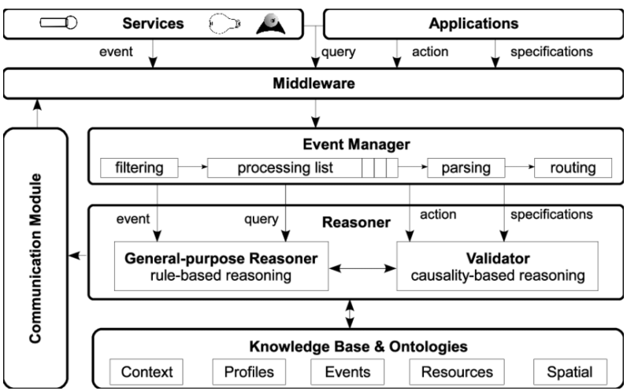
Figure 1: Event Management Framework
(Source: Patkos et al., 2021)

Event Concept
Over the three days in Portmeirion, delegates will partake in a Welsh folklore, crafts, and storytelling afternoon as well as Welsh cookery with a MasterChef winner.
Day 1: Traditional harp performance at an early evening welcome reception and a community dinner with local ingredients (gov. Wales, 202)
Day 2: Interactive workshops (love spoon carving, sheep herding demo, and herbal remedy crafting). Guided walks and visits to the market make up the afternoon session of evening stargazing led by local astronomers and narration about folklore.
Day 3: Yoga and herbal tea (morning wellness session), a cultural reflection circle, and a farewell brunch.
Throughout, participants will reside in Portmeirion's boutique hotels, working with local artisans in line with the principles of slow and emotionally enriching travel, as well as sustainable rural tourism.

Aim and Objectives of the Meeting/Event
To develop an immersive, culturally authentic rural tourism experience in Portmeirion, celebrating Wales' heritage, promoting sustainable tourism, and deepening emotional links between international delegates and the local community.
The following SMART objectives will guide the planning and execution of the event:
Specific | Measurable | Achievable | Relevant | Timeline
Attract 50 international delegates to participate in the whole 3-day event | Track delegate registrations and final attendance records | Targeted digital marketing and partnerships with tour agents | Supports Visit Wales’ goal to expand international tourism engagement | 1 month
Conduct five interactive workshops highlighting traditional Welsh culture | Workshop sign-ups and participant feedback forms | Local artisans and guides secured through community networks | Aligns with cultural preservation and rural community engagement | 3 months
Achieve at least 85% positive feedback rate on sustainability and hospitality | Post-event feedback surveys and sustainability audit tools | Incorporate local food, eco-practices, and training for staff | Reinforces sustainable tourism goals of the “Year of Croeso” campaign | 4 months
(Source: Learner)

Required Skills and Resources for Event Management
Organizing the "From Hill to Heart" event requires a multifaceted effort to ensure the operability of operations, planning, and marketing. In operation, event coordinators are skilled at managing logistics of accommodation, transport arrangements, Catering, safety measures, and publicity. They must be able to adapt quickly and solve problems on-site (Fox et al., 2014). Demonstrating cultural sensitivity, strong interpersonal communication, and fluency in both English and basic Welsh greetings are all things that hospitality staff need to possess to encompass the ethos of 'Croeso.'
Activities in planning will be conducted in conjunction with local authorities, artisans, and tourism boards. Strong organizational skills and those related to budgeting are necessary for project managers to demonstrate that the project lives within the timeline and that resources are allocated and executed to meet the set sustainability goals (Getz and Page, 2019). Develop early on risk assessments, vendor contracts, and contingency plans.
To market an event internationally, a team with digital communication expertise and skills in social media, storytelling, and influencer outreach is needed (Meredith, 2022). These will be enhanced through visuals, videos, and blog posts created by content creators that highlight Welsh culture, generating interest and bookings.
Other additional resources include workshop materials (e.g., wood for carving and/or handcrafting, herbs for remedies), AV equipment for presentations, eco lighting for evening sessions, and sustainability tools for 'tracking' the environmental footprint of the event (Rogers and Wynn-Moylan, 2022). Cohesive coordination of all functions will ensure the event reflects Wales’ warm, authentic welcome.

Event Budget
The budget for "From Hill to Heart" comprises both actual income and expenditure, with a particular emphasis on various sustainable and community-driven practices. The expected overall price range is £35,000, with profits derived from registration fees, authorities grants, sponsorships, and partnerships with cultural enterprises (Bagga et al., 2021).
Income Sources:
- Delegate Registration Fees (50 x £300): £15,000

- Visit Wales Cultural Grant: £10,000

- Local Sponsorships and CSR Contributions: £5,000

- Partnership with Travel Agencies (Commissions and promotions): £3,000

- Merchandise and Workshop Product Sales: £2,000

Expenditure:
- Accommodation and Catering (3 days): £12,000

- Workshop Materials and Artisan Fees: £4,000

- Marketing and Influencer Campaigns: £5,000

- Transport and Logistics (Local shuttle, staff travel): £3,000

- AV Equipment and Eco-lighting: £2,500

- Staff Wages and Volunteer Expenses: £4,000

- Sustainability Tools and Auditing Services: £2,000

- Contingency Fund (10%): £2,500

The income strategy is diverse, ensuring financial stability and alignment with event objectives. Registration fees reflect the various premium values of a particular bespoke cultural experience. Public investment helps align the occasion with national cultural objectives, even as neighborhood sponsorships foster business-network relationships. Merchandise income from workshops, such as handmade love spoons, offers additional economic benefits and cultural engagement.
On the expenditure side, precedence is given to locally sourced Catering and boutique lodging to guide the rural economic system (Bazzanella et al., 2021). Investments in eco-lights and sustainability audits align with the marketing campaign’s desires and enchantment to environmentally conscious delegates.

Industry Trends, Issues, and Impacts
The fast-changing world of the UK's meetings and events industry is responding to evolving attendee expectations, technological advances, and the increased emphasis on sustainability. These trends apply more directly to events like 'From Hill to Heart' that seek to provide immersive, culturally rich experiences.
1. Economic Significance and Recovery
The UK conference and events sector contributes approximately £11 billion annually to the national economy and spends around £19.2 billion on conferences and meetings (Statista, 2017). Event bookings have recovered robustly post-pandemic, with a particularly striking increase in bookings for summer 2024, led by social events, corporate events, and weddings (The Guardian, 2024). This is because the resurgence is a societal shift towards prioritizing in-person interaction and experiences.
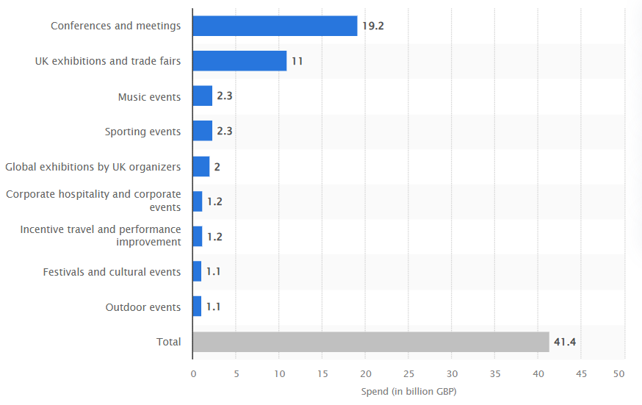
Figure: Direct spending in the events sector in the United Kingdom (UK) as of 2017 by event type
(Source: Statista, 2017)
2. Sustainability, environmental responsibility
Event planning has increasingly become concerned with sustainability. Eco-friendly practices, such as reducing single-use plastics, locally sourcing and organic food, and minimizing waste, are being steadily adopted by the industry (Tan et al., 2021). In most cases, these measures align with environmental goals and are valued by the attendees.
3. Attendee Engagement and Personalisation
Attendees now expect a personalised and interactive experience. The moving into a traditional format most activities include workshops, wellness sessions and cultural immersions (Buchanan et al., 2021). As an evolution of the inclination towards content, this transition is meant to offer an experiential learning environment, comparable to an overall shift in education in America and worldwide towards experiential teaching and learning.
4. Technological Integration
Technology integration has been a major role in ensuring that from managing operations to improving attendee experience, the events management model has been running seamlessly. Virtual reality and data analytics tools which are AI-driven personalisation, enable organisers to adapt the content and interaction to each one’s taste (Buhalis et al., 2019). Efficiency is improved but attendees' behaviour is also better understood allowing continuous improvement to occur.
5. Elevated Costs and Operational Pressures
Event organisers are under pressure to operate within escalating costs, without compromising the customer experience. Also, dynamic pricing models and the costs of production (equipment, crew and logistics) are higher. Taken literally and many British festivals lost this year will be translated into 72 festivals (The Guardian, 2025). 2025).Aligning with these industry trends, “From Hill to Heart” can provide a compelling, sustainable and engaging experience that aligns with current expectations and sets a benchmark for future events to meet the same.

Situational and Cultural Considerations
The success of the “From Hill to Heart” event particularly depends not only on internal planning but also on how well it aligns with that of the broader external situational as well as cultural factors. The PESTEL framework—which examines Political, Economic, Social, Technological, Environmental, and Legal influences—presents a comprehensive lens for assessing the environment wherein this cultural wellbeing retreat will take area in Portmeirion, Wales.
Political Factors: “From Hill to Heart” is directly supported by the Welsh Government’s ‘Year of Croeso 2025’ (translated as the Year of Welcome) campaign, which invests over £5 million yearly in promoting sustainable tourism and regional improvement. This political help offers now not handiest financial opportunity however also credibility, helping to steady public quarter partnerships and permissions. However, post-Brexit implications are some of the still relevant. According to VisitBritain, EU visitors declined by 18% between 2019 and 2023 because of changes in visa regulations and tour requirements (assets, 2021). This method organisers ought to offer clear travel recommendations for EU delegates and probably provide a guide with visa letters. Politically, operating closely with Gwynedd Council and Portmeirion’s personal estate management is crucial to ensure compliance with protection, noise, and occasion regulations.
Economic Factors: Tourism contributed approximately about £5 billion to the Welsh economy in the year 2022, with North Wales alone attracting 29 million visits annually,, many to scenic and cultural locations which includes Portmeirion. Hosting the event here gives a right away opportunity to guide the local economy, which continues to be recuperating from the economic downturn due to the COVID-19 pandemic.
However, UK inflation reached 11.1% in 2022, it's one of the highest in 40 years, and while it has begun to decline in 2024, it still hugely affects event costs such as food, accommodation, and staffing. Additionally, in the context of GBP/EUR exchange rate fluctuated between 1.14 and 1.19 in the past year, which has the ability to affect international affordability(Schwarz et al., 2021). To mitigate this, the occasion will enforce a tiered pricing strategy, providing early chicken reductions, organization applications, and scholar prices, even as additionally exploring sponsorships from eco-conscious brands and furnish programs beneath the Welsh Tourism Growth Fund
Social: Culturally, the event supports the actual preservation of the Welsh traditions through folklore, crafts, as well as cuisine Social inclusivity is emphasized, growing respectful spaces wherein each locals and visitors can interact (Stein et al., 2021). A robust emphasis on community involvement fosters trust and adds authenticity to the occasion. Organisers have to remain touchy to cultural norms and linguistic range, making sure that fundamental Welsh greetings and traditions are reputable and included.
Technological: Digital tools are crucial for promotion as well as registration. Platforms such as the Eventbrite, Instagram, and TikTok will be used for the purpose of storytelling, while the QR codes can assist in green information sharing all through the event. Technological infrastructure in a rural area can be limited, so AV gadget and internet reliability need to be checked in advance.
Environmental: Environmental sustainability is a core value. Portmeirion's fragile natural beauty requires the use of the various eco-lighting, low-waste Catering, and carbon tracking gear. Partnering with local transport offerings reduces emissions. Waste reduction techniques and composting also are part of the sustainability plan.
Legal: Compliance with GDPR, food safety standards, and occasion coverage are crucial. Contracts with providers and records safety for delegates need to be legally sound. Additionally, COVID-19 contingency protocols, at the same time as much less outstanding now, nonetheless warrant preparedness in case of sudden outbreaks.
These issues are crucial to ensuring that the event now not handiest meets operational goals but additionally respects and responds to its cultural, economic, and environmental context (Handy et al., 2021). Through thoughtful analysis and coaching, “From Hill to Heart” will become greater than an occasion—it becomes a shared cultural experience grounded in recognition, sustainability, and celebration.

Conclusion
“From Hill to Heart” is a culturally rich, sustainable tourism event that mainly celebrates Welsh heritage through various form of immersive experiences. Supported through strategic making plans inside the event cycle, carefully constructed budgeting, and contextual analysis through the PESTEL framework, the event is well-positioned to create significant cultural connections, economic benefits, and lasting emotional impact for both delegates and the area people. In addition, the event fosters a sense of community pride as well as strengthens local identity by the process of showcasing authentic Welsh traditions and crafts. By the process of prioritizing sustainability and inclusivity, "From Hill to Heart" ensures that the tourism growth well aligns with long-term regional development goals. Therefore this particular event serves as a model for how the way in which cultural tourism can be both economically viable as well as socially meaningful.

References
Buchanan, K., Velandia, M., Weckend, M. and Bayes, S., 2021. Learning objectives of cultural immersion programs: A scoping review. Nurse Education Today, 100, p.104832.
Buhalis, D., Harwood, T., Bogicevic, V., Viglia, G., Beldona, S. and Hofacker, C., 2019. Technological disruptions in services: lessons from tourism and hospitality. Journal of service management, 30(4), pp.484-506.
Fox, D., Gouthro, M.B., Morakabati, Y. and Brackstone, J., 2014. Doing events research: From theory to practice. Routledge.
Getz, D. and Page, S.J., 2019. Event studies: Theory, research and policy for planned events. Routledge.
Gov.wales, 2025. Event Wales: A Major Events Strategy For Wales 2010 – 2020. Available at: https://www.gov.wales/sites/default/files/publications/2019-06/event-wales-a-major-events-strategy-for-wales-2010-to-2020.pdf (Accessed: 31 May 2025).
Meredith, J., 2022. Project management: a managerial approach.
Rogers, T. and Wynn-Moylan, P., 2022. Conferences and conventions: a global industry. 4th Edition. Routledge: Oxford.
Statista, 2017. Events sector spending by type UK 2017, Statista. Available at: https://www.statista.com/statistics/426464/direct-spending-in-the-events-sector-in-the-united-kingdom/ (Accessed: 31 May 2025).
Tan, J., Tiwari, S.K. and Ramakrishna, S., 2021. Single-use plastics in the food services industry: can it be sustainable?. Materials Circular Economy, 3(1), p.7.
The Guardian, 2024. Britons splash out on get-togethers as events industry toasts summer boom. Available at: https://www.theguardian.com/business/article/2024/aug/16/britons-splash-out-on-get-togethers-as-events-industry-toasts-summer-boom?utm (Accessed: 31 May 2025).
The Guardian, 2025. UK festivals face ‘really tough’ year due to fewer headline acts and rising costs. Available at: https://www.theguardian.com/music/2025/jan/12/uk-festivals-face-really-tough-year-due-to-fewer-headline-acts-and-rising-costs?utm (Accessed: 31 May 2025).
Wang, Y. and Jin, X., 2019. Event-based destination marketing: The role of mega-events. Event Management, 23(1), pp.109-118.
assets.publishing.service(2021) British Tourist Authority Trading as VisitBritain and VisitEngland https://assets.publishing.service.gov.uk/media/67064e34e84ae1fd8592f034/E03131761_BTA_ARA_2023-24_Accessible_v2.pdf [Assessed on: 31:05:2025]
gov.wales (2022) £5 million investment in tourism projects will enhance visitor experience Assessed from: https://www.gov.wales/5-million-investment-tourism-projects-will-enhance-visitor-experience[Assessed on: 31:05:2025]

