Speaker`s notes:
2. Slides: Career can take many forms and meaning. I think that with the right work experience if I realize my goals and constantly gain new knowledge, it can be called a career. In return for all this there is both: a monetary and a moral reward.

3. Slides: I will explain why I think the above. It is important, how long we have been working because our work experience changes a lot in our attitude.
-We can change our original plan,
-We can continue learning or
-We can change our profession.
In addition, self-realization is of great importance, because if we succeed in our work, it affects all areas of our lives. However, to grow, we also need to improve our skills or learn new skills. The world is changing e.g.: technology, we must progress to be competitive and successful.

4. Slides: Of course, that success means many different things to many different people. Because that, I don`t want to formulate a definition, just simply tell you my opinion. I argue that success is when we have set ourselves goals the achievement of time, work invested, will depend on the success or failure of the activity in this case of career. To this happen we need planning.

5. Slides: Career planning is about how we take responsibility for finding work that meets our needs and motivation. So, career planning is, in fact, the exact planning of where we want to go from where we are now. By summarizing the information through several points e.g.: ideal tasks, success criteria, skills to be developed, further training or volunteering. How do I start ….?

6. Slides: To prepare a career plan considering that we want to be successful we need to determine the focus points, about ourselves and our activities. Based on the focus points, the following contexts were born:
7. Slides:
- If I' m very good at something and I like to do it, but it's not profitable: it could be my hobby, but I probably won't make a living from it, (e.g.: charity)
- If I' m very good at one thing which is profitable too, but I don't really like it: Although I can do that activity effectively, I may not do it with pleasure, with all my heart, (e.g.: translation)
- If I like something and it is profitable, but I am not particularly good at it, I am happy to do it, but I am unlikely to be successful in this field. (e.g.: to be a singer)

When I have found the area where my needs and motivation meet, I integrate this with my order of values.

8. Slides: represent the fundamental belief in how a particular behaviour is valued in society. Values are important because they influence our perceptions and define our core beliefs about ourselves, other people, and the world which we live in. Our beliefs are deep within us, so we live our lives without thinking or questioning them. To conclude, my theory resulted as follows:

9. Slides: I have an interest in people in the community. It is important for me to be able to do useful, helpful activities and to serve others. I enjoy being able to connect with people, get involved in their lives, help solve their problems. I feel good in tasks where I can work in company, teams, or work groups.

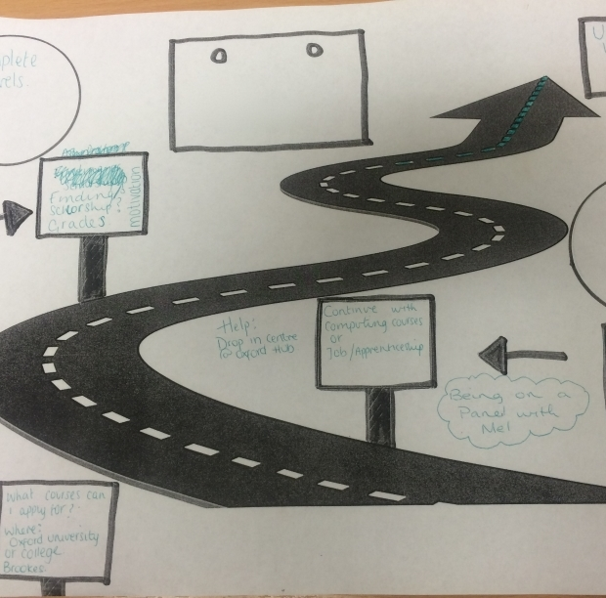University of Wales Trinity Saint David
Academic and Employability skills
(BMSW4001_LON)

My intended career

Student: Valeria Varga (9009456) London, 2020.

Tutor: Timothy Hopkins This Photo by Unknown Author is licensed under CC BY-NC-ND

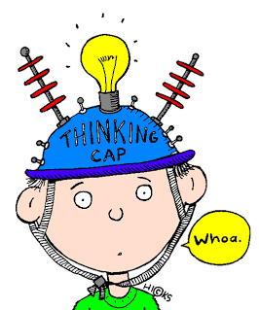
What is the meaning of career???

Performance unfold success validation money position
This Photo by Unknown Author is licensed under CC BY-NC-ND

I think the career is..............

vtime spent at work – work experience

vself-realization-satisfaction

vdeveloping my skills-I am still learning

This Photo by Unknown Author is licensed under CC BY-NC

The meaning of success!!!

vHaving goals in mind

vSeeking opportunities to move towards them

vInvesting time and activity

This Photo by Unknown Author is licensed under CC BY

Why is a career plan important?

DURING OF THE PLANING I AM LEARNING ABOUT MYSELF LEARNING ABOUT JOB GET FULL PICTURES FROM
TWO IMPORTANT AREAS:

Focus points vMy Strength (learn about myself)

vWhat I like (learn about job)

vMy value system

(knowing my basic beliefs and needs)

This Photo by Unknown Author is licensed under CC BY-NC-ND

Let’s DO it!!!!

My strengths What are the things I like to do

Creativity

Self-control Versatility

• Reading. ... • Coaching. ...

Continuous Learning

Integrity

Flexibility

Focused
• Walking.
• Time spent on personal growth and
goals. ...

• Living my truth every day. ...
• The joy and freedom of an open mind.
...

• Relationships that improve me. ...

Dedication

Honesty
Taking Initiative

• The story I am telling myself every day. ... • The positive spin of life's surprises.

Value system

vbasic truths what we learn from the:

• patterns • society
vwe feel proud if our values in a comfortable place

vwe feel anger if a place that threatens our values
This Photo by Unknown Author is licensed under CC BY-NC

Conclusion:

My intended careers:

Education, Society, Communication,
Human services or Lifestyle.

This Photo by Unknown Author is licensed under CC BY-NC-ND Thank you for attention!

References

• Can Akdeniz, Jonas Stark (2014) The self Improvement Book: A Guide for success and Personal Development. Bad Bodendorf, Germany

• Wendy Hirsh and Charles Jackson (2012) Planning your career in a week, Start career planning in seven simple steps, Hachette UK

This Photo by Unknown Author is licensed under CC BY

