Student Name: Ionela Vlad
Module name: Personnel Resourcing and Development
Module code: M5X01921
Lecturer name: Dr. Jahanzeeb Qurashi
Assignment title: The Project Proposal- The Langham Hotel London

TABLE OF CONTENTS
Introduction…………………………………………………………………………………………page 03
Task One………………………………………………………………………………………….….page 04
Task Two………………………………………………………………………………………………page 04
Task Three……………………………………………………………………………………………page 05
Task Four………………………………………………………………………………………………page 06
Conclusion……………………………………………………………………………………………page 06
References……………………………………………………………………………………………page 07

Introduction
The aim of the today’s assignment is to analyse the level of employee engagement of a chosen organisation and based on this to create a proposal comparing the chosen hotel’s issues with the issues from other hotel at the same or lower standards that are managing to keep those issues away, mentioning next to that the strategies that are used to keep improving that aspect. The proposal will therefore be based on The Langham Hotel London, a hotel with luxury standards and with high prices destinated to people that are in middle classes and want to have a holiday at a really high standard.
The assignment will represent four task, which will describe the chosen hotel in more depth and also will introduce the main issues related to employee engagement, also saying how it does affect the reputation of the hotel, after this another hotels at the same standards as the chosen hotel such as Royal Lancaster Hotel London, which is also an expensive hotel loved by the ones from higher classes that have got the possibility to pay more for their holiday which needs to be so comfortable and with great services.
In a hotel with high standards the employee engagement is doubly important than in the one with low prices as people do always expect everything from an expensive hotel (Kurtzman, 2017). Employee engagement is defined as being the emotional commitment the employee has to the organisation and its goals (Kruse, 2012)
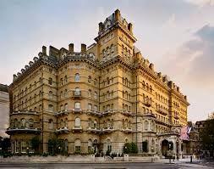
Langham Hotel London Hilton London Metropole

Task One
Langham Hotel is a hotel Located in London that started to initiate and develop its services since 1865 (The Langham Hotel, 2020), and recently more things have been added to it to ensure that the guests are having a wide range of rooms to chose from and it does also have been and still is the first hotel in Europe that is evolving.
Because the hotel is located in London, the capital of the country, tourists and guests generally tend to aim for as high as possible considering the price and the options of the rooms. Next to that, guests tend to appreciate the hotel and form a good impression about it before getting into the hotel is because of the location of the hotel that provides great surroundings and nice views.
Thinking about the hotel development since it opened it is clear that the main general managers had time to ensure that the employees in the hotel are working effectively and as they should following all the rules to ensure the best for the guests that are coming and also to ensure that those employees are not dragging down the hotel in any of the ways (peoplevalue.net, 2019)
The proposal, therefore, will focus on the strategies used by this hotel that are helping them maintain the performance of having five out of five stars at the customer feedback (TripAdvisor, 2020) and also the proposal will compare this hotel which is at high standards and having fabulous reviews with an hotel that is known in England but still does not manage to have balanced rating. The hotel that will be used as a negative example is Hilton Hotel Metropole that needs to learn more about how to have a good business (TripAdvisor, 2020) five stars, comparing to Langham Hotel which, as mentioned has got five out of five stars.
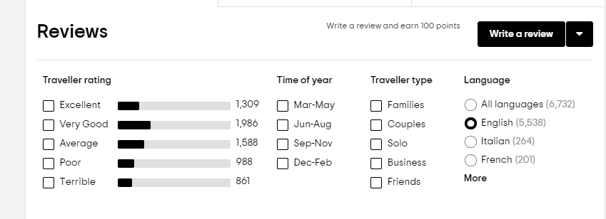 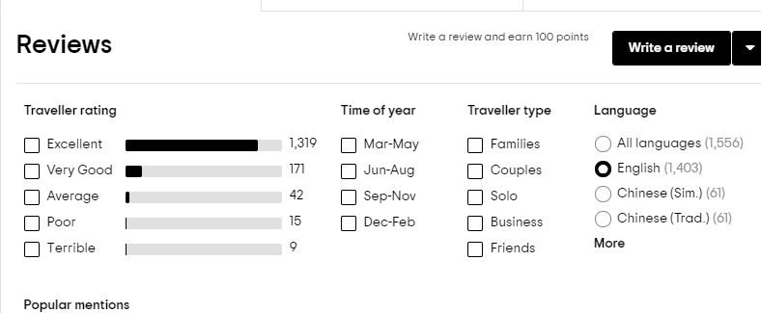 Langham Hotel London Hilton London Metropole

Task Two
It has been proved that some employees are more motivated than the others and this because some of them are doing the job they want to do and the job they have done their qualifications for, while others are doing the job just because they needed a job urgently (Strauss, 2017). Therefore, the ones that are doing the job that they did not want to do will pull the company down as their level of motivation is down so their engagement is the same (Gish, 2019). Thinking about Langham Hotel, it does not have any issues with these aspects as the ones holding interviews and the ones that are selecting the applicants are ensuring that they are coming to work in the hotel because this is what they want to do and this is what they do have experience in and they are focusing on these people as these are the ones that need to be valued the most to ensure that the work they will do will be good enough for their business that continuously needs to be well-maintained. When it comes to Hilton Hotel Metropole it has got high standards as well as Langham Hotel, but the only difference is that Hilton London Metropole is not focusing on applicants that are having experience in the industry and this is affecting the periods in which they are employing just the ones that seem to be suitable for the job. Therefore, because they are not paying to much attention people are just coming for the job doing their basic work and never aim for more or for great quality of their work (Jiggens, 2020). Some example of good practice of engaged employees are the following:
- Listen one to another when working in a team- as if employees start to feel useful they will be more motivated for doing work and they will start to be more engaged and performing their tasks without having the only concept of “I need to do it” (Eversham, 2016)
- Get to know the appreciation of customers- once the guest satisfaction is seen the employee will feel that their work is being appreciated and that they are not working for nothing. Once appreciation is shown the employee will feel like needing more appreciation and the execution of tasks will become better and better all the time
- Look around at competitors in the company- as this is one of the main things that are having impact on the engagement, if there is someone else with the same function that is being seen better than the level of engagement for the initial employee will increase its motivation to be better seen as well as the other employee (Riavoglou, 2019).
Task Three
The corporate social responsibility is defined as being as an ideal form of the manager’s attention on the demonstration of the quality of the products. The CSR is the strategy that represent the opportunity for more engagement and involvement by employees, this bringing economic growth to the company (Knowles, 2014). This strategy is necessary because it is pushing the engagement towards better performances. Next to that each employee needs to be informed that their engagement is the one that is raising the overall progression of the company.
When it comes to the long employment the main thing to say is that the good employees are the ones that last the longest and this because they are the ones that recognize the importance of a good job and the importance of having a good amount of experience in the domain.
Hilton London Metropole did not prove that it is using the Corporate Social Responsibility and this because there are so many reviews that are talking about the ignorance of employees facing their requests and also, they tend to struggle with timing. Whereas, the Langham Hotel does not have any bad reviews at all, thing that clearly shows that they are using the strategy effectively.
Task Four
As a future plan for Hilton London Metropole, it is important to keep in mind that the employees are the ones that are maintaining the development of the business in terms of everything, economy, profits, customer satisfaction… As a result to this the general managers must think about introducing more detailed interviews to check if the applicants are confident with what they can do and what experience they are able to recall. Next to that it is important the employer is saying from the start what it is expecting from the employee as if it is not mentioning what it wants from the start then the employee will start to play with what is being said.
Some of the things that can be done to improve employee engagement (Clarke, 2018) are the following:
- Encourage flexibility- This referring to giving to the employees the free will of choosing where to do their work, how to their work and when to do their work as long as everything is on time and right/. Flexibility gives to the employee the freedom but in the same times they are responsible for proving that they are capable to finish a piece of work on time and right.
- Mentor your employees- As otherwise they will never know what they are doing wrong and it is better to tell them what they need to improve rather than letting them carry on with the work in the wrong way and then re-do it.
- Encourage collaboration- As this is the one thing that is promoting teamworking and also it is the thing that promotes the learning from one and another. This also develops each employee by seeing what others are able to do and how.
- Promote short but many breaks- As this helps each employee to get themselves together at least three times in 8 hours.
- Clarify the goals- As everyone needs to know what they are working for, in the same time knowing what their responsibility is and what period of time they have got to finish everything.
Conclusion
The proposal clearly mentioned the issue found in Hilton London Metropole, reflecting the employee engagement and this is important because it has been compared with a luxury hotel as well, that has absolutely no negative reviews. Moreover, the report itself has shown that there are quite few things that need to be considered before drawing conclusions about the engagement.

References
Clarke, L. (2018), “Proven Methods to Increase Employee Engagement in the Workplace”, (online) available on: https://www.2degreesnetwork.com/groups/2degrees-community/resources/whats-difference-between-csr-and-sustainability/ accessed on: 21/07/2020
Eversham, E. (2016), “Could better staff engagements be solved?”, (online) available on: https://www.bighospitality.co.uk/Article/2016/01/07/Could-better-staff-engagement-solve-hospitality-s-recruitment-problem accessed on: 21/07/2020
Gish, W. (2019), “Hotel Employee Functions”, (online) available on: https://smallbusiness.chron.com/hotel-employee-functions-17800.html accessed on: 21/07/2020
Jiggens, M. (2020), “Engaged workers a minority”, (online) available on: https://www.talentcanada.ca/engaged-workers-a-minority-but-your-business-desperately-needs-them/ accessed on: 21/07/2020
Kruse, K. (2012), “What is employee engagement”, (online) available on: https://www.forbes.com/sites/kevinkruse/2012/06/22/employee-engagement-what-and-why/#76dbddeb7f37 accessed on:21/07/2020
Knowles, V. (2014), “What’s the difference between CSR and Sustainability”, (online) available on: https://www.2degreesnetwork.com/groups/2degrees-community/resources/whats-difference-between-csr-and-sustainability/ accessed on: 21/07/2020
Kurtzman, J. (2017), “Why is employee engagement in the hospitality industry important”, (online) available on: http://blog.rewardian.com/why-is-employee-engagement-in-the-hospitality-industry-important accessed on: 21/07/2020
The Langham Hotel London, (2020), “Overall Information”, (online) available on: https://wwwlanghamhotels.com/en/the-langham/london/overview/ accessed on: 21/07/2020
TripAdvisor, (2020), “The Langham London”, (online) available on: https://www.tripadvisor.co.uk/Hotel_Review-g186338-d187569-Reviews-The_Langham_London-London_England.html accessed on: 21/07/2020
TripAdvisor, (2020), “Hilton London Metropole Hotel”, (online) available on: https://www.tripadvisor.co.uk/Hotel_Review-g186338-d193089-Reviews-Hilton_London_Metropole-London_England.html accessed on: 21/07/2020
Peoplevalue.net, (2019), “Host next employee engagement round table”, (online) available on: https://peoplevalue.net/peoplevalue-to-host-next-employee-engagement-round-table-event/ accessed on: 21/07/2020
Riavoglou, V. (2019), “The importance of proper competition in the hotel”, (online) available on: https://www.hotelieracademy.org/the-importance-of-identifying-the-right-competition/ accessed on: 21/07/2020
Strauss, K. (2017), “Why are some employees more engaged than the others”, (online) available on: https://www.forbes.com/sites/karstenstrauss/2016/05/31/why-are-some-employees-more-engaged-than-others/#2ab2e775341d accessed on: 21/07/2020

