
Skills for the Workplace
Module Assignment Submission
Student Name: | Parvin Begum
Student Number: | 2016138
Module No: | BMSK4005
Module Title: | Professional Career Development

Statement of Confirmation of Authenticity
By the act of making this submission, the student declares that this is the work of the student named above. The work has not, in whole or in part, been knowingly presented elsewhere for assessment, or where assessment has been built on a previous assessment, this has been identified. Where materials have been used from other sources it has been properly acknowledged. If this statement is untrue, the student acknowledges that an assessment offence has been committed.
Attention is drawn to the plagiarism and unfair practice policies of both the University and of ILM.

Table of Contents
Introduction 3
Section 1: Know how to identify development needs 4
1.1Identify learning styles for self and another 4
1.2 Useasimple technique for identifyingdevelopmentneeds for self & another 5
1.3Identifypotential barriers to learning for self and another. 6
1.4Explain how these barriers to learning can be overcome. 8
Section2:Knowhowtodevelopself& otherstoachieve organisationalobjectives 10
2.1Analyse learning/developmentoptions tomeet needs of self& another. 10
2.2Identifysupportmechanisms for thedevelopmentofself & another 10
2.3 Prepare development plans for yourself and another person 11
2.4Method usedtomonitor the developmentof self & another. 12
Section 3: Know how to prepare for the recruitment process 14
Reflection on the recruitment process 14
3.1 Description 14
3.2 Feelings 15
3.3 Evaluation 15
3.4 Analysis 16
3.5 Conclusion 16
3.6 Action Plan 16
References 17
AppendixA 18
AppendixB 19
AppendixC 22
AppendixD 24

Introduction
The focus of this assignment is to create a personal development plan and be able to assess potential strengths and weaknesses to address. The assignment can be identified through sections; section 1: identify ways to develop self by utilising learning styles, section 2: understanding the importance of individual development and developing others to be able to attain objectives. Lastly, section 3: be able to go understand the recruitment phase by applying to jobs and develop an understanding of it.

Section 1: Know how to identify development needs

1.1 Identify learning styles for self and another
Learning styles are used to help identify what specific learning style an individual presents. This helps understand what an individual needs to develop and what their strengths are. There are three common types of learning styles used such as; VARK (Flemming, 1987), Dantec, and Honey and Mumford (1982).
By using these learning styles I will be indentifying what learning style describes me best. The first learning style that was answered was the Honey and Mumford questionnaire. There are four categories that describe an individual; Activist, Theorist, Pragmatist and Reflector (University of Leicester, 2020). The results from the questionnaire indicted that I am a pragmatist learner. This type of learner is able to adapt to learning easily as long as it is practical for them to achieve, PLAN most applies with pragmatist learners as they independently like to plan ways through, before doing it to make sure it is achievable (Rumson, 2017).
In comparison to my colleague, their learning style came out as an Activist, who learn by practically doing things, they learn best when they with new experiences and like to lead in a team (Rosewell, 2005). Both me and my colleague are aware of our learning styles and happily agree that the learning styles reflect the type of person we both are.
Moving on, the second learning model that was used by me and my colleague was VARK (Flemming, 1987). The results from this questionnaire identified that I have a multimodal preference, but my colleague’s learning style was most recognised as Mild Read/Write. The last model that was used to identify learning styles was Dantec. The results from this model reflected me being a visual, auditory and kinaesthetic learner, also that I am pragmatist, which similarly related to the Honey and Mumford learning style.

1.2 Use a simple technique for identifying development needs for self & another
The following section will identify a SWOTS analysis on me and a colleague. A SWOT helps analyse ones strengths, weaknesses, opportunities and threats, on their personal development but can also be used on a product, company and service, to help develop and meet goals (Grant & Scott, 2020). SWOT person 1 will be my analysis and SWOT person 2 will be my colleague.
SWOT Person 1

STRENGTHS  - Patient  - Friendly  - Empathetic  - Trustworthy  - Good Listener  - Multi-tasking | WEAKNESSES  - Shy  - Confidence  - Time management  - Understanding  - Technological skills  - Socialising  - No education  - Less experience
OPPORTUNITIES  - Able to work differently  - Learn about new things  - Study differently | THREATS  - Low self- esteem  - Managing family duties  - Travelling  - Overwhelmed

When reflecting on my SWOTs it is clear that there are many weaknesses to address, but it is also possible for those weaknesses to be developed. Many of the weaknesses relate to one another such as shy, confidence, socialising as one category, no education, less experience, technological skills, understanding as another. To develop my weaknesses I can learn to gain confidence by trying new things and researching about things I do not understand, and apply to places that offer help with gaining skills and experience. This can then give me opportunities to work in place and gain new experiences.
SWOT Person 2

STRENGTHS  - Experienced  - Education  - Confident  - Team player  - Sociable | WEAKNESSES  - Impatient  - Unorganised  - Time management
OPPORTUNITIE  - Better work opportunities  - Better salary  - More experience | THREATS  - Family responsibilities  - Basic qualifications  - Unable to adapt to positions

When analysing my colleague’s SWOTs their weaknesses were much more less than mine which showed they had more practical and educational experience than me. However, their weaknesses can also be easily developed as there are few and basic ones. They can learn to plan their time out using planners and notes to schedule their timetable and note what days they have specific events. This can also help with being organised with time and basic organisation skills such as keeping on task with duties and responsibilities, which will help feel more encouraged to be patient.

1.3 Identify potential barriers to learning for self and another.
There are always potential barriers that can affect one’s life to achieve their goals, with higher education course there can be many barriers that impact on the studying.

 | Barriers | Overcome
Myself | - Childcare  - Lack of skills  - Time management  - No experience with higher level education | - Arrange family members to look after children  - Attend educational classes to gain skills  - Note down dates and events in a planner
Colleague | - Time management  - Financial  - Multi-tasking  - Family | - Plan dates and events in a planner  - Budget expenses or get support  - Plan out ways to meet all goals  - Ensure family are aware of studying timetable

The barriers that I have listed for myself indicate that they are basic barriers that are also recognised as some of my weaknesses from my SWOTS. I am a mother of six children two which are above 18 and the rest under 16. I have to be able to arrange my older children times to look after my children to attend online classes without interruption and noise from younger children. But sometimes my older children are not home which means I have to manage the children alone as my husband’s always in work.
The next barriers relate to the same category such as lack of skills and no experience high level education, these two barriers impact on me very much so, as I have not studied for a very long time. My previous studies I last did were during high school and I did not do very well in them. Therefore, when starting this higher level course after a very long time of no studying at all, makes it difficult to keep up and understand learning. It also makes me lose confidence when comparing myself to others in the class who are younger and experienced in studying. The last barrier of time management can be overcome but sometimes with many younger children and housewife duties, it can impact on my online classes’ attendance and to be on time.
Due to covid-19 the classes have been placed online for a short period, however once classes are carried out in class this will also develop another barrier of travelling as I do not have a car to reach there, which means I would have to rely on my husband.
When analysing my colleague’s barriers they have different ones to me except time management, like me they find it difficult to manage time and family with their studying, as there are many responsibilities to maintain. They have a barrier of financial issues as they are a single parent getting support from student finance for their studies like I did would be beneficial for them. As they are a single parent it is hard for them to rely on family members to look after their child as others are busy or have their own responsibilities. Lastly, multi-tasking is another barrier that impacts their studying as well as they have to multi-task parenting and their studies while doing it alone.

1.4Explain how these barriers to learning can be overcome.
As barriers impact negatively on learning and lifestyles it is important to overcome them as soon as possible, in ways that is achievable. It is important to seek advice from lecturers, family and friends, who may have ideas to help you overcome these barriers.
When understanding my barriers I can overcome my time management by using a planner, where I can note down the days I am busy and the days I am free. I can also use this as way to manage my time to do my assignments but also make time for my children. Also, with the barrier of childcare I can be able to list down days and times my older children are free to babysit and if my husband can as well, that way I can prepare myself for the days where I will manage the children myself. Instead of being overwhelmed and stressed last minute, I can then organise ways ot keep my children occupied while I study.
The last two barriers I can overcome them by accessing online skills courses where I can gain qualifications from completing them. This will help build my confidence to keep trying and also have more skills to put on my CV. I also have other family members who have completed this course; I can seek advice from them and learn skills and how to succeed in my assignments.
Moving on to my colleague, like me their barrier of childcare impacts on managing their studies, however since they are a single parent it puts double pressure on them. They should reach out to family members and plan days they are free to babysit. As they have another barrier of financial issues, they should apply for student finance which also provides childcare, which they can receive to help pay for childcare services if no family can help with babysitting. Also, as their family can pressure them to do favour and basic duties, they should explain to their families how important their studying is and that they do not have a lot of time to do a lot of things. This way when managing her time she can plan out like me using a planner, to understand what days she has classes to be able to arrange childcare and this way she can multi-task her parenting as well as her other responsibilities such as working, shopping.

Section2: Know how to develop self & others to achieve organisational objectives

2.1Analyse learning/development options to meet needs of self& another.
In section 1.2 the SWOT analysis I had created on myself acknowledged many weaknesses that I had developed. The weakness of confidence is a major weakness that affects me when it comes to new things. For example, knowing that I have to meet new people and engage in team building tasks in class discussions, although this makes me feel nervous, I do think once I try it and get used to, it will help bring out my character and be more confident around others. Once the confidence has grown the shyness and socialising can also be developed.

2.2Identify support mechanisms for the development of self & another
Although there are many weaknesses between me and my colleague, being given support can help achieve these developments. One support mechanism that can help me managing my studies and responsibilities as a parent is my family members. As I have a very big family where my brothers and sisters are much more experienced than me with working, education, by having their encouragement and advice to attain my studies will help me build confidence to complete this course. As it builds pressure and stress trying to manage my lifestyle it will be beneficial to have family members who can look after my basic duties while I try and complete my studies.
I lack in many technological skills where using basic IT as it has been very long since I have last studied. Therefore, being able to get support from my lecturers on advice on how to attain my assignments and the resources available will be very useful for me. As well as this gaining feedback on my developments for my work will also help me to improve my skills to get better outcomes.
In relation to my colleague they have suggested that their work employment help them manage their times to be able to meet other responsibilities. As being a single parent trying to manage many roles, their work placement allows them to have flexible times where shifts can meet their routine with their child. For example, having shifts that finish before school finishes, so they can pick up their child on time, where my colleague will offer to do more hours where they are free.
2.3 Prepare development plans for yourself and another person
Part 1: Personal Analysis
In order to develop myself I will need to create a plan, I will be using my STOT analysis (see section 1.2) to help encounter the threats I have come across and try and turn them into attainable opportunities.
Part 2: Setting Goals
What do I want to learn? | What do I have to do? | What support and resources will I need? | How will I measure success? | Target Date for Review
Develop my low self- esteem/ be more confident | -Try new things to have more confidence  -Have belief in myself  -Start seeing things with a positive attitude  -Always Try and Never give up | -Checklist of things to achieve to see progress in achievements | -Each week identify what was achieved and what needs further progress  -Date and Time of how long these achievements took to progress next time | January 2021
Develop a balance between family, work and studies | -Work out my timings with Uni and assignment deadlines  -Ask family members to help out during desperate measures  -Talk to Family and Lecturers about the issues to gain advice | -Planner with days and times | -For the first term in Uni everyday keep track of timings, then in the new term look back at the planner to see if it was successful | January 2021
Be able to work out ways of travelling | -Ask family to help with lifts  -Workout timings with public transport to get on time to class | - Family support  -Public transport and money | -Keep note of which family members have helped out  -Find the public transport timetables to keep track of times and delays | February 2021
Express feelings and emotions to prevent being overwhelmed | -Talk to someone and open up to be able to receive support when needed | -Family and Friends support  -Meetings with lecturers | -End of each week discuss feelings to a person and note them down  -Then read through and understand ways to be better | December 2020

Part3: Personal Objectives

Short Term Goals (next 12 months)
Within these 12 months I aim to complete my 1 year Skills for workforce degree and achieve a qualification, as well as develop many educational skills and personal skills. Such as confidence, communication, knowledge and understanding and learning.
Medium Term Goals (2-3 years)
After gaining qualifications with the university course, I would like to reach out in work placement that can offer me better positions that suit me and attain a good salary. As well as this gain more experience and have more skills to develop in future positions.

Long Term Goals (3-5 years)
Hopefully after gaining experience and finance from previous years, be able to attend short-term courses in colleges that I can gain other qualifications in areas I lack in such as Numeracy, IT and Practical skills. This will help develop future opportunities and personally achieve my weaknesses.

2.4Method used to monitor the development of self & another.
By creating a Personal development plan it helps understand what potential threats are negatively impacting me, and how I can monitor these in ways to achieve them.
Using the PDP I can reflect how well each week or so I am doing with my goals. I can also evaluate whether I have met my objectives and developed my weaknesses. Furthermore, when evaluating my goals whether I have achieved them or not by reviewing them so often, will help work out what I need to change and whether what I have decided to do is working or not. This will help prevent me from committing the same mistakes and ensure this does not impact my future goals.
I did not create a PDP plan on my colleague as she already has ways where she is able to monitor her developments. As she is given training and appraisals in work every new term, which helps were see from the start of the year to the end how well she has improved and whether these methods are working for her. She can also workout whether her SMART objectives she has aimed to meet can be attainable throughout her development phases.
As well as using PDP and Personal objectives to meet goals there are other ways that can help develop skills and progress in learning. This can be achieved using types of learning tools. One learning tool that is commonly used is Kolb’s Learning Cycle that illustrates four categories; Concrete Experience, Testing Implications of concepts in new situations, Observations and Reflections and Formation of abstract concepts & generalisations.
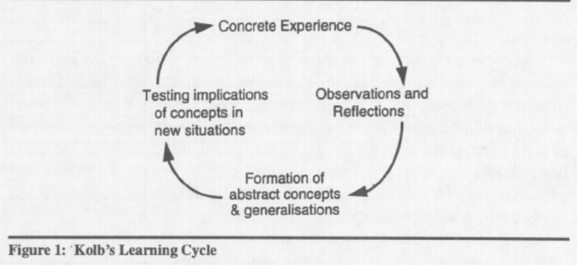
The cycle has been utilised in both management development and management education (Gill & Johnson, 1991; Mifsud, 1990). The learning cycle helps establish individual’s experiences and events and how to understand what comes out of these experiences. The model is beneficial when using with professional development as it can help distinguish your own experiences and issues with development and reflect ways to overcome them with detailed plans and methods (Vince, 1998).

Section 3: Know how to prepare for the recruitment process

Reflection on the recruitment process
The following section discusses a reflection on the recruitment process; Gibbs (1988) reflective cycle will be used to structure the section.


(Gibbs 1988).

3.1 Description
When applying to jobs it is important to have CVs that match the job description and a cover letter stating that you have applied. The recruitment process can depend on the company you apply for and the type of job it is. Some companies require in depth information as they need to do extra security and background checks, whereas some just need basic education or skills for the job.
I have applied to a job on indeed where I came across a care assistant job. The care assistant job is based with bluebird care careers. I am a carer for a family member who has severe mental health, who I cook and clean for as they cannot do it themselves all the time. Therefore, applying for this job was something I already have some experience in which encouraged me to apply. The only difference is by applying to a company I would be able to get better pay and do more hours to how I like as it is quite flexible. As located in the appendix the application form for this job was very simple and did not require lengthy information. This is very beneficial for me as I do not have much education and knowledge there for it makes it easier for me to gain a job where I can gain a lot of training beforehand. Since I have applied the company have not yet responded this can be due to Covid-19 and how applications and recruitment are very delayed than usual. But this can also mean they do not need me or have declined the application.

3.2 Feelings
Within this whole recruitment process I think applying for the job was very simple and easy to do. However, not hearing any responses for the job does make me feel less confident about applying to jobs, as I feel I am not experienced enough for specific careers. But I do understand that not every job can be successful and sometimes it’s not the person and can simply be the company themselves. As I have come across vacancies in the past where they are the same job but some companies are better at recruiting people with no experience, compared to some companies that only base on experience.
Before applying to the job I felt confident that I can be able to go ahead with this job as I have current experience of being a carer. But now after applying I feel less confident as I have not been given any responses yet. This can either be due to my CV that may not interest them or based on their own reasons.

3.3 Evaluation
The positive aspect of the recruitment process is that applying to jobs builds experience and confidence to keep on trying. As well as this creating CVs and cover letters makes it easier to use for other jobs that may be similar. As within a CV the most important part to change for each job is the personal statement.
The negative part would be not actually hearing from the job or getting rejected, which makes someone feel as if they cannot ever get a better job. This also impacts on self-esteem and confidence levels which have been identified within my SWOTs as one of many personal weaknesses.

3.4 Analysis
Applying for the job went well as it was quite simple to do. However, to why the job did not go as successful for me can be based on my CV where my experience and education may be poor to them. I thought seeing I have experience as a carer for a family member and the job application was very simple to do online, I thought this would mean there is a better chance for the job. But now seeing it can be based on how they feel about me, or simply whether there are anymore vacancies available. As I have not probably been successful or interested in I am not aware of any more big applications to fill out, so the one online must have been a basic general application, and if I am successful they will give me a more detailed application to fill. I now know how the process is so when it comes to other similar jobs I must be patient and just be aware of the process.

3.5 Conclusion
To conclude, from my experience of the recruitment process I do think I gained beneficial experiences and knowledge. Although I did not experience an interview yet for my preferred job application I do think this is something I wish I had experienced to be able to understand what it is like. As I have not worked in a long time with many jobs in companies out there, seeing a face to face interview would have been a great experience for future instances and prepare for future roles.

3.6 Action Plan
If I was able to do this again I would make sure I apply to the correct jobs that relate to them and I can be successful in. I would also prepare myself for any let downs in applications so it does not impact my confidence.

References
Grant, M. &. Scott, G. (2020). Strength, Weakness, Opportunity, and Threat (SWOT) Analysis. Investopedia. [Online] Available at: https://www.investopedia.com/terms/s/swot.asp. (Accessed 10th November 2020).
Gillm J. &Johnson, P. (1991). Research methods for managers. London: Paul Chapman.
Gibbs G (1988). Learning by Doing: A guide to teaching and learning methods. Further Education Unit. Oxford Polytechnic: Oxford.
Mifsud, A. (1990). Guidelines for trainers: A trainers manual. Valetta, Malta: Office of the Prime Minister, Staff Development Organisation.
Rumson, R. (2017). Honey and Mumford Learning Styles. The e-learning network. [Online] Available at: https://www.eln.io/blog/honey-and-mumford-learning-styles. (Accessed 10th November).
Rosewell, J. (2005). Learning Styles. The Open University. [Online] Available at: https://www.open.edu/openlearn/ocw/pluginfile.php/629607/mod_resource/content/1/t175_4_3.pdf. (Accessed 10th November).
University of Leicester. (2020). Honey and Mumford. [Online] Available at: https://www2.le.ac.uk/departments/doctoralcollege/training/eresources/teaching/theories/honey-mumford#:~:text=Learning%20styles%20were%20developed%20by,%2C%20Theorist%3B%20Pragmatist%20and%20Reflector.&text=understand%20their%20learning%20style,to%20learn%20using%20that%20style. (Accessed 04th November 2020).
Vince, R. (1998). Behind and Beyond Kolb's Learning Cycle. Journal of Management Education. June, 22, 3; pg. 304.

AppendixA

VARK Questionnaire

Colleague

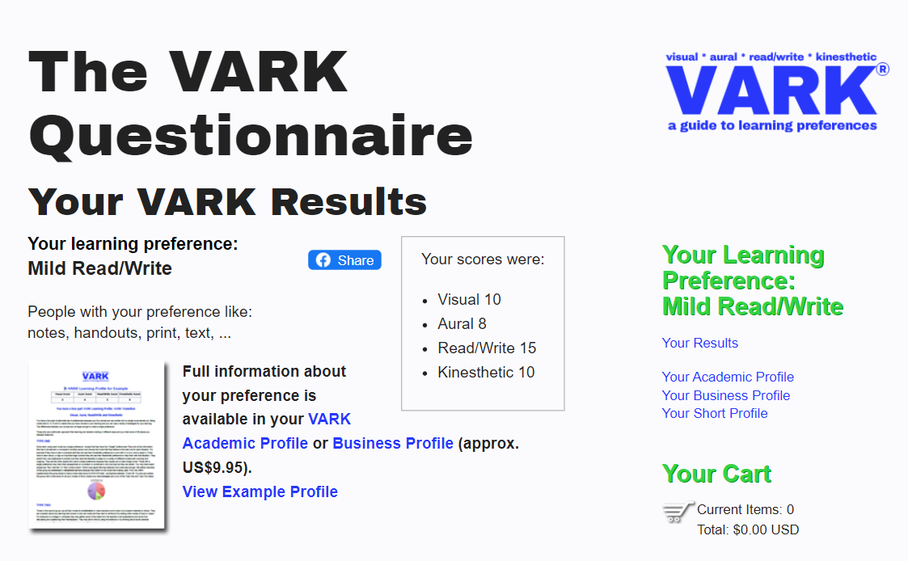

Myself

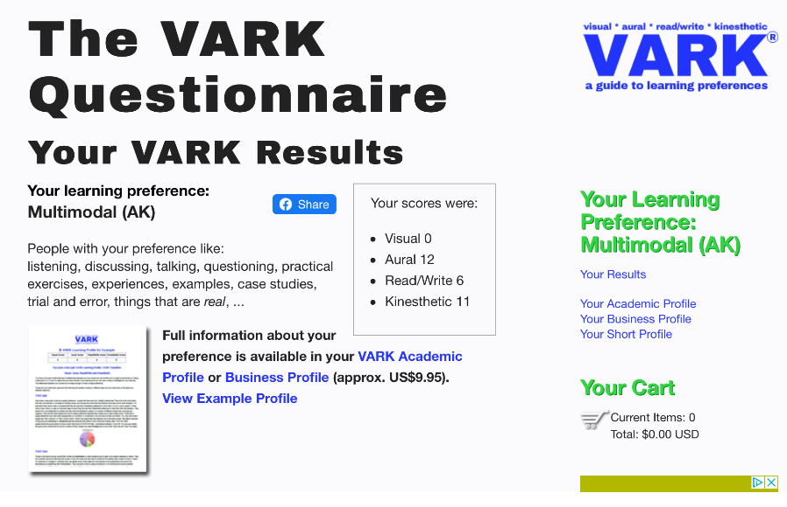

Honey and Mumford Scores and Results
Colleague
2 | 7 | 1 | 5
4 | 13 | 3 | 9
6 | 15 | 8 | 11
10 | 16 | 12 | 19
17 | 25 | 14 | 21
23 | 28 | 18 | 27
24 | 29 | 20 | 35
32 | 31 | 22 | 37
34 | 33 | 26 | 44
38 | 36 | 30 | 49
40 | 39 | 42 | 50
43 | 41 | 47 | 53
45 | 46 | 51 | 54
48 | 52 | 57 | 56
58 | 55 | 61 | 59
64 | 60 | 63 | 65
71 | 62 | 68 | 69
72 | 66 | 75 | 70
74 | 67 | 77 | 73
79 | 76 | 78 | 80
Total Y 17 | Total Y 14 | Total Y 13 | Total Y 15
ACTIVIST | REFLECTOR | THEORIST | PRAGMATIST

Myself
2 | 7 | 1 | 5
4 | 13 | 3 | 9
6 | 15 | 8 | 11
10 | 16 | 12 | 19
17 | 25 | 14 | 21
23 | 28 | 18 | 27
24 | 29 | 20 | 35
32 | 31 | 22 | 37
34 | 33 | 26 | 44
38 | 36 | 30 | 49
40 | 39 | 42 | 50
43 | 41 | 47 | 53
45 | 46 | 51 | 54
48 | 52 | 57 | 56
58 | 55 | 61 | 59
64 | 60 | 63 | 65
71 | 62 | 68 | 69
72 | 66 | 75 | 70
74 | 67 | 77 | 73
79 | 76 | 78 | 80
Total Y 16 | Total Y 15 | Total Y 13 | Total Y 18
ACTIVIST | REFLECTOR | THEORIST | PRAGMATIST

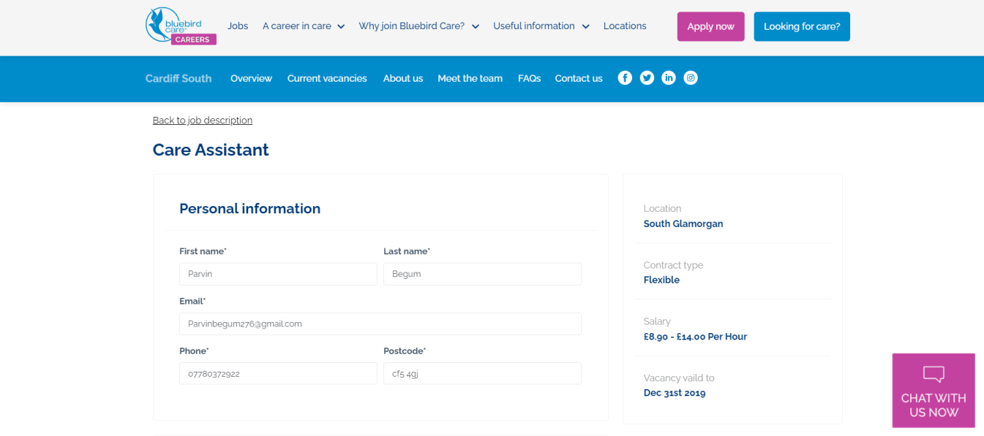
AppendixB

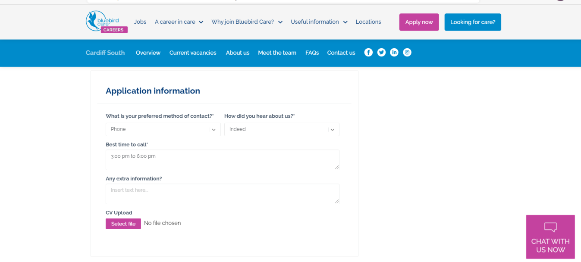

Appendix C
Parvin Begum

Location: Cardiff, Ely |Contact: 07780372922 |Email: Parvinbegum276@gmail.com

Personal Profile

I am a highly motivated and hardworking individual. I am looking to secure a work placement to utilise my skills and further develop my employability skills to put me in best position. I am efficient and can manage a busy lifestyle as a parent with work. Furthermore, I am very adaptable person and am able to work in a team as well as independently. I am able to take on opportunities to help me further develop new skills and gain experience.

Key Skills

Key skills
- Problem-solving- able to help create solutions for any problems within a workplace
- Professional attitude towards work with excellent communication skills gained from work placement such as communicating with team members and always looking to satisfy customer needs and expectations.
- Basic use of Microsoft office, PowerPoint and Word
- Creativity skills- able to construct creative ideas independently and with others.
- Communication- able to communicate with new people confidently
- Teamwork- able to work as a team and adapt each other’s roles to one another
- I am a bilingual individual who can speak fluent Bengali and English.

Education

Fitzalan High School (1988-1994)

Work Experience
Avana Bakery (1994- 1995)
Carer (2019-Present)
- A carer for a family member with mental health problems
- Cleaning, tidying

References

Appendix D

Parvin Begum
33 Grand Avenue
Ely
Cardiff
CF5 4GJ

Blue Bird Care
St Hilary Court
Copthorne Way
Culverhouse Cross,
Cardiff
CF5 6ES

29/ 11/ 2020

Dear Bluebird Care,
I have come across your vacancy on your company site and have applied for the position as a care assistant. My CV has been attached to the application.
As your vacancy is quite flexible and I have basic carer experience I believe I will be right for the job and can gain more practical experience.
I am positive that I can help represent bluebird care professionally and also help those in care.
I hope you can consider my application and I hope to hear from you soon.

Yours sincerely,
Parvin Begum

