

Name of the student: Shaan Aboobacker
Student ID:2503771
Programme: Master of Business Administration
Module: Human Capital Management
Module code: LCMB7023
Lecturer’s Name: Dr.Gladius kulothungan
Work Count :2666
Term: 1

Executive summary
This paper looks at the impact of global economic, technical, demographic, and geopolitical changes in the HRM and IHRM or labour markets. With the influence of automation, AI, and digitalisation on job structures, skills, and recruiting, HR will have to embrace the notion of constant learning, flexible workforce planning, and ethical integration of technologies. Migration, ageing, and diversity pose as a challenge to companies in terms of inclusiveness, compliance and retention of knowledge. Risk management, adaptation, and well-being of employees are highlighted by geopolitical volatility, trade disputes, and other global health crisis. In strategic HRM, the build, buy, borrow, and bind talent programs are used to meet the technological, healthcare, and hospitality skills demand. In the reflection of the report on global leadership, cross-cultural understanding, and digital fluency, individual and organisational competitiveness is improved. To sum up, the world of HRM must be sustainable, which means that it needs a strategic vision, digital literacy, and people-centric leadership enhancing life-long education, resilience, and ethical international cooperation.

Table of Contents
Introduction 3
Question 1: Technology & Labour Markets 4
The Reshaping of Labour Markets 4
Implications for HRM/IHRM Strategies 5
Question 2: Demographic & Geopolitical Factors 8
Key Demographic Factors 8
Key Geopolitical Factors 8
Challenges for HR Professionals 9
Question 3: Skills Gaps & Strategic HRM 11
Understanding the Causes 11
Strategic HRM Approaches 11
Sector-Specific Examples 12
Question 4: Reflective Report on Capabilities 13
Introduction 13
Self-Assessment 13
Development Plan 15
Conclusion 16
References 17
Appendix 20
SWOT Analysis 20

Introduction
Context of the report
Economic uncertainty, demographic change, and rapid digital innovation require smart, flexible people worldwide. The analysis stresses the strategic importance of investing in people utilising modern HRM theories and global insights.
Impact of Global Forces on Labour Markets and HRM
Internationalisation has increased job market competition, flexibility, and talent mobility. Economic integration, migration, and geopolitical crises change workforce availability and cost structures, therefore HR professionals must be flexible, inclusive, and global. International HRM must adapt locally and collaborate worldwide to manage diverse workforces.
Impact of Technological Forces on Labour Markets and HRM
AI, automation, and digital platforms alter jobs and skills. Automation replaces and creates skilled IT jobs. HRM must prioritise learning, talent reskilling, and data-driven decision-making over administration.

Question 1: Technology & Labour Markets

The Reshaping of Labour Markets
Automation & AI: AI ethicists and automation strategists are new, specialised careers. These technologies are changing job markets by favouring cognitive agility, ethical judgement, and digital fluency over manual labour (World Economic Forum, 2025). Cloud deployments will boost worldwide Agentic AI in the labour market from USD 2.5 billion in 2024 to USD 73.9 billion in 2034, a 40.3% CAGR.
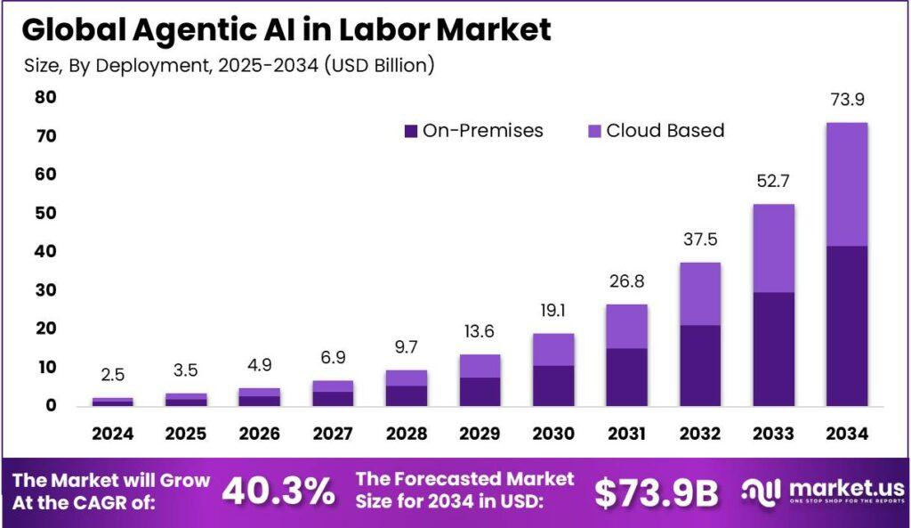
Fig 1: AI in Labor Market
Source: (market.us, 2025)
The Gig Economy & Digital Platforms: With gig economy and internet platforms, the long-term contracts have been substituted with job opportunities on a task basis. This approach enhances independence and global access to talent at the expense of blurring employee-contractor lines, undermining job security, benefits and rights of workers.
Skills Churn: Skills are dynamic and hence important skills are forgotten and learned again as a result of learning. Digital literacy, adaptability and STEM are vital since technology transforms other sectors. Lifelong learning is necessary in an innovative based economy since high skills turnover motivates individuals and companies to evolve (Wang, 2025).

Implications for HRM/IHRM Strategies
Talent Acquisition
Acquisition of talent is more accurate with AI. AI automation in sourcing, screening, and applicant matching saves 30-33% time-to-hire in 67% of companies across the globe (Brynjolfsson and McAfee, 2014). These systems apply NLP and predictive analytics to the resumes, skills, and culture. Automation increases efficiency but brings justice, discrimination, and authenticity issues, which need humans to control.
Learning & Development (L&D)
The contemporary dynamic workforce demands continuous up and reskilling in order to remain sustainable and succeed in their profession. More than 7 out of 10 employees feel that they do not have the skills they will need in future and 94 out of 10 say that they will stay longer in the companies who invest in their learning as technology changes employment requirements very rapidly. The solution to this dilemma lies in modern L&D shifting away towards agile and technology-driven ecosystems that will not only support lifelong learning but also switch the focus of learning away from classrooms. Micro-learning modules, digital credentials, and AI-driven learning platforms permit flexible education which allows employees to learn targeted skills in real time. This change causes learning to be an ongoing and strategic process that enhances creativity, retention and competitiveness in the dynamic world of HRM and IHRM.
Strategic HR Planning
Strategic HR planning should be able to predict full-time, part-time, and gig worker abilities. By automating and causing digitalisation to change job structures, HR professionals have to rely on workforce analytics to forecast new skills and align human pipelines with long-term company objectives. By being proactive, this enables the companies to have a coherent, engaged and productive deploying of various labour pools.
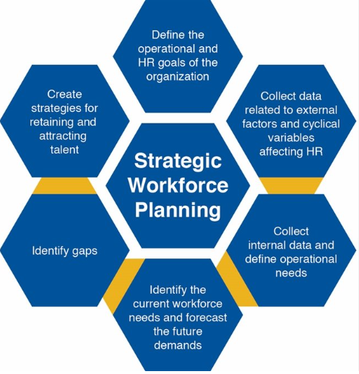
Fig 2: Strategic HR Planning
Source: (Damnjanović et al., 2016)
IHRM Specifics
The current state of international HRM includes intercontinental cooperation and remote workforce that is borderless and digital in nature. The digital environments can be used to source and manage global labour, which provides organisations with unparalleled flexibility and competencies. This worldwide presence complicates its ability to adhere to international labour regulations, as well as data protection regulations such as the EU General Data Protection Regulation (GDPR) which limits the ability to process employee data and transfer information across borders. Legal and ethical concerns of IHRM are as a result of national rules in gig work, taxation, and classification of employment (SHRM, 2024). Contemporary IHRM needs cultural, regulatory and technological knowhow. Global HR policy should not violate the local labour laws, ethics, privacy and involvement of employees. Compliance systems based on AI and cloud-based HR systems structure contracts, payroll, and performance across jurisdictions.

Question 2: Demographic & Geopolitical Factors

Key Demographic Factors
Ageing Populations
Ageing populations confront HR management in major economies. The EU's old-age dependence ratio was 33.9% on January 1, 2024. Labour support is just over three working-age adults per 65-year-old. Japanese working-age (15-64) population is 73.3 million in August 2025, indicating a declining talent pool (PwC, 2024). As youthful workers decline, HR professionals must retain older workers, exchange expertise, and rethink multi-generational team roles and perks.
Changing Migration Patterns
Global migration alters labour markets through brain drain and gain. India lost 1.7 million talented workers to OECD countries in 2024 as emerging economies moved to industrialised ones for greater opportunities. Progressive immigration policies have filled healthcare, technological, and engineering talent deficits in Canada, Australia, and Germany. Germany's Skilled Immigration Act (2023) increased foreign specialists by 12%, while Canada's Tech Talent Strategy (2024) hired thousands of AI and IT workers (Gupta and Gupta, 2025). Global HR and IHRM recruitment and retention strategies are essential owing to migration.
Increasing Workforce Diversity
Globalisation, migration, and changing societal norms have expanded labour diversity, altering organisational dynamics. Nearly 85% of worldwide organisations support diversity and inclusion, and employees are more diverse in ethnicity, gender, generation, and culture. Beyond compliance, HR professionals must promote equity, belonging, and mutual respect through inclusive policies.

Key Geopolitical Factors
Trade Wars & Protectionism
Trade disputes and protectionist policies have disrupted global supply chains, forcing companies to reassess staffing and operations. Multinational firms transfer recruiting and production to Vietnam, Mexico, and India when U.S.-China disputes and Europe's strategic autonomy goals tighten trade laws and tariffs. In workforce planning, HRM and IHRM must balance cost, geopolitical stability, and worker adaption across locations.
Political Instability & Sanctions
Political unrest and economic sanctions in Eastern Europe and the Middle East have increased expatriate and global operations risks. Foreign payroll, employee safety, and changing rules are company duties. HR professionals need specific contingency and risk mitigation plans including remote work, relocation limits, and crisis response frameworks to ensure worker safety and operational continuity in dangerous scenarios.
Pandemics & Global Health Crises
The COVID-19 pandemic accelerated the global shift to remote and hybrid models and exposed organisational resilience gaps. HR must digitise emergency health, safety, and well-being (Deloitte, 2024). Strategic HRM encompasses business continuity planning, mental health programs, and adaptive work rules to maintain productivity and employee trust in a world where health emergencies can transform global labour markets.

Challenges for HR Professionals
Talent Mobility: The problem with talent mobility lies in the fact that HR professionals find it hard to cope with regional visa and work permit regulations. The speed of deployment, as well as compliance, should be balanced because countries are restricting their immigration policies and competing to recruit talent worldwide. Hiring and retention (56%), followed by leadership development and employee engagement.
Risk Management: Crisis management and duty of care in HR teams should be reinforced because of uncertainty across the globe. To absorb wars, pandemics, and political strife, foreigners must have an active awareness, live connection, and cross-border counter-narcotics (Dowling, Festing & Engle, 2017).
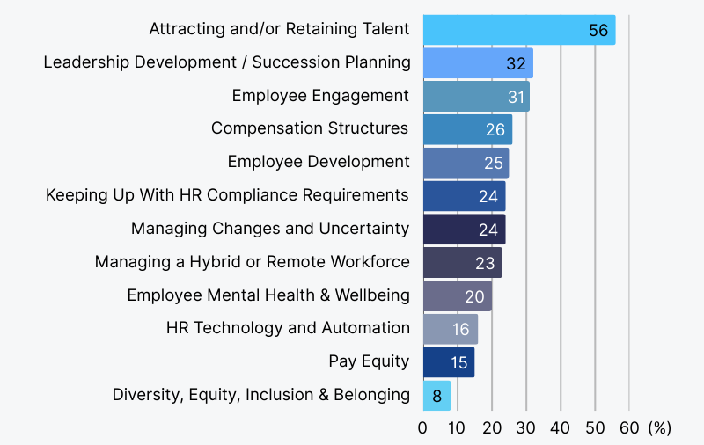
Fig 3: HR Challenges
Source: (Nguyen, 2025)
Compliance: There is also state to state differences in employment rules and it is not easy to comply. Local labour, tax, and data privacy laws require HR professionals to comply with them to prevent fines and reputation loss.
Cultural Integration: Multicultural intelligence and inclusion are needed in ethnic, geographically spread teams when leading such team members (Chung and Sparrow, 2024). The HR needs to tailor communication and teambuilding to cross-cultural understanding.

Question 3: Skills Gaps & Strategic HRM

Understanding the Causes
There is rapid development of technologies, fluctuating industrial needs, and mismatch between education institutions and worker’s needs, forming gaps in global labour market skills. 6 out of 10 workers do not have adaptation training and 44% of skills will be disrupted in five years. The new generation of organisations is failing to locate digital, analytic and flexible workforce because AI, automation and data analytics have substituted conventional education. This is aggravated by L&D underinvestment particularly in small and medium-sized businesses that lack funds. This imbalance in a structure is the result of a lack of alignment between the changing demands of employment and the unchanged structures of the skill-building infrastructures, which produce graduates who are academically competent yet practically ill-equipped.

Strategic HRM Approaches
"Build" Strategies: Developing internal talent matters more: 90% of organisations maintained or increased their L&D budgets last year, demonstrating that learning is now a business strategy. Constant learning strengthens corporate loyalty for 70% of workers (Cappelli, 2008). Apprenticeships, corporate academies, mandatory upskilling, and partnerships with universities or ed-tech companies build workforce loyalty and resilience to rapid change while teaching in-house skills.
"Buy" Strategies: A tight labour market requires external talent recruitment: employer branding can save hiring costs by 50% and double applicants. Talent analytics-supported strategic recruitment helps organisations find new talent sources, optimise hiring channels, and provide competitive packages for unusual capabilities when internal pipelines are dry.
"Borrow" Strategies: Consultants, freelancers, and outsourcing help companies fill skill gaps quickly and cheaply. In 2025, when many organisations face changing skill demands and labour supply concerns, “borrow” allows projects move forward while internal capabilities catch up (Zhivkova, 2025).
"Bind" Strategies: 51% of employees want new chances, while better management and engagement can reduce turnover by 42%. Engaging career paths, coaching, job rotation, and a learning culture keep employees. Individual and institutional knowledge are protected by non-churn.

Sector-Specific Examples
Tech: Technology requires “build” and “borrow” due to rapid innovation and shifting digital ecosystems. Google and IBM have heavily invested in internal coding bootcamps and digital skills academies. Tech organisations worldwide struggle to hire qualified programmers (85%). The gig economy is vital for AI and data capabilities, with Upwork and Toptal demand reaching 20% annually.
Healthcare: Healthcare corporations must use “buy” and “bind” techniques to address 10 million global staff shortages by 2030. The UK, Canada, and Germany are aggressively recruiting nurses and clinicians abroad and improving working conditions, flexible scheduling, and career paths to retain them. Staff well-being and career development reduced turnover by 30% in hospitals, indicating that retention is as important as recruiting in healthcare (Darwish et al., 2024).
Hospitality: To stabilise staff after the pandemic, the hospitality industry uses “build” and “buy” methods. Hotels and restaurants are training local managers and executives as global hospitality employment dips 12% below pre-2020 levels (ManpowerGroup, 2025). Strong firm branding and competitive pay attract workers in a tight market with high mobility and little job commitment.

Question 4: Reflective Report on Capabilities

Introduction
MBA pursuing student must be global and versatile to lead in fast-changing, networked companies. Executives must think globally, communicate across cultures, and adapt to new challenges to compete in complex global markets with digital innovation, cultural diversity, and geopolitical uncertainty. Cross-cultural awareness, digital fluency, and strategic agility help MBA professionals face uncertainty, innovate, and flourish in a transnational economy where adaptation is the new leadership standard.

Self-Assessment
Description
The MBA course also provided me with international and flexible skills that enhanced my work and learning flexibility. Class and projects involved the use of MS Teams and complicated tools of data analysis. My academic work has been improved with the aid of AI, such as ChatGPT, which is able to synthesise research and generate ideas (Gibbs, 1988). Openness, empathy, and flexibility in group interaction and intercultural interaction enhanced my communication and cooperation.
Feelings
I was concerned about my use of a variety of online resources and collaboration with other teams in a high-stress academic environment. Efforts turn out to be findings and being empowered with confidence. My team consisted of a variety of people, which provoked interest and pride and stimulated self-confidence in the form of arguments and remarks in groups.
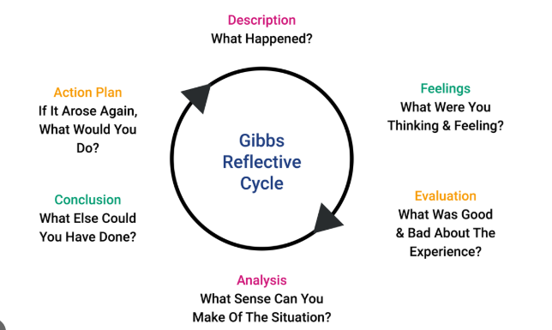
Fig 4: Gibbs Reflective Cycle
Source: (Dynamic Training, 2025)
Evaluation
Initiative, adaptability and communication were taught to me through experience. I powered through and made contributions (OECD, 2018). Comments on good group presentation made me communicate and engage the audience more. Strategic leadership and high-pressure advanced data analysis. My methods are diversity, analysis, focused practice and coaching.
Analysis
My abilities are in line with global leadership. My strengths include cross-functional team work and digital skills. According to Gibb, the Reflective Cycle, self-reflection and self-awareness enhance learning. The studies of AI have left me inquisitive and learning-oriented in solving the problem (UNESCO, 2023). Teamwork Multicultural collaboration meant that I needed power, empathy, inclusivity, and vision to be a leader, and these aspects enhanced my emotional intelligence.
Conclusion
This program enhanced my technological, interpersonal and leadership competencies and I am an international professional. I have now understood that flexibility, deliberate practice, communication and cooperation cause development and leadership. Being aware of my areas of weaknesses allows me to plan and weigh my opinions.
Action Plan
I will nurture my leadership and analysis abilities. The understanding of HR analytics and data-based decision-making will be beneficial to me. To develop my international outlook, peer evaluation, mentoring of junior staff, and cross-cultural engagements are the requirements of reflective leadership. The combination of professional organisations and AI technologies will ensure that I remain tech-savvy, thus becoming a versatile, innovative, and efficient global leader.

Development Plan
Leveraging Strengths: I will nurture my leadership and analysis abilities. The understanding of HR analytics and data-based decision-making will be beneficial to me. To develop my international outlook, peer evaluation, mentoring of junior staff, and cross-cultural engagements are the requirements of reflective leadership. The combination of professional organisations and AI technologies will ensure that I remain tech-savvy, thus becoming a versatile, innovative, and efficient global leader.
Addressing Weaknesses: I am weak in the areas of data-driven decision-making and scalability of cross-cultural teams. To enhance my leadership and technical skills, I would like to complete a Coursera certification Data Analytics for HR Leaders and Leading Global Teams by March 2026. To put my theory into practice and have mentor and peer feedback, I would like to volunteer in the next multicultural team project in my program or workplace. The systematic learning and experience will enhance my analytical, cultural, and strategic leadership.

Conclusion
My MBA changed my leadership, learning, and cooperation with the world, as reflected in this reflective analysis. I have been able to learn that in the contemporary leadership, one needs to be flexible, visionary, and trustful in most situations. By assessing my strengths and weaknesses, I was able to learn the significance of self-development and self-awareness in professional achievement. I can now understand that the global success does not need a balanced approach to data-focused and human-oriented leadership. I am forward-thinking and resilient to fit the shortage of analytical depth and strategic leadership with adaptation and collaboration. I would like to manage organisations with empathy, question, dexterity, creativity, and variety.

References
Brynjolfsson, E. and McAfee, A. (2014) The Second Machine Age: Work, Progress, and Prosperity in a Time of Brilliant Technologies. New York: W. W. Norton & Company. Available at: https://wwnorton.com/books/The_Second_Machine_Age/
Cappelli, P. H. (2008) Talent on Demand: Managing Talent in an Age of Uncertainty. Boston, MA: Harvard Business Press.
Chung, C. and Sparrow, P., (2024). Exploring the configuration of international HRM strategies for global integration and local responsiveness in MNEs. The InTernaTIonal Journal of human resource managemenT, 35(11), pp.1943-1969.
Darwish, T.K., Khassawneh, O., Melhem, M. and Singh, S., (2024). HR directors in India: Navigating institutional incoherence for HRM stability and change. Employee Relations: The International Journal, 46(4), pp.776-794.
Deloitte (2024) Global Human Capital Trends 2024. Available at: https://www.deloitte.com/us/en/insights/topics/talent/human-capital-trends/2024.html
Dowling, P. J., Festing, M. and Engle, A. D. (2017) International Human Resource Management. 7th edn. London: Cengage Learning.
Gibbs, G. (1988). Learning by Doing: A Guide to Teaching and Learning Methods. Oxford: Oxford Further Education Unit.
Gupta, N. and Gupta, A.K., (2025). International Human Resource Management. In Human Resource Management for Organisational Success: Volume II (pp. 315-344). Singapore: Springer Nature Singapore.
ManpowerGroup (2025) Talent Shortage Survey – Global 2025 Report. Available at: https://go.manpowergroup.com/talent-shortage
Organisation for Economic Co-operation and Development (OECD) (2018). Skills for the 21st Century: Findings and Policy Lessons from the OECD Survey of Adult Skills. OECD Education Working Paper No. 166. Paris: OECD.
PwC (2024) Global Workforce Hopes & Fears Survey 2024. Available at: https://www.pwc.com/gx/en/news-room/press-releases/2024/global-hopes-and-fears-survey.html
Society for Human Resource Management (SHRM). (2024) From Adoption to Empowerment: Shaping the AI-Driven Workforce of Tomorrow. Alexandria, VA: SHRM. Available at: https://www.shrm.org/content/dam/en/shrm/topics-tools/research/from-adoption-to-empowerment-shaping-the-ai-driven-workforce-of-tomorrow.pdf
United Nations Educational, Scientific and Cultural Organization (UNESCO) (2023). The futures we build: abilities and competencies for the future of education and work. Paris: UNESCO.
Wang, J., (2025). Impact of bilateral influence and host labor market conditions on the deployment of chinese contracted project workers in africa. The International Journal of Human Resource Management, 36(6), pp.994-1024.
World Economic Forum. (2025) The Future of Jobs Report 2025. Geneva: World Economic Forum. Available at: https://www3.weforum.org/docs/WEF_Future_of_Jobs_Report_2025.pdf
Zhivkova, S., (2025). FOR SOME TECHNOLOGY DRIVEN NOVELTIES IN THE INTERNATIONAL HUMAN RESOURCE MANAGEMENT. Strategies for Policy in Science & Education/Strategii na Obrazovatelnata i Nauchnata Politika, 33(3).
Image Reference
Damnjanović, A., Jovanović, Z. & Đurašković, J. (2016) ‘Management of the workforce and business planning’, 6th International Conference “Economics and Management Based on New Technologies” (EMoNT-2016), 16–19 June, Vrnjačka Banja, Serbia. Available at: https://www.researchgate.net/profile/Phd-Aleksandar-Damnjanovic/publication/309134471_MANAGEMENT-OF-THE_WORKFORCE-AND-BUSINESS-PLANNING/links/580095bf08ae494b8c1abbba/MANAGEMENT-OF-THE-WORKFORCE-AND-BUSINESS-PLANNING.pdf
Dynamic Training (2025) Understanding Gibbs’ Reflective Cycle. Available at: https://www.dynamictraining.org.uk/learner-pulse/study-skill-gibbs-reflective-cycle/
market.us (2025) Agentic AI in Labour Market: Size, Share, Forecast (2025-2034). Available at: https://market.us/report/agentic-ai-in-labor-market/
Nguyen, A. (2025) 100+ Critical HR Statistics and Trends for 2025. Select Software Reviews. Available at: https://www.selectsoftwarereviews.com/blog/hr-statistics

Appendix

SWOT Analysis
SWOT Analysis | Description
Strengths | Strong communication and teamwork skills; adaptability to new technologies; proactive leadership and initiative.
Weaknesses | Limited experience in advanced data analytics; occasional difficulty balancing multiple priorities under pressure.
Opportunities | Growing global demand for tech-savvy leaders; access to continuous learning platforms and AI-driven tools for skill enhancement.
Threats | Rapid technological disruption outpacing skill development; high competition in global job markets for leadership roles.

