
Programme: BA Developing Leadership and Management
Module: Developing a Research Proposal
Module code: BMSW5014
Module Lead: Jaliya De Silva
Student: Cristian Dinicuta
Student ID: 2323940
Assignment Title: Developing a Research Proposal – The Impact of Remote Working on Employee Well-being and Productivity in UK SMEs
Date: 26.06.2026

Table of Contents
1. Title and Introduction 4
1.1 Research Title 4
1.2 Introduction and Background 4
1.3 Research Aim 4
1.4 Research Objectives 4
1.5 Research Questions 5
1.6 Significance of the Study 5
2. Literature Review 5
2.1 Defining Remote Working 5
2.2 Theoretical Frameworks for Well-being 5
2.3 Remote Working and Productivity: Contested Evidence 6
2.4 Moderating Factors 7
2.5 Identified Research Gap 7
3. Research Methodology 8
3.1 Research Philosophy 8
3.2 Research Approach 8
3.3 Research Design: Sequential Explanatory Mixed Methods 9
3.4 Data Collection Methods 9
3.4.1 Phase 1 – Structured Questionnaire Survey 9
3.4.2 Phase 2 – Semi-Structured Interviews 10
3.5 Population and Sampling 10
3.6 Data Analysis 10
3.7 Ethical Considerations 10
3.8 Limitations and Mitigation 11
4. Project Plan and Timeline 11
Reference List 13
Appendix A – Ethical Considerations Summary 15
Appendix B – Project Milestones 15
Appendix C – Comparison of Methodological Approaches 16

1. Title and Introduction

1.1 Research Title
The Impact of Remote Working on Employee Well-being and Productivity in Small and Medium-sized Enterprises (SMEs): A Mixed Methods Investigation.

1.2 Introduction and Background
The way people work has changed sharply. The COVID-19 pandemic pushed organisations of every size into remote working almost overnight, and what began as an emergency response is now a lasting feature of working life. This is especially true for SMEs, which make up around 99% of UK businesses and employ over 16 million people (Department for Business and Trade, 2023). Understanding how remote working shapes well-being and productivity is therefore a pressing concern for managers and policymakers, not only an academic one.
Research on remote working grew rapidly during the pandemic, but much of it concentrates on large, well-resourced firms (Bloom et al., 2015; Chung et al., 2021). SMEs operate with tighter budgets, flatter structures and limited HR capacity, which may change how remote working, well-being and productivity relate. This proposal locates its inquiry in that under-researched SME setting.

1.3 Research Aim
To investigate the impact of remote working arrangements on employee well-being and perceived productivity within UK-based SMEs.

1.4 Research Objectives
- To critically review the theoretical and empirical literature on remote working, well-being and productivity.
- To examine how remote working affects employee well-being (physical, psychological and social) in UK SMEs.
- To explore employees’ perceptions of their productivity when remote compared with office-based work.
- To identify organisational and individual factors that moderate these relationships.
- To develop practical recommendations for SME managers seeking to optimise remote working policy.

1.5 Research Questions
The study is guided by three focused, answerable research questions:
- RQ1: To what extent does remote working affect the well-being of employees in UK SMEs?
- RQ2: How do employees in UK SMEs perceive their productivity when working remotely compared with in-office?
- RQ3: What organisational and individual factors moderate the impact of remote working on well-being and productivity?

1.6 Significance of the Study
The study addresses a clear gap: most evidence comes from large corporations or well-resourced knowledge workers, yet SMEs face particular resource and cultural constraints that may sharpen both the benefits and risks of remote work. Managers in these firms need accessible, evidence-based guidance rather than generic frameworks, giving the work both academic and professional value.

2. Literature Review
This review synthesises the key academic theories and recent empirical evidence on remote working, well-being and productivity, drawing on peer-reviewed journal articles and established research-methods textbooks.

2.1 Defining Remote Working
Remote working, also called teleworking or homeworking, covers any arrangement where employees work away from a traditional, employer-designated workplace, usually supported by digital communication technologies (Eurofound, 2020). The idea is not new; interest emerged in the 1970s when oil crises prompted attention to alternatives to commuting. What has changed is the scale, with post-pandemic adoption turning remote working from a fringe benefit into mainstream practice.

2.2 Theoretical Frameworks for Well-being
Well-being is multi-dimensional. The literature distinguishes hedonic well-being (positive feeling and the absence of negative affect) from eudaimonic well-being (engagement, purpose and growth) (Ryan and Deci, 2001). In organisational settings, the Job Demands-Resources (JD-R) model (Bakker and Demerouti, 2007) is a dominant lens. It proposes that job demands such as workload and role conflict deplete psychological resources and can lead to burnout, while job resources such as autonomy, social support and feedback buffer those demands and build engagement (Figure 1). Remote working reshapes both at once: it usually increases autonomy and removes the commute, but can also blur the work-home boundary and reduce informal support.
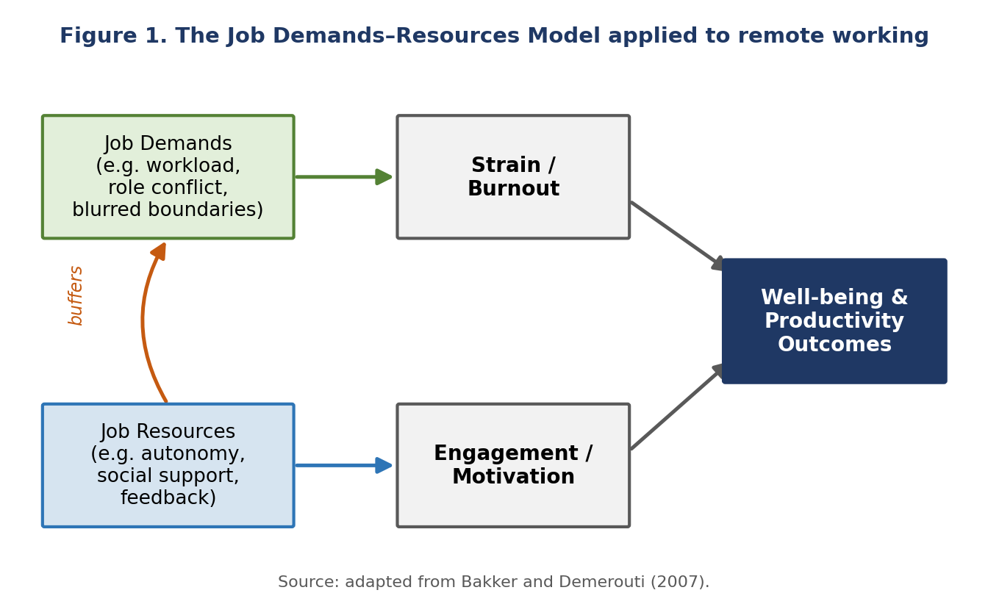
Figure 1. The Job Demands-Resources model applied to remote working (adapted from Bakker and Demerouti, 2007).
Warr’s (1987) Vitamin Model offers a complementary view, arguing that job features such as control, environmental clarity and valued social position have dose-response relationships with well-being. Remote working may strengthen some of these while eroding others, a tension that makes the relationship worth studying.

2.3 Remote Working and Productivity: Contested Evidence
The productivity evidence is mixed. A widely cited Stanford study by Bloom et al. (2015) reported a 13% productivity gain among home-based call-centre staff, but it measured objective output for a highly routine role, which limits how far it transfers to creative or interdependent work. Pandemic-era research is more nuanced: a Microsoft study found that many employees reported higher productivity while their managers were markedly less confident in team output (Teevan et al., 2022). These contradictory findings suggest that productivity outcomes depend less on remote working in itself than on contextual factors such as organisational size, managerial oversight and job characteristics. This gap between self-reported and observed productivity is itself a methodological challenge the present study acknowledges directly. Within the SME literature, smaller firms may be especially exposed to the risks of remote work because they rely on tacit knowledge shared through informal, co-located contact, which remote arrangements tend to disrupt (Begemann et al., 2024); their comparative agility, however, may also help them adapt (Saunders et al., 2023). Taken together, the evidence resists a single verdict: remote working helps some outcomes, for some workers, in some settings. That conditionality is why a context-specific study is needed.

2.4 Moderating Factors
The effect of remote working is not uniform. Reported moderators include job type and task interdependence, managerial style (with trust-based, results-oriented cultures linked to better outcomes), home environment quality, and individual traits such as self-efficacy and extraversion (Luse et al., 2013; Bryman and Bell, 2023). Peer-reviewed UK evidence further shows that its effects on effort and work–life balance depend on how much of the week is home-based (Felstead and Henseke, 2017). The quality of digital leadership matters too: leaders who communicate well virtually and visibly recognise remote staff appear to soften the well-being risks of isolation. These factors rarely act alone; an employee with a quiet home office but a low-trust manager may fare differently from one facing the reverse, so this study examines several moderators together rather than singly.

2.5 Identified Research Gap
Three gaps stand out. First, most studies are based in large organisations or homogeneous samples of knowledge workers, which limits their relevance to SMEs (Bloom et al., 2015; Chung et al., 2021). Second, many quantitative studies rely on self-reported productivity with limited methodological triangulation (Teevan et al., 2022). Third, longitudinal research is scarce, with most studies capturing a single point in time (Felstead and Henseke, 2017). Despite extensive research on remote working, little evidence addresses its combined effect on both well-being and productivity specifically within UK SMEs. This proposal targets the first two gaps by focusing on SMEs and triangulating the survey with in-depth interviews, not a single self-report measure, answering Creswell and Creswell’s (2023) call for contextually embedded research. Figure 2 summarises the resulting conceptual framework.
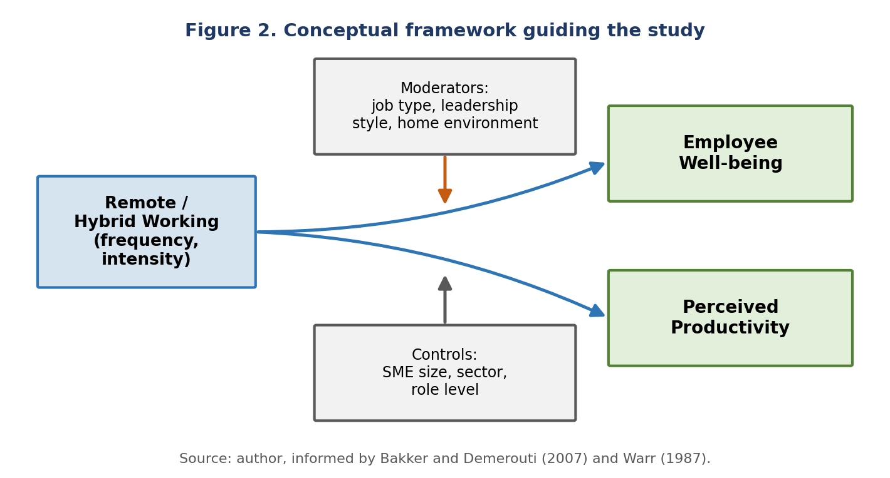
Figure 2. Conceptual framework linking remote working to well-being and productivity via moderators and controls.

3. Research Methodology

3.1 Research Philosophy
The study takes a pragmatist position. Pragmatism judges knowledge claims by their usefulness in answering the research problem and frees the researcher from loyalty to a single paradigm (Tashakkori et al., 2020). It contrasts with positivism, which assumes one objective reality measurable through standard instruments, and interpretivism, which stresses subjective, context-bound meaning. These paradigmatic differences rest on contrasting ontological and epistemological assumptions about the nature of reality and how it can be known (Scotland, 2012). Because this study seeks both to measure remote working’s impact and to understand the experiences behind it, pragmatism is the most coherent fit. As Saunders et al. (2023, p. 147) put it, pragmatism allows the use of different methods, both quantitative and qualitative, as tools that serve the research purpose.

3.2 Research Approach
The study follows an abductive logic, combining deductive and inductive elements as is typical of pragmatist mixed methods. The survey operationalises established constructs, such as the Warwick-Edinburgh Mental Well-being Scale, to test theory-driven relationships, while the interviews build understanding inductively from participants’ own accounts. As Gray (2021) notes, the line between induction and deduction is rarely clean in mixed methods work, and this combination suits the aim of generating grounded insight into an under-explored context.

3.3 Research Design: Sequential Explanatory Mixed Methods
The design is sequential explanatory mixed methods (Creswell and Creswell, 2023), shown in Figure 3. Phase one (quantitative) is an online survey of SME employees. Phase two (qualitative) uses the survey findings to shape semi-structured interview questions, adding depth to the statistical patterns. This logic suits studies where the quantitative phase raises questions needing qualitative elaboration (Braun and Clarke, 2022).
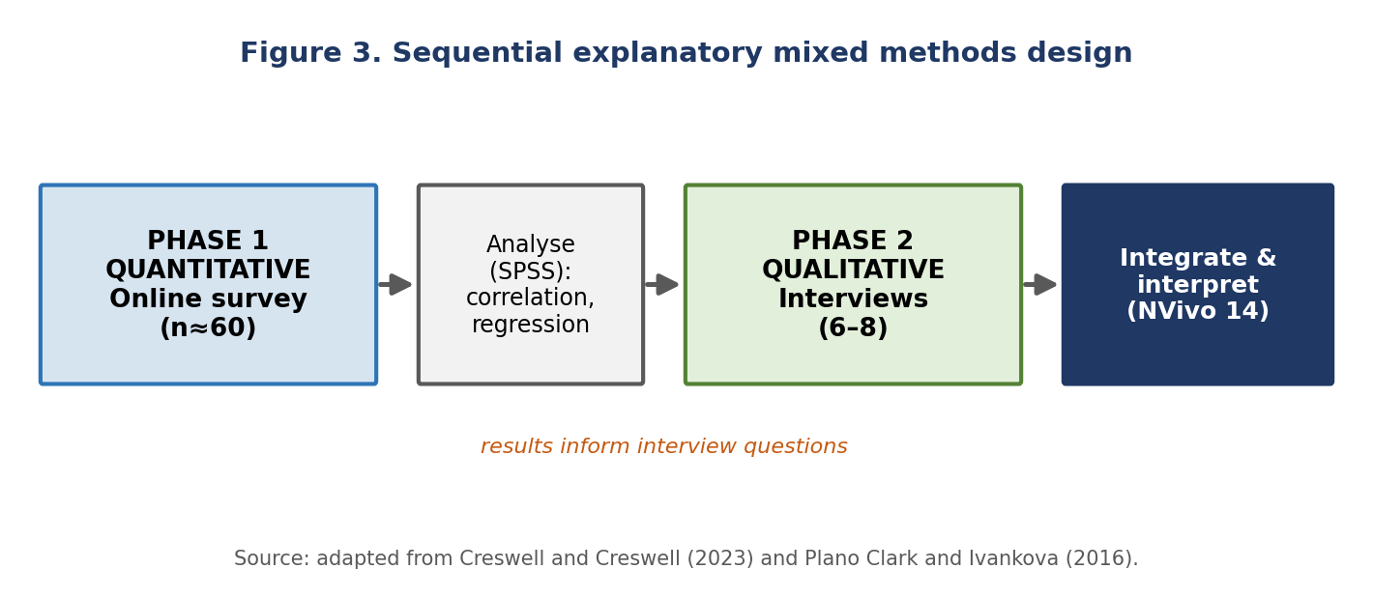
Figure 3. Sequential explanatory mixed methods design (adapted from Creswell and Creswell, 2023).

3.4 Data Collection Methods

3.4.1 Phase 1 – Structured Questionnaire Survey
An online questionnaire (LimeSurvey) will be distributed via professional networks (LinkedIn) and direct email to SME managers who cascade it to staff. It combines three validated instruments: the Warwick-Edinburgh Mental Well-being Scale (WEMWBS) (Stewart-Brown et al., 2009); a Remote Work Productivity Index adapted from Bloom et al. (2015); and a Remote Work Quality Scale adapted from Eurofound (2020), all using 5-point Likert items. Demographic items (sector, role level, SME size, remote frequency) are also captured. The target is 60 valid responses over six weeks, meeting Pallant’s (2020) minimum of 50 cases for exploratory regression. To keep the sample adequate, the regression will include no more than four predictors, consistent with the rule of roughly 10 to 15 cases per predictor (Field, 2024). Relying on validated, widely used instruments also supports reliability and validity, since these scales are tested for internal consistency and construct validity.

3.4.2 Phase 2 – Semi-Structured Interviews
Six to eight interviews will be held via Microsoft Teams with purposively selected phase-one participants, varying by sector, role and well-being score. Semi-structured interviews allow flexible yet focused exploration of participant accounts, balancing structure with the freedom to follow up unexpected issues (Flick, 2023; Silverman, 2024). Interviews will be audio-recorded with consent, transcribed verbatim and analysed thematically.

3.5 Population and Sampling
The target population is employees who currently work, or recently worked, remotely or in hybrid mode in a UK SME (fewer than 250 employees). Phase one uses convenience sampling through LinkedIn and SME networks, supported by snowball sampling; phase two uses purposive sampling to ensure diversity. These choices suit exploratory, cross-sectional research at this scale (Robson and McCartan, 2024). These non-probability methods limit statistical generalisability but are realistic for a small-scale undergraduate study working to a fixed timeline without a national sampling frame.

3.6 Data Analysis
Quantitative data will be analysed in IBM SPSS. Descriptive statistics will profile the sample, and Pearson correlation and multiple linear regression will test relationships between remote working frequency, well-being and productivity while controlling for demographics. Qualitative data will be analysed using Braun and Clarke’s (2022) six-phase reflexive thematic analysis (familiarisation; coding; constructing themes; reviewing; defining; writing up), organised in NVivo 14. Reflexive thematic analysis was chosen over alternatives such as grounded theory or phenomenology because the aim is to interpret patterned meaning rather than build a formal theory. The two strands are integrated at the interpretation stage, where themes contextualise the statistical associations.

3.7 Ethical Considerations
Ethical approval will be sought from the UWTSD ethics committee before any data is collected. As Denzin and Lincoln (2023) argue, sound ethical process is integral to research quality, not a formality. Participation is voluntary, no employer will see individual responses, and only aggregate data will be shared with organisations. A full summary appears in Appendix A.

3.8 Limitations and Mitigation
- Sample size: 60 responses limits statistical power; triangulation with interview data compensates.
- Self-report bias: respondents may over- or under-report; validated scales and guaranteed anonymity reduce this (Robson and McCartan, 2024).
- Common method bias: gathering predictor and outcome measures from the same self-report survey can inflate the relationships observed; varying item wording and response formats, and triangulating with interview data, help to limit it (Saunders et al., 2023).
- Social desirability bias: participants may answer in line with what they think is expected; anonymous, self-administered online completion reduces this pressure (Robson and McCartan, 2024).
- Convenience sampling: findings are indicative, not statistically generalisable; transferability is the appropriate standard (Lincoln and Guba, 1985, cited in Bryman and Bell, 2023).
- Cross-sectional design: a single time point cannot establish causality, so the study is framed as exploratory.

4. Project Plan and Timeline
The study runs over roughly ten weeks from April to July 2026, aligned with the module schedule. The milestone-based plan reserves reading week for consolidating the literature and front-loads ethical approval and the literature review, so that data collection, the most time-sensitive stage, keeps a realistic six-week window. Figure 4 presents the Gantt chart, and the key milestones and target dates are summarised in Appendix B.
Key dates anchor the plan. Ethical approval will be secured by the end of Week 2, the literature review completed by Week 4, and the questionnaire finalised by Week 5. Data collection then runs across Weeks 6 to 8 and targets 60 responses, with interviews held in Weeks 7 and 8. Analysis and writing fall in Weeks 8 and 9, ahead of the written proposal deadline on 26 June 2026, and the presentation follows in the week beginning 6 July 2026. Building slack around recruitment guards against slow responses, a common risk at this scale.
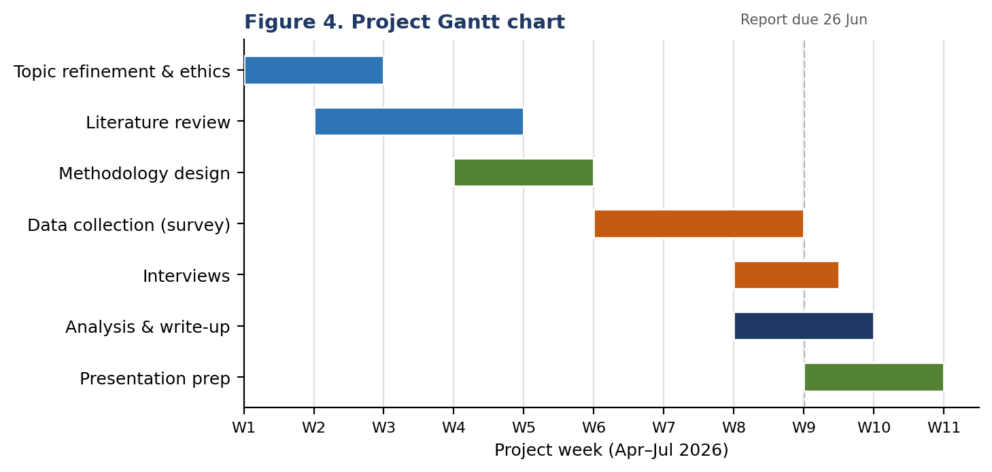
Figure 4. Project Gantt chart, April to July 2026.

Reference List
Bakker, A.B. and Demerouti, E. (2007) ‘The job demands-resources model: state of the art’, Journal of Managerial Psychology, 22(3), pp. 309–328.
Begemann, V., Handke, L. and Lehmann-Willenbrock, N. (2024) ‘Enabling and constraining factors of remote informal communication: a socio-technical systems perspective’, Journal of Computer-Mediated Communication, 29(5), zmae008.
Bloom, N., Liang, J., Roberts, J. and Ying, Z.J. (2015) ‘Does working from home work? Evidence from a Chinese experiment’, Quarterly Journal of Economics, 130(1), pp. 165–218.
Braun, V. and Clarke, V. (2022) Thematic Analysis: A Practical Guide. London: SAGE.
Bryman, A. and Bell, E. (2023) Business Research Methods. 5th edn. Oxford: Oxford University Press.
Chung, H., Birkett, H., Forbes, S. and Seo, H. (2021) ‘COVID-19, flexible working, and implications for gender equality in the United Kingdom’, Gender & Society, 35(2), pp. 218–232.
Creswell, J.W. and Creswell, J.D. (2023) Research Design: Qualitative, Quantitative and Mixed Methods Approaches. 6th edn. London: SAGE.
Denzin, N.K. and Lincoln, Y.S. (eds.) (2023) The SAGE Handbook of Qualitative Research. 6th edn. Thousand Oaks: SAGE.
Department for Business and Trade (2023) Business Population Estimates for the UK and Regions 2023. London: Department for Business and Trade.
Eurofound (2020) Telework and ICT-based Mobile Work: Flexible Working in the Digital Age. Luxembourg: Publications Office of the European Union.
Felstead, A. and Henseke, G. (2017) ‘Assessing the growth of remote working and its consequences for effort, well-being and work–life balance’, New Technology, Work and Employment, 32(3), pp. 195–212.
Field, A. (2024) Discovering Statistics Using IBM SPSS Statistics. 6th edn. London: SAGE.
Flick, U. (2023) An Introduction to Qualitative Research. 7th edn. London: SAGE.
Gray, D.E. (2021) Doing Research in the Real World. 5th edn. London: SAGE.
Luse, A., McElroy, J.C., Townsend, A.M. and DeMarie, S. (2013) ‘Personality and cognitive style as predictors of preference for working in virtual teams’, Computers in Human Behavior, 29(4), pp. 1825–1832.
Pallant, J. (2020) SPSS Survival Manual: A Step-by-Step Guide to Data Analysis Using IBM SPSS. 7th edn. Maidenhead: McGraw-Hill.
Robson, C. and McCartan, K. (2024) Real World Research. 5th edn. Chichester: Wiley.
Ryan, R.M. and Deci, E.L. (2001) ‘On happiness and human potentials: a review of research on hedonic and eudaimonic well-being’, Annual Review of Psychology, 52, pp. 141–166.
Saunders, M.N.K., Lewis, P. and Thornhill, A. (2023) Research Methods for Business Students. 9th edn. Harlow: Pearson.
Scotland, J. (2012) ‘Exploring the philosophical underpinnings of research’, English Language Teaching, 5(9), pp. 9–16.
Silverman, D. (2024) Doing Qualitative Research: A Practical Handbook. 6th edn. London: SAGE.
Stewart-Brown, S., Tennant, A., Tennant, R., Platt, S., Parkinson, J. and Weich, S. (2009) ‘Internal construct validity of the Warwick-Edinburgh Mental Well-being Scale (WEMWBS)’, Health and Quality of Life Outcomes, 7(15), pp. 1–8.
Tashakkori, A., Johnson, R.B. and Teddlie, C. (2020) Foundations of Mixed Methods Research. 2nd edn. London: SAGE.
Teevan, J., Baym, N., Butler, J., Hecht, B., Jaffe, S., Nowak, K., Sellen, A. and Yang, L. (2022) Microsoft New Future of Work Report 2022. Microsoft Research. Available at: https://www.microsoft.com/en-us/research/publication/microsoft-new-future-of-work-report-2022/ (Accessed: 1 March 2026).
Warr, P. (1987) Work, Unemployment, and Mental Health. Oxford: Clarendon Press.

Appendix A – Ethical Considerations Summary
The table below summarises the ethical principles governing the study, consistent with UWTSD guidelines and the framework discussed by Denzin and Lincoln (2023).
Ethical Principle | Action Taken
Informed consent | Written information sheet provided; signed consent form completed before participation.
Confidentiality & anonymity | All data anonymised; no identifying information reported or shared with employers.
Data protection (GDPR) | Data held on password-protected, encrypted systems; deleted within 12 months of submission.
Voluntary participation | Participants may withdraw at any time without consequence or explanation.
Harm avoidance | Non-sensitive questions only; no personal financial or medical data requested.
AI transparency | Any use of generative AI declared per the university academic integrity policy.
Ethics approval | Institutional ethics form approved before any data collection.

Appendix B – Project Milestones
Phase / Milestone | Timeframe | Key Activities
Topic & ethics | Weeks 1–2 | Finalise question; complete ethics form; initial reading.
Literature review | Weeks 2–4 | Systematic search; critical evaluation; identify gap.
Methodology design | Weeks 4–5 | Confirm philosophy; design questionnaire.
Data collection | Weeks 6–8 | Distribute survey; follow-up; reach 60 responses.
Analysis & write-up | Weeks 8–9 | Statistical and thematic analysis; draft proposal.
Submission | 26 June 2026 | Submit 2,000-word proposal via Turnitin.
Presentation | w/c 6 July 2026 | Deliver 7–10 minute presentation to cohort.

Appendix C – Comparison of Methodological Approaches
Criterion | Qualitative | Quantitative | Mixed Methods
Paradigm | Interpretivism | Positivism | Pragmatism
Data type | Words / themes | Numbers / statistics | Both
Sampling | Small, purposive | Large, random | Variable
Best suited to | Meaning, experience | Testing relationships | Complex phenomena
This study | Phase 2 (interviews) | Phase 1 (survey) | Selected approach

