Research Proposal
A Hybrid Deep Learning Framework for Real-Time Cyber-Threat Detection in Cloud Computing Environments

Student Name:
Student ID:
Programme: MSc Computing
Module Title: Research Methods and Professional Development
Module Code: ACFA7004

Table of Contents
1.1 Context and Background 2
1.2 Research Problem 5
1.3 Research Aim and Objectives 6
1.4 Importance of the Study 7
2. Literature Review 8
2.1 Introduction to the Literature Review 8
2.2 Thematic Review of Existing Research 9
2.3 Major Contributions and Gaps 12
2.4 Theoretical and Technical Frameworks 13
2.5 Positioning of Proposed Research 13
2.6 Summary of Literature Review 13
3. Research Design and Methodology 14
3.1 Research Design 14
3.2 Research Methods 15
3.3 Research Materials 17
4. Expected Outcomes 18
5. Project Timeline 19

1. Introduction

1.1 Context and Background
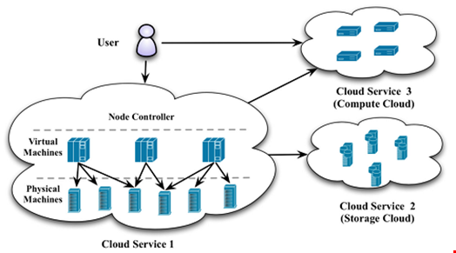
Figure 1: NIST cloud computing reference architecture illustrating core characteristics such as multi-tenancy, rapid elasticity, and distributed service delivery.
Source: Mell and Grance (2011).
Cloud computing has become the predominant infrastructure paradigm underlying modern digital services, fundamentally changing the provisioning, scaling, and securing of computing resources. The NIST definition defines five core characteristics: on-demand self-service, broad network access, rapid elasticity, resource pooling (multi-tenancy), and measured service, all of which enable scalability and cost efficiency (Mell and Grance, 2011). While these very architectural traits contribute to systemic security risks, as illustrated in Figure 1, multi-tenancy aggregates risks across shared physical infrastructure, elasticity accelerates changes in configurations, and distributed workloads create complexity in establishing consistent security controls across various environments. Therefore, nowadays, cloud security failures have arisen mostly due to the architectural complexity and not standing technical vulnerabilities.
The global nature of cloud acceptance has significantly enlarged this exposure. According to Gartner (2024), global public cloud end-user spending is anticipated to reach USD 723.4 billion by 2025, which can be interpreted as a major shift from the experimental adoption of cloud to serious migration of mission-critical workloads. With the rapid growth of attacks in the cloud, organizations are increasingly relying on software-defined infrastructure and programmable interfaces to manage their operations at scale. Different from conventional enterprise networks, cloud environments do not come with physical boundaries and any security considerations are now based on identity, configuration, and continuous monitoring mechanisms (Cloud Security Alliance, 2024).

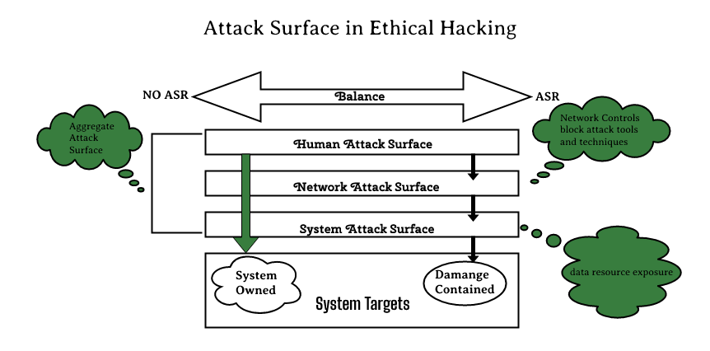

Figure 2: Expansion of the cloud attack surface across APIs, identity and access management, virtual machines, and orchestration layers.
Source: Cloud Security Alliance (2024).
Disparities in performance occur in various areas, such as companies today still focusing on making a cost-effective and complain-free intrusion detection and prevention system, which produces too many false alarms. Different security entry points related to the threat to newer cloud infrastructure have been covered. All such entry points shared risk have been depicted in Figure 2. The APIs, identity services, control planes, and other channels easily accessible by the attackers create an atmosphere for cost-effective attacks to run over a network scaled on the basis of manual controls to defeat existing defenses. Contemporary breaches in the cloud space increasingly depend on the compromised credential, insecure APIs, lateral moves between the virtual instances, and zero-day vulnerabilities- reports ENISA (2024) that are increasingly malfunctioning according to explicit signs of malware attack patterns. Such activities are more difficult to detect as these simulates real cloud activity, typically involving trusted identities rather than abnormal network traffic.
The economic vastness of these threats is real. IBM and Ponemon Institute (2024) say that breaches in public clouds tend to be most costly on average with losses exceeding USD 5m per incident. Backing this evidence is the fact that it further illustrates that cloud intrusion detection is not merely a technical challenge but also a strategic and financial imperative for organisations operating in these highly digitalised environments.
Typical intrusion detection systems are signature and rule-based, which are mismatched to phenomenon due to cloud computing. Their assumptions are relatively fixed traffic patterns and identifiable attack behavior, which are often not relevant in elastic multi-tenant infrastructures. Autoscaling workload, microservices communication, and a temporary resource pattern make the traffic profile highly dynamic, producing high false positives and alert fatigue (Alqahtani, Ahmad and Hussain, 2022). Most significantly, traditional IDS fail to identify completely novel and evolving attack forms, including zero-day exploits or multi-stage intrusions that are time-dependent.
In the light of these limitations, DL techniques come in as a possible alternative. DL has shown significant promise for intrusion detection in the cloud, especially with Convolutional Neural Networks (CNN). The excellent capability of CNN in the extraction of spatial features in high-dimensional network traffic has tremendously improved detection of complex attack patterns (Kang, Park and Kim, 2023). Long short-term memory (LSTM) also extends this capability and models temporal dependencies, enabling identification of sequential attacks and low-and-slow attacks that are frequently found in clouds (Singh and Ahmed 2022). Further, it helps by allowing encoding of the learned representations of normal traffic behaviors, deviation from which may identify entirely new threats (Zhang et al., 2024).
continued development, but currently most of the training of the various DL-based IDS models is done with offline experimental conditions that emphasize classification accuracy while under-addressing essential operational constraints such as inference latency, scalability, and robustness to concept drift (Rahman, Biswas and Khan, 2024). Very small detection delays, measured in milliseconds, can allow for rapid lateral movement and privilege escalation in real cloud environments. There exists, therefore, an unaddressed research gap in this disconnect between academic performance and deployment feasibility such as real-time, integrated deep-learning intrusion detection frameworks balancing the three accuracy, speed, and adaptation through fusion.

1.2 Research Problem
Deep learning has increased intrusion detection system deployment, and higher detection accuracies have mainly been achieved under experimental and offline environments. Several studies report classification accuracies over 95% when evaluating CNN-, LSTM-, or hybrid models using benchmark datasets, such as CICIDS2017 or UNSW-NB15 (Kang, Park and Kim, 2023; Rahman, Biswas and Khan, 2024). Nonetheless, an impressive amount of accomplishments does not match performance in the offline environment with operational reality-the major conventional research area of this study.
The cloud tends to produce very high-velocity and high-volume networks due to factors like autoscaling, microservices communication, and workloads of many tenants. Such traffic is usually difficult for many offline-trained DL-IDS models to process within the low-latency requirements for online threat detection, thus resulting in alerts being delayed and leading attackers either to take advantage of the opportunities provided by this delay to escalate privileges or move laterally across services (Xu, Li and Wang, 2023). In addition, most current models are highly specialized and do not generalize well to unseen attacks because they rely on static datasets that do not capture evolving cloud threat patterns. As a result, their performance degrades when deployed in live environments (Yadav and Misra, 2023).
Another major issue involved with DL includes very high false-positive rates. Indeed, deep learning models eliminate much manual rule engineering, yet they still mistakenly label benign, if unusual, cloud traffic as malicious (Alqahtani, Ahmad and Hussain, 2022)-especially in elastic settings where extremely rapid change occurs in the definition of "normal" behavior. Too many false positives unvalue IDS by drowning security teams under alerts and eroding trust in automated alerts. Moreover, scalability remains a challenge. Most DL-IDS solutions are computationally expensive and will, therefore, not be an option when deploying across large-scale, multi-tenant cloud infrastructures where resources are meant to be shared efficiently and inference cost-effective (Rahman, Biswas and Khan, 2024).
Altogether, the literature has shown that while DL-IDS models have indeed performed quite well in controlled evaluations, they fail to satisfy the combined requirements of accuracy, low latencies, robustness, and scalability required for real-time cloud environments..
Research Problem Statement:
There is currently no validated deep learning–based intrusion detection framework that simultaneously achieves high detection accuracy, low-latency inference, strong generalisation to unseen attacks, and scalable deployment in real-time, multi-tenant cloud computing environments.

1.3 Research Aim and Objectives
This research aims at bridging the gap between offline performance of DL-IDS and the required real-time operation in the cloud through a detection framework that would empirically validate itself by being accurate and operationally feasible. The envisaged study takes a solutions-oriented viewpoint for intrusion detection because it's not just a classification task but also a time-critical, resource-constrained security function present in cloud environments.
Research Aim
The primary goal of this research is to develop and evaluate a hybrid intrusion detection framework based on deep learning techniques combining convolutional neural networks, long short-term memory networks, and autoencoders to provide accurate cyber threat detection with low latency within real-time environments in the cloud computing space.
This goal is directly tied to the limitations identified in Section 1.2 because this goal targets complementary strengths of multiple deep learning architectures. CNNs are leveraged for spatial feature extraction, LSTMs for modeling temporal attack patterns, and Autoencoders for detecting anomalous behavior approaches to address the limitations of single-model methods.
To achieve this aim, the study will be mainly guided by the following SMART objectives which are research objectives.
- To start with, existing deep learning-based intrusion detection models for cloud environments will be critically reviewed with regard to their architectural choices, evaluation strategies, and reported limitations.
- Second, a hybrid CNN–LSTM–Autoencoder framework will be conceived that captures spatial, temporal, and anomaly-based characteristics of cloud traffic.
- Third, the proposed model will be trained and validated using up-to-date benchmark datasets, including CICIDS2017 and UNSW-NB15, to guarantee relevance and comparability with existing studies.
- Fourth, performance evaluation of the model will be done using established metrics_accuracy, precision, recall, F1-score, ROC-AUC, and detection latency_to ascertain both classification effectiveness and real-time feasibility.
- Last, the hybrid framework will systematically be compared with baseline machine learning and deep learning models, including single class classifiers CNN, LSTM, and traditional classifiers, to demonstrate relative performance gain.
These objectives hence ensure clear and logical progression from problem identification to methodological execution and provide a strong base to address the challenges of real time intrusion detection in cloud environments.

1.4 Importance of the Study
This research is important in addressing the gap between high-performance deep learning intrusion detection systems and the reduced effectiveness they exhibit in real time in cloud computing environments. The contribution, by way of academic justification, is that this research extends existing understanding into hybrid deep learning architectures beyond initial offline evaluation by going into latency-aware, real-time cloud contexts involving CNNs, LSTMs, and autoencoders. By taking detection speed, scalability, and generalisation into the evaluation framework, this research provides more operational grounding for assessments of deep learning–based intrusion detection, an area that remains underdeveloped in current literature (Rahman, Biswas and Khan, 2024).
On the technical front, the architecture that is put forward would be as much geared to enhancing detection accuracy as it would be to bettering inference latency. Such dual principles work to address specific weaknesses that pervade earlier DL-IDS formulations, which generally focus on classification performance while they wholly disregard deployment constraints (Xu, Li, and Wang, 2023). Improvements are especially relevant for elastic, high-throughput infrastructures in the cloud, as the latency in detection will allow prompt escalation of this attack.
On the practical side, the research would directly benefit cloud service providers and Security Operations Centre (SOC) teams through prompter threat detections, decreased false positives, and raised actionability of alerts. More broadly, stronger intrusion detection for cloud environments helps protect critical services hosted in the cloud—healthcare, finance, and government systems—and contributes to the building of digital trust and resilience in societies that increasingly depend on cloud services (ENISA, 2024).

2. Literature Review

2.1 Introduction to the Literature Review
The purpose of this literature review is to thoroughly assess the existing literature about intrusion detection systems (IDSs) in cloud-based environments in the context of the specific application of deep-learning (DL) techniques. This literature review identifies the research themes that dominate the field. It assesses methodological strengths and weaknesses, as well as gaps that provide justification for the present study proposed. The scope of the review includes all literature published between 2018 and 2025. This period corresponds to a profuse maturing of cloud computing along with a parallel adoption of AI in cyberspace research into security.
The review presents various dimensions of IDS relevant to cloud environment. They range from the traditional signature-based systems to machine learning-based systems, all the way to the deep learning based advanced architectures such as CNNs, LSTMs, autoencoders, and hybrid model methods. It not much only indicates how these methods perform against the cloud specific constraints like high traffic velocity, elasticity, and multi-tenancy, but also demonstrates the importance in synthesizing findings thematically rather than chronology-by-chronological summaries from each study, thus establishing a coherent basis for identification of open challenges in real-time cloud intrusion detection.

2.2 Thematic Review of Existing Research
Traditional IDS Pitfalls versus Intelligent IDS
Early studies on intrusion detection were in general about signature-based and rule-based IDS i.e., Snort and Suricata, which use predefined attack patterns. Static but effective on enterprise networks, such systems will not work at all well on clouds since they would fail to detect novel threats and adapt to a dynamic pattern of traffic (Behl & Behl, 2020). Studies had noted that when traditional IDS were applied in elastic cloud infrastructures, there was always a high rate of false positives, primarily because perfectly legitimate autoscaling actions were suspected of being anomalous activities (Alqahtani, Ahmad and Hussain, 2022). The limitation has led the researchers to the use of intelligent IDS built mainly by using machine learning and deep learning techniques.
CNN-Based IDS Models
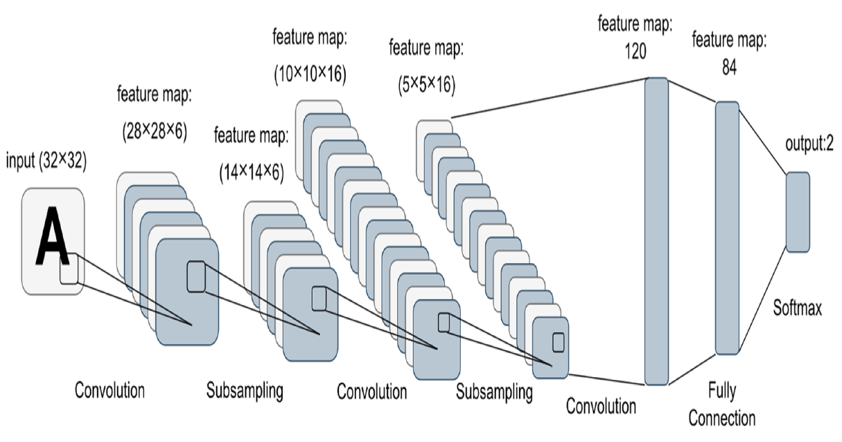
Figure 3: CNN-based intrusion detection architecture illustrating automated spatial feature extraction from network traffic data.
Source: Kang, Park and Kim (2023).
The application of all the several families of neural networks in intrusion detection is predicated on the information that The CNNs can easily extract spatial features from high-dimensional network traffic data. It is widely accepted that the CNN-based IDSs perform much better on detecting known attack patterns than other traditional machine learning classifiers, particularly in benchmark datasets such as CICIDS2017 (Kang, Park and Kim, 2023). However, CNNs take fixed-size input representations, lacking any inherent mechanisms to model temporal dependencies. This consequently leads to poor performance against slow-moving or multi-stage attacks that evolve over time- a very pertinent drawback specifically in the cloud- where attackers capitalize on persistence and lateral movement (Xu, Li and Wang, 2023).
LSTM-Based Sequential Detection
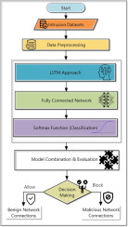

Figure 4: LSTM-based IDS capturing temporal dependencies in sequential network traffic data.
Source: Singh and Ahmed (2022).
Long short-term memory (LSTM) networks have succeeded where CNs are unable by modeling the sequential dependencies of time series data. The LSTM-based intrusion detection system has proven to be efficient at detecting advanced persistent threats and multi-stage intrusions (Singh and Ahmed, 2022). However, these advantages come at a premium cost, which does not make them suitable for real-time applications in very high-throughput cloud environments. Studies have revealed that inference latency increases dramatically with the increase in sequence length, limiting scalability and responsiveness (Yadav and Misra, 2023).
Autoencoder-based anomaly detection
An autoencoder detects anomalies in most cases without supervision as it learns representations of normal traffic and flags deviations as potential intrusions. Most appealing is the fact that this method is applicable to zero-day attacks, which cannot use labelled training data (Zhang et al., 2024). In contrast, autoencoder-based intrusion detection systems usually tend to perform poorly in terms of classification accuracy. Anomalies, after all, do not always mean that the observation pertains to a 'bad' thing. Such deficiencies increase the rate of false positives and decrease reliability in cloud, always changing the workload environment (Al-Ghuwairi et al., 2023).
Hybrid Deep Learning Architectures

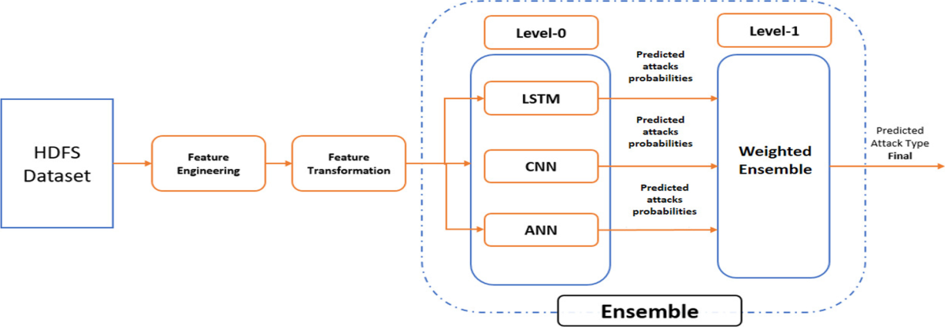

Figure 5: Hybrid CNN–LSTM intrusion detection framework combining spatial and temporal feature learning.
Source: Rahman, Biswas and Khan (2024).
Hybrid deep learning frameworks based on a combination of CNNs, LSTMs, and autoencoders have been proposed in recent studies to overcome the shortcomings of single model architecture. Such hybrid CNN-LSTM models perform better than single architectures with respect to detection accuracy, achieving more than 97% detection accuracy rates on benchmark databases (Rahman, Biswas and Khan, 2024). However, most hybrid studies only focus on offline evaluations and neglect criteria such as inference latency, resource consumption, or feasibility for deployment in real cloud environments.

2.3 Major Contributions and Gaps
The literature is filled with significant advancements in detection accuracy, automated feature extractions, and anomaly detection. However, there are three important gaps. First, most studies concentrate on offline performance at the expense of real-time operational constraints. Not only that, but the use of static benchmark data also limits generalization to a fairly changing threat landscape in the cloud. Finally, increasing scalability and latency remain under-explored areas, especially under multi-tenant clouds where computations need to be efficient (Xu, Li and Wang, 2023; Yadav and Misra, 2023).

2.4 Theoretical and Technical Frameworks
IDS based on deep learning are built in accordance with the learning theory, which is called representation learning. Basically, with such models, the hierarchical representations of increasingly abstract features from raw data are learned. CNNs use convolutional operations whereby an abstraction of space occurs, whereas LSTMs apply memory mechanisms gated for capturing time dependencies, and autoencoders minimize reconstruction error for anomaly detection (Goodfellow, Bengio and Courville, 2016). Evaluation has mostly relied on metrics like accuracy, precision, recall, F1-score, ROC-AUC, and increasingly with the critical metric of detection latency, which applies to real-time cloud applications (Rahman, Biswas and Khan, 2024).

2.5 Positioning of Proposed Research
This study builds on what has already been done through reconceptualizing research from purely offline accuracy to feasibility works in real-time cloud environments. The amalgamation of CNNs, LSTMs, and autoencoders into a single hybrid framework with explicit evaluation of detection latency and scalability is such a way that the approach caters to other limitations identified in earlier works. There is no real-time deployment assumption in the existing studies but this orientation of research would make operational performance a major criterion for evaluation.

2.6 Summary of Literature Review
Thus, the literature testifies to the promise of deep learning for intrusion detection in the cloud while at the same time pointing to continuing gaps, especially regarding real-time deployment, scalability, and generalization. These therefore justify the proposed hybrid framework and inform the methodological choices which will be discussed in the next chapter. The transition to research design and methodology, therefore, builds directly on the critical insights derived from this review.

3. Research Design and Methodology

3.1 Research Design
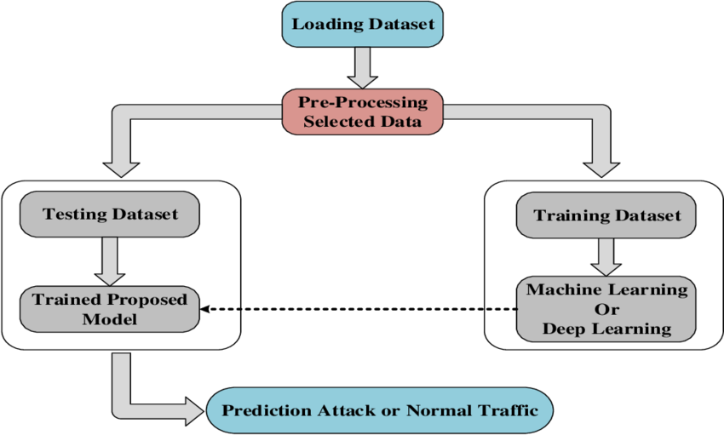
Figure 6: Experimental research workflow for deep learning–based intrusion detection, from data acquisition to model evaluation.
Source: Adapted from Xu, Li and Wang (2023).
In addition, this research has a quantitative, experimental research design that is suitable for assessing the performance of deep learning models for intrusion detection in cloud computing environments. Quantitative experimentalism sees that the model's effectivenesss is measured objectively by means of statistically substantiated performance metrics, such as accuracy, F1-score, and detection latency. The assistance of these metrics is paramount in cosseting any kind of research relevant to cyber security, where decisions have to be evidence based (Goodfellow, Bengio and Courville, 2016).
An experimental approach is especially suitable since the research intends to compare different detection models under controlled condition. By training, validating, and testing different deep learning architectures on the same datasets, the effect of their architectural choices on detection accuracy, generalization, and real-time feasibility can be isolated. This is in sync with established cyber-security research practices where reproducibility and comparability across models are essential to demonstrate scientific validity (Alqahtani, Ahmad and Hussain, 2022).
Moreover, the experimental evaluation is critical for addressing the main research problem identified in Chapter 1, i.e. offline performance versus real-time cloud deployment. Cloud intrusion detection is inherently a time-critical task where delayed alerts usually allow fast lateral movement and privilege escalation- as is illustrated in figure 9. The research design is thus explicitly inclusive of performance evaluation stages that measure classification accuracy along with inference latency and scalability so that experimental outcomes can be aligned with operational cloud security requirements (Rahman, Biswas and Khan, 2024).
Overall, a quantitative, experimental design would prove a rigorous and impressive framework for evaluating whether this hybrid deep learning architecture can meet the joint demands of precision, swiftness, and durability in dynamic cloud environments..

3.2 Research Methods
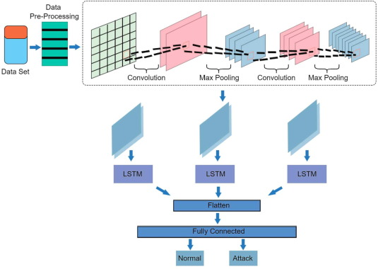

Figure 7: Proposed hybrid CNN–LSTM–Autoencoder architecture for cloud intrusion detection.
Source: Author’s conceptual design informed by Rahman, Biswas and Khan (2024).
It involves the design, implementation, and evaluation of a hybrid deep learning intrusion detection model as the core research methodology. The proposed architecture integrates three complementary components to address the limitations identified in previous works. First, a Convolutional Neural Network (CNN) will learn spatial features from representations of network traffic and possible attacks, providing automated learning of complex attack signatures that are very difficult to engineer manually (Kang, Park, and Kim, 2023). Second, a Long Short Memory (LSTM) layer will model temporal dependencies in traffic sequences, which form a strong consideration for detecting slow-moving and multi-stage attacks, particularly familiar in cloud environments (Singh and Ahmed, 2022). Third, an autoencoder was included to learn what baseline traffic behaviour looks like and from these deviations that might indicate zero-day or previously unseen attacks (Zhang et al., 2024) to support anomaly detection.
The architecture will be trained and evaluated by using two widely applied benchmark data sets, namely CICIDS2017 and UNSW-NB15. The first network traffic simulated by CICIDS2017 is realistic and labelled according to quite modern attack scenarios such as brute force, botnet, and denial-of-service attacks (Sharafaldin, Lashkari, and Ghorbani, 2018). Furthermore, complement this through various attacks found in the current situation and feature distributions to enhance improving generalisation assessment (Moustafa and Slay, 2015). The urge of two datasets mitigates overfitting to dataset-specific characteristics and enhances external validity.
Before exposing the data to the model for training purposes, there will be data preprocessing to ensure reliability of the experiments. Data cleaning, handling of missing values, feature normalization, and class balancing through Synthetic Minority Oversampling Technique (SMOTE), are part of preprocessing to classify classes where their occurrences are very few (Chawla, 2021). Cut records of traffic into the fixed-length sequences for the time dimension modeling by the LSTM component.
The model performance will be evaluated using standard measures stemming from IDS research such as accuracy, precision, recall, F1-score, and ROC-AUC. Importantly, detection latency will also be examined for real-time feasibility, as opposed to a major weakness of existing DL-IDS research, which tends to focus solely on offline accuracy (Xu, Li, and Wang, 2023). Benchmark comparisons will be provided against all baseline models: standalone CNN, LSTM, and traditional machine learning classifiers, to demonstrate relative performance gains.

3.3 Research Materials


Figure 8: Cloud-based GPU infrastructure supporting scalable deep learning model training and evaluation.
Source: Google Colab documentation (2024).
The primary research data includes publicly accessible network traffic datasets (the CICIDS2017 and UNSW-NB15), which are commonly referred to in intrusion detection literature and do not contain any personally identifiable information. Therefore, very few ethical risks accrue on the study; nevertheless, ethical approval will be sought as per institutional requirement for compliance with responsible research practice. The software tools include the programming language Python for algorithm development with TensorFlow and PyTorch for deep learning model development. Jupyter Notebooks shall be used for experiments and documentation purposes, while Google Colab shall provide access to cloud-based GPU resources for efficient training and evaluation. These tools are well established in both academic research and industry practice, supporting reproducibility and scalability (Goodfellow et al., 2016).
The hardware requirements, on the other hand, include access to GPU-enabled cloud compute resources that are supposed to train the deep learning model within reasonable time. GPU in the cloud, furthermore, simulates the deployment context of the proposed IDS, hence realistic performance evaluation. Data will be handled in accordance with the secure handling process, including restricting access, encrypted storage only if applicable, and training-testing dataset separation to deter any data leakage.

4. Expected Outcomes
This research is expected to provide both technical and theoretical contributions pertaining to cloud intrusion detection. In terms of performance, it is expected the hybrid CNN-LSTM-Autoencoder framework proposed will achieve higher detection accuracies than any single deep learning or classical machine learning models due to its ability to combine spatial feature extraction, temporal modelling and finally offer anomaly detection. Prior hybrid studies suggested that complementing the hybridizing architectures can hence make the classification more robust, mainly when it comes to distinguishing complex and multi-stage attacks (Rahman et al., 2024).
A significant and expected outcome will be a reduction in false positives, which continues to be one of the operational drawbacks of IDS in elastic cloud environments. Considering that the autoencoder will learn the normal traffic behaviour while the LSTM will model the temporal dependencies, it is expected that the framework will distinguish benign anomalies from really malicious activities well (Zhang et al., 2024). Furthermore, explicit optimization and measurement of detection latency should demonstrate that the hybrid model meets all reasonable time constraints for real-time cloud protection, helping to address a limitation that has often been cited in DL-IDS literature (Xu et al, 2023).
On the theoretical grounds, it is expected that the study will provide empirical evidence that real-time feasibility should be treated as an important evaluation criterion in research on DL-based IDS, not as an implicit assumption. On the practical side, such findings might influence the design of more deploy-able IDS solutions for cloud service providers and Security Operation Centres.
However, several limitations are expected. Our study will rely on the benchmark datasets because they do not represent the full diversity of live cloud traffic, while evaluation on GPU may not embrace all cost constraints related to production. Such limitations would be duly noted while interpreting the results.

5. Project Timeline
The project is structured to match the MSc project lifecycle while obtaining logical clarity to account for movement from conceptual development to empirical evaluation and reporting. The timetable is drawn realistically and would, therefore, afford enough time for experimentation, validation, and critical analysis against the academic deadlines.
Table 1: Proposed MSc Research Project Timeline
Phase | Activities | Duration
Phase 1 | Literature review and refinement of research problem and objectives | Weeks 1–3
Phase 2 | Design of hybrid CNN–LSTM–Autoencoder architecture | Weeks 4–5
Phase 3 | Dataset preparation, preprocessing, and feature engineering | Weeks 6–7
Phase 4 | Model training and validation using CICIDS2017 and UNSW-NB15 | Weeks 8–10
Phase 5 | Performance evaluation and benchmarking against baseline models | Weeks 11–12
Phase 6 | Analysis of results and interpretation of findings | Weeks 13–14
Phase 7 | Final report writing, revision, and submission | Weeks 15–16
This phased structure ensures that foundational activities, such as literature review and model design, are completed before experimental implementation. Adequate time is allocated for validation and benchmarking to support rigorous comparison, while the final phase allows for synthesis and critical reflection. Overall, the timeline demonstrates feasibility and effective project management consistent with postgraduate-level research expectations.

References
Al-Ghuwairi, A.R., Al-Qudah, A. and Al-Badarneh, A. (2023) ‘Time-series intrusion detection in cloud computing environments’, Journal of Cloud Computing, 12(1), pp. 1–18. Available at:
https://journalofcloudcomputing.springeropen.com/articles/10.1186/s13677-023-00491-x
Alqahtani, A., Ahmad, M. and Hussain, F. (2022) ‘Deep learning for cloud intrusion detection: A survey’, IEEE Access, 10, pp. 103112–103135. Available at:
https://ieeexplore.ieee.org/document/9950146
Behl, A. and Behl, K. (2020) Cybersecurity and Cyberwar: What Everyone Needs to Know. Oxford: Oxford University Press. Available at:
https://global.oup.com/academic/product/cybersecurity-and-cyberwar-9780190078148
Chawla, N.V., Bowyer, K.W., Hall, L.O. and Kegelmeyer, W.P. (2002) ‘SMOTE: Synthetic minority over-sampling technique’, Journal of Artificial Intelligence Research, 16, pp. 321–357. Available at:
https://jair.org/index.php/jair/article/view/10302
Cloud Security Alliance (2024) Top Threats to Cloud Computing 2024. Available at:
https://cloudsecurityalliance.org/artifacts/top-threats-to-cloud-computing-2024
ENISA (2024) ENISA Threat Landscape 2024. European Union Agency for Cybersecurity. Available at:
https://www.enisa.europa.eu/publications/enisa-threat-landscape-2024
Gartner (2024) Gartner forecasts worldwide public cloud end-user spending to total $723 billion in 2025. Available at:
https://www.gartner.com/en/newsroom/press-releases/2024-11-19-gartner-forecasts-worldwide-public-cloud-end-user-spending-to-total-723-billion-dollars-in-2025
Goodfellow, I., Bengio, Y. and Courville, A. (2016) Deep Learning. Cambridge, MA: MIT Press. Available at:
https://www.deeplearningbook.org
IBM and Ponemon Institute (2024) Cost of a Data Breach Report 2024. Available at:
https://www.ibm.com/reports/data-breach
Kang, H., Park, J. and Kim, D. (2023) ‘CNN-based intrusion detection systems’, Computers & Security, 132, 103307. Available at:
https://www.sciencedirect.com/science/article/pii/S0167404823002346
Mell, P. and Grance, T. (2011) The NIST Definition of Cloud Computing (SP 800-145). National Institute of Standards and Technology. Available at:
https://nvlpubs.nist.gov/nistpubs/legacy/sp/nistspecialpublication800-145.pdf
Moustafa, N. and Slay, J. (2015) UNSW-NB15: A comprehensive data set for network intrusion detection systems. Australian Centre for Cyber Security. Available at:
https://research.unsw.edu.au/projects/unsw-nb15-dataset
Rahman, T., Biswas, A. and Khan, S. (2024) ‘Hybrid CNN–LSTM intrusion detection systems for cloud environments’, Journal of Network and Computer Applications, 224, 103593. Available at:
https://www.sciencedirect.com/science/article/pii/S1084804524000637
Sharafaldin, I., Lashkari, A.H. and Ghorbani, A.A. (2018) CICIDS2017 dataset. University of New Brunswick. Available at:
https://www.unb.ca/cic/datasets/ids-2017.html
Singh, R. and Ahmed, Z. (2022) ‘LSTM-based anomaly detection in cloud computing systems’, IEEE Transactions on Cloud Computing, 10(4), pp. 2331–2344. Available at:
https://ieeexplore.ieee.org/document/9712754
Xu, Z., Li, Y. and Wang, J. (2023) ‘Real-time intrusion detection challenges in cloud environments’, Future Internet, 15(4), p. 112. Available at:
https://www.mdpi.com/1999-5903/15/4/112
Yadav, P. and Misra, N. (2023) ‘Scalability challenges of deep learning-based intrusion detection in cloud computing’, Journal of Cloud Computing, 12(14). Available at:
https://journalofcloudcomputing.springeropen.com/articles/10.1186/s13677-023-00412-8
Zhang, Y., Liu, H. and Chen, X. (2024) ‘Autoencoder-driven anomaly detection for network security’, Future Internet, 16(2), p. 54. Available at:
https://www.mdpi.com/1999-5903/16/2/54

