

Managing an IT Project for home user
‘Project initiation Document’

Shannon Cranfield
P149078
Module: Project Management
M5X00615
Sue Maw

SECTION 1 3
Background 3
Project Objectives 3
Project Scope: 3
Project Constraints: 4
Authority 4
Resources 5
Project Stakeholders 6
Project plan 9
BIBLIOGRAPHY 12

_{SECTION 1}

Background
The Local Mumbles Rangers Football Club is the selected charity organisation; this project will aim to ensure that the Rangers Football club will have an improved HR system, which will be created in Microsoft Access to create a database which will store required information for Mumbles Rangers Football club. Mumbles Rangers Football club has many teams for example their ladies team, girls team, senior teams and their different youth group teams. At the end of this project, the system should make the managing of people in the Mumbles Rangers Football Club easier.

Project Objectives
- To provide the Mumbles Rangers Football club with a well sustainable and functional database system; this will be achieved by sticking to the time schedules so that this database can be handed in on time.
- To provide the Mumbles Rangers Football Club with a secure and reliable database system
- To ensure that the database meets the HR Requirements of the Mumbles Rangers Football Club.
- To test the database for functionality and its sustainability for meeting the user requirements.
- To ensure that the system will help improve the managing of people linked with the club.

Project Scope:
The main scope of this project is to plan, design, develop and implement a database that enables the Mumbles Ranges Football club with the functionality of being able to manage their club members more efficiently. Access and permissions will be granted to the appropriate personnel in order to allow them to update, manage, and view club member’s details and subscription information. The scope will include creating a user-friendly interface which will enable users to select from a menu of options. Users will also be able to generate reports on the statistics of club members, which should be able to allow for club member reflection.

Included in the project therefore is:
- The ability to store personal information about each club member
- The ability to be able to store club member subscriptions
- The ability to be able to store and manage the club teams
- The ability to be able to manage the statistics for each member of each game.
- Manuals to assist with the use of the Mumbles Ranges Information System (MRIS)

The scope of this project includes all requirements gathering, planning, design, development, and implementation of the Mumbles Ranges Information System (MRIS).
The project will not include the following:
- Ongoing maintenance of the MRIS
- This system will only be a standalone system that can be installed on an individual computer, and accessed via that individual computer.

Project Constraints:
- This project has a due date of April 2018 and therefore must be completed on or before this time, however, there are other competing projects which must be completed in a similar timeframe, hence strict project management guidelines and deadlines must be adhered to.
- The MRIS has to take into account the limitations of the hardware currently available as there is no money to upgrade RAM or hard-drive storage.
- Limited access to team members given the time constraints and availability of the teams and project members, hence the user requirements will have to be effectively collected.
- There is no allocated budget for this project, and therefore this will also impact on the scope of the project limiting it to the basic user requirements functionality as specified.
- Functionality should be for all users for example novice users as well as intermediate

Authority
For the purposes of the project for the Mumbles Ranges Football Club, the following lines of responsibility and authority will be used:
- Project Sponsor: This project has been initiated by Susan Maw, who is the project sponsor and has ultimate authority and control over the project and its implementation.
- Project Manager: Henry Cobbold, has been assigned as the Project Manager, and will be responsible for the overall coordination of the project, and making sure that all team members are on task as well as assigning tasks to all team members.
- Project Organization Chart/Structure: There are 5 project members in the project: Shannon Cranfield, Henry Cobbold, Jack Holland, Peter Davies and Rutendo Gure

PROJECT TEAM HIERARCHICAL CHART

Resources
The Project Team: The project Team consists of the Project Sponsor, The Project Manager, five team members, and the club manager will be a business user on the team. NO funding has been allocated to this project hence the skills within the team will need to be harnessed. The strengths of each team member therefore was analysed and based on this, roles and tasks assigned.
The roles for the team has been allocated as follows:
- Shannon Cranfield ( Systems Analyst) – will be creating the designs for the database (ERD and data flow diagrams)
- Henry Cobbold (Project Manager / Developer) – will be developing and creating the database from the designs
- Jack Holland ( Data Entry) – will be inputting the data into the database
- Peter Davies (User interface design) – will be designing the input forms, and menu interface in a user friendly manner
- Rutendo Gure (Systems Testing) – will be responsible for testing the systems once created to ensure that all data validation is checked, and that the logic of the system meets the user requirements.

_{Project Team}
Name | Position | Internal/External | Project Role | Information
_{Shannon} | _{Systems Analyst} | _{Internal} | _{Team Member} | _{shannon@gmail.com}
_{Henry} | _{Project Manager / Developer} | _{Internal} | _{Team Member} | _{henry@gmail.com}
_{Jack} | _{Data Entry} | _{Internal} | _{Team Member} | _{jack@gmail.com}
_{Peter} | _{User Interface Design} | _{Internal} | _{Team Member} | _{peter@gmail.com}
_{Rutendo} | _{Systems Testing} | _{Internal} | _{Team Member} | _{Rutendo@gmail.com}
_{Sue} | _{Project Sponsor} | _{Internal} | _{Project Sponsor} | _{sue@gmail.com}

Equipment: The project team will need to make use of computers, which the University provides, project team members will also need access to Microsoft Access to create the Database solution, as well as data flow diagram modelling software. For this project there has not been a budget provided hence there are no funds allocated to the project.

Project Stakeholders

There are several stakeholders of Mumbles Rangers football club. The table below shows the different stakeholders:
 | _{Name} | _{Position / project role} | _{Internal/External} | _{Information}
₁ | _{Martin Duffy} | _{Treasurer} | _{External} | _{martinduffy@gmail.com}
₂ | _{Michael Podbielski} | _{Secretary} | _{External} | _{mike@mumblesrangers.co.uk}
₃ | _{Chris Parkin} | _{Chairman} | _{External} | _{rangers85@sky.com}
₄ | _{Nikki Harris} | _{Safeguaring officer} | _{Internal} | _{nicola.harris@ntlworld.com}
₅ | _{Haydn Lewis} | _{junior co-ordinator} | _{External} | _{haydnlewis@gmail.com}
₆ | _{Mumbles Players} |  | _{External} | ₋
₇ | _{Club manager} |  | _{External} | ₋
₈ | _{Mumbles competitors} |  | _{External} | ₋
₉ | _{Mumbles coaches} |  | _{Internal} | ₋
₁₀ | _{The council} |  | _{External} | _{swanseacouncil@gmail.com}
₁₁ | _{Sponsors} |  | _{External} | ₋
₁₂ | _{Shannon} | _{Systems Analyst/team member} | _{Internal} | _{shannon@gmail.com}
₁₃ | _{Henry} | _{Project Manager / Developer/} | _{Internal} | _{henry@gmail.com}
₁₄ | _{Jack} | _{Data Entry} | _{Internal} | _{jack@gmail.com}
₁₅ | _{Peter} | _{User Interface Design} | _{Internal} | _{peter@gmail.com}
₁₆ | _{Rutendo} | _{Systems Testing} | _{Internal} | _{Rutendo@gmail.com}
₁₇ | _{Sue} | _{Project Sponsor} | _{Internal} | _{Sue@gmail.com17}

Power/Interest Grid
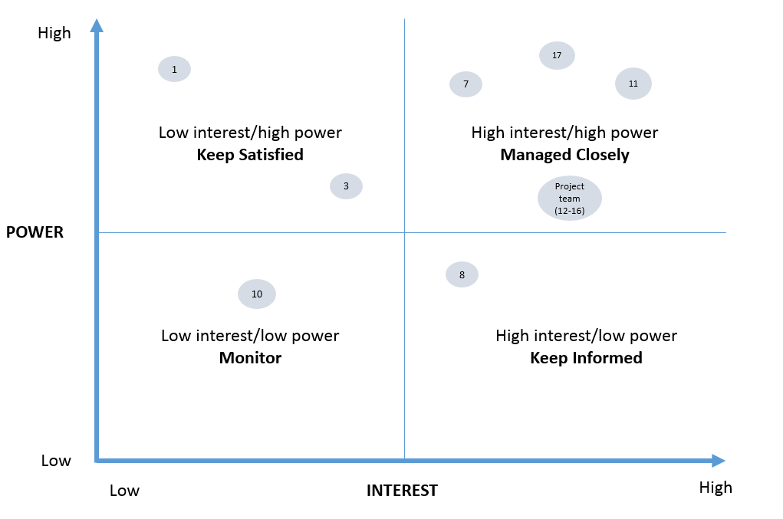

The project team evaluated the potential stakeholder related risks and two potential stakeholder risks were identified except:
- The stakeholders wanted the project to be delivered earlier than planned, and could pull out of the project if not satisfied, and
- As the Mumbles Ranges Football club is a charity there is the risk of the charity closing or stopping to operate due to lack of sponsorship.

Project plan
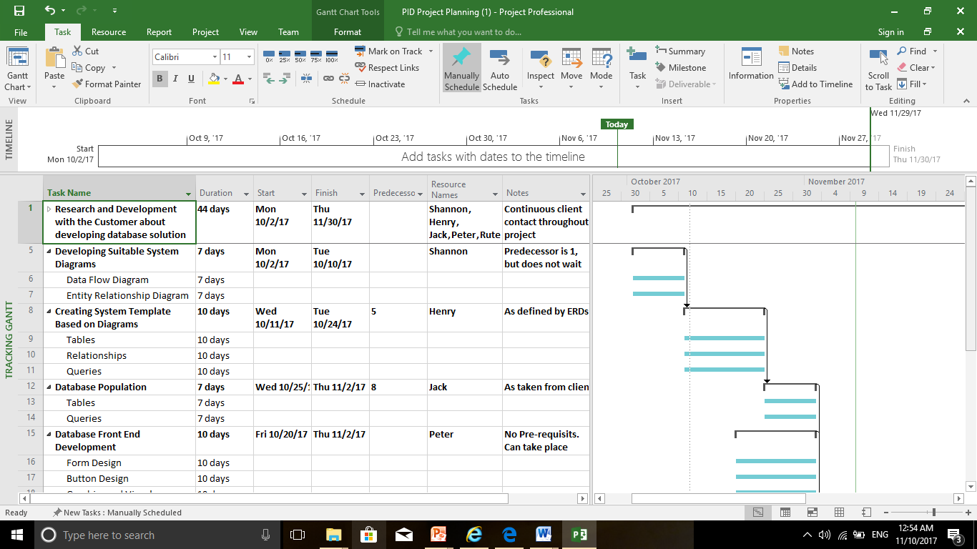
The project plan can be seen below. The project team is made up of 5 team members, each responsible for different tasks to ensure that the Mumbles Rangers Football club can receive the MRI system on time. The plan has been split up into research, developing, creating, populating and testing, with each member assigned to a task, each task is reliant on the previous task so it is important for members to stick to their time limit so no rushing takes place to complete that task.

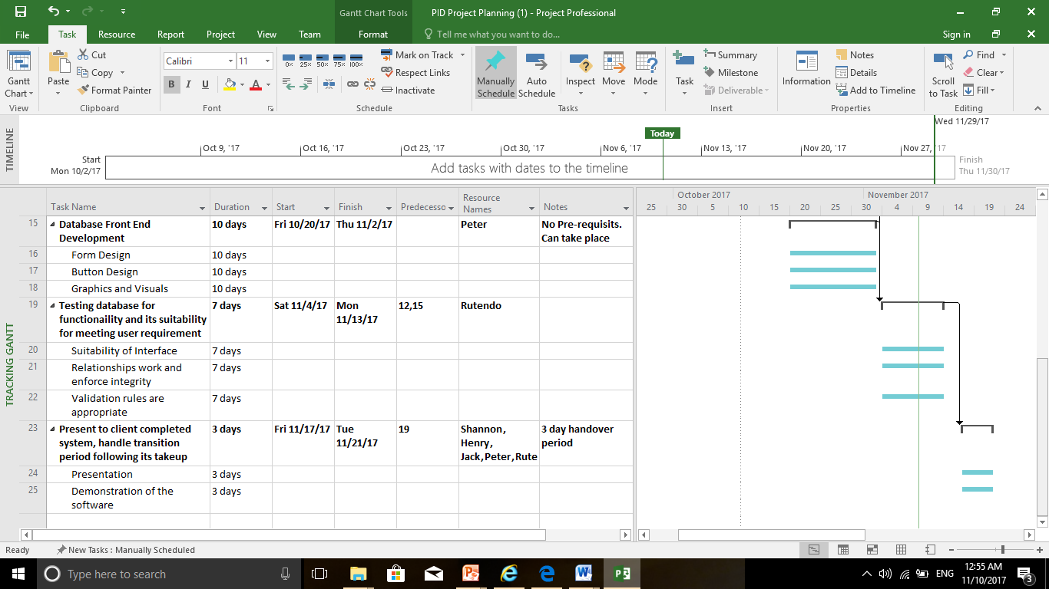

_{BIBLIOGRAPHY}
[1] “Homepage | Mumbles Rangers FC.” [Online]. Available: https://www.clubwebsite.co.uk/mumblesrangers/. [Accessed: 10-Nov-2017].

