BA BUSINESS MANAGEMENT
MARKETING FUNDAMENTALS
LCBB4004_BIRM
MARKETING PROCESS (Individual Report)
STUDENT NAME/STUDENT NUMBER:
Mariana Acris (2239619)
LECTURER’S NAME:
Nazia Saeed.

Contents
1. Introduction 3
1.1 Estée Lauder Marketing Strategy & Marketing Mix (4Ps) 3
1.2. Marketing function post Covid-19 pandemic for Estée Lauder companies. 6
1.2.1. The Estee Lauder Companies Inc. Price, Consensus and EPS Surprise. 7
2. Strategic marketing: Creating competitive advantage of the new developments within the business environment. 8
2.1 Competitive advantage: VRIO framework. 8
2.2. Competition: 9
2.3. Marketing and Brand innovation: 10
3. Stakeholders of the Estée Lauder company. 12
3.1. Estée Lauder Stakeholders Impact on Marketing function. 12
5. Estée Lauder Marketing strategies and it’s challenges. 13
4. Conclusion: 15
References 16

ABSTRACT
Estée Lauder used the appropriate approach in the past to report the COVID-19 Global markets and pandemic growth have been trending positively (W. Huang, 2023).
This essay analyses the market competition and marketing model using Estée Lauder as an example, and it offers pertinent suggestions for potential issues that might come up. It was observed that Estée Lauder's marketing approach proved to be efficacious, as the company effectively mitigated the impact of the COVID-19 pandemic and minimized its threat (W. Huang, 2023).

Introduction
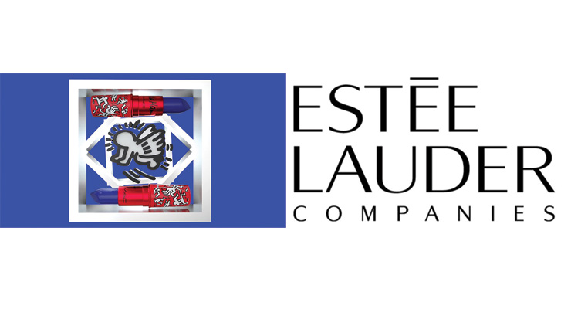
Estée Lauder, a global leader in the beauty and cosmetics industry, has long been synonymous with elegance, luxury, and innovation. Established in 1946 by Estée and Joseph Lauder, the company has grown into a powerhouse, boasting a portfolio of iconic brands that resonate with consumers worldwide (Tucker, 2022). With a commitment to quality, creativity, and a customer-centric approach, Estée Lauder has become a trendsetter in the ever-evolving beauty landscape. Estée Lauder owns and manages a portfolio of well-known brands, including Estée Lauder itself, Clinique, MAC, Bobbi Brown, La Mer, Jo Malone London, and many others. Each brand has its own unique identity and caters to various consumer preferences. The studies of Estée Lauder's competition and marketing model are quite a few due to its preponderant influence (C. Geng and H. Wang, 2022).

Estée Lauder Marketing Strategy & Marketing Mix (4Ps)

Estée Lauder, as a prominent player in the beauty and cosmetics industry, employs a well-crafted marketing strategy and marketing mix, often referred to as the 4Ps (Product, Price, Place, Promotion), to promote its products and maintain its brand presence (mbaskool, 2023). Here's an overview of Estée Lauder's marketing strategy and marketing mix:

Place
Promotion
Product
Price
Estée Lauder Company-Marketing Mix (4Ps)

- Product:
  - Diverse Product Portfolio:
Estée Lauder offers a wide range of beauty and skincare products under various brands within its portfolio. This includes skincare solutions, makeup products, fragrances, and hair care items.
  - Product Quality and Innovation:
The company is known for its commitment to product quality and innovation. They invest in research and development to create cutting-edge formulations and technologies to address different beauty concerns.
  - Branding and Brand Identity:
Each brand within Estée Lauder's portfolio has its own unique identity and target market. For example, Clinique is known for its dermatologist-developed products, while MAC is renowned for its inclusivity and bold makeup offerings.
  - Seasonal and Limited Editions:
Estée Lauder often releases limited edition or seasonal collections to create excitement and urgency among consumers.

- Price:
- Premium Pricing:
Estée Lauder positions itself as a premium brand, and its products are often priced at the higher end of the market. This pricing strategy reflects the brand's image of luxury, quality, and prestige.

- Pricing Tiers:
The company offers products at various price points, allowing customers to choose products that fit their budget while still experiencing the brand's luxury.
- Place:
- Global Distribution:
Estée Lauder products are available in a wide range of distribution channels, including department stores, specialty retailers, standalone brand boutiques, and e-commerce platforms. Sold in more than 120 countries and territories, indicating a widespread international presence.
- International Presence:
The brand has a global reach, with a strong presence in various countries. Its distribution strategy ensures accessibility to consumers worldwide.
- E-commerce:
The company has invested significantly in its online presence, providing a user-friendly website and mobile app, enabling customers to shop online, access personalized recommendations, and receive product information.
- Promotion:
- Marketing and Advertising:
Estée Lauder invests in marketing and advertising campaigns to build and maintain brand awareness. These efforts may include print and digital advertisements, social media marketing, and collaborations with celebrities and influencers.
- Customer Engagement:
The brand engages with customers through various channels, including social media platforms, email marketing, and customer loyalty programs. Estée Lauder also provides personalized product recommendations and virtual try-on tools.
- Events and Sampling:
The company often hosts events and promotions to engage with customers, including in-store events, product launches, and free samples with purchases.
- Philanthropy:
Estée Lauder's marketing strategy also includes its philanthropic efforts, such as the Breast Cancer Campaign, which helps build a positive brand image associated with social responsibility.
Overall, Estée Lauder's marketing strategy and marketing mix emphasize product quality, brand differentiation, a premium image, and global accessibility. The company continually adapts its marketing efforts to align with changing consumer preferences and market trends in the beauty and cosmetics industry (Valades, 2022).

1.2. Marketing function post Covid-19 pandemic for Estée Lauder companies.
Estee Lauder's response to COVID-19 demonstrated their ability to pivot and adapt to challenging circumstances. Their emphasis on digital marketing, social responsibility, personalization, and innovation allowed them to maintain customer engagement and trust during the pandemic. This adaptability and responsiveness are valuable lessons for companies facing similar challenges in the future (RELEASE, 2020).
Estée Lauder's announcement of the "Post-COVID Business Acceleration Program" (PCBA Program) in August 2020, indicated the company's strategic response to the challenges posed by the COVID-19 pandemic.
The PCBA Program's main areas of focus, include several strategic initiatives aimed at addressing the evolving consumer landscape and optimizing the company's operations (RELEASE, 2023). Let's break down these focus areas:
1. Accelerating the Shift to Online:
- Estée Lauder recognized the importance of e-commerce and the growing trend of online shopping accelerated by the pandemic.
- The company likely invested in improving its online shopping platforms, enhancing user experiences, and increasing its online product offerings.
- Online marketing efforts, including social media campaigns, influencer collaborations, and virtual try-on tools, may have been bolstered to engage consumers in the digital space.
2. Realignment of Distribution Network:
- The closure of certain freestanding stores and department store locations in North America and Europe, the Middle East & Africa reflects a strategic shift in the company's physical retail presence.
3. Reduction in Brick-and-Mortar Point of Sale Employees:
- The reduction in in-store personnel and support staff aligns with the evolving retail landscape where online sales become increasingly dominant.
- This cost-saving measure likely aimed to reallocate resources to support online and digital channels.
4. Redesign of Branded Marketing Organizations:
- The redesign of regional branded marketing organizations reflects a strategic approach to align marketing efforts with the changing consumer landscape and shifting priorities.
- This restructuring may involve redefining marketing strategies, adjusting product portfolios, and focusing on customer engagement in line with post-COVID-19 consumer preferences.
Overall, the PCBA Program appears to be a comprehensive strategy to adapt to the new post-COVID-19 business environment. It includes a significant shift towards online channels, a realignment of the physical retail presence, cost-saving measures, and a reconfiguration of marketing and organizational structures to remain competitive and agile in the evolving market.
These changes reflect Estée Lauder's commitment to staying responsive to consumer needs and market dynamics. The statement suggests a nuanced evaluation of Estée Lauder's business dynamics, acknowledging the transformative impact of online shopping while recognizing challenges and the influence of external factors such as the global COVID-19 pandemic.

1.2.1. The Estee Lauder Companies Inc. Price, Consensus and EPS Surprise.
As the Estee Lauder Companies begins its fiscal year in 2023, it faces a number of challenges, including record-high inflation, supply chain interruptions, unfavourable exchange rates, and the possibility of a slowdown in a number of global markets. Management is nevertheless upbeat about the prospects for expansion in the field of international prestige beauty (Zacks, 2022).

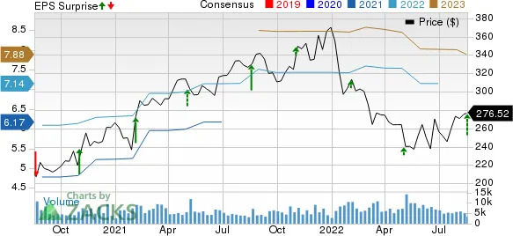
The Estee Lauder Companies Inc. Price, Consensus and EPS Surprise
(imag.1. source of (Zacks, 2022)

Management accentuated that net sales growth in every category was driven by strong growth in The Americas, which was brought about by increased foot traffic in brick-and-mortar stores. The negative effects of increased COVID-related restrictions throughout China more than offset this, having a detrimental effect on travel and retail traffic. Furthermore, its Shanghai distribution units experienced a temporary capacity restriction as a consequence. In addition, the business halted operations in Russia and Ukraine because of the invasion of that country. Lower net sales in Asia/Pacific and EMEA were the outcome of the shift (Zacks, 2022).

2. Strategic marketing: Creating competitive advantage of the new developments within the business environment.
An organization's ability to achieve its goals and objectives depends on its ability to manage its operations effectively. This study examines the marketing strategy, competitive advantage analysis, PESTLE analysis, competitor position, and strategic management effectiveness within the framework of ESTEE LAUDER (MOMIN, 2022).

2.1 Competitive advantage: VRIO framework.
To assess the VRIO framework for competitive advantage at Estée Lauder, we'll examine some key resources and capabilities (Harvey, 2020):

SUSTAINED COMPETITIVE ADVANTAGE

Is the resources or capability…? Is the company well…?
O
ORGANIZED
V
VALUABLE
R
RARE
I
INIMITABLE
yes yes yes

no no no no
UNUSED COMPETITIVE ADVANTAGE
TEMPORARY COMPETITIVE ADVANTAGE
COMPETITIVE PARITY
COMPETITIVE DISADVANTAGE

Overall, these aspects suggest that Estée Lauder possesses valuable, rare, and difficult-to-imitate resources and capabilities, which, when effectively organized and exploited, contribute to its competitive advantage within the beauty and cosmetics industry (John E Gamble, 2014).

2.2. Competition:
Consumer choices among competing products and brands are influenced by a variety of factors.
Brand recognition, product quality and effectiveness, distribution channels, and price point, Marketing, merchandising, in store experiences and demonstrations, and new product innovation. the Estée Lauder company compete against a number of global and local companies. Some of the competitors are large, well-know, multinational manufactures and marketers of skin care, makeup, fragrance and hair care production, most of which market and sell the products under multiple brand names. The competitors include L’Oreal S.A.; Unilever; Procter & Gamble; Shiseido Company, Ltd.; LVMH Moët Hennessey Louis Vuitton; Beiersdorf; Chanel S.A.; Natura & Co.; Coty Inc.; and Bath & Body Works, Inc.
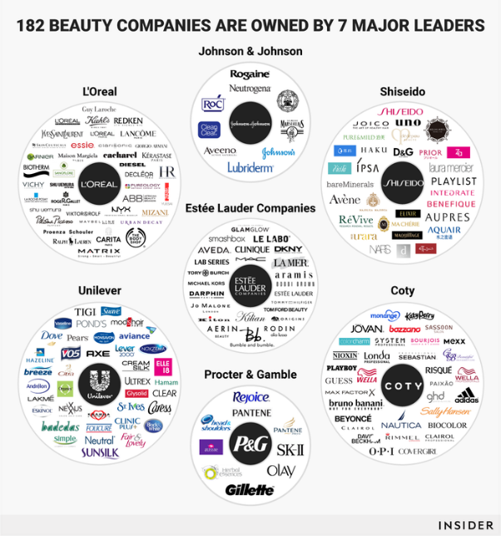
ESTEE LAUDER, on the other hand, is a well-known producer and marketer of beauty products, having established their company in New York City and recently growing into Canada (LAUDER, 2017).
Targeting the premium market, ESTEE LAUDER concentrates on high prices. The primary rivals of this kind of organisation are L'Oreal, Avon, and Coty. In contrast to other cosmetic companies that employ synthetic materials in their products, ESTEE LAUDER provides natural skin care products, which is a helpful strategy for gaining competitive advantages in the global market (Rosen, 2000).

Table 1. Advantages and disadvantages of Estée Lauder
Advantages | Disadvantages
- Estée Lauder is recommended for women in the 20–50 age range.  - High product value, first-rate product support, positive results, an emphasis on R&D, and innovative product development.  - Positioning high-end, taking the route of scarcity.  - Reaching out to a diverse group of people.  - Strong Leadership and Management.  - Customer Loyalty Programs. | - Fewer shops, lower market share, higher prices, beyond the average person's spending power.  - A wide range of products, requiring a relatively large investment.  - Animal Testing Controversy.  - Premium Pricing.

Overall, Estée Lauder Companies, Inc. benefits from a combination of strong brands, innovation, global reach, and a commitment to quality and sustainability, which has contributed to its success in the beauty industry.
It's important to note that these disadvantages are not unique to Estée Lauder and are common challenges in the beauty and skincare industry. The company continues to evolve and adapt to address these concerns and maintain its position in the market (C. Geng and H. Wang, 2022).

2.3. Marketing and Brand innovation:
Reaching over 100 million people globally through social channels is a remarkable achievement in the world of marketing and brand communication. This statement emphasizes the brand's commitment to innovation and building meaningful, long-lasting relationships with its consumers (Shakeel ul Rehman, 2022). Here's what this statement signifies:
Global Reach:
The fact that Estée Lauder reaches over 100 million people globally indicates the brand's extensive global presence. It highlights its ability to connect with a vast and diverse audience worldwide.

Social Media Impact:
Social media is a powerful tool for reaching and engaging with customers. Estée Lauder's extensive presence on social channels underscores its commitment to leveraging these platforms for brand promotion and customer interaction (Gomez, 2023).
Innovation:
The statement acknowledges the importance of innovation in communication. By stating they will "continue to innovate the way we communicate through content," Estée Lauder demonstrates a proactive approach to adapting to changing consumer preferences and emerging technologies.
Customer-Centric Approach:
Building meaningful, long-lasting relationships with consumers is a key objective. It shows that Estée Lauder values its customers and aims to establish trust and loyalty over time.
Content Marketing:
The mention of "the way we communicate through content" highlights the significance of content marketing. Estée Lauder recognizes that creating compelling and relevant content is essential for engaging and retaining customers.
Brand Consistency:
Maintaining a consistent brand message and image across social channels is likely a crucial part of the brand's strategy to reach and connect with millions of people.
Data and Analytics:
To reach and engage such a large audience effectively, data and analytics likely play a significant role in understanding consumer behaviour, preferences, and the impact of marketing efforts.
Community Building:
Building meaningful and long-lasting relationships involves creating a sense of community around the brand. This can be achieved through user engagement, customer support, and user-generated content.
Adaptability:
The commitment to innovation indicates that Estée Lauder is open to change and adaptation as the marketing landscape evolves. This adaptability is essential in the fast-paced world of digital marketing.
Overall, the statement reflects the brand's success in using social channels to connect with a vast audience and its dedication to evolving and innovating in its communication strategies to maintain strong relationships with its customers.

3. Stakeholders of the Estée Lauder company.
Stakeholders in Estée Lauder, a well-known cosmetics and beauty company, can have a significant impact on the marketing function in various ways. Stakeholders are individuals, groups, or entities that have an interest or concern in the company's operations and performance.
- The primary stakeholders of Estée Lauder may include customers, employees, shareholders, suppliers, investors, retailers, regulatory bodies and local communities.
- The secondary stakeholders include civic institutions, government regulators, social pressure groups, media and academic commentators, trade bodies, competitors – Maybellene, Loreal, MAC and Clinique.
The first official stakeholder engagement was carried out by the company in 2013. The input validated the emphasis on establishing precise goals for corporate social responsibility, coordinating the approach across brands and the company, and providing open and honest reporting on the final results. In order to create a more comprehensive strategy for engaging stakeholders with important internal and external audiences, is collaborated with Business for Social Responsibility in 2014. In addition to more than 100 global managers and leaders from throughout the company, the Estée Lauder company interacted with over 70 external organisations in Brazil, China, the United Kingdom, and the United States.

3.1. Estée Lauder Stakeholders Impact on Marketing function.
The effectiveness of marketing efforts, strategies, and campaigns is influenced by the needs, interests, and expectations of these stakeholders.
Here's an overview of the key stakeholders and their impact on Estée Lauder's marketing functions:
 | Impact on Marketing
Customers | Customer preferences, buying behaviours, and feedback directly shape Estée Lauder's marketing strategies. Understanding customer demographics and psychographics helps tailor product development, pricing, and promotional campaigns to target audiences.
Employees | Motivated and well-informed employees can be brand advocates, helping to convey the company's values and mission through their interactions with customers. Additionally, employees involved in product development, customer service, and retail play a critical role in delivering consistent brand messaging.
Suppliers | The quality, availability, and sustainability of raw materials and ingredients from suppliers influence product development and marketing claims. Highlighting ethical and sustainable sourcing can be a selling point in marketing efforts.
Academic Institutions | Collaboration with educational institutions can lead to joint research projects and marketing partnerships.
Communities | Community relations can influence local marketing efforts, especially in areas where Estée Lauder has facilities or stores. Engaging with communities in a positive way can enhance the brand's image.

Understanding and responding to the interests and concerns of these stakeholders is crucial for creating effective marketing strategies, building brand trust, and meeting customer expectations.

Estée Lauder Marketing strategies and it’s challenges.
Estée Lauder, like any business, faces various challenges in the ever-evolving cosmetics and beauty industry.
Here are some recommendations for marketing strategies to address some of these challenges:
- Increased Competition:
Recommendation: Invest in product differentiation and innovation. Highlight unique features, ingredients, or benefits that set Estée Lauder products apart from competitors. Leverage customer reviews and endorsements from beauty influencers to showcase the quality and effectiveness of products.
- Changing Consumer Preferences:
Recommendation: Conduct regular market research to stay updated on consumer trends and preferences. Use this information to adapt product offerings and marketing campaigns. Consider offering customizable or personalized beauty products to cater to individual preferences.
- Sustainability and Environmental Concerns:
Recommendation: Emphasize the company's commitment to sustainability and responsible sourcing. Implement eco-friendly packaging and practices, and communicate these efforts in marketing materials. Collaborate with environmental organizations and launch marketing campaigns that support relevant causes.
- Ethical Sourcing and Supply Chain Transparency:
Recommendation: Highlight the transparent and ethical sourcing of ingredients in product marketing. Share stories and videos about the sourcing process and the positive impact on local communities. Ensure that suppliers align with the company's ethical standards and values.
- Global Expansion and Cultural Sensitivity:
Recommendation: Customize marketing campaigns to resonate with local cultures and consumer preferences in target markets. Collaborate with local influencers and celebrities who can authentically represent the brand in various regions.
- Digital Transformation:
Recommendation: Invest in digital marketing strategies, including e-commerce, social media, and influencer partnerships. Implement personalized marketing tactics, such as AI-driven product recommendations and virtual try-on tools, to enhance the online shopping experience.
- Rising Marketing Costs:
Recommendation: Optimize marketing spend by focusing on data-driven strategies. Use analytics to identify the most effective marketing channels and campaigns. Consider influencer partnerships, content marketing, and referral programs to maximize ROI.
- Changing Retail Landscape:
Recommendation: Diversify distribution channels and adapt to changing consumer behaviour. Enhance the e-commerce platform, invest in mobile apps, and offer omnichannel shopping experiences. Explore partnerships with e-retailers and explore pop-up stores and beauty kiosks in high-traffic areas.

- Brand Loyalty and Retention:
Recommendation: Implement a customer loyalty program to reward repeat customers. Offer exclusive promotions, early access to new products, and personalized recommendations to encourage customer retention. Engage with customers on social media and encourage user-generated content to foster a sense of community.
- Regulatory Compliance:
Recommendation: Stay informed about regulatory changes in the beauty industry. Ensure all marketing materials and product claims align with current regulations. Develop strong relationships with regulatory agencies to proactively address compliance issues.
- Community Engagement:
Recommendation: Foster positive relationships with the communities where Estée Lauder operates by supporting local causes and initiatives. Highlight community engagement in marketing campaigns to showcase the company's commitment to social responsibility.
- Employee Advocacy:
Recommendation: Encourage employees to be brand advocates. Provide training and resources to help them share the brand's values and products on social media and in their personal networks.

4. Conclusion:
Estée Lauder's response to the challenges brought by the COVID-19 pandemic by showing adaptability, innovation, and a commitment to meeting the evolving needs of consumers. As the global business landscape continues to evolve, the company's strategic initiatives post-pandemic position it for continued success in the dynamic beauty and cosmetics industry. Ongoing vigilance, adaptability, and a dedication to core values will be crucial as Estée Lauder navigates the uncertainties of the post-COVID-19 world (Mitchell, 2022).
In summary, the study underscores Estée Lauder's effective marketing strategy and its ability to respond proactively to challenges posed by external factors such as COVID-19. The recommendation for more research on various consumer segments reflects a forward-looking approach, accentuating the importance of understanding and adapting to evolving consumer dynamics to maintain and enhance competitiveness.
In many aspects, beauty brands are at the forefront of the content marketing industry when it comes to social media engagement. They frequently set the standard for what other industries can accomplish through content marketing, from tying content to commerce to leveraging influencers, embracing fans, and being early adopters on new platforms (Papandrea, 2021).

References
C. Geng and H. Wang, 2022. Research on Estée Lauder's Competition and Marketing Model. s.l., s.n.
Gomez, R., 2023. The importance of social media marketing: 7 stats that prove social’s role in business success. Sproutsocial, 18 september.
Harvey, M., 2020. VRIN/VRIO Analysis Of Estee Lauder. Essay48, 8 April.
John E Gamble, A. A. T. ,. P., 2014. Essentials of Strategic Management: The Quest for Competitive Advantage. s.l.:s.n.
LAUDER, E., 2017. Esteelauder.com.. [Online]
Available at: https://www.esteelauder.com/
[Accessed 17 july 2017].
mbaskool, 2023. mbaskool. [Online]
Available at: https://www.mbaskool.com/marketing-mix/products/16821-estee-lauder.html
Mitchell, S., 2022. The Estée Lauder Companies Releases Fiscal 2021 Social Impact and Sustainability Report. Ethical Marketing News, 17 may.
MOMIN, A., 2022. Estee Lauder SWOT Analysis: A Pioneer in the Competitive Cosmetics Industry. PESTLE ANALYSIS, 9 Ddecember.
Papandrea, D., 2021. springboard. [Online]
Available at: https://www.studioid.com/springboard/best-in-class/beauty-content-marketing-tips-from-the-estee-lauder-companies-alicianne-rand/
[Accessed 12 april 2021].
RELEASE, P., 2020. The Estée Lauder Companies Updates on COVID-19 Initiatives. Estée Lauder Companies Logo, 15 APR .
RELEASE, P., 2023. Estée Lauder Companies. [Online]
Available at: https://www.elcompanies.com/en/news-and-media/newsroom/press-releases/2023/02-02-2023-114522448
Rosen, C. &. S. C., 2000. Business and the environment. Harvard Business School.. [Online]
Available at: https://hbswk.hbs.edu/archive/1352.html
[Accessed 14 March 2000].
Shakeel ul Rehman, R. G. a. W. A., 2022. Developing the Integrated Marketing Communication (IMC) through Social Media (SM): The Modern Marketing Communication Approach. SageJournals.
Tucker, J., 2022. FROM HUMBLE BEGINNINGS TO ICONIC BUSINESSWOMAN: ESTÉE LAUDER. headspace.
Valades, B., 2022. Blucactus. [Online]
Available at: https://blucactus.blue/what-is-estee-lauders-marketing-strategy/
W. Huang, S. L. J. a. W., 2023. Marketing Channel Innovation in the Beauty Industry in the Post-Epidemic Era - Estee Lauder Brand as an Example. s.l., s.n., p. 499–508.
Zacks, E., 2022. finance.yahoo.com. [Online]
Available at: https://finance.yahoo.com/news/estee-lauder-companies-el-beats-151403604.html?guccounter=1&guce_referrer=aHR0cHM6Ly93d3cuZ29vZ2xlLmNvLnVrLw&guce_referrer_sig=AQAAAB1LTHO3ZUVFxGfnstxJec1GzqkoXqiOyCQTaVDh7k2sYzKFMRp7-arPJh5nPgrbsC8ogDvS1lF6v2CdXlQehVoJveWrm
[Accessed 18 august 2022].

