Item CCM 2018.994 - Egyptian Clappers: Catalogue Entry

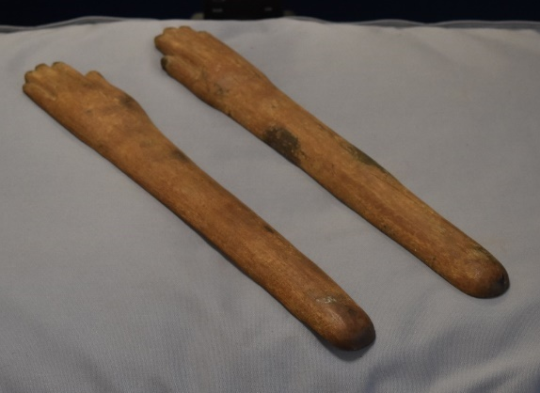
Fig 1. Side View of both clappers (©Katharina Zinn)

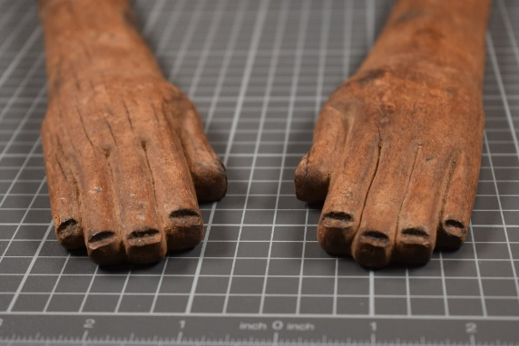
Fig 2. Photo showing notches on fingertips (©Katharina Zinn)

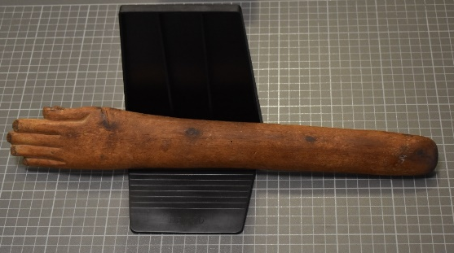
Fig 3. Photo of Left hand clapper (©Katharina Zinn)

Cyfarthfa Castle, Merthyr Tydfil CCM 2018.994
Object type: Musical Instrument
Material: Wood (type currently unknown, believed to be hardwood)
Period: From 6th Dynasty
Provenance: Egypt, location not clear
Dimensions:
Left Hand:
Length: 39.5cm
Width: 5.5cm (at widest)
Circumference (arm): 9.6cm
Right Hand:
Length: 40cm
Width: 5.5cm (at widest)
Circumference (arm): 9.5cm

Object Analysis by Thomas Clarke (1900472)

Object CCM 2018.994 is a pair of straight wooden ‘clappers’, 39.5 and 40cm in length. They are rounded at one end culminating in a hand opposite. Carved lines detail the joins of the fingers. The fingertips appear to be notched, perhaps indicating that fingernails were inlaid, possibly with ivory or bone. At their widest point they are 5.5cm. They are semi-circular in shape. The underside of each is flat and undecorated, with a later mark reading: ‘S22’. Also visible on the upper surface (near the base) of the right-hand is faint white writing which may read: ‘EYA 192’. The type of wood used is currently unascertained.

It is likely this wood was imported from locations such as Lebanon, Sinai and the mountainous regions of Asia Minor as the arid climate of Egypt restricted the growth of suitable timber. Specialised woods like Cedar may have been used for ceremonial and ritualistic items. The role of the clappers may have affected the type of wood used but, especially if connected to the ceremonial/ritual sphere, it could be of a high quality. The suggestion that this item was inlaid with another material would corroborate this. An example of wood associated with musical instruments is the Common Boxwood (Buxus sempervirens).

In daily life, clappers served as musical instruments and were one of the earliest attested examples of Egyptian instrument. As a percussion instrument they kept time within a musical ‘troupe’. They featured in annual temple festivals which not only celebrated the king, but gave their support, enabling the king to extend and strengthen their rule. They are recorded at the Opet festival in Thebes, in which Libyans, accompanying the royal procession, used throwsticks (curved hunting sticks from which clappers are thought to derive) as clappers providing rhythm to the dancing Nubians. The volume of the noise created by the clappers would have been louder than simply ‘hand clapping’.

In comparing CCM 2018.994 to other examples, we see the form (straight or curved) and materials used continued, however the decorative style varied often within Egypt’s timeframe. Clappers often widely differed in the context of a single tomb. Therefore, it is challenging to delineate a ‘timeline’ of Egyptian clappers. There is very little inscription present on CCM 2018.994, however, others had inscribed jewellery (perhaps emblematic of the people who used them) or lotiform patterns (a flower which symbolised rebirth). Some Middle Kingdom examples such as MMA 22.1.143a-b display incised roundels, but the significance of these is unclear. Hathor’s epithet as the “Mistress of music, dancing and drunkenness”, provides a suitable explanation for the proliferation of Hathoric imagery on instruments such as sistra and clappers.
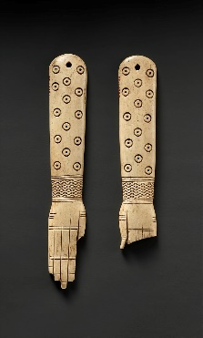
Fig 4. - 12-13th Dynasty Memphite Ivory Clappers: The holes indicate that they were joined by string and held together in one hand (MMA 22.1.143a,b)

A Naqada II vase (c. 3300BC) in the British Museum (BM ‘EA35502’), depicts figures holding clappers, whilst another expressively dances, their arms possibly a symbolic representation of Hathor’s horns in her form as a cow. The presence of ‘Hathoric symbolism’ could indicate a ritualistic relationship to musical performance from an early period. Depictions of Hathor are theriomorphic (a deity bearing strong animalistic forms/features) in this case combined with the ears of a cow. In her bovine form, she is depicted as the monarch’s protector and royal nurse, suckling them as an adult. Evident displays of Hathoric imagery are not clear on this example, however symbolism is seen in the incorporation of the ‘hand’. The ‘Hand of Atum’ bore great significance to the Egyptians. In mythology, the creator god Atum performed a self-copulatory act, creating the gods, Shu and Tefnut. Hathor personified his hand, establishing her epithet as the ‘Hand of Atum’. By using clappers, they celebrated Hathor’s role in creation. Egyptian artistic stylisations often provide an insight into an object’s suggested function. A relief in the tomb of Mereruka, depicts Hathoric dancing, with one dancer holding a bronze mirror (also symbolic of Hathor) surrounded by dancers holding hand shaped clappers. The sunlight catches the mirror, and they re-capture and witness, the birth of everything.

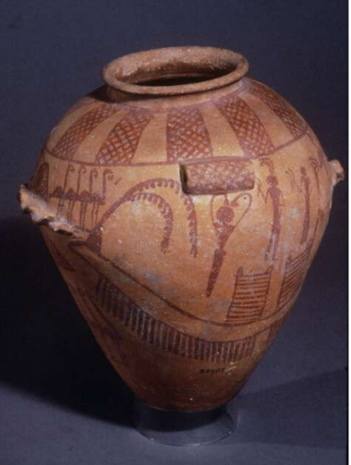
Fig 5. Predynastic Naqada II Vase (BM EA35502) In this picture we see the dancing figure with arms above their head, resembling the horns of Hathor. Alongside are other figures with clappers

In a funerary context, clappers were part of the ritual of burying the dead. Often at an Egyptian funeral, the deceased’s relatives would visit the tomb to ‘reunite’ with them. As an example, the Beautiful Festival of the Valley consisted of an annual procession from Karnak to the temples at Thebes. Once there, they would go to the tomb and eat and drink, honouring the deceased. This occasion would be accompanied by music and dancing. Music and the funerary sphere were intrinsically connected on several fronts. At mortuary banquets, singers and dancers would perform, to celebrate the individual and communicate with deity figures. Additionally, clappers were used to ‘ward off’ evil spirits. It was believed that Hathor would shake her sistrum and, through the noise created, consequently drive away evil. This also applied to clappers. They served as a means for protection for the deceased, the loud noise emitted acted as a ‘renewal’ extending individual protection. In Fifth and Sixth Dynasty tombs, funerary ritual scenes are depicted, incorporating khener dancers invoking the ‘Golden One’, identified as Hathor. Musicians accompanied these dancers, who were sometimes attached to funerary estates.

In using clappers, the Egyptians celebrated and directly communicated with Hathor “the goddess of the afterlife” as a direct appeal to gift immortality to the individual in the next life. The clappers are a testament to her regenerative powers. The Egyptians had a preoccupation with death, possibly born out of a fear, and they wished to extend their life for as long as possible following death, possessing a newly acquired divine ranking.

Word count: 997

Bibliography

- Personal communication with Katharina Zinn, 28/01/21
- Personal communication with Katharina Zinn, 28/01/21
- Shaw, I. (2002) ‘The Oxford History of Ancient Egypt’; New York: Oxford University Press, pg. 81
- Dixon, D.M (1974) ‘Timber in Ancient Egypt’ in The Commonwealth Forestry Review Vol. 53, Iss. 3; Shropshire: The Commonwealth Forestry Association, pg. 206
- Gale, R; Gasson, P and Hepper, N. (2000) ‘Wood: Botanical Section’ in Nicholson, P and Shaw, I. ‘Ancient Egyptian Materials and Technology’; Cambridge: Cambridge University Press, pg. 335
- Gale, R; Gasson, P and Hepper, N. (2000) ‘Wood: Botanical Section’ in Nicholson, P and Shaw, I. ‘Ancient Egyptian Materials and Technology’; Cambridge: Cambridge University Press, pg. 335
- Darnell, J.C (2010) ‘Opet Festival’ In Dieleman, J. and Wendrich, W. (eds.), UCLA Encyclopedia of Egyptology 1(1); Los Angeles: University of California Press, pg. 8
- Morris, E (2014) ‘Middle Kingdom, clappers, dancers, birth magic, and the reinvention of ritual’, ‘Company of Images: Modelling the Imaginary World of Middle Kingdom Egypt (2000 – 1500BC), Proceedings of the International Conference of the EPOCHS Project held 18th – 20th September 2014 at UCL, London; Leuven: Peeters Publishers, pg 287
- Ivory Clappers (MMA 22.1.143a-b): https://www.metmuseum.org/art/collection/search/546840 [date accessed: 5th February 2021]
- Pinch, G. (1982) ‘Offerings to Hathor’ in Folklore, Vol. 93, Iss. 2; Oxford: Taylor & Francis Ltd, pg. 139
- Naqada II Vase (BM EA35502): https://www.britishmuseum.org/collection/object/Y_EA35502 [date accessed: 4th February 2021]
- Wilson, H. (1997) ‘People of the Pharoahs: From Peasant to Courtier’; London: Michael O’Mara Books Ltd, pg. 100
- Wilkinson, R.H (2003) ‘The Complete Gods and Goddesses of Ancient Egypt’; London: Thames and Hudson Ltd, pg. 141
- Duell, P. (1938) ‘The Mastaba of Mereruka: Part I, Chambers A11-13, Doorjambs and Inscriptions of Chambers A1-21, Tomb Chamber, Exterior, Plates 104-219’; Chicago: The University of Chicago Oriental Institute Publications, pl. 164
- Graves-Brown, C. (2010) ‘Dancing for Hathor: Women in Ancient Egypt’; London: Bloomsbury Academic, pg. 96
- Graves-Brown, C. (2010) ‘Dancing for Hathor: Women in Ancient Egypt’; London: Bloomsbury Academic, pg. 96
- Nord, D (1981) ‘The term Xnr: “Harem” or “Musical Performers?” in Simpson, W.K and Davis, W (eds), ‘Studies in Honor of Dows Dunham, Studies in Ancient Egypt and the Sudan’; Boston: Museum of Fine Art Boston, pg 141
- Wilkinson, R.H (2003) ‘The Complete Gods and Goddesses of Ancient Egypt’; London: Thames and Hudson Ltd, pg. 143
- Ritner, R.K (1997) ‘The Mechanics of Ancient Egyptian Practice (Studies in Ancient Oriental Civilisations: 54)’ Chicago; The University of Chicago Oriental Institute Publications, pg. 132

Illustration Credits
Fig 1. © Dr Katharina Zinn [date accessed 4th February 2021]
Fig 2. © Dr Katharina Zinn [date accessed 4th February 2021]
Fig 3. © Dr Katharina Zinn [date accessed 4th February 2021]
Fig 4. Ivory Clappers (MMA 22.1.143a-b):
https://www.metmuseum.org/art/collection/search/546840 [date accessed: 5th February 2021]
Fig 5. Naqada II Vase (BM EA35502): https://www.britishmuseum.org/collection/object/Y_EA35502 [date accessed: 4th February 2021]

Personal communication with Dr. Katharina Zinn, 28.01.2021
Personal communication with Dr. Katharina Zinn, 28.01.2021
Shaw 2002: pg. 81
Dixon 1974: pg. 206
Gale et al. 2000: pg. 335
Gale et al. 2000: pg. 337
Darnell 2010: 8
Morris 2014: pg. 287
Metropolitan Museum of Art MMA 22.1.143a-b
Pinch 1982: pg. 139
The British Museum: EA35502
Wilson 1997: pg. 100
Wilkinson 2003: pg. 141
The Saqqara Expedition (1938): pl. 164
Graves-Brown 2010: pg. 96
Graves-Brown 2010: pg. 96
Nord 1981: pg. 141
Wilkinson 2003: pg. 143
Ritner 1997: pg. 132

