SKILLS FOR THE WORK PLACE EFFECTIVE TEAM WORKING AND COMMUNICATION
- Name:Ana Maria Beta
- Student number:1815908
- Lecturer name:Christopher Mafuva
- Module title:Skills for the work place effective team working and communication.
Table of Contents
Introduction 3
Types and principles of communication 4
Comparison of different types of communication approach 7
Practical application and development 9
Skills in the segment of professional practice and team working 11
Conclusion: 12
Reference List 13

Introduction
Communication in a workplace is the procedure of exchanging details, data, and ideas between different employees or parties through verbal or non-verbal forms of communication. This study aims at the determination of various significant theories of communication. In addition, the various models for team working and their significance will be discussed. Further, the study will focus on the various practical applications of communication and team working in a proper workplace. For better understanding, the execution of the study will be done with firm assistance from Berlo’s model of communication. The rationale of the same lies in the dynamicity and application of the model on the various aspects of teamwork in workplace.

Types and principles of communication
In general, communication can be divided in two segments:
Verbal communication: This can be also termed as the oral communication, in which the message is transferred through verbal words. In this type of communication, the sender describes his emotions, feelings, and opinions in form of speeches, conversations, and discussions. Examples of verbal communication in the workplace are voice messages, online video messages, and voice calls (Claret, 2014).
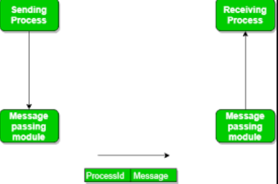
Figure 1: Communication mechanism
(Source: Vlăduțescu, 2014)
Non-verbal communication: In case of non-verbal communications, the sender and receiver communicate through written or formal procedures. This can also be termed as the manual language in a workplace. The body language of the various individuals in a workplace can also be termed as a significant form of non-verbal communication (McQuail, 2015). For example, the body language of an employee portrays the level of acceptance and comfortableness in the workplace. This is highly beneficial for a working organization as it displays the approach of the organization in a professional manner.
The above figure portrays the mechanism of the communication. Therefore, it can be concluded that the communication is a closed and cyclic procedure, which transfers the various messages from the sender to the receiver through various channels like online messages, telephone calls, online videos, email, etc. With the help of this procedure or cycle, both the sender and receiver are able to stay updated with the help of significant messages, feedbacks, and information.
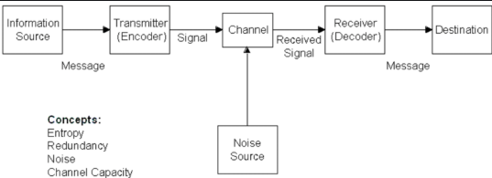
Figure 2: Shannon Weaver Communication model
(Source: Lindlof, 2017)
An effective conduction of efficient communication requires proper models. The Shannon-Weaver Mathematical model provides the principles for converted communication. This model portrays a specific method that includes the conversions of the messages forwarded by a specific sender. The conversions are done in such a way that the messages are changed to an understandable form before being delivered to the receiver through various communication channels (Lin, 2014). The receiver further decodes the messages and identifies the multiple details and information. This technique is highly used by various armed troops across the globe. However, in business organizations, the same technique is used in the social media platforms. For example, the messages sent through the Whatsapp application are first changed to a formal language. Further, the receiver with the help of a proper software application decodes it.
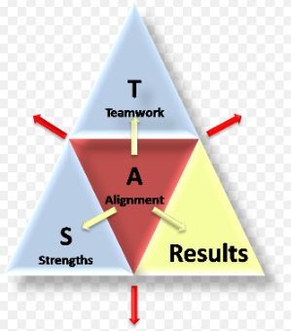
Figure 3: Star teamwork model
(Source: Adler, 2016)
The star-team working model portrays the significant attributes of team working in a workplace. Form the above diagram, it can be concluded that the teamwork is the ability of an organization to execute tasks and deliver successful outcomes with assistance of another working organization. The rationale behind considering another significant organisation is to determine the significant tasks that are required for a joint venture. However, there are specific limitations of the model, which are:
The Shannon Weaver model leads to increase of misrepresentations of the human nature and further, there is an increased chance of the message being decoded without proper permissions of the receiver. This happens due to the presence of MITM in the communication channel (Suzuki, 2015).
The star team-working model effectively represents the closer relationships (Bello, 2014). Therefore, in a dynamic teamwork, the work is often ineffective and there is absence of proper uses of the available skills among the members.

Comparison of different types of communication approach
Multiple deductions and attributes can be achieved from the working principle of Shannon Weaver mathematical model. This can be achieved with the help of various affects of the sources and the encoding results. The significant affects that can be obtained are:
- Development in credibility
- Attractiveness
- Expertise
The major challenges related to the model are the various errors in the encoding procedures. In general, the encoding is executed through a universal approach, which states that the software for encoding on the sender and receiver end must be same. Further, this approach is limits the chances of any specific changes in the messages that are transferred to the receiver. The changes and modification in the errors will lead to inefficient assumptions among the vase audience. Specific words and expression portray different meanings in the universal platform of communication. Therefore, there is a high chance that the encoder might change the initial meaning of a message or word. This will lead to the encoder delivering messages with different meanings than intended. However, there are specific procedures to overcome this particular challenge. A proper contingency method can be providing an appropriate drop-down menu or option. This menu would display the language based on the different language practiced in the different nations across the globe. The various choices of language provided by the Microsoft office can be a prime example of the same technique. In addition, this will allow the sender to deliver the message to the receiver with the initial intentions and ideas.
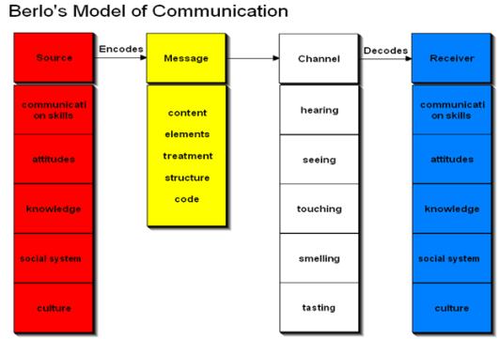
Figure 4: Berlo’s Model Of communication
(Source: Portfors, 2014)
The Berlo’s model of communication provides various characteristics and attributes in context to communication. This is a prime advantage that the model offers to the various individuals in a workplace. This model considers the different methods and channels for communication and determines the culture of the receiver during the communication procedure. However, this model has a major setback, which is same as the Shanon weaver model. This approach is highly dependent on the culture of the sender and the receiver (Rak, 2017). Therefore, a huge scale of assumptions from the sender and receiver are required in this technique.
The star team-working approach aims at the effective use of the strengths of the various members in the team. The focus is laid on encouragement of the members. Further, this leads to the motivation of the members and there is a considerable increase in the relationship among them. With all these factors, the team will be able to execute the work properly and the outcome will be efficient in nature (El-Said, 2014). The model provides firm assistance for the development of the framework of team cycle in context to the various tasks of the team. However, the biggest drawback of this model is the affect of the various external factors on the tasks of the team. These external elements are the works of the other teams, organizations, and other outside elements. All these factors coupled with the demands of the customers are executed within the framework, which increases the effectiveness of the teamwork with the help of the available skills and abilities.

Practical application and development
In this segment, a proper classroom exercise will be considered to understand the importance of proper communications. The English professor of the Welsh University, who lived near a little village failed to achieve help from the villagers when there was a fire breakout in his house. This scenario occurred because there was gap in the understanding. The professor communicated at a higher level of communication, which the villagers failed to understand. Therefore, the villagers did not provide any help. From the above scenario, it can be concluded that proper language is essential for any individual. This is the evident from the various aspects of Berlo’s model of communication. This model portrays the various types of the communication barriers that exist between the sender and receiver in a communication cycle.
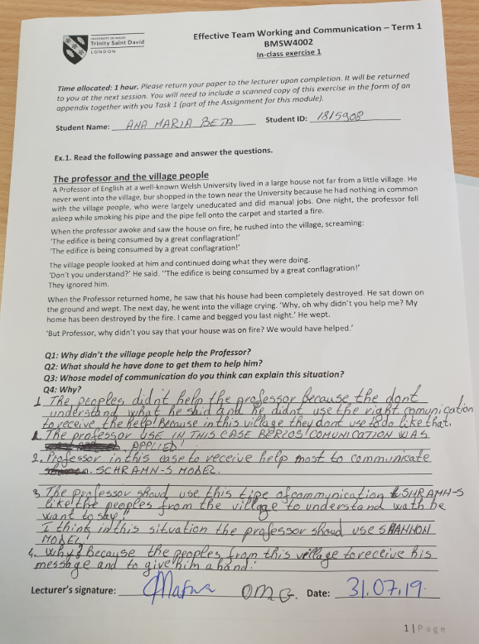
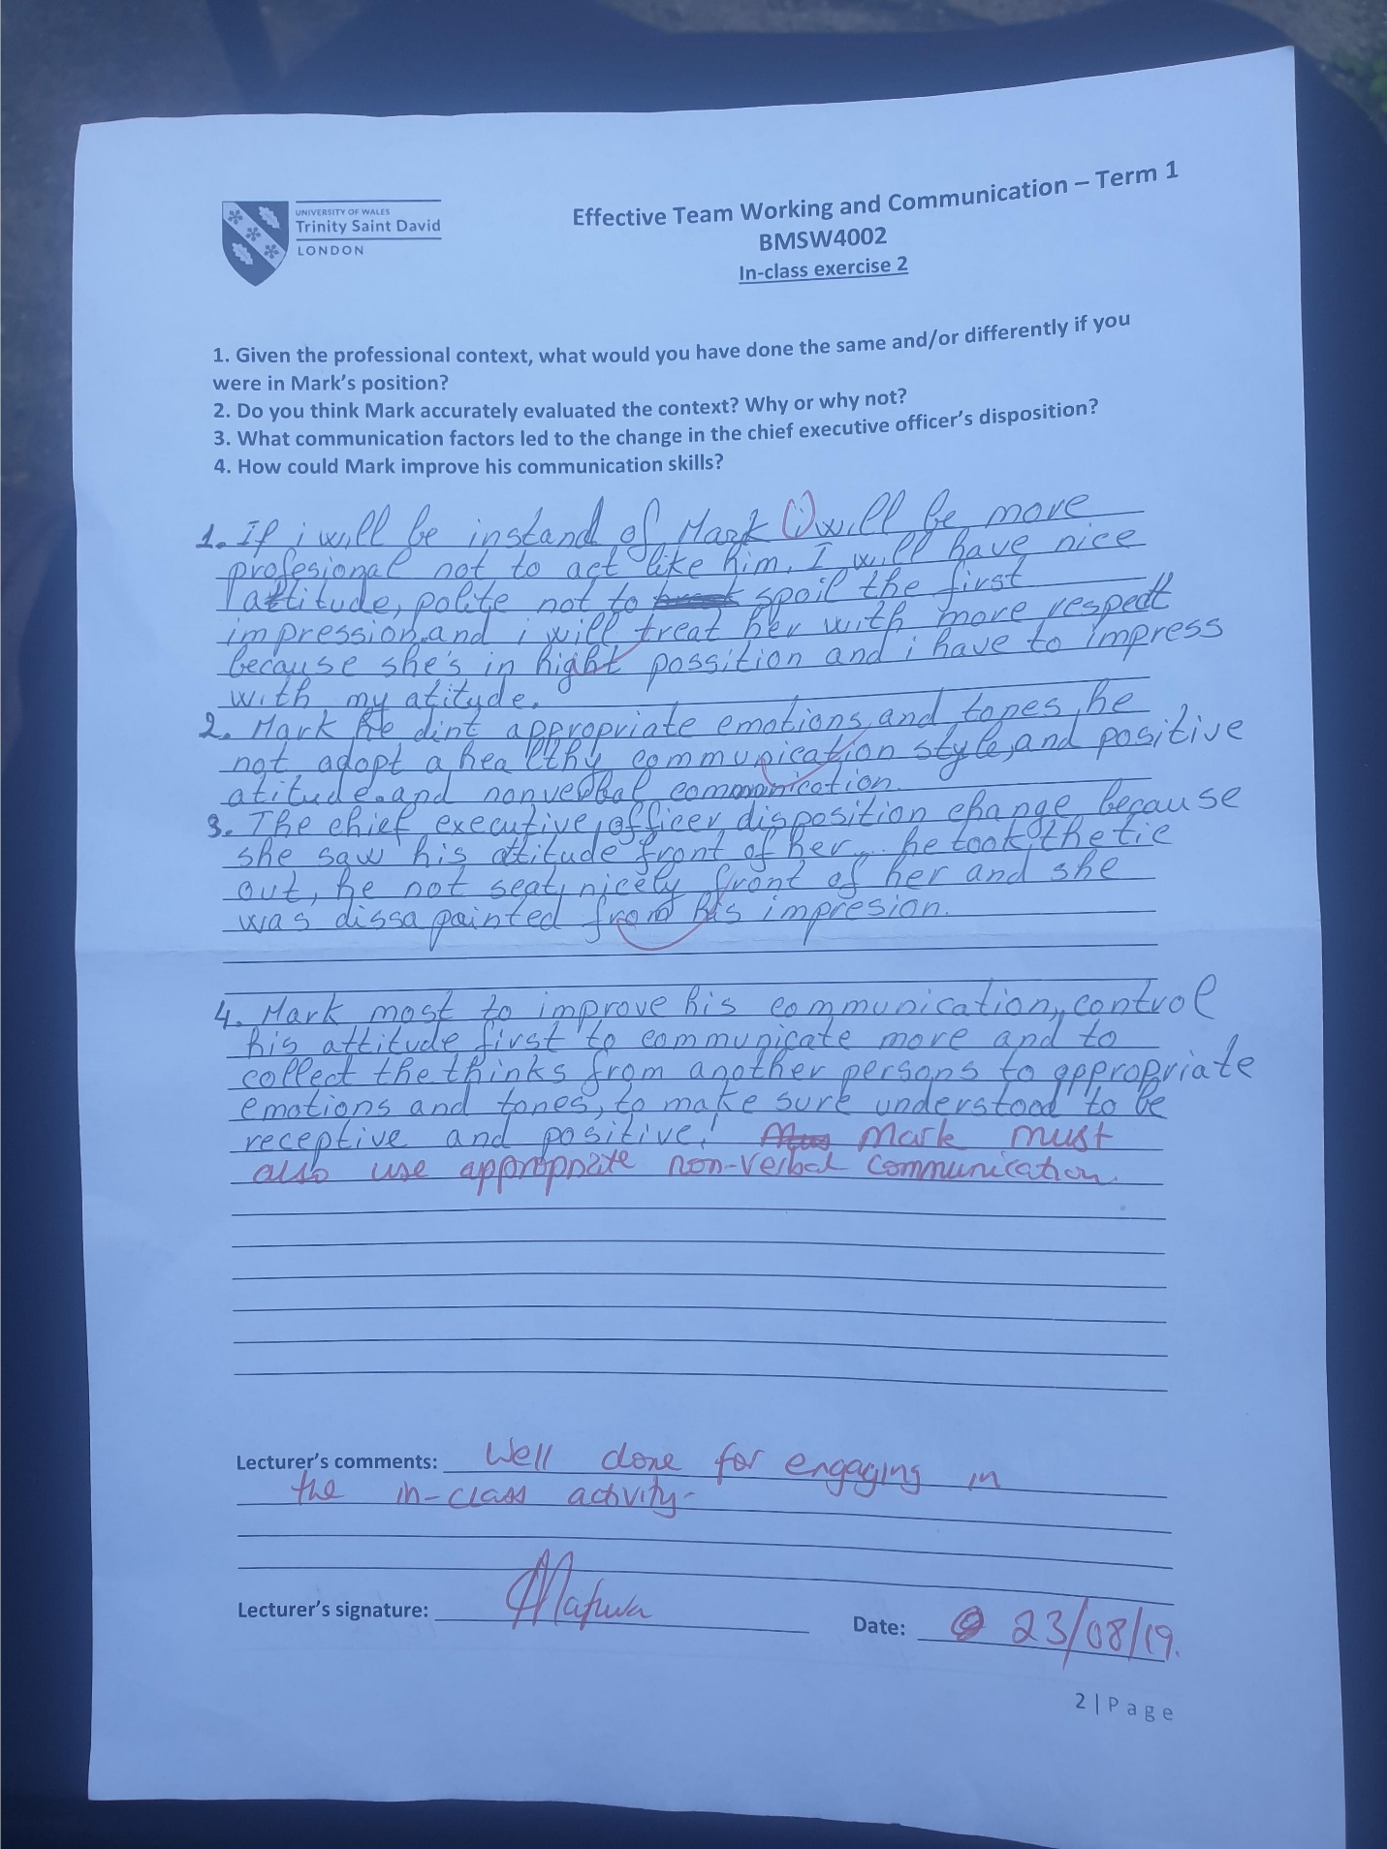
Figure 5: In-class exercises
(Source: Taken from support)
This model states that the sender must be of the same culture as of the receiver for the establishment of proper communication between them. Through this model, it can be concluded that the source tried to communicate in a language culture that was clearly high form the culture of the receiver. The channel of the communication was verbal and the sender totally depended on delivering the message with the help of words and expressions. The rationale for this includes the exchange of the message through verbal communications and expressions. Moreover, this included non-verbal communications like expressions and feelings. Due to the difference in culture, the receiver failed to encode the message and react to the situation.
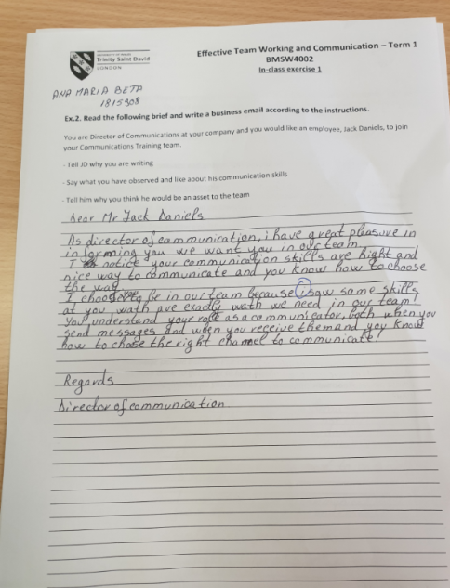
Figure 6: In-class exercises
(Source: Taken form support)
Further, the second scenario portrayed the selection of a candidate in the team due to his efficient communication skills. With the help of the specific star teamwork model, the importance of the strength of the various individuals in the team can be understood. Further, the reasons behind his inclusion can be determined through this process. Further, this can be used to develop the various professional skills of the individual. The main aim of this technique is to ensure high motivation of the members, which will further lead to the improvement of the relationships among the members. Further, proper training procedures will be included in these techniques.
These techniques will provide vast opportunities for me to develop my skills in the workplace. These trainings will help me to understand the various differences in the cultures across the world. I will be able to develop proper skills that I can use on mutual grounds to communicate with the various global cultures. Further, the team working techniques and trainings will help to gather the various aspects of the team. I will be able to work effectively in a team and develop proper relationships with my peers. With developed communication skills, I will be able to achieve higher growth in the five star hotels that I am employed in. For example, I will be able to determine the significant information provided to me by my managers through the messages. Further, in the academic fields, I will have the ability to successfully execute the various researches. The various principles of proper communication will help me to execute multiple tasks and projects and deliver a suitable outcome. Further, I will be able to attain success and degrees in my academic area. Moreover, I will have an opportunity to attain various job posts like marketing executives and human resource executives.

Skills in the segment of professional practice and team working
Based on the scenario mentioned above, the principles of the verbal and non-verbal communications can be determined. In context to the various above initiatives, my aim I this segment is to develop my verbal communication skills and communicate with my peers in a loud and clear manner to deliver the information to my peers. Further, in reference to effective team working, I aim at proper involvements in the teams with my colleagues and peers. The size of the team is the prime aspect that is required to be considered in this segment.
Therefore, it can be concluded that the proper skills and abilities are required for effective participation and contributions in the team. For advancements in professional segment, it is essential to execute proper verbal communications. The various kinds of verbal communications are posters, messages, and video representations. These skills are essential for the creative approaches and annual reports of the corporation. Moreover, the development of the team working abilities requires proper critical analysis abilities and communication excellence. However, the various groups include members with different approach and personal strengths. This can result in mixed outcomes in the long-run of the company (Yu, 2017).
In addition, the most significant skill while working in a group as a team is the determination of the nature of the task. For example, in case of an oral representation, the emphasis must laid on the verbal communication techniques. On the other hand, in case of annual representation of the company, the focus must be laid on the non-verbal communications like graphical representations and visual representations. These will also include the modulation of the skills required for effective teamwork. Further, to understand the various responsibilities of the team, a firm dynamic approach is required to be incorporated in the teamwork. Further, the improvements in the visual communications require proper advancements and knowledge in the graphical representations in qualitative mannerism.

Conclusion:
From the above study it can concluded that there are mainly two types of communications that are practiced in the professional ad academic fields. The three major communication types are verbal, visual, and non-verbal types of communications. However, the visual representations of communication can be termed as the mix of verbal and non-verbal form of communication. Further, the study establishes the importance of proper communication in the different tasks of the teamwork. The models determined in the study establish proper dynamic approach of the various forms of communication in context to the various approaches of the teamwork. This is because the communication channels established in the teamwork and communication models can be modified based on the target audience and nature of the task.

Reference List
Adler, R.B., Rodman, G.R. and Du Pré, A., 2016. Understanding human communication (Vol. 10). Oxford University Press.
Bello, O. and Zeadally, S., 2014. Intelligent device-to-device communication in the internet of things. IEEE Systems Journal, 10(3), pp.1172-1182.
Claret, J.V.B., Moreno, J.L.G., Molinero, S.I., Egan, J.V. and Corella, A.B., MaxLinear Hispania SL, 2014. Communication node including transceivers transmitting on different types of transmission lines and performing data repeating functions. U.S. Patent 8,885,689.
El-Said, O.A., 2014. Impacts of respect, support, and teamwork on hotel employees' morale in Egypt. Anatolia, 25(2), pp.211-227.
Lin, C.A., 2014. Communication technology and social change. In Communication Technology and Social Change (pp. 17-30). Routledge.
Lindlof, T.R. and Taylor, B.C., 2017. Qualitative communication research methods. Sage publications.
McQuail, D. and Windahl, S., 2015. Communication models for the study of mass communications. Routledge.
Portfors, C.V. and Perkel, D.J., 2014. The role of ultrasonic vocalizations in mouse communication. Current opinion in neurobiology, 28, pp.115-120.
Rak, J. and Boryczko, K., 2017. Assessment of water supply diversification using the Pielou index. Environmental Engineering V, Leiden, pp.53-58.
Robinson, L. and Bawden, D., 2014. Mind the gap: transitions between concepts of information in varied domains. In Theories of information, communication and knowledge (pp. 121-141). Springer, Dordrecht.
Suzuki, T., Asakura, H., Matsuda, M. and Tanaka, S., Brother Industries Ltd, 2015. Function executing device with two types of interfaces for executing a communication with a terminal device. U.S. Patent 9,106,781.
Vlăduțescu, Ș., 2014. Convictive Communication and Persuasive Communication. International Letters of Social and Humanistic Sciences, (26), pp.164-170.
Yu, H., Shen, Z., Miao, C., Leung, C., Chen, Y., Fauvel, S., Lin, J., Cui, L., Pan, Z. and Yang, Q., 2017. A dataset of human decision-making in teamwork management. Scientific data, 4, p.160127.

